
Faculty of Science

Course: CSCI 3230U: Web Application Development
Lab: #9
Topic: Web services

Overview
In this lab, you will develop an application that displays news stories obtained from the Internet.

Instructions
Assume that on your server somewhere is a file called topnews.atom, which is an XML file containing the news stories of the week. The XML file is a well-known news format, called Atom. An example Atom file is given below, which you should treat at similar to what you'd expect to receive in your application.

<?xml version="1.0" encoding="utf-8"?>
<feed xmlns="http://www.w3.org/2005/Atom">
<title>Weekly World News Report</title>
<subtitle>Events from around the globe</subtitle>
<link href="http://www.weeklyworldnews.info" rel="self" />
<updated>2013-02-05T08:44:10-05:00</updated>
<author>
<name>Gudri Porter</name>
<email>gporter@weeklyworldnews.info</email>
</author>
<id></id>

<entry>
<title>Yeti Finds Love In... New Jersey</title>
<link>http://www.weeklyworldnews.info/story/581</link>
<id>urn:uuid:1bdbb2e6-8aac-c014-696f-766f231c070f</id>
<published>2013-01-02T04:01:44-04:00</published>
<updated>2013-01-02T04:01:44-04:00</updated>
<summary>Residents of Hoboken New Jersey were surprised, to say the least, when a Yeti and a local woman walked into the local Denny's and asked for a table. Later, residents learned that the couple was in love, and living in their town.</summary>
<content type="html">Hoboken, NJ: Some residents were delighted, others horrified, all confused. "I thought Yetis lived in Nepal, but what do I know?" said one resident. "What in the world is a Yeti?" asked another. Hobokeners are confused, but also touched by these two lovebirds. At the same time, the Mayor's office has reported a 700% increase in mauling deaths since the Yeti arrived. Some residents think it no coincidence.</content>
</entry>
<entry>
<title>Washington Man Abducted by Family of Bears</title>
<link>http://www.weeklyworldnews.info/story/582</link>
<id>urn:uuid:756b8b06-565d-bad6-baf8-61c8cf653353</id>
<published>2013-01-02T03:57:40-04:00</published>
<updated>2013-01-02T03:57:40-04:00</updated>
<summary>A man in his early 60s was abducted in Charlotte, Washington late last night. Neighbours claim the perpetrators were a family of three grizzly bears.</summary>
<content type="html">Charlotte, WA: A man described as 'very friendly' by his neighbours was abducted last night, by a family of grizzly bears. Since then, his whereabouts are still unknown.
"He's always been a quiet fella." said his next door neighbour, Alice. "We didn't talk to him much, because of the weird smell coming from his back yard." Late last night, however, Alice peeked out of her front window and caught a glimpse of one large grizzly, and two smaller grizzly bears, carrying off the man wrapped in what appeared to be a carpet. Police are investigating this as a potential homicide, and are asking any other witnesses to come forward.</content>
</entry>
</feed>
Your application will be an HTML5 webpage that uses jQuery to obtain and process the XML results of this page, using jQuery AJAX, and uses jQuery UI to display it in an accordion control, as shown in figure 1. A DIV element with the ID "topStories" should be inserted into your HTML document for you to insert your content. Afterwards, you should make that DIV into an accordion using jQuery UI. For the purposes of this example, simply copy the sample file into your XAMPP directory, under the name 'topstories.atom' and use that as the source of your news data.
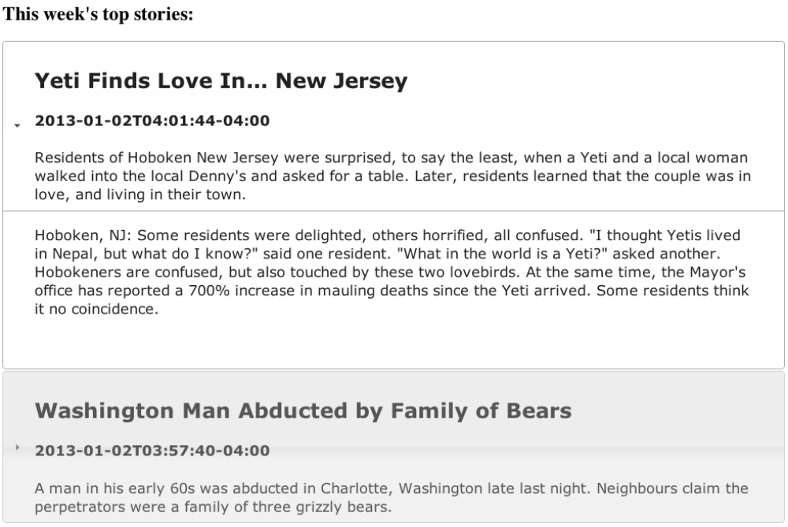
Figure 1: Sample output for this lab

Hint: When you get the response back from the AJAX request, you should create a structure similar to the following (dynamically), for each news story:
<div>
<h2>Washington Man Abducted by Family of Bears</h2>
<h4>2013-01-02T03:57:40-04:00</h4>
<div>
A man in his early 60s was abducted in Charlotte, Washington late last
night. Neighbours claim the perpetrators were a family of three grizzly
bears.
</div>
</div>
<div>
Charlotte, WA: A man described as 'very friendly' by his neighbours was
abducted last night, by a family of grizzly bears. Since then, his
whereabouts are still unknown. "He's always been a quiet fella." said his
next door neighbour, Alice. "We didn't talk to him much, because of the weird
smell coming from his back yard." Late last night, however, Alice peeked out
of her front window and caught a glimpse of one large grizzly, and two
smaller grizzly bears, carrying off the man wrapped in what appeared to be a
carpet. Police are investigating this as a potential homicide, and are asking
any other witnesses to come forward.
</div>
Note: You should not hardcode anything from this file (even the number of stories). You should use this Atom file as an example to understand the format of Atom only.

How to Submit
Submit the HTML, CSS, and JavaScript files in a ZIP file, with a name following the same pattern as previous labs: Lab9_FirstNameLastName_StudentNumber.zip (e.g. Lab9_RandyFortier_100539147.zip) to the appropriate Lab drop box on Blackboard. The TA may allow you to submit the lab in person. If so, you can do that, but you are still required to submit the file on Blackboard for posterity.

