
Faculty of Science

Course: CSCI 3230U: Web Application Development
Lab: #10
Topic: PHP

Getting Started
Create a directory within the XAMPP directory structure for your lab assignments (either in the lab, or on your own PC). On a Windows machine, this directory will likely be C:\xampp\htdocs\labs. Create a new text file, called lab1.php. At the top of this file, in comments, you must include your name and student ID. In general, all assignments, lab assignments, and project files will have this comment at the top, preferably along with a short description of the file. An example is shown in example 1. If you’d like, you are welcome to use this as a template for all future PHP pages.

Example 1: The sample skeleton code for your assignment.
<?php
#
# Randy J. Fortier (123456789)
#
# Lab 10: Displays an invoice, generated dynamically using data stored in arrays.
#
?>
<!DOCTYPE html>
<html>
<head>
<title>CSCI 3210 – Lab 10</title>
</head>
<body>
<?php
... your code goes here ...
?>
</body>
</html>
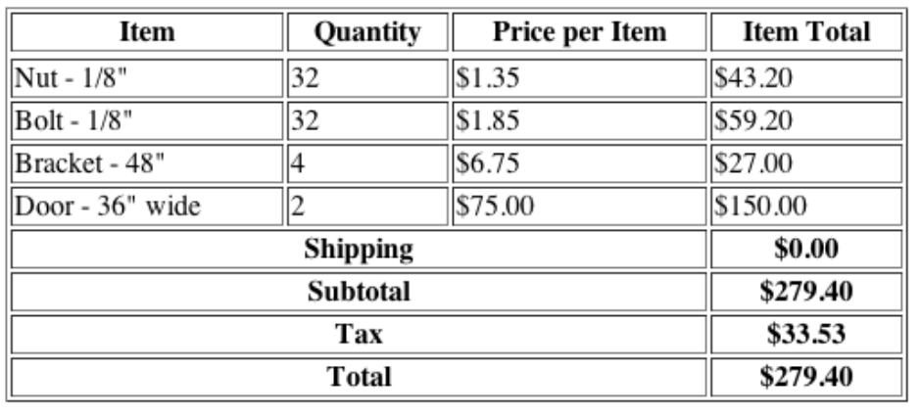
Figure 1: The expected output of your PHP program

Requirements
The purpose of this lab assignment is to dynamically generate an invoice web page, using PHP. The data for this invoice is displayed in figure 1. If you have completed this assignment correctly, your output should look like figure 1. It is critical that you do not just create the web page shown in direct, static HTML, without using PHP. Doing so will not get you the marks for this lab.
- Create a variable for the tax rate, with the value 0.12.
- Using the data in figure 1 as a reference, create a set of arrays, one for each data field/column (item name, quantity, price). Ensure that each array has the same length.
- Loop through these arrays, generating an HTML table dynamically. If the length of the arrays were to change, none of the code in your loop should change, but the output should change accordingly.
- Inside this loop, calculate the subtotal of all items on the invoice.
- If the subtotal is greater than or equal to $50, the shipping cost is $0.00. If the subtotal is between $25 and $50, the shipping cost is $4.99. Otherwise, the shipping cost is $9.99.
- After the loop completes, generate lines for the subtotal, tax, and total, as shown in figure 1

How to Submit
Submit all files necessary to view your work, together in a ZIP file, with a name following the same pattern as previous labs: Lab10_FirstNameLastName_StudentNumber.zip (e.g. Lab10_RandyFortier_100539147.zip) to the appropriate Lab drop box on Blackboard. The TA may allow you to submit the lab in person. If so, you can do that, but you are still required to submit the file on Blackboard for posterity.

