
Faculty of Science

Course: CSCI 3230U: Web Application Development
Lab: #5
Topic: JavaScript

Overview
For this lab, you will create a JavaScript file for an HTML web page that you worked on in the previous lab. If you missed that lab, download Lab4.zip and start there. You will extend the HTML, CSS, and JavaScript to accommodate login and chat user interfaces (but not functionality).

Instructions
Chat Window
The chat box (on the bottom right, if you’ve completed lab #4, see figure 1) is a clickable element. When the up array in the chat box is clicked, display a simple chat window, as shown in figure 2. Make this element invisible when the page loads, and put one <div> inside it with a message from Sam.

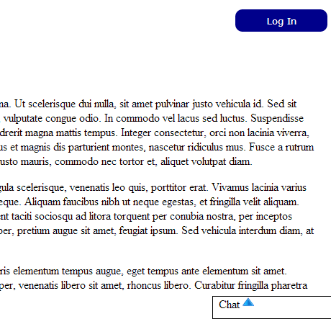
Figure 1: The chat box before it has been clicked

The chat popup contains two elements. First, it contains a list of messages. Below, it contains a single text field without a label.

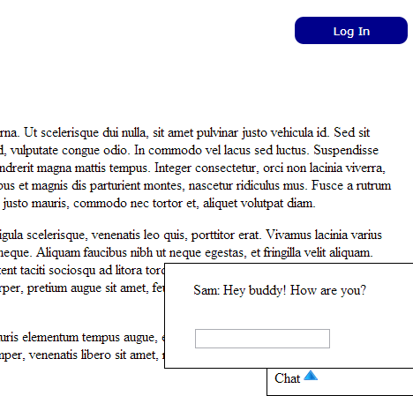
Figure 2: The chat box after being clicked, showing the chat popup

When the enter key is pressed while typing in the text field, you should use basic DHTML to append a new DIV containing the message (format: You: <message text>) to the chat popup.

How to Submit
Submit the HTML, CSS, and JavaScript files in a ZIP file, with a name following the same pattern as previous labs: Lab5_FirstNameLastName_StudentNumber.zip (e.g. Lab5_RandyFortier_100539147.zip) to the appropriate Lab drop box on Blackboard. The TA may allow you to submit the lab in person. If so, you can do that, but you are still required to submit the file on Blackboard for posterity.

