
Faculty of Science

Course: CSCI 3230U: Web Application Development
Lab: #4
Topic: CSS

Overview
For this lab, you will create a CSS stylesheet for an HTML web page provided with this lab (also see figure 1). You can find the supporting files for this lab in the ‘Labs’ tool, in a file called Lab4.zip.

Instructions
Use a float layout to ensure that the header section is at the top. Use display: table-row to get the left, centred, and right justified components on the header as in figure 2. The naviation bar consists of an unordered list, with list items for each navigable button. These items would be clickable in a production website, but are not for the purposes of this lab.

The chat tool should be absolutely positioned in the bottom right corner of the page (it will overlap any content in that area). This, too, would be clickable in a real web site, but will not be for our purposes.

Many other components need adjustment in other ways (e.g. image size, background colours, borders, list styles, margins, padding, etc.


Figure 1: The unstyled web page

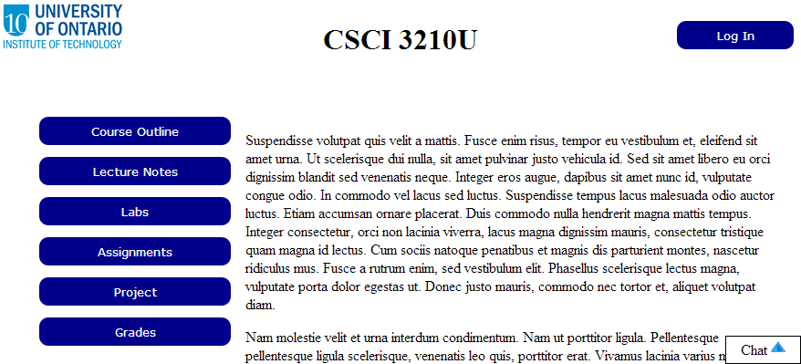
Figure 2: The styled web page

How to Submit
Submit the HTML file and CSS file in a ZIP file, with a name following the same pattern as previous labs: FirstNameLastName_StudentNumber.zip (e.g. RandyFortier_100539147.zip) to the appropriate Lab drop box on Blackboard. The TA may allow you to submit the lab in person. If so, you can do that, but you are still required to submit the file on Blackboard for posterity.

