
Faculty of Science

Course: CSCI 3230U: Web Application Development
Lab: #7
Topic: AJAX

Overview
For this lab, you will create an AJAX-enabled web page for processing student records. The output of this web page will look very much like that of lab #6, but it will be generated dynamically via DHTML using AJAX to retrieve the data to be displayed. Once finished, integrate the JavaScript from Lab #6 so that your table is still clickable in a way similar to a spreadsheet.

Instructions
Data Source
As we have not yet learned about PHP, our data source will be a static text file (called student_data.csv). Presumably, this data could be generated dynamically (in PHP) using data from a database. The file’s contents will look like the following:

Listing 1: Contents of student_data.csv:
100000000,4.5,3.75,3.4
100000001,4.25,4.12,4.25
100000002,5.0,4.75,4.5

HTML Page
Create a simple HTML page with only two elements in its body:
- A button: When clicked, your JavaScript code will issue an AJAX request. The button text will be ‘Generate Spreadsheet.’
- An empty DIV: This is where your dynamically-generated table will be placed, when you receive the response to the AJAX request.

JavaScript
Implement a click event handler for the button that issues an AJAX request for the page student_data.csv. When the response comes back for this request, you will generate a table of student grades, as shown in figure 1, using DHTML. The number of students is not known, but you can assume the headers will remain exactly the same as in figure 1.

Integrate the code from lab #6, so that the columns, rows, and cells are clickable just like the static HTML table from that lab assignment.

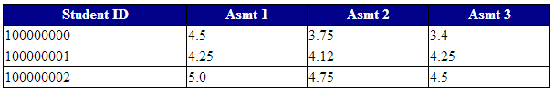
Figure 1: The table after the AJAX request

How to Submit
Submit the HTML, CSS, and JavaScript files in a ZIP file, with a name following the same pattern as previous labs: Lab7_FirstNameLastName_StudentNumber.zip (e.g. Lab7_RandyFortier_100539147.zip) to the appropriate Lab drop box on Blackboard. The TA may allow you to submit the lab in person. If so, you can do that, but you are still required to submit the file on Blackboard for posterity.

