Machine Learning Assignment 1 Report
Geothermal Plant Modelling: Steam Turbine Optimisation (var1) and Thermal Reservoir Mapping (var2)
By: Siddharth Brijesh Tripathi (IMT2024011)

Common Methodology (both problems)
Model: For each problem, the inputs are expanded into all monomials up to total degree d, i.e. every product of the form xᵢ·xⱼ·… whose powers sum to at most d. This is the "degree-d polynomial" in the sense of the problem statement. A linear model with a bias term is then fitted on these features. The bias is not penalised. The number of features for n variables is $C\left(n+d,d\right)-1$.
Regularisation: Elastic Net. Because the number of monomials grows quickly with degree (8,007 features at degree 10 for 6 variables, 1,770 at degree 20 for 3 variables) and there are only 1,000 training rows, plain least squares would overfit. The objective was:
$$min‖y-Φw-b‖²+λ₂‖w‖²+λ₁‖w‖₁$$
The L1 term performs automatic term selection (sparsity), and the L2 term stabilises correlated monomials.
Optimiser: I implemented the solver from scratch in PyTorch rather than using sklearn. It is FISTA (accelerated proximal gradient) with (THIS HAS BEEN GIVEN BY AI WHEN I TOLD IT TO NOT USE SKLEARN):
- analytical gradients, with no autograd graph;
- soft-thresholding as the proximal step for the L1 term;
- Nesterov momentum;
- a step size $1/L$, with $L=2\left(σ_{max}​{\left(\left[ Φ∣1 \right]\right)}^{2}+λ_{2}\right)$, where $σ_{max}$ is the spectral norm of the feature matrix computed per fold.
The code ran on a Tesla T4 GPU in float32 on google colab.
Model selection: For every candidate degree, I did a K-fold cross-validated grid search over (λ₁, λ₂). The metric was the mean validation RMSE at the last iteration. The best (λ₁, λ₂) per degree was refit on all training data (3,000 FISTA iterations) and used to predict the test set. The degree was then chosen by comparing the best CV RMSE across degrees. Folds were fixed with seed 0, so all degrees are compared on identical splits.
Final diagnostics: Out-of-fold predictions (each row predicted by a model that never saw it) were used to compute honest R², residual plots, and error-vs-boundary analysis.

Section 1: Power Plant Steam Turbine Optimisation (var1)

1.1 Data and Exploratory Analysis
- Train: 1000 × 7 (x1 to x6, y). Test: 1000 × 6. There were no missing values.
- All features lie in [-1, 1] with std ≈ 0.7. A large number of the points are exactly at ±1, which suggests the inputs were clipped at the boundaries. y ranges from -8.99 to 12.31 (mean 0.92, std 3.14).
- Raw linear correlations with y are weak (largest |r| = 0.21 for x5, 0.20 for x6, 0.15 for x3, and ≈0 for x1 and x2). A purely linear model is therefore expected to perform poorly.
- The inputs are moderately correlated with each other (x1 x4 and x5 x6 cluster, r ≈ 0.4–0.5).
- Correlating y with engineered terms (xᵢ, xᵢ², xᵢ·xⱼ) shows that the signal is in the interactions and squares, not the raw inputs. The strongest terms were x1·x5 (-0.445), x6² (+0.383), x2·x3 (-0.353), x3² (-0.290) and x3·x6 (-0.247). This points clearly to a non-linear, interaction-heavy response surface.
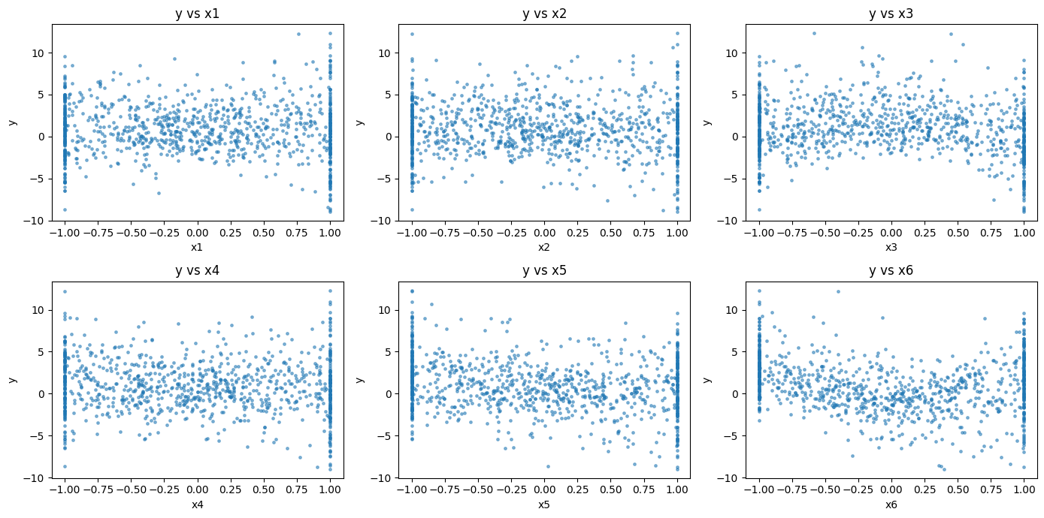
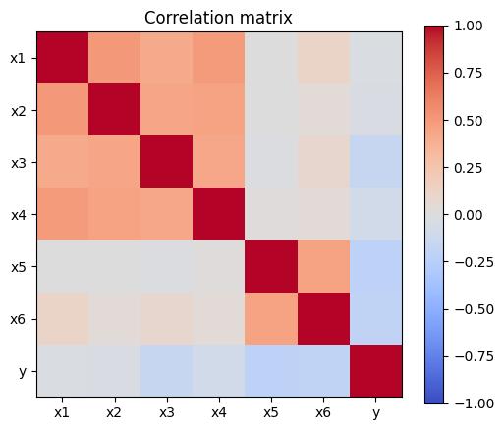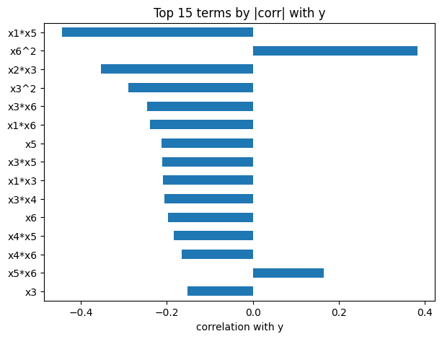

1.2 Degree Selection
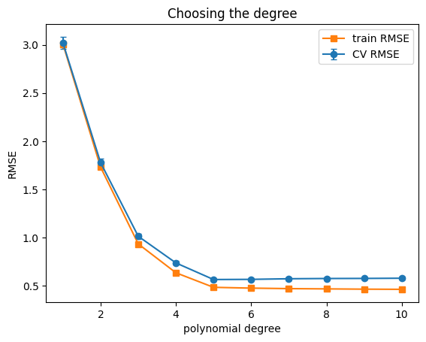
I swept degrees 1–10 (the stated upper bound) using 10-fold CV. The grid was 10 × 10, with λ₁ ∈ {0, 0.5, 1, 2, 3, 4, 6, 10, 15, 30} and λ₂ ∈ {0, 0.01, 0.03, 0.1, 0.3, 1, 3, 10, 30, 100}. This amounts to 100 hyperparameter settings × 10 folds per degree.
Degree | #Features | Best λ₁ | Best λ₂ | CV RMSE | CV SE | Train RMSE | Non-zero
1 | 6 | 0 | 30 | 3.0185 | 0.064 | 3.006 | 6
2 | 27 | 10 | 0 | 1.7765 | 0.044 | 1.730 | 25
3 | 83 | 6 | 0 | 1.0133 | 0.027 | 0.934 | 66
4 | 209 | 6 | 0 | 0.7369 | 0.021 | 0.635 | 117
5 | 461 | 6 | 0 | 0.5646 | 0.012 | 0.484 | 122
6 | 923 | 6 | 0 | 0.5663 | 0.012 | 0.475 | 144
7 | 1715 | 6 | 0 | 0.5727 | 0.013 | 0.470 | 167
8 | 3002 | 6 | 0 | 0.5752 | 0.013 | 0.467 | 171
9 | 5004 | 6 | 0 | 0.5761 | 0.013 | 0.465 | 179
10 | 8007 | 6 | 0.01 | 0.5781 | 0.013 | 0.463 | 193
Observations and rationale.
- Underfitting for degree ≤ 4. CV RMSE falls sharply from 3.02 (linear) to 0.74 (degree 4), and train and CV errors are close, so these models lack capacity.
- Plateau from degree 5. CV RMSE reaches its minimum of 0.5646 at degree 5. From degree 6 onward the CV error goes upward (0.566 to 0.578) while the train RMSE keeps declining. This is the classic overfitting signature, although it is mild because the L1 penalty prunes most of the higher-order terms.
- Higher degrees add no value. The differences between degrees 5-10 are within one CV standard error (≈ 0.012). I chose the lowest degree on the plateau, degree 5. It has the lowest CV error in absolute terms and is also the simplest model: 461 candidate features, of which only about 122-126 are retained.
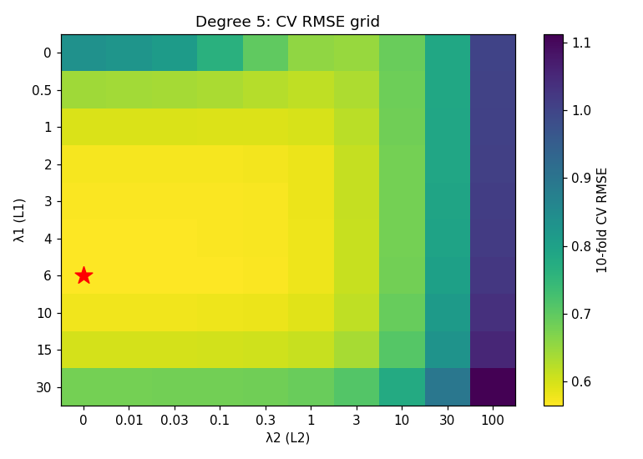
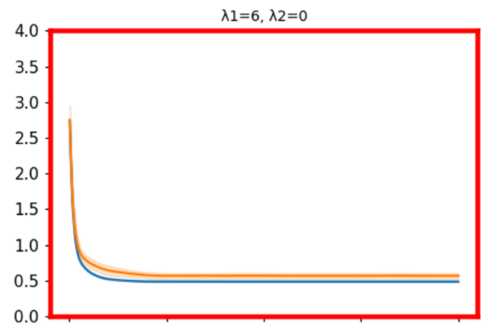
- Regularisation pattern. Across every degree ≥ 2, the best configuration had λ₂ = 0 (or the negligible 0.01 at degree 10) and λ₁ in the range 6-10. Pure L1 sparsity is what the problem wants, which suggests the underlying function is a sparse polynomial. Degree 1 is the exception, where mild ridge (λ₂ = 30) was preferred.

1.3 Hyperparameter Fine-tuning
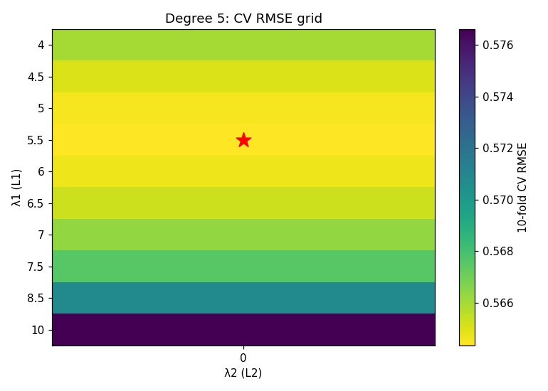
The coarse sweep showed the optimum sitting at λ₁ ≈ 6 with λ₂ = 0 for every degree. I therefore ran a finer search at degree 5 only, with λ₂ fixed at 0 and λ₁ ∈ {4, 4.5, 5, 5.5, 6, 6.5, 7, 7.5, 8.5, 10} (10-fold CV).
- Best: λ₁ = 5.5, λ₂ = 0, CV RMSE = 0.5644 ± 0.0123, with 126 of 461 coefficients non-zero.
- The gain over the coarse optimum (0.5646) is negligible, which confirms that the CV surface is flat near the optimum and the result is not sensitive to the exact λ₁.

1.4 Final Model and Diagnostics
Chosen model: degree 5 polynomial, Elastic Net with λ₁ = 5.5, λ₂ = 0. It was refit on all 1,000 training rows for 3,000 FISTA iterations.
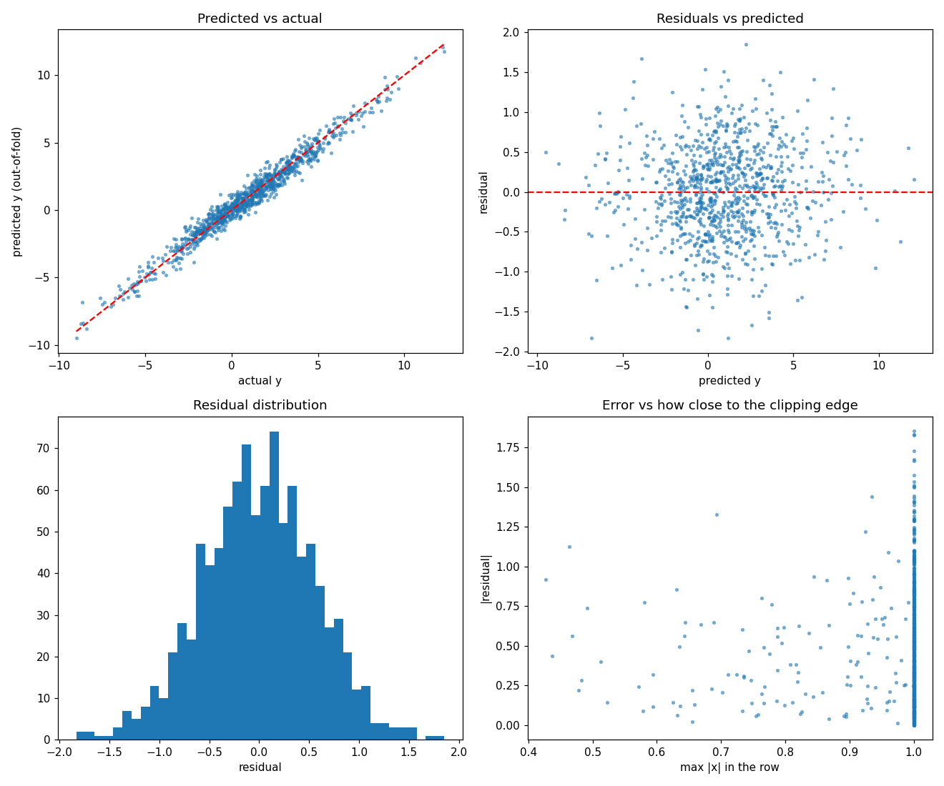
Out-of-fold performance (10-fold): RMSE = 0.5656, R² = 0.9676. In MSE terms, the expected test MSE is therefore ≈ 0.32.
Strongest retained terms (coefficient magnitudes):
Term | Coefficient
x1·x5 | -2.666
x2³·x3 | -2.391
x2·x4·x6 | -1.892
x3·x6 | -1.669
x1·x3²·x6² | -1.544
x2²·x4²·x5 | -1.512
x3³·x6² | -1.508
x4²·x5² | +1.490
x6² | +1.482
x1²·x3²·x5 | -1.372

The leading term, x1·x5, matches the strongest term from the EDA (corr -0.445), so the model agrees with the exploratory analysis. The mix of degree-2 to degree-5 interaction terms confirms that the response is driven by interactions, not main effects.
Sanity check: The test prediction range is [-10.13, 14.95], against a training y range of [-8.99, 12.31]. This is slightly wider than the training range.
Prediction file: IMT2024011_pred_var1.csv (column y_pred, 1,000 rows).

Section 2: Subterranean Thermal Reservoir Mapping (var2)

2.1 Data and Exploratory Analysis
- Train: 1000 × 4 (x1, x2, x3, y). Test: 1000 × 3. There were no missing values.
- Inputs lie in [-1, 1] with std ≈ 0.68–0.70, and many points are at exactly on the ±1 boundar. y has a much larger spread than in var1: -29.5 to 39.3, std 7.04, mean 2.24.
- The input features are essentially uncorrelated (|r| ≤ 0.07).
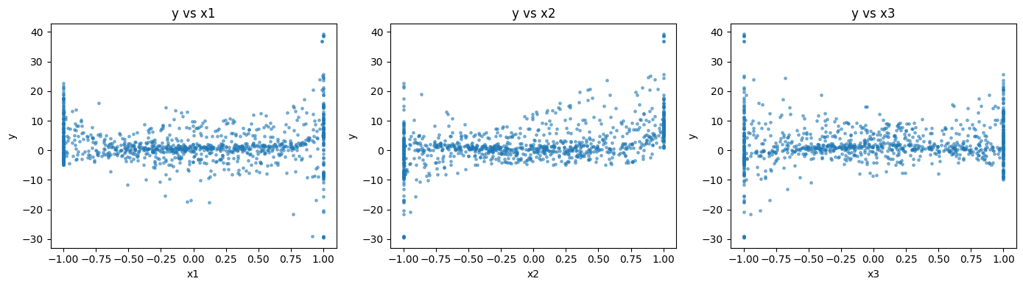
- Linear correlation with y is weak except for x2 (r = 0.47). x1 and x3 are almost uncorrelated with y (0.02 and 0.10).
- Among engineered terms, x2 (0.470), x1·x2 (0.428), x1² (0.269) and x2·x3 (-0.164) are strongest. As in var1, x1 matters only through interactions and even powers, so the surface is strongly non-linear, which is consistent with the "up to degree 20" hint.
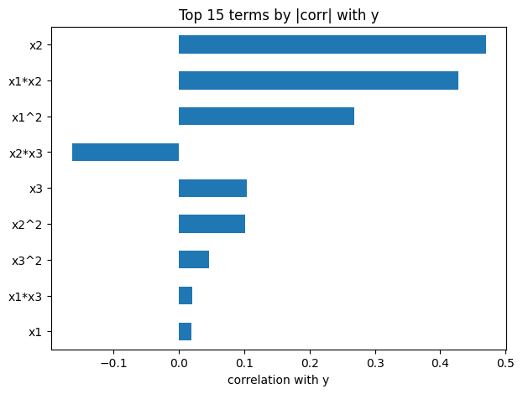
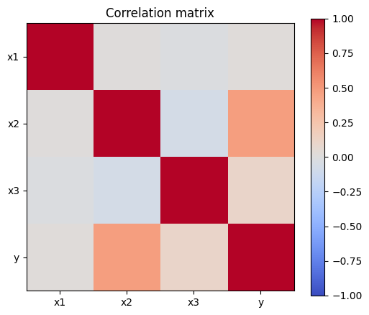

2.2 Degree Selection
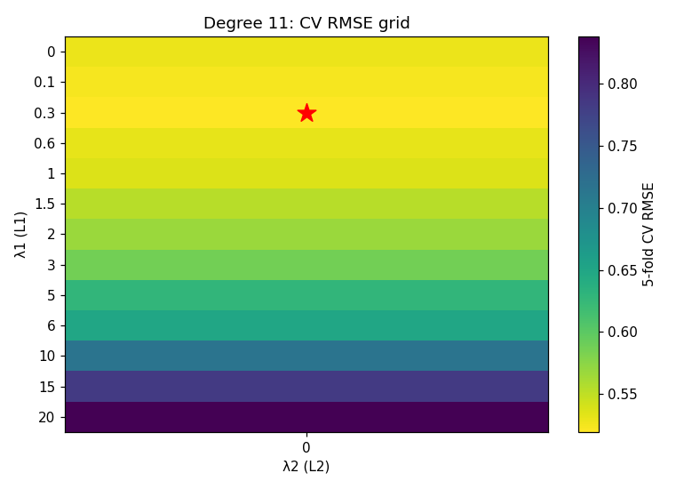
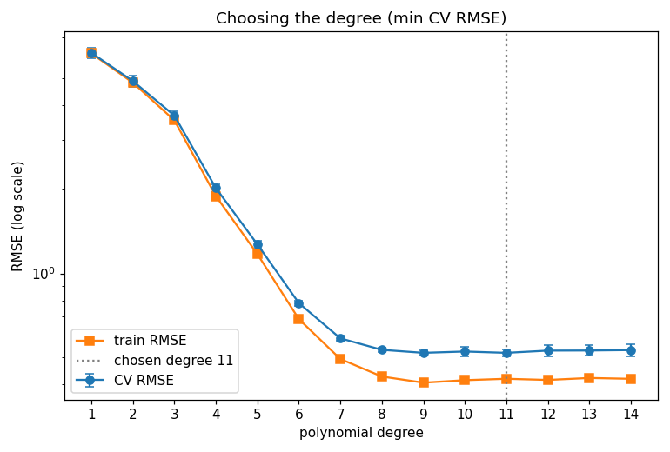
With only 3 variables, even degree 20 is tractable (1,770 features). I therefore swept all degrees 1–20 with 7-fold CV and an 8 × 8 grid: λ₁ ∈ {0, 0.05, 0.1, 0.15, 0.2, 0.3, 0.5, 1} and λ₂ ∈ {0, 0.003, 0.01, 0.03, 0.1, 0.13, 0.15, 0.3}. The grid is finer and lower in scale than in var1, because here the signal is dense rather than sparse. The curves were logged every 5 iterations.
Degree | #Features | Best λ₁ | Best λ₂ | CV RMSE | CV SE | Train RMSE | Non-zero
1 | 3 | 1 | 0.3 | 6.1061 | 0.322 | 6.133 | 3
2 | 9 | 1 | 0.3 | 4.8973 | 0.217 | 4.819 | 9
3 | 19 | 1 | 0.3 | 3.6812 | 0.166 | 3.532 | 19
4 | 34 | 0 | 0 | 2.0414 | 0.083 | 1.892 | 34
5 | 55 | 0 | 0 | 1.2828 | 0.048 | 1.174 | 55
6 | 83 | 0 | 0.01 | 0.7868 | 0.014 | 0.686 | 83
7 | 119 | 0 | 0.003 | 0.5907 | 0.014 | 0.494 | 119
8 | 164 | 0 | 0.01 | 0.5373 | 0.013 | 0.432 | 164
9 | 219 | 0.05 | 0.003 | 0.5158 | 0.013 | 0.416 | 215
10 | 285 | 0.05 | 0.03 | 0.5136 | 0.014 | 0.418 | 278
11 | 363 | 0 | 0.1 | 0.5067 | 0.014 | 0.416 | 363
12 | 454 | 0 | 0.15 | 0.5079 | 0.014 | 0.414 | 454
13 | 559 | 0 | 0.3 | 0.5083 | 0.014 | 0.417 | 559
14 | 679 | 0 | 0.3 | 0.5100 | 0.014 | 0.413 | 679
15 | 815 | 0.05 | 0.3 | 0.5117 | 0.015 | 0.412 | 710
16 | 968 | 0.3 | 0.13 | 0.5118 | 0.014 | 0.413 | 458
17 | 1139 | 0.3 | 0.13 | 0.5142 | 0.014 | 0.412 | 492
18 | 1329 | 0.3 | 0.1 | 0.5130 | 0.014 | 0.408 | 498
19 | 1539 | 0.5 | 0 | 0.5147 | 0.013 | 0.408 | 387
20 | 1770 | 0.3 | 0.003 | 0.5135 | 0.014 | 0.400 | 589

Observations and rationale.
- Huge improvement up to degree ≈ 9. CV RMSE decreases from 6.11 (linear) to 0.52 (degree 9), a >10× reduction, with train and CV errors closely tracking each other, so the low-degree models are underfitting.
- Flat floor at ≈ 0.51 for degrees 9–20. Beyond degree 9, the CV RMSE stops improving while train RMSE continues to shrink slowly (0.416 to 0.400). The residual error of ≈ 0.5 is then noise, not model bias, and the CV curve is nearly flat over 12 degrees, with a minimum at degree 11 (CV RMSE 0.5067).
- Why degree 11. The selection rule was to choose the degree with the lowest CV RMSE. Degree 11 is the minimum, though degrees 9–20 are all within about 1 standard error (≈ 0.014) of it. Choosing degree 11, rather than 20, avoids carrying over 1,400 unnecessary features and gives a smaller, more stable model with the same accuracy. Note that the "up to degree 20" in the problem statement is an upper bound, and the data does not need that capacity.
- Regularisation behaviour. Up to degree 15, the best fits use almost no L1 and a small L2 (0–0.3), which means dense coefficients. At degree 16 and above, the best settings use L1 (0.3–0.5) to prune about 55–75% of the terms, and the CV error does not improve for it. At the chosen degree 11 the model is pure Ridge (λ₁ = 0, λ₂ = 0.1) with all 363 coefficients active.

2.3 Final Model and Diagnostics
Chosen model: degree 11 polynomial, Elastic Net with λ₁ = 0, λ₂ = 0.1 (effectively Ridge), refit on all 1,000 rows for 3,000 iterations.
Out-of-fold performance (10-fold): RMSE = 0.5015, R² = 0.9949. The expected test MSE is therefore ≈ 0.25.
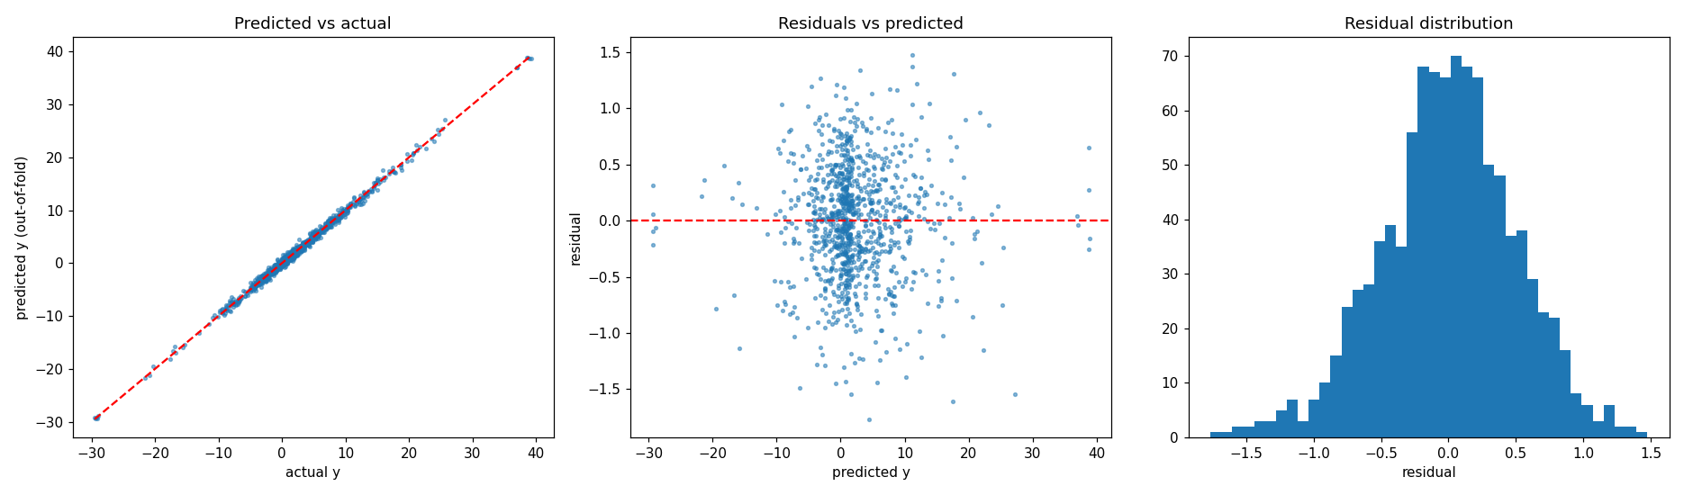 Error vs boundary clipping. Because many inputs are clipped at ±1, I checked whether error depends on how many coordinates lie exactly on the boundary:

# coords at ±1 | Rows | RMSE
0 | 414 | 0.486
1 | 424 | 0.499
2 | 143 | 0.534
3 | 19 | 0.619

Strongest retained terms: x1·x2 (+2.486), x1⁴·x2·x3⁶ (+2.422), x2⁹·x3 (-2.340), x2²·x3³ (+2.284), x2⁶ (+2.225), x1³·x3 (+1.930), x2⁴ (+1.857). The dominant x1·x2 term mirrors the EDA finding (corr 0.428), and the mix of low- and high-order interactions among all three variables explains why a high-degree model is needed.
Sanity check. The test prediction range is [-28.58, 38.81], against a train y range of [-29.51, 39.33]. The predictions remain inside the training range, so there is no extrapolation blow-up, which is the most common failure mode of high-degree polynomials.
Prediction file: IMT2024011_pred_var2.csv (column y_pred, 1,000 rows).

Summary of Results
 | Problem 1 (var1) | Problem 2 (var2)
Inputs | 6 | 3
Chosen degree | 5 | 11
Candidate features at chosen degree | 461 | 363
Regulariser | L1 (λ₁ = 5.5, λ₂ = 0) | L2 (λ₁ = 0, λ₂ = 0.1)
Active coefficients | 126 | 363
10-fold CV RMSE | 0.564 | 0.507
Out-of-fold RMSE | 0.5656 | 0.5015
Out-of-fold R² | 0.9676 | 0.9949

Code and Reproducibility
All code is in the GitHub repository, with one notebook per problem (ML_Assignment1a.ipynb for var1, ML_Assignment1b.ipynb for var2). Both use a fixed CV seed (0) and the same from-scratch FISTA Elastic Net solver (fit_enet) and polynomial feature generator (poly_features).

