Branding Guidelines

Branding guidelines for the basic usage of the siduction brand, including official media and artwork

October 2011

Official and non-official
First of all there should be a distinction between official and non-official and even more “official non compliant” rules. Official means all media that are given from the project to the rest of the world representing the project itself. This does not cover release (product) dependent artwork like wallpapers etc. This is the “official non compliant” part. Non-official is the usage of siduction by people that do not belong directly to the siduction project, like language dependent native support forums etc. They may use their own color sets, but when re-using e.g. the siduction logo, they should follow the guidelines described in this document.

Brand philosophy
The corporate brand is most important for recognition of the siduction project. Since it is directly visible to the user or even guests, the interpretation of the seen will influence the feeling of that very person. So here are the claims that should result from the official and non-official artwork:
- understatement
- cool
- fresh
- reliable
The definitions described in this document will give you a summary of the “do's and don'ts” when creating stuff for or around the siduction project.

Material
The siduction project will offer you media for logo, slogans, templates for libreoffice for download on the official website.

License
The complete artwork of the siduction project must be under one of the following licenses to guarantee the freedom of usage:
- License: CC-BY-SA 3.0

Name
This project's name is “siduction”. The idea behind the name is to seduce people into using debian sid.
The name must be kept in one piece written in a single word. All letters must be lowercase. Do not split the name in parts like sid-uction or highlight parts of it (siduction) or use different scale (SIDuction, sidUCTION, sid_{uction}) when using the name in official or non-official manner.

Slogans
Every release will have its own slogan in that they are named after famous songs from the wealth of popular rock music. The slogan will be used for the ISO-Image in the form of:
siduction-[yy-n]-(releasename)
where 'n' is the number of the release of the respective year (yy).
Release dependent artwork may be freely following the slogan of that release. e.g. if the slogan is “yellow submarine” the colors will belong to that slogan like yellow, blue sea and so on. It would not make sense to use a “Lord of the rings alike background” as wallpaper for that release, even if it is a fine piece of art. However, to get some kind of recognition, the wallpaper etc should contain the official logo “as a watermark”.
The current slogan will not reflect the official artwork on e.g. website, papers, presentations. In this case the basic official branding is used. This means that there is no new website-design for every release. The user should have a continuous feeling on visiting the official website(s) – this should reflect the “reliable” claim of the philosophy..
The next slogan is selected by the team. If you have a cool idea for one of the next release names, please let us know.

Layout
Textlayout for documentation, guidelines, howtos do have 2 colums with a spacing of 0.4 cm between the columns. The text in that columns should be in justification.

Fonts
“Droid Sans” is the primary font for all print and PDF items.
For regular text it is used in the normal style. In titles it is used as bold and for headlines also in italic.

Documents
title → Droid Sans
header → Droid Sans
body → Droid Sans

Presentations
title → Droid Sans
body → Droid Sans

Logo
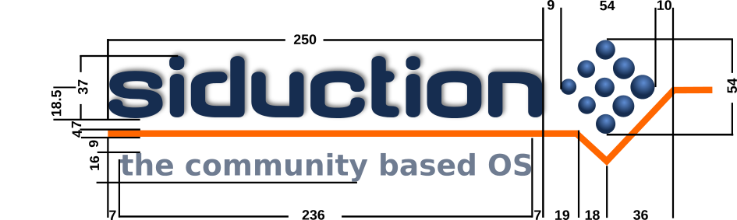

Symbol


Colors
The official color palette
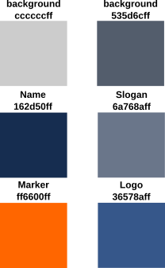

Official and non-official use of the logo and symbol
The logo must be used as is without any extra effect like drop shadows, glowing, rotation, reflection, outline etc. There must not be any other objects like text or symbols that overlap the logo (e.g. language flags for local support sites).

