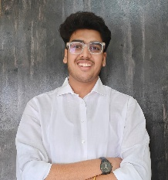
Siddhesh Nimodiya
siddheshnimodiya22@gmail.com |
(+91) 8956638354 | linkedin

Objective
Computer Science undergraduate with hands-on experience in web development and programming. Skilled in HTML, CSS, JavaScript, React, Python, and C++. Built and deployed an official college website. Strong team player with problem-solving skills, currently exploring software development, machine learning, and data analysis..

Skills
- Web Development: HTML, CSS, JavaScript, React, Responsive Design, UI/UX Principles
- Programming Languages: Python, C++
- Soft Skills: Problem-Solving, Leadership, Team Collaboration, Time Management

Education
Bachelor of Technology in Computer Science Engineering
G.H. Raisoni College of Engineering, Nagpur
CGPA: 8.06 | Graduation Year: 2026

Work Experience
Web Developer – Antaragni College Fest (Antaragni)
G.H. Raisoni College of Engineering, Nagpur | Feb 2025 – Mar 2025
Technologies: HTML, CSS, JavaScript, React
- Developed and deployed the official college fest website, ensuring full mobile responsiveness and cross-browser compatibility.
- Enhanced user interface by applying UI/UX principles to improve navigation, accessibility, and design consistency.
- Reduced website load time by 99.9%, resulting in faster user interaction and improved performance metrics.
- Achieved over 95% SEO compliance, increasing visibility on major search engines.
- Ensured 99.9% accessibility compliance with WCAG standards to support inclusive user experience.

Certifications & Achievements
- Certified in Graphics and Web Design
- Certified in PC Assembly, Maintenance, and Troubleshooting

