Salary Range Prediction
NYC Jobs Postings — Predictive Model for Salary Range From/To
Prepared for: Spinnaker Analytics
Prepared by: Siddhant Varma — Boston Institute of Analytics
Date: September 2026

1. Executive Summary
This project builds a machine learning model that predicts the minimum and maximum salary (Salary Range From and Salary Range To) for a New York City government job posting, using only the attributes of the posting itself — agency, title, job category, career level, and a few derived text features. The goal, per the project brief, is to support recruiters in aligning postings with market rates, giving candidates transparent expectations, and informing budget planning.
The dataset (5,120 raw postings) required real cleanup before modelling: roughly half were duplicate postings under the same Job ID, and salaries were mixed across three different pay frequencies (Annual, Hourly, Daily) that aren't directly comparable. After de-duplication and normalising every salary to an annualised basis, 2,615 unique postings remained for training and evaluation.
Five candidate model families were compared on a held-out test set; a tuned XGBoost model performed best on both targets and was taken forward as the final solution.
Final test-set performance:
Target | R² | MAE (USD) | RMSE (USD)
Salary Range From (annualised) | 0.657 | $8,177 | $15,113
Salary Range To (annualised) | 0.803 | $11,575 | $18,622

In practical terms: the model explains about 66% of the variation in starting salary and 80% of the variation in the top of the salary range, with a typical prediction error of roughly $8,200 (From) and $11,600 (To) against a median posting salary in the $65,000–$90,000 band. That's precise enough to flag postings that look out of line with the market, though not precise enough to set an exact number without human review.

2. Data Overview
Source: Jobs_NYC_Postings.csv, provided by Spinnaker Analytics, with an accompanying data dictionary describing all 30 columns. The data spans postings across 59 city agencies and 183 job-category combinations.

2.1 Data quality issues identified
- Duplicate postings: 2,494 of 5,120 rows shared a Job ID with at least one other row. Inspection confirmed these were exact reposts (e.g. the same role listed once as "Internal" and once as "External") with identical salary figures — not conflicting records — so duplicates were safely dropped, keeping the first occurrence.
- Mixed salary frequency: postings were listed as Annual (4,686), Hourly (384), or Daily (50). Comparing these directly would be meaningless — a $22/hour listing looks like it pays far less than a $70,000/year listing when in fact it may pay more. Every salary was converted to an annualised figure (hourly × 40 × 52; daily × 5 × 52) before modelling.
- Zero-value salaries: 23 postings had a Salary Range From of 0 under the Annual frequency — a data-entry gap rather than a real salary floor. These were removed rather than imputed, since a plausible-looking guess would misrepresent the ground truth.
- High-cardinality text fields: Civil Service Title (365 unique values) and Job Category (183 unique values) carry real signal about seniority and pay grade but are too fragmented for one-hot encoding. These were handled with smoothed, cross-validated target encoding rather than dropped or naively one-hot encoded.

2.2 Salary distribution
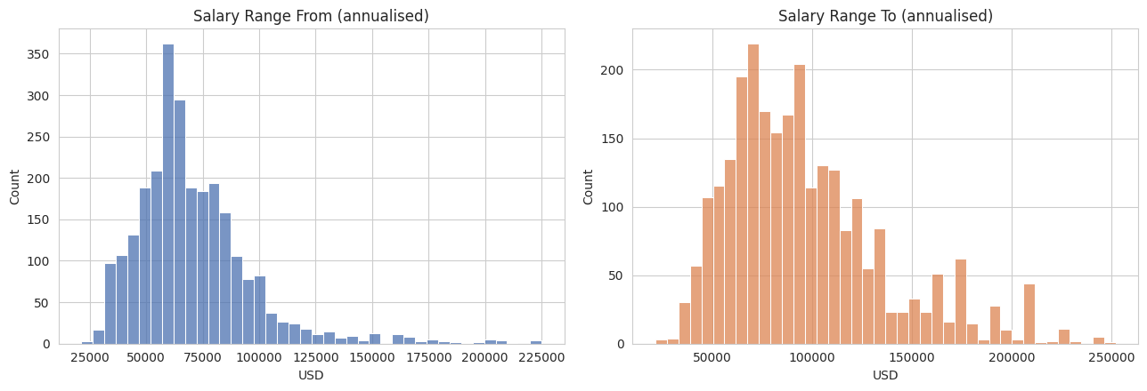
Figure 1. Distribution of annualised starting and ceiling salaries across all postings.
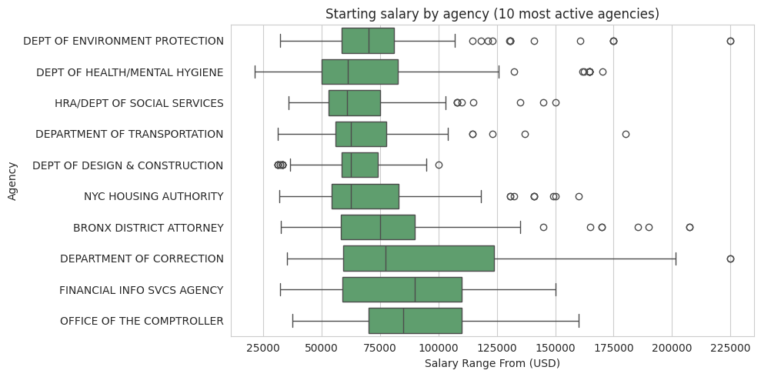
Figure 2. Starting salary spread across the 10 most active agencies.
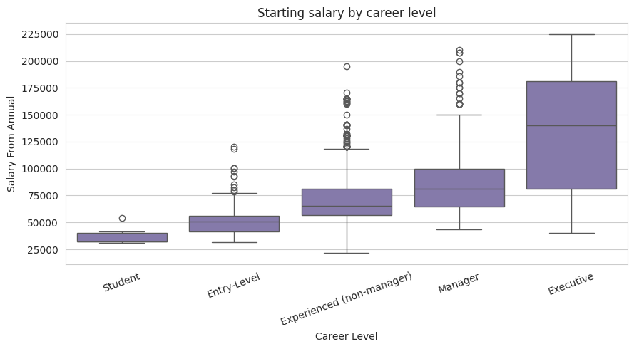
Figure 3. Starting salary by career level, showing the expected step-up from student through executive roles.

3. Methodology

3.1 Cleaning and feature engineering
After de-duplication and salary normalisation, the following features were engineered for modelling:
- Categorical: Agency, Posting Type, Job Category, Full-Time/Part-Time indicator, Career Level, Level, Title Classification, Civil Service Title.
- Numeric: number of positions, job-description word count, qualifications word count, whether preferred skills were listed, posting month.
Work Location and Division/Work Unit were excluded — both are free-text fields with hundreds of near-unique values and no clean way to group them into a smaller, reusable location feature without introducing noise.

3.2 Encoding strategy
Civil Service Title and Job Category are far too granular for one-hot encoding without exploding the feature space. Instead, each categorical feature was replaced with a smoothed target encoding — the average salary midpoint for that category — computed out-of-fold (5-fold cross-validation) on the training set to prevent test-set leakage, with smoothing to pull rare categories toward the global average.

3.3 Model selection
Five model families were trained and compared on an 80/20 train-test split (random_state=42), predicting both salary targets jointly via MultiOutputRegressor:
Model | R² (From) | R² (To) | MAE From | MAE To
Ridge Regression | 0.491 | 0.735 | $12,117 | $14,743
Random Forest | 0.642 | 0.785 | $8,762 | $12,150
Gradient Boosting | 0.622 | 0.789 | $9,651 | $12,489
XGBoost (baseline) | 0.631 | 0.797 | $8,403 | $11,810
LightGBM | 0.615 | 0.797 | $9,323 | $11,955
XGBoost (tuned) — final | 0.657 | 0.803 | $8,177 | $11,575

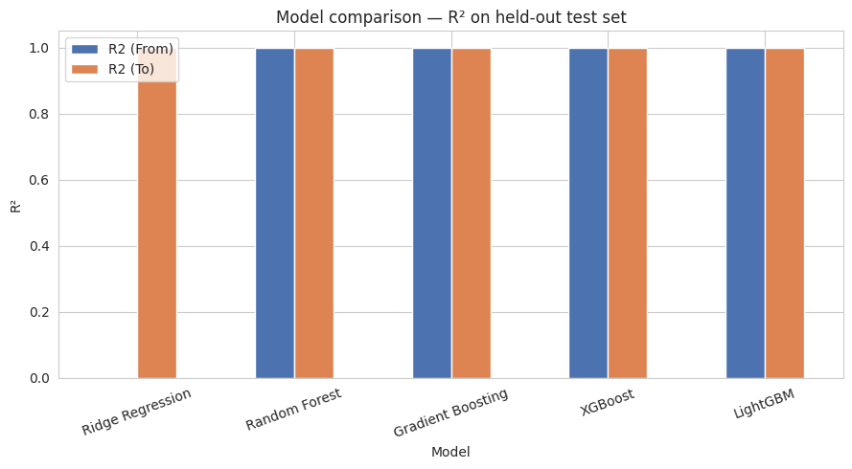
Figure 4. R² comparison across candidate models on the held-out test set.
XGBoost was the clear front-runner and was carried forward for hyperparameter tuning.

3.4 Hyperparameter tuning
Separate XGBoost models were tuned for Salary From and Salary To using RandomizedSearchCV (40 iterations, 5-fold cross-validation, scored on mean absolute error), searching over tree depth, learning rate, subsampling ratio, and L1/L2 regularisation.

4. Results
Final performance on the untouched 20% test set:
Target | R² | MAE (USD) | RMSE (USD)
Salary Range From (annualised) | 0.657 | $8,177 | $15,113
Salary Range To (annualised) | 0.803 | $11,575 | $18,622

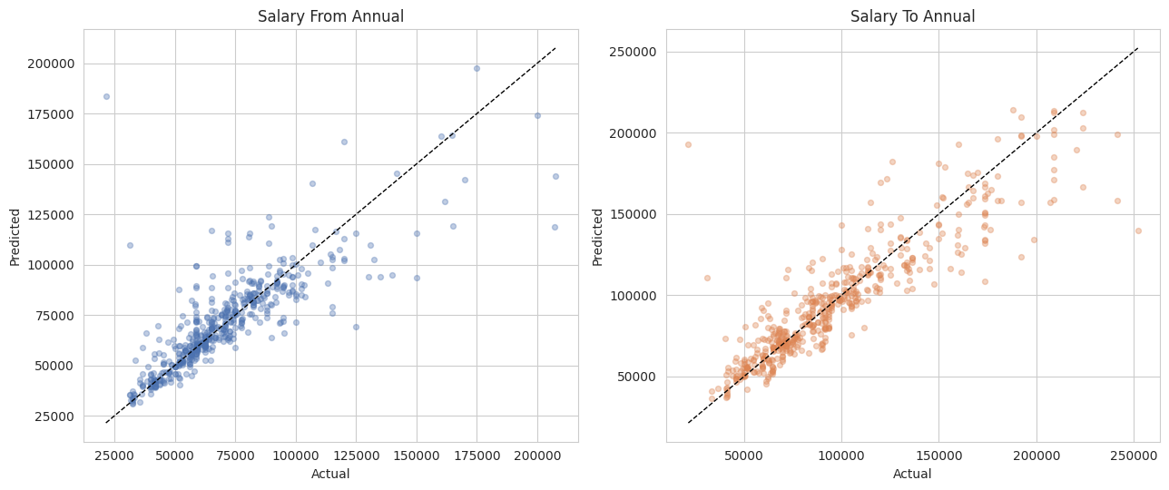
Figure 5. Predicted vs. actual salary on the test set. Points tracking the diagonal indicate accurate predictions.
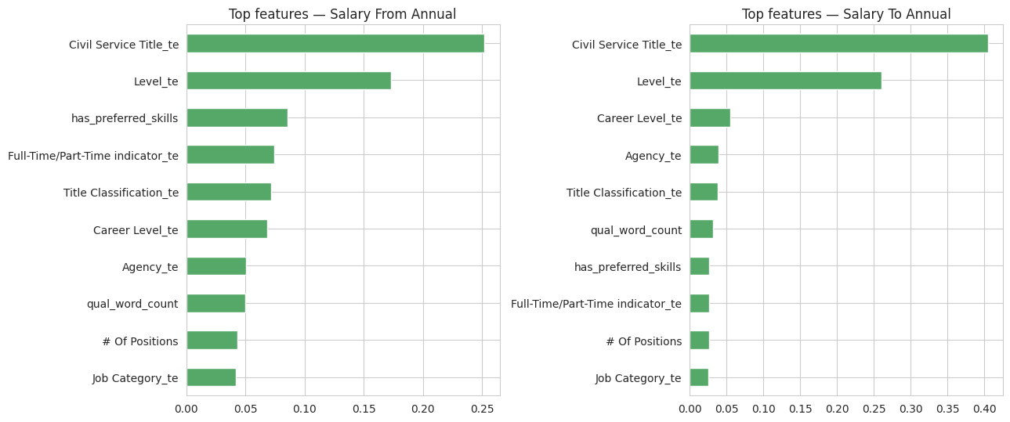
Figure 6. Top 10 most influential features for each target, by XGBoost feature importance.
Civil Service Title, Job Category, and Level dominate feature importance for both targets — consistent with how NYC's civil-service compensation actually works, since pay is largely determined by formal title and grade rather than negotiated case-by-case. Salary Range To is predicted more accurately (R² = 0.80) than Salary Range From (R² = 0.66), which suggests the ceiling of a pay band is more standardised across postings than the floor, where individual agencies appear to have more discretion.

5. Recommendations
- Use the model as a screening / sanity-check tool: flag postings where the predicted range differs substantially from the posted range for manual review, rather than as an automatic salary-setter.
- Incorporate NYC's official civil-service pay-grade tables as an additional feature — since Civil Service Title and Level are already the strongest predictors, a direct grade-to-pay-band lookup would likely tighten the Salary Range From estimate specifically.
- Track prediction error by agency over time; agencies with above-average error are the ones where the model would benefit most from additional features (e.g. union contract flags, borough/cost-of-living adjustments).
- Refresh the model periodically as new postings come in — salary bands shift with city budget cycles and cost-of-living adjustments, so a model trained on a single snapshot will drift.

6. Deliverables
- Jupyter notebook (Salary_Range_Prediction.ipynb) — full, executed analysis with all outputs and charts.
- Cleaned dataset (data/processed/jobs_cleaned.csv).
- Trained models (models/salary_from_xgb.pkl, models/salary_to_xgb.pkl).
- Predictions on the full dataset with train/test split flag (predictions/salary_predictions.csv) and the final scores table (predictions/model_scores.csv).
- This report.

