* BEFORE, CREATING PO, CHECK CUSTOMERS ASPL FROM SHAREPOINT, TO CONFIRM THE SUPPOLIER IS STILL APPROVED.   
    
  Click Purchase order tab then Purchase order word.

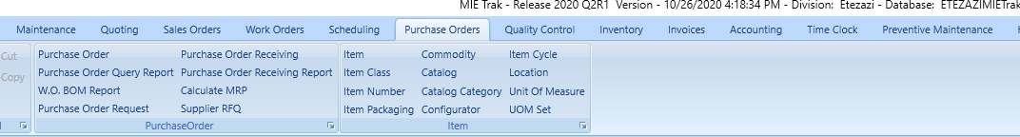

Purchase order screen. Click the drop down on the new tab.

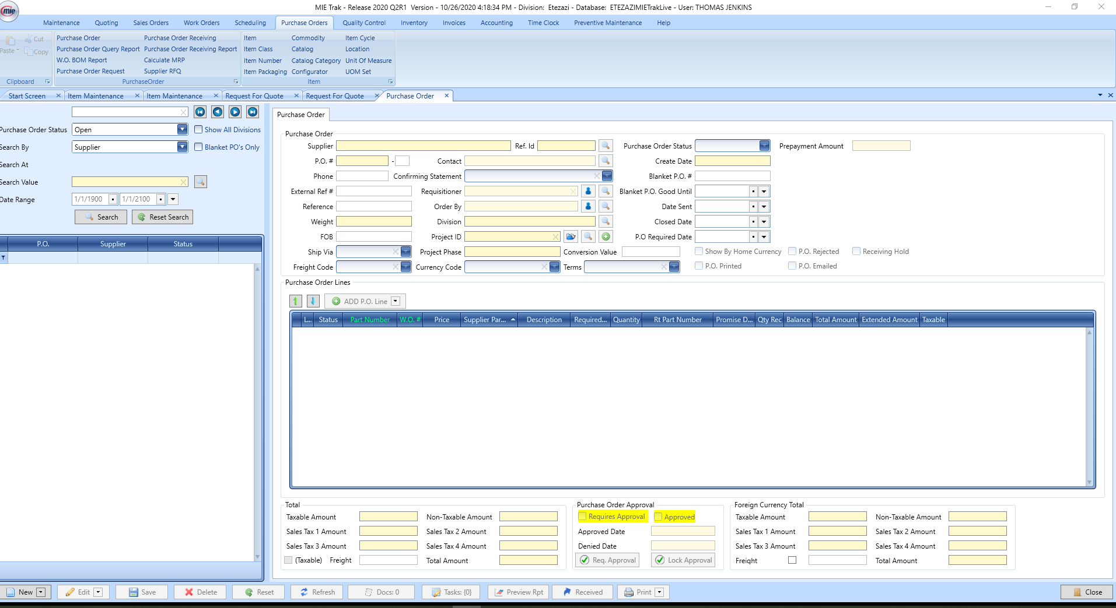

Create PO by WO BOM (Work order number)

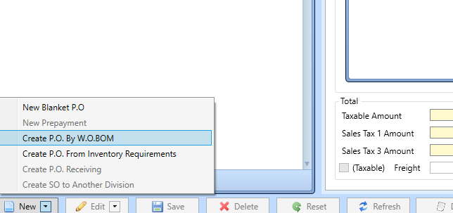

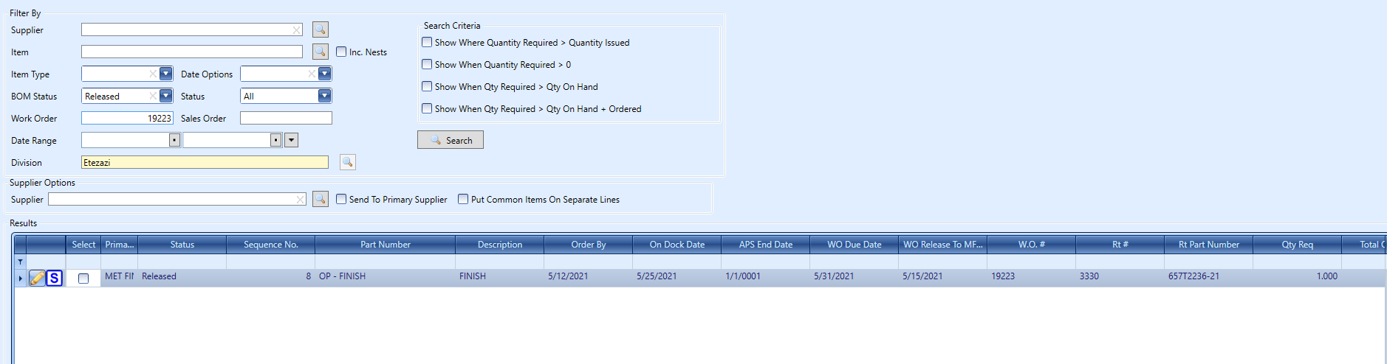

Enter WO number and press search, click the correct operation then choose your supplier (You can change the supplier from what was originally called out. Click and choose your supplier and click OK.

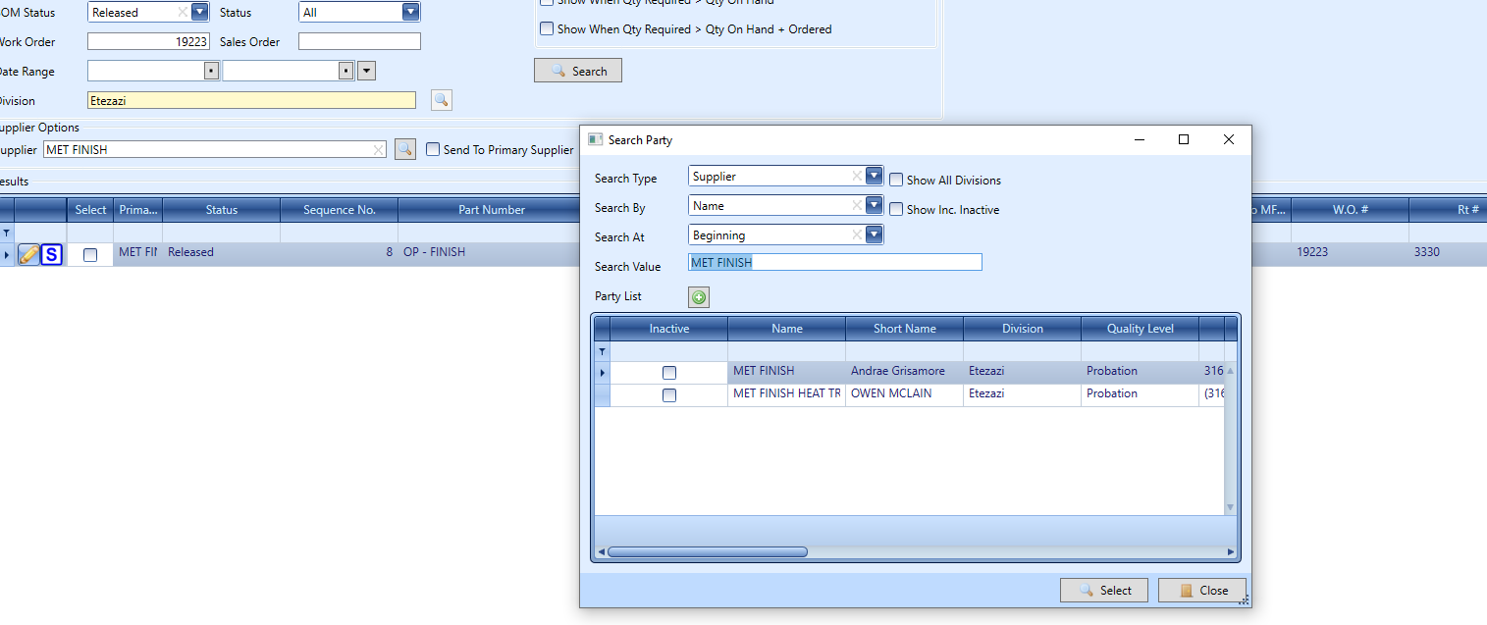

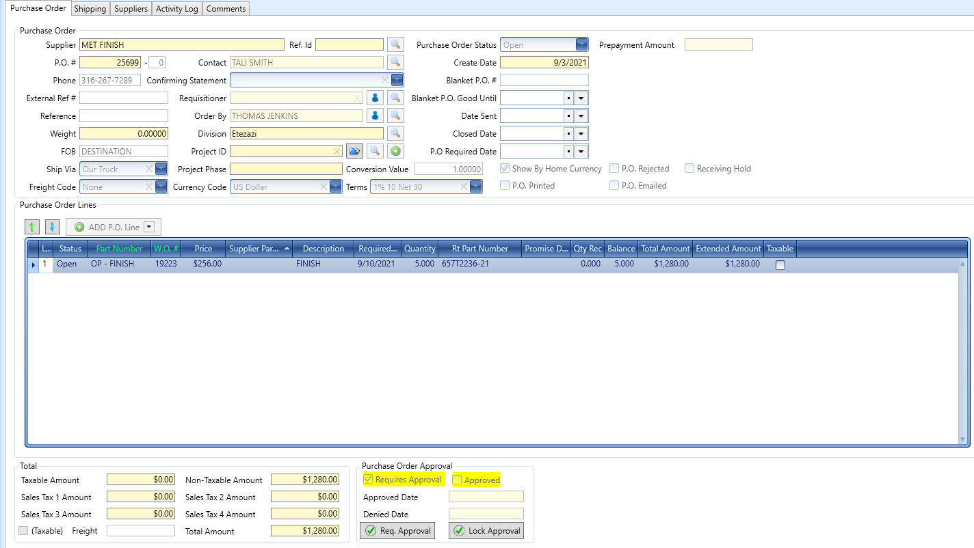

Your PO will open. You’ll populate the following fields.

FOB = Destination Currency Code = US Dollar

Ship Via = Our Truck Term = Net 30

Freight Code = None Check PO Printed box and date sent.

Click Edit and open the line.

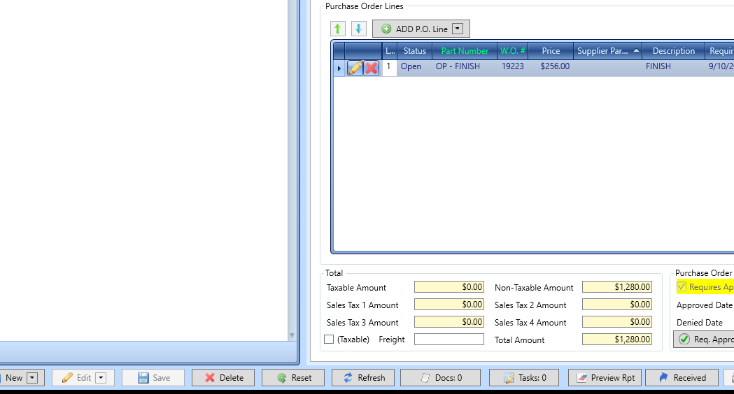

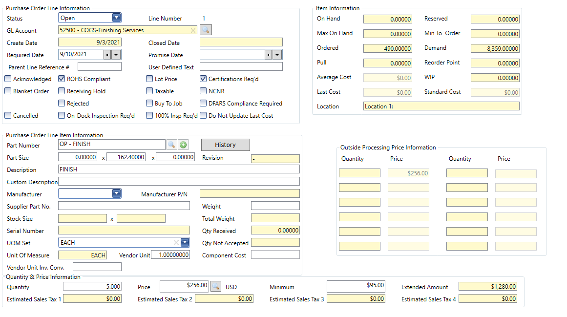

Verify that quote and PO match, pricing, quantity and due date. Open comments and verify that the processes, quote price and LT match.

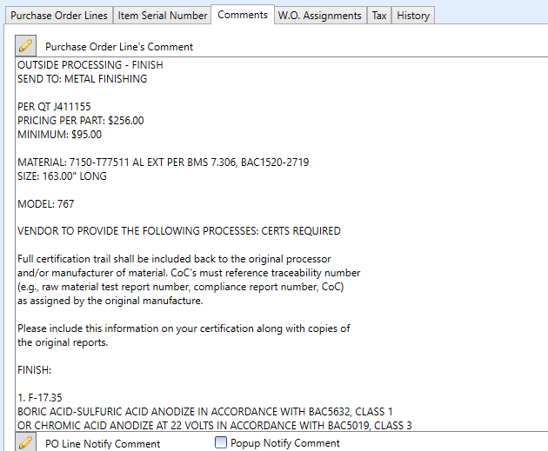

Print the PO and save it to the appropriate folder.

Click Print, OP, Vendors pick the appropriate supplier, create a folder with PO number, save file.

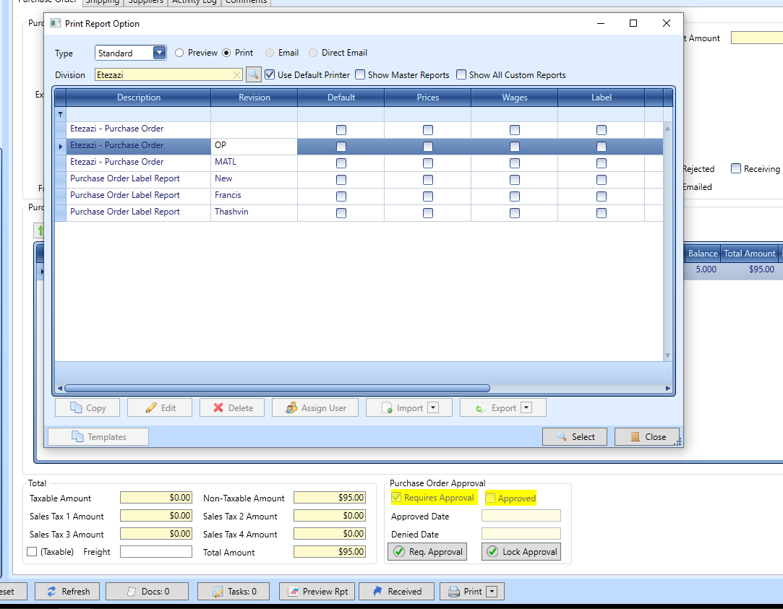

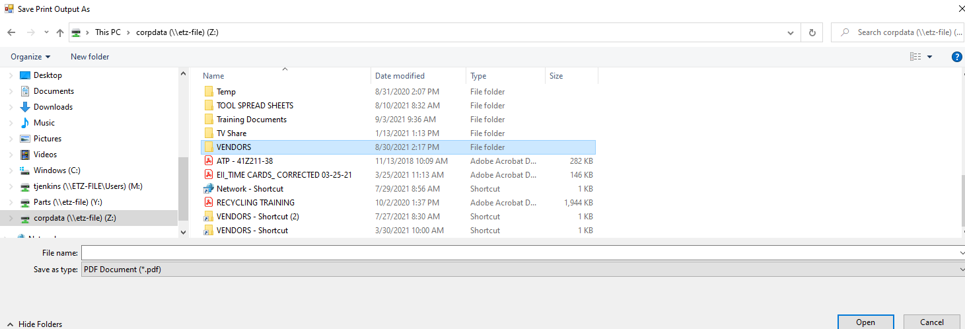

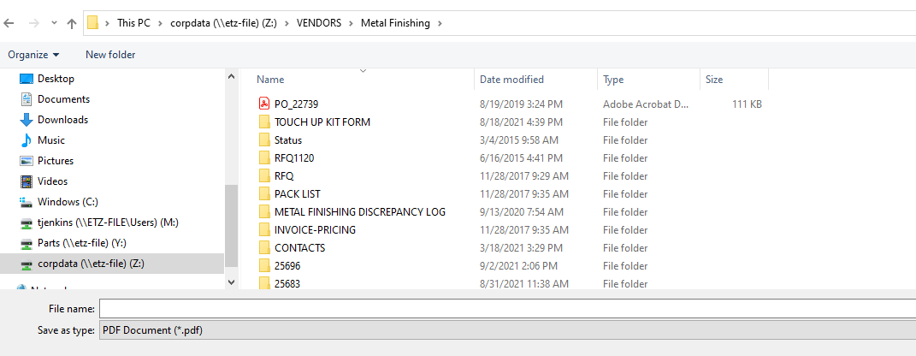

Send an Email to the appropriate contact copying CSR, Planning, Procurement. **Add a copy of the drawing and print a copy as well to send with the PO.**

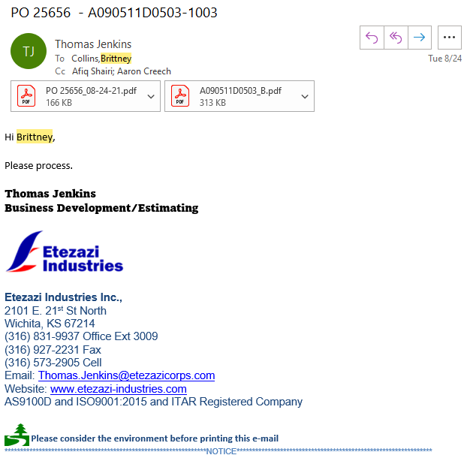

Print two copies of the PO and a copy of the drawing to send with the parts. Place a label (Thashvin -print on Brother printer) on the box and stage on the outbound rack.

