The Impact of Quick Commerce on Shopping Behavior

# Abstract

The rapid rise of quick commerce (q-commerce) platforms has transformed consumer shopping behavior, offering unprecedented speed and convenience. This study investigates the impact of q-commerce on shopping habits, focusing on usage patterns, satisfaction levels, and its influence on traditional shopping methods. Using survey data from 35 respondents, we employ machine learning techniques to analyze factors driving q-commerce adoption, customer segmentation, and its perceived impact on local businesses. Results indicate that speed of delivery and convenience are primary drivers of q-commerce usage, with significant implications for traditional retail and impulsive buying behavior. This study provides actionable insights for businesses and policymakers to adapt to the evolving retail landscape.

# 1. Introduction

The advent of quick commerce (q-commerce) has revolutionized the retail industry, enabling consumers to receive goods within minutes of placing an order. This paradigm shift is driven by advancements in logistics, technology, and changing consumer preferences for convenience. While q-commerce offers undeniable benefits, its impact on traditional shopping behavior, local businesses, and consumer decision-making remains underexplored.

This study aims to address the following research questions:

1. What factors influence the adoption and satisfaction of q-commerce platforms?
2. How does q-commerce affect traditional shopping habits, such as planning and impulsive buying?
3. What is the perceived impact of q-commerce on local businesses?

By analyzing survey data using machine learning models, this paper provides a comprehensive understanding of the q-commerce phenomenon and its implications for consumers and retailers.

# 2. Literature Review

Previous research has highlighted the growth of e-commerce and its impact on consumer behavior. The exponential rise in q-commerce in India, development factors, its impact on customer behaviour, and future of q-commerce (Gauri et al., 2023) has introduced new dynamics, such as customer segmentation, benefits, and instant gratification, which warrant further investigation.

This study builds on existing literature by incorporating machine learning techniques to analyze survey data, offering a data-driven perspective on q-commerce adoption and its consequences.

# 3. Methodology

## 3.1 Survey Design

A structured survey was conducted to collect data on q-commerce usage and its impact. The survey included 14 questions covering demographics, usage frequency, product preferences, satisfaction levels, and perceived impact on local businesses. The survey was distributed online, and responses were collected from 35 participants.

## 3.2 Data Preprocessing

The raw survey data was preprocessed to handle missing values, encode categorical variables, and splitting on multiple values. Key preprocessing steps included:

* One-hot encoding for categorical variables (e.g., occupation, platforms used).
* Splitting multiple responses into distinct values (e.g., items categories)

## 3.3 Data Visualizations and Exploratory Data Analysis

The following data visualizations were made in Power BI and Python to observe the data and find out any meaningful visual analysis that would help in modeling ML models.

* Heatmap for correlation
* Histogram for observing trends
* Bar Graphs for comparing categorical values based on outcome
* Scatter Plot, Box Plot, etc.

## 3.4 Machine Learning Models

The following machine learning techniques were employed:

1. Predictive Modeling: Logistic Regression to predict future reliance based on all the attributes of the dataset.
2. Customer Segmentation: K-means clustering to identify distinct user groups based on usage patterns and demographics.
3. Association Rule Mining: Apriori algorithm to uncover relationships between platforms and product categories.
4. Classification: Decision Tree to predict future reliance.

## 3.5 Evaluation Metrics

Model performance was evaluated using accuracy, confusion matrix, mse, and mae for classification and regression tasks. Clustering results were assessed using silhouette scores and visual inspection.

# 4. Results

## 4.1 Data Visualization

Platforms Distribution

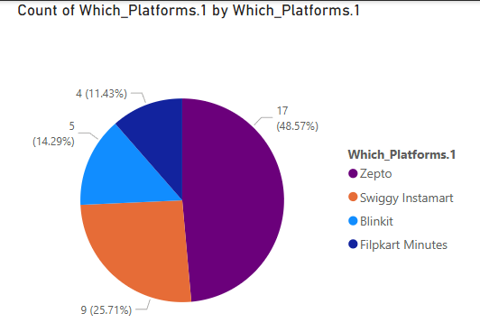

Product Categories Distribution

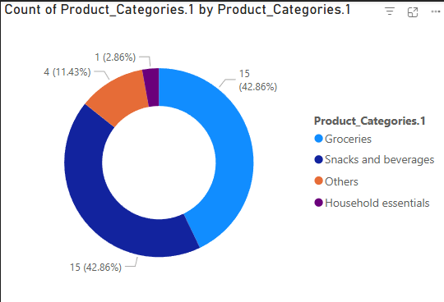

Comparing Future Reliance and Delivery Speed

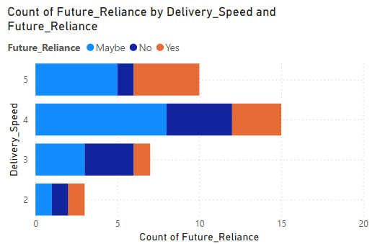

Unplanned Items based on Shopping Planning

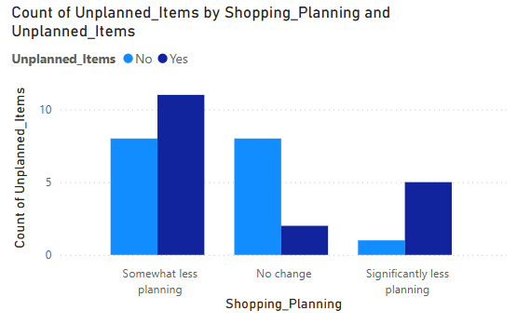

Trend of Negative Impact according to shopping replacement

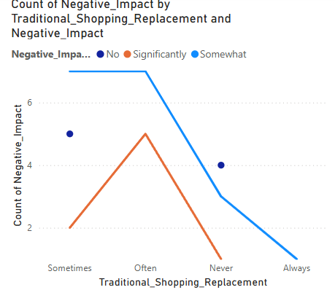

Platform Usage Frequecy

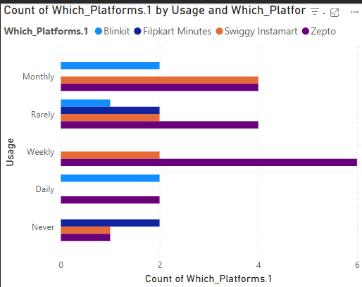

Funnel Diagram for usage

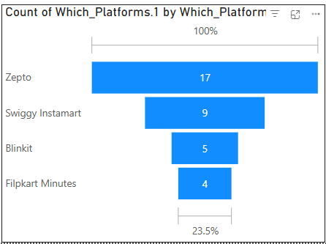

Usage Trend

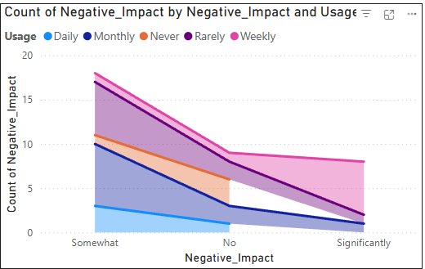

Averages

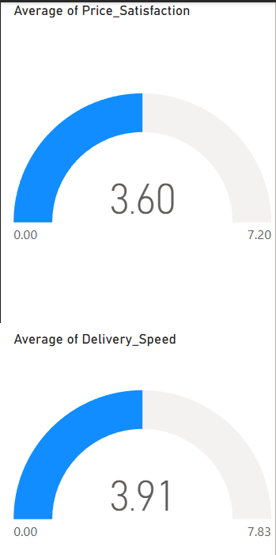

Negative Impact Distribution

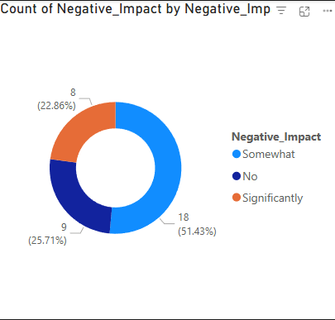

Deliver Speed and Life Easier Trend

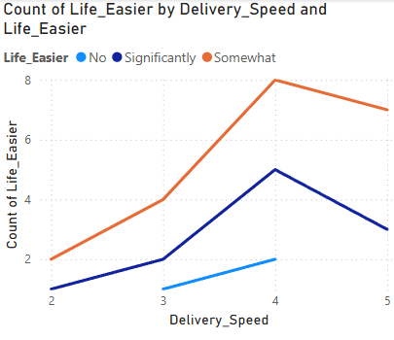

## 4.2 Exploratory Data Analysis

Heatmap

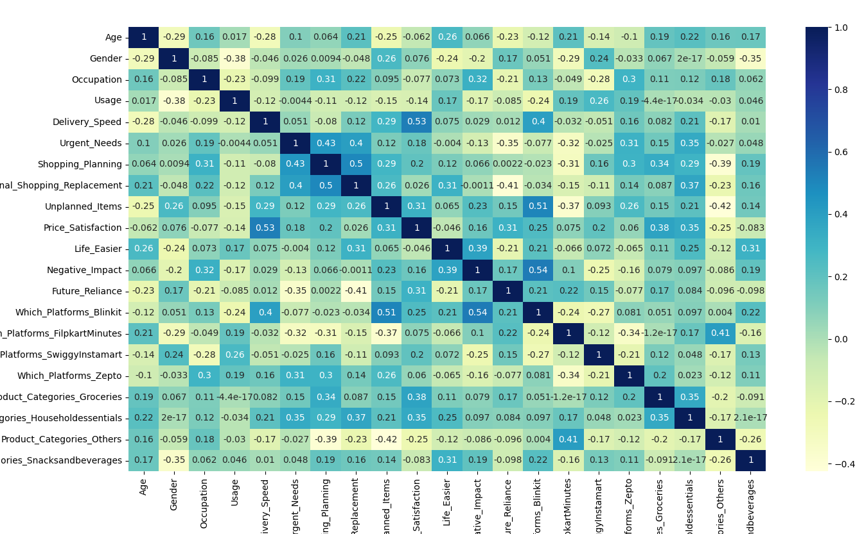

The three major corelations that were observed in the heatmap were:

1. Between price satisfaction and delivery speed
2. Platform Blinkit with unplanned item
3. Platform Blinkit with negative impact

Bar Graph

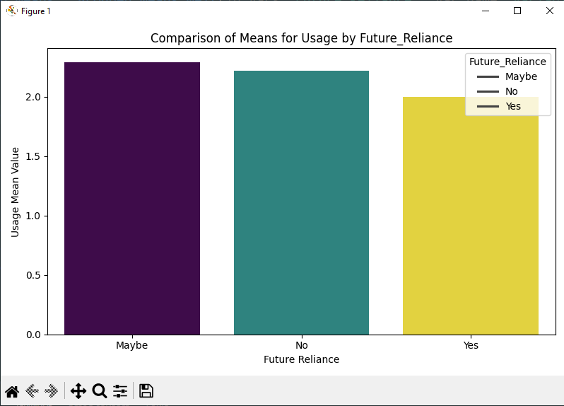

There was a bifurcation between two groups with high usage with different opinions (‘maybe’ and ‘no’) and the other group with low usage believes in users’ future dependency on the platforms.

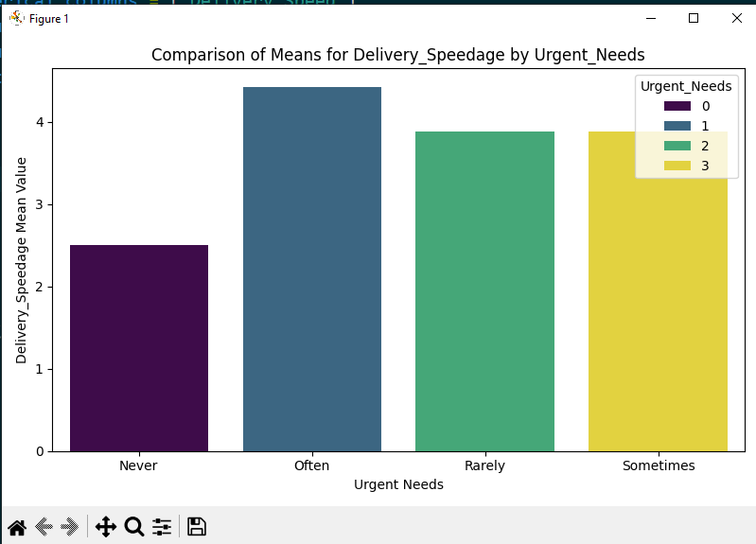

Two major conclusions drawn from the above graph was that the users who never use any services don’t care about the delivery speed, while the users who use the services often have delivery speed as a major factor for using the service.

Histogram

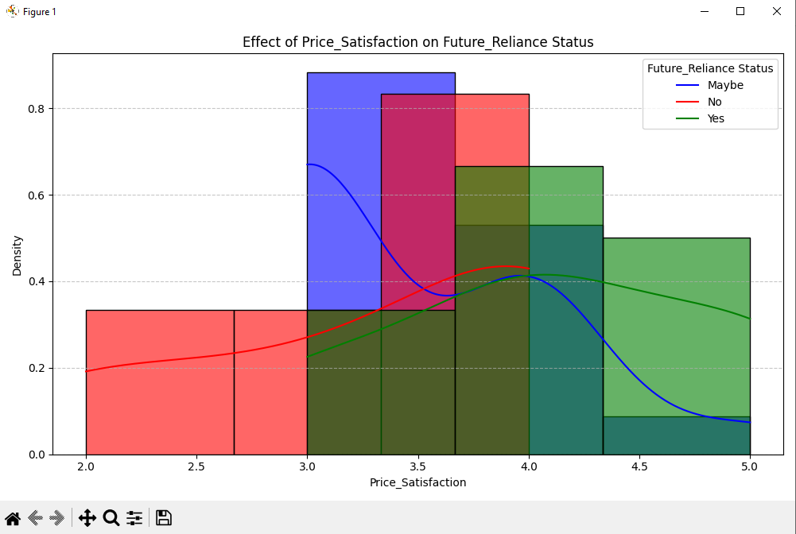

The stacked histogram graph showed that the users with future reliance as ‘Maybe’ and ‘Yes’ have higher price satisfaction (so most probably they are gonna continue using the services) than other users.

Pie Chart

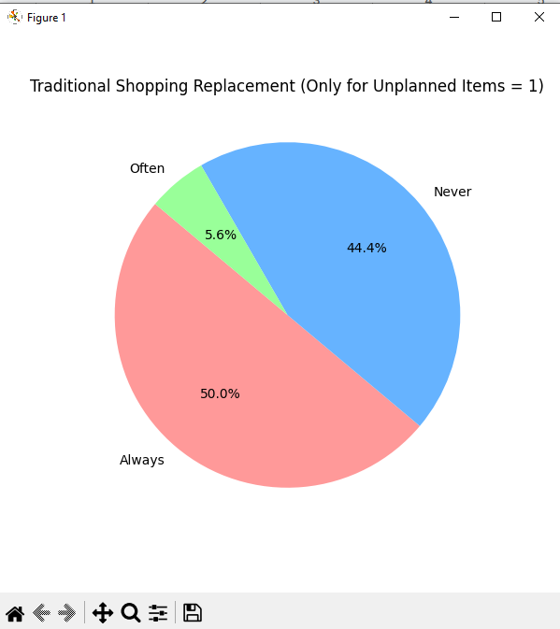

Again, there are two major groups who shop impulsively through either q-commerce services or traditional shopping means. So, q-commerce might not contribute to impulsive shopping as it comes down to user behaviour.

Line Chart

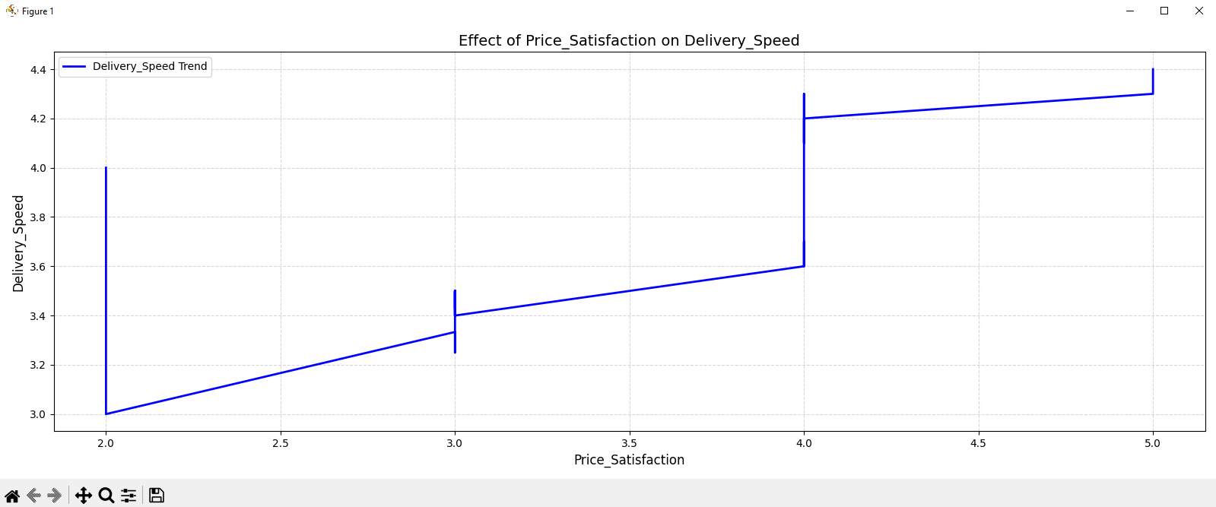

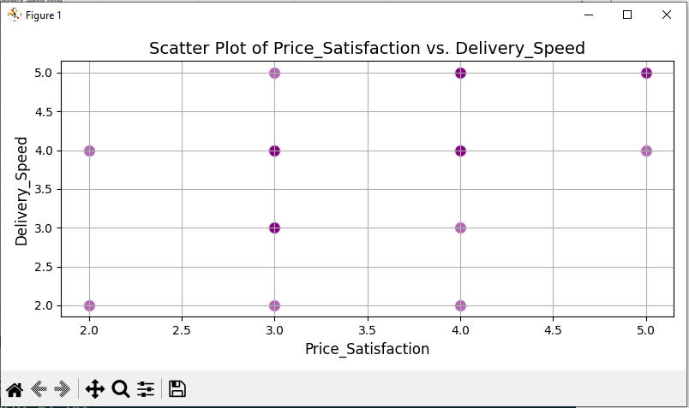

(Not properly continuous numeric values for scatter plot)

The line graph showed the trend between delivery speed and price satisfaction as seen previously in the heatmap.

Radar Chart

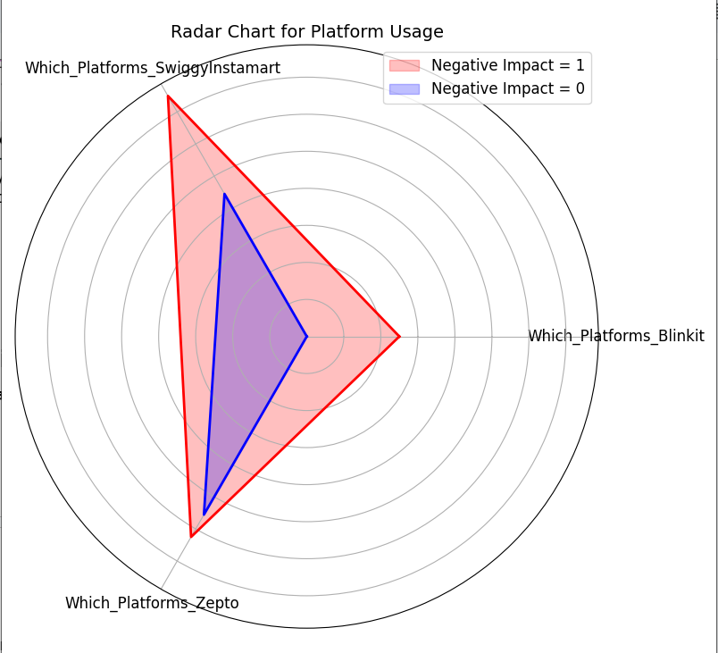

The radar chart showed the platform's negative impact with Swiggy Instamart having the most negative impact when compared to other platforms. There was no particularly explainable reason behind that, as Zepto and Swiggy Instamart had almost the same amount of users.

## 4.3 Predictive Modeling

**Future Reliance Prediction**

Logistic Regression achieved an accuracy of 57.14%, with Traditional_Shopping_Replacement and Unplanned Items being the most important predictors.

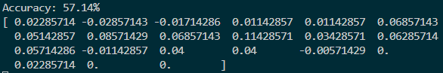

Naive Bayes model achieved an accuracy of 54.55%, similar to that of the Logistic Regression model. Here, we got an idea of average accuracy of our dataset when models are perfectly fitted.



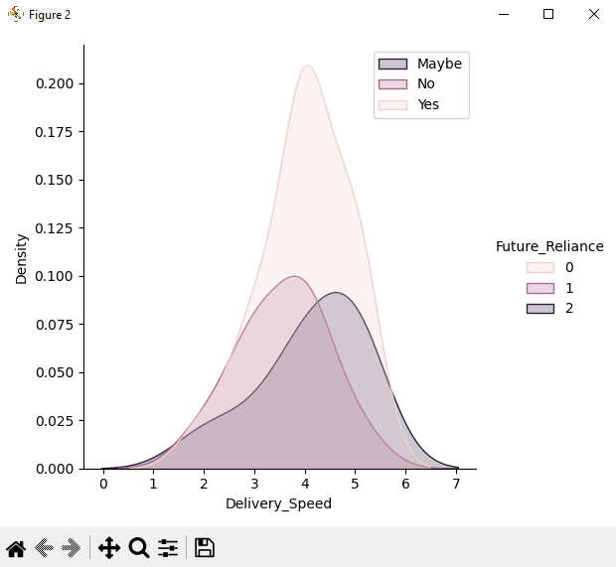

The above graph showed the segmentation of users based on future reliance and delivery speed. Users who opted for ‘Maybe’ option have more preference for faster delivery contradicting users who selected ‘No’ having less preference for faster delivery speed.

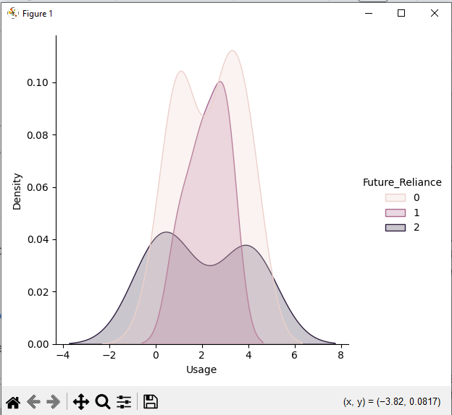

The second graph showed that usage has no effect on the outcome of future reliance; it was independent of that.

**Linear Regression**

Linear regression model for attribute Delivery Speed and Price Satisfaction (which showed good correlation between in the heatmap) had a MSE of 0.72, which is on the higher end supporting the accuracy scores in logistic regression model and naive bayes model.

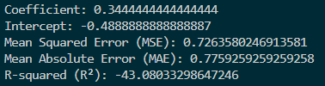

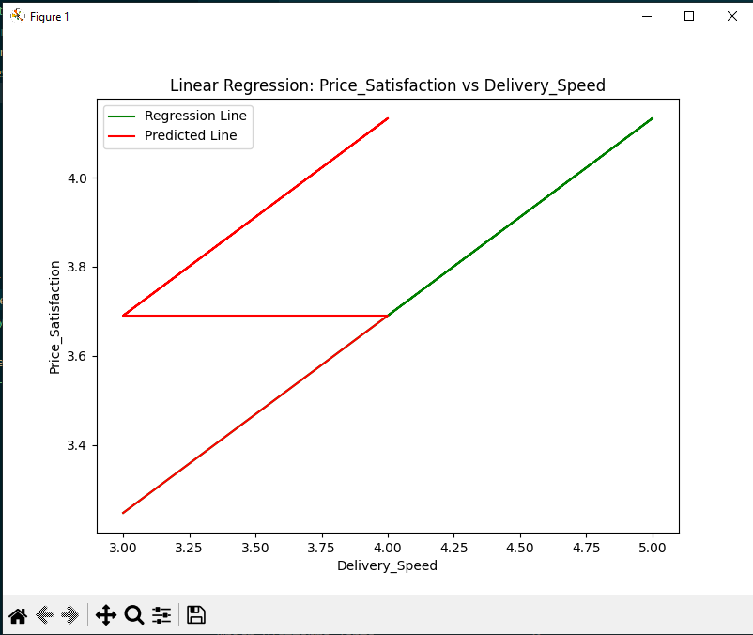

The model was able to predict some values correctly, as seen with the half of the prediction line aligning with the actual regression line.

## 4.4 Customer Segmentation

K-means clustering revealed majorly three distinct user segments:

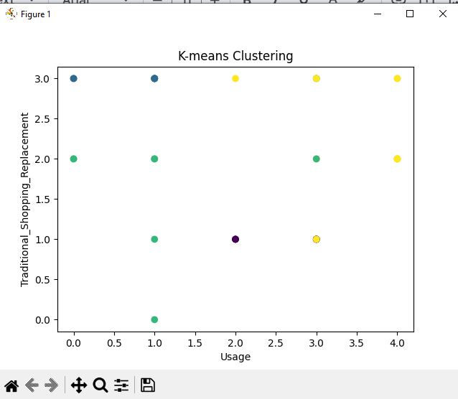

1. Frequent Users (yellow): High usage frequency, primarily for groceries and last-minute needs but may still prefer traditional shopping methods.
2. Occasional Users (blue): Moderate usage, driven by convenience and specific product categories and prefers traditional shopping methods.
3. Skeptical Users (green): Low adoption, citing concerns about pricing and impact on local businesses. Most likely do traditional shopping.

## 4.5 Association Rule Mining

The Apriori algorithm identified associations between specific platforms and product categories. For example, Zepto was frequently associated with grocery purchases, while Platform Flipkart Minutes was linked to electronics (others).

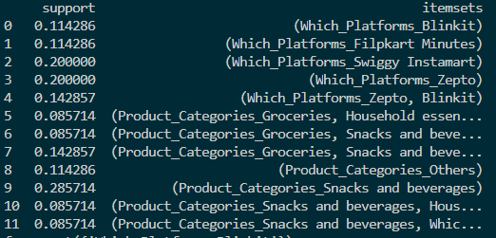

## 4.6 Classification

The Decision Tree predicted the outcome of future reliance based on all attributes of the dataset and achieved an accuracy of 42% with “Traditional Shopping Replacement” attribute on top of the tree with highest gini.

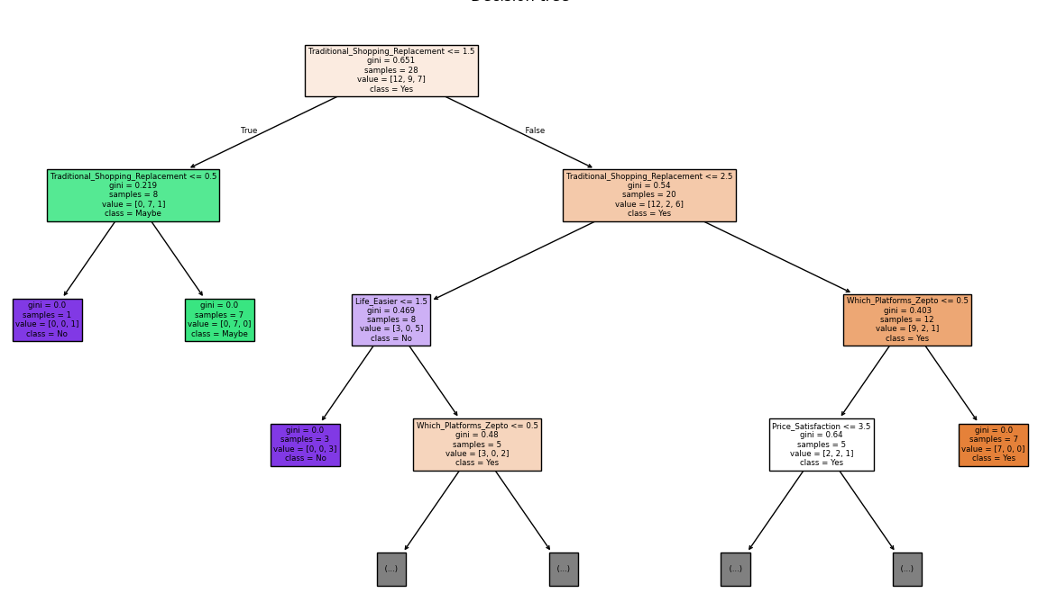

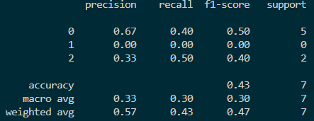

# 5. Discussion

## 5.1 Key Findings

* Speed and Convenience: Delivery speed emerged as the most critical factor influencing q-commerce adoption, aligning with previous studies.
* Impulsive Buying: Majorly the users were divided into two groups, one who believed q-commerce has influenced more impulsive buying (due to various marketing tactics and behaviour analysis) and other who believed users also do impulsive buying white going on traditional shopping.
* Impact on Local Businesses: Many respondents expressed concerns about the negative impact of q-commerce on small local shops, suggesting a need for balanced growth strategies.

## 5.2 Implications

* For Businesses: Q-commerce platforms should focus on improving delivery efficiency, pricing, and expanding product variety to enhance customer satisfaction.
* For Policymakers: Regulations may be needed to support local businesses and ensure fair competition in the q-commerce ecosystem.

# 6. Conclusion

This study provides a comprehensive analysis of the impact of q-commerce on shopping behavior, leveraging machine learning techniques to uncover key insights. The findings underscore the importance of speed and convenience in driving q-commerce adoption while highlighting potential challenges for traditional retail. Future research could explore longitudinal trends and the role of emerging technologies in shaping the q-commerce landscape.

# References

1. Gauri et al. (2023). [Rise of Quick Commerce in India: Business Models and](https://www.iima.ac.in/sites/default/files/2023-06/Q-com%20-%20Ranjekar%20%26%20Roy_0.pdf)

[Infrastructure Requirements](https://www.iima.ac.in/sites/default/files/2023-06/Q-com%20-%20Ranjekar%20%26%20Roy_0.pdf)