Practical No. 3A

Tic - Tac - Toe Game Implementation (Simple)

**Q.1]** Write a Python program for implementing a Simple Tic-Tac-Toe game (Based on randoly selecting bo).

**Code:**

import random

**class** TickTacToe:

mat= []

**def** printAfterTurn(self):

print("Game after you turn:")

self.printKeymat()

**def** printKeymat(self):

for i in range(3):

for j in range(3):

print(self.mat[i][j],"|",end="")

print("\n")

**def** initMat(self):

self.mat = [[" " for i in range(3)] for j in range(3)]

**def** startGame(self):

turnNum = 0

whichTurn = 0

while (turnNum < 9):

if whichTurn == 0:

whichTurn = 1

turnNum += 1

self.player1Input()

if (self.checkWin("O")):

print("Player 1 win")

break

else:

whichTurn = 0

turnNum += 1

self.player2Play()

if (self.checkWin("X")):

print("Player Bot win")

break

**def** player1Input(self):

print("Player 1 Turn:")

pos = self.takeInput()

self.fillMat(pos, 0)

self.printAfterTurn()

**def** player2Play(self):

print("Bot turn:")

pos = self.getEmptyPos()

self.fillMat(pos, 1)

self.printAfterTurn()

**def** getEmptyPos(self):

rnList = []

for i in range(3):

for j in range(3):

if (self.mat[i][j] == " "):

rnList.append((i, j))

random.shuffle(rnList)

return rnList[0]

**def** fillMat(self, pos, whichTurn):

row, col = pos

if (whichTurn == 0):

self.mat[row][col] = "O"

else:

self.mat[row][col] = "X"

**def** takeInput(self):

valid = False

numRow, numCol = 0, 0

while (valid == False):

numRow = int(input("Enter the row (0-2): "))

numCol = int(input("Enter the col (0-2): "))

if (self.mat[numRow][numCol] == " "):

valid = True

else:

print("Invalid input, try again!")

return (numRow, numCol)

**def** checkWin(self, whichTurn):

isWin = False

if (self.mat[0][0] == whichTurn and self.mat[0][1] == whichTurn and self.mat[0][2] == whichTurn):

isWin = True

elif (self.mat[1][0] == whichTurn and self.mat[1][1] == whichTurn and self.mat[1][2] == whichTurn):

isWin = True

elif (self.mat[2][0] == whichTurn and self.mat[2][1] == whichTurn and self.mat[2][2] == whichTurn):

isWin = True

elif (self.mat[0][0] == whichTurn and self.mat[1][0] == whichTurn and self.mat[2][0] == whichTurn):

isWin = True

elif (self.mat[0][1] == whichTurn and self.mat[1][1] == whichTurn and self.mat[2][1] == whichTurn):

isWin = True

elif (self.mat[0][2] == whichTurn and self.mat[1][2] == whichTurn and self.mat[2][2] == whichTurn):

isWin = True

elif (self.mat[0][0] == whichTurn and self.mat[1][1] == whichTurn and self.mat[2][2] == whichTurn):

isWin = True

elif (self.mat[0][2] == whichTurn and self.mat[1][1] == whichTurn and self.mat[2][0] == whichTurn):

isWin = True

return isWin

Game = TickTacToe()

Game.initMat()

Game.startGame()

**Output:**

**1] Bot win**

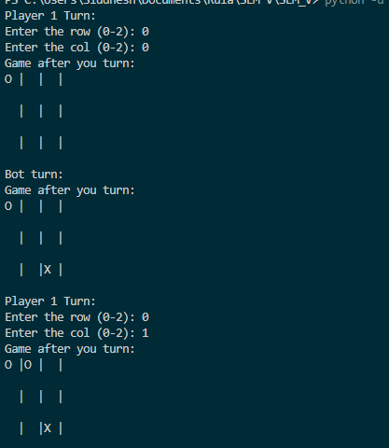

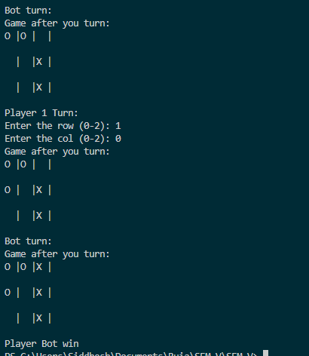

**2] Player win**

