Practical No. 1

AngularJS Basics

**Q.1]**To append name in h1/p tag.

**Code:**

<!doctype html>

<html>

<head>

<script src="https://ajax.googleapis.com/ajax/libs/angularjs/1.8.2/angular.min.js"></script>

</head>

<body ng-app="">

<div>

<label>Name:</label>

<input type="text" ng-model="yourName" placeholder="Enter a name here">

<hr>

<h1 ng-bind="yourName"></h1>

<p>Hello today we are learning AngularrJs</p>

</div>

</body>

</html>

**Output:**

**Default Home**

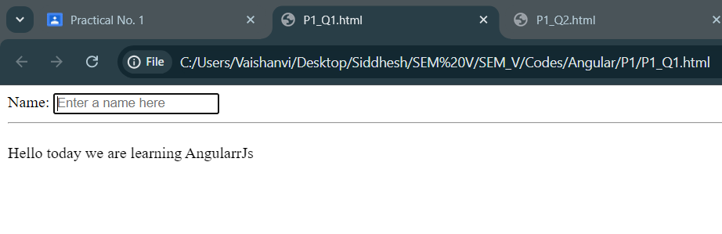

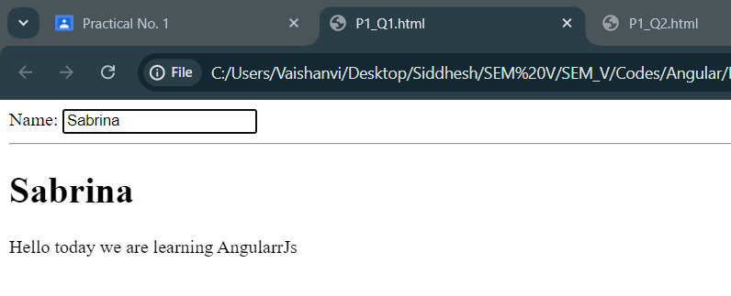

**Q.2]**To read the data & display it on the page simultaneously.

**Code:**

<!doctype html>

<html>

<head>

<script src="https://ajax.googleapis.com/ajax/libs/angularjs/1.8.2/angular.min.js"></script>

</head>

<body ng-app="myApp" ng-controller="myCtrl">

<div>

<label>First Name:</label>

<input type="text" ng-model="firstName" placeholder="Enter your first name here">

<hr>

<label>Last Name:</label>

<input type="text" ng-model="lastName" placeholder="Enter your last name here">

<hr>

<p>Your Name: {{firstName + " " + lastName}}</p>

</div>

<script>

var app = angular.module('myApp', []);

app.controller('myCtrl', function($scope) {

$scope.firstName= "Taylor";

$scope.lastName= "Swift";

});

</script>

</body>

</html>

**Output:**

**Default Home**

