Practical No. 4

Tables and Select tag in AngularJS

**Q.1]** Write a program in AngularJS for the following.

1. To change three data together.
2. Using AngularJS tables.

**Code:**

**[N1.html]**

<!doctype html>

<html>

<head>

<script src="https://ajax.googleapis.com/ajax/libs/angularjs/1.8.2/angular.min.js"></script>

</head>

<body ng-app="myApp" ng-controller="myCtrl">

<div>

<p>Select a car:</p>

<select ng-model="selectedCar" ng-options="x for (x, y) in cars">

</select>

<h1>You selected: {{selectedCar.brand}}</h1>

<h2>Model: {{selectedCar.model}}</h2>

<h3>Color: {{selectedCar.color}}</h3>

</div>

<script>

var app = angular.module('myApp', []);

app.controller('myCtrl', function($scope) {

$scope.cars = {

car01 : {brand : "Ford", model : "Mustang", color : "red"},

car02 : {brand : "Fiat", model : "500", color : "white"},

car03 : {brand : "Volvo", model : "XC90", color : "black"}

}

}

);

</script>

</body>

</html>

**[N2.html]**

<!doctype html>

<html>

<head>

<script src="https://ajax.googleapis.com/ajax/libs/angularjs/1.8.2/angular.min.js"></script>

<style>

table, th , td {

border: 1px solid grey;

border-collapse: collapse;

padding: 5px;

}

table tr:nth-child(odd) {

background-color: #f1f1f1;

}

table tr:nth-child(even) {

background-color: #ffffff;

}

</style>

</head>

<body ng-app="myApp" ng-controller="myCtrl">

<div>

<table>

<tr>

<td>Enter first name:</td>

<td><input type="text" ng-model="userdata.name.firstName"/></td>

</tr>

<tr>

<td>Enter last name:</td>

<td><input type="text" ng-model="userdata.name.lastName"/></td>

</tr>

<tr>

<td>Name:</td>

<td>{{userdata.getName()}}</td>

</tr>

<tr>

<td>Subject:</td>

<td>

<table>

<tr ng-repeat="x in userdata.subjects">

<td>{{x.name}}</td>

<td>{{x.Marks}}</td>

</tr>

</table>

</td>

</tr>

</table>

</div>

<script>

var app = angular.module('myApp', []);

app.controller('myCtrl', function($scope) {

$scope.userdata = {

name: {firstName: "Default", lastName: "Name"},

subjects: {

headin : {name: "Subjects", Marks: "Marks"},

sub1 : {name: "Physics", Marks: "70"},

sub2 : {name: "Chemistry", Marks: "80"},

sub3 : {name: "Math", Marks: "65"},

sub4 : {name: "English", Marks: "75"},

sub5 : {name: "Hindi", Marks: "67"}

},

getName: function(){

return $scope.userdata.name.firstName + " " + $scope.userdata.name.lastName

}

}

}

);

</script>

</body>

</html>

**Output:**

**1.**

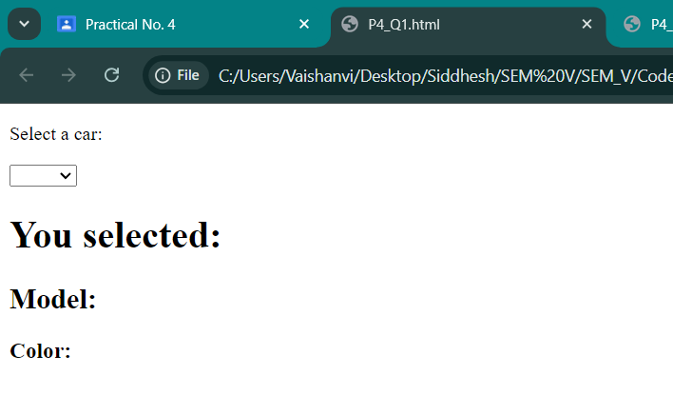

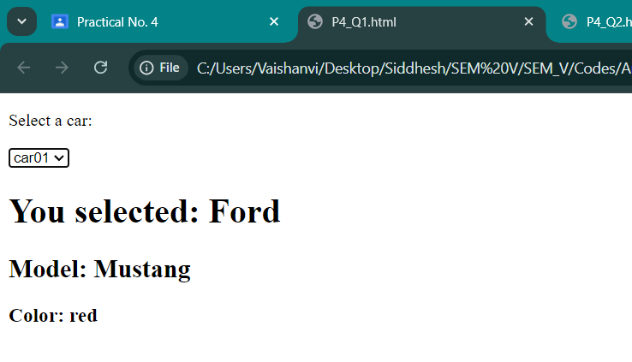

**2.**

