Practical No. 1A

Google Dorks

Q.1] Display Python programs in PDF format format tutorialspoint

Command: python site:tutorialspoint.com filetype:pdf

Output:

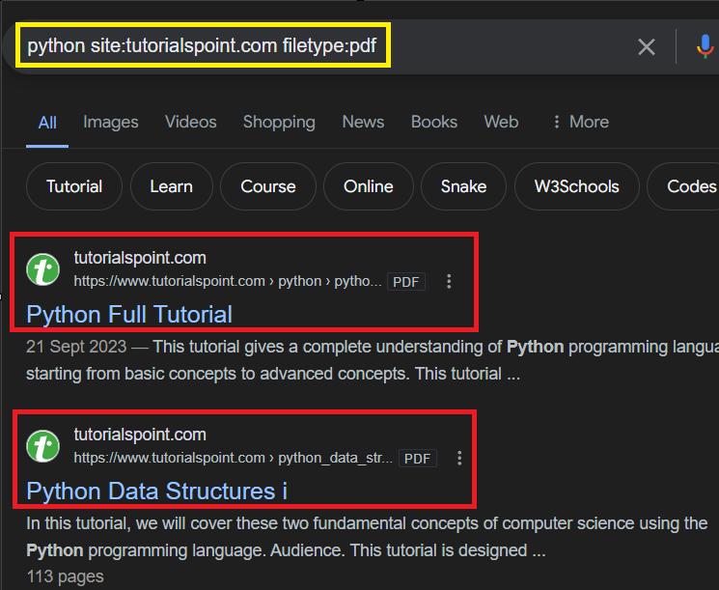

Q.2] Display the facebook page of Ruia CS&IT

Command:

Output:

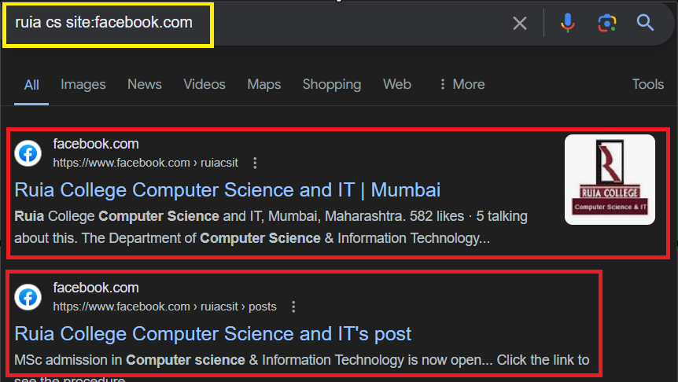

Q.3] Display the images related to Covid-19

Command: covid-19 site:\*.gov inurl:images/covid-19

Output:

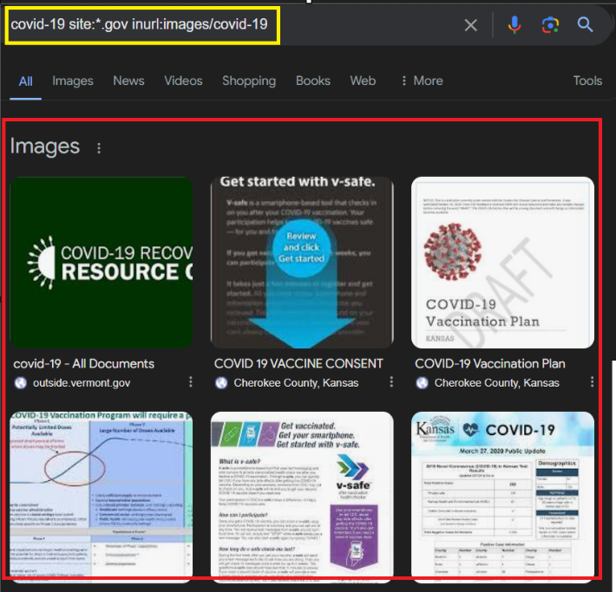

Q.4] Display all audio and video files related to NASA

Command: nasa inurl:images/|videos/

Output:

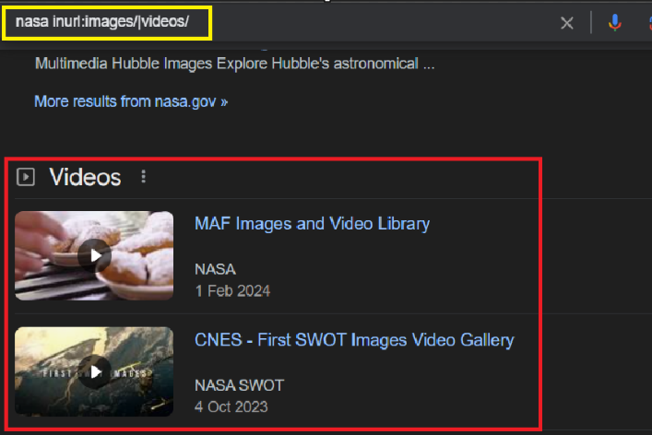

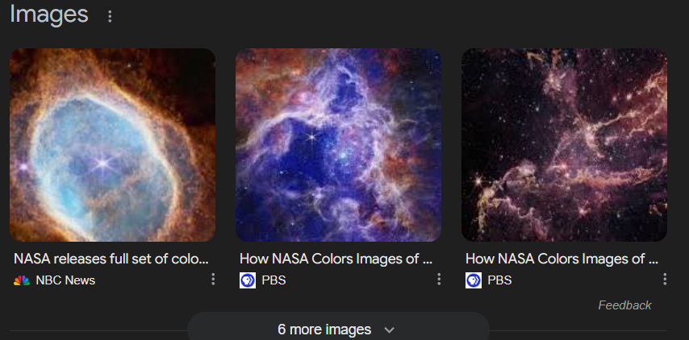

Q.5] Display today’s weather for Germany

Command: weather location:berlin, weather: berlin

Output:

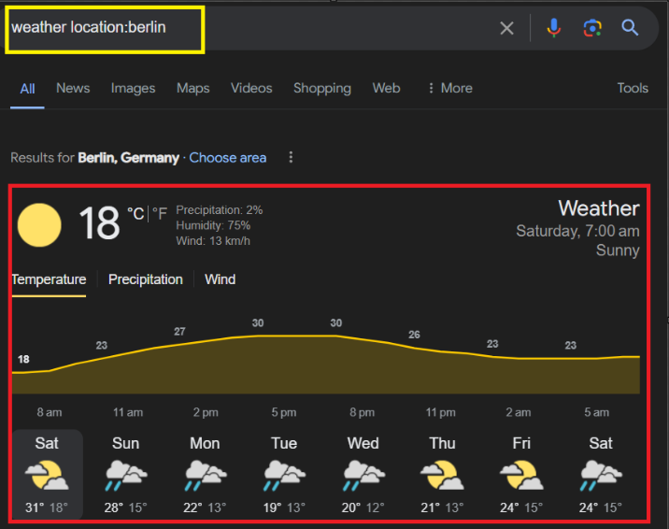

Q.6] Display all security plans of national level from government website

Command: india security plans site:\*.gov

Output:

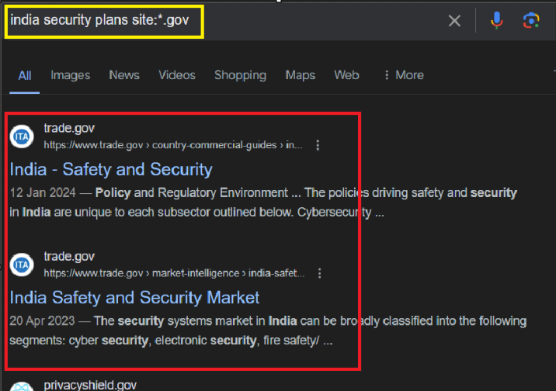

Q.7] Display route from Mumbai to Goa

Command: route location:mumbai&goa

Output:

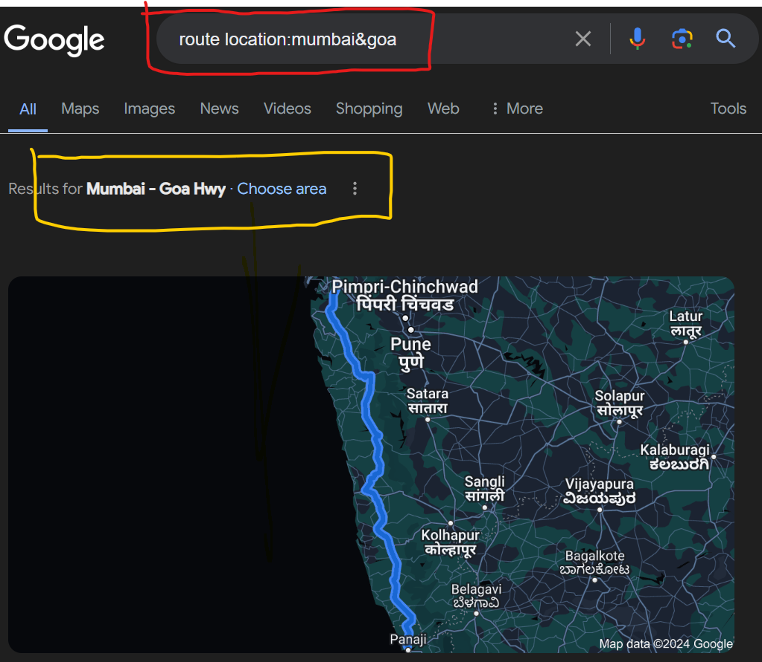

Q.8] Find the white paper for Bitcoin

Command: bitcoin white paper filetype:pdf

Output:

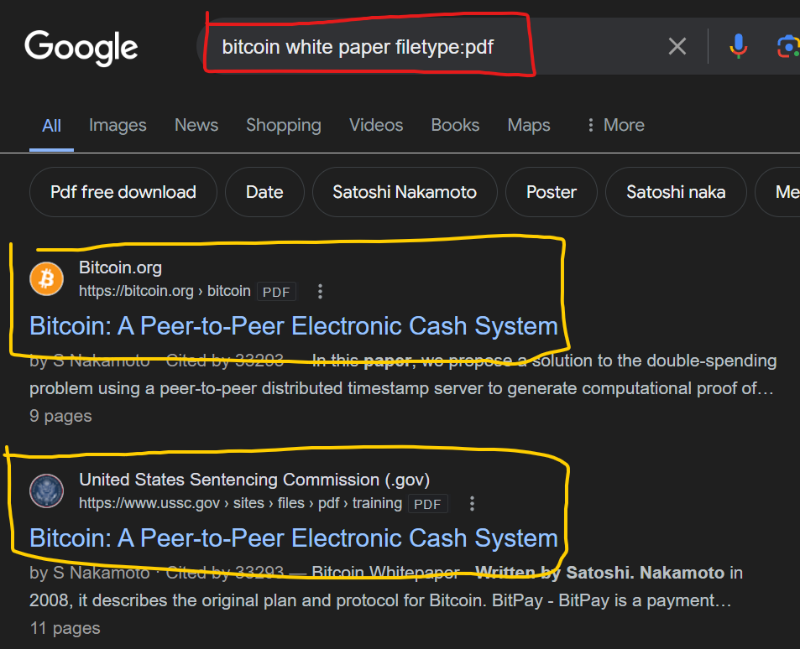

Q.9] Display the oath ceremony video of PM

Command: india pm oath ceremony 2024 site:youtube.com

Output:

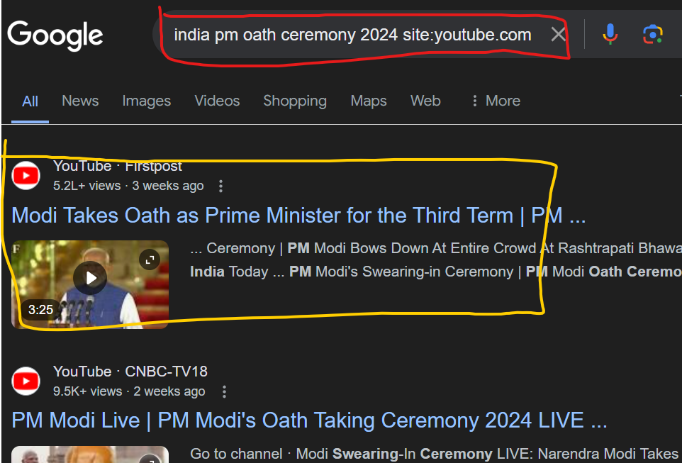

Q.10] Display ATKT timetable from Ruia Website

Command: atkt timetable site:ruiacollege.edu filetype:pdf

Output:

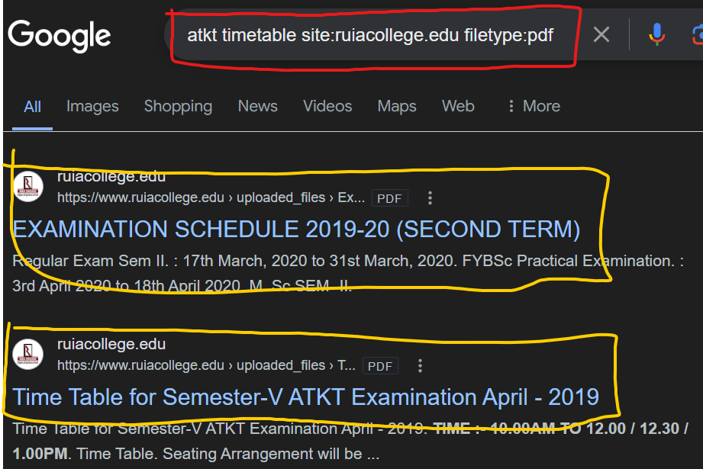

Q.11] Display information related to NEP

Command: national education policy filetype:pdf

Output:

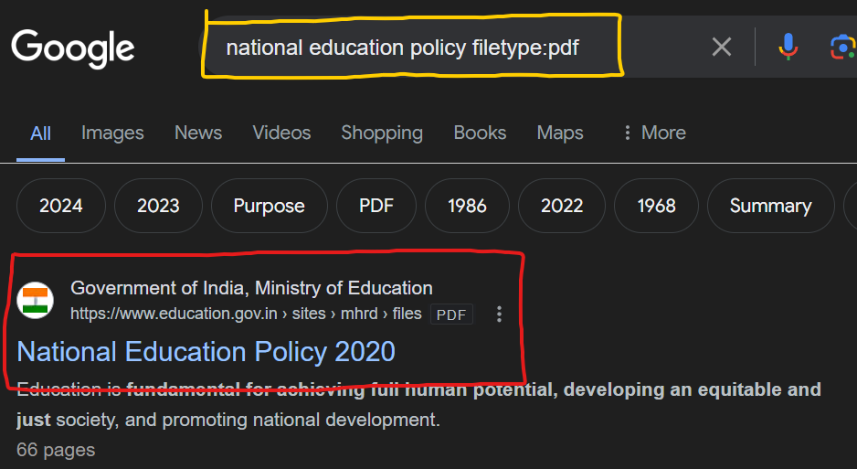

Q.12] Display different specialization in IIM in PDF format

Command: pg courses site:iimb.ac.in filetype:pdf

Output:

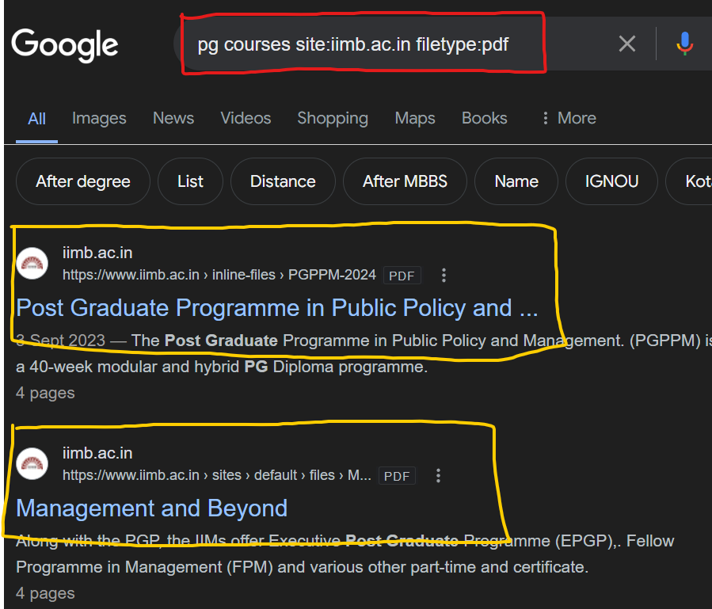

Q.13] Find jobs listings of google

Command: jobs site:careers.google.com

Output:

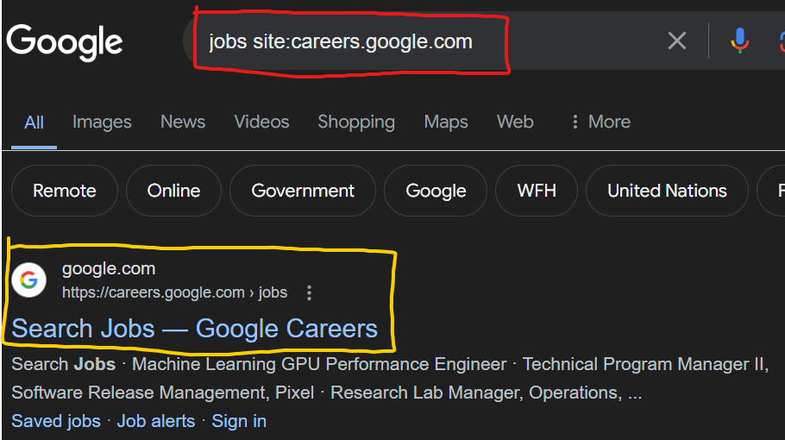

Q.14] Find PPTs on topic cybersecurity

Command: filetype:ppt cybersecurity

Output:

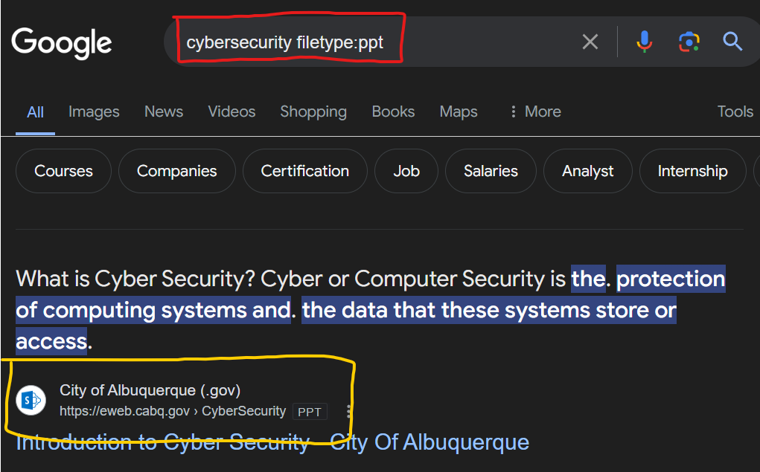

Q.15] Find documentation related to ReactJS

Command: reactjs documentation filetype:pdf

Output:

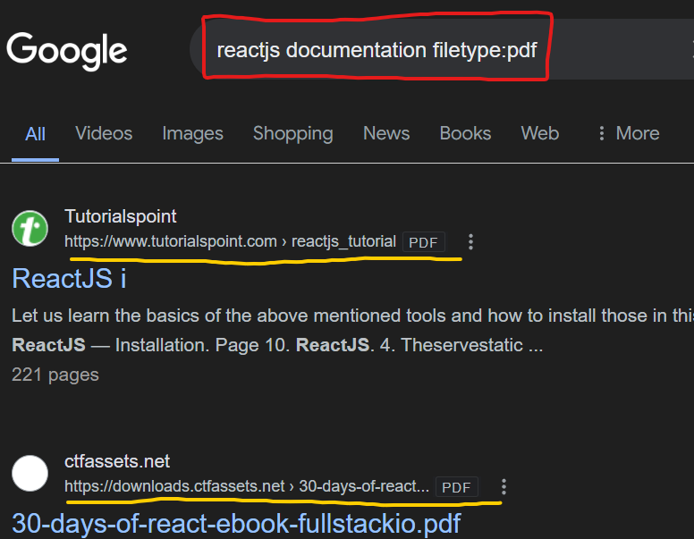

Q.16] find movie streaming links for a specific movie

Command: inception inurl:watch OR inurl:stream

Output:

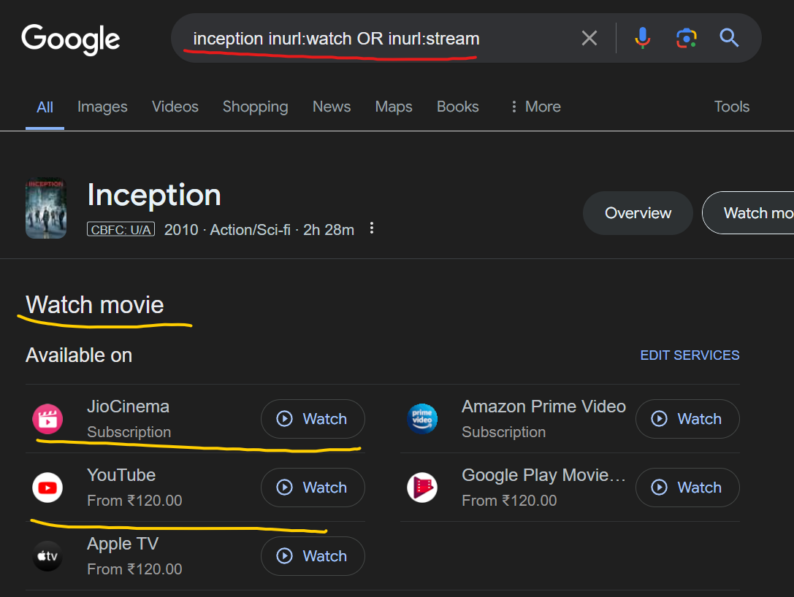

Q.17] locate recent news articles about technology trends

Command: "technology trends" site:news.google.com OR site:bbc.com OR site:cnn.com

Output:

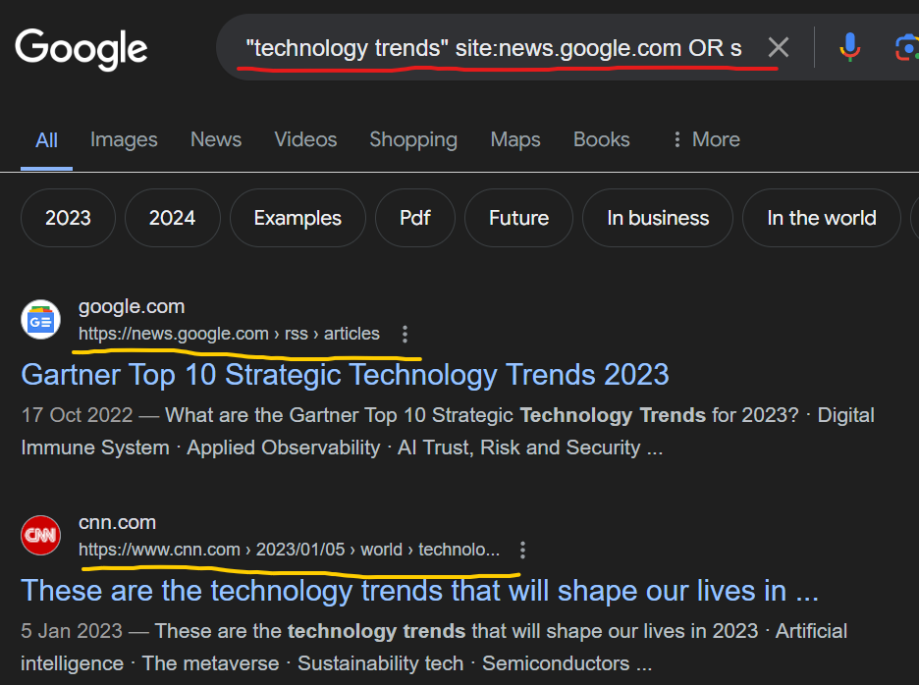

Q.18] find free downloadable eBooks on a specific topic

Command: "free ebook" "digital marketing" filetype:pdf

Output:

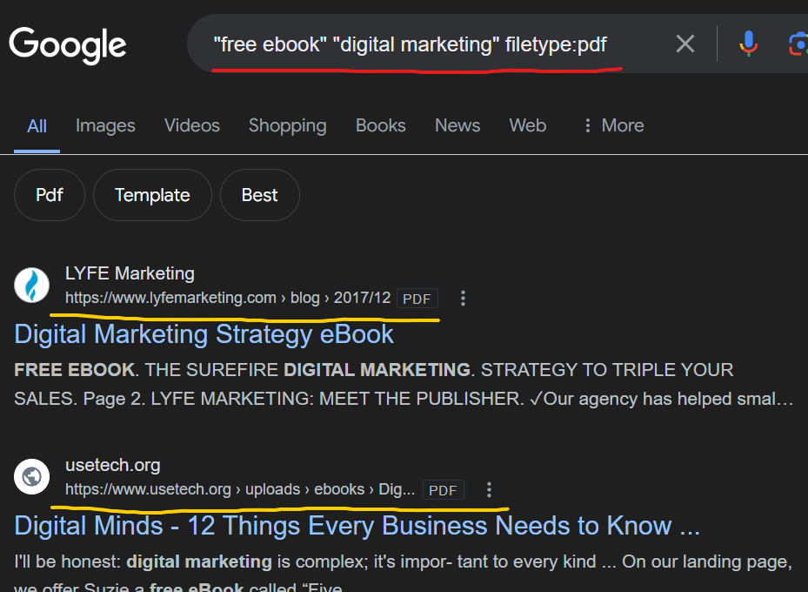

Q.19] discover recipes for vegan dishes

Command: "vegan recipe" filetype:pdf OR site:allrecipes.com OR site:foodnetwork.com

Output:

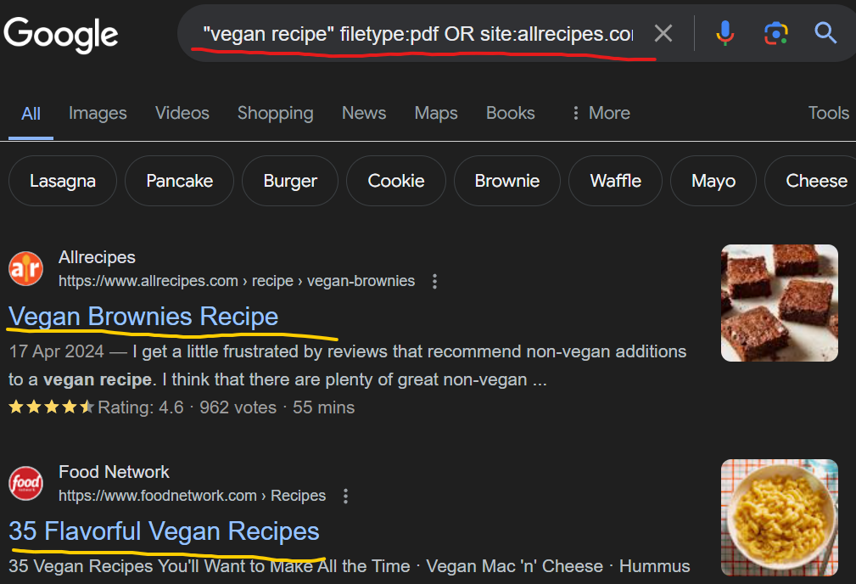

Q.20] find music download links for a specific song

Command: "Blinding Lights" "The Weeknd" inurl:download OR intitle:download

Output:

