Practical No. 1B

Whois tool

Q.1] Gather the information about Ruia college website

Output:

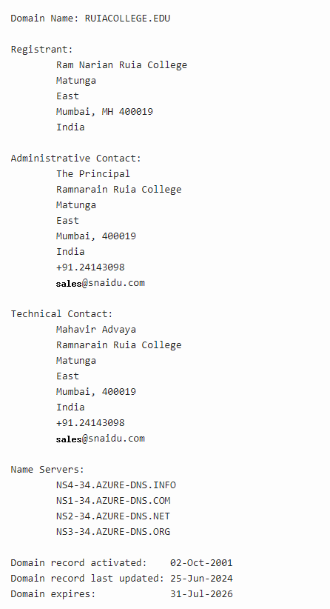

Q.2] FInd IP address of Yahoo.com server

Tool: https://whois.domaintools.com/yahoo.com

Output:

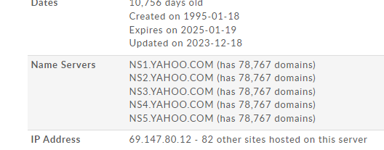

Q.3] List the name servers of microsoft.com

Output:

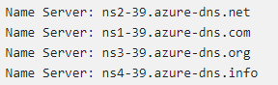

Q.4] Which country hosted the server of Google

Output:

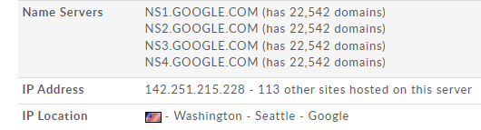

Q.5] Display the expiry date of Mumbai university website

Output:

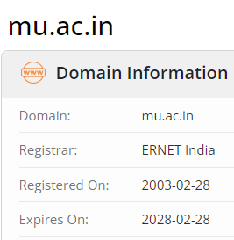

Q.6] Display registration date of linkedin server

Output:

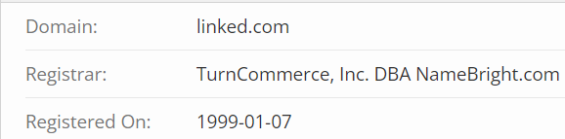

Q.7] Find the administration contact of IIT Bombay

Output:

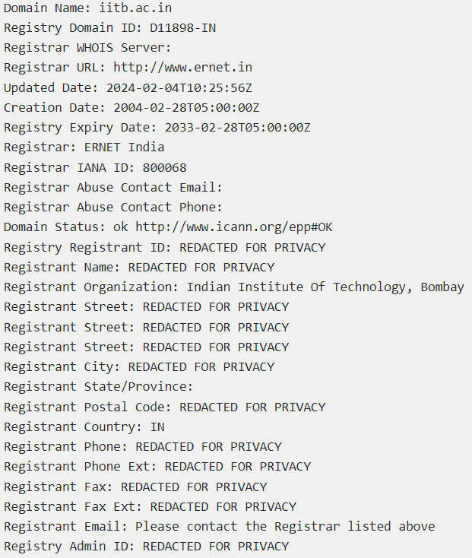

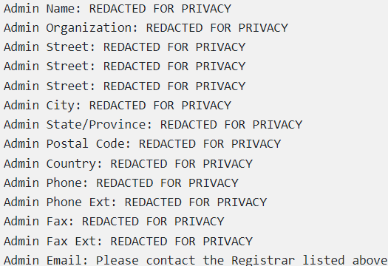

Q.8] Find the IP range of facebook

Output:

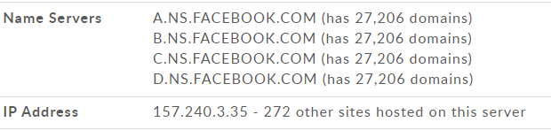

Q.9] Display admin organization details of Whatsapp server

Output:

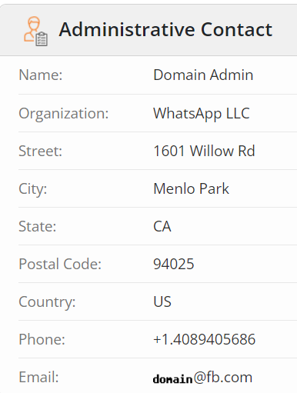

Q.10] Find latest date of updation of Instagram

Output:

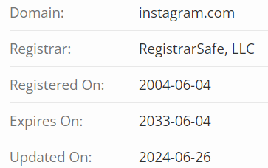

Q.11] Display IP location of facebook along with map

Output:

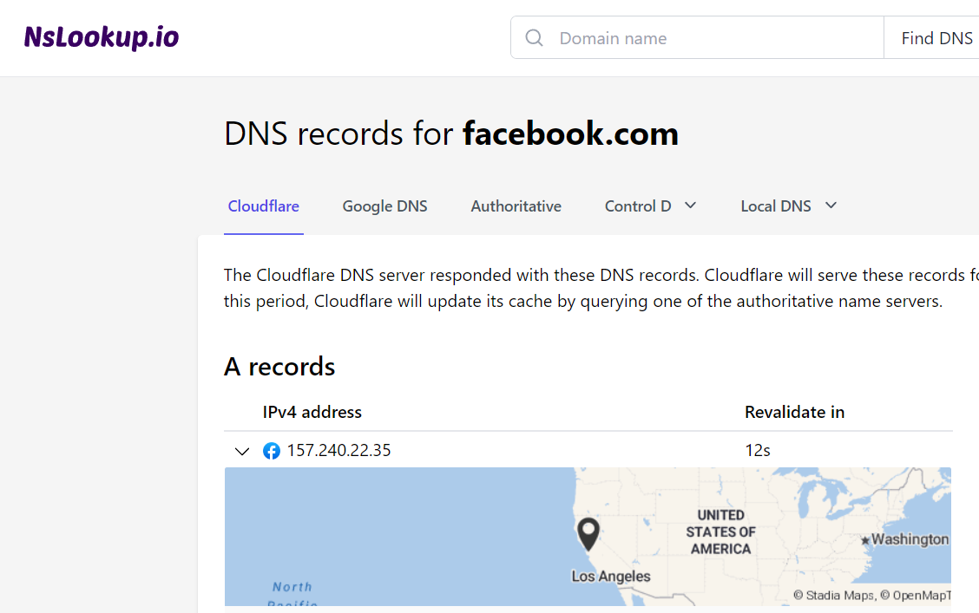

Q.12] Display the creation date of Google.com server

Output:

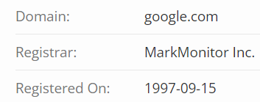

Q.13] Find last updated date of groww.com

Output:

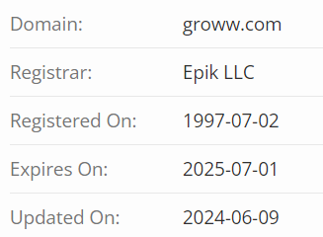

Q.14] Find technical contact of blocksphere.com

Output:

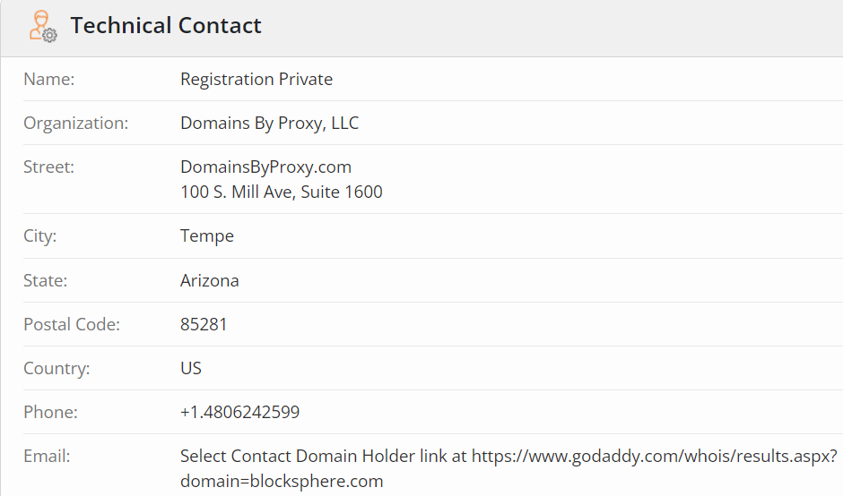

Q.15] Find name servers of jupiter.com

Output:

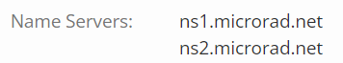

Q.16] Find location of IP of amazon.in

Output:

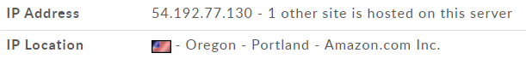

Q.17] Find expiry date of flipkart.com

Output:

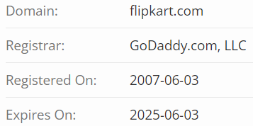

Q.18] Find admin details of opensea.com

Output:

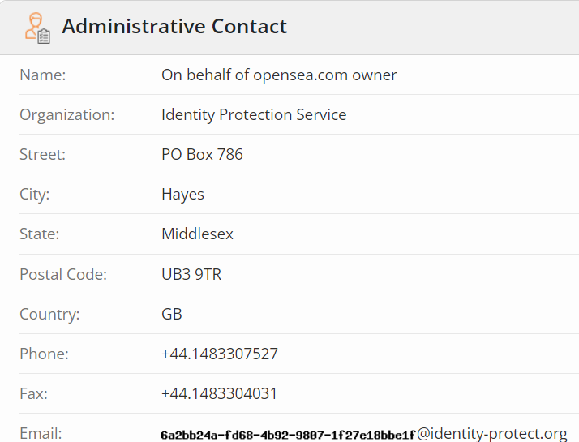

Q.19] Find registar details of tokenpocket.com

Output:

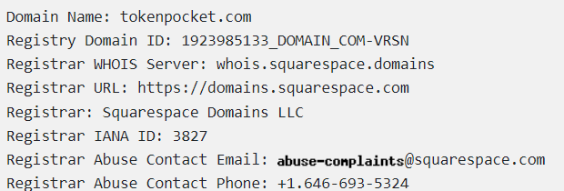

Q.20] Find name servers of apple.in

Output:

