Practical No. 2

Cryptool

**Q.1]** Use Caesar cipher in Cryptool.

**Steps:**

**Encryption**

1. Go to File > New
2. Type some plaintext in the window

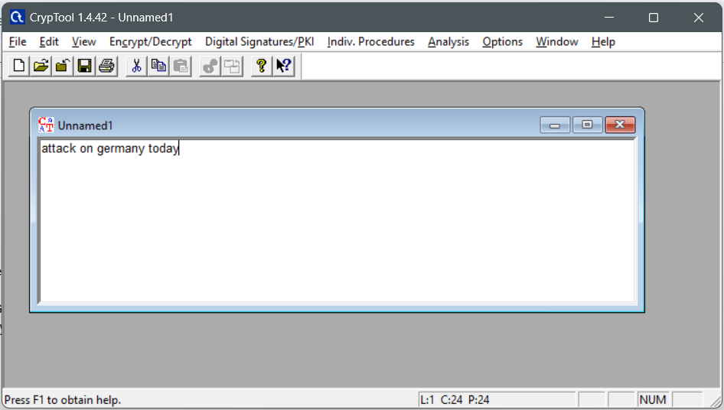

1. Go to Encrypt/Decrypt > Symmetric > Caesar

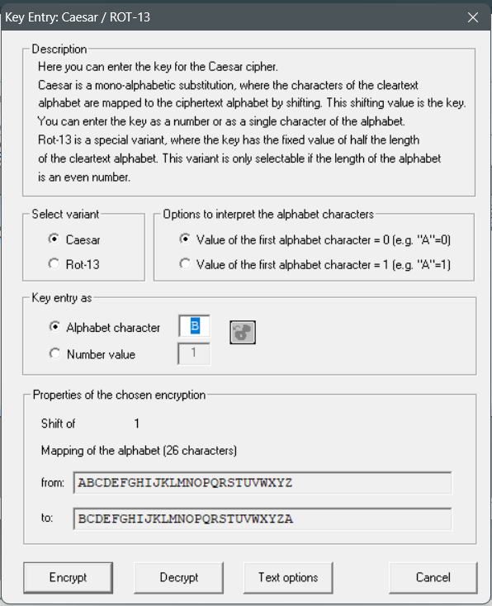

1. Change to number value and choose the key

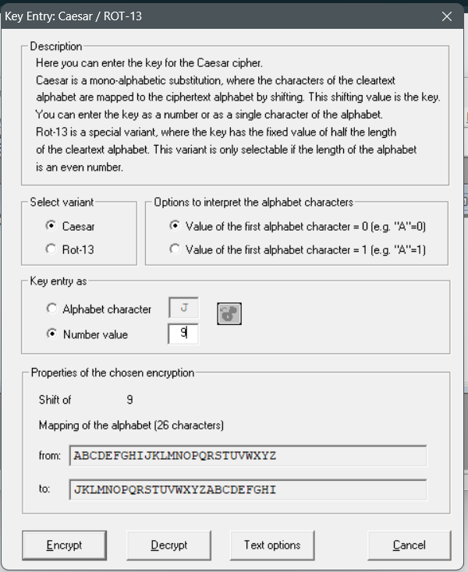

1. Click on encrypt button and the cipher text is displayed

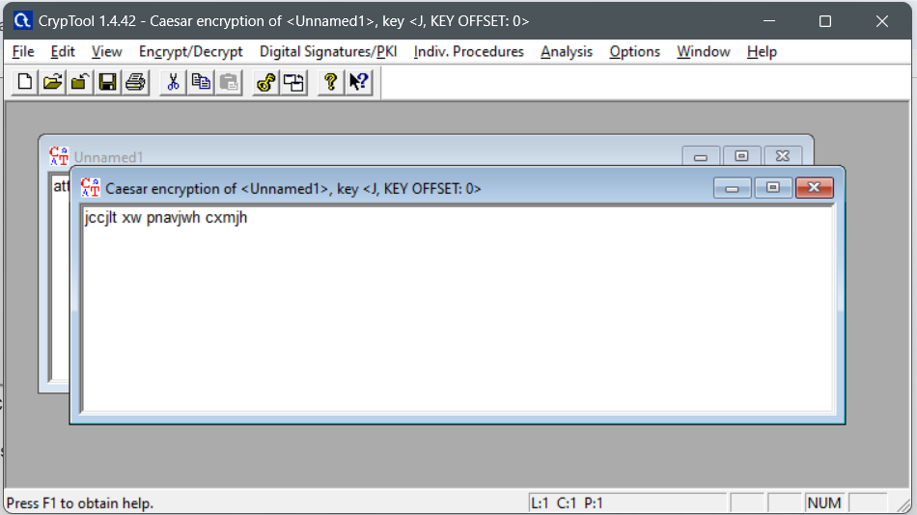

1. Copy the cipher text for decryption

**Decryption:**

1. Open a new window and paste the cipher text

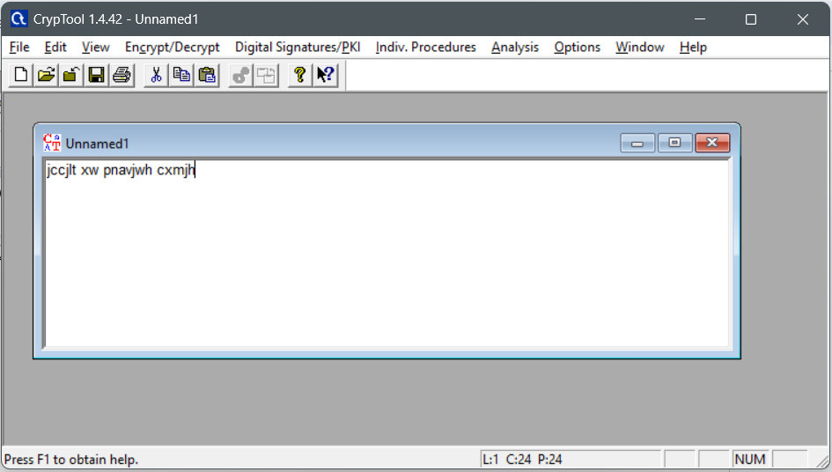

1. Go to Encrypt/Decrypt > Symmetric > Caesar
2. Change to number value and choose the key as 9

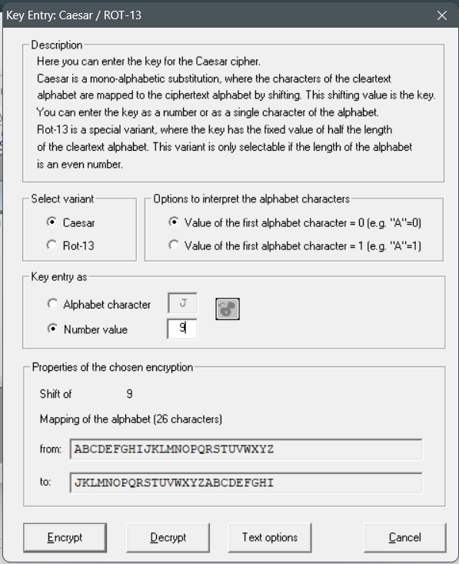

1. Click Decryption button and the deciphered text will be displayed

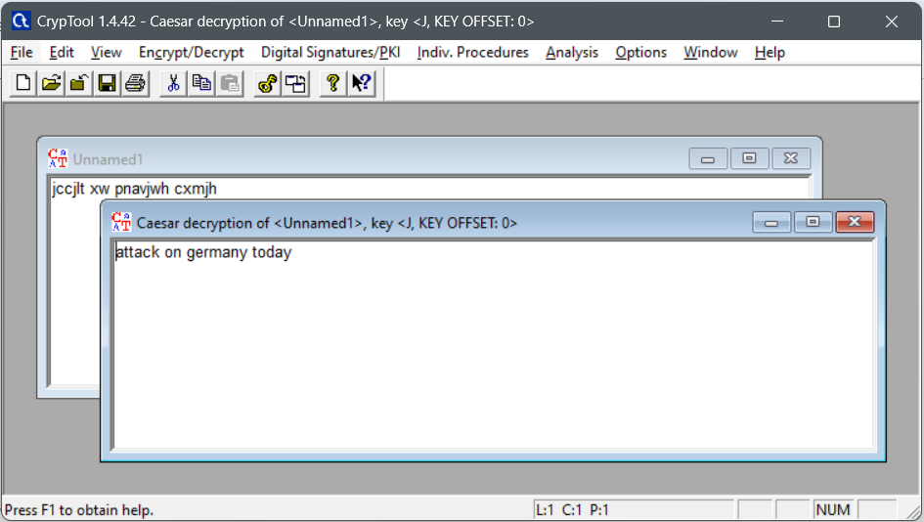

**Q.2]** Vigenere cipher

**Steps:**

**Encryption & Decryption**

1. Do the basic steps
2. Enter the key

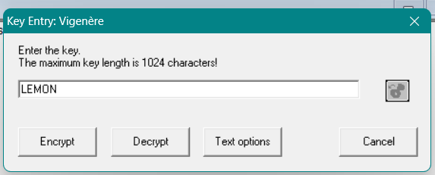

1. Cipher text

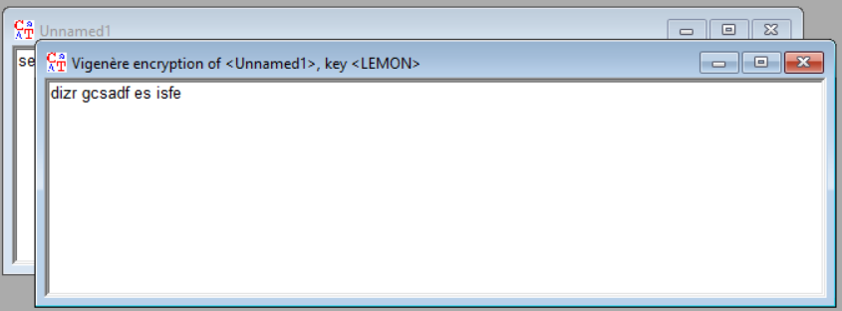

1. Now decrypt the cipher using decrypt button

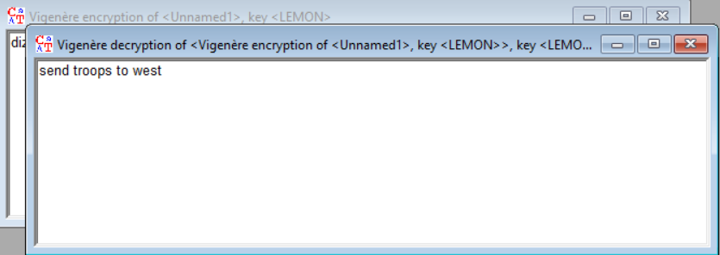

**Q.3]** Playfair cipher

**Steps:**

**Encryption & Decryption**

1. Do the basic steps
2. Enter the 5x5 key matrix

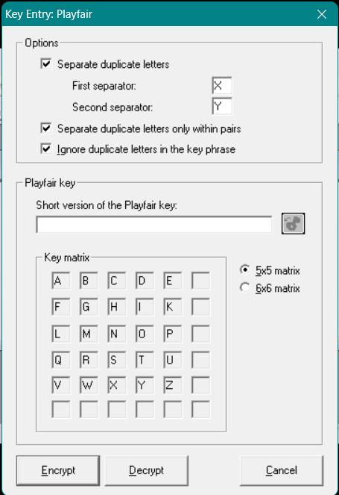

1. Click encrypt

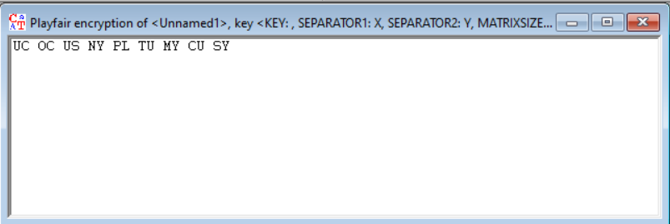

1. Now decrypt the cipher text using the same 5x5 key matrix

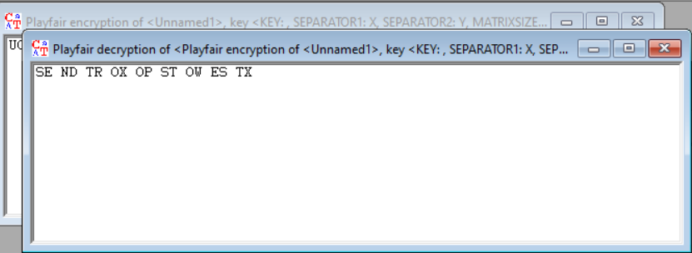

**Q.4]** DES (EBC)

**Steps:**

**Encryption & Decryption**

1. Do the basic steps
2. Enter the key

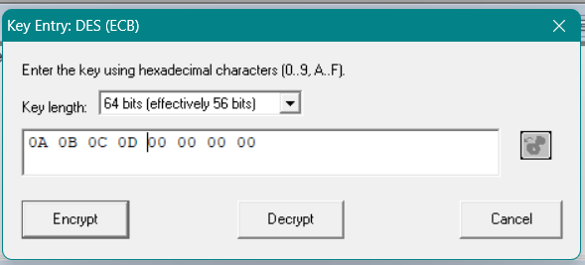

1. Click encrypt

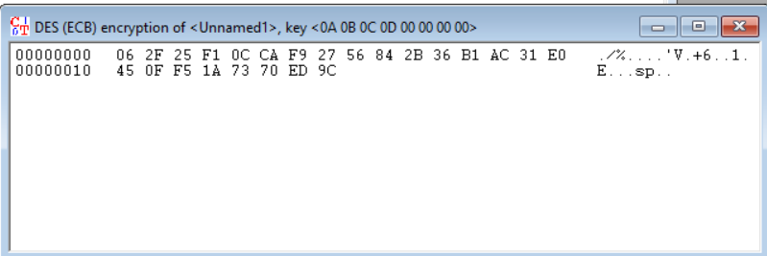

1. Now the decrypt the cipher text

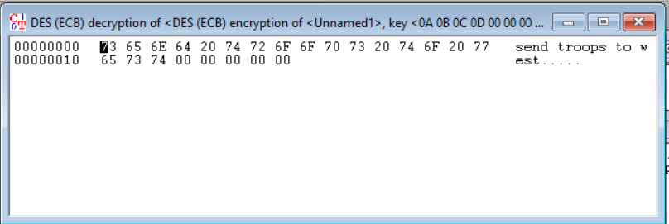

**Q.5]** AES (CBC)

**Steps:**

**Encryption & Decryption**

1. Do the basic steps
2. Enter the 128 bit key

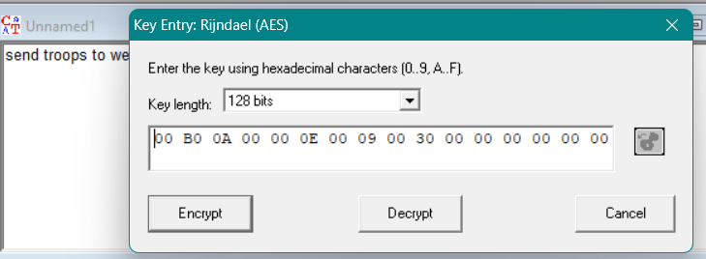

1. Now click encrypt

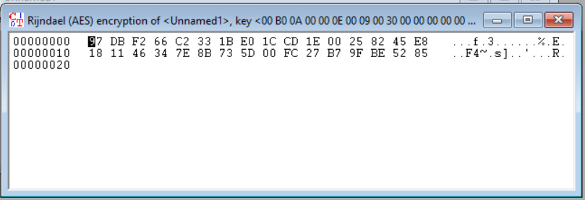

1. Now decrypt using the same 128 bit key

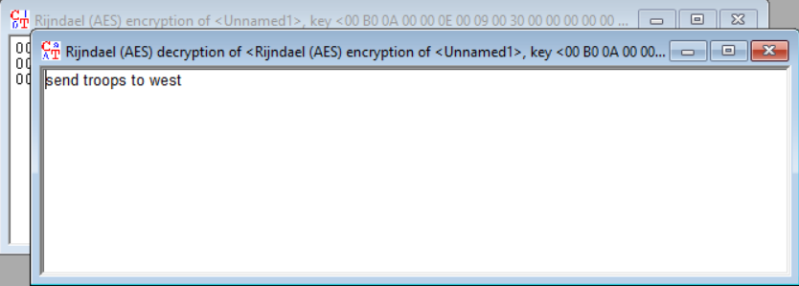

**Q.6]** RC4

**Steps:**

**Encryption & Decryption**

1. Do the basic steps
2. Enter they key

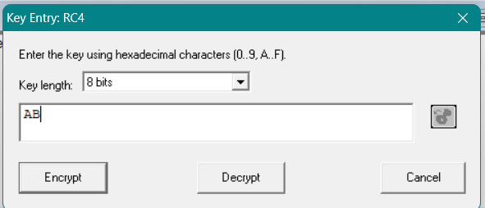

1. Click encrypt

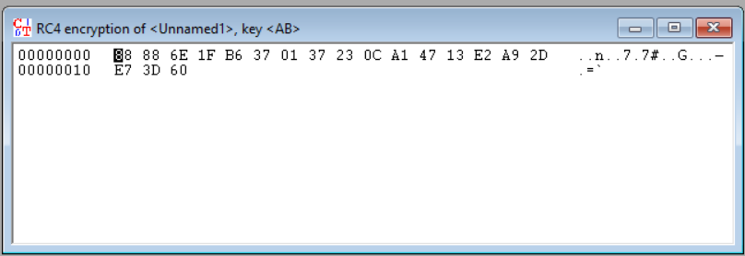

1. Now decrypt using the same key

