Practical No. 2

Manual Testing using Selenium

**Q.1]** Write manual test cases for calculator website

**IDE:**

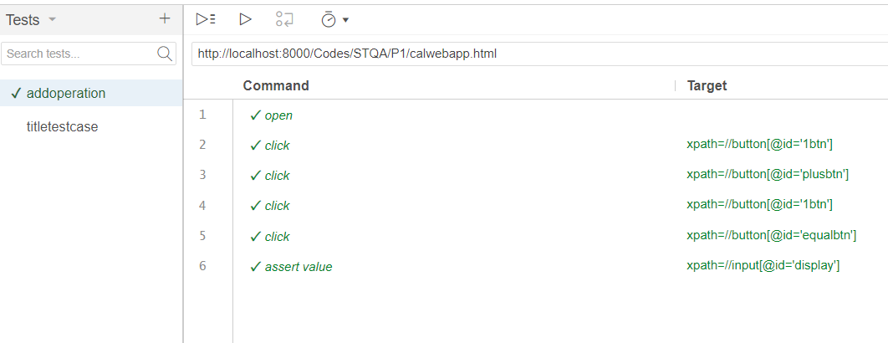

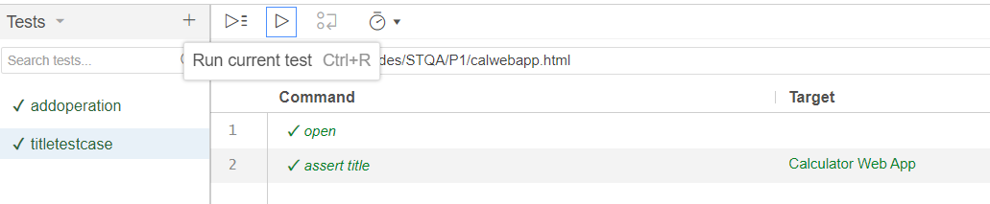

**Final Output:**

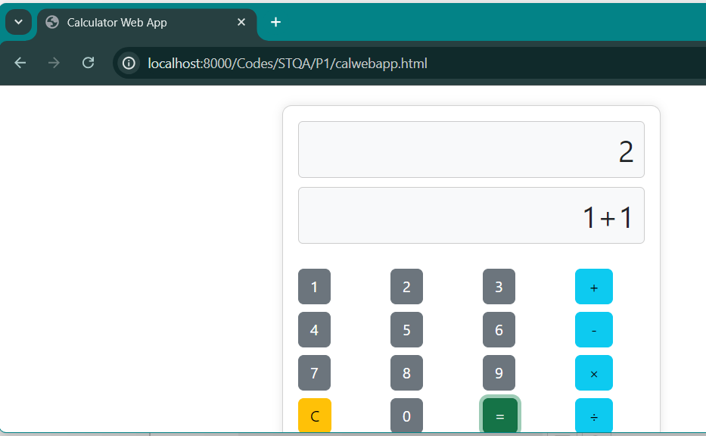

**Log:**

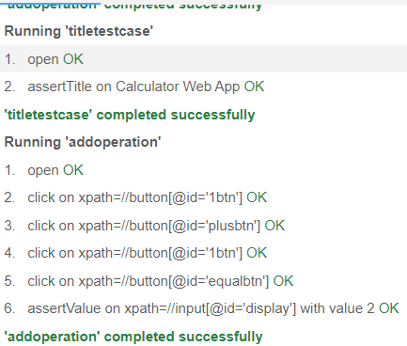

**Q.2]** Write manual test cases for redbus website (Finding trains by entering the route)

**IDE:**

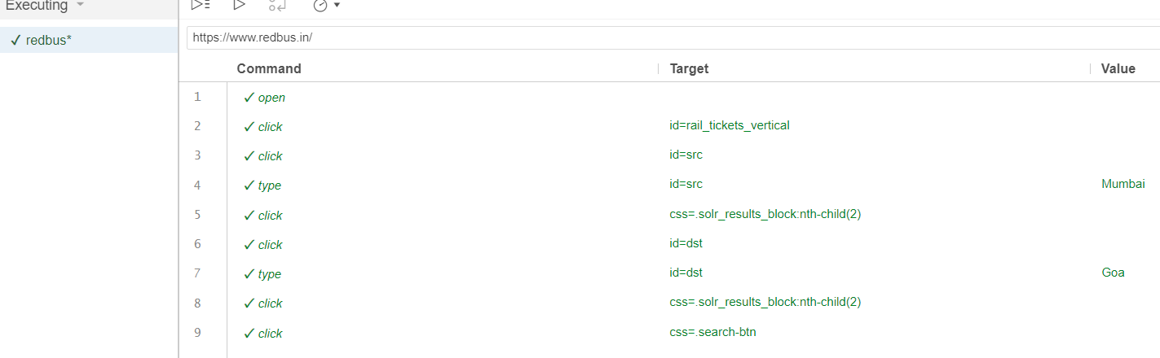

**Final Output:**

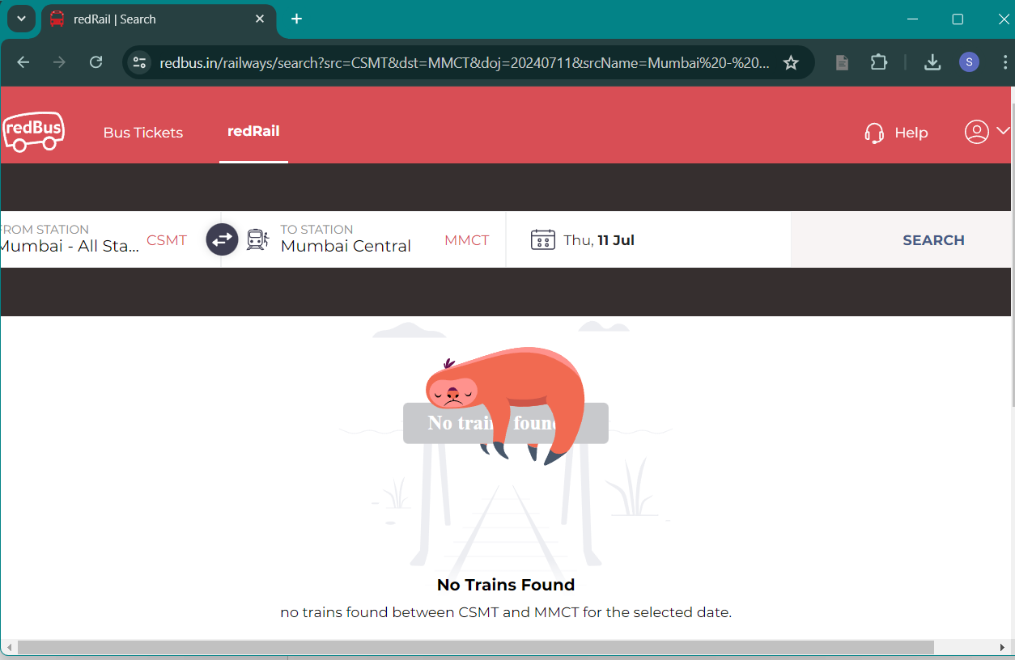

**Log:**

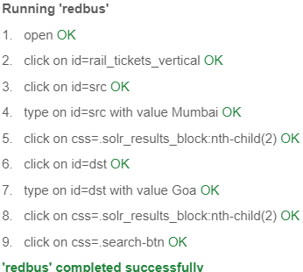

**Q.3]** Write manual test cases for gmail website (Going to trash email section)

**IDE:**

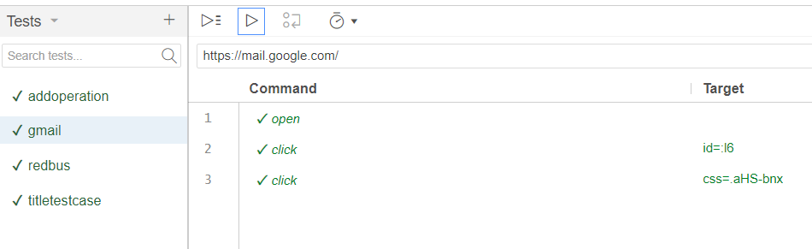

**Final Output:**

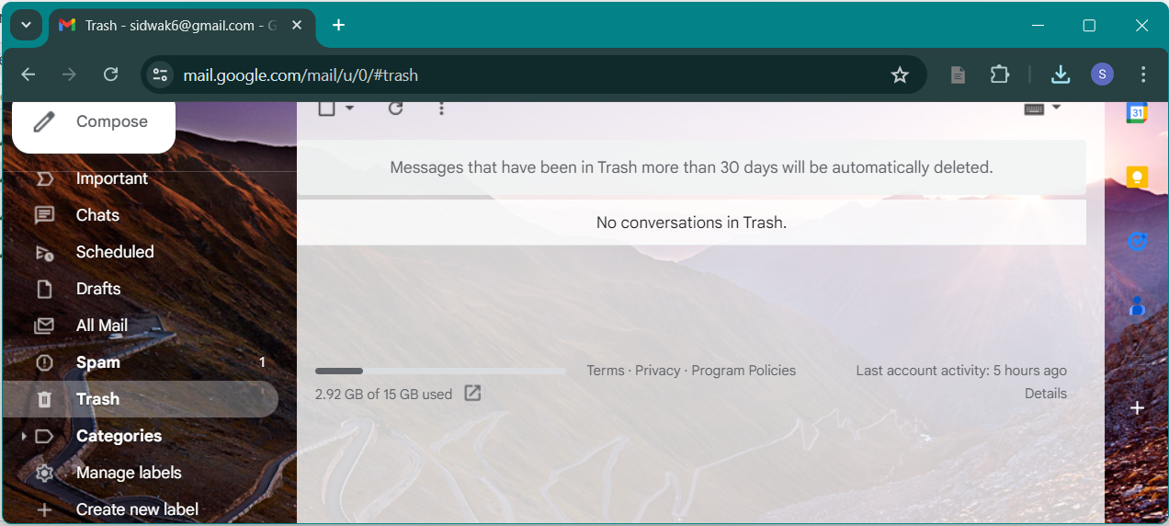

**Log:**

