Practical No. 3

Testing using Selenium WebDriver in Java

**Q.1]** Install Selenium webdriver & demonstrate it using a script in Java.

**Test Cases:**

1. To check title
2. To check GCD website result value

**Notes:**

1. Uncheck the create module-info file while creating the project
2. Create the class in default package
3. Add JARs in classpath NOT module path
4. To run, right anywhere in the code and select run as > java application

**Java Code:**

import org.openqa.selenium.WebDriver;

import org.openqa.selenium.WebElement;

import org.openqa.selenium.chrome.ChromeDriver;

import java.time.Duration;

import org.openqa.selenium.By;

public class gcdtest {

public static void main(String[] args) {

System.setProperty("webdriver.chrome.driver", "C:/app/ChromeDriver/chromedriver-win64/chromedriver.exe");

WebDriver driver = new ChromeDriver();

driver.get("http://localhost:8000/indexmain.html");

String pageTitle = driver.getTitle();

if (pageTitle.equals("GCD Calculator")) {

System.out.println("Title matched, test case passed, title: "+pageTitle);

}

else {

System.out.println("Title NOT matched, test case failed");

}

WebElement textBox1 = driver.findElement(By.id("number1"));

textBox1.sendKeys("24");

WebElement textBox2 = driver.findElement(By.id("number2"));

textBox2.sendKeys("10");

WebElement calButton = driver.findElement(By.id("subbtn"));

calButton.click();

WebElement resultText = driver.findElement(By.id("result"));

driver.manage().timeouts().implicitlyWait(Duration.ofMillis(100));

if (resultText.getText().equals("GCD of 24 and 10 is 2")) {

System.out.println("Result matched with expected output of 2, test case passed");

}

try {

//right anywhere here and select run as > java application

Thread.sleep(3000);

}

catch (InterruptedException e) {

e.printStackTrace();

}

// Close the browser

driver.quit();

}

}

**Main Website:**

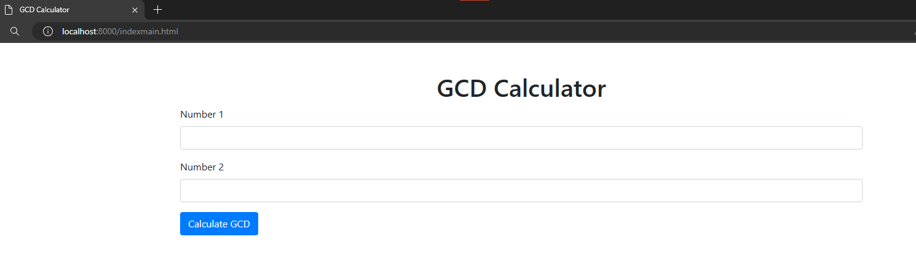

**Output:**

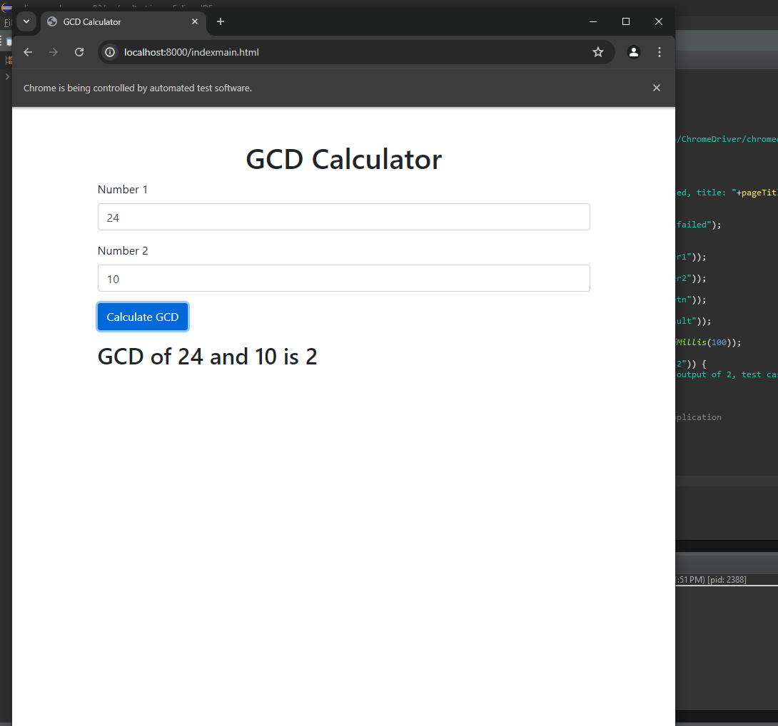

**Logs:**

