Practical No. 4

Test Login

**Q.1]** Write and test a program to login to a specific web page.

1. Facebook login

**Steps:**

1. Create a Maven project in eclipse
2. Check “create a simple project”
3. Give the groupId and ArtifactId (any project name)
4. Edit the pom.xml and add the following
5. Add the external JAR files

**Code:**

**[pom.xml]**

<project xmlns="http://maven.apache.org/POM/4.0.0" xmlns:xsi="http://www.w3.org/2001/XMLSchema-instance" xsi:schemaLocation="http://maven.apache.org/POM/4.0.0 https://maven.apache.org/xsd/maven-4.0.0.xsd">

<modelVersion>4.0.0</modelVersion>

<groupId>test1</groupId>

<artifactId>test1</artifactId>

<version>0.0.1-SNAPSHOT</version>

<dependencies>

<dependency>

<groupId>org.seleniumhq.selenium</groupId>

<artifactId>selenium-java</artifactId>

<version>4.10.0</version>

</dependency>

<!-- https://mvnrepository.com/artifact/org.seleniumhq.selenium/selenium-java -->

<dependency>

<groupId>org.seleniumhq.selenium</groupId>

<artifactId>selenium-chrome-driver</artifactId>

<version>4.10.0</version>

</dependency>

</dependencies>

</project>

**[maintest.java]**

package test1;

import org.openqa.selenium.By;

import org.openqa.selenium.WebDriver;

import org.openqa.selenium.chrome.ChromeDriver;

public class maintest {

public static void main(String[] args) {

// TODO Auto-generated method stub

WebDriver driver= new ChromeDriver();

driver.get("https://facebook.com");

driver.findElement(By.id("email")).sendKeys("email@email.com");

driver.findElement(By.id("pass")).sendKeys("pass");

driver.findElement(By.xpath("//button[text()='Log in']")).click();

}

}

**Output:**

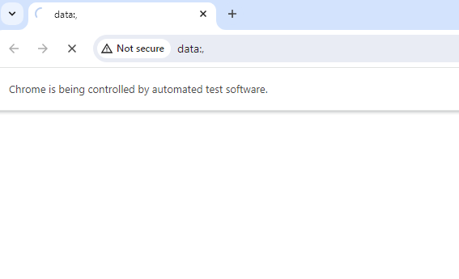

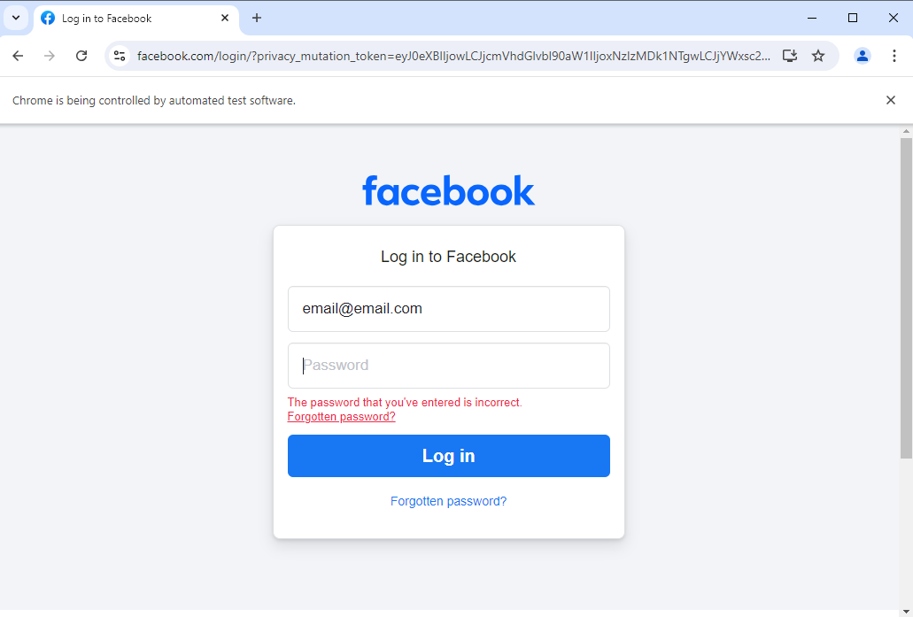

**Q.2]** Write and test a program to login to a specific web page.

1. Gmail login

**Code:**

**[maintest2.java]**

package test1;

import org.openqa.selenium.By;

import org.openqa.selenium.WebDriver;

import org.openqa.selenium.chrome.ChromeDriver;

public class maintest2 {

public static void main(String args[]) {

WebDriver driver=new ChromeDriver();

driver.get("https://accounts.google.co.in");

driver.findElement(By.id("identifier")).sendKeys("email@email.com");

driver.findElement(By.id("identifierNext")).click();

driver.findElement(By.xpath("//button[text()='Log in']")).click();

}

}

**Output:**

