Practical No. 7

Reading Data from Excel using Java

**Q.1]** Write and test a program to select the number of students who have scored more than 60 in any subject (or all subjects).

**Excel Sheet:**

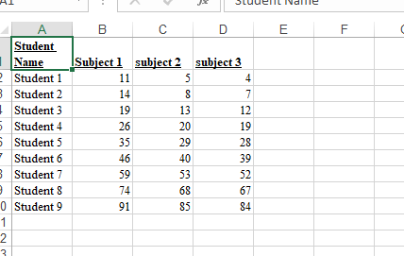

**Codes**

**[pom.xml]:**

<project xmlns="http://maven.apache.org/POM/4.0.0" xmlns:xsi="http://www.w3.org/2001/XMLSchema-instance" xsi:schemaLocation="http://maven.apache.org/POM/4.0.0 https://maven.apache.org/xsd/maven-4.0.0.xsd">

<modelVersion>4.0.0</modelVersion>

<groupId>p7</groupId>

<artifactId>p7</artifactId>

<version>0.0.1-SNAPSHOT</version>

<dependencies>

<dependency>

<groupId>org.seleniumhq.selenium</groupId>

<artifactId>selenium-java</artifactId>

<version>4.10.0</version>

</dependency>

<!-- https://mvnrepository.com/artifact/org.seleniumhq.selenium/selenium-java -->

<dependency>

<groupId>org.seleniumhq.selenium</groupId>

<artifactId>selenium-chrome-driver</artifactId>

<version>4.10.0</version>

</dependency>

<dependency>

<groupId>net.sourceforge.jexcelapi</groupId>

<artifactId>jxl</artifactId>

<version>2.6.12</version>

</dependency>

</dependencies>

</project>

**[maintest.java]:**

package p7;

import java.io.File;

import java.io.IOException;

import jxl.Workbook;

import jxl.read.biff.BiffException;

public class maintest {

public static void main(String[] args) throws IOException, BiffException {

Workbook workbook = Workbook.*getWorkbook*(new File("C:\\Users\\Siddhesh\\Documents\\Ruia\\SEM V\\SEM_V\\Codes\\STQA\\p6output.xls"));

jxl.Sheet sheet = workbook.getSheet(0);

int studentCountAbove60 = 0;

System.***out***.println("Student Name\tSubject 1\tSubject 2\tSubject 3");

for (int i = 1; i<sheet.getRows(); i++) {

String studentName = sheet.getCell(0, i).getContents();

int subject1Score = Integer.*parseInt*(sheet.getCell(1, i).getContents());

int subject2Score = Integer.*parseInt*(sheet.getCell(2, i).getContents());

int subject3Score = Integer.*parseInt*(sheet.getCell(3, i).getContents());

if (subject1Score > 60 || subject2Score > 60 || subject3Score > 60) {

System.***out***.println(studentName + "\t\t" + subject1Score + "\t\t" + subject2Score + "\t\t" + subject3Score);

studentCountAbove60++;

}

}

System.***out***.println("Student count with marks >60: " + studentCountAbove60);

workbook.close();

}

}

**Output:**

