CMPEN 472

HW#10 Report

**Homework 10: Analog signal acquisition with HCS12**

By

Siddharth Dutta (svd5571@psu.edu)

April 21st, 2020

**Objective**

To learn timer module and interrupt based Analog Signal Acquisition programming.

**Quantitative Results**

**Square Wave (AWAVE100Q):**

**Figure 1**

**Figure 2**

$$Frequency= \frac{1}{T}=\frac{1}{80*125*{10}^{-6}}=100 Hz$$

The given signal, which is a square wave, oscillates between the magnitudes of 50 and 250 over 1024 points or a time length of $1024*125*{10}^{-6}=0.128 seconds$. Each cycle requires 80 points to complete and since each point is 125µs long, this means the time period for one cycle is $80*125*{10}^{-6}=0.01 seconds$. The square wave signal is evenly spaced out and can be approximated to have a 50% duty cycle as a PWM signal.

**Sine Wave (AWAVE100S):**

**Figure 3**

**Figure 4**

$$Frequency= \frac{1}{T}=\frac{1}{80*125*{10}^{-6}}=100 Hz$$

The given signal, which is a sine wave, oscillates between the magnitudes of 0 and 250 over 1024 points or a time length of $1024*125*{10}^{-6}=0.128 seconds$. Each cycle requires 80 points to complete and since each point is 125µs long, this means the time period for one cycle is $80*125*{10}^{-6}=0.01 seconds$.

**Triangle Wave (AWAVE100T):**

**Figure 5**

**Figure 6**

$$Frequency= \frac{1}{T}=\frac{1}{80*125*{10}^{-6}}=100 Hz$$

The given signal, which is a triangle wave, oscillates between the magnitudes of 0 and 250 over 1024 points or a time length of $1024*125*{10}^{-6}=0.128 seconds$. Each cycle requires 80 points to complete and since each point is 125µs long, this means the time period for one cycle is $80*125*{10}^{-6}=0.01 seconds$.

**Mixed Signal (AWAVE200S):**

**Figure 7**

**Figure 8**

$$Frequency= \frac{1}{T}=\frac{1}{80*125*{10}^{-6}}=100 Hz$$

The given signal, which is a triangle wave, oscillates between the magnitudes of 29 and 238 over 1024 points or a time length of $1024*125*{10}^{-6}=0.128 seconds$. Each cycle requires 80 points to complete and since each point is 125µs long, this means the time period for one cycle is $80*125*{10}^{-6}=0.01 seconds$. The resulting graph shows that two signals or waveforms of different frequencies were used to produce the waveform seen in the figures above. The independent frequencies of each signal can be calculated by performing FFT on the acquired set of data points from the simulation.

**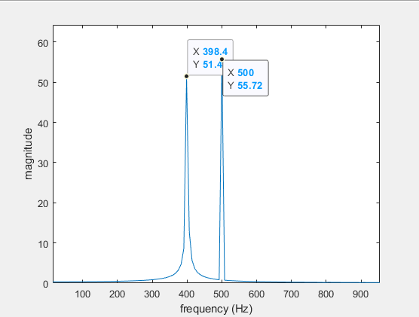  
Figure 9: FFT of mixed signal**

Performing FFT on the points received by sampling the mixed audio signal (AWAVE200S), we can see that it produces two peaks, one at 398.4Hz ≈ 400Hz and another one at 500Hz. This indicates that the input signal consisted of two cosine waves at the aforementioned frequencies which produces the graph as seen on figures 7 and 8. The FFT was performed with a sampling rate of 8000 since the ADC’s conversion rate is 8KHz.

**Conclusion**

Overall, the code implementation was successful. The results produced were as expected for the known waves with little to no error. The output for the mixed signal was verified by performing FFT on the acquired data points through the simulation.