Objective/Aim
This thesis primarily investigates the effects of environmental enrichment on the behavioural manifestation of cancer-related cognitive impairments in a juvenile rodent model. More specifically, employing a mouse model that mirrors the hyper-CVAD regimen used in acute lymphoblastic leukemia treatment enables us to investigate the potential neuroprotective role of environmental enrichment (1,2,3). Manipulating these two factors (environmental enrichment and hyper-CVAD) yields an experimentally rigorous design capable of producing causal evidence to address the research objective.
The main hypotheses of this thesis are as follows. First, we hypothesize that hyper-CVAD treatment will lead to a reduction in overall cognitive ability. These changes are expected to manifest as a main effect of treatment on a test battery assessing memory, cognitive flexibility, anxiety, social interaction, and attention. Second, we hypothesize that environmental enrichment will enhance cognitive performance regardless of treatment condition, observable as a main effect of environment on the same test battery. Furthermore, we hypothesize an interaction between treatment and environment, such that the cognitive benefits of environmental enrichment will be more pronounced in hyper-CVAD mice compared to healthy controls. Finally, we expect a recency effect, such that mice exposed to the Marlau cage most recently would show stronger enrichment benefits than those ending in the alternative environment, with this recency effect being most pronounced in hyper-CVAD–treated mice.
From a broader perspective, this work aims to facilitate future translational applications that enhance quality of life in patients with acute lymphoblastic leukemia. Future research may benefit from building on this line of work, which provides a rigorous experimental foundation for interventions and applications with direct clinical relevance.

Methods and Design

Research Animals

Table 1
Distribution of mice across treatment, environment, and sex.
 | Female |  | Male
Treatment | PE | EE | PE | EE
CVAD | 4 | 4 | 1 | 3
Saline | 10 | 7 | 2 | 4
Note. Values represent sample sizes (n) of pseudo‑randomly assigned mice across treatment, environment, and sex. PE = poor environment; EE = enriched environment; CVAD = chemotherapy; Saline = control treatment. One female mouse in the CVAD-PE group died before analysis; the effective sample size is therefore reduced by one. Due to limited male offspring in these cohorts, data from male and female mice were combined in subsequent analyses to maximize statistical power.
Experimental mice were generated by breeding female CD-1 mice with male C57BL/6J mice. Consequently, all rodents used in this thesis were in-house bred (CD-1 × C57BL/6J) F1 mice. Female CD-1 mice were weighed twice weekly and separated from the sire immediately upon confirmation of pregnancy. Offspring were weaned from the dam at postnatal day 21 (P21). On the same day, they were randomly assigned to one of the experimental groups listed in Table 1. Mice were matched by sex to improve comparability across experimental groups. This ensured that each group included approximately equal numbers of males and females based on the available offspring of each sex. A total of 35 mice (10 males, 25 females; mean weight males = 17.22 ± 2.37 g, mean weight females = 15.21 ± 1.24 g; See appendix fig. for weight graphs) were included in the experiment. Table 1 shows the number of mice allocated to each experimental group. Animals that died before the endpoint were excluded from analysis (n = 1). Humane endpoints were applied in accordance with institutional guidelines. All animals were housed under standard conditions (22±2°C, 12h light-dark cycle, 50-80% humidity, food and water ad libitum) in groups of 1 to 7 per cage.
Experimental Manipulations
To test our hypotheses, we used a 4x4 between-subject design meaning that each mouse only belonged to one experimental group. The experiment included two manipulated factors: treatment and environment. Each of them had two levels, resulting in a 2×2 factorial design.
- Treatment
All mice were pseudo-randomly assigned to one of two treatment conditions: a saline control treatment or hyper-CVAD treatment. The saline control treatment consisted of phosphate-buffered saline (PBS), an inert vehicle that does not alter cognitive performance, which allowed us to control for nonspecific effects of handling, injection-related stress, and other procedural factors. The hyper-CVAD regimen included five components: methotrexate (), cyclophosphamide (), vincristine (), doxorubicin (), and dexamethasone () (see the Introduction for a more detailed description). Both treatments were administered intraperitoneally at 1% body weight, five times per week at the same time of day to minimize timing‑related variability. The treatment period lasted four weeks, after which behavioral testing started (Figure 1). Injections were withheld when predefined welfare-based criteria were met to reduce discomfort and limit drop-out, particularly in mice most affected by the treatment.

Figure 1
Timeline of drug injections during the housing period.
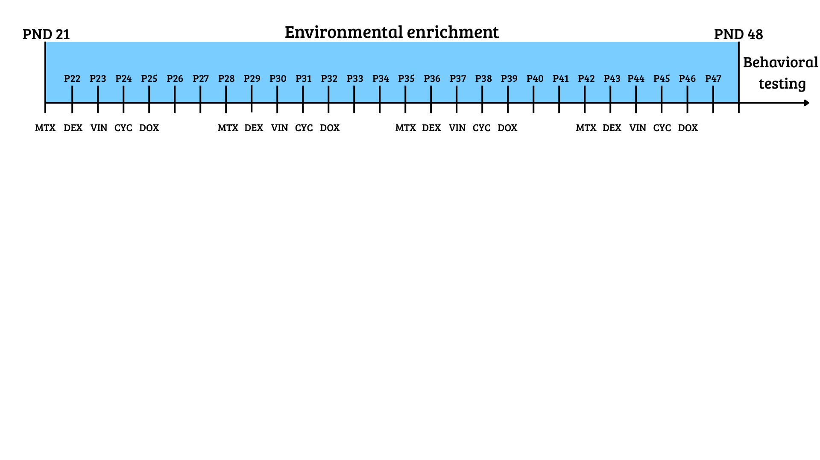Note. The enriched environment phase applied only to mice assigned to enriched housing; all other mice remained in standard housing. MTX = methotrexate, DEX = dexamethasone, VIN = vincristine, CYC = cyclophosphamide, DOX = doxorubicin; PND/P = postnatal day.

- Environment
For the second manipulation, mice were pseudo-randomly assigned to one of two environmental conditions: standard environment or enriched environment. Standard housing consisted of transparent type II cages (320 x 160 x 140 mm) each containing woodchips as bedding and shredded paper for nest-building. The enriched environment consisted of Marlau® cages alongside transparent cages containing woodchips and additional toys. The Marlau® cage is a standardized enrichment system designed to provide continuous cognitive, sensory, and social stimulation and has been shown to enhance cognitive performance and promote neural plasticity. (4, 5). The cage included standard housing features such as shredded paper, as well as additional enrichment elements including hiding boxes, stepladders, mazes, running wheels, and trapdoors (Figure 2A). The maze was located on the second floor, which mice accessed via a stepladder (Figure 2B). To reach their food, mice had to pass the maze, which was changed weekly to prevent habituation and promote learning and problem-solving. This setup required mice to actively interact with their surroundings and engage cognitive processes to obtain food. Because only a limited number of Marlau® cages were available, mice in the enriched-environment condition alternated between two weeks in a Marlau® cage and two weeks in an alternative enriched environment. The alternative enriched environment consisted of a larger transparent cage equipped with additional running wheels, marbles, and hiding boxes. The order in which mice experienced the two enrichment setups was counterbalanced to minimize order effects. However, because the Marlau® cage was expected to provide a stronger enrichment effect than the alternative setup, this design also allowed us to examine potential recency effects reported in the literature.

Figure 2
Environmental enrichment (Marlau® cage) structure.
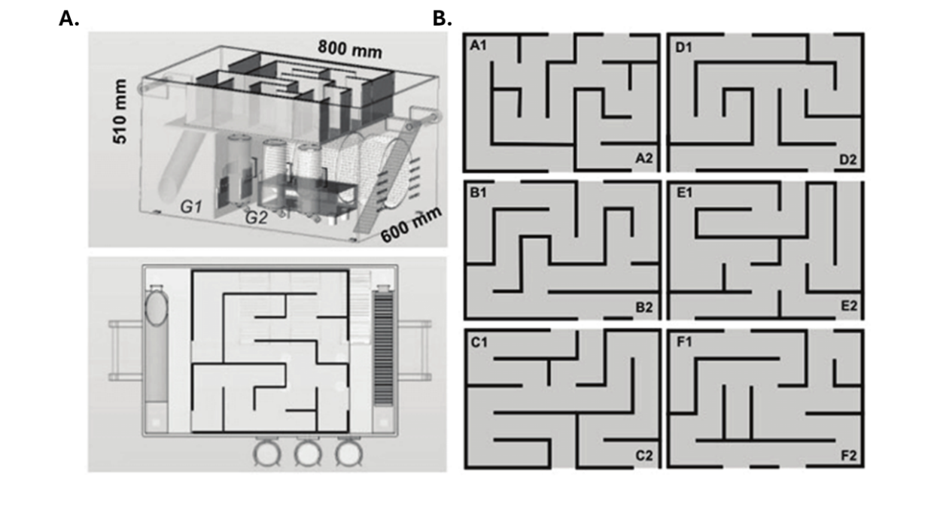
Note. Reprinted from Yolanda et al. (2019) (23). Panel A (top) shows the overall structure of the Marlau cage with both floors visible; Panel A (bottom) shows the top floor containing the maze. Panel B displays the different maze configurations.

Behavioral tests
To evaluate the effect of these manipulations, we administered a cognitive test battery to each mouse, serving as the independent variable. The test battery measures constructs such as memory, cognitive flexibility, anxiety, social interaction, and attention. All mice underwent the tests in the same prespecified order (Figure 3). The sequence was designed so that the most stressful assessments were performed last, minimizing stress-related influences on cognitive outcomes. Below, each test is described in the order in which it was administered.

Figure 3
Timeline of behavioral tests.
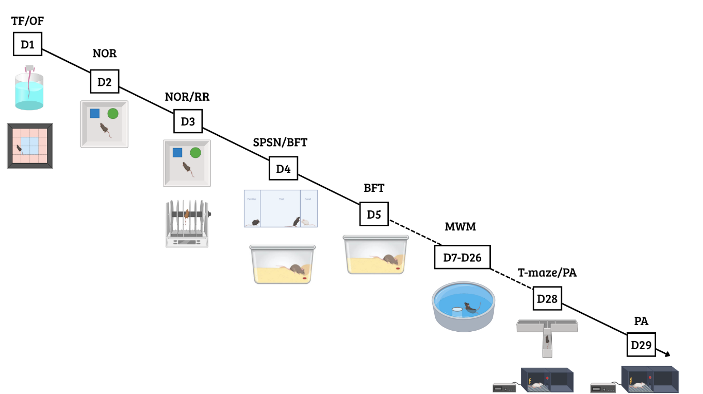
Note. TF = tail flick test; NOR = novel object recognition test; RR = rotarod; SPSN = sociability and preference for social novelty test; BFT = buried food test; MWM = Morris water maze; PA = passive avoidance.

- Open field test
The open field (OF) test is a widely recognized test for assessing locomotion and anxiety-related behavior in mice (6). The apparatus consisted of a brightly illuminated plexiglass arena (50 × 50 × 30 cm) with transparent walls to promote anxiety-inducing behavior (Figure 4).
Figure 4
Layout of the open field test arena.
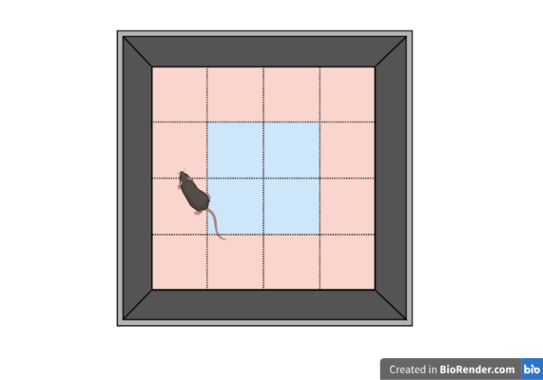
Note. Illustrated above is the setup used for the open field test. The red area represents the periphery, and the blue area represents the central zone.

Prior to testing, all mice were placed in a fully dark cabinet for 30 minutes to facilitate habituation and enhance anxiety-induced behavior even further. Each mouse was then placed in the lower-left corner of the arena and allowed to habituate for 1 minute before beginning a 10-minute trial during which it could freely explore. Locomotor activity was recorded using a Logitech camera and ANY-maze software (Stoelting Co., 2023). The arena was divided into central and peripheral zones. The primary outcome measures were total path length, time spent in the periphery, and time spent in the center. To minimize confounding effects from olfactory cues, the arena was thoroughly cleaned before and after each trial with 50% Ethanol. All animals were tested on the same day and at the same time of day to reduce variability due timing-specific influences.
- Tail flick test
The tail-flick test assesses nociception in mice (7). Mice were restrained by the scruff, after which the distal half of the tail (approximately 3 cm) was immersed in hot water maintained at 50 ± 2 °C. A heater was used to ensure a constant temperature across trials and to minimize temperature-related variability. Latency to withdraw the tail from the water was measured using a stopwatch. A cutoff time of 60 seconds was applied to prevent potential tissue damage. Each animal was tested three times to reduce the influence of outliers due to measurement variability in any single trial.
- Novel object recognition test
The novel object recognition (NOR) test is commonly used to assess recognition memory and learning in rodents (8). The testing arena consisted of a wooden box (40 × 40 × 30 cm) with four designated object locations, one in each corner and positioned approximately 5 cm from the corner. The task was conducted over two days and consisted of three sessions. During the first session (habituation), mice were placed in the empty arena for 10 minutes to familiarize them with the environment and reduce anxiety-related behaviors during subsequent phases (Figure 5A). On the second day, the training and testing phases were performed. In the training phase, two identical novel objects (Falcon tubes filled with ink) were placed in two of the predefined corner locations, always arranged in opposite corners (Figure 5B). Each mouse was allowed 5 minutes to explore the objects. Object locations were randomized across mice to minimize positional bias effects. After training, mice were returned to their home cage for approximately 30 minutes before the testing phase. During the testing phase, one of the familiar objects was replaced with a novel object (a plastic pine tree), and mice were again given 5 minutes to explore (Figure 5C). The positions of the novel and familiar objects were counterbalanced across trials to minimize location-dependent biases. Because mice have an innate tendency to explore novelty (9), this paradigm provides a robust measure of memory. From these sessions, we calculated the novel object preference (NOP), defined as the time spent exploring the novel object divided by the total exploration time for both objects: $NOP=T_{novel}/(T_{novel}+T_{familiar})$. Total exploration time was also recorded as an index of locomotor activity and general exploratory behavior. Animals that spent fewer than 15 seconds exploring during the training phase were excluded, as insufficient engagement prevents meaningful interpretation of performance during the testing phase.

Figure 5.
Novel object recognition test: apparatus design and experimental phases.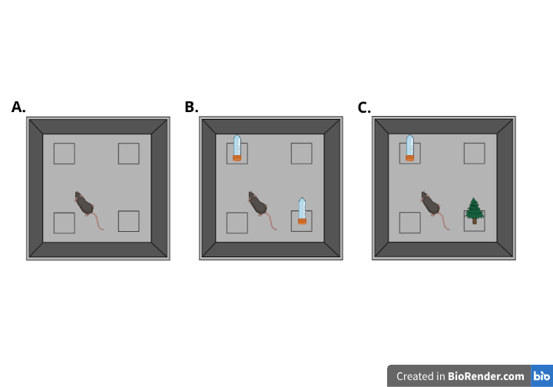
Note. Panel A shows the habituation phase, where mice explore an empty arena. The four marked positions represent possible object locations. Panel B shows the training phase, during which mice are exposed to the familiar object. Panel C illustrates the testing phase, in which a novel object is introduced to assess recognition memory.
- Rotarod
The rotarod task assesses motor coordination and balance by placing mice on a rotating rod (10). The full procedure consists of a training and a testing phase. During training, all mice were placed on a slowly rotating rod (5rpm) for 2 min to familiarize them with the apparatus. Afterward, they were given a 3 min rest period to minimize carry-over effects between successive phases. In the testing phase, mice were placed on an accelerating rod (5-40rpm) for a maximum of 5 min. Each mouse completed four trials to improve the signal-to-noise ratio, and a rest period of at least five minutes was provided between trials for the same reason described above. Latency to fall was the dependent variable of interest, with a maximum cutoff of 300 seconds (5 min) for mice that did not fall. Five mice could be tested in parallel and the apparatus was cleaned between each test.
- Sociability and preference for social novelty test (SPSN)
We used the sociability and preference for social novelty (SPSN) test to provide a measure of general social behavior and social (11). The setup consists of a plexiglass arena with three compartments. The middle compartment (40 x 10 cm) contained the test mouse and was connected to two smaller side compartments (10x 10 cm) through walls with small openings (8mm holes), each of which could hold an unfamiliar mouse. The arena was illuminated just enough to allow reliable tracking of the test mouse behavior while remaining dim enough to minimize anxiety. The test consisted of three consecutive phases. First, the test mouse was placed in the middle compartment and given five minutes to habituate to the environment. Next, a stranger mouse was introduced into one of the two possible side chambers, and the test mouse was given ten minutes to explore (Figure 6A). Time spent interacting with this stranger mouse served as a measure of general sociability. After the first exploration phase, a second stranger mouse was placed in the opposite side compartment (Figure 6B). The test mouse was again given 10 minutes to explore its environment freely. Following the same rationale described for the novel object recognition task regarding novelty preference (see Novel Object Recognition), time spent near the newly introduced stranger mouse was used as an indicator of social memory. Both stranger mice were of the same sex and were completely unfamiliar to the test mouse. All behavior was recorded using a Logitech webcam and ANY-maze software (Stoelting Co., 2023). To minimize confounding factors, all mice were tested on the same day, and the apparatus was thoroughly cleaned between sessions to eliminate timing-related effects and residual odors.
Figure 6
Sociability and preference for social novelty test
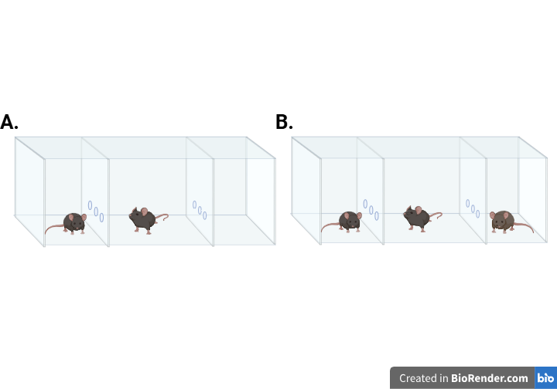
Note. Panel A illustrates the first phase of the SPSN test, during which the mouse is allowed to explore a single stranger mouse. Panel B depicts the second phase, where a novel stranger mouse is introduced into the opposite chamber.
- Buried food-seeking test
Many patients receiving chemotherapy report alterations in smell and taste (24). Because food odors are essential for survival in mice, the Buried food-seeking test (BFT) allowed us to model these sensory alterations in mice (12). Specifically, the test measures the ability to detect and recognize these odors. Before testing, mice were food-deprived for 24 h to enhance their motivation to locate the buried food. On the test day, each mouse was placed in a clean Type III macrolon cage containing 3 cm of bedding, with a piece of almond hidden at a random location. The almond (5mm) was buried 1 cm beneath the surface and fully covered with bedding to eliminate any visual cues. Mice were given 15 min to locate the buried food. The primary outcome measure was the latency to find the food. Animals that failed to locate the food within the allotted time were assigned a maximum latency of 900 seconds. After each trial, cages were cleaned and fresh bedding was added to minimize residual odor cues from previous mice.
-----------
- Morris Water Maze
The Morris water maze (MWM) was first developed by Richard G. Morris in the early 1980s (13). Since then, it has become a widely used behavioral paradigm for assessing hippocampus-dependent spatial learning and memory (14, 15, 16). The setup consisted of a circular pool filled with water maintained at 26 ± 1 °C and mixed with an opacifier (Acusol Op 301, Dow Chemicals) to enhance tracking of dark-coated mice. Water temperature was measured daily to ensure stability, as deviations toward colder or warmer temperatures can impair both learning and locomotion. The pool was divided into four virtual quadrants, which served as the starting positions during the experiment (Figure 7A). One of these quadrants was designated as the target quadrant and contained a hidden escape platform that mice were required to locate to exit the water. Because the water was rendered opaque, the platform was minimally visible, increasing reliance on learned spatial cues rather than direct visual detection and thereby promoting learning. The quadrant directly opposite the original target quadrant was designated as the reversal target quadrant and was used in later stages of the protocol to assess reversal learning.
The full Morris water maze protocol lasted three weeks and consisted of an acquisition phase, probe trials, a reversal acquisition phase, and a reversal probe trial. The protocol began with the acquisition phase, during which the platform was placed in the original target quadrant. For a total of ten training days, mice learned to locate the escape platform using distal spatial cues. Each day, all mice performed four swim trials from four different starting positions, with up to 100 seconds available to locate the platform. Mice that failed to locate the platform within this time were guided to it by the experimenter and allowed to remain there for 15–20 seconds to facilitate learning of spatial cues. Starting positions were determined by a randomized daily sequence, with each sequence used only once. On the sixth and eleventh day, probe trials were conducted. For each of these trials, the platform was removed and each mouse completed a single swim starting from the quadrant opposite the original target quadrant. Mice were allowed to swim freely for 100 seconds, and the time spent in the original target quadrant was recorded as an index of spatial reference memory. On the same day as the final probe trial, the reversal acquisition phase began. This phase followed the same procedure as the initial acquisition, except that the platform was relocated to the opposite target quadrant. Reversal acquisition lasted five days, during which mice again completed four daily swim trials with a maximum duration of 100 seconds to locate the platform. On the sixteenth day, a reversal probe trial was conducted in which the platform was removed from the reversal target quadrant, and mice were allowed to swim freely for 100 seconds. Total path length, distance until the platform was reached, and time spent in the target quadrant during probe trials were quantified as measures of spatial and reversal learning. All behavior was recorded using an overhead Basler camera and Ethovision tracking software.
Figure 7
Experimental setups for the Morris water maze and T-maze
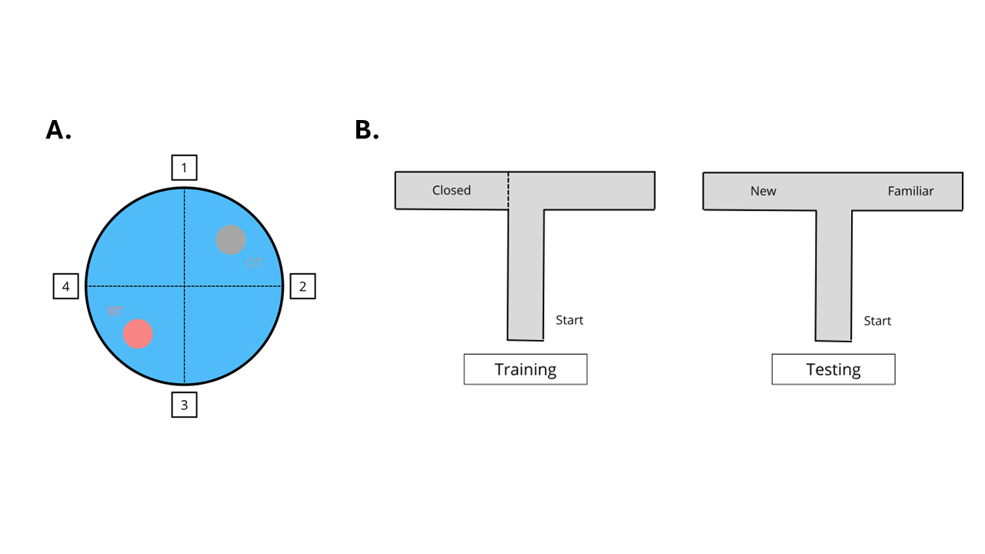
Note. (A) Top view of the water maze. OT = original target platform; RT = reversal target platform. The numbers represent possible starting positions. (B) Training and testing phases of the T-maze task. The “Start” point marks the mouse’s initial position at the beginning of each trial.

- Elevated T-maze
Because mice naturally explore novel environments to scavenge, the elevated T-maze was used to assess spatial working memory (17). The setup consisted of an elevated T-shaped arena. The two shorter lateral arms, hereafter referred to as the goal arms, extend symmetrically from the central starting arm (5 x 30 cm), which is a longer segment oriented perpendicular to them (5x 40cm). The procedure consisted of two phases: a training phase and a testing phase. During the training phase, one of the two goal arms was closed off, with the choice determined by a predetermined randomized order (Figure 7B left). Each mouse was given 5 min to explore the starting arm and the single open goal arm. After training, mice were returned to their home cage for 5 min while the apparatus was thoroughly cleaned with 50% ethanol. For the testing phase, mice were again placed in the starting arm, but now both goal arms were open (Figure 7B right). Mice were given another 5 min to explore their environment freely. Novel arm preference (NAP) was calculated as an index of spatial working memory ($NAP=T_{novel}/(T_{novel}+T_{familiar})$. Total path length was recorded as a measure of general locomotion. The apparatus was illuminated sufficiently to ensure reliable tracking while minimizing anxiety, and it was thoroughly cleaned after each mouse to reduce the influence of residual odors.
- Passive avoidance test
The passive avoidance test is commonly used as a fear-conditioning paradigm to assess associative learning and contextual memory (18). Unlike active avoidance tasks, it does not employ an explicit cue. Instead, the context itself serves as the conditional stimulus and becomes associated with an aversive event, such as a foot shock. The experiment used a passive avoidance apparatus with two compartments: a brightly lit compartment and a dark compartment connected by a trap door. Mice always started in the illuminated compartment, which induces mild anxiety and creates an incentive to enter the darker compartment. Each mouse was placed in the bright compartment with the trap door closed and allowed to explore for 5 seconds, after which the door opened. When the mouse entered the dark compartment, the door closed and four mild foot shocks were delivered through the grid floor (0.3 mA, 2 seconds each). The procedure was repeated 24 hours later, but no shock was administered during the second session. If a mouse did not enter the dark compartment within 300 seconds, the trial was terminated and a maximum latency of 300 seconds was recorded. Latency to enter the dark compartment was measured on both days as the primary outcome.

Data Analysis
All statistical analyses were conducted in R (version 4.4.3; R Core Team, 2025). Analyses were first performed within a frequentist framework, and the specific tests were chosen based on the data structure and experimental design. Two‑way ANOVAs were fitted to assess the effects of treatment, environment, and their interaction on each outcome variable. When measurements were repeated within subjects, repeated‑measures ANOVAs were used to account for within‑subject dependency. In cases where the data exhibited hierarchical or interdependent structure, models were fitted using multilevel (mixed‑effects) approaches to appropriately account for this dependency (19). Models were fitted using either base R (aov) for standard ANOVA designs or lme4 for mixed-effects models. Post hoc pairwise comparisons were conducted using estimated marginal means (emmeans), with t-tests used for contrasts. A significance threshold of p < .05 was applied. Inferential results are reported with the test statistic, p‑value, and effect size. Post hoc contrasts are reported as estimated mean differences, standard errors, and p-values. When applicable, Tukey’s HSD was used to adjust these p-values for pairwise comparisons.
All models were additionally fitted in a Bayesian framework, and Bayes factors were computed for each effect by testing whether the corresponding parameter differed from zero. A Bayes factor quantifies the relative evidence for two competing hypotheses as the ratio of the marginal likelihoods of the data under each model. Here we compute the Savage–Dickey Bayes factor for a single parameter, which is defined as the ratio of the prior density at zero to the posterior density at zero:
$${BF}_{01}=\frac{p\left(θ=0 \right| prior)}{p\left(θ=0 \right| posterior)}$$
Bayesian hypothesis testing is included because, unlike frequentist p-values, Bayes factors can distinguish between evidence supporting the null hypothesis and evidence that is inconclusive (20). Bayesian models were written and fitted in Stan (Stan Development Team, 2024) using cmdstanr, which performs Markov chain Monte Carlo sampling. All variables were normalized before fitting the Bayesian models. For each effect, we report the Bayes factor and the 90% highest-density interval (HDI) for the estimate. Values greater than 1 indicate evidence in favor of the alternative hypothesis, whereas values less than 1 indicate evidence in favor of the null. We interpreted Bayes factors according to the guidelines of Wagenmakers et al. (2018) (21), which are adapted from the original scale created by Jeffrey (1961) (22). Details of the priors employed in the testing procedure are provided in the Appendix, which also includes the parameter-recovery analyses for all models.

Results
- Open field test
Total path length was used as a measure of general exploration and locomotor activity (fig). To assess the effects of treatment, environment, and their interaction on locomotor activity, we conducted a two-way ANOVA. There was a robust main effect of environment, with mice housed in enriched conditions showing higher locomotor activity than those in poor environments (F(1, 30) = 16.18, p < .001, η² = 0.35). We also observed a significant main effect of treatment (F(1, 30) = 6.86, p = 0.014, η² = 0.19), indicating overall differences between saline- and CVAD-treated mice. The interaction between treatment and environment was not significant (F(1, 30) = 0.63, p = 0.43, η² = 0.02). Consequent Bayesian analysis added interpretive clarity by showing that the data provided only anecdotal evidence for no interaction (${BF}_{01}$= 0.59, ${HDI}_{90\%}$=[-0.53;1.09]) showing that more data is needed to draw conclusions. To further examine these effects, we conducted post hoc pairwise contrasts. First, we compared saline and CVAD within the poor environment. Mice treated with saline showed higher locomotor activity than those treated with CVAD, although this effect was only marginally non-significant (Δ = 12.59, SE = 4.75, p = 0.06). Bayesian follow-up analysis provided strong evidence for this effect, likely masked in the frequentist results by Tukey’s correction (${BF}_{01}$= 10.70, ${HDI}_{90\%}$=[-1.64;-0.36]). The same comparison conditioned on the enriched environment did not reach significance (Δ = 7.59, SE = 3.97, p = 0.24). However, the Bayesian analysis showed anecdotal evidence for the effect (${BF}_{01}$= 1.34, ${HDI}_{90\%}$=[-1.32;-0.12]). Next, we compared the two environments within each treatment group. Enriched housing increased locomotor activity relative to poor housing for both saline-treated mice (Δ = −9.98, SE = 3.43, p = 0.03) and CVAD-treated mice (Δ = −14.88, SE = 5.15, p = 0.03). Notably, the effect of enrichment appeared larger in the CVAD group, suggesting a potential protective role of environmental enrichment. Finally, we found that locomotor performance in the saline PE and CVAD EE groups was statistically indistinguishable (Δ = −2.29, SE = 3.91, p = 0.94), further strengthening the argument of a protective role of EE on locomotion. The Bayesian analysis similarly offered moderate evidence for the null (${BF}_{01}$= 0.14, ${HDI}_{90\%}$=[-0.41;0.80]).
Thigmotaxis and exploration were quantified as time spent in the periphery and center, respectively. A two-way ANOVA revealed no main effect of environment in both peripheral (F(1, 30) = 2.94 , p = 0.10, η² = 0.09), and central time (F(1, 30) = 0.44 , p = .51, η² = .01). However, the Bayesian analysis provided moderate moderate evidence for an environment effect on peripheral time (${BF}_{01}$= .71, ${HDI}_{90\%}$=[-1.22;-0.21]), but only anecdotal evidence for the absence of an effect on central time (${BF}_{01}$= .54, ${HDI}_{90\%}$=[-0.18;-0.93]). This pattern could suggest that with a larger sample, the environment effect on peripheral time might have reached significance, whereas for central time the effect is likely genuinely absent. However, more data is needed to draw conclusions. Similarly, the main effect of treatment did not reach significance for either peripheral (F(1, 30) = 1.40, p = .25, η² = .04) or central time (F(1, 30) = 1.25, p = .27, η² = .04). Consistent with this, the Bayesian analysis indicated anecdotal evidence for the absence of a treatment effect in both peripheral time (${BF}_{01}$= 0.68, ${HDI}_{90\%}$=[0.09;0.95]), and central time (${BF}_{01}$= 0.53, ${HDI}_{90\%}$=[-0.94;0.18]). Notably, the interaction effect was significant for both periphery (F(1, 30) = 10.10, p =.003, η² = .25) and center time (F(1, 30) = 5.10, p =.03, η² = .15). The interaction indicated that the PE–EE contrast was stronger in CVAD mice, with a greater reduction in periphery time and a greater increase in center time than observed in saline controls (fig).
Post hoc comparisons were conducted to further clarify the effects. First we compared treatment conditional on environment. Within PE, the treatment comparison was significant for peripheral time (Δ = −84.25, SE = 25.1, p = 0.01), but not for central time (Δ = 19.26, SE = 7.69, p = 0.08). Bayesian analysis provided only anecdotal evidence for a group difference (${BF}_{01}$= 2.41, ${HDI}_{90\%}$=[-1.55;-0.07]), suggesting that a true effect may exist but remained undetected in this dataset. In contrast, the same comparison within EE did not reach significance for either peripheral time (Δ = 19.95, SE = 21, p = 0.78) or central time (Δ = -3.41, SE = 6.44, p = 0.95). Bayesian analyses supported these null findings, providing moderate evidence for no treatment effect in both peripheral time $({BF}_{01}$= 0.22, ${HDI}_{90\%}$=[-0.84;0.48]) and central time $({BF}_{01}$= 0.22, ${HDI}_{90\%}$=[-0.67;0.76]). Next, we compared environments within each treatment group. For saline-treated mice, no differences were observed between PE and EE in either peripheral time (Δ = −6.07, SE = 18.2, p = 0.99) or central time (Δ = 3.90, SE = 5.56, p = 0.90). Bayesian analyses supported this interpretation, showing moderate evidence for the null in peripheral time $({BF}_{01}$= 0.33, ${HDI}_{90\%}$=[-0.65;0.42]) and anecdotal evidence for the null in central time $({BF}_{01}$= 0.35, ${HDI}_{90\%}$=[-0.63;0.51]). For CVAD-treated mice, the environment comparison revealed a significant difference in peripheral time (Δ = 98.13, SE = 27.3, p = 0.006), but not in central time (Δ = 18.76, SE = 8.35, p = 0.13). However, the Bayesian analysis did not provide meaningful evidence for either hypothesis $({BF}_{01}$= 0.92, ${HDI}_{90\%}$=[-0.05;1.65]), making this effect difficult to interpret. Finally, we compared SAL-PE mice with CVAD-EE mice. No significant differences were found for peripheral time (Δ = 13.88, SE = 20.7, p = 0.91) or central time (Δ = -3.41, SE = 6.44, p = 0.95). Bayesian analyses supported the absence of differences, providing moderate evidence for the null in peripheral time $({BF}_{01}$= 0.18, ${HDI}_{90\%}$= [-0.96;0.41]) and in central time (${BF}_{01}$= 0.14, ${HDI}_{90\%}$= [-0.05;1.65]).
Taken together, the analysis showed a clear negative effect of chemotherapy and a clear positive effect of EE on locomotion and exploration. However, EE did not appear to protect against chemotherapy-induced deficits in CVAD animals, although Bayesian analyses indicate that evidence is inconclusive and should be interpreted cautiously. We also found no overall effect of chemotherapy or environment on anxiety-like behavior, but EE showed a protective effect in CVAD animals based on the interaction and post hoc tests. Again, Bayesian results advise caution on the latter. Overall, EE appears to mitigate chemotherapy-related increases in anxiety.

- Tail flick test
Table 2
Post-hoc Comparisons of Tail-Flick Latencies (Frequentist and Bayesian Estimates)
 | Frequentist |  |  | Bayesian
Differences | Δ | SE | p | $${BF}_{01}$$ | $${HDI}_{90\%}$$
SAL PE – CVAD PE | -2.14 | 2.88 | 0.88 | 0.59 | [-0.44;1.07]
SAL EE – CVAD EE | -1.06 | 2.41 | 0.97 | 0.24 | [-0.52;0.95]
SAL PE – SAL EE | 2.43 | 2.08 | 0.65 | 0.83 | [-1.04;0.16]
CVAD PE – CVAD EE | 3.51 | 3.12 | 0.68 | 0.46 | [-1.40;0.29]
SAL PE – CVAD EE | 1.37 | 2.37 | 0.94 | 0.18 | [-1.00;0.52]

Average latency to remove the tail from the water was measured to assess nociception (fig). A two-way ANOVA was then performed on these averages to examine the effects of treatment, environment, and their interaction. Analysis revealed that neither the treatment (F(1, 30) = 0.34, p = 0.56, η² = 0.01) nor the environment effect (F(1, 30) = 2.55 , p = 0.12, η² = 0.08) reached significance. The interaction between treatment and environment was also non-significant (F(1, 30) = 0.08 , p = 0.77, η² = 0.003). Bayesian analyses provided anecdotal evidence in favor of the null hypothesis for treatment (${BF}_{01}$= 0.37, ${HDI}_{90\%}$= [-0.32;0.84]), environment(${BF}_{01}$= 0.84, ${HDI}_{90\%}$= [-1.07;0.07]), and their interaction (${BF}_{01}$= 0.60, ${HDI}_{90\%}$= [-1.03;0.80]) effects, suggesting that the absence of detectable effects is more likely, although these conclusions should be interpreted with caution. Post-hoc comparisons were conducted to further explore these effects. However, none of the contrasts reached significance and Bayesian estimates all provided anecdotal to moderate evidence for the differences being zero (Table 2). It is important to note that measurement error related to handling procedures may have influenced these outcomes.
- Novel object recognition test

Appendix

References (still need to check for mistakes!!)
- Kantarjian, H. M., O’Brien, S., Smith, T. L., Cortes, J., Giles, F. J., Beran, M., Pierce, S., Huh, Y., Andreeff, M., Koller, C., Ha, C. S., Keating, M. J., Murphy, S., & Freireich, E. J. (2000). Results of treatment with Hyper-CVAD, a Dose-Intensive regimen, in adult acute lymphocytic leukemia. Journal of Clinical Oncology, 18(3), 547. https://doi.org/10.1200/jco.2000.18.3.547 (hyper-CVAD in adults)
- Siegel, S. E., Advani, A., Seibel, N., Muffly, L., Stock, W., Luger, S., Shah, B., DeAngelo, D. J., Freyer, D. R., Douer, D., Johnson, R. H., Hayes‐Lattin, B., Lewis, M., Jaboin, J. J., Coccia, P. F., & Bleyer, A. (2018). Treatment of young adults with Philadelphia‐negative acute lymphoblastic leukemia and lymphoblastic lymphoma: Hyper‐CVAD vs. pediatric‐inspired regimens. American Journal of Hematology, 93(10), 1254–1266. https://doi.org/10.1002/ajh.25229 (hyper-CVAD in YA)
- Gültekin, Z., D’Hooge, R., & Callaerts-Végh, Z. (2023). A new juvenile mouse model of early childhood chemotherapy [Master’s thesis, KU Leuven]. https://repository-teneo-libis-be.kuleuven.e-bronnen.be/delivery/DeliveryManagerServlet?dps_pid=IE17918495 (thesis CVAD)
- Fares, R. P., Belmeguenai, A., Sanchez, P. E., Kouchi, H. Y., Bodennec, J., Morales, A., Georges, B., Bonnet, C., Bouvard, S., Sloviter, R. S., & Bezin, L. (2013). Standardized Environmental Enrichment Supports Enhanced Brain Plasticity in Healthy Rats and Prevents Cognitive Impairment in Epileptic Rats. PLoS ONE, 8(1), e53888. https://doi.org/10.1371/journal.pone.0053888
- Khalil, M. H. (2024). Environmental enrichment: a systematic review on the effect of a changing spatial complexity on hippocampal neurogenesis and plasticity in rodents, with considerations for translation to urban and built environments for humans. Frontiers in Neuroscience, 18, 1368411. https://doi.org/10.3389/fnins.2024.1368411
- Çevik, Ö. S., Yıldırım, D. D., Uzun, C., & Horata, E. (2025). Contribution of distinctive outcome measures to the assessment of anxiety in the open field: A meta-analysis of factors mediating open-field test variability in rodent models of anxiety. Behavioural Brain Research, 490, 115612. https://doi.org/10.1016/j.bbr.2025.115612
- Leo, S., Straetemans, R., Dhooge, R., & Meert, T. (2008). Differences in nociceptive behavioral performance between C57BL/6J, 129S6/SvEv, B6 129 F1 and NMRI mice. Behavioural Brain Research, 190(2), 233–242. https://doi.org/10.1016/j.bbr.2008.03.001
- Lueptow, L. M. (2017). Novel Object Recognition Test for the Investigation of Learning and Memory in Mice. Journal Of Visualized Experiments, 126, 55718. https://doi.org/10.3791/55718
- Berlyne, D. (1950). Novelty and curiosity as determinants of exploratory behavior. British Journal of Psychology. General Section, 41(1-2), 68–80.
- Deacon, R. M. (2013). Measuring motor coordination in mice. Journal Of Visualized Experiments, 75, 2609. https://doi.org/10.3791/2609

- Nadler, J. J., Moy, S. S., Dold, G., Trang, D., Simmons, N., Perez, A., Young, N. B., Barbaro, R. P., Piven, J., Magnuson, T. R., & Crawley, J. N. (2004). Automated apparatus for quantitation of social approach behaviors in mice. Genes Brain & Behavior, 3(5), 303–314. https://doi.org/10.1111/j.1601-183x.2004.00071.x

- Machado, C., Reis-Silva, T., Lyra, C., Felicio, L., & Malnic, B. (2018). Buried Food-seeking Test for the Assessment of Olfactory Detection in Mice. BIO-PROTOCOL, 8(12), e2897. https://doi.org/10.21769/bioprotoc.2897

- Morris, R. G. (1981). Spatial localization does not require the presence of local cues. Learning And Motivation, 12(2), 239–260. https://doi.org/10.1016/0023-9690(81)90020-5

- Redish, A. D., & Touretzky, D. S. (1998). The Role of the Hippocampus in Solving the Morris Water Maze. Neural Computation, 10(1), 73–111. https://doi.org/10.1162/089976698300017908

- Othman, M. Z., Hassan, Z., & Has, A. T. C. (2022). Morris water maze: a versatile and pertinent tool for assessing spatial learning and memory. EXPERIMENTAL ANIMALS, 71(3), 264–280. https://doi.org/10.1538/expanim.21-0120

- Florian, C., & Roullet, P. (2004). Hippocampal CA3-region is crucial for acquisition and memory consolidation in Morris water maze task in mice. Behavioural Brain Research, 154(2), 365–374. https://doi.org/10.1016/j.bbr.2004.03.003

- D’Isa, R., Comi, G., & Leocani, L. (2021). Apparatus design and behavioural testing protocol for the evaluation of spatial working memory in mice through the spontaneous alternation T-maze. Scientific Reports, 11(1), 21177. https://doi.org/10.1038/s41598-021-00402-7

- Ögren, S. O., & Stiedl O. (2015). Passive avoidance. In I. P. Stolerman & L. H. Price (Eds.), Encyclopedia of Psychopharmacology (2nd ed., pp. 1220–1228). Springer. https://doi.org/10.1007/978-3-642-36172-2

- Osborne, J. W. (2000). Advantages of hierarchical linear modeling. Practical Assessment, Research & Evaluation, 7(1), 1. https://doi.org/10.7275/pmgn-zx89

- Schmalz, X., Manresa, J. B., & Zhang, L. (2021). What is a Bayes factor? Psychological Methods, 28(3), 705–718. https://doi.org/10.1037/met0000421

- Wagenmakers, E., Love, J., Marsman, M., Jamil, T., Ly, A., Verhagen, J., Selker, R., Gronau, Q. F., Dropmann, D., Boutin, B., Meerhoff, F., Knight, P., Raj, A., Van Kesteren, E., Van Doorn, J., Šmíra, M., Epskamp, S., Etz, A., Matzke, D., . . . Morey, R. D. (2017). Bayesian inference for psychology. Part II: Example applications with JASP. Psychonomic Bulletin & Review, 25(1), 58–76. https://doi.org/10.3758/s13423-017-1323-7

- Jeffreys, H. (1961). Theory of probability (3rd ed.). Oxford University Press.
- Yolanda, S., Redjeki, S., Andraini, T., Santoso, D. I. S., Ibrahim, N., & Mailani, R. (2019). Combination of Aerobic Exercise and Continuous Environmental Enrichment Improves Adult Male Rats’ Spatial Memory: Study on Hippocampal Insulin Like Growth Factor 1 (IGF-1) and Fibroblast Growth Factor 2 (FGF-2) Expression. The Indonesian Biomedical Journal, 11(2), 210–216. https://doi.org/10.18585/inabj.v11i2.731

- Amézaga, J., Alfaro, B., Ríos, Y. et al. Assessing taste and smell alterations in cancer patients undergoing chemotherapy according to treatment. Support Care Cancer 26, 4077–4086 (2018). https://doi.org/10.1007/s00520-018-4277-z

