KU LEUVEN

FACULTEIT PSYCHOLOGIE EN
PEDAGOGISCHE WETENSCHAPPEN

Environmental Enrichment Mitigates Chemotherapy-Induced Neurocognitive and Affective Impairment

Masterproef aangeboden tot het verkrijgen van de graad van Master of Science in de psychologie door
Siebe Everaerts

promotor: Dr. Zsuzsanna Callaerts-Végh
m.m.v.: Congcong Gao

2025-2026



Copyright informatie:
studiewerk van een student in het kader van de academische opleiding en examenbeoordeling.
Na deze beoordeling vond geen correctie plaats
van het studiewerk.

KU LEUVEN

FACULTEIT PSYCHOLOGIE EN
PEDAGOGISCHE WETENSCHAPPEN

Environmental Enrichment Mitigates Chemotherapy-Induced Neurocognitive and Affective Impairment

Masterproef aangeboden tot het verkrijgen van de graad van Master of Science in de psychologie door
Siebe Everaerts

promotor: Dr. Zsuzsanna Callaerts-Végh
m.m.v.: Congcong Gao

2025-2026
Summary
Chemotherapy-induced cognitive impairment is a common side effect in paediatric oncology, with adverse consequences for post-treatment academic achievement, social functioning, and everyday life. Yet, effective interventions to prevent or alleviate these difficulties remain scarce. Environmental enrichment, which integrates social, cognitive, physical, and sensory stimulation, has shown encouraging neurocognitive benefits in experimental models. Nevertheless, studies assessing a totally comprehensive enrichment in chemotherapy-treated children are currently absent.
To address this gap, we turned to a preclinical model to examine whether a comprehensive environmental enrichment protocol could mitigate chemotherapy-induced neurocognitive impairments in juvenile mice. The mice were separated from their mother at 21 days old and were given either a four-week hyper-CVAD chemotherapy treatment or a saline control. This approach allowed us to model children who survive acute lymphoblastic leukaemia after receiving intensive chemotherapy. Throughout the treatment period, animals were housed in either a comprehensive environmental enrichment condition integrating social, cognitive, physical, and sensory stimulation, or in an enrichment-poor environment reflecting standard housing. After the four-week treatment and housing protocol, mice completed a multidomain behavioural test battery assessing physical and sensorimotor abilities, social and affective functioning, and neurocognitive performance. The cognitive tasks primarily targeted spatial learning and memory, cognitive flexibility, recognition memory, and fear-based learning. This ensemble allowed for a broad assessment of chemotherapy-related neurocognitive outcomes. The total design enabled us to evaluate whether enrichment offered broad or domain-specific protection across physical, affective, and neurocognitive outcomes.
We found no evidence that environmental enrichment protected physical or sensorimotor functioning after chemotherapy, whereas limited evidence emerged for benefits in specific cognitive domains. In contrast, we observed a clear protective effect of environmental enrichment on affective functioning deficits following chemotherapy. Future work should focus on translating a comprehensive environmental enrichment approach to childhood cancer survivors to determine whether similar benefits can be achieved in these domains. Another key step is to examine why enrichment is effective in some domains but not in others, and why the findings are sometimes inconsistent.

Preface
Before anything else, I would like to express my sincere gratitude to everyone who supported me throughout this journey. I am deeply thankful to the entire Laboratory of Biological Psychology at KU Leuven. From the very beginning, you made me feel welcome and offered me my first real connection to a scientific community. You are an exceptional group of bright, generous people, and I feel genuinely fortunate to have ended up in this lab. I want to give a special thanks to Zsuzsanna, whose guidance throughout this thesis has been invaluable. Working with you has been truly inspiring; your scientific insight, clarity of thought, and depth of knowledge consistently amazed me. If, at your career stage, I can express even a fraction of your expertise and passion for my field, I would consider myself a proud scientist. My heartfelt thanks also go to Congcong, my thesis mentor. Your door was always open, whether I needed help, advice, or simply someone to talk to. In that sense, I am truly glad to have had you as a mentor throughout this process, and I am equally glad to have you as a friend within the academic world. Thank you for the assistance, the conversations, and the laughs we shared. I will cherish all of them. Finally, I would like to thank Jesper F. Ehmsen, a research assistant I met during my internship at Aarhus University. Thank you for helping me discover my passion and for being, as we like to call it, my statistical modelling sparring partner.
On a more personal note, I would like to thank my friends: Bryan, Luca, Hannes, Roald, Rauls, Roberts, and Thomas. I have known all of you since we were little boys, and over the years we have grown into much more than just friends. Thank you for listening to me complain about long lab hours and the stress of writing my thesis. I would not be where I am today without all of you. Last but not least, I would like to thank my family: my parents and my brother. Saying “thank you” does not come close to expressing the depth of my gratitude. I know how much you have sacrificed for me to be where I am today. There is not a single day when I am not thinking about making you proud. I know you would be proud of me regardless, but I hope this thesis and the effort behind it show that I have never forgotten the time, love, and dedication you invested in me. Thank you for everything. I love you more than words can say.
The last five years at KU Leuven have been an incredible journey. I have grown from a boy with no clear direction into a man with a passion for science and the ambition to pursue a PhD. Although the path was not always easy, I would not rewrite any part of it. This thesis feels like a fitting endpoint to that journey, shaped to reflect both my interests and who I have become. It is often said that “science is built on the shoulders of giants”, and while I do not consider myself one of them, I still hope this work sparks curiosity, interest, and inspiration in others.
A sincere thank you to everyone who is taking the time to read this!
Siebe Everaerts
Contribution
During the start of my thesis, the overarching research question had already been largely defined, so my contribution to that initial conceptualisation was limited. However, from the start of the experimental preparation onward, I carried out the majority of the practical work myself. Apart from a few days when I was sick, I was responsible for the full day-to-day workflow. During the first days, Zsuzsanna and Congcong trained me in animal handling and injection procedures. Once trained, I independently carried out all these routine tasks, such as preparing and maintaining the environmental enrichment, cleaning, feeding, and administering daily injections. During the behavioural testing phase, I performed nearly all procedures myself. I occasionally received help from Congcong and An-Sofie, a fellow student working on a related project (we supported each other during periods of high workload). The perfusions and tissue collection were performed together with Congcong and Zsuzsanna, partly out of personal interest, as these procedures were not part of the formal scope of my thesis.
All data cleaning, analysis, and programming were conducted independently by me. Zsuzsanna briefly pointed me in the right direction by indicating the general analytical approaches typically used for this type of data. From that point onward, I independently designed (sometimes tweaked), implemented, and carried out the full analysis myself. The reporting of results and the full writing process were also carried out by me, again with guidance and supervision rather than hands-on contributions. While I received valuable direction and feedback, the literature search, figure creation, and all written sections were produced by me. Overall, I completed the experimental, analytical, and writing work myself, with supervision and guidance where necessary.
Table of Contents
List of Tables 10
List of Figures 11
Introduction 13
1. Chemobrain: Definition, Mechanisms, and Potential Interventions 13
2. Paediatric Cancer and Treatments 14
3. Rodent Models of Hyper-CVAD and Environmental Enrichment 16
3.1. Cyclophosphamide 16
3.2. Vincristine 16
3.3. Doxorubicin 17
3.4. Dexamethasone 17
3.5. Methotrexate 18
3.6. Environmental Enrichment 18
4. Objective/Aim 19
Methods and Design 21
1. Research Animals 21
2. Experimental Manipulations 22
2.1. Treatment 22
2.2. Environment 22
3. Behavioural Tests 23
3.1. Open field test 24
3.2. Tail flick test 25
3.3. Novel object recognition test 25
3.4. Rotarod 26
3.5. Sociability and preference for social novelty test (SPSN) 27
3.6. Buried food-seeking test 28
3.7. Morris water maze 28
3.8. Elevated T-maze 29
3.9. Passive avoidance test 30
4. Data Analysis 30
Results 32
1. Open field 32
2. Tail flick test 34
3. Novel object recognition test 35
4. Rotarod 36
5. Sociability and preference for social novelty test (SPSN) 36
6. Buried food-seeking test 39
7. Morris water maze 39
7.1. Learning during the acquisition phase 39
7.2. Reversal learning during the reversal acquisition phase 42
8. Elevated T-maze 44
9. Passive avoidance 46
Discussion & Limitations 48
1. Physical and sensorimotor function 48
2. Social and affective function 49
3. Cognitive function 50
4. General limitations 51
Conclusion & Future Directions 53
References 54

List of Tables
Table 1 21
Distribution of mice across treatment, environment, and sex.
Table 2 42
Bayesian results from the analysis of the reversal acquisition phase.

List of Figures
Figure 1 21
Timeline of drug injections during the housing period.
Figure 2 22
Environmental enrichment (Marlau® cage) structure.
Figure 3 23
Timeline of behavioural tests.
Figure 4 24
Layout of the open field test arena.
Figure 5 25
Novel object recognition test: apparatus design and experimental phases.
Figure 6 26
Sociability and preference for social novelty test.
Figure 7 28
Experimental setups for the Morris water maze and T-maze.
Figure 8 31
Behavioural measures from the open field test.
Figure 9 33
Results from the tail flick and Rotarod test.
Figure 10 34
Novel object recognition test results.
Figure 11 36
Total path length results from the SPSN test.
Figure 12 37
Sociability and social memory results from the SPSN.
Figure 13 38
Buried food -seeking test results.
Figure 14 39
Results from the Morris water maze acquisition phase.
Figure 15 40
Results from the Morris water maze acquisition phase.
Figure 16 43
Results from the Morris water maze reversal acquisition phase.
Figure 17 43
Results from the Morris water maze reversal target quadrant probe trial.
Figure 18 44
Results from the T-maze test.
Figure 19 46
Results from the passive avoidance test.

Introduction
  - Chemobrain: Definition, Mechanisms, and Potential Interventions
Cancer is a major global health burden and remains one of the leading causes of disease-related death among children worldwide. Each year, an estimated 400.000 children and adolescents (0–19 years) are diagnosed with cancer worldwide, posing a particularly severe threat to vulnerable populations (Lam et al., 2019). Although global childhood cancer mortality has declined over recent decades, approximately 38% of affected children still die from the disease, with the burden being highest for low- and middle-income countries (Force et al., 2026). Among paediatric cancers, acute lymphoblastic leukaemia (ALL) is the most common subtype, originating in hematopoietic stem and progenitor cells. In this type of cancer, malignant transformation disrupts normal blood cell development, leading to uncontrolled proliferation of abnormal leukocytes and impaired immune and hematopoietic function (Loke & Kansagra, 2022; Steliarova-Foucher et al., 2017). Many treatments for paediatric cancer exist, but the most common current treatment strategies include radiotherapy, immunotherapy, surgery, and chemotherapy, with the latter being the most widely used due to its acknowledged efficacy (Urruticoechea et al., 2010; Shih et al., 2015).
One of the most widely used paediatric chemotherapy regimens is hyper-CVAD, an intensive multi-agent chemotherapy protocol for aggressive hematologic malignancies. Developed by Kantarjian and colleagues in the late 1980s, it was modelled after paediatric ALL regimens but designed with a reduced reliance on asparaginase due to its well-documented toxicity profile (Jabbour & Kantarjian, 2021). The dose-intensive phase of the regimen consists of eight courses of alternating chemotherapy: four cycles of hyper-CVAD alternated with four cycles of high-dose methotrexate (MTX) plus high-dose cytarabine (Garcia-Manero & Kantarjian, 2000). The hyper-CVAD cycle consists of cyclophosphamide (CYC), vincristine (VIN), doxorubicin (DOX), and dexamethasone (DEX). CYC is included because alkylating agents have demonstrated strong efficacy in treating highly proliferative B-cell malignancies such as Burkitt lymphoma, making it a key cytotoxic backbone in intensive ALL-derived regimens (Norin & Onyango, 1977). VIN is included because it is an antimitotic compound that disrupts microtubule dynamics and arrests the cell cycle, making it an effective agent against rapidly dividing cancer cells (Škubník et al., 2021). Doxorubicin is an anthracycline antitumor antibiotic that inhibits topoisomerase II, preventing cancer cells from properly unwinding their deoxyribonucleic acid (DNA). This causes DNA strand breaks and ultimately stops the cells from replicating (Kciuk et al., 2023). DEX is administered because it has strong anti-inflammatory effects and binds to glucocorticoid receptors to alter gene expression in lymphoid cells, reducing cytokine production and inducing apoptosis (Inaba & Pui, 2010). It additionally has a long half-life and penetrates the central nervous system (CNS) well. The other cycle includes MTX, a folate antagonist that blocks DNA replication by interfering with the synthesis of purines and pyrimidines, making it a well-suited component to treat ALL (Puig, 2014). Although cytarabine is occasionally administered alongside MTX, it was not part of our treatment protocol and will therefore not be discussed in this thesis. Taken together, these agents form a potent combination that has demonstrated strong clinical efficacy in the treatment of ALL (Kantarjian et al., 2000).
  - Paediatric Cancer and Treatments
Over the past five decades, advances in treatments such as hyper-CVAD have led to substantial improvements in survival for ALL (Hunger & Mullighan, 2015). However, these gains come with an increased risk of long-term treatment-related conditions. One of the most common adverse effects of chemotherapy regimens is the development of neurocognitive deficits (Ikonomidou, 2018). These deficits, collectively referred to as chemotherapy-induced cognitive impairment (CICI) or ‘chemobrain’ encompass difficulties in memory, attention, processing speed, and executive functioning (Belcher et al., 2022; Kotb et al., 2019; Winick, 2011). For example, Wengenroth et al. (2015) found that childhood cancer survivors showed reduced concentration, slower processing speed, and lower memory capacity compared to their healthy siblings, independent of treatment type. Similarly, a meta-analysis by Iyer et al. (2015) demonstrated that survivors of ALL performed worse than healthy controls across three Wechsler intelligence scale domains, indicating deficits at a domain-general level. In real-world settings, these cognitive difficulties can express themselves as challenges in daily-life functioning and academic reintegration. For instance, children returning to school frequently experience difficulties with the transition back and with their overall academic performance (Chen et al., 2015; Walker et al., 2019). Related to this, studies show that paediatric cancer survivors often experience difficulties reintegrating into physical education at school, which can occur in both the short and long term (Kesting et al., 2016). Social functioning may also be affected, with some survivors reporting challenges in peer relationships and even symptoms of social phobia (Vance et al., 2004). In the same study, parents additionally noted difficulties in everyday tasks such as managing finances and maintaining personal hygiene, underscoring the broader impact of treatment-related neurocognitive deficits. Overall, the evidence indicates that CICI extends well beyond isolated test performance, affecting school participation, social relationships, and daily activities.
At the neural level, several mechanisms have been proposed to explain the emergence of CICI. One prominent theory suggests that neurotoxic chemotherapeutic agents cross the blood–brain barrier, triggering excessive generation of reactive oxygen species (ROS) that induce DNA damage and mitochondrial dysfunction. These processes can ultimately impair synaptic plasticity and reduce neurogenesis (Kim et al., 2025). Another account proposes that chemotherapy disrupts white matter integrity, which in turn contributes to cognitive deficits (Matsos et al., 2017). However, the underlying mechanism of this account is unknown. A potential explanation comes from in vitro and in vivo evidence showing that chemotherapeutic agents may reduce the population of oligodendrocyte precursor cells (Briones & Woods, 2014). These precursor cells generate the oligodendrocytes that form and maintain CNS myelin, explaining how their loss may impair myelination and disrupt neural signalling. Another hypothesis proposes that these white matter alterations may reflect accelerated neural ageing, as patients often exhibit age-related comorbidities such as elevated inflammatory biomarkers and increased cardiovascular risk (Alfano et al., 2017; Hurria et al., 2016). When considering these possible alterations in survivors of paediatric cancer, the concern extends beyond changes in brain structure to potential disruptions in typical brain development. For example, a voxel-based morphometry study found that survivors of ALL showed reduced white matter volume in the right prefrontal cortex (PFC) (Carey et al., 2008). Another study compared long-term adult survivors of ALL to healthy controls and found that patients treated with chemotherapy alone had a lower white matter–to–intracranial volume ratio in the frontal and temporal lobes, and these reductions were associated with differences in neurocognitive task performance (Edelmann et al., 2014). Similarly, in mouse models receiving chemotherapy from postnatal day (PND) 19 onward, researchers identified a cluster of microglia-related genes in the PFC and hippocampus that predicted poorer performance on a general cognitive test battery at PND 136 (Laaker et al., 2023). Taken together, these studies suggest that chemotherapy influences brain development, with particularly strong associations between PFC alterations and lower task performance. This is consistent with extensive evidence that the PFC supports goal-directed behaviour through executive functions and cognitive control, processes that are fundamental for performance across a wide range of cognitive tasks (Friedman & Robbins, 2022; Salehinejad et al., 2021).
Currently, an effective treatment for CICI is still lacking. However, emerging evidence suggests that certain interventions may help reduce the impact of CICI. For example, a recent meta-analysis found that paediatric cancer survivors who engaged in physical activity performed better on cognitive tests than those who did not (Bernal et al., 2023). In addition, studies of cognitive remediation programs show that childhood cancer survivors who completed such training demonstrated improved attention and academic performance compared to peers who did not receive the intervention (Butler & Copeland, 2002; Butler et al., 2008). At the social level, substantial evidence shows that social skills group interventions can enhance self-control, improve social competence, and increase overall quality of life (Barrera & Schulte, 2009; Die-Trill et al., 1996). Collectively, these interventions can be grouped within the overarching concept of an enriched environment (EE), as they each offer enhanced stimulation across cognitive, sensory, psychological, or social domains (Han et al., 2022). Yet, despite this shared foundation, there is little to no research for a multimodal EE program that integrates all components into a single intervention in human populations.

  - Rodent Models of Hyper-CVAD and Environmental Enrichment
To address these gaps in the chemotherapy and EE literature, researchers often turn to animal models, where chemotherapy and environmental conditions can be systematically manipulated to reveal causal effects on cognition. Rodent models provide a unique opportunity to isolate how components of the hyper-CVAD regimen affect learning, memory, and neural plasticity. They further allow us to test whether environmental enrichment can mitigate or reverse these deficits. This body of work forms the foundation for understanding CICI at a mechanistic level. In the following sections, we first outline the neurocognitive effects of hyper-CVAD, then review evidence on EE, and finally discuss what is known about their interaction.
    - Cyclophosphamide
CYC is a key cytotoxic agent in the treatment of ALL, yet it is also associated with neurocognitive deficits. Several mechanisms have been proposed to underlie these deficits. These include excessive production of ROS leading to DNA damage, lipid peroxidation, and mitochondrial dysfunction, as well as sustained inflammatory responses that contribute to neurodegeneration (Ibrahim et al., 2024). Across studies, the hippocampus appears to be particularly vulnerable to CYC. Work in juvenile mice shows both short- and long-term reductions in hippocampal neurogenesis following CYC administration (Onaka et al., 2022). This pattern is consistent with studies linking CYC-induced decreases in Ki-67 and DCX expression within 12–24 h to subsequent impairments in learning and memory performance (Reiriz et al., 2006; Yang et al., 2010). However, CYC impacts more than hippocampus-dependent learning processes; mice treated with CYC show reduced overall activity levels and spend less time on the treadmill compared to baseline (Crouch et al., 2017). The researchers attribute this reduced activity to markedly lower mitochondrial function and ATP production, a pattern consistent with the elevated ROS hypothesis. Together, these findings indicate that CYC has severe neurocognitive side effects that stretch beyond the intended cytotoxic action.
    - Vincristine
VIN is another drug known for its high therapeutic efficacy in treating cancer, but also for its pronounced neurotoxic effects. Although VIN can affect the CNS, its impact on the peripheral nervous system is particularly severe, with peripheral sensorimotor neuropathy being one of its most common side effects (Mora et al., 2016). In rodent models, VIN administration leads to reductions in the amplitude of sensory nerve action potentials and compound muscle action potentials in the sciatic and tail nerves (Ja’afer et al., 2006). These electrophysiological deficits correspond to histological evidence of axonal degeneration and demyelination, confirming the presence of neuropathy (Ja’afer et al., 2006). Behaviorally, it has similarly been shown that rats treated with VIN display pronounced hypersensitivity to mechanical and cold stimulation of the hind paw, while also showing impaired grip strength (Li et al., 2021). The mechanisms underlying VIN-induced neurotoxicity remain incompletely understood, but current hypotheses point to axonal injury caused by vincristine binding to β-tubulin, leading to microtubule destabilisation and axonal dysfunction. Additional proposed mechanisms include mitochondrial impairment and neuroinflammatory processes (Ahmed et al., 2025).
    - Doxorubicin
DOX is an anthracycline anticancer agent with a well-documented profile of neurotoxic side effects. Preclinical work demonstrates consistent deficits in hippocampal-dependent memory. Alharbi et al. (2020) reported reduced Y-maze performance indicative of short- and long-term memory impairments following DOX administration. Similarly, Moretti et al. (2021) replicated this effect using the novel object recognition task. Beyond memory, DOX also affects affective behaviour. Research indicates that DOX increases anxiety-like behaviour, possibly driven by DOX-induced hippocampal gene-expression changes (Kitamura et al., 2015; Moretti et al., 2021). In addition to its neurotoxicity, DOX is well known for its cardiotoxic effects (Olson & Mushlin, 1990). Although historically assumed not to cross the blood-brain barrier, current evidence indicates that DOX exhibits reduced blood-brain barrier permeability. This complicates clear mechanistic interpretations of its central neurotoxic effects. Proposed mechanisms emphasize hippocampal vulnerability, including impaired neurotransmission, apoptosis, and lipid peroxidation (Alhowail et al., 2019). These processes appear to be driven by elevated ROS and DOX-induced DNA damage (Ren et al., 2019). Complementing these findings, DOX has also been shown to slow glutamate uptake in the PFC (Thomas et al., 2017), suggesting broader disruptions to cortical excitatory signalling.
    - Dexamethasone
In contrast to DOX, DEX is highly permeable across the blood-brain barrier and has a long biological half-life. However, this does not mean that the neurotoxic mechanisms of glucocorticoids are fully understood. A systematic review of preclinical studies shows that DEX disproportionately affects the hippocampus and prefrontal cortex: producing reduced neuron density, disrupted dopaminergic, serotonergic and GABAergic signalling, decreased neural proliferation, and increased apoptosis (van der Merwe et al., 2020). The amygdala also appears to be affected, although to a lesser extent. Mechanistically, glucocorticoid receptors could prove to play an important role in the neurotoxic effects of DEX. This has been demonstrated experimentally. When RU486, a glucocorticoid antagonist, is administered to DEX-treated pups, DEX-induced apoptosis is reduced by approximately 60% compared to untreated controls (Sze et al., 2013), suggesting that glucocorticoid receptor overactivation may be a central driver of neurotoxicity. Behaviourally, DEX induces anxiety and reduces locomotion, as shown in open-field and elevated-plus-maze tasks (Hiroi et al., 2016; Oliveira et al., 2006). Additionally, it has been shown to impair spatial memory performance (Yılmaz et al., 2015).

    - Methotrexate
MTX is among the most extensively studied anticancer drugs, largely due to its long clinical history. It was developed in the early 1950s as a folic acid antagonist and as a less toxic successor to aminopterin, building on the discovery that folate antagonists could induce temporary leukaemia remissions (Farber et al., 1948). Despite its therapeutic value, MTX carries significant neurotoxic risks that can manifest acutely, subacutely, or chronically (Mshaymesh, 2025). Although the precise mechanisms underlying MTX‑induced neurotoxicity remain incompletely understood, converging evidence points toward leukoencephalopathy, a structural alteration of cerebral white matter characterized by damage to oligodendrocytes and myelin structure (Mshaymesh, 2025). Experimental work supports this interpretation; rats treated with MTX show persistent reductions in oligodendrocytes and their progenitors, along with decreased corpus callosum volume and lower myelin basic protein levels (Berlin et al., 2020). In the same study, it was shown that these white-matter changes are accompanied by impaired performance on memory tasks such as the Morris water maze and the novel object recognition test. Similar to other components of the hyper-CVAD regimen, the hippocampus appears particularly vulnerable, with MTX-induced hippocampal damage producing depression-like behaviour and clear deficits in learning and memory (Wen et al., 2018; Yang et al., 2011). Biochemically, MTX also produces cerebrospinal fluid folate depletion and a reduced S‑adenosylmethionine to S‑adenosylhomocysteine ratio, an effect associated with spatial memory impairments (Li et al., 2010). These biochemical alterations may help explain the white-matter pathology observed after MTX exposure. While the full mechanism of MTX neurotoxicity has not yet been resolved, it is clear that MTX disrupts multiple neural systems and produces measurable deficits across several neurocognitive domains.
    - Environmental Enrichment
Since we defined an EE as the combined influence of cognitive, physical, social, and sensory stimulation, it is not surprising that a large body of work investigated its potential neurocognitive benefits. For example, spatial complexity reliably enhances neurogenesis and correlates positively with hippocampal plasticity (Khalil, 2024). Furthermore, these neurogenic effects often coincide with improved learning and memory performance (Nilsson et al., 1999; Van Der Borght et al., 2007; Van Praag et al., 1999). Cognitive enrichment can even reverse early-life stress-induced spatial memory deficits, likely through adjustments in dentate gyrus–CA3 synaptic connectivity (Shobe et al., 2025). Physical exercise, another component of an EE, also exerts robust neural effects. Voluntary wheel running alters serotonin- and noradrenaline-mediated stress responses in the dorsal raphe nucleus and locus coeruleus (Greenwood et al., 2003; Soares et al., 1999). Both the serotonin and noradrenaline systems are essential for regulating the stress response, which is behaviourally reduced after voluntary physical exercise (Greenwood et al., 2007). Exercise further protects against neurodegenerative processes, with studies in Alzheimer’s mouse models showing prevention of Alzheimer’s disease-related synaptic dysfunction (Revilla et al., 2014). Social enrichment, another dimension of an EE, has also demonstrated neurocognitive benefits. For instance, communal nesting increases nerve growth factor, brain-derived neurotrophic factor, and social competence in juvenile mice (Branchi et al., 2006). Likewise, social housing enhances cognitive performance and lowers ROS levels relative to social isolation (Doulames et al., 2014). Taken together, the literature provides robust evidence that parts of an EE support neurocognitive functioning and improve performance across a range of behavioural domains.
The body of literature examining the neuroprotective role of an EE in CICI is comparatively limited. For example, a study using an incomplete chemotherapy regimen showed that chemotherapy-treated rats housed in a poor environment (PE) were impaired on tasks assessing spatial memory and learning, whereas chemotherapy-treated rats in an EE performed at normal levels. Moreover, performance differences between groups correlated with levels of neurogenesis (Winocur et al., 2016). Notably, the EE used in that study contained minimal cognitive stimulation. Other work has shown that an EE can enhance sensitivity to chemotherapeutic treatment during cancer, although potential side-effects were not assessed (Wu et al., 2016). Taken together, many studies in the literature use either a partly comprehensive EE or an incomplete treatment regimen. This shows that a clear study investigating the effects of a comprehensive EE on CICI following a clinically relevant chemotherapy regimen in juvenile mice modelling ALL survivors is still lacking.
  - Objective/Aim
This thesis primarily investigates whether a comprehensive EE can mitigate the behavioural manifestations of CICI in a juvenile mouse model. More specifically, by employing a model that mirrors the hyper-CVAD regimen used in ALL treatment, we mimic the clinical profile of paediatric ALL survivors more closely. This approach allows us to test whether a comprehensive EE exerts a neuroprotective role in a model that closely reflects paediatric ALL survivors. Overall, manipulating these two factors (environment and treatment) yields an experimentally rigorous design capable of producing causal evidence to address the research objective.
The main hypotheses of this thesis are as follows. First, we hypothesize that hyper-CVAD treatment will lead to a reduction in overall cognitive ability. These changes are expected to manifest as a main effect of treatment on a test battery assessing memory, cognitive flexibility, anxiety, and social interaction. Second, we hypothesize that environmental enrichment will enhance cognitive performance regardless of treatment condition, observable as a main effect of environment on the same test battery. Furthermore, we hypothesize an interaction between treatment and environment, such that the cognitive benefits of environmental enrichment will be more pronounced in hyper-CVAD mice compared to healthy controls.
With our study design, combining a comprehensive EE paradigm with a clinically relevant chemotherapy regimen for ALL, we aim to inform future translational approaches that improve quality of life in ALL survivors. Future research may benefit from building on this line of work, which provides a rigorous experimental foundation for interventions and applications with direct clinical relevance.

Methods and Design
All data processing scripts, simulation code, and analysis materials are accessible in the accompanying GitHub repository (https://github.com/siebe2208/Master_thesis.git). Ethical approval for all procedures was granted by the ethical committee of the KU Leuven (BioPsy069/2022).
  - Research Animals
Table 1
Distribution of mice across treatment, environment, and sex.
 | Female |  | Male
Treatment | PE | EE | PE | EE
CVAD | 4 | 4 | 1 | 3
Saline | 10 | 7 | 2 | 4
Note. Values represent sample sizes (n) of pseudo‑randomly assigned mice across treatment, environment, and sex. PE = poor environment; EE = enriched environment; CVAD = chemotherapy; Saline = control treatment. One female mouse in the CVAD-PE group died before analysis; the effective sample size is therefore reduced by one. Due to limited male offspring in these cohorts, data from male and female mice were combined in subsequent analyses to maximize statistical power.
Experimental mice were generated by breeding female CD-1 mice with male C57BL/6J mice. Consequently, all rodents used in this thesis were in-house bred (CD-1 × C57BL/6J) F1 mice. Female CD-1 mice were weighed twice weekly and separated from the sire immediately upon confirmation of pregnancy. Offspring were weaned from the dam at PND 21. On the same day, they were randomly assigned to one of the experimental groups: poor environment saline, enriched environment saline, poor environment chemotherapy (CVAD), or enriched environment CVAD (Table 1). Mice were matched by sex to improve comparability across experimental groups. This ensured that each group included approximately equal numbers of males and females based on the available offspring of each sex. A total of 35 mice (10 males, 25 females; mean weight males = 17.22 ± 2.37 g, mean weight females = 15.21 ± 1.24 g; See Appendix Fig. I for weight graphs and Appendix Table I and II for analyses) were included in the experiment. Table 1 shows the number of mice allocated to each experimental group. Animals that died before the endpoint were excluded from analysis (n = 1). Humane endpoints were applied in accordance with institutional guidelines (See Figure V, Appendix). All animals were housed under standard conditions (22±2°C, 12h light-dark cycle, 50-80% humidity, food and water ad libitum) in groups of 1 to 7 per cage.

  - Experimental Manipulations
To test our hypotheses, we used a between-subject design, meaning that each mouse only belonged to one experimental group. The experiment included two manipulated factors: treatment and environment. Each of them had two levels, resulting in a 2×2 factorial design.
    - Treatment
All mice were pseudo-randomly assigned to one of two treatment conditions: a saline control treatment or a hyper-CVAD treatment. The saline control treatment consisted of phosphate-buffered saline, an inert vehicle that does not alter cognitive performance. This allowed us to control for nonspecific effects of handling, injection-related stress, and other procedural factors. The hyper-CVAD regimen included five components: methotrexate (100mg/kg), cyclophosphamide (150mg/kg), vincristine (0.3 mg/kg), doxorubicin (4mg/kg), and dexamethasone (16mg/kg). Both treatments were administered intraperitoneally at 1% body weight, five times per week at the same time of day to minimize timing‑related variability. The treatment period lasted four weeks, after which behavioural testing started (Figure 1). Injections were withheld when predefined welfare-based criteria were met to reduce discomfort and limit drop-out, particularly in mice most affected by the treatment.
Figure 1
Timeline of drug injections during the housing period.
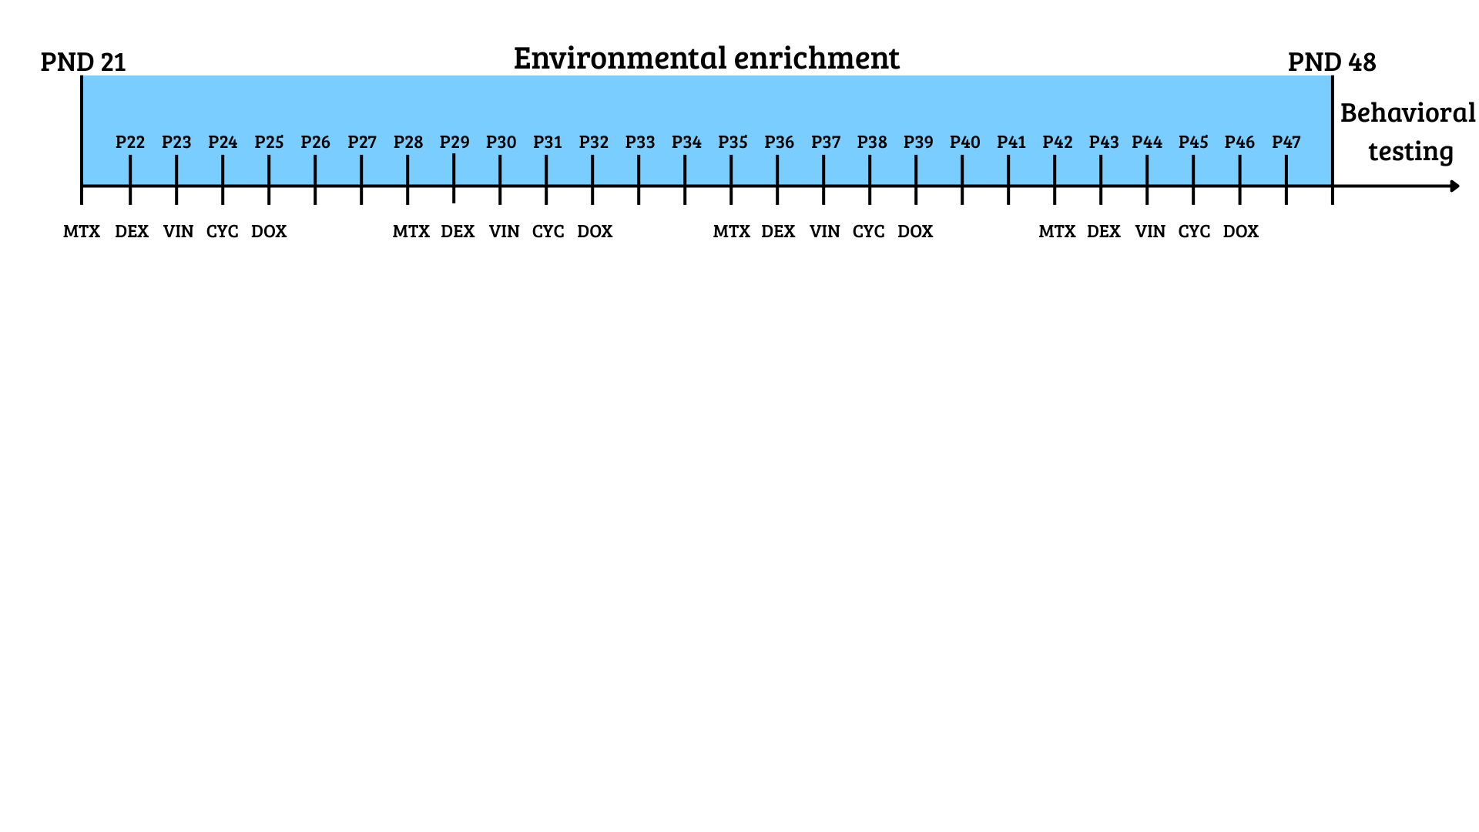Note. The figure shows the treatment timeline; injections were administered five times per week, with two rest days during the weekend. The enriched environment phase applied only to mice assigned to enriched housing; all other mice remained in standard housing. MTX = methotrexate, DEX = dexamethasone, VIN = vincristine, CYC = cyclophosphamide, DOX = doxorubicin; PND/P = postnatal day.
    - Environment
For the second manipulation, mice were pseudo-randomly assigned to one of two environmental conditions: standard environment or enriched environment. Standard housing consisted of transparent type II cages (320 x 160 x 140 mm) each containing woodchips as bedding and shredded paper for nest-building. The enriched environment consisted of Marlau® cages alongside transparent cages containing woodchips and additional toys. The Marlau® cage is a standardized two-floor enrichment system designed to provide continuous cognitive, sensory, and social stimulation and has been shown to enhance cognitive performance and promote neural plasticity (Fares et al., 2013; Khalil, 2024). The cage included standard housing features such as shredded paper and woodchip bedding, as well as additional enrichment elements including hiding boxes, stepladders, mazes, running wheels, and trapdoors (Figure 2A). The maze was located on the second floor, which mice accessed via a stepladder (Figure 2B). To reach their food, mice had to pass the maze, which was changed weekly to provide increased mental stimulation and promote learning and problem-solving. This setup required mice to actively interact with their surroundings and engage cognitive processes to obtain food. Because only a limited number of Marlau® cages were available, mice in the enriched-environment condition alternated between two weeks in a Marlau® cage and two weeks in an alternative enriched environment. The alternative enriched environment consisted of a larger transparent cage equipped with additional running wheels, marbles, and hiding boxes. The order in which mice experienced the two enrichment setups was counterbalanced to minimize order effects. However, the Marlau® cage may still have been a stronger enrichment manipulation than the alternative setup.
Figure 2
Environmental enrichment (Marlau® cage) structure.
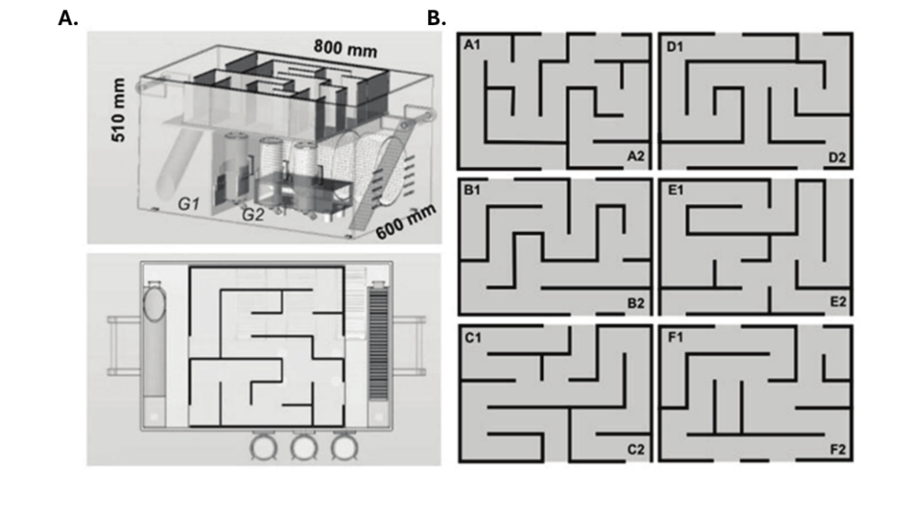
Note. Reprinted from Yolanda et al. (2019). Figure shows the Marlau® cage used for our enriched environment. Panel A (top) shows the overall structure of the Marlau® cage with both floors visible; Panel A (bottom) shows the top floor containing the maze. Panel B displays the different maze configurations on the top floor.
  - Behavioural Tests
To evaluate the effect of our treatment and environment manipulations, we administered a cognitive test battery to each mouse, serving as the dependent variable. The test battery assessed memory, cognitive flexibility, anxiety, social interaction, and recognition memory. All mice underwent the tests in the same prespecified order (Figure 3). The sequence was designed so that the most stressful assessments were performed last, minimizing stress-related influences on cognitive outcomes. Below, each test is described in order of administration
Figure 3
Timeline of behavioural tests.
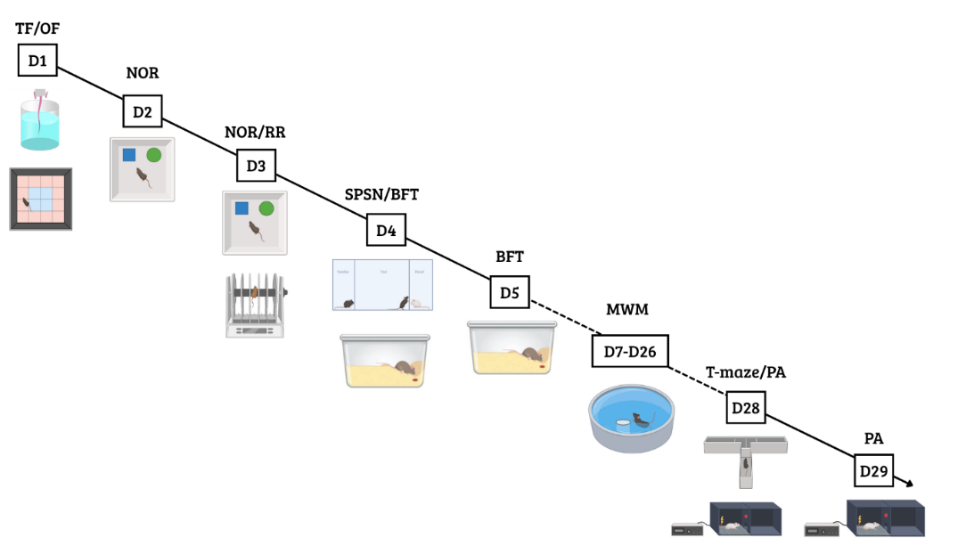
Note. Timeline of the behavioural tests; the dotted line means it lasted for an extensive period. TF = tail flick test; NOR = novel object recognition test; RR = rotarod; SPSN = sociability and preference for social novelty test; BFT = buried food test; MWM = Morris water maze; PA = passive avoidance.
    - Open field test
The open field test is a widely recognized test for assessing locomotion and anxiety-related behaviour in mice (Çevik et al., 2025). The apparatus consisted of a brightly illuminated plexiglass arena (50 × 50 × 30 cm) with transparent walls to promote anxiety-inducing behaviour (Figure 4). Prior to testing, all mice were placed in a fully dark cabinet for 30 min for habituation. This habituation ensured that mice would experience the brightly lit arena as anxious. Each mouse was then placed in the lower-left corner of the arena and allowed to habituate for 1 min before beginning a 10-min trial during which it could freely explore. Locomotor activity was recorded using a Logitech camera and ANY-maze software (Stoelting Co., 2023). The arena was divided into central and peripheral zones. The primary outcome measures were total path length, time spent in the periphery, and time spent in the centre. To minimize confounding effects from olfactory cues, the arena was thoroughly cleaned before and after each trial with 50% Ethanol. All animals were tested on the same day and at the same time of day to reduce variability due to timing-specific influences.

Figure 4
Layout of the open field test arena.
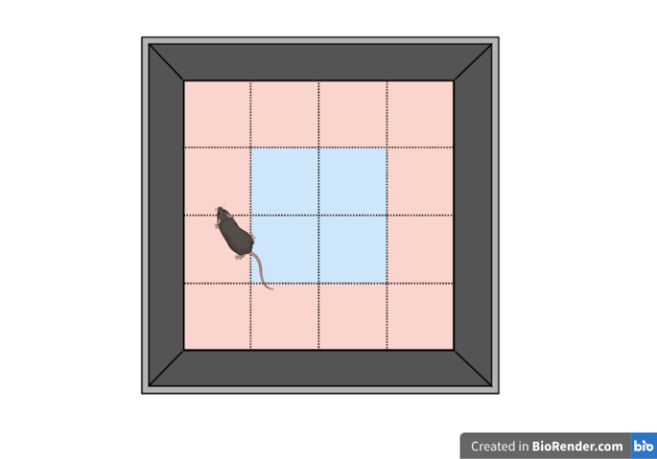
Note. Illustrated above is the setup used for the open field test. The red area represents the periphery, and the blue area represents the central zone.
    - Tail flick test
The tail-flick test assesses nociception in mice (Leo et al., 2008). Mice were restrained by the scruff of the neck, and the distal half of the tail (approximately 3 cm) was immersed in hot water (50 ± 1 °C). A heater was used to ensure a constant temperature across trials and to minimize temperature-related variability. Latency to withdraw the tail from the water was measured using a stopwatch. A cutoff time of 60 s was applied to prevent potential tissue damage. Each animal was tested three times to reduce the influence of outliers due to measurement variability in any single trial.
    - Novel object recognition test
The novel object recognition test is commonly used to assess recollection memory and learning in rodents (Lueptow, 2017). During foraging, mice have an innate tendency to explore novelty (Berlyne, 1950), and this behaviour can be harnessed to evaluate memory. Over several trials, animals were presented with two objects (made from plastic), and the time exploring these objects (sniffing) was recorded. Recalling that an object is familiar and showing increased approach to a novel object can be quantified as recollection memory. The testing arena consisted of a wooden box (40 × 40 × 30 cm) with four designated object locations, one in each corner, positioned approximately 5 cm from the corner (Figure 5). The task was conducted over two days and consisted of three trials. During the first trial (habituation), mice were placed in the empty arena for 10 min to familiarize themselves with the environment and to reduce anxiety-related behaviours during subsequent phases (Figure 5A). On the second day, the training and testing phases were performed. In the training phase, two identical objects (Falcon tubes filled with ink) were placed in two of the predefined corner locations, always arranged in opposite corners (Figure 5B). Each mouse was allowed 5 min to explore both objects. After training, mice were returned to their home cage for approximately 30 min before the testing phase. During the testing phase, one of the familiar objects was replaced with a novel object (a plastic pine tree), and mice were again given 5 min to explore (Figure 5C). The positions of the novel and familiar objects were counterbalanced across trials to minimize location-dependent biases. From these sessions, we calculated the novel object preference (NOP), defined as the time spent exploring the novel object divided by the total exploration time for both objects: $NOP=T_{novel}/(T_{novel}+T_{familiar})$. Total exploration time was also recorded as an index of locomotor activity and general exploratory behaviour. Animals that spent fewer than 15 s exploring during the training phase were excluded, as insufficient engagement prevents meaningful interpretation of performance during the testing phase. In practice, no animals spent less than 15 s exploring, so none were excluded.
Figure 5
Novel object recognition test: apparatus design and experimental phases.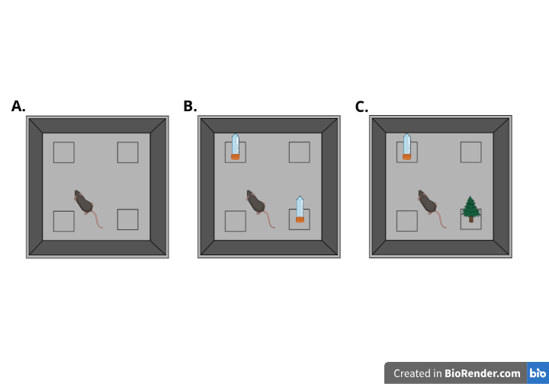
Note. Panel A shows the habituation phase, where mice explore an empty arena. The four marked positions represent possible object locations. Panel B shows the training phase, during which mice are exposed to the familiar object. Panel C illustrates the testing phase, in which a novel object is introduced to assess recognition memory.
    - Rotarod
The rotarod task assesses motor coordination and balance by placing mice on a rotating rod (Deacon, 2013). The full procedure consists of training and testing phases. During training, all mice were placed on a slowly rotating rod (5rpm) for 2 min to familiarize them with the task, then they were placed back in their home cage. After a 3 min rest period, the mice were placed four times on an accelerating rod (5-40rpm) for a maximum of 5 min. After each trial, mice were placed back in their home cage for a 5-min break before the next trial began. Latency to fall was the dependent variable of interest, with a maximum cutoff of 300 s (5 min) for mice that did not fall. Five mice could be tested in parallel, and the apparatus was cleaned between each test.

    - Sociability and preference for social novelty test (SPSN)
We used the sociability and preference for social novelty (SPSN) test to provide a measure of general social behaviour and social recognition memory (Moy et al., 2004). Mice are social animals and show interest in unknown conspecifics. This curiosity towards unknown animals can be harvested to evaluate social approach and social recognition memory (Moy et al., 2004). The setup consisted of a plexiglass arena with three compartments. The middle compartment (40 x 10 cm) contained the test mouse and was connected to two smaller side compartments (10x 10 cm) through walls with small openings (8mm holes). Each side compartment could hold an unfamiliar mouse. The arena was illuminated dimly (just enough to allow reliable tracking of the test mouse behaviour while remaining dim enough to minimize anxiety). The test consisted of three consecutive phases. First, the test mouse was placed in the middle compartment and given 5 min to habituate to the environment. Next, a stranger mouse was introduced into one of the two possible side chambers, and the test mouse was given 10 min to explore (Figure 6A). Time spent interacting with this stranger mouse served as a measure of general sociability. After the first exploration phase, a second stranger mouse was placed in the other side compartment (Figure 6B). The test mouse was again given 10 min to explore its environment freely. Following the same rationale described for the novel object recognition task regarding novelty preference (see Novel Object Recognition), time spent near the newly introduced stranger mouse was used as an indicator of social recognition memory. Time spent near the first stranger mouse was used as a measure of general sociability. Both stranger mice were of the same sex and were completely unfamiliar to the test mouse. All behaviour was recorded using a Logitech webcam and ANY-maze software (Stoelting Co., 2023). To minimize confounding factors, all mice were tested on the same day, and the apparatus was thoroughly cleaned between sessions to eliminate timing-related effects and residual odours.
Figure 6
Sociability and preference for social novelty test.
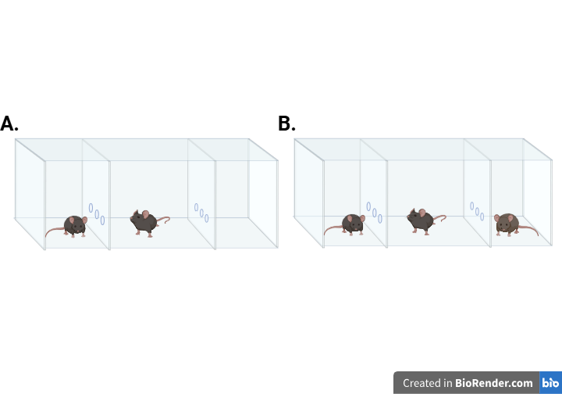
Note. Panel A illustrates the first phase of the SPSN test, during which the mouse is allowed to explore a single stranger mouse. Panel B depicts the second phase, where a novel stranger mouse is introduced into the opposite chamber.
    - Buried food-seeking test
Many patients receiving chemotherapy report alterations in smell and taste (Amézaga et al., 2018). Because food odours are essential for survival in mice, the Buried food-seeking test allowed us to model these sensory alterations in mice (Machado et al., 2018). Specifically, the test measures the ability to detect and recognize food odours. Before testing, mice were food-deprived for 24 h to enhance their motivation to locate the buried food. On the test day, each mouse was placed in a clean Type III macrolon cage containing 3 cm of bedding, with a piece of almond hidden at a random location. The almond (5mm) was buried 1 cm beneath the surface and fully covered with bedding to eliminate any visual cues. Mice were given 15 min to locate the buried food. The primary outcome was the latency to find the food. Animals that failed to locate the food within the allotted time were assigned a maximum latency of 900 s. After each trial, cages were cleaned, and fresh bedding was added to minimize residual odour cues from previous mice.
    - Morris water maze
The Morris water maze was first developed by Richard G. Morris in the early 1980s to test hippocampus-dependent learning (Morris, 1981). Since then, it has become a widely used behavioural paradigm for assessing hippocampus-dependent spatial learning and memory (Florian & Roullet, 2004; Othman et al., 2022; Redish & Touretzky, 1998). The setup consisted of a circular pool filled with opacified water (26 ± 1 °C) to enhance tracking of dark-coated mice (Acusol Op 301, Dow Chemicals). Water temperature was measured daily to ensure stability, as deviations toward colder or warmer temperatures can impair both learning and locomotion. The pool was divided into four virtual quadrants, which served as the starting positions during the experiment (Figure 7A). One of these quadrants was designated as the target quadrant and contained a hidden escape platform that mice were required to locate to exit the water. Because the water was rendered opaque, the platform was minimally visible, increasing reliance on learned spatial cues rather than direct visual detection and thereby promoting learning. The quadrant directly opposite the original target quadrant was designated as the reversal target quadrant and was used in later stages of the protocol to assess cognitive flexibility.
The full Morris water maze protocol lasted three weeks and consisted of an acquisition phase, probe trials, a reversal acquisition phase, and a reversal probe trial. The protocol began with the acquisition phase, during which the platform was placed in the original target quadrant. For a total of ten training days, mice learned to locate the escape platform using distal spatial cues. Each day, all mice performed four swim trials from four different starting positions, with up to 100 s available to locate the platform. Mice that failed to locate the platform within this time were guided to it by the experimenter and allowed to remain there for 15 to 20 s to facilitate learning of spatial cues. Starting positions were determined by a randomized daily sequence, with each sequence used only once. On the sixth and eleventh day, probe trials were conducted. For each of these trials, the platform was removed and each mouse completed a single swim starting from the quadrant opposite the original target quadrant. Mice were allowed to swim freely for 100 s, and the time spent in the original target quadrant was recorded as an index of spatial reference memory. On the same day as the final probe trial, the reversal acquisition phase began. This phase followed the same procedure as the initial acquisition, except that the platform was relocated to the opposite target quadrant. Reversal acquisition lasted five days, during which mice again completed four daily swim trials with a maximum duration of 100 s to locate the platform. On the sixteenth day, a reversal probe trial was conducted in which the platform was removed from the reversal target quadrant, and mice were allowed to swim freely for 100 s. Total path length, Euclidean distance to the platform, and time spent in the target quadrant during probe trials were quantified as measures of spatial and reversal learning. All behaviour was recorded using an overhead digital camera (Basler GIGE camera) and Ethovision tracking software.
Figure 7
Experimental setups for the Morris water maze and T-maze.
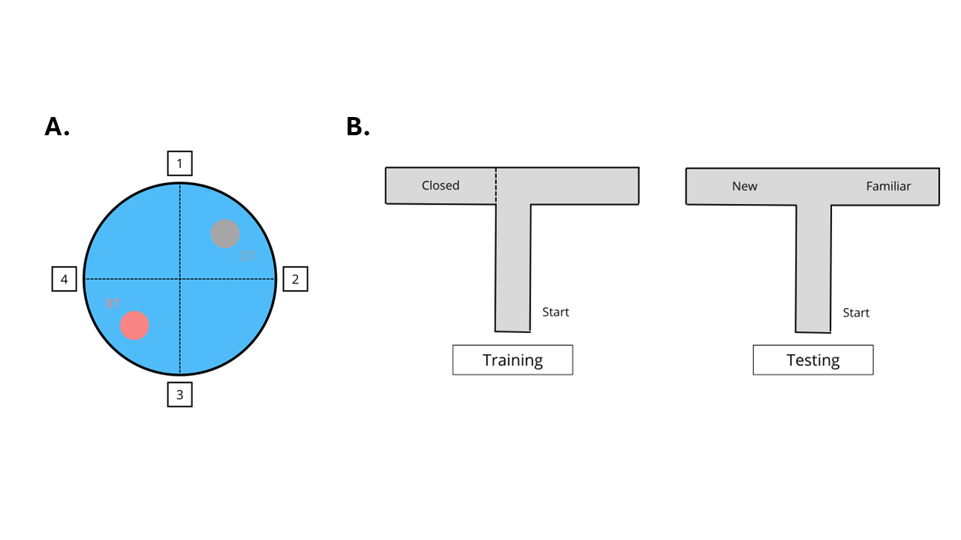
Note. (A) Top view of the water maze. OT = original target platform; RT = reversal target platform. The numbers represent possible starting positions. (B) Training and testing phases of the T-maze task. The “Start” point marks the mouse’s initial position at the beginning of each trial.
    - Elevated T-maze
Because mice naturally explore novel environments to scavenge, the elevated T-maze was used to assess spatial working memory (d’Isa et al., 2021). The setup consisted of an elevated T-shaped arena. The two shorter lateral arms, hereafter referred to as the goal arms, extend symmetrically from the central starting arm (5 x 30 cm), which is a longer segment oriented perpendicular to them (5x 40cm). The procedure consisted of two phases: a training phase and a testing phase. During the training phase, one of the two goal arms was closed off, with the choice determined by a predetermined randomized order (Figure 7B left). Each mouse was given 5 min to explore the starting arm and the single open goal arm. After training, mice were returned to their home cage for 5 min while the apparatus was thoroughly cleaned with 50% ethanol. For the testing phase, mice were again placed in the starting arm, but now both goal arms were open (Figure 7B right). Mice were given another 5 min to explore their environment freely. Novel arm preference (NAP) was calculated as an index of spatial working memory ($NAP=T_{novel}/(T_{novel}+T_{familiar})$. Total path length was recorded as a measure of general exploration. The apparatus was illuminated sufficiently to ensure reliable tracking while minimizing anxiety, and it was thoroughly cleaned after each mouse to reduce the influence of residual odours.
    - Passive avoidance test
The passive avoidance test is commonly used as a fear-conditioning paradigm to assess associative learning and contextual memory (Ögren & Stiedl, 2015). Unlike active avoidance tasks, it does not employ an explicit cue. Instead, the context itself serves as the conditional stimulus and becomes associated with an aversive event, such as a foot shock. The experiment used a passive avoidance apparatus with two compartments: a brightly lit compartment and a dark compartment connected by a trap door. Mice always started in the illuminated compartment, which induces mild anxiety and creates an incentive to enter the darker compartment. Each mouse was placed in the bright compartment with the trap door closed and allowed to explore for 5 s, after which the door opened. When the mouse entered the dark compartment, the door closed and four mild foot shocks were delivered through the grid floor (0.3 mA, 2 s each). The procedure was repeated 24 h later, but no shock was administered during the second session. If a mouse did not enter the dark compartment within 300 s, the trial was terminated and a maximum latency of 300 s was recorded. Latency to enter the dark compartment was measured on both days as the primary outcome.
  - Data Analysis
All statistical analyses were conducted in R (version 4.4.3; R Core Team, 2025). Analyses were first performed within a frequentist framework, and the specific tests were chosen based on the data structure and experimental design. Two‑way ANOVAs were fitted to assess the effects of treatment, environment, and their interaction on each outcome variable. In cases where the data exhibited hierarchical or interdependent structure, models were fitted using multilevel (mixed‑effects) approaches to appropriately account for this dependency (Osborne, 2000). Models were fitted using either base R (aov) for standard ANOVA designs or lme4 for mixed-effects models. Post hoc pairwise comparisons were conducted to further examine significant main effects, using estimated marginal means (emmeans) with t-tests applied to the contrasts. A significance threshold of p < .05 was applied for all frequentist tests. Inferential results are reported with the test statistic, p‑value, and effect size. Post hoc contrasts are reported as estimated mean differences, standard errors, and p-values. When applicable, Tukey’s HSD was used to adjust these p-values for multiple comparisons.
All models were additionally fitted in a Bayesian framework, and Bayes factors were computed for each non-significant effect by testing whether the corresponding parameter differed from zero. A Bayes factor quantifies the relative evidence for two competing hypotheses as the ratio of the marginal likelihoods of the data under each model. Here we compute the Savage–Dickey ratio for a single parameter, which is defined as the ratio of the prior density at zero to the posterior density at zero:
$${BF}_{01}=\frac{p\left(θ=0 \right| prior)}{p\left(θ=0 \right| posterior)}$$
Bayesian hypothesis testing is included because, unlike classic frequentist p-values, Bayes factors can distinguish between evidence supporting the null hypothesis and evidence that is inconclusive (Schmalz et al., 2023). Bayesian models were written and fitted in Stan (Stan Development Team, 2024) using cmdstanr, which performs Markov chain Monte Carlo sampling. All variables were normalized before fitting the Bayesian models. For each effect, we report the Bayes factor and the 90% highest-density interval (HDI) for the estimate. Bayes factors greater than one indicate evidence in favour of the alternative hypothesis, whereas values less than 1 indicate evidence in favour of the null. We interpreted Bayes factors according to the guidelines of Wagenmakers et al. (2018), which are adapted from the original scale, created by Jeffreys (1961). Details of the priors employed in the testing procedure are provided in the Appendix (Table IX & X), which also includes the parameter-recovery for all models (Figure II, III & IV)

Results
  - Open field
Total path length was used as a measure of general exploration and locomotor activity (Figure 8A). To assess the effects of treatment, environment, and their interaction on locomotor activity, we conducted a two-way ANOVA. There was a robust main effect of environment, with mice housed in enriched conditions showing higher locomotor activity than those in poor environments (F(1, 30) = 16.18, p < .001, η² = 0.35). We also observed a significant main effect of treatment (F(1, 30) = 6.86, p = 0.014, η² = 0.19), indicating overall differences between saline- and CVAD-treated mice. The interaction between treatment and environment was not significant (F(1, 30) = 0.63, p = 0.43, η² = 0.02). Consequent Bayesian analysis added interpretive clarity by showing that the data provided only anecdotal evidence for no interaction (${BF}_{01}$= 0.59, ${HDI}_{90\%}$=[-0.53;1.09]) showing that more data is needed to draw conclusions. To further examine the main effects, we conducted post hoc pairwise contrasts. First, we compared saline and CVAD within the poor environment. Mice treated with saline showed higher locomotor activity than those treated with CVAD, although this effect failed to reach significance (Δ = 12.59, SE = 4.75, p = 0.06). Bayesian follow-up analysis provided strong evidence for this effect, likely masked in the frequentist results by Tukey’s correction (${BF}_{01}$= 10.70, ${HDI}_{90\%}$=[0.36;1.64]). The same comparison conditioned on the enriched environment did not reach significance (Δ = 7.59, SE = 3.97, p = 0.24). However, the Bayesian analysis showed anecdotal evidence for the effect (${BF}_{01}$= 1.34, ${HDI}_{90\%}$= [0.12;1.32]). Next, we compared the two environments within each treatment group. Enriched housing increased locomotor activity relative to poor housing for both saline-treated mice (Δ = −9.98, SE = 3.43, p = 0.03) and CVAD-treated mice (Δ = −14.88, SE = 5.15, p = 0.03).
Figure 8
Behavioural measures from the open field test.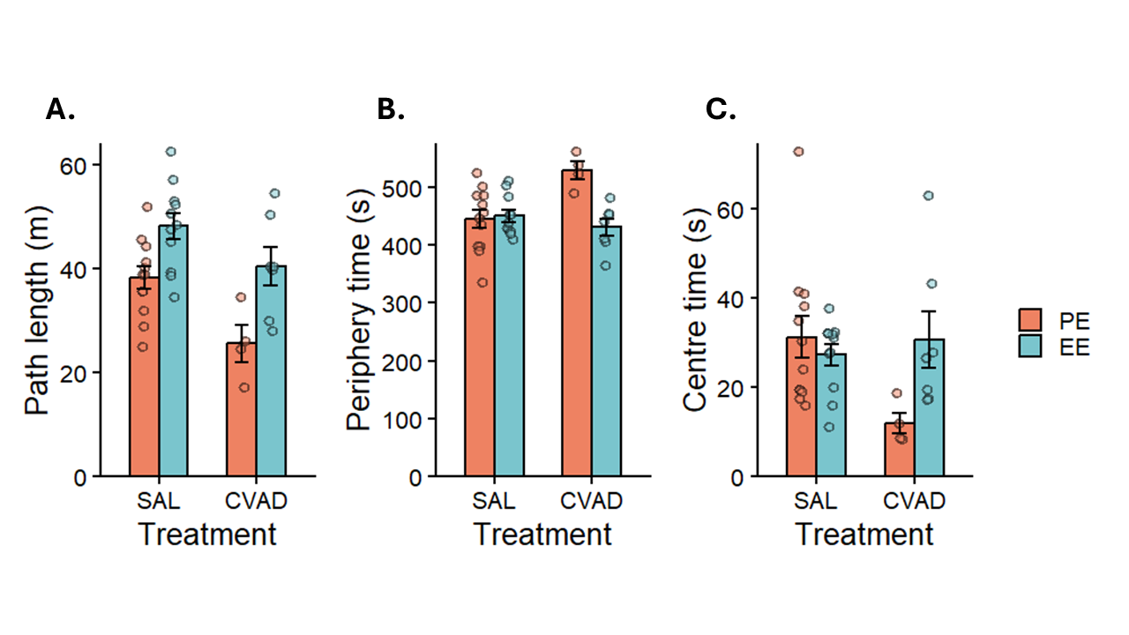
Note. Path length results, representing general locomotor activity. (B) Time spent in the periphery of the arena. (C) Time spent in the centre of the arena. Bars show means ± SEM; individual points represent raw data. SAL = Saline; CVAD = chemotherapy; PE = poor environment; EE = enriched environment.
Thigmotaxis and centre exploration were quantified as time spent in the periphery and centre, respectively. A two-way ANOVA revealed no main effect of environment in both peripheral (F(1, 30) = 2.94, p = 0.10, η² = 0.09) and central time (F(1, 30) = 0.44, p = .51, η² = .01). However, the Bayesian analysis provided moderate evidence for an environment effect on peripheral time (${BF}_{01}$= 3.65, ${HDI}_{90\%}$=[-1.22;-0.21]), and anecdotal evidence for the absence of an effect on central time (${BF}_{01}$= .54, ${HDI}_{90\%}$=[-0.18;-0.93]). This pattern could suggest that with a larger sample, the environment effect on peripheral time might have reached significance, whereas for central time, the effect is likely genuinely absent. However, more data is needed to draw conclusions. Similarly, the main effect of treatment did not reach significance for either peripheral (F(1, 30) = 1.40, p = .25, η² = .04) or central time (F(1, 30) = 1.25, p = .27, η² = .04). Consistent with this, the Bayesian analysis indicated anecdotal evidence for the absence of a treatment effect in both peripheral time (${BF}_{01}$= 0.68, ${HDI}_{90\%}$=[0.09;0.95]), and central time (${BF}_{01}$= 0.53, ${HDI}_{90\%}$=[-0.94;0.18]). Notably, the interaction effect was significant for both periphery (F(1, 30) = 10.10, p =.003, η² = .25) and centre time (F(1, 30) = 5.10, p =.03, η² = .15). The interaction indicated that the PE–EE contrast was stronger in CVAD mice, with a greater reduction in periphery time and a greater increase in centre time than observed in saline controls.
Taken together, the analysis showed a clear negative effect of chemotherapy and a clear positive effect of an EE on locomotion and exploration. Post-hoc comparisons suggested that the chemotherapy effect was larger when conditioned on PE, as supported by the Bayesian comparison. However, because the interaction was not significant, this apparent difference-in-differences should not be interpreted as a protective role of EE. Bayesian analyses did suggest a potential interaction, though additional data would likely be required to determine whether this effect is genuine. We also found no overall effect of chemotherapy or environment on anxiety-like behaviour, but EE showed a protective effect in CVAD-treated animals based on the interaction. Overall, EE appears to mitigate chemotherapy-related increases in anxiety.

  - Tail flick test
In the tail flick test, latency to withdraw the tail from the hot water was used as a measure of nociception in mice (Figure 9A). A mixed-effects model with random intercepts was fitted on these latencies to examine the effects of treatment, environment, and their interaction. Analysis revealed that neither the treatment (t(30) = 0.74, p = 0.46, R² = 0.007) nor the environment effect (t(30) = -1.17, p = 0.25, R² = 0.02) reached significance. The interaction between treatment and environment was also non-significant (t(30) = -0.29, p = 0.78, R² = 0.001). Bayesian analyses provided moderate evidence in favour of the null-hypothesis for treatment (${BF}_{01}$= 0.25, ${HDI}_{90\%}$= [-0.19;0.58]) and anecdotal evidence in the same direction for environment (${BF}_{01}$= 0.59, ${HDI}_{90\%}$= [-0.74;0.04]), and their interaction (${BF}_{01}$= 0.44, ${HDI}_{90\%}$= [-0.80;0.60]) effects, suggesting that the absence of detectable effects is more likely, although these conclusions should be interpreted with caution. It is also important to note that measurement error related to handling procedures may have influenced these outcomes.
Figure 9
Results from the tail flick and Rotarod test.
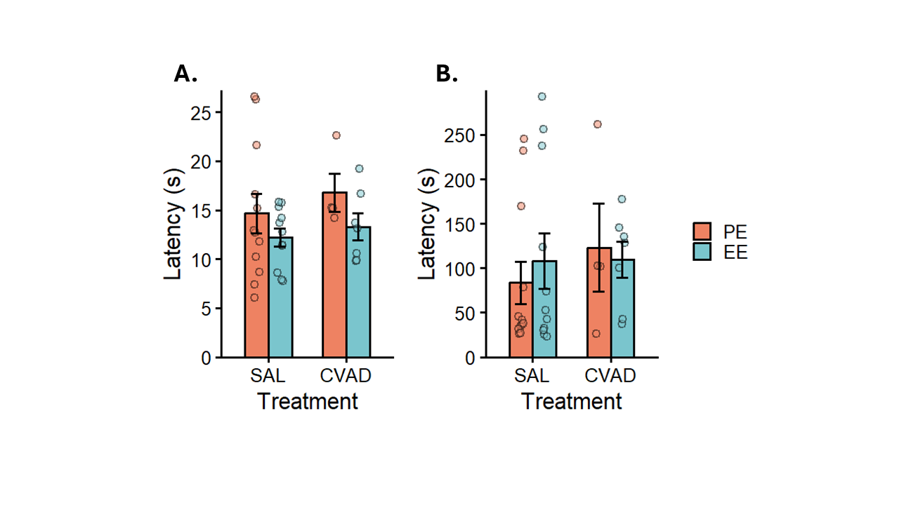
Note. (A) Tail withdrawal latency results, representing nociception. (B) Fall latency results, representing motor coordination. Bars show means ± SEM; individual points represent individual means. SAL = Saline; CVAD = chemotherapy; PE = poor environment; EE = enriched environment.

  - Novel object recognition test
Figure 10
Novel object recognition test results.
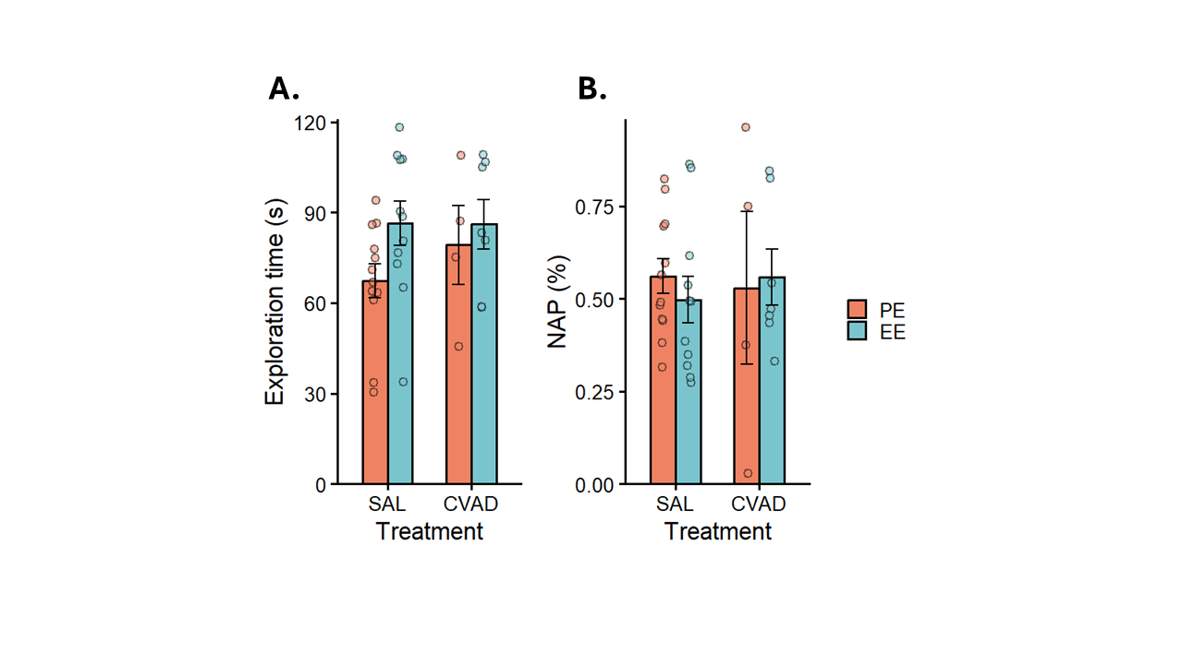
Note. (A) General exploration time as time spent in the familiar and novel zones during the test phase. (B) Novel object preference (NAP), which measures recognition memory. Bars show means ± SEM; individual points represent raw data. SAL = Saline; CVAD = chemotherapy; PE = poor environment; EE = enriched environment.
In the novel object recognition test, general exploration and locomotion were assessed by summing the time spent in the familiar and novel zones during the test phase (Figure 10A). A two‑way ANOVA was performed on total exploration time to examine the main and interaction effects of treatment and environment. The treatment effect did not reach significance (F(1, 30) = 0.74, p = 0.40, η² = 0.02), indicating that treatments did not differ in general exploration. The Bayesian analysis further supported this conclusion, providing moderate evidence for the absence of an effect (${BF}_{01}$= 0.31, ${HDI}_{90\%}$= [-0.39;0.74]). The environment effect was also non-significant (F(1, 30) = 3.82 , p = 0.06, η² = 0.11). However, the Bayesian analysis suggested caution in interpreting this result, as it indicated essentially no evidence in either direction (${BF}_{01}$= 0.91, ${HDI}_{90\%}$= [-0.01;1.10]). Finally, we also found no interaction effect (F(1, 30) = 0.51, p = 0.48, η² = 0.02), with the Bayesian analysis providing anecdotal evidence for the null (${BF}_{01}$= 0.57, ${HDI}_{90\%}$= [-1.12;0.73]). We also conducted a two-way ANOVA on the novel object preference (NOP) scores to assess these effects on recognition memory (Figure 10B). The analysis revealed no treatment effect (F(1, 30) = 0.04, p = 0.84, η² = 0.001), and no environment effect (F(1, 30) = 0.21, p = 0.65, η² = 0.007). The Bayesian follow-up analyses provided moderate evidence for the absence of both a treatment effect (${BF}_{01}$= 0.30, ${HDI}_{90\%}$= [-0.52;0.69]) and an environment effect (${BF}_{01}$= 0.29, ${HDI}_{90\%}$= [-0.69;0.52]), suggesting that there is presumably no detectable effect present. The interaction term was likewise non-significant (F(1, 30) = 0.31, p = 0.58, η² = 0.01), as supported by the Bayesian analysis providing anecdotal evidence for the null (${BF}_{01}$= 0.63, ${HDI}_{90\%}$= [-1.10;0.73]).
To sum up, we found no differences in general exploration or recognition memory across treatment groups. There was also no overall benefit of an EE for either measure, although the Bayesian analysis suggests that an undetected effect on general exploration cannot be ruled out. Finally, the interaction effects were non-significant, indicating that EE cannot be interpreted as providing a protective influence on either memory retention or general exploration in chemotherapy-treated mice.
  - Rotarod
To analyse the effects of treatment and environment on balance and motor coordination, we fitted a mixed-effects model with random intercepts on the latencies to fall in the rotarod task (Figure 9B). The analysis revealed no main effect of treatment (t(30) = 0.78, p = 0.44, R² = 0.01), and no main effect of environment (t(30) = 0.67, p = 0.51, R² = 0.008). Bayesian analyses further supported these conclusions, providing moderate evidence for the null for both the treatment effect (${BF}_{01}$= 0.28, ${HDI}_{90\%}$= [-0.35;0.64]), and the environment effect (${BF}_{01}$= 0.24, ${HDI}_{90\%}$= [-0.41;0.]). The interaction between the two was also non-significant (t(30) = -0.58 , p = 0.57, R² = 0.006), with the Bayesian analysis offering anecdotal evidence for the absence of the effect (${BF}_{01}$= 0.52, ${HDI}_{90\%}$= [-1.00;0.63]). Overall, these results suggest that neither treatment nor environment altered motor coordination. Likewise, we found no indication that EE offered a protective benefit for motor coordination in chemotherapy-treated mice.
  - Sociability and preference for social novelty test (SPSN)
The SPSN test offered an additional measure to investigate the effects of treatment, environment, and their interaction on general locomotion and exploratory behaviour. Additional analyses showed that the SPSN stages differed sufficiently that they could not be treated as reflecting the same underlying process regarding locomotion (Figure 11A; See Table III Appendix). Because we aimed to isolate locomotion from social exploration, path length during the habituation phase was selected as the dependent variable (Figure 11B). A two-way ANOVA revealed a significant main effect of treatment (F(1, 30) = 9.55, p = 0.004, η² = 0.24), but no significant effect of environment (F(1, 30) = 0.98, p = 0.33, η² = 0.03) and no interaction (F(1, 30) = 0.47, p = 0.50, η² = 0.02). Similarly, Bayesian analysis found anecdotal evidence for the absence of both the environment effect (${BF}_{01}$= 0.64, ${HDI}_{90\%}$= [-0.12;0.97]) and the interaction effect (${BF}_{01}$= 0.59, ${HDI}_{90\%}$= [-0.73;1.03]), but more data is needed to draw robust conclusions. Consequent post-hoc contrasts showed that Saline-treated mice explored significantly more in the PE condition (Δ = 2.76, SE = 1.10, p = 0.02), but not in the EE condition (Δ =1.78, SE = 0.92, p = 0.06). However, Bayesian comparison for the EE condition yielded anecdotal support for a treatment effect (${BF}_{01}$= 1.73, ${HDI}_{90\%}$= [-0.52;0.69]), again suggesting that additional data may be required to clarify this pattern.
Figure 11
Total path length results from the SPSN test.
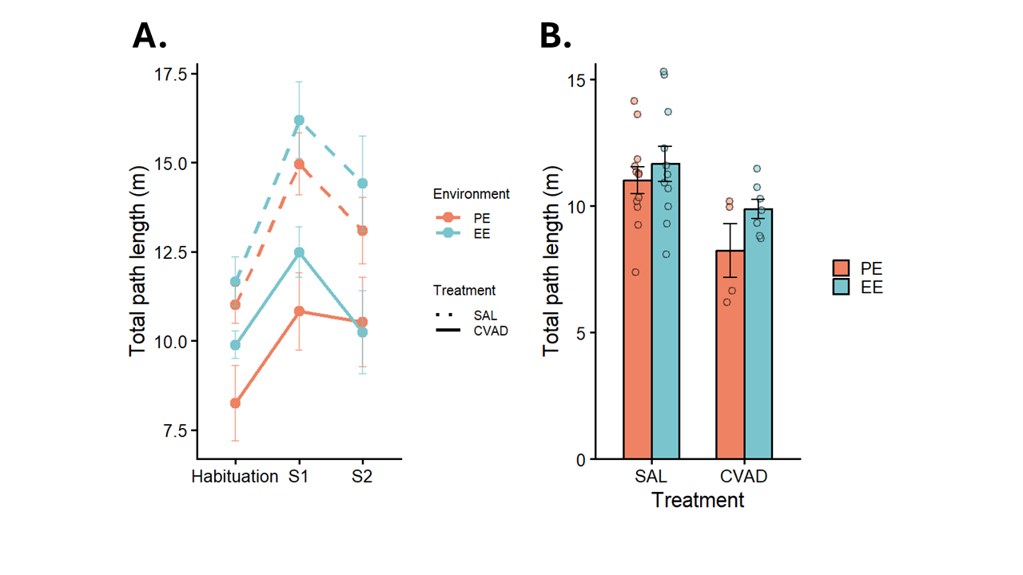
Note. (A) Total path length per SPSN stage; dots represent cell means ± SEM. Habituation = habituation phase ; S1 = only one stranger is presented; S2= new stranger gets introduced. (B) Total path length during the habituation phase; data are shown as mean ± SEM with raw data overlaid. SAL = Saline; CVAD = chemotherapy; PE = poor environment; EE = enriched environment.
Time spent near the first stranger mouse was used as a metric of general sociability, and a two-way ANOVA was conducted to examine the effects of treatment, environment, and their interaction (Figure 12A). We found no significant main effect of treatment (F(1, 30) = 1.05, p = 0.31, η² = 0.03), but we did observe a significant main effect of environment (F(1, 30) = 6.50, p = 0.02, η² = 0.18). The interaction did not reach significance (F(1, 30) = 0.04, p = 0.84, η² = 0.001). Bayesian analyses for the treatment (${BF}_{01}$= 0.42, ${HDI}_{90\%}$= [-0.24;0.84]) and interaction terms (${BF}_{01}$= 0.54, ${HDI}_{90\%}$= [-0.83;0.94]) likewise provided anecdotal evidence for the absence of an effect. Post hoc comparisons showed that mice in the PE condition spent significantly more time near the stranger mouse when treated with saline (Δ = 44, SE = 18.80, p = 0.02), but not when treated with CVAD (Δ = 37, SE = 28.2, p = 0.20). The Bayesian comparison supported this pattern by providing anecdotal evidence for the absence of a difference in the CVAD group (${BF}_{01}$= 0.76, ${HDI}_{90\%}$= [-1.56;0.09]). Given the limited strength of the evidence, additional data will be needed to draw firm conclusions.

Figure 12
Sociability and social memory results from the SPSN.
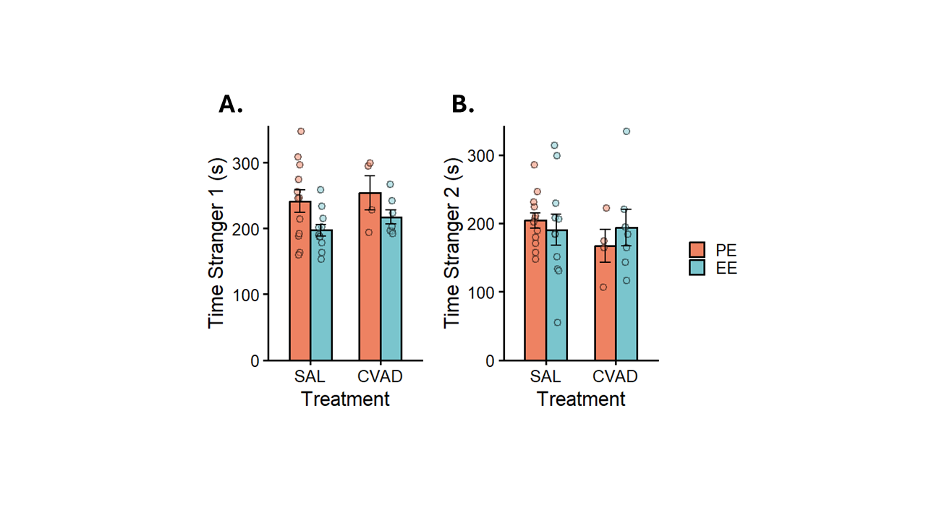
Note. (A) Time spent near the first stranger mouse during the second stage of the SPSN, representing general sociability. (B) Time spent near the second stranger mouse during the last stage of the SPSN, representing social memory. Bars show means ± SEM; individual points represent raw data. SAL = Saline; CVAD = chemotherapy; PE = poor environment; EE = enriched environment.
Finally, time spent near the second stranger mouse in the final stage of the SPSN was used as an index of social recognition memory (Figure 12B). Again, a two-way ANOVA was fitted to the data. The analysis revealed no main effect of environment (F(1, 30) = 0.02, p = 0.88, η² = 0.007), and no main effect of treatment (F(1, 30) = 0.35, p = 0.56, η² = 0.01). The interaction also did not reach significance (F(1, 30) = 0.79, p = 0.38, η² = 0.03). Bayesian follow-up analyses provided moderate evidence for the absence of an environment effect (${BF}_{01}$= 0.29, ${HDI}_{90\%}$= [-0.54;0.64]) and only anecdotal evidence regarding the absence of a treatment effect (${BF}_{01}$= 0.34, ${HDI}_{90\%}$= [-0.78;0.40]). Similarly, the analysis revealed only anecdotal evidence for the absence of an interaction between the two (${BF}_{01}$= 0.66, ${HDI}_{90\%}$= [-0.61;1.26]). Given the limited evidence for the absence of an interaction, an effect cannot be ruled out. However, the current dataset does not provide sufficient information to support any of these claims. Because this metric does not account for preference over the familiar mouse, it may be more strongly influenced by overall activity levels. Therefore, we repeated the analysis using the social novelty preference, defined as time spent near stranger two divided by the total time spent near stranger one and stranger two (see Appendix; Table IV). Using this index, the outcome remained unchanged, and no significant effects were observed.

  - Buried food-seeking test
Figure 13
Buried food -seeking test results.
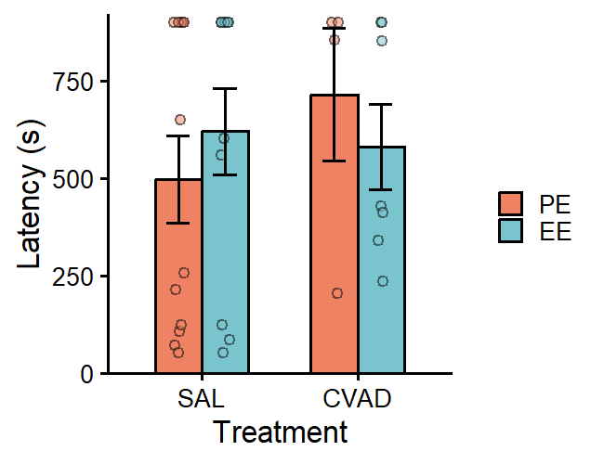
Note. Results from the BFT, measuring olfactory function. Bars show means ± SEM; individual points represent raw data. SAL = Saline; CVAD = chemotherapy; PE = poor environment; EE = enriched environment.
Olfactory function was quantified as the latency to find food during the buried food-seeking test (fig). A two-way ANOVA was conducted to examine the effects of treatment, environment, and their interaction. The analysis revealed no significant main effect of treatment (F(1, 30) = 0.31, p = 0.58, η² = 0.01) and no significant main effect of environment(F(1, 30) = 0.12, p = 0.73, η² = 0.004). There was also no interaction effect observed (F(1, 30) = 0.90, p = 0.35, η² = 0.03). Bayesian analyses similarly provided moderate evidence for the absence of both treatment (${BF}_{01}$= 0.32, ${HDI}_{90\%}$= [-0.44;0.77]) and environment effects (${BF}_{01}$= 0.28, ${HDI}_{90\%}$= [-0.56;0.62]). Evidence for the absence of an interaction was only anecdotal (${BF}_{01}$= 0.61, ${HDI}_{90\%}$= [-1.29;0.59]), indicating that additional data would be required to draw firm conclusions.
  - Morris water maze
    - Learning during the acquisition phase
To quantify spatial learning, total path length during the 10-day acquisition phase was analysed using a mixed-effects model with random intercepts (Figure 14A). The model included fixed effects of treatment, environment, and day. All two- and three-way interactions were also included to assess whether learning trajectories differed between groups. One mouse was excluded because it missed 19 swims (due to the effects of chemotherapy), meaning it did not receive a comparable opportunity to learn. Including this animal would have introduced bias into the estimation of group-level learning rates. There was no significant main effect of environment (t(268) = -0.18, p = 0.86, R² = 0.00), but there were significant main effects of day (t(1283) = -7.53, p < 0.001, R² = 0.04) and treatment (t(268) = 3.68, p < 0.001, R² = 0.01). The Bayesian analysis likewise provided moderate evidence supporting the absence of an environment effect (${BF}_{01}$= 0.14, ${HDI}_{90\%}$= [-0.28;0.17]). Across all groups, path length decreased over days, indicating learning, and chemotherapy‑treated mice showed overall poorer initial performance. For the two‑way interactions, the Day × Treatment interaction was significant (t(1283) = -2.66, p = 0.007, R² = 0.005), indicating that CVAD‑treated mice showed a steeper learning curve. This pattern could potentially be explained by their significantly higher initial path length. The Treatment × Environment interaction was also significant (t(268) = -3.44, p < 0.001, R² = 0.01), suggesting that environmental enrichment provided a stronger protective effect for chemotherapy-treated mice than for saline controls in terms of their path length on day one. In contrast, the Day × Environment interaction did not reach significance (t(1283) = -0.84, p = 0.40, R² = 0.001). The Bayesian analysis provided very strong evidence for the absence of this effect, indicating that no meaningful interaction was present (${BF}_{01}$= 0.03, ${HDI}_{90\%}$= [-0.05;0.02]). Finally, the three-way interaction was significant (t(1283) = -2.64, p = 0.008, R² = 0.005), indicating that the treatment-related difference in learning rate depended on the environment. Under standard housing, CVAD-treated mice learned faster than saline controls, but this difference was reduced under environmental enrichment. Again, this effect is likely explained by the higher starting point on Day 1.
Figure 14
Results from the Morris water maze acquisition phase.
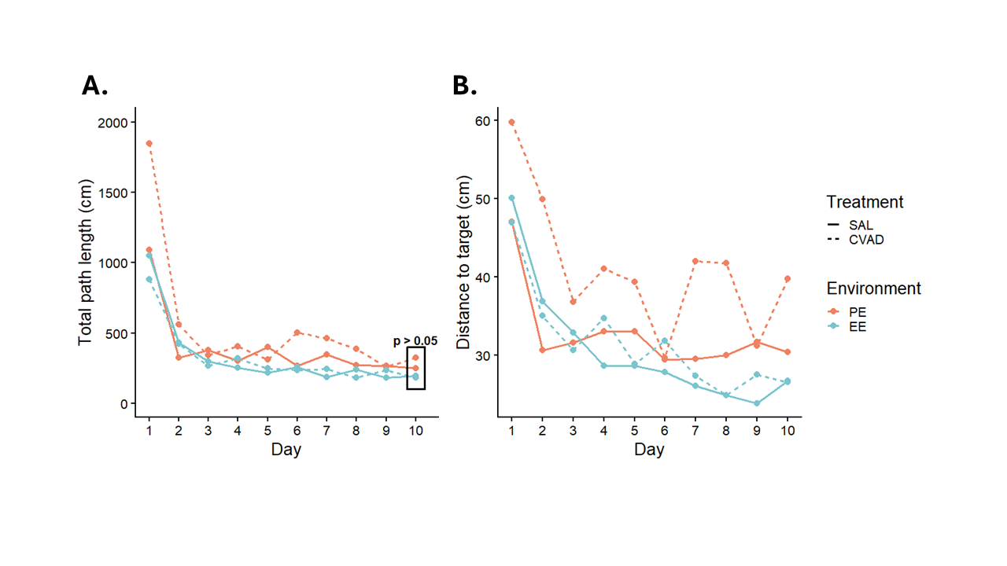
Note. (A) Total path length decreased over days; the black box highlights that no group differences were present on Day 10. (B) Distance-to-target scores also declined over time. Dots represent group means for each day. SAL = Saline; CVAD = chemotherapy; PE = poor environment; EE = enriched environment.
To assess differences in spatial learning success, we fitted a mixed-effects model to total path length on the final day of the acquisition phase (Figure 14A). All mice successfully located the platform, and there were no significant main effects of treatment (t(29) = 1.03, p = 0.31, R² = 0.01) or environment (t(29) = -1.22, p = 0.23, R² = 0.02). The interaction term also failed to reach significance (t(29) = -0.96, p = 0.34, R² = 0.01). However, under the Bayesian framework, treatment (${BF}_{01}$= 0.56, ${HDI}_{90\%}$= [-0.16;0.83]), environment (${BF}_{01}$= 0.74, ${HDI}_{90\%}$= [-0.67;0.01]), and their interaction (${BF}_{01}$= 0.62, ${HDI}_{90\%}$= [-0.99;0.23]) all showed only anecdotal evidence for the absence of an effect. This suggests that additional data would be required to draw firmer conclusions. Because total path length may be confounded by overall activity and swim speed, we repeated the analysis using distance to target (Figure 14B). The same main effects emerged as for path length. However, the interaction pattern differed slightly: only the Environment × Treatment and Day × Environment interactions reached significance. The three-way interaction was also non-significant, and the Bayesian analysis provided moderate evidence for the absence of this effect. Taken together, these results suggest that the apparent benefit of PE for chemotherapy-treated mice was not due to improved learning, but was more likely driven by differences in activity levels or swim speed on Day one. The same applies to the Day × Treatment interaction, which confirms our earlier assumption that the apparent effect was driven by differences in Day one activity rather than genuine differences in learning (See Table V & VI, Appendix).
Figure 15
Results from Morris water maze target quadrant probe trials.
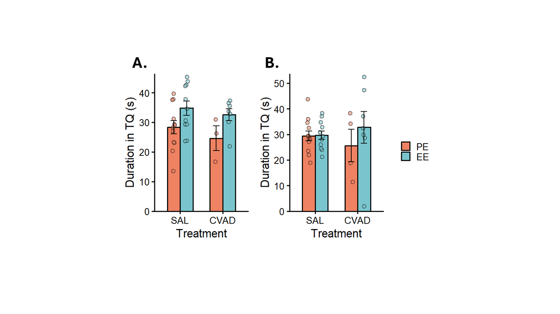
Note. (A) Duration in the target quadrant during the first probe trial (Day 6). (B) Duration in the target quadrant during the second probe trial (Day 11). Bars show means ± SEM; individual points represent raw data. SAL = Saline; CVAD = chemotherapy; PE = poor environment; EE = enriched environment.
To quantify spatial memory retention, we measured the time spent in the target quadrant during two probe trials conducted on Day 6 and Day 11. For each probe trial, we fitted a two-way ANOVA to assess treatment and environment effects on retention at two separate time points. During Probe 1, there was a significant main effect of environment (F(1, 29) = 6.12, p = 0.02, η² = 0.17), whereas treatment did not affect time spent in the target quadrant (F(1, 29) =0.96, p = 0.34, η² = 0.03) (Figure 15A). The environment × treatment interaction also failed to reach significance (F(1, 29) = 0.06, p = 0.81, η² = 0.002). Bayesian analysis supported the conclusions for both the treatment (${BF}_{01}$= 0.43, ${HDI}_{90\%}$= [-0.88;0.26]) and interaction effects (${BF}_{01}$= 0.59, ${HDI}_{90\%}$= [-0.82;1.06]), providing only anecdotal evidence for the null. This level of evidence suggests that additional data may be required to draw more robust inferences. Post‑hoc comparisons were conducted to clarify the direction of the environmental effect. Within saline‑treated mice, EE animals spent more time in the target quadrant than PE animals (Δ = -6.49, SE = 3.07, p = 0.04). This difference was not present within chemotherapy-treated mice (Δ = -7.94, SE = 5.07, p = 0.13), and the Bayesian analysis provided no evidence (${BF}_{01}$= 1.01, ${HDI}_{90\%}$= [-1.73;0.03]). Consequently, no firm conclusions can be drawn for this contrast. Analysis of Probe 2 showed no main effect of treatment (F(1, 29) = 0.004, p = 0.95, η² < 0.001), and the previously observed environment effect was no longer significant (F(1, 29) = 0.51, p = 0.48, η² = 0.02) (Figure 15B). This suggests that the environmental advantage in memory retention did not persist. The interaction term again failed to reach significance (F(1, 29) = 0.87, p = 0.36, η² = 0.03). Bayesian analysis provided moderate support for the absence of a treatment effect (${BF}_{01}$= 0.28, ${HDI}_{90\%}$= [-0.56;0.61]) and anecdotal support for the absence of environment (${BF}_{01}$= 1.01, ${HDI}_{90\%}$= [-0.29;0.89]) and interaction effects (${BF}_{01}$= 0.76, ${HDI}_{90\%}$= [-0.51;1.33]). This pattern suggests that the absence of true underlying effects is more likely, although additional data is desirable.
Taken together, the results indicate a clear learning effect across days for all mice. Learning rates differed between treatments, with CVAD-treated mice showing a steeper learning curve, likely due to their elevated starting path length. An EE did not provide a protective effect against spatial learning deficits in chemotherapy-treated mice, nor did these mice learn faster, as confirmed by our supplementary analysis. However, there was a protective effect of environment on the chemotherapy-induced deficit in the initial starting value, indicating that an EE supported overall activity levels before learning had occurred. By Day 10, all mice successfully learned the platform location. Memory retention did not differ between groups, aside from a small environmental effect during Probe 1 that was no longer present in Probe 2.
    - Reversal learning during the reversal acquisition phase
Table 2
Bayesian results from the analysis of the reversal acquisition phase.
 | BF | HDI low | HDI high
Day | 43.9 | -0.22 | -0.09
Treatment | 0.65 | -1.15 | 0.783
Environment | 0.84 | -1.54 | 0.69
Day x Environment | 0.06 | -0.08 | 0.09
Day x Treatment | 0.05 | -0.05 | 0.10
Environment x Treatment | 0.84 | -0.92 | 1.50
Day x Treatment x Environment | 0.07 | -0.123 | 0.07
Note. HDI low and HDI high indicate the bounds of the 90% highest density interval.
During the reversal acquisition phase, the same procedure and analysis used in the initial acquisition phase were applied. In this phase, total path length quantified cognitive flexibility, as mice were required to abandon the previously learned platform location and acquire a new spatial contingency (Figure 16A). The mixed-effects analysis revealed a significant main effect of day (t(652) = -4.94, p < 0.001, R² = 0.01), indicating that all groups improved across sessions. No main effects of treatment (t(652) = -0.33, p = 0.74, R² < 0.001) or environment were observed (t(652) = -1.02, p = 0.31, R² = 0.002), and no interaction effects between Day × Environment (t(652) = 0.67, p = 0.50, R² = 0.001), Day × Treatment (t(652) = 0.46, p = 0.65, R² < 0.001), or Environment × Treatment (t(652) = 0.75, p = 0.45, R² = 0.001) reached significance. The three-way interaction was also non-significant (t(652) = -0.79, p = 0.43, R² = 0.001). The Bayesian results are provided in Table 2. The same analysis was repeated for distance to target, and again only Day reached significance (Figure 16B; see Table VII & VIII, Appendix). This means that across both measures, no group differences in learning rate were observed.
Figure 16
Results from the Morris water maze reversal acquisition phase.
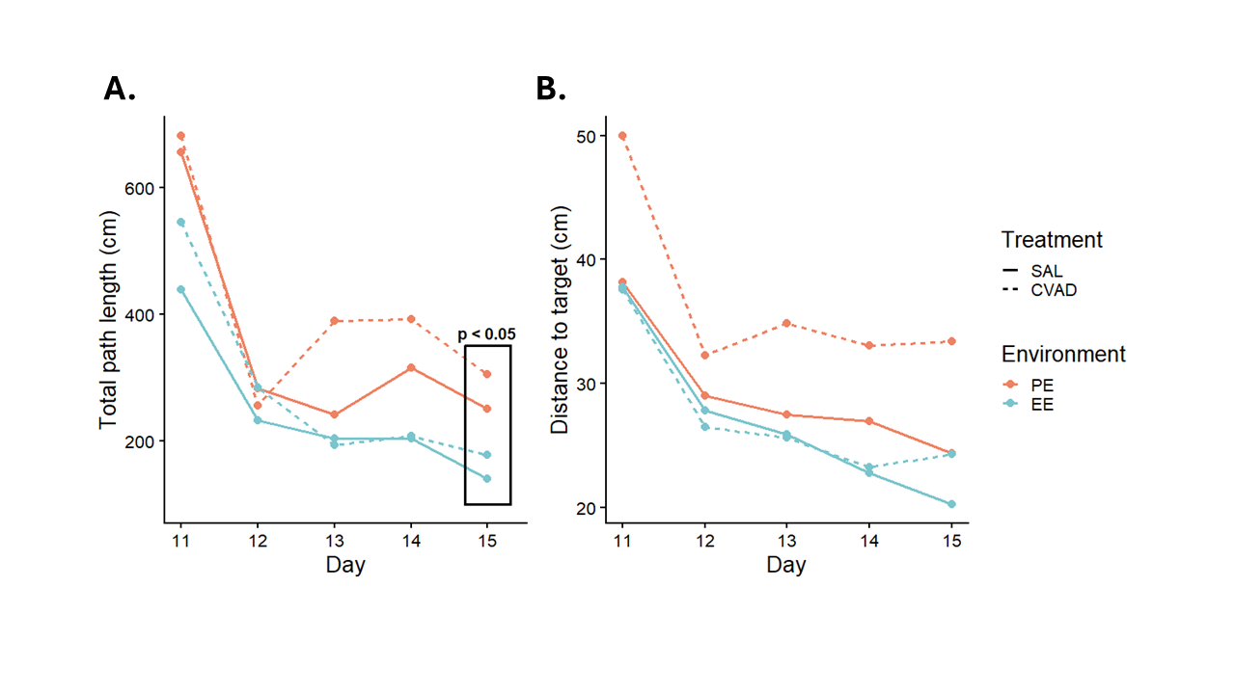
Note. (A) Total path length decreased over days; the black box highlights that only the environment group differences were present on Day 15. (B) Distance-to-target scores also declined over time. Dots represent group means for each day. SAL = Saline; CVAD = chemotherapy; PE = poor environment; EE = enriched environment.
To assess learning success during the reversal acquisition phase, a mixed-effects model was fitted to total path length on the final day. This analysis revealed a significant main effect of environment (t(29) = -2.30, p = 0.03, R² = 0.06), with EE-housed mice traveling less than PE-housed mice on the final day, indicating more successful learning. No effect of treatment (t(29) = 0.74, p = 0.47, R² = 0.006) or interaction was observed (t(29) = -0.18, p = 0.86, R² < 0.001). Consistent with this, the Bayesian analysis provided anecdotal evidence for the absence of a treatment (${BF}_{01}$= 0.42, ${HDI}_{90\%}$= [-0.22;0.74]) and interaction effect (${BF}_{01}$= 0.37, ${HDI}_{90\%}$= [-0.67;0.51]). Finally, we assessed retention of the reversal platform by fitting a two‑way ANOVA to time spent in the reversal quadrant during the final probe trial on Day 15. Neither treatment (F(1, 29) = 0.80, p = 0.78, η² = 0.003) nor environment (F(1, 29) = 0.87, p = 0.77, η² = 0.003) showed a significant main effect, and the interaction was also non‑significant (F(1, 29) = 1.54, p = 0.23, η² = 0.05). Together, this indicates that no detectable differences in memory retention are present. Bayesian analyses similarly provided only anecdotal evidence for the absence of treatment (${BF}_{01}$= 0.36, ${HDI}_{90\%}$= [-0.38;0.85]), environment (${BF}_{01}$= 0.41, ${HDI}_{90\%}$= [-0.91;0.32]), and interaction effects (${BF}_{01}$= 0.61, ${HDI}_{90\%}$= [-1.08;0.84]), suggesting that these null findings should be interpreted with caution.
Figure 17
Results from the Morris water maze reversal target quadrant probe trial.
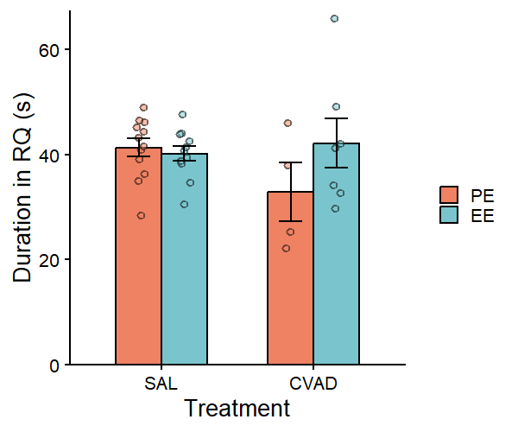
Note. Duration in the reversal target quadrant during the last probe trial (Day 15). Bars show means ± SEM; individual points represent raw data. SAL = Saline; CVAD = chemotherapy; PE = poor environment; EE = enriched environment.
  - Elevated T-maze
During the elevated T-maze task, total path length was used as an additional measure of general exploration (Figure 18A). We fitted a mixed-effects model with random intercepts to examine the effects of treatment, environment and stage. We included only the environment × treatment interaction because our focus was on overall differences in stage, rather than on how stage-specific effects varied across groups. Stage-related interactions did not provide additional insight into general exploration and were therefore omitted from the model. We found no significant main effect of stage (t(33) = 1.48, p = 0.15, R² = 0.02), indicating that mice explored equally during the training and testing phases. However, we did find a significant main effect of treatment (t(30) = -2.18, p = 0.04, R² = 0.10), whereas environment did not influence exploration (t(30) = 0.76, p = 0.45, R² = 0.01). Overall, chemotherapy-treated mice explored less than saline-treated mice. The environment × treatment interaction was also non-significant (t(30) = 0.72, p = 0.48, R² = 0.01). Bayes factors provided only anecdotal evidence for the absence of environment (${BF}_{01}$= 0.45, ${HDI}_{90\%}$= [-0.23;0.79]), stage (${BF}_{01}$= 0.45, ${HDI}_{90\%}$= [-0.03;0.48]), and interaction effects (${BF}_{01}$= 0.53, ${HDI}_{90\%}$= [-0.61;1.01]), indicating that additional data would be required to draw robust conclusions.
Figure 18
Results from the T-maze test.
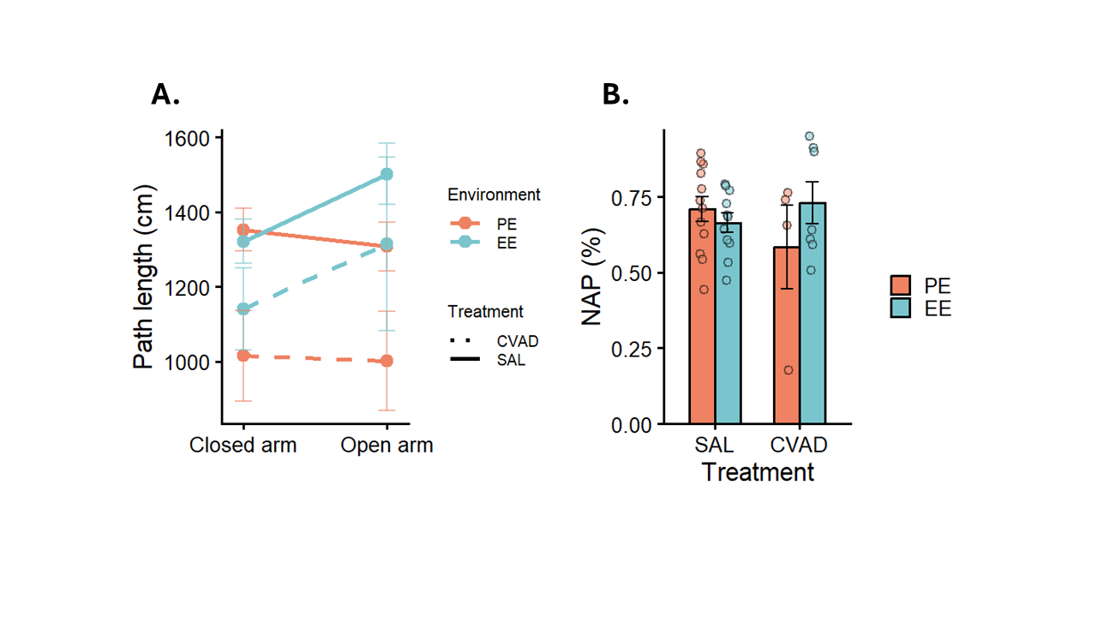
Note. (A) Overall locomotor activity, quantified as total path length (cm) across T-maze trials. “Closed arm” represents the first stage, during which one arm was blocked, and “Open arm” represents the second stage, where all arms were accessible. Dots represent cell means ± SEM. (B) Novel arm preference (NAP), calculated as the proportion of time spent in the novel arm relative to both arms, indexing spatial working memory. Bars show group means ± SEM with individual data points overlaid. SAL = Saline; CVAD = chemotherapy; PE = poor environment; EE = enriched environment.
To assess spatial working memory, we computed the novel arm preference (NAP) as the proportion of time spent in the novel arm relative to the total time spent in both arms (Figure 18B). A two‑way ANOVA revealed no significant main effects of treatment (F(1, 30) = 0.05, p = 0.83, η² = 0.002) or environment (F(1, 30) = 0.04, p = 0.83, η² = 0.001), and the interaction was also non‑significant (F(1, 30) = 2.54, p = 0.12, η² = 0.08), indicating no detectable differences in spatial working memory across groups. Accordingly, environmental enrichment did not provide a protective benefit against chemotherapy-induced spatial working memory deficits. However, while the Bayesian analysis provided moderate evidence for the absence of a treatment effect (${BF}_{01}$= 0.29, ${HDI}_{90\%}$= [-0.67;0.51]), it offered only anecdotal evidence for the absence of an environment effect (${BF}_{01}$= 0.35, ${HDI}_{90\%}$= [-0.37;0.80]) and no evidence regarding the interaction (${BF}_{01}$= 1.13, ${HDI}_{90\%}$= [-0.30;1.58]). This pattern suggests that the current dataset is not sufficiently informative, and these effects should therefore be interpreted with caution.
  - Passive avoidance
To assess associative learning and contextual memory, latency to enter the dark compartment during the passive avoidance test was analysed using a mixed-effects model with trial as the repeated factor and treatment and environment as between-subject factors (Figure 19). The analysis revealed a significant main effect of trial (t(30) = 3.68, p < 0.001, R² = 0.17), indicating that all animals showed learning across the two sessions regardless of treatment or environment. Neither treatment (t(30) = 0.06, p = 0.95, R² < 0.001) nor environment (t(30) = 0.25, p = 0.81, R² = 0.001) showed significant main effects. Bayesian analysis supported these findings, providing moderate evidence for the absence of an environment effect (${BF}_{01}$= 0.31, ${HDI}_{90\%}$= [-0.59;0.39]) and only anecdotal evidence for the absence of a treatment effect (${BF}_{01}$= 0.41, ${HDI}_{90\%}$= [-0.76;0.45]). None of the two way interactions (trial × environment (t(30) = -1.43, p = 0.16, R² = 0.03), trial × treatment (t(30) = -0.52, p = 0.61, R² = 0.004), or environment × treatment (t(30) = -0.10, p = 0.92, R² < 0.001)) reached significance. Bayes factors similarly indicated anecdotal evidence for the absence of trial x environment (${BF}_{01}$= 0.56, ${HDI}_{90\%}$= [-0.93;0.30]), trial x treatment (${BF}_{01}$= 0.48, ${HDI}_{90\%}$= [-0.67;0.87]) and treatment x environment effects (${BF}_{01}$= 0.53, ${HDI}_{90\%}$= [-0.52;1.00]). The three-way interaction (trial × environment × treatment) was also non-significant (t(30) = 1.90, p = 0.06, R² = 0.05), suggesting that enriched environment did not reliably protect against potential treatment-related impairments in learning. However, the Bayes factor for this interaction indicated anecdotal evidence for the presence of the effect (${BF}_{01}$= 2.25, ${HDI}_{90\%}$= [-0.02;1.88]). Taken together with the relatively small p-value, these results suggest that a subtle interaction may be present but the current dataset was insufficient to detect it. Further data is needed to clarify this possibility.

Figure 19
Results from the passive avoidance test.
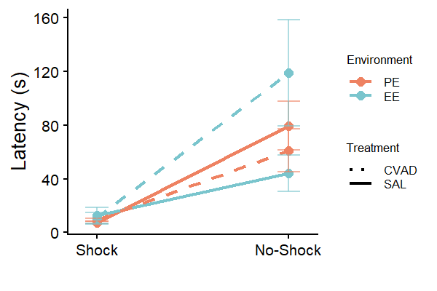
Note. Latencies to enter the dark room during the passive avoidance are presented. Shock represents the first part where animals got shocked, no-shock represents the 2nd part were animals did not receive a shock. Data are presented as group means conditioned on phase ± SEM. SAL = Saline; CVAD = chemotherapy; PE = poor environment; EE = enriched environment.

Discussion & Limitations
This thesis investigated the potential protective role of EE against chemotherapy-induced cognitive and physical impairments in juvenile mice. Using the Marlau® cage allowed us to combine multiple dimensions of enrichment (physical, social, sensory, and cognitive stimulation), thereby implementing a more comprehensive EE paradigm than is used in the literature at times. In parallel, we employed a chemotherapy protocol that more closely models the hyper-CVAD regimen used in human populations, increasing the ecological and clinical relevance of the work. Finally, by focusing on juvenile mice, the study more accurately reflects the developmental context of childhood ALL survivors. Overall, we found no consistent chemotherapy-induced impairment, but also no clear benefit of EE. We likewise did not observe a consistent neuroprotective buffer of EE against CICI. Instead, the effects appear to depend on the specific subdomain tested. In the following section, we discuss our findings, their limitations, and potential interpretations in each subdomain.
  - Physical and sensorimotor function
When considering the overall physical outcomes, we assessed general activity and exploratory behaviour across four tests. Across these four tests, the pattern of effects did not converge. We observed an environment effect in one test (with a possible small effect in the novel object recognition test) and a treatment effect in two others. The clear environment effect was only observed during the open field test. A plausible explanation for the strong environment effect in the open field test is that this task is more dependent on anxiety-related behaviour than the others. Whereas the SPSN, T-maze, and novel object recognition test were conducted in dimly lit arenas to minimize anxiety, the open field test is intentionally brightly lit to elicit anxiety. This interpretation is supported by the pattern in our anxiety measures, where an environment effect was present but a reliable treatment effect was not. It is therefore possible that locomotion in the open field test was confounded by processes more closely tied to anxiety than to general activity. A second explanation is that the influence of an EE on locomotion and exploration diminishes over time, which is consistent with the large effect in the open field test and the smaller effect in the novel object recognition test. Similarly, Amaral et al. (2008) reported that locomotor differences observed after four weeks of EE were no longer detectable following a two-month withdrawal period. The same study also indicated that a minimum of four weeks of enrichment is required to produce reliable locomotor effects. Given that our alternative EE was likely a weaker form of stimulation than the Marlau® cage, the animals effectively experienced only about two weeks of meaningful enrichment. This limited exposure may explain the rapid decline of EE-related locomotor effects. However, studies systematically combining EE duration with both short- and long-term behavioural assessments are still lacking, making this interpretation provisional. Interpreting the inconsistencies in treatment effects is more challenging, especially given the existing evidence for chemotherapy-induced changes in physical activity (Crouch et al., 2017). When examining the novel object recognition test, our only test showing substantial evidence against a treatment effect, it is important to note that locomotion in this task is quantified as time spent in the two object zones rather than as path length. This metric may reflect exploratory curiosity more than general locomotion. A mouse may move very little yet spend considerable time in the object zones, or conversely move extensively without remaining in those zones. In contrast, the other tests measured path length, which is a more direct and reliable index of overall activity. If we therefore treat the novel object recognition test as a less valid measure of true locomotion, the majority of remaining evidence points toward a treatment effect. Regardless of the presence of a treatment effect, it was clear that an EE did not provide a stronger protective benefit for chemotherapy-treated mice than for saline controls. Future work could examine whether more precise monitoring or more intensive forms of physical enrichment offer better protection against chemotherapy-related declines in physical activity. To conclude, chemotherapy appears to reliably alter overall activity, but EE does not provide protection against these deficits.
For the remaining physical and sensorimotor functions (motor coordination, nociception, and olfactory function), we did not observe any reliable effects. The tail-flick test assessing nociception was highly handling-intensive, which likely introduced substantial measurement error, as reflected in the large variability around the group means. A similar issue occurred in the rotarod (motor coordination) and Buried food-seeking test (olfactory function), where the signal-to-noise ratio was extremely low, making it difficult to detect any meaningful effects. Although the source of this noise is unclear, it is evident that there were large individual differences in performance. Interestingly, this pattern aligns with the documented inconsistency in olfactory function following chemotherapy in human populations (Spotten et al., 2017), where substantial interindividual variability is also observed. Future work should investigate what drives these individual differences and how they interact with chemotherapy and enrichment conditions.
  - Social and affective function
We assessed anxiety-like behaviour using two outcome measures in the open field test. When considered together, these measures provide little evidence that an EE reduced anxiety, regardless of treatment. This aligns with the broader literature showing that an EE can influence anxiety, but that its effects depend strongly on species, enrichment type, duration, group size, and other methodological factors (Lopes et al., 2018). Future work should therefore clarify the specific conditions under which EE mitigates anxiety-related behaviour. Similarly, chemotherapy did not increase anxiety in our cohort, despite reports of chemo-related affective disturbances in the literature. Notably, however, EE did exert a protective effect for CICI animals that was not observed in saline controls. One potential mechanism is that chemotherapy induces an exaggerated stress response, as seen in human patients where treatment alters stress-related biomarkers regulated by the hypothalamic–pituitary–adrenal (HPA) axis (Limberaki et al., 2011). Complementary animal work shows that EE reduces HPA-axis activation compared to PE housing (Belz et al., 2003). Together, these findings suggest that EE may buffer chemotherapy-induced alterations in HPA-axis responsiveness, thereby providing a selective protective effect in CICI mice.
In terms of general sociability, only an environmental effect emerged. This reduction in social approach in EE-housed mice is likely attributable to habituation, as increased social exposure in enriched cages may diminish the novelty value of an unfamiliar conspecific. Treatment did not alter sociability, and EE did not confer protection against chemotherapy-related social impairments. Importantly, the SPSN primarily indexes social novelty preference, not broader social functioning. As such, the observed effects may be task-specific rather than reflective of genuine differences in general sociability. Future work would benefit from incorporating more ecologically valid social tests to determine whether similar patterns emerge under more naturalistic social conditions.
  - Cognitive function
The majority of the behavioural tests in this thesis measured cognitive function, with a particular emphasis on different forms of memory. This focus aligns with our primary research question, whether EE can protect against CICI. In total, five tasks were used to assess distinct cognitive domains: the novel object recognition test, SPSN, Morris water maze, T-maze, and passive avoidance test. Together, these tests allowed us to evaluate recognition memory (object and social), spatial learning and memory, cognitive flexibility, spatial working memory, and associative learning.
For recognition memory, no group differences were observed, indicating that neither environment nor treatment influenced performance. Recognition memory, particularly social recognition, is relatively understudied in the chemotherapy literature. However, Seigers et al. (2015) compared multiple chemotherapeutic agents to chance performance in the novel object recognition task and found that only three out of eight treatment types failed to perform above chance, with some treatments even outperforming controls. Additionally, studies show that recognition memory relies primarily on the peri-postrhinal cortex, rather than the hippocampus, which supports spatial learning (Winters et al., 2004). To date, there is no clear evidence that chemotherapy damages peri-postrhinal cortical areas, whereas hippocampal vulnerability is extensively documented. If these cortical regions are relatively resistant to chemotherapy-induced neurotoxicity, recognition memory would be expected to remain intact. This could also explain why we did not observe a protective effect of EE: when baseline deficits are minimal or absent, detecting enrichment-related improvements becomes inherently more difficult. Future work could benefit from testing these assumptions at the neural level, as direct evidence on chemotherapy-induced changes in peri-postrhinal cortical areas is lacking. Such studies could clarify whether the preserved recognition memory observed here reflects true neurobiological resilience in these regions.
In comparison, the neurotoxic effects of chemotherapy on the hippocampus and the associated impairments in hippocampus-dependent spatial (working) memory are well-documented (Thomas et al., 2017; Yang et al., 2010; Yang et al., 2011). However, we did not observe consistent effects of treatment, environment, or a potential protective role of EE on spatial (working) memory or cognitive flexibility in this thesis. The absence of treatment differences is somewhat unexpected given the existing literature. One could argue that our treatment manipulation was ineffective, but the weight-loss data clearly indicate that the chemotherapy regimen produced the expected physiological impact (see Appendix Figure I, Table I, and Table II). Although we detected a treatment effect at the start of the Morris water maze, these early differences likely reflect differences in initial search strategies on day one rather than genuine differences in spatial (working) memory. It remains unclear why spatial memory did not differ between treatment groups. Bayes factors frequently yielded only anecdotal evidence for treatment effects and, in some cases, no evidence or anecdotal evidence for an interaction effect. This suggests that true effects cannot be ruled out but may have been too subtle to detect with the current sample size. As discussed later, the study is underpowered for several of the behavioural outcomes, and replication with a larger sample would be necessary to draw firm conclusions about the presence or absence of chemotherapy-induced spatial memory deficits.
Finally, Associative learning and fear-based memory were assessed using the passive avoidance task. Although aversive learning deficits have been reported in the literature (Kitamura et al., 2015), no such effects emerged in the present dataset. Neither treatment nor environment altered associative learning or fear-based memory. One possible explanation for the absence of these effects is through a ceiling effect. Fear-conditioned learning typically produces strong avoidance, creating a high and uniform motivation to learn across all animals, which may obscure potential group differences in learning. It is also important to note that this was the final task, conducted at least 28 days after the last treatment and after withdrawal from the EE. Stronger effects may therefore have diminished over time (Amaral et al., 2008). However, Bayesian analyses did indicate a potential protective effect of EE against chemotherapy-related impairments in fear-based memory. As suggested by the error bars in Figure 19, additional data would be required to determine whether this effect is robust and replicable.
  - General limitations
It is important to note that this thesis also has several overarching limitations. First, the consistently low Bayes factors for non-significant effects indicate that the study was underpowered to detect many effects, if small effects were present. This is not surprising given the small sample sizes, particularly within the CVAD group, where the PE condition included only four animals and the EE condition seven. Such numbers provide limited interpretability, especially for tasks with only a single trial, such as the buried food-seeking test or the probe trials in the Morris water maze. The reason for this constraint was mostly practical. During the period in which the experimental cohort was generated, the breeding colony yielded fewer offspring than expected. Due to project time constraints, additional litters could not be obtained, leading to the limited sample size. Second, the cognitive test battery was relatively limited and primarily assessed hippocampus-dependent functions. As discussed in the introduction, chemotherapy also affects other brain regions, including the PFC (Edelmann et al., 2014; Thomas et al., 2017). Including tasks that probe PFC-dependent domains would provide a more comprehensive assessment of chemotherapy-related cognitive impairment. Future studies using a more carefully selected set of cognitive tests that cover broader domains, rather than multiple tests assessing similar outcomes, may reveal effects not detectable in the present dataset. Finally, it is important to note that the cognitive testing battery itself may have acted as a confounding variable. Introducing repeated cognitive challenges could have provided enrichment even for PE-housed animals, thereby reducing the contrast between the environmental conditions.

Conclusion & Future Directions
To conclude, this thesis provides novelty by combining a comprehensive EE protocol with a chemotherapy regimen that closely models clinical treatment for ALL. Overall, the findings are mixed. Chemotherapy reliably altered physical, but not sensorimotor, function, and EE did not confer protection in either domain. At the cognitive level, there is little evidence that EE may serve as a non-pharmacological intervention, although additional data are needed to substantiate this pattern. In contrast, the affective results suggest a clearer protective effect of EE against chemotherapy-induced anxiety. Taken together, these findings offer tentative support for a protective role of EE in CICI and related behavioural domains, but the evidence is limited and insufficient to draw firm conclusions about the presence or absence of effects.
Future work should aim to determine when chemotherapy induces neural alterations and when these changes manifest behaviourally. Establishing this relationship is essential for evaluating whether EE can provide meaningful non-pharmacological protection. Further research should also strengthen the translational bridge. While mice offer a powerful model for controlled manipulations, humans are not mice, and the ultimate goal of this line of research is to improve the quality of life in clinical populations. This is particularly important for children experiencing CICI that disrupts daily functioning. Therefore, future studies would benefit from examining how a combined EE approach translates to human populations and whether protective effects can be achieved.

References
Ahmed, S. A., Omar, H. E.-D. M., & Abd Elghaffar, S. K. (2025). Vincristine sulfate induced neurotoxicity. Journal of Applied Molecular Biology, 3(1), 1–16. https://doi.org/10.21608/jamb.2024.309244.1028
Alfano, C. M., Peng, J., Andridge, R. R., Lindgren, M. E., Povoski, S. P., Lipari, A. M., Agnese, D. M., Farrar, W. B., Yee, L. D., Carson, W. E., & Kiecolt-Glaser, J. K. (2017). Inflammatory cytokines and comorbidity development in breast cancer survivors versus noncancer controls: Evidence for accelerated aging? Journal of Clinical Oncology, 35(2), 149–156. https://doi.org/10.1200/JCO.2016.67.1883
Alharbi, I., Alharbi, H., Almogbel, Y., Alalwan, A., & Alhowail, A. (2020). Effect of metformin on doxorubicin-induced memory dysfunction. Brain Sciences, 10(3), 152. https://doi.org/10.3390/brainsci10030152
Alhowail, A. H., Bloemer, J., Majrashi, M., Pinky, P. D., Bhattacharya, S., Yongli, Z., Bhattacharya, D., Eggert, M., Woodie, L., Buabeid, M. A., Johnson, N., Broadwater, A., Smith, B., Dhanasekaran, M., Arnold, R. D., & Suppiramaniam, V. (2019). Doxorubicin-induced neurotoxicity is associated with acute alterations in synaptic plasticity, apoptosis, and lipid peroxidation. Toxicology Mechanisms and Methods, 29(6), 457–466. https://doi.org/10.1080/15376516.2019.1600086
Amaral, O. B., Vargas, R. S., Hansel, G., Izquierdo, I., & Souza, D. O. (2008). Duration of environmental enrichment influences the magnitude and persistence of its behavioral effects on mice. Physiology & Behavior, 93(1–2), 388–394. https://doi.org/10.1016/j.physbeh.2007.09.009
Amézaga, J., Alfaro, B., Ríos, Y., Larraioz, A., Ugartemendia, G., Urruticoechea, A., & Tueros, I. (2018). Assessing taste and smell alterations in cancer patients undergoing chemotherapy according to treatment. Supportive Care in Cancer, 26(12), 4077–4086. https://doi.org/10.1007/s00520-018-4277-z
Barrera, M., & Schulte, F. (2009). A group social skills intervention program for survivors of childhood brain tumors. Journal of Pediatric Psychology, 34(10), 1108–1118. https://doi.org/10.1093/jpepsy/jsp018
Belcher, E. K., Culakova, E., Gilmore, N. J., Hardy, S. J., Kleckner, A. S., Kleckner, I. R., Lei, L., Heckler, C., Sohn, M. B., Thompson, B. D., Lotta, L. T., Werner, Z. A., Geer, J., Hopkins, J. O., Corso, S. W., Rich, D. Q., Van Wijngaarden, E., & Janelsins, M. C. (2022). Inflammation, attention, and processing speed in patients with breast cancer before and after chemotherapy. JNCI: Journal of the National Cancer Institute, 114(5), 712–721. https://doi.org/10.1093/jnci/djac022
Belz, E. E., Kennell, J. S., Czambel, R. K., Rubin, R. T., & Rhodes, M. E. (2003). Environmental enrichment lowers stress-responsive hormones in singly housed male and female rats. Pharmacology Biochemistry and Behavior, 76(3–4), 481–486. https://doi.org/10.1016/j.pbb.2003.09.005
Berlin, C., Lange, K., Lekaye, H. C., Hopland, K., Phillips, S., Piao, J., & Tabar, V. (2020). Long-term clinically relevant rodent model of methotrexate-induced cognitive impairment. Neuro-Oncology, 22(8), 1126–1137. https://doi.org/10.1093/neuonc/noaa086
Berlyne, D. (1950). Novelty and curiosity as determinants of exploratory behavior. British Journal of Psychology. General Section, 41(1-2), 68–80.
Bernal, J. D. K., Recchia, F., Yu, D. J., Fong, D. Y., Wong, S. H. S., Chung, P.-K., Chan, D. K. C., Capio, C. M., Yu, C. C. W., Wong, S. W. S., Sit, C. H. P., Chen, Y.-J., Thompson, W. R., & Siu, P. M. (2023). Physical activity and exercise for cancer-related cognitive impairment among individuals affected by childhood cancer: A systematic review and meta-analysis. The Lancet Child & Adolescent Health, 7(1), 47–58. https://doi.org/10.1016/S2352-4642(22)00286-3
Branchi, I., D’Andrea, I., Fiore, M., Di Fausto, V., Aloe, L., & Alleva, E. (2006). Early social enrichment shapes social behavior and nerve growth factor and brain-derived neurotrophic factor levels in the adult mouse brain. Biological Psychiatry, 60(7), 690–696. https://doi.org/10.1016/j.biopsych.2006.01.005
Briones, T. L., & Woods, J. (2014). Dysregulation in myelination mediated by persistent neuroinflammation: Possible mechanisms in chemotherapy-related cognitive impairment. Brain, Behavior, and Immunity, 35, 23–32. https://doi.org/10.1016/j.bbi.2013.07.175
Butler, R. W., & Copeland, D. R. (2002). Attentional processes and their remediation in children treated for cancer: A literature review and the development of a therapeutic approach. Journal of the International Neuropsychological Society, 8(1), 115–124. https://doi.org/10.1017/S1355617701020112
Butler, R. W., Copeland, D. R., Fairclough, D. L., Mulhern, R. K., Katz, E. R., Kazak, A. E., Noll, R. B., Patel, S. K., & Sahler, O. J. Z. (2008). A multicenter, randomized clinical trial of a cognitive remediation program for childhood survivors of a pediatric malignancy. Journal of Consulting and Clinical Psychology, 76(3), 367–378. https://doi.org/10.1037/0022-006X.76.3.367
Carey, M. E., Haut, M. W., Reminger, S. L., Hutter, J. J., Theilmann, R., & Kaemingk, K. L. (2008). Reduced frontal white matter volume in long-term childhood leukemia survivors: A voxel-based morphometry study. American Journal of Neuroradiology, 29(4), 792–797. https://doi.org/10.3174/ajnr.A0904
Çevik, Ö. S., Yıldırım, D. D., Uzun, C., & Horata, E. (2025). Contribution of distinctive outcome measures to the assessment of anxiety in the open field: A meta-analysis of factors mediating open-field test variability in rodent models of anxiety. Behavioural Brain Research, 490, 115612. https://doi.org/10.1016/j.bbr.2025.115612
Chen, C.-M., Hsu, B.-H., Chen, Y.-C., Cheng, S.-N., & Liaw, J.-J. (2015). Meshing gears: Mothers and their adolescents returning to their social life after cancer treatment in taiwan. Journal of Pediatric Oncology Nursing, 32(4), 219–229. https://doi.org/10.1177/1043454214563402
Crouch, M.-L., Knowels, G., Stuppard, R., Ericson, N. G., Bielas, J. H., Marcinek, D. J., & Syrjala, K. L. (2017). Cyclophosphamide leads to persistent deficits in physical performance and in vivo mitochondria function in a mouse model of chemotherapy late effects. PLOS ONE, 12(7), e0181086. https://doi.org/10.1371/journal.pone.0181086
d’Isa, R., Comi, G., & Leocani, L. (2021). Apparatus design and behavioural testing protocol for the evaluation of spatial working memory in mice through the spontaneous alternation T-maze. Scientific Reports, 11(1), 21177. https://doi.org/10.1038/s41598-021-00402-7
Deacon, R. M. J. (2013). Measuring motor coordination in mice. Journal of Visualized Experiments, 75, 2609. https://doi.org/10.3791/2609
Die-Trill, M., Bromberg, J., Lavally, B., Portales, L. A., Sanfeliz, A., & Patenaude, A. F. (1996). Development of social skills in boys with brain tumors: A group approach. Journal of Psychosocial Oncology, 14(2), 23–41. https://doi.org/10.1300/J077v14n02_02
Doulames, V., Lee, S., & Shea, T. B. (2014). Environmental enrichment and social interaction improve cognitive function and decrease reactive oxidative species in normal adult mice. International Journal of Neuroscience, 124(5), 369–376. https://doi.org/10.3109/00207454.2013.848441
Edelmann, M. N., Krull, K. R., Liu, W., Glass, J. O., Ji, Q., Ogg, R. J., Sabin, N. D., Srivastava, D. K., Robison, L. L., Hudson, M. M., & Reddick, W. E. (2014). Diffusion tensor imaging and neurocognition in survivors of childhood acute lymphoblastic leukaemia. Brain, 137(11), 2973–2983. https://doi.org/10.1093/brain/awu230
Farber, S., Diamond, L. K., Mercer, R. D., Sylvester, R. F., & Wolff, J. A. (1948). Temporary remissions in acute leukemia in children produced by folic acid antagonist, 4-aminopteroyl-glutamic acid (aminopterin). New England Journal of Medicine, 238(23), 787–793. https://doi.org/10.1056/NEJM194806032382301
Fares, R. P., Belmeguenai, A., Sanchez, P. E., Kouchi, H. Y., Bodennec, J., Morales, A., Georges, B., Bonnet, C., Bouvard, S., Sloviter, R. S., & Bezin, L. (2013). Standardized environmental enrichment supports enhanced brain plasticity in healthy rats and prevents cognitive impairment in epileptic rats. PLoS ONE, 8(1), e53888. https://doi.org/10.1371/journal.pone.0053888
Florian, C., & Roullet, P. (2004). Hippocampal CA3-region is crucial for acquisition and memory consolidation in Morris water maze task in mice. Behavioural Brain Research, 154(2), 365–374. https://doi.org/10.1016/j.bbr.2004.03.003
Force, L. M., Kocarnik, J. M., May, M. L., Bhangdia, K., Crist, A., Penberthy, L., Pritchett, N., Acheson, A., Deitesfeld, L., Aalruz, H., Abate, Y. H., Abouzid, M., Abreu, L. G., Aburuz, S., Afrashteh, F., Afzal, M. S., Ahmad, D., Ahmed, A., Ahmed, S. A., … Bhakta, N. (2026). Global burden of cancer in children and adolescents aged 0–19 years, 1990–2023: A systematic analysis for the Global Burden of Disease Study 2023. The Lancet, 407(10536), 1360–1373. https://doi.org/10.1016/S0140-6736(26)00200-X
Friedman, N. P., & Robbins, T. W. (2022). The role of prefrontal cortex in cognitive control and executive function. Neuropsychopharmacology, 47(1), 72–89. https://doi.org/10.1038/s41386-021-01132-0
Garcia-Manero, G., & Kantarjian, H. M. (2000). The hyper-CVAD regimen in adult acute lymphocytic leukemia. Hematology/Oncology Clinics of North America, 14(6), 1381–1396. https://doi.org/10.1016/S0889-8588(05)70192-1
Greenwood, B. N., Foley, T. E., Day, H. E. W., Campisi, J., Hammack, S. H., Campeau, S., Maier, S. F., & Fleshner, M. (2003). Freewheel running prevents learned helplessness/behavioral depression: Role of dorsal raphe serotonergic neurons. The Journal of Neuroscience, 23(7), 2889–2898. https://doi.org/10.1523/JNEUROSCI.23-07-02889.2003
Greenwood, B. N., Strong, P. V., Dorey, A. A., & Fleshner, M. (2007). Therapeutic effects of exercise: Wheel running reverses stress-induced interference with shuttle box escape. Behavioral Neuroscience, 121(5), 992–1000. https://doi.org/10.1037/0735-7044.121.5.992
Han, Y., Yuan, M., Guo, Y.-S., Shen, X.-Y., Gao, Z.-K., & Bi, X. (2022). The role of enriched environment in neural development and repair. Frontiers in Cellular Neuroscience, 16, 890666. https://doi.org/10.3389/fncel.2022.890666
Hiroi, R., Carbone, D. L., Zuloaga, D. G., Bimonte-Nelson, H. A., & Handa, R. J. (2016). Sex-dependent programming effects of prenatal glucocorticoid treatment on the developing serotonin system and stress-related behaviors in adulthood. Neuroscience, 320, 43–56. https://doi.org/10.1016/j.neuroscience.2016.01.055
Hunger, S. P., & Mullighan, C. G. (2015). Acute lymphoblastic leukemia in children. New England Journal of Medicine, 373(16), 1541–1552. https://doi.org/10.1056/NEJMra1400972
Hurria, A., Mohile, S., Gajra, A., Klepin, H., Muss, H., Chapman, A., Feng, T., Smith, D., Sun, C.-L., De Glas, N., Cohen, H. J., Katheria, V., Doan, C., Zavala, L., Levi, A., Akiba, C., & Tew, W. P. (2016). Validation of a prediction tool for chemotherapy toxicity in older adults with cancer. Journal of Clinical Oncology, 34(20), 2366–2371. https://doi.org/10.1200/JCO.2015.65.4327
Ibrahim, K. M., Darwish, S. F., Mantawy, E. M., & El-demerdash, E. (2024). Molecular mechanisms underlying cyclophosphamide-induced cognitive impairment and strategies for neuroprotection in preclinical models. Molecular and Cellular Biochemistry, 479(8), 1873–1893. https://doi.org/10.1007/s11010-023-04805-0
Ikonomidou, C. (2018). Chemotherapy and the pediatric brain. Molecular and Cellular Pediatrics, 5(1), 8. https://doi.org/10.1186/s40348-018-0087-0
Inaba, H., & Pui, C.-H. (2010). Glucocorticoid use in acute lymphoblastic leukaemia. The Lancet Oncology, 11(11), 1096–1106. https://doi.org/10.1016/S1470-2045(10)70114-5
Iyer, N. S., Balsamo, L. M., Bracken, M. B., & Kadan-Lottick, N. S. (2015). Chemotherapy-only treatment effects on long-term neurocognitive functioning in childhood ALL survivors: A review and meta-analysis. Blood, 126(3), 346–353. https://doi.org/10.1182/blood-2015-02-627414
Ja’afer, F. M. H., Hamdan, F. B., & Mohammed, F. H. (2006). Vincristine-induced neuropathy in rat: Electrophysiological and histological study. Experimental Brain Research, 173(2), 334–345. https://doi.org/10.1007/s00221-006-0499-2
Jabbour, E., & Kantarjian, H. (2021). The hyper-CVAD regimen is an optimal pediatric-inspired regimen for adolescents and adults with acute lymphoblastic leukemia. Clinical Lymphoma Myeloma and Leukemia, 21(1), 63–65. https://doi.org/10.1016/j.clml.2020.09.001
Jeffreys, H. (1961). Theory of probability (3rd ed.). Oxford University Press.
Kantarjian, H. M., O’Brien, S., Smith, T. L., Cortes, J., Giles, F. J., Beran, M., Pierce, S., Huh, Y., Andreeff, M., Koller, C., Ha, C. S., Keating, M. J., Murphy, S., & Freireich, E. J. (2000). Results of treatment with hyper-CVAD, a dose-intensive regimen, in adult acute lymphocytic leukemia. Journal of Clinical Oncology, 18(3), 547–547. https://doi.org/10.1200/JCO.2000.18.3.547
Kciuk, M., Gielecińska, A., Mujwar, S., Kołat, D., Kałuzińska-Kołat, Ż., Celik, I., & Kontek, R. (2023). Doxorubicin—an agent with multiple mechanisms of anticancer activity. Cells, 12(4), 659. https://doi.org/10.3390/cells12040659
Kesting, S. V., Götte, M., Seidel, C. C., Rosenbaum, D., & Boos, J. (2016). One in four questioned children faces problems regarding reintegration into physical education at school after treatment for pediatric cancer. Pediatric Blood & Cancer, 63(4), 737–739. https://doi.org/10.1002/pbc.25852
Khalil, M. H. (2024). Environmental enrichment: A systematic review on the effect of a changing spatial complexity on hippocampal neurogenesis and plasticity in rodents, with considerations for translation to urban and built environments for humans. Frontiers in Neuroscience, 18, 1368411. https://doi.org/10.3389/fnins.2024.1368411
Kim, H.-G., Rashid, M. A., Poleschuk, M., Ullah, F., Lee, S. H., Kim, S. H., Qin, B., Zheng, X. F. S., & Jang, M.-H. (2025). Cognitive dysfunction in chemobrain: Molecular mechanisms and therapeutic implications. Biomedicine & Pharmacotherapy, 192, 118581. https://doi.org/10.1016/j.biopha.2025.118581
Kitamura, Y., Hattori, S., Yoneda, S., Watanabe, S., Kanemoto, E., Sugimoto, M., Kawai, T., Machida, A., Kanzaki, H., Miyazaki, I., Asanuma, M., & Sendo, T. (2015). Doxorubicin and cyclophosphamide treatment produces anxiety-like behavior and spatial cognition impairment in rats: Possible involvement of hippocampal neurogenesis via brain-derived neurotrophic factor and cyclin D1 regulation. Behavioural Brain Research, 292, 184–193. https://doi.org/10.1016/j.bbr.2015.06.007
Kotb, M. G., Soliman, A. E. R., Ibrahim, R. I., Said, R. M. M., & El Din, M. M. W. (2019). Chemotherapy-induced cognitive impairment in hematological malignancies. The Egyptian Journal of Neurology, Psychiatry and Neurosurgery, 55(1), 56. https://doi.org/10.1186/s41983-019-0104-9
Laaker, C. J., Cantelon, C., Davis, A. B., Lloyd, K. R., Agyeman, N., Hiltz, A. R., Smith, B. L., Konsman, J. P., & Reyes, T. M. (2023). Early life cancer and chemotherapy lead to cognitive deficits related to alterations in microglial-associated gene expression in prefrontal cortex. Brain, Behavior, and Immunity, 113, 176–188. https://doi.org/10.1016/j.bbi.2023.07.009
Lam, C. G., Howard, S. C., Bouffet, E., & Pritchard-Jones, K. (2019). Science and health for all children with cancer. Science, 363(6432), 1182–1186. https://doi.org/10.1126/science.aaw4892
Leo, S., Straetemans, R., Dhooge, R., & Meert, T. (2008). Differences in nociceptive behavioral performance between C57BL/6J, 129S6/SvEv, B6 129 F1 and NMRI mice. Behavioural Brain Research, 190(2), 233–242. https://doi.org/10.1016/j.bbr.2008.03.001
Li, A.-L., Crystal, J. D., Lai, Y. Y., Sajdyk, T. J., Renbarger, J. L., & Hohmann, A. G. (2021). An adolescent rat model of vincristine-induced peripheral neuropathy. Neurobiology of Pain, 10, 100077. https://doi.org/10.1016/j.ynpai.2021.100077
Li, Y., Vijayanathan, V., Gulinello, M. E., & Cole, P. D. (2010). Systemic methotrexate induces spatial memory deficits and depletes cerebrospinal fluid folate in rats. Pharmacology Biochemistry and Behavior, 94(3), 454–463. https://doi.org/10.1016/j.pbb.2009.10.008
Limberaki, E., Eleftheriou, P., Gasparis, G., Karalekos, E., Kostoglou, V., & Petrou, C. (2011). Cortisol levels and serum antioxidant status following chemotherapy. Health, 3(8), 512–517. https://doi.org/10.4236/health.2011.38085
Loke, J., & Kansagra, A. J. (2022). Fast Facts: Leukemia (2nd ed.). S. Karger AG. https://doi.org/10.1159/isbn.978-3-318-06949-5
Lopes, D. A., Céspedes, I. C., & Viana, M. B. (2018). Effects of environmental enrichment on anxiety measurements: A review. Research and Reviews: Neuroscience, 2(1), 1–6.
Lueptow, L. M. (2017). Novel object recognition test for the investigation of learning and memory in mice. Journal of Visualized Experiments, 126, 55718. https://doi.org/10.3791/55718
Machado, C., Reis-Silva, T., Lyra, C., Felicio, L., & Malnic, B. (2018). Buried food-seeking test for the assessment of olfactory detection in mice. BIO-PROTOCOL, 8(12), e2897. https://doi.org/10.21769/BioProtoc.2897
Matsos, A., Loomes, M., Zhou, I., Macmillan, E., Sabel, I., Rotziokos, E., Beckwith, W., & Johnston, I. N. (2017). Chemotherapy-induced cognitive impairments: White matter pathologies. Cancer Treatment Reviews, 61, 6–14. https://doi.org/10.1016/j.ctrv.2017.09.010
Mora, E., Smith, E. M. L., Donohoe, C., & Hertz, D. L. (2016). Vincristine-induced peripheral neuropathy in pediatric cancer patients. American Journal of Cancer Research, 6(11), 2416–2430.
Moretti, R. L., Dias, E. N., Kiel, S. G., Augusto, M. C. M., Rodrigues, P. S., Sampaio, A. C. S., Medeiros, L. S., Martins, M. F. M., Suffredini, I. B., Cardoso, C. V., & Bondan, E. F. (2021). Behavioral and morphological effects of resveratrol and curcumin in rats submitted to doxorubicin-induced cognitive impairment. Research in Veterinary Science, 140, 242–250. https://doi.org/10.1016/j.rvsc.2021.09.009
Morris, R. G. M. (1981). Spatial localization does not require the presence of local cues. Learning and Motivation, 12(2), 239–260. https://doi.org/10.1016/0023-9690(81)90020-5
Moy, S. S., Nadler, J. J., Perez, A., Barbaro, R. P., Johns, J. M., Magnuson, T. R., Piven, J., & Crawley, J. N. (2004). Sociability and preference for social novelty in five inbred strains: An approach to assess autistic‐like behavior in mice. Genes, Brain and Behavior, 3(5), 287–302. https://doi.org/10.1111/j.1601-1848.2004.00076.x
Mshaymesh, S. (2025). Neurotoxic effects of the chemotherapeutic drug “methotrexate”: A literature review. Annals of Medicine & Surgery, 87(3), 1394–1405. https://doi.org/10.1097/MS9.0000000000002863
Nadler, J. J., Moy, S. S., Dold, G., D. Trang, Simmons, N., Perez, A., Young, N. B., Barbaro, R. P., Piven, J., Magnuson, T. R., & Crawley, J. N. (2004). Automated apparatus for quantitation of social approach behaviors in mice. Genes, Brain and Behavior, 3(5), 303–314. https://doi.org/10.1111/j.1601-183X.2004.00071.x
Nilsson, M., Perfilieva, E., Johansson, U., Orwar, O., & Eriksson, P. S. (1999). Enriched environment increases neurogenesis in the adult rat dentate gyrus and improves spatial memory. Journal of Neurobiology, 39(4), 569–578. https://doi.org/10.1002/(SICI)1097-4695(19990615)39:4%253C569::AID-NEU10%253E3.0.CO;2-F
Norin, T., & Onyango, J. (1977). Radiotherapy in Burkitt’s lymphoma conventional or superfractionated regime—Early results. International Journal of Radiation Oncology*Biology*Physics, 2(5–6), 399–406. https://doi.org/10.1016/0360-3016(77)90149-3
Ögren, S. O., & Stiedl, O. (2015). Passive avoidance. In I. P. Stolerman & L. H. Price (Eds.), Encyclopedia of Psychopharmacology (pp. 1220–1228). Springer Berlin Heidelberg. https://doi.org/10.1007/978-3-642-36172-2
Oliveira, M., Bessa, J. M., Mesquita, A., Tavares, H., Carvalho, A., Silva, R., Pêgo, J. M., Cerqueira, J. J., Palha, J. A., Almeida, O. F. X., & Sousa, N. (2006). Induction of a hyperanxious state by antenatal dexamethasone: A case for less detrimental natural corticosteroids. Biological Psychiatry, 59(9), 844–852. https://doi.org/10.1016/j.biopsych.2005.08.020
Olson, R. D., & Mushlin, P. S. (1990). Doxorubicin cardiotoxicity: Analysis of prevailing hypotheses. The FASEB Journal, 4(13), 3076–3086. https://doi.org/10.1096/fasebj.4.13.2210154
Onaka, Y., Yamaguchi, T., & Yoneyama, M. (2022). Treatment with cyclophosphamide in post-weaning mice causes prolonged suppression of neural stem cell proliferation in the hippocampal dentate gyrus. Brain Research, 1796, 148108. https://doi.org/10.1016/j.brainres.2022.148108
Osborne, J. W. (2000). Advantages of Hierarchical Linear Modeling. Practical Assessment, Research, and Evaluation, 7(1), 1. https://doi.org/10.7275/PMGN-ZX89
Othman, M. Z., Hassan, Z., & Che Has, A. T. (2022). Morris water maze: A versatile and pertinent tool for assessing spatial learning and memory. Experimental Animals, 71(3), 264–280. https://doi.org/10.1538/expanim.21-0120
Puig, L. (2014). Methotrexate: New therapeutic approaches. Actas Dermo-Sifiliográficas (English Edition), 105(6), 583–589. https://doi.org/10.1016/j.adengl.2014.05.011
Redish, A. D., & Touretzky, D. S. (1998). The role of the hippocampus in solving the Morris water maze. Neural Computation, 10(1), 73–111. https://doi.org/10.1162/089976698300017908
Reiriz, A. B., Reolon, G. K., Preissler, T., Rosado, J. O., Henriques, J. A. P., Roesler, R., & Schwartsmann, G. (2006). Cancer chemotherapy and cognitive function in rodent models: Memory impairment induced by cyclophosphamide in mice. Clinical Cancer Research, 12(16), 5000–5001. https://doi.org/10.1158/1078-0432.CCR-06-0138
Ren, X., Keeney, J. T. R., Miriyala, S., Noel, T., Powell, D. K., Chaiswing, L., Bondada, S., St. Clair, D. K., & Butterfield, D. A. (2019). The triangle of death of neurons: Oxidative damage, mitochondrial dysfunction, and loss of choline-containing biomolecules in brains of mice treated with doxorubicin. Advanced insights into mechanisms of chemotherapy induced cognitive impairment (“chemobrain”) involving TNF-α. Free Radical Biology and Medicine, 134, 1–8. https://doi.org/10.1016/j.freeradbiomed.2018.12.029
Revilla, S., Suñol, C., García-Mesa, Y., Giménez-Llort, L., Sanfeliu, C., & Cristòfol, R. (2014). Physical exercise improves synaptic dysfunction and recovers the loss of survival factors in 3xTg-AD mouse brain. Neuropharmacology, 81, 55–63. https://doi.org/10.1016/j.neuropharm.2014.01.037
Salehinejad, M. A., Ghanavati, E., Rashid, M. H. A., & Nitsche, M. A. (2021). Hot and cold executive functions in the brain: A prefrontal-cingular network. Brain and Neuroscience Advances, 5, 1–19. https://doi.org/10.1177/23982128211007769
Schmalz, X., Biurrun Manresa, J., & Zhang, L. (2023). What is a Bayes factor? Psychological Methods, 28(3), 705–718. https://doi.org/10.1037/met0000421
Seigers, R., Loos, M., Van Tellingen, O., Boogerd, W., Smit, A. B., & Schagen, S. B. (2015). Cognitive impact of cytotoxic agents in mice. Psychopharmacology, 232(1), 17–37. https://doi.org/10.1007/s00213-014-3636-9
Shih, Y.-C. T., Smieliauskas, F., Geynisman, D. M., Kelly, R. J., & Smith, T. J. (2015). Trends in the Cost and Use of Targeted Cancer Therapies for the Privately Insured Nonelderly: 2001 to 2011. Journal of Clinical Oncology, 33(19), 2190–2196. https://doi.org/10.1200/JCO.2014.58.2320
Shobe, J. L., Ghanbarian, E., Bain, R., Saxena, R., Chandrasekaran, M., & McNaughton, B. L. (2025). Cognitive enrichment improves spatial memory and alters hippocampal synaptic connectivity in a mouse model for early-life stress. Frontiers in Cellular Neuroscience, 19, 1646883. https://doi.org/10.3389/fncel.2025.1646883
Siegel, S. E., Advani, A., Seibel, N., Muffly, L., Stock, W., Luger, S., Shah, B., DeAngelo, D. J., Freyer, D. R., Douer, D., Johnson, R. H., Hayes‐Lattin, B., Lewis, M., Jaboin, J. J., Coccia, P. F., & Bleyer, A. (2018). Treatment of young adults with Philadelphia‐negative acute lymphoblastic leukemia and lymphoblastic lymphoma: Hyper‐CVAD vs. pediatric‐inspired regimens. American Journal of Hematology, 93(10), 1254–1266. https://doi.org/10.1002/ajh.25229
Škubník, J., Pavlíčková, V. S., Ruml, T., & Rimpelová, S. (2021). Vincristine in combination therapy of cancer: Emerging trends in clinics. Biology, 10(9), 849. https://doi.org/10.3390/biology10090849
Soares, J., Holmes, P. V., Renner, K. J., Edwards, G. L., Bunnell, B. N., & Dishman, R. K. (1999). Brain noradrenergic responses to footshock after chronic activity-wheel running. Behavioral Neuroscience, 113(3), 558–566. https://doi.org/10.1037/0735-7044.113.3.558
Spotten, L. E., Corish, C. A., Lorton, C. M., Ui Dhuibhir, P. M., O’Donoghue, N. C., O’Connor, B., & Walsh, T. D. (2017). Subjective and objective taste and smell changes in cancer. Annals of Oncology, 28(5), 969–984. https://doi.org/10.1093/annonc/mdx018
Steliarova-Foucher, E., Colombet, M., Ries, L. A. G., Moreno, F., Dolya, A., Bray, F., Hesseling, P., Shin, H. Y., Stiller, C. A., & the IICC-3 contributors. (2017). International incidence of childhood cancer, 2001–10: A population-based registry study. The Lancet Oncology, 18(6), 719–731. https://doi.org/10.1016/S1470-2045(17)30186-9
Sze, C.-I., Lin, Y.-C., Lin, Y.-J., Hsieh, T.-H., Kuo, Y. M., & Lin, C.-H. (2013). The role of glucocorticoid receptors in dexamethasone-induced apoptosis of neuroprogenitor cells in the hippocampus of rat pups. Mediators of Inflammation, 2013, 628094. https://doi.org/10.1155/2013/628094
Thomas, T. C., Beitchman, J. A., Pomerleau, F., Noel, T., Jungsuwadee, P., Butterfield, D. A., Clair, D. K. St., Vore, M., & Gerhardt, G. A. (2017). Acute treatment with doxorubicin affects glutamate neurotransmission in the mouse frontal cortex and hippocampus. Brain Research, 1672, 10–17. https://doi.org/10.1016/j.brainres.2017.07.003
Urruticoechea, A., Alemany, R., Balart, J., Villanueva, A., Vinals, F., & Capella, G. (2010). Recent Advances in Cancer Therapy: An Overview. Current Pharmaceutical Design, 16(1), 3–10. https://doi.org/10.2174/138161210789941847
Van Der Borght, K., Havekes, R., Bos, T., Eggen, B. J. L., & Van Der Zee, E. A. (2007). Exercise improves memory acquisition and retrieval in the Y-maze task: Relationship with hippocampal neurogenesis. Behavioral Neuroscience, 121(2), 324–334. https://doi.org/10.1037/0735-7044.121.2.324
Van Der Merwe, J. L., Sacco, A., Toelen, J., & Deprest, J. (2020). Long-term neuropathological and/or neurobehavioral effects of antenatal corticosteroid therapy in animal models: A systematic review. Pediatric Research, 87(7), 1157–1170. https://doi.org/10.1038/s41390-019-0712-1
Van Praag, H., Christie, B. R., Sejnowski, T. J., & Gage, F. H. (1999). Running enhances neurogenesis, learning, and long-term potentiation in mice. Proceedings of the National Academy of Sciences, 96(23), 13427–13431. https://doi.org/10.1073/pnas.96.23.13427
Vance, Y. H., Eiser, C., & Horne, B. (2004). Parents’ views of the impact of childhood brain tumours and treatment on young people’s social and family functioning. Clinical Child Psychology and Psychiatry, 9(2), 271–288. https://doi.org/10.1177/1359104504041923
Wagenmakers, E.-J., Love, J., Marsman, M., Jamil, T., Ly, A., Verhagen, J., Selker, R., Gronau, Q. F., Dropmann, D., Boutin, B., Meerhoff, F., Knight, P., Raj, A., Van Kesteren, E.-J., Van Doorn, J., Šmíra, M., Epskamp, S., Etz, A., Matzke, D., … Morey, R. D. (2018). Bayesian inference for psychology. Part II: Example applications with JASP. Psychonomic Bulletin & Review, 25(1), 58–76. https://doi.org/10.3758/s13423-017-1323-7
Walker, A. J., Lewis, F. M., Lin, Y., Zahlis, E., & Rosenberg, A. R. (2019). Trying to feel normal again: Early survivorship for adolescent cancer survivors. Cancer Nursing, 42(4), E11–E21. https://doi.org/10.1097/NCC.0000000000000629
Wen, J., Maxwell, R. R., Wolf, A. J., Spira, M., Gulinello, M. E., & Cole, P. D. (2018). Methotrexate causes persistent deficits in memory and executive function in a juvenile animal model. Neuropharmacology, 139, 76–84. https://doi.org/10.1016/j.neuropharm.2018.07.007
Wengenroth, L., Rueegg, C. S., Michel, G., Gianinazzi, M. E., Essig, S., Von Der Weid, N. X., Grotzer, M., Kuehni, C. E., & for the Swiss Paediatric Oncology Group SPOG. (2015). Concentration, working speed and memory: Cognitive problems in young childhood cancer survivors and their siblings. Pediatric Blood & Cancer, 62(5), 875–882. https://doi.org/10.1002/pbc.25396
Winick, N. (2011). Neurocognitive outcome in survivors of pediatric cancer. Current Opinion in Pediatrics, 23(1), 27–33. https://doi.org/10.1097/MOP.0b013e32834255e9
Winocur, G., Wojtowicz, J. M., Merkley, C. M., & Tannock, I. F. (2016). Environmental enrichment protects against cognitive impairment following chemotherapy in an animal model. Behavioral Neuroscience, 130(4), 428–436. https://doi.org/10.1037/bne0000155
Winters, B. D., Forwood, S. E., Cowell, R. A., Saksida, L. M., & Bussey, T. J. (2004). Double dissociation between the effects of peri-postrhinal cortex and hippocampal lesions on tests of object recognition and spatial memory: heterogeneity of function within the temporal lobe. The Journal of Neuroscience, 24(26), 5901–5908. https://doi.org/10.1523/JNEUROSCI.1346-04.2004
Wu, Y., Gan, Y., Yuan, H., Wang, Q., Fan, Y., Li, G., Zhang, J., Yao, M., Gu, J., & Tu, H. (2016). Enriched environment housing enhances the sensitivity of mouse pancreatic cancer to chemotherapeutic agents. Biochemical and Biophysical Research Communications, 473(2), 593–599. https://doi.org/10.1016/j.bbrc.2016.03.128
Yang, M., Kim, J.-S., Kim, J., Kim, S.-H., Kim, J.-C., Kim, J., Wang, H., Shin, T., & Moon, C. (2011). Neurotoxicity of methotrexate to hippocampal cells in vivo and in vitro. Biochemical Pharmacology, 82(1), 72–80. https://doi.org/10.1016/j.bcp.2011.03.020
Yang, M., Kim, J.-S., Song, M.-S., Kim, S.-H., Kang, S. S., Bae, C.-S., Kim, J.-C., Wang, H., Shin, T., & Moon, C. (2010). Cyclophosphamide impairs hippocampus-dependent learning and memory in adult mice: Possible involvement of hippocampal neurogenesis in chemotherapy-induced memory deficits. Neurobiology of Learning and Memory, 93(4), 487–494. https://doi.org/10.1016/j.nlm.2010.01.006
Yılmaz, T., Gedikli, Ö., & Yildirim, M. (2015). Evaluation of spatial memory and locomotor activity during hypercortisolism induced by the administration of dexamethasone in adult male rats. Brain Research, 1595, 43–50. https://doi.org/10.1016/j.brainres.2014.04.034
Yolanda, S., Redjeki, S., Andraini, T., Santoso, D. I. S., Ibrahim, N., & Mailani, R. (2019). Combination of aerobic exercise and continuous environmental enrichment improves adult male rats’ spatial memory: Study on hippocampal insulin like growth factor 1 (IGF-1) and fibroblast growth factor 2 (FGF-2) expression. The Indonesian Biomedical Journal, 11(2), 210–216. https://doi.org/10.18585/inabj.v11i2.731

