KU LEUVEN

FACULTEIT PSYCHOLOGIE EN
PEDAGOGISCHE WETENSCHAPPEN

TITEL VAN DE MASTERPROEF
Eventuele ondertitel

Masterproef aangeboden tot het verkrijgen van de graad van Master of Science in de psychologie door
Siebe Everaerts

promotor: Prof. Dr. Zsuzsanna Callaerts-Végh
copromotor: (indien van toepassing)
m.m.v.: Congcong Gao

2025-2026

Introduction
- Pediatric Cancer and Treatments
Cancer is a major global health burden and remains one of the leading causes of disease-related death among children worldwide. Each year, an estimated 400.000 children and adolescents (0–19 years) are diagnosed with cancer, posing a particularly severe threat to vulnerable populations (Lam et al., 2019). Although global childhood cancer mortality has declined over recent decades, approximately 38% of affected children still die from the disease, with the burden being highest for low- and middle-income countries (Force et al., 2026). Among pediatric cancers, acute lymphoblastic leukemia (ALL) is the most common subtype, originating in hematopoietic stem and progenitor cells. Malignant transformation disrupts normal blood cell development, leading to uncontrolled proliferation of abnormal leukocytes and impaired immune and hematopoietic function (Loke & Kansagra, 2022; Steliarova-Foucher et al., 2017). Many treatments for pediatric cancer exist but the most common current treatment strategies include radiotherapy, immunotherapy, surgery, and chemotherapy, with the latter being the most widely used due to its acknowledged efficacy (Urruticoechea et al., 2010; Shih et al., 2015).
One of the most widely used pediatric chemotherapy regimens is hyper-CVAD, an intensive multi-agent chemotherapy protocol for aggressive hematologic malignancies. Developed by Kantarjian and colleagues in the late 1980s, it was modeled after pediatric ALL regimens but designed with a reduced reliance on asparaginase due to its well-documented toxicity profile (Jabbour & Kantarjian, 2021). The dose-intensive phase of the regimen consists of eight courses of alternating chemotherapy: four cycles of hyper-CVAD alternating with four cycles of high-dose methotrexate (MTX) plus high-dose cytarabine (Garcia-Manero & Kantarjian, 2000). The hyper-CVAD cycle consists of cyclophosphamide (CYC), vincristine (VIN), doxorubicin (DOX), and dexamethasone (DEX). CYC is included because alkylating agents have demonstrated strong efficacy in treating highly proliferative B-cell malignancies such as Burkitt lymphoma, making it a key cytotoxic backbone in intensive ALL-derived regimens (Norin & Onyango, 1977). VIN is included because it is an antimitotic compound that disrupts microtubule dynamics and arrests the cell cycle, making it an effective agent against rapidly dividing cancer cells (Škubník et al., 2021). Doxorubicin is an anthracycline antitumor antibiotic that inhibits topoisomerase II, preventing cancer cells from properly unwinding their DNA. This causes DNA strand breaks and ultimately stops the cells from replicating (Kciuk et al., 2023). DEX is included because it has strong anti-inflammatory effects and binds to glucocorticoid receptors to alter gene expression in lymphoid cells, reducing cytokine production and inducing apoptosis (Inaba & Pui, 2010). Furthermore, it additionally has a long half-life and penetrates the CNS well. The other cycle includes MTX, a folate antagonist that blocks DNA replication by interfering with the synthesis of purines and pyrimidines, making it a well-suited component to treat ALL (Puig, 2014). Although cytarabine is occasionally administered alongside MTX, it was not part of our treatment protocol and will therefore not be discussed in this thesis. Taken together, these agents form a potent combination that has demonstrated strong clinical efficacy in the treatment of ALL (Kantarjian et al., 2000).
- Chemobrain: Definition, Mechanisms, and Potential Interventions
Over the past five decades, advances in these treatments, including regimens such as hyper-CVAD, have led to substantial improvements in survival for ALL (Dmochowski & Norcia, 2015). However, these gains come with an increased risk of long-term treatment-related conditions. One of the most common adverse effects of chemotherapy regimens, such as hyper-CVAD, is the development of neurocognitive deficits (Ikonomidou, 2018). These cognitive impairments, collectively referred to as chemotherapy-induced cognitive impairment (CICI) or ‘chemobrain’ encompass difficulties in memory, attention, processing speed, and executive functioning (Belcher et al., 2022; Kotb et al., 2019; Winick, 2011). For example, Wengenroth et al. (2015) found that childhood cancer survivors showed reduced concentration, slower processing speed, and lower memory capacity compared to their healthy siblings, independent of treatment type. Similarly, a meta-analysis by Iyer et al. (2015) demonstrated that survivors of acute lymphoblastic leukemia (ALL) performed worse than healthy controls across three Wechsler intelligence scale domains, highlighting the broad neurocognitive deficits associated with chemotherapy exposure. In real-world settings, these cognitive difficulties can express themselves as challenges in daily life functioning and academic reintegration. For instance, children returning to school often struggle with the transition back to school and overall academic performance (Chen et al., 2015; Walker et al., 2019). Related to this, studies show that pediatric cancer survivors often experience difficulties reintegrating into physical education at school, which can occur in both the short and long term (Kesting et al., 2016). Social functioning may also be affected: some survivors report challenges with peer relationships and even symptoms of social phobia (Vance et al., 2004). In the same study, parents additionally noted difficulties in everyday tasks such as managing finances and maintaining personal hygiene, underscoring the broader impact of treatment-related neurocognitive deficits. Overall, the evidence indicates that chemotherapy-related cognitive impairments extend well beyond isolated test performance, affecting school participation, social relationships, and routine daily activities.
At the neural level, several mechanisms have been proposed to explain the emergence of these deficits. One prominent theory suggests that neurotoxic chemotherapeutic agents cross the blood–brain barrier (BBB), triggering excessive generation of reactive oxygen species (ROS) that induce DNA damage and mitochondrial dysfunction. These processes can ultimately impair synaptic plasticity and reduce neurogenesis (Kim et al., 2025). Another account proposes that chemotherapy disrupts white matter integrity, which in turn contributes to cognitive deficits (Matsos et al., 2017). However, the underlying mechanism of this account is unknown. Some research shows both in vitro and in vivo that chemotherapeutic agents reduce the population of oligodendrocyte precursor cells (Briones & Woods, 2014). Because these precursor cells give rise to oligodendrocytes, which produce and maintain myelin sheaths in the CNS, their loss may impair myelination and disrupt neural signaling. Another hypothesis proposes that these white-matter alterations may reflect accelerated neural ageing, as patients often exhibit age-related comorbidities such as elevated inflammatory biomarkers and increased cardiovascular risk (Alfano et al., 2017; Hurria et al., 2016). When considering these possible alterations in survivors of pediatric cancer, the concern extends beyond changes in brain structure to potential disruptions in typical brain development. For example, a voxel-based morphometry study found that survivors of ALL showed reduced white-matter volume in the right prefrontal cortex (PFC) (Carey et al., 2008). Another study compared long-term adult survivors of ALL to healthy controls and found that patients treated with chemotherapy alone had a lower white-matter–to–intracranial-volume ratio in the frontal and temporal lobes, and these reductions were associated with differences in neurocognitive task performance (Edelmann et al., 2014). Similarly, in mouse models receiving chemotherapy from postnatal day (P)19 onward, researchers identified a cluster of microglia-related genes in the PFC and hippocampus that predicted poorer performance on a general cognitive test battery at P136 (Laaker et al., 2023). Taken together, these studies suggest that chemotherapy does influence brain development, with particularly strong associations between prefrontal cortex (PFC) alterations and lower task performance. This is consistent with extensive evidence that the PFC supports goal-directed behavior through executive functions and cognitive control, processes that are fundamental for performance across a wide range of cognitive tasks (Friedman & Robbins, 2022; Salehinejad et al., 2021).
Currently, a clear and effective treatment for CICI is still lacking. However, emerging evidence suggests that certain interventions may help reduce its impact. For example, a recent meta-analysis found that pediatric cancer survivors who engaged in physical activity and exercise performed better on cognitive tests than those who did not (Bernal et al., 2022). In addition, studies of cognitive remediation programs show that childhood cancer survivors who completed such training demonstrated improved attention and academic performance compared to peers who did not receive the intervention (Butler & Copeland, 2002; Butler et al., 2008). On the social level, substantial evidence shows that social-skills group interventions can enhance self-control, improve social competence, and increase overall quality of life (Barrera & Schulte, 2009; Die-Trill et al., 1996). Collectively, these interventions can be grouped within the overarching concept of an enriched environment (EE), as they each offer enhanced stimulation across cognitive, physical, psychological, or social domains. Yet, despite this shared foundation, there is little to no evidence for a multimodal EE program that integrates all components into a single intervention in human populations.
- Rodent Models of Hyper-CVAD and Environmental Enrichment
To address these gaps, researchers often turn to animal models, where chemotherapy and enriched environmental conditions can be systematically manipulated to reveal causal effects on cognition. Rodent models provide a unique opportunity to isolate how components of the hyper-CVAD regimen impair learning, memory, and neural plasticity, and to test whether enriched environments can buffer or reverse these deficits. This body of work forms the foundation for understanding chemotherapy-related cognitive impairment at a mechanistic level. In the following sections, we first outline the neurocognitive effects of hyper-CVAD, then review evidence on EE, and finally discuss what is known about their interaction.
- Cyclophosphamide
CYC is a key cytotoxic agent in the treatment of ALL, yet it is also associated with neurocognitive deficits. Several mechanisms have been proposed to underlie these impairments, including excessive production of ROS leading to DNA damage, lipid peroxidation, and mitochondrial dysfunction, as well as sustained inflammatory responses that contribute to neurodegeneration (Ibrahim et al., 2024). Across studies, the hippocampus appears to be particularly vulnerable to CYC. Work in juvenile mice shows both short- and long-term reductions in hippocampal neurogenesis following CYC administration (Onaka et al., 2022). This pattern is consistent with studies linking CYC-induced decreases in Ki-67 and DCX expression within 12–24 hours to subsequent impairments in learning and memory performance (Reiriz et al., 2006; Yang et al., 2010). However, CYC impacts more than hippocampus-dependent learning processes; mice treated with CYC show reduced overall activity levels and spend less time on the treadmill compared to baseline (Crouch et al., 2017). The researchers attribute this reduced activity to markedly lower mitochondrial function and ATP production, a pattern consistent with the elevated ROS hypothesis. Together, these findings indicate that CYC has severe neurocognitive side effects that stretch beyond the intended cytotoxic action.
- Vincristine
VIN is another drug known for its high therapeutic efficacy but also for its pronounced neurotoxic effects. Although VIN can affect the CNS, its impact on the peripheral nervous system is particularly severe, with peripheral sensorimotor neuropathy being one of its most common side effects (Mora et al., 2016). In rodent models, VIN administration leads to reductions in the amplitude of sensory nerve action potentials and compound muscle action potentials in the sciatic and tail nerves; these electrophysiological deficits correspond to histological evidence of axonal degeneration and demyelination, confirming the presence of neuropathy (Ja’afer et al., 2006). Behaviorally, it has similarly been shown that rats treated with VIN display pronounced hypersensitivity to mechanical and cold stimulation of the hind paw, while also showing impaired grip strength (Li et al., 2021). The mechanisms underlying vincristine-induced neurotoxicity remain incompletely understood, but current hypotheses point to axonal injury caused by vincristine binding to β-tubulin, leading to microtubule destabilization and axonal dysfunction. Additional proposed mechanisms include mitochondrial impairment and neuroinflammatory processes (Ahmed et al., 2025).
- Doxorubicin
Doxorubicin (DOX) is an anthracycline anticancer agent with a well-documented profile of neurotoxic side effects, including robust neurocognitive impairments. Preclinical work demonstrates consistent deficits in hippocampal-dependent memory: Alharbi et al. (2020) reported reduced Y-maze performance indicative of short- and long-term memory impairments. Similarly, Moretti et al. (2021) replicated this effect using the novel object recognition task. Beyond memory, DOX also affects affective behavior. Research indicates that DOX increases anxiety-like behavior, possibly driven by DOX-induced hippocampal gene-expression changes (Kitamura et al., 2015; Moretti et al., 2021). In addition to its neurotoxicity, DOX is well known for its cardiotoxic effects (Olson & Mushlin, 1990). Although historically assumed not to cross the BBB, current evidence indicates that DOX exhibits reduced BBB permeability. This complicates clear mechanistic interpretations of its central neurotoxic effects. Proposed mechanisms emphasize hippocampal vulnerability, including impaired neurotransmission, apoptosis, and lipid peroxidation (Alhowail et al., 2019). These processes appear to be driven by elevated reactive oxygen species (ROS) and DOX-induced DNA damage (Ren et al., 2019). Complementing these findings, DOX has also been shown to slow glutamate uptake in the prefrontal cortex (Thomas et al., 2017), suggesting broader disruptions to cortical excitatory signaling.
- Dexamethasone
In contrast to DOX, DEX is highly permeable across the blood–brain barrier and has a long biological half-life. However, this does not mean that the neurotoxic mechanisms of glucocorticoids are fully understood. A systematic review of preclinical studies shows that DEX disproportionately affects the hippocampus and prefrontal cortex, producing reduced neuron density, disrupted dopaminergic, serotonergic, and GABAergic signaling, decreased neural proliferation, and increased apoptosis (van der Merwe et al., 2020). The amygdala also appears to be affected, although to a lesser extent. Mechanistically, glucocorticoid receptors could prove to play an important role in the neurotoxic effects of DEX. This has been shown experimentally: administering RU486, a glucocorticoid antagonist, to DEX-treated pups reduces DEX-induced apoptosis by approximately 60% compared to untreated controls (Sze et al., 2013), indicating that glucocorticoid receptor overactivation could be a central driver of neurotoxicity. Behaviorally, DEX induces anxiety-like behavior and reduces locomotion, as shown in open-field and elevated-plus-maze tasks (Hiroi et al., 2016; Oliveira et al., 2006). Additionally, it has been shown to impair spatial memory performance (Yılmaz et al., 2015).
- Methotrexate
MTX is among the most extensively studied anticancer drugs, largely due to its long clinical history. It was developed in the early 1950s as a folic-acid antagonist and as a less toxic successor to aminopterin, building on the discovery that folate antagonists could induce temporary leukemia remissions (Farber et al., 1948).
- Environmental Enrichment
- Objective/Aim
This thesis primarily investigates the effects of environmental enrichment on the behavioural manifestation of cancer-related cognitive impairments in a juvenile rodent model. More specifically, employing a mouse model that mirrors the hyper-CVAD regimen used in ALL treatment enables us to investigate the potential neuroprotective role of environmental enrichment (Kantarjian et al., 2000). Manipulating these two factors (environmental enrichment and hyper-CVAD) yields an experimentally rigorous design capable of producing causal evidence to address the research objective.
The main hypotheses of this thesis are as follows. First, we hypothesize that hyper-CVAD treatment will lead to a reduction in overall cognitive ability. These changes are expected to manifest as a main effect of treatment on a test battery assessing memory, cognitive flexibility, anxiety, social interaction, and attention. Second, we hypothesize that environmental enrichment will enhance cognitive performance regardless of treatment condition, observable as a main effect of environment on the same test battery. Furthermore, we hypothesize an interaction between treatment and environment, such that the cognitive benefits of environmental enrichment will be more pronounced in hyper-CVAD mice compared to healthy controls.
From a broader perspective, this work aims to facilitate future translational applications that enhance quality of life in patients with acute lymphoblastic leukemia. Future research may benefit from building on this line of work, which provides a rigorous experimental foundation for interventions and applications with direct clinical relevance.

Methods and Design
All data processing scripts, simulation code, and analysis materials are accessible in the accompanying GitHub repository (https://github.com/siebe2208/Master_thesis.git). Ethical approval for all procedures was granted by the ethical committee of the KU Leuven (BioPsy069/2022).

- Research Animals
Table 1
Distribution of mice across treatment, environment, and sex.
 | Female |  | Male
Treatment | PE | EE | PE | EE
CVAD | 4 | 4 | 1 | 3
Saline | 10 | 7 | 2 | 4
Note. Values represent sample sizes (n) of pseudo‑randomly assigned mice across treatment, environment, and sex. PE = poor environment; EE = enriched environment; CVAD = chemotherapy; Saline = control treatment. One female mouse in the CVAD-PE group died before analysis; the effective sample size is therefore reduced by one. Due to limited male offspring in these cohorts, data from male and female mice were combined in subsequent analyses to maximize statistical power.
Experimental mice were generated by breeding female CD-1 mice with male C57BL/6J mice. Consequently, all rodents used in this thesis were in-house bred (CD-1 × C57BL/6J) F1 mice. Female CD-1 mice were weighed twice weekly and separated from the sire immediately upon confirmation of pregnancy. Offspring were weaned from the dam at postnatal day 21 (P21). On the same day, they were randomly assigned to one of the experimental groups listed in Table 1. Mice were matched by sex to improve comparability across experimental groups. This ensured that each group included approximately equal numbers of males and females based on the available offspring of each sex. A total of 35 mice (10 males, 25 females; mean weight males = 17.22 ± 2.37 g, mean weight females = 15.21 ± 1.24 g; See appendix fig. for weight graphs) were included in the experiment. Table 1 shows the number of mice allocated to each experimental group. Animals that died before the endpoint were excluded from analysis (n = 1). Humane endpoints were applied in accordance with institutional guidelines. All animals were housed under standard conditions (22±2°C, 12h light-dark cycle, 50-80% humidity, food and water ad libitum) in groups of 1 to 7 per cage.

- Experimental Manipulations
To test our hypotheses, we used a 4x4 between-subject design meaning that each mouse only belonged to one experimental group. The experiment included two manipulated factors: treatment and environment. Each of them had two levels, resulting in a 2×2 factorial design.
- Treatment
All mice were pseudo-randomly assigned to one of two treatment conditions: a saline control treatment or hyper-CVAD treatment. The saline control treatment consisted of phosphate-buffered saline (PBS), an inert vehicle that does not alter cognitive performance, which allowed us to control for nonspecific effects of handling, injection-related stress, and other procedural factors. The hyper-CVAD regimen included five components: methotrexate (100mg/kg), cyclophosphamide (150mg/kg), vincristine (0.3 mg/kg), doxorubicin (4mg/kg), and dexamethasone (16mg/kg). Both treatments were administered intraperitoneally at 1% body weight, five times per week at the same time of day to minimize timing‑related variability. The treatment period lasted four weeks, after which behavioral testing started (Figure 1). Injections were withheld when predefined welfare-based criteria were met to reduce discomfort and limit drop-out, particularly in mice most affected by the treatment.
Figure 1
Timeline of drug injections during the housing period.
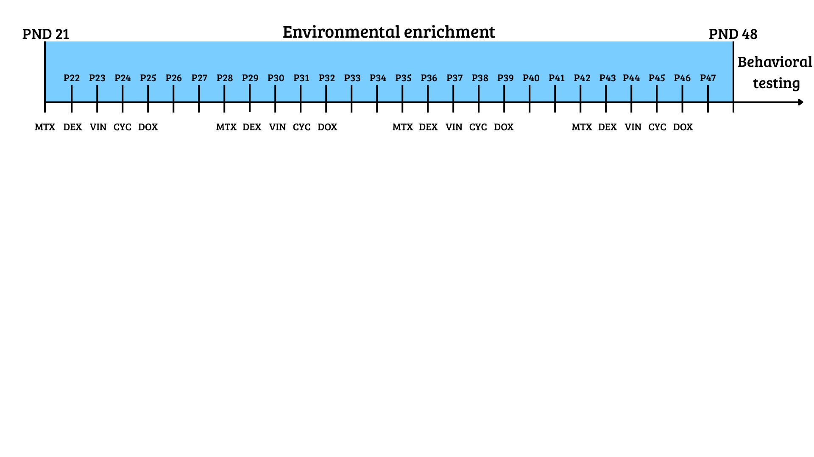Note. The enriched environment phase applied only to mice assigned to enriched housing; all other mice remained in standard housing. MTX = methotrexate, DEX = dexamethasone, VIN = vincristine, CYC = cyclophosphamide, DOX = doxorubicin; PND/P = postnatal day.
- Environment
For the second manipulation, mice were pseudo-randomly assigned to one of two environmental conditions: standard environment or enriched environment. Standard housing consisted of transparent type II cages (320 x 160 x 140 mm) each containing woodchips as bedding and shredded paper for nest-building. The enriched environment consisted of Marlau® cages alongside transparent cages containing woodchips and additional toys. The Marlau® cage is a standardized two-floor enrichment system designed to provide continuous cognitive, sensory, and social stimulation and has been shown to enhance cognitive performance and promote neural plasticity (Fares et al., 2013; Khalil, 2024). The cage included standard housing features such as shredded paper and woodchip bedding, as well as additional enrichment elements including hiding boxes, stepladders, mazes, running wheels, and trapdoors (Figure 2A). The maze was located on the second floor, which mice accessed via a stepladder (Figure 2B). To reach their food, mice had to pass the maze, which was changed weekly to provide increased mental stimulation and promote learning and problem-solving. This setup required mice to actively interact with their surroundings and engage cognitive processes to obtain food. Because only a limited number of Marlau® cages were available, mice in the enriched-environment condition alternated between two weeks in a Marlau® cage and two weeks in an alternative enriched environment. The alternative enriched environment consisted of a larger transparent cage equipped with additional running wheels, marbles, and hiding boxes. The order in which mice experienced the two enrichment setups was counterbalanced to minimize order effects. However, because the Marlau® cage was expected to provide a stronger enrichment effect than the alternative setup, this design also allowed us to examine potential recency effects reported in the literature.

Figure 2
Environmental enrichment (Marlau® cage) structure.
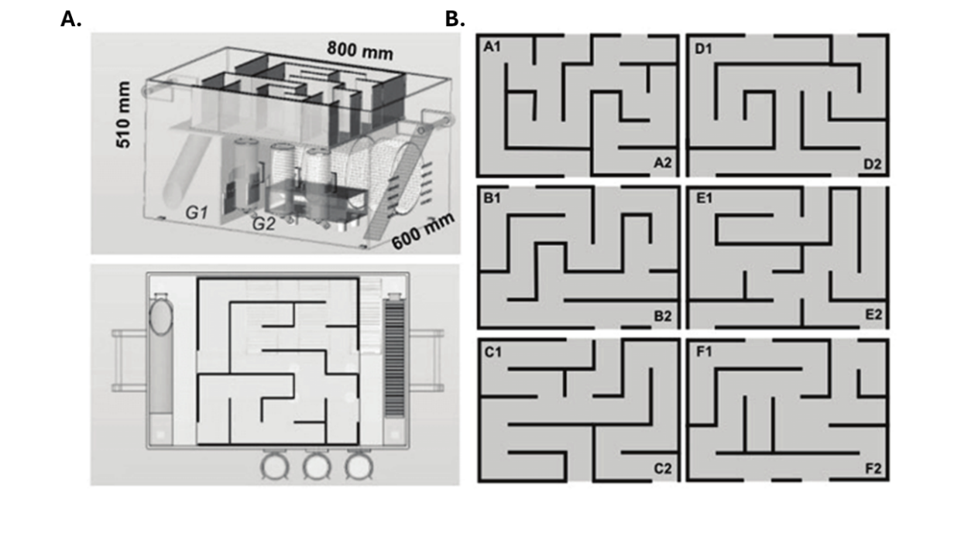
Note. Reprinted from Yolanda et al. (2019). Panel A (top) shows the overall structure of the Marlau cage with both floors visible; Panel A (bottom) shows the top floor containing the maze. Panel B displays the different maze configurations.

- Behavioral tests
To evaluate the effect of these manipulations, we administered a cognitive test battery to each mouse, serving as the independent variable. The test battery assesses memory, cognitive flexibility, anxiety, social interaction, and attention. All mice underwent the tests in the same prespecified order (Figure 3). The sequence was designed so that the most stressful assessments were performed last, minimizing stress-related influences on cognitive outcomes. Below, each test is described in the order in which it was administered.
Figure 3
Timeline of behavioral tests.
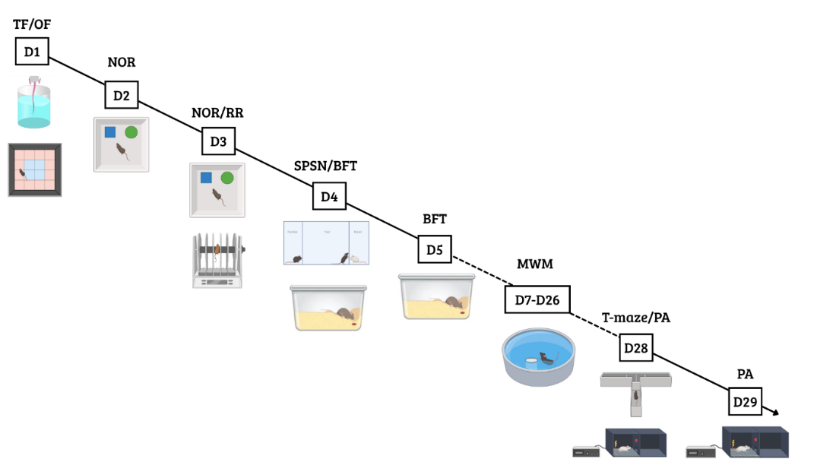
Note. TF = tail flick test; NOR = novel object recognition test; RR = rotarod; SPSN = sociability and preference for social novelty test; BFT = buried food test; MWM = Morris water maze; PA = passive avoidance.

- Open field test
The open field (OF) test is a widely recognized test for assessing locomotion and anxiety-related behavior in mice (Çevik et al., 2025). The apparatus consisted of a brightly illuminated plexiglass arena (50 × 50 × 30 cm) with transparent walls to promote anxiety-inducing behavior (Figure 4).
Figure 4
Layout of the open field test arena.
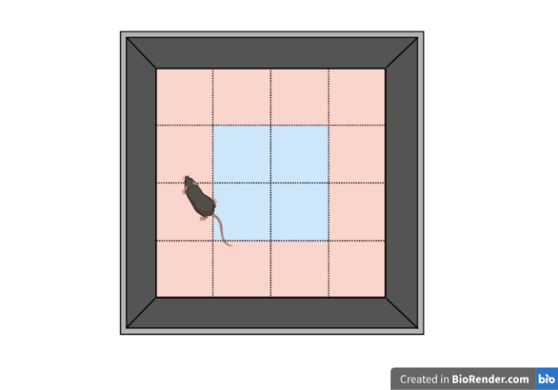
Note. Illustrated above is the setup used for the open field test. The red area represents the periphery, and the blue area represents the central zone.
Prior to testing, all mice were placed in a fully dark cabinet for 30 minutes for habituation and enhance anxiety-induced behavior even further. Each mouse was then placed in the lower-left corner of the arena and allowed to habituate for 1 minute before beginning a 10-minute trial during which it could freely explore. Locomotor activity was recorded using a Logitech camera and ANY-maze software (Stoelting Co., 2023). The arena was divided into central and peripheral zones. The primary outcome measures were total path length, time spent in the periphery, and time spent in the center. To minimize confounding effects from olfactory cues, the arena was thoroughly cleaned before and after each trial with 50% Ethanol. All animals were tested on the same day and at the same time of day to reduce variability due timing-specific influences.
- Tail flick test
The tail-flick test assesses nociception in mice (Leo et al., 2008). Mice were restrained by the scruff of the neck, and the distal half of the tail (approximately 3 cm) was immersed in hot water (50 ± 1 °C). A heater was used to ensure a constant temperature across trials and to minimize temperature-related variability. Latency to withdraw the tail from the water was measured using a stopwatch. A cutoff time of 60 seconds was applied to prevent potential tissue damage. Each animal was tested three times to reduce the influence of outliers due to measurement variability in any single trial.
- Novel object recognition test
The novel object recognition (NOR) test is commonly used to assess recollection memory and learning in rodents (Lueptow, 2017). During foraging, mice have an innate tendency to explore novelty (Berlyne, 1950), and this behavior can be harnessed to evaluate memory. Over several trials, animals are presented 2 objects (made from plastic) and time exploring these objects (sniffing) is recorded. Recalling that an object is familiar, and showing increased approach to a novel object can be quantified as recollection memory. The testing arena consisted of a wooden box (40 × 40 × 30 cm) with four designated object locations, one in each corner and positioned approximately 5 cm from the corner (Figure 5). The task was conducted over two days and consisted of three trials. During the first trial (habituation), mice were placed in the empty arena for 10 min to familiarize to the environment and reduce anxiety-related behaviors during subsequent phases (Figure 5A). On the second day, the training and testing phases were performed. In the training phase, two identical objects (Falcon tubes filled with ink) were placed in two of the predefined corner locations, always arranged in opposite corners (Figure 5B). Each mouse was allowed 5 min to explore both objects. After training, mice were returned to their home cage for approximately 30 min before the testing phase. During the testing phase, one of the familiar objects was replaced with a novel object (a plastic pine tree), and mice were again given 5 minutes to explore (Figure 5C). The positions of the novel and familiar objects were counterbalanced across trials to minimize location-dependent biases. From these sessions, we calculated the novel object preference (NOP), defined as the time spent exploring the novel object divided by the total exploration time for both objects: $NOP=T_{novel}/(T_{novel}+T_{familiar})$. Total exploration time was also recorded as an index of locomotor activity and general exploratory behavior. Animals that spent fewer than 15 seconds exploring during the training phase were excluded, as insufficient engagement prevents meaningful interpretation of performance during the testing phase.

Figure 5.
Novel object recognition test: apparatus design and experimental phases.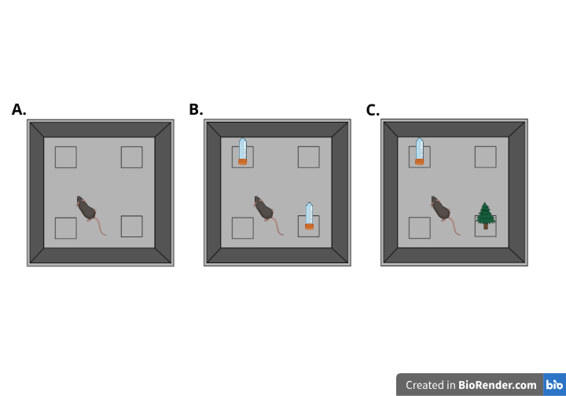
Note. Panel A shows the habituation phase, where mice explore an empty arena. The four marked positions represent possible object locations. Panel B shows the training phase, during which mice are exposed to the familiar object. Panel C illustrates the testing phase, in which a novel object is introduced to assess recognition memory.
- Rotarod
The rotarod task assesses motor coordination and balance by placing mice on a rotating rod (Deacon, 2013). The full procedure consists of training and testing phases. During training, all mice were placed on a slowly rotating rod (5rpm) for 2 min to familiarize them with the task, then they were placed back in their home cage. After a 3 min rest period, the mice were placed four times on an accelerating rod (5-40rpm) for a maximum of 5 min. After each trial, mice were placed back in their home cage for a 5 min before the next trial began. Latency to fall was the dependent variable of interest, with a maximum cutoff of 300 seconds (5 min) for mice that did not fall. Five mice could be tested in parallel and the apparatus was cleaned between each test.
- Sociability and preference for social novelty test (SPSN)
We used the sociability and preference for social novelty (SPSN) test to provide a measure of general social behavior and social (Moy et al., 2004). Mice are social animals and show interest in unknown con-specifics. This curiosity towards stranger animals can be harvested to evaluate social approach and social recognition memory (Moy et al., 2004). The setup consisted of a plexiglass arena with three compartments. The middle compartment (40 x 10 cm) contained the test mouse and was connected to two smaller side compartments (10x 10 cm) through walls with small openings (8mm holes). Each side compartment could hold an unfamiliar mouse. The arena was illuminated dimly (just enough to allow reliable tracking of the test mouse behavior while remaining dim enough to minimize anxiety). The test consisted of three consecutive phases. First, the test mouse was placed in the middle compartment and given five minutes to habituate to the environment. Next, a stranger mouse was introduced into one of the two possible side chambers, and the test mouse was given ten minutes to explore (Figure 6A). Time spent interacting with this stranger mouse served as a measure of general sociability. After the first exploration phase, a second stranger mouse was placed in the other side compartment (Figure 6B). The test mouse was again given 10 minutes to explore its environment freely. Following the same rationale described for the novel object recognition task regarding novelty preference (see Novel Object Recognition), time spent near the newly introduced stranger mouse was used as an indicator of social memory. Time spent near the first stranger mouse was used as a measure of general sociability. Both stranger mice were of the same sex and were completely unfamiliar to the test mouse. All behavior was recorded using a Logitech webcam and ANY-maze software (Stoelting Co., 2023). To minimize confounding factors, all mice were tested on the same day, and the apparatus was thoroughly cleaned between sessions to eliminate timing-related effects and residual odors.
Figure 6
Sociability and preference for social novelty test
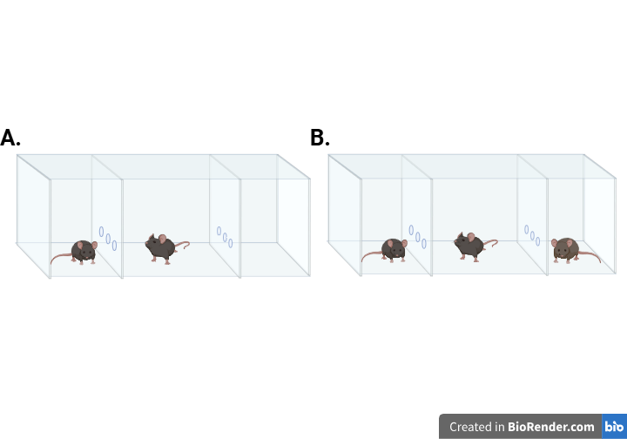
Note. Panel A illustrates the first phase of the SPSN test, during which the mouse is allowed to explore a single stranger mouse. Panel B depicts the second phase, where a novel stranger mouse is introduced into the opposite chamber.
- Buried food-seeking test
Many patients receiving chemotherapy report alterations in smell and taste (Amézaga et al., 2018). Because food odors are essential for survival in mice, the Buried food-seeking test (BFT) allowed us to model these sensory alterations in mice (Machado et al., 2018). Specifically, the test measures the ability to detect and recognize these odors. Before testing, mice were food-deprived for 24 h to enhance their motivation to locate the buried food. On the test day, each mouse was placed in a clean Type III macrolon cage containing 3 cm of bedding, with a piece of almond hidden at a random location. The almond (5mm) was buried 1 cm beneath the surface and fully covered with bedding to eliminate any visual cues. Mice were given 15 min to locate the buried food. The primary outcome measure was the latency to find the food. Animals that failed to locate the food within the allotted time were assigned a maximum latency of 900 seconds. After each trial, cages were cleaned and fresh bedding was added to minimize residual odor cues from previous mice.
- Morris water maze
The Morris water maze (MWM) was first developed by Richard G. Morris in the early 1980s to test hippocampus-dependent learning (Morris, 1981). Since then, it has become a widely used behavioral paradigm for assessing hippocampus-dependent spatial learning and memory (Florian & Roullet, 2004; Othman et al., 2022; Redish & Touretzky, 1998). The setup consisted of a circular pool filled with opacified water (26 ± 1 °C) to enhance tracking of dark-coated mice (Acusol Op 301, Dow Chemicals). Water temperature was measured daily to ensure stability, as deviations toward colder or warmer temperatures can impair both learning and locomotion. The pool was divided into four virtual quadrants, which served as the starting positions during the experiment (Figure 7A). One of these quadrants was designated as the target quadrant and contained a hidden escape platform that mice were required to locate to exit the water. Because the water was rendered opaque, the platform was minimally visible, increasing reliance on learned spatial cues rather than direct visual detection and thereby promoting learning. The quadrant directly opposite the original target quadrant was designated as the reversal target quadrant and was used in later stages of the protocol to assess reversal learning.
The full Morris water maze protocol lasted three weeks and consisted of an acquisition phase, probe trials, a reversal acquisition phase, and a reversal probe trial. The protocol began with the acquisition phase, during which the platform was placed in the original target quadrant. For a total of ten training days, mice learned to locate the escape platform using distal spatial cues. Each day, all mice performed four swim trials from four different starting positions, with up to 100 seconds available to locate the platform. Mice that failed to locate the platform within this time were guided to it by the experimenter and allowed to remain there for 15–20 seconds to facilitate learning of spatial cues. Starting positions were determined by a randomized daily sequence, with each sequence used only once. On the sixth and eleventh day, probe trials were conducted. For each of these trials, the platform was removed and each mouse completed a single swim starting from the quadrant opposite the original target quadrant. Mice were allowed to swim freely for 100 seconds, and the time spent in the original target quadrant was recorded as an index of spatial reference memory. On the same day as the final probe trial, the reversal acquisition phase began. This phase followed the same procedure as the initial acquisition, except that the platform was relocated to the opposite target quadrant. Reversal acquisition lasted five days, during which mice again completed four daily swim trials with a maximum duration of 100 seconds to locate the platform. On the sixteenth day, a reversal probe trial was conducted in which the platform was removed from the reversal target quadrant, and mice were allowed to swim freely for 100 seconds. Total path length, distance until the platform was reached, and time spent in the target quadrant during probe trials were quantified as measures of spatial and reversal learning. All behavior was recorded using an overhead digital camera camera (Basler GIGE camera) and Ethovision tracking software.
Figure 7
Experimental setups for the Morris water maze and T-maze
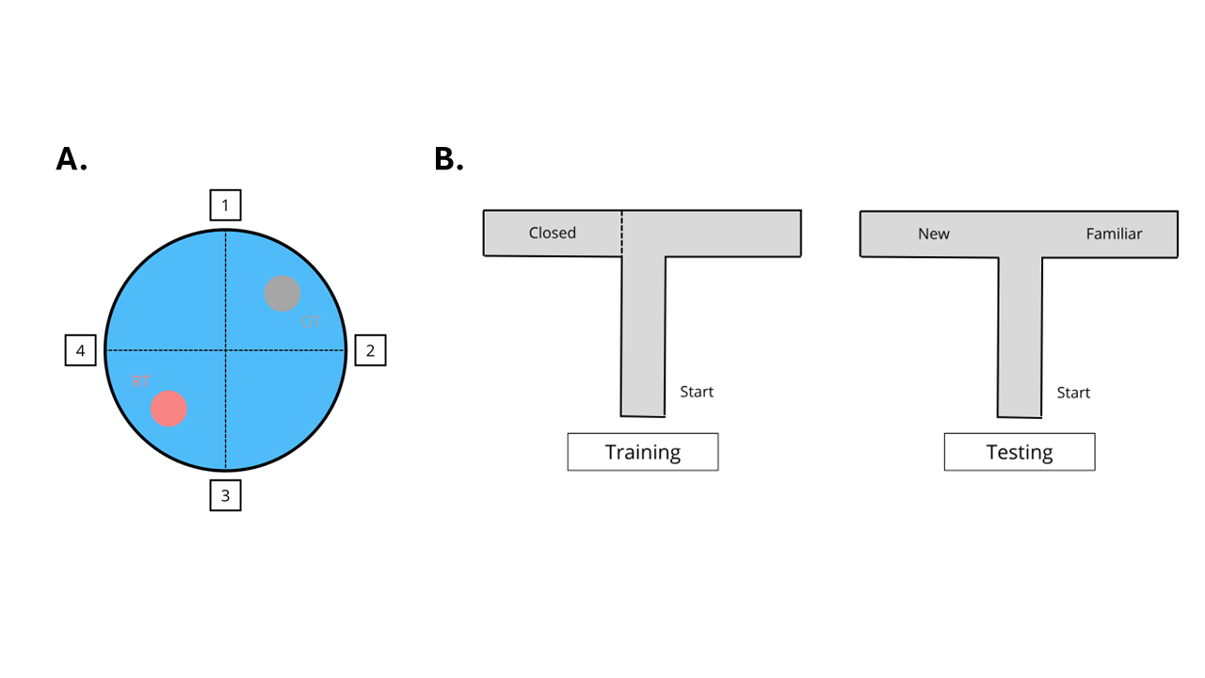
Note. (A) Top view of the water maze. OT = original target platform; RT = reversal target platform. The numbers represent possible starting positions. (B) Training and testing phases of the T-maze task. The “Start” point marks the mouse’s initial position at the beginning of each trial.
- Elevated T-maze
Because mice naturally explore novel environments to scavenge, the elevated T-maze was used to assess spatial working memory (d’Isa et al., 2021). The setup consisted of an elevated T-shaped arena. The two shorter lateral arms, hereafter referred to as the goal arms, extend symmetrically from the central starting arm (5 x 30 cm), which is a longer segment oriented perpendicular to them (5x 40cm). The procedure consisted of two phases: a training phase and a testing phase. During the training phase, one of the two goal arms was closed off, with the choice determined by a predetermined randomized order (Figure 7B left). Each mouse was given 5 min to explore the starting arm and the single open goal arm. After training, mice were returned to their home cage for 5 min while the apparatus was thoroughly cleaned with 50% ethanol. For the testing phase, mice were again placed in the starting arm, but now both goal arms were open (Figure 7B right). Mice were given another 5 min to explore their environment freely. Novel arm preference (NAP) was calculated as an index of spatial working memory ($NAP=T_{novel}/(T_{novel}+T_{familiar})$. Total path length was recorded as a measure of general exploration. The apparatus was illuminated sufficiently to ensure reliable tracking while minimizing anxiety, and it was thoroughly cleaned after each mouse to reduce the influence of residual odors.
- Passive avoidance test
The passive avoidance test is commonly used as a fear-conditioning paradigm to assess associative learning and contextual memory (Ögren & Stiedl, 2015). Unlike active avoidance tasks, it does not employ an explicit cue. Instead, the context itself serves as the conditional stimulus and becomes associated with an aversive event, such as a foot shock. The experiment used a passive avoidance apparatus with two compartments: a brightly lit compartment and a dark compartment connected by a trap door. Mice always started in the illuminated compartment, which induces mild anxiety and creates an incentive to enter the darker compartment. Each mouse was placed in the bright compartment with the trap door closed and allowed to explore for 5 seconds, after which the door opened. When the mouse entered the dark compartment, the door closed and four mild foot shocks were delivered through the grid floor (0.3 mA, 2 seconds each). The procedure was repeated 24 hours later, but no shock was administered during the second session. If a mouse did not enter the dark compartment within 300 seconds, the trial was terminated and a maximum latency of 300 seconds was recorded. Latency to enter the dark compartment was measured on both days as the primary outcome.

- Data Analysis
All statistical analyses were conducted in R (version 4.4.3; R Core Team, 2025). Analyses were first performed within a frequentist framework, and the specific tests were chosen based on the data structure and experimental design. Two‑way ANOVAs were fitted to assess the effects of treatment, environment, and their interaction on each outcome variable. When measurements were repeated within subjects, repeated‑measures ANOVAs were used to account for within‑subject dependency. In cases where the data exhibited hierarchical or interdependent structure, models were fitted using multilevel (mixed‑effects) approaches to appropriately account for this dependency (Osborne, 2000). Models were fitted using either base R (aov) for standard ANOVA designs or lme4 for mixed-effects models. Post hoc pairwise comparisons were conducted to further examine significant main effects, using estimated marginal means (emmeans) with t-tests applied to the contrasts. A significance threshold of p < .05 was applied for all frequentist tests. Inferential results are reported with the test statistic, p‑value, and effect size. Post hoc contrasts are reported as estimated mean differences, standard errors, and p-values. When applicable, Tukey’s HSD was used to adjust these p-values for pairwise comparisons.
All models were additionally fitted in a Bayesian framework, and Bayes factors were computed for each effect by testing whether the corresponding parameter differed from zero. A Bayes factor quantifies the relative evidence for two competing hypotheses as the ratio of the marginal likelihoods of the data under each model. Here we compute the Savage–Dickey ratio for a single parameter, which is defined as the ratio of the prior density at zero to the posterior density at zero:
$${BF}_{01}=\frac{p\left(θ=0 \right| prior)}{p\left(θ=0 \right| posterior)}$$
Bayesian hypothesis testing is included because, unlike frequentist p-values, Bayes factors can distinguish between evidence supporting the null hypothesis and evidence that is inconclusive (Schmalz et al., 2023). Bayesian models were written and fitted in Stan (Stan Development Team, 2024) using cmdstanr, which performs Markov chain Monte Carlo sampling. All variables were normalized before fitting the Bayesian models. For each effect, we report the Bayes factor and the 90% highest-density interval (HDI) for the estimate. Values greater than 1 indicate evidence in favor of the alternative hypothesis, whereas values less than 1 indicate evidence in favor of the null. We interpreted Bayes factors according to the guidelines of Wagenmakers et al. (2018), which are adapted from the original scale created by Jeffrey (1961). Details of the priors employed in the testing procedure are provided in the Appendix, which also includes the parameter-recovery for all models.

Results
- Open field
Total path length was used as a measure of general exploration and locomotor activity (Figure 8A). To assess the effects of treatment, environment, and their interaction on locomotor activity, we conducted a two-way ANOVA. There was a robust main effect of environment, with mice housed in enriched conditions showing higher locomotor activity than those in poor environments (F(1, 30) = 16.18, p < .001, η² = 0.35). We also observed a significant main effect of treatment (F(1, 30) = 6.86, p = 0.014, η² = 0.19), indicating overall differences between saline- and CVAD-treated mice. The interaction between treatment and environment was not significant (F(1, 30) = 0.63, p = 0.43, η² = 0.02). Consequent Bayesian analysis added interpretive clarity by showing that the data provided only anecdotal evidence for no interaction (${BF}_{01}$= 0.59, ${HDI}_{90\%}$=[-0.53;1.09]) showing that more data is needed to draw conclusions. To further examine the main effects, we conducted post hoc pairwise contrasts. First, we compared saline and CVAD within the poor environment. Mice treated with saline showed higher locomotor activity than those treated with CVAD, although this effect failed to reach significance (Δ = 12.59, SE = 4.75, p = 0.06). Bayesian follow-up analysis provided strong evidence for this effect, likely masked in the frequentist results by Tukey’s correction (${BF}_{01}$= 10.70, ${HDI}_{90\%}$=[-1.64;-0.36]). The same comparison conditioned on the enriched environment did not reach significance (Δ = 7.59, SE = 3.97, p = 0.24). However, the Bayesian analysis showed anecdotal evidence for the effect (${BF}_{01}$= 1.34, ${HDI}_{90\%}$=[-1.32;-0.12]). Next, we compared the two environments within each treatment group. Enriched housing increased locomotor activity relative to poor housing for both saline-treated mice (Δ = −9.98, SE = 3.43, p = 0.03) and CVAD-treated mice (Δ = −14.88, SE = 5.15, p = 0.03).
Figure 8
Behavioral Measures from the Open Field Test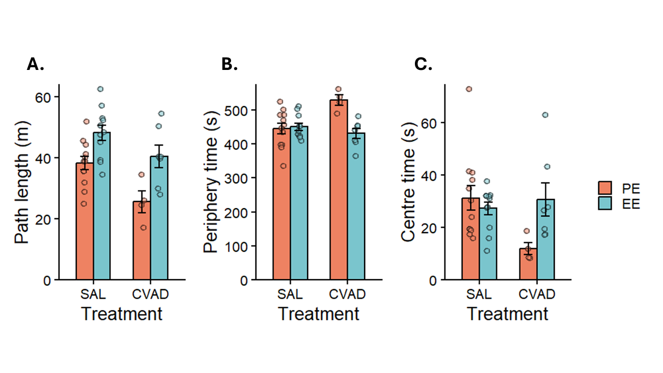
Note. Path length results, representing general locomotor activity. (B) Time spent in the periphery of the arena. (C) Time spent in the centre of the arena. Bars show means ± SEM; individual points represent raw data.
Thigmotaxis and center exploration were quantified as time spent in the periphery and center, respectively. A two-way ANOVA revealed no main effect of environment in both peripheral (F(1, 30) = 2.94 , p = 0.10, η² = 0.09), and central time (F(1, 30) = 0.44 , p = .51, η² = .01). However, the Bayesian analysis provided moderate evidence for an environment effect on peripheral time (${BF}_{01}$= 3.65, ${HDI}_{90\%}$=[-1.22;-0.21]), and anecdotal evidence for the absence of an effect on central time (${BF}_{01}$= .54, ${HDI}_{90\%}$=[-0.18;-0.93]). This pattern could suggest that with a larger sample, the environment effect on peripheral time might have reached significance, whereas for central time the effect is likely genuinely absent. However, more data is needed to draw conclusions. Similarly, the main effect of treatment did not reach significance for either peripheral (F(1, 30) = 1.40, p = .25, η² = .04) or central time (F(1, 30) = 1.25, p = .27, η² = .04). Consistent with this, the Bayesian analysis indicated anecdotal evidence for the absence of a treatment effect in both peripheral time (${BF}_{01}$= 0.68, ${HDI}_{90\%}$=[0.09;0.95]), and central time (${BF}_{01}$= 0.53, ${HDI}_{90\%}$=[-0.94;0.18]). Notably, the interaction effect was significant for both periphery (F(1, 30) = 10.10, p =.003, η² = .25) and center time (F(1, 30) = 5.10, p =.03, η² = .15). The interaction indicated that the PE–EE contrast was stronger in CVAD mice, with a greater reduction in periphery time and a greater increase in center time than observed in saline controls.
Taken together, the analysis showed a clear negative effect of chemotherapy and a clear positive effect of EE on locomotion and exploration. Post-hoc comparisons suggested that the chemotherapy effect was larger when conditioned on PE, as supported by the Bayesian comparison. However, because the interaction was not significant, this apparent difference-in-differences should not be interpreted as a protective role of EE. Bayesian analyses did suggest a potential interaction, though additional data would likely be required to determine whether this effect is genuine. We also found no overall effect of chemotherapy or environment on anxiety-like behavior, but EE showed a protective effect in CVAD animals based on the interaction and post hoc tests. Again, Bayesian results advise caution on the latter. Overall, EE appears to mitigate chemotherapy-related increases in anxiety.
- Tail flick test
Figure 9
Results from the tail flick and Rotarod test
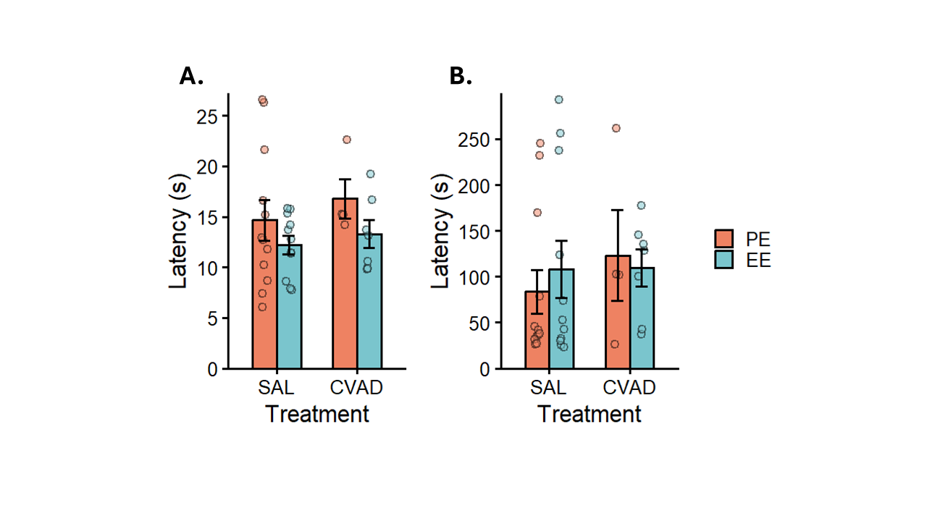
Note. (A) Tail withdrawal latency results, representing nociception. (B) Fall latency results, representing motor coordination. Bars show means ± SEM; individual points represent individual means.
In the tail flick test, latency to withdraw the tail from the hot water is used as a measure of nociception in mice (Figure 9A). A mixed-effects model with random intercepts was fitted on these latencies to examine the effects of treatment, environment, and their interaction. Analysis revealed that neither the treatment (t(30) = 0.74, p = 0.46, R² = 0.007) nor the environment effect (t(30) = -1.17 , p = 0.25, R² = 0.02) reached significance. The interaction between treatment and environment was also non-significant (t(30) = -0.29, p = 0.78, R² = 0.001). Bayesian analyses provided moderate evidence in favor of the null hypothesis for treatment (${BF}_{01}$= 0.25, ${HDI}_{90\%}$= [-0.19;0.58]) and anecdotal evidence in the same direction for environment (${BF}_{01}$= 0.59, ${HDI}_{90\%}$= [-0.74;0.04]), and their interaction (${BF}_{01}$= 0.44, ${HDI}_{90\%}$= [-0.80;0.60]) effects, suggesting that the absence of detectable effects is more likely, although these conclusions should be interpreted with caution. It is also important to note that measurement error related to handling procedures may have influenced these outcomes.
- Novel object recognition test
Figure 10
Novel object recognition test results
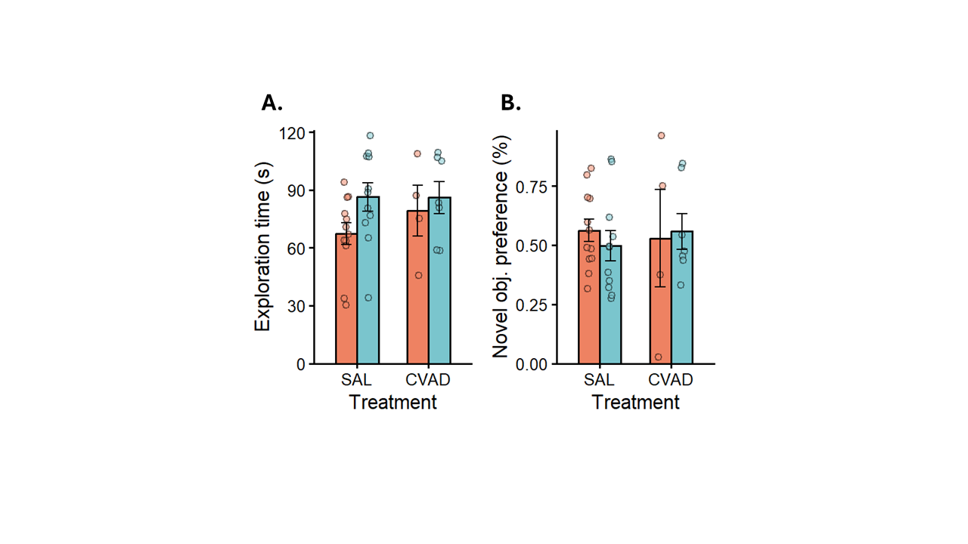
Note. (A) General exploration time as time spent in the familiar and novel zones during the test phase. (B) Novel object preference, which measures recognition memory. Bars show means ± SEM; individual points represent raw data.
In the novel object recognition test, general exploration and locomotion were assessed by summing the time spent in the familiar and novel zones during the test phase (Fgure 10A). A two‑way ANOVA was performed on total exploration time to examine the main and interaction effects of treatment and environment. The treatment effect did not reach significance (F(1, 30) = 0.74, p = 0.40, η² = 0.02), indicating that treatments did not differ in general exploration. The Bayesian analysis further supported this conclusion, providing moderate evidence for the absence of an effect (${BF}_{01}$= 0.32, ${HDI}_{90\%}$= [-0.41;0.75]). The environment effect was also non-significant (F(1, 30) = 3.82 , p = 0.06, η² = 0.11). However, the Bayesian analysis suggested caution in interpreting this result, as it indicated essentially no evidence in either direction (${BF}_{01}$= 0.92, ${HDI}_{90\%}$= [-1.10;0.73]). Finally, we also found no interaction effect (F(1, 30) = 0.51, p = 0.48, η² = 0.02), with the Bayesian analysis providing anecdotal evidence for the null (${BF}_{01}$= 0.59, ${HDI}_{90\%}$= [-1.07;0.73]). We also conducted a two-way ANOVA on the novel object preference (NOP) scores to assess these effects on recognition memory (Figure 10B). The analysis revealed no treatment effect (F(1, 30) = 0.04 , p = 0.84, η² = 0.001), and no environment effect (F(1, 30) = 0.21, p = 0.65, η² = 0.007). The Bayesian follow-up analyses provided moderate evidence for the absence of both a treatment effect (${BF}_{01}$= 0.30, ${HDI}_{90\%}$= [-0.52;0.69]) and an environment effect (${BF}_{01}$= 0.29, ${HDI}_{90\%}$= [-0.69;0.52]), suggesting that there is presumably no detectable effect present. The interaction term was likewise non-significant (F(1, 30) = 0.31, p = 0.58, η² = 0.01), as supported by the Bayesian analysis providing anecdotal evidence for the null (${BF}_{01}$= 0.63, ${HDI}_{90\%}$= [-1.10;0.73]).
To sum up, we found no differences in general exploration or recognition memory across treatment groups. There was also no overall benefit of environment for either measure, although the Bayesian analysis suggests that an undetected effect on general exploration cannot be ruled out. Finally, the interaction effects were non-significant, indicating that EE cannot be interpreted as providing a protective influence on either memory retention or general exploration in chemotherapy-treated mice.
- Rotarod
To analyze the effects of treatment and environment on balance and motor coordination, we fitted a mixed-effects model with random intercepts on the latencies to fall in the rotarod task (Figure 9B). The analysis revealed no main effect of treatment (t(30) = 0.78, p = 0.44, R² = 0.01), and no main effect of environment (t(30) = 0.67, p = 0.51, η² = 0.008). Bayesian analyses further supported these conclusions, providing moderate evidence for the null for both the treatment effect (${BF}_{01}$= 0.28, ${HDI}_{90\%}$= [-0.35;0.64]), and the environment effect (${BF}_{01}$= 0.24, ${HDI}_{90\%}$= [-0.41;0.]). The interaction between the two was also non-significant (t(30) = -0.58 , p = 0.57, R² = 0.006), with the Bayesian analysis offering anecdotal evidence for the absence of the effect (${BF}_{01}$= 0.52, ${HDI}_{90\%}$= [-1.00;0.63]). Overall, these results suggest that neither treatment nor environment altered motor coordination. Likewise, we found no indication that EE offers a protective benefit for motor coordination in chemotherapy-treated mice.
- Sociability and preference for social novelty test (SPSN)
The SPSN test offered an additional measure to investigate the effects of treatment, environment, and their interaction on general locomotion and exploratory behavior. Additional analyses showed that the SPSN stages differed sufficiently that they could not be treated as reflecting the same underlying process regarding locomotion (Figure 11A; See Appendix for detailed results). Because we aimed to isolate locomotion from social exploration, path length during the habituation phase was selected as the dependent variable (Figure 11B). A two-way ANOVA revealed a significant main effect of treatment (F(1, 30) = 9.55, p = 0.004, η² = 0.24), but no significant effect of environment (F(1, 30) = 0.98, p = 0.33, η² = 0.03) and no interaction (F(1, 30) = 0.47, p = 0.50, η² = 0.02). Similarly, Bayesian analysis found anecdotal evidence for the absence of both the environment effect (${BF}_{01}$= 0.64, ${HDI}_{90\%}$= [-0.12;0.97]) and the interaction effect (${BF}_{01}$= 0.59, ${HDI}_{90\%}$= [-0.73;1.03]), but more data is needed to draw robust conclusions. Consequent post-hoc contrasts showed that Saline-treated mice explored significantly more in the PE condition (Δ = 2.76, SE = 1.10, p = 0.02), but not in the EE condition (Δ =1.78, SE = 0.92, p = 0.06). However, Bayesian comparison for the EE condition yielded anecdotal support for a treatment effect (${BF}_{01}$= 1.73, ${HDI}_{90\%}$= [-0.52;0.69]), again suggesting that additional data may be required to clarify this pattern.
Figure 11
Total path length results from the sociability and preference for social novelty test
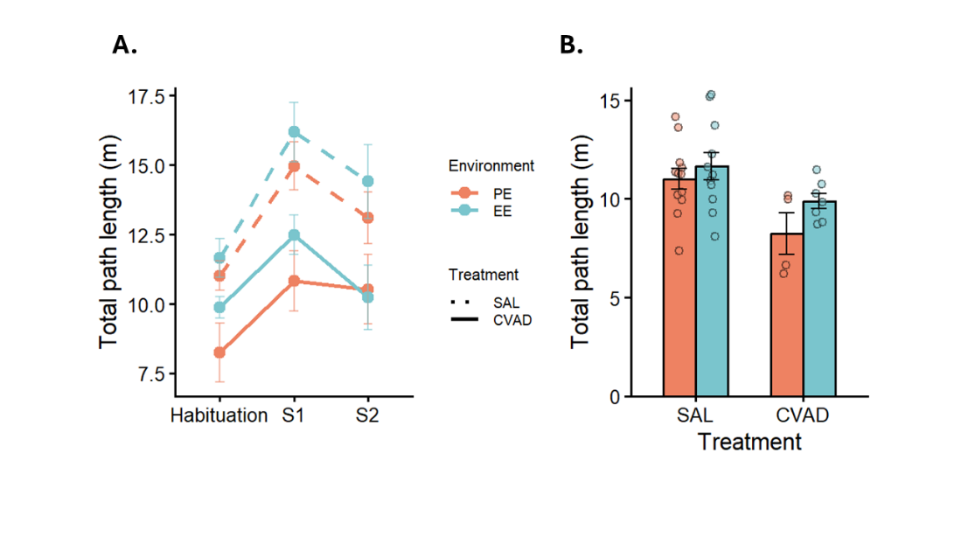
Note. (A) Total path length per SPSN stage; dots represent cell means ± SEM. (B) Total path length during the habituation phase; data are shown as mean ± SEM with raw data overlaid.
Time spent near the first stranger mouse was used as a metric of general sociability, and a two-way ANOVA was conducted to examine the effects of treatment, environment, and their interaction (Figure12A). We found no significant main effect of treatment (F(1, 30) = 1.05, p = 0.31, η² = 0.03), but we did observe a significant main effect of environment (F(1, 30) = 6.50, p = 0.02, η² = 0.18). The interaction did not reach significance (F(1, 30) = 0.04, p = 0.84, η² = 0.001). Bayesian analyses for the treatment (${BF}_{01}$= 0.42, ${HDI}_{90\%}$= [-0.24;0.84]) and interaction terms (${BF}_{01}$= 0.54, ${HDI}_{90\%}$= [-0.83;0.94]) likewise provided anecdotal evidence for the absence of an effect. Post hoc comparisons showed that mice in the PE condition spent significantly more time near the stranger mouse when treated with saline (Δ = 44, SE = 18.80, p = 0.02), but not when treated with CVAD (Δ = 37, SE = 28.2, p = 0.20). The Bayesian comparison supported this pattern by providing anecdotal evidence for the absence of a difference in the CVAD group (${BF}_{01}$= 0.76, ${HDI}_{90\%}$= [-1.56;0.09]). Given the limited strength of the evidence, additional data will be needed to draw firm conclusions.
Figure 12
Sociability and social memory results from the SPSN
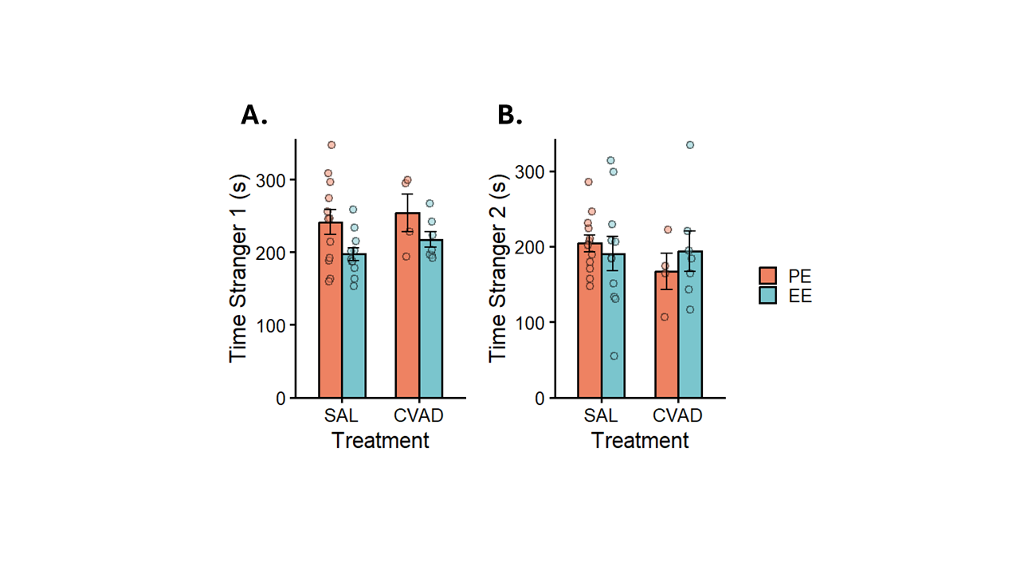
Note. (A) Time spent near the first stranger mouse during the second stage of the SPSN, representing general sociability. (B) Time spent near the second stranger mouse during the last stage of the SPSN, representing social memory. Bars show means ± SEM; individual points represent raw data.
Finally, time spent near the second stranger mouse in the final stage of the SPSN was used as an index of social recognition memory (Figure12B). Again, a two-way ANOVA was fitted to these data. The analysis revealed no main effect of environment (F(1, 30) = 0.01, p = 0.91, η² < 0.001), but a significant main effect of treatment (F(1, 30) = 7.27, p = 0.01, η² = 0.20), with Saline-treated animals spending more time exploring the novel mouse. The interaction did not reach significance (F(1, 30) = 0.24, p = 0.63, η² = 0.008). Bayesian follow-up analyses provided moderate evidence for the absence of an environment effect (${BF}_{01}$= 0.30, ${HDI}_{90\%}$= [-0.41;0.71]) and only anecdotal evidence regarding the absence of an interaction (${BF}_{01}$= 0.54, ${HDI}_{90\%}$= [-0.87;0.94]). Post-hoc comparisons were conducted to examine the treatment effect further. Under PE conditions, saline-treated mice spent more time near the novel stranger mouse than chemotherapy-treated mice (Δ = 42, SE = 19.90, p = 0.04). This difference did not reach significance under EE conditions (Δ = 29.30, SE = 16.70, p = 0.09). However, the same comparison in a Bayesian framework indicated essentially no evidence for either hypothesis in the EE condition (${BF}_{01}$= 1.18, ${HDI}_{90\%}$= [-1.50;-0.09]). Given the limited evidence for the absence of an interaction and the inconclusive EE contrast, an interaction cannot be ruled out. However, the current dataset does not provide sufficient information to support any of these claims.
- Buried food-seeking test
Figure 13
Buried food -seeking test results
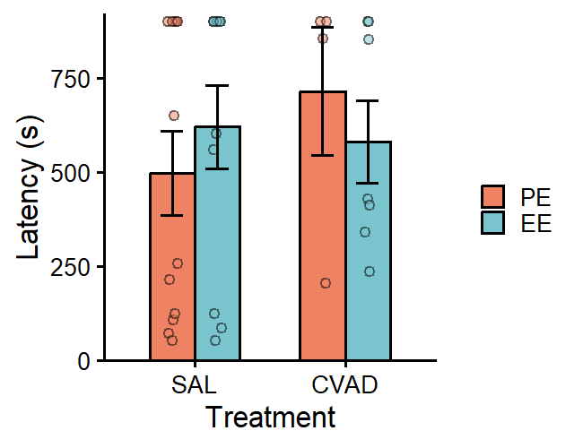
Note. Results from the BFT, measuring olfactory function. Bars show means ± SEM; individual points represent raw data.
Olfactory function was quantified as the latency to find food during the buried food-seeking test (fig). A two-way ANOVA was conducted to examine the effects of treatment, environment, and their interaction. The analysis revealed no significant main effect of treatment (F(1, 30) = 0.31, p = 0.58, η² = 0.01) and no significant main effect of environment(F(1, 30) = 0.12, p = 0.73, η² = 0.004). There was also no interaction effect observed (F(1, 30) = 0.90, p = 0.35, η² = 0.03). Bayesian analyses similarly provided moderate evidence for the absence of both treatment (${BF}_{01}$= 0.32, ${HDI}_{90\%}$= [-0.43;0.76]) and environment effects (${BF}_{01}$= 0.28, ${HDI}_{90\%}$= [-0.54;0.62]). Evidence for the absence of an interaction was only anecdotal, indicating that additional data would be required to draw firm conclusions.
- Morris water maze
- Learning during the acquisition phase
To quantify spatial learning, total path length during the 10-day acquisition phase was analyzed using a mixed-effects model with random intercepts (Figure 14A). The model included fixed effects of treatment, environment, and day. All two- and three-way interactions were also included to assess whether learning trajectories differed between groups. One mouse was excluded because it missed 19 swims (due to the effects of chemotherapy), meaning it did not receive a comparable opportunity to learn. Including this animal would have introduced bias into the estimation of group-level learning rates. There was no significant main effect of environment (t(268) = -0.18, p = 0.86, R² = 0.00), but there were significant main effects of day (t(1283) = -7.53, p < 0.001, R² = 0.04) and treatment (t(268) = 3.68, p < 0.001, R² = 0.01). The Bayesian analysis likewise provided moderate evidence supporting the absence of an environment effect (${BF}_{01}$= 0.14, ${HDI}_{90\%}$= [-0.28;0.17]). Across all groups, path length decreased over days, indicating learning, and chemotherapy‑treated mice showed overall poorer initial performance. For the two‑way interactions, the Day × Treatment interaction was significant (t(1283) = -2.66, p = 0.007, R² = 0.005), indicating that CVAD‑treated mice showed a steeper learning curve. This pattern could potentially be explained by their significantly higher initial path length. The Treatment × Environment interaction was also significant (t(268) = -3.44, p < 0.001, R² = 0.01), suggesting that environmental enrichment provided a stronger protective effect for chemotherapy-treated mice than for saline controls in terms of their initial value. In contrast, the Day × Environment interaction did not reach significance (t(1283) = -0.84, p = 0.40, R² = 0.001). The Bayesian analysis provided very strong evidence for the absence of this effect, indicating that no meaningful interaction was present (${BF}_{01}$= 0.03, ${HDI}_{90\%}$= [-0.05;0.02]). Finally, the three-way interaction was significant (t(1283) = -2.64, p = 0.008, R² = 0.005), indicating that the treatment-related difference in learning rate depended on the environment. Under standard housing, CVAD-treated mice learned faster than saline controls, but this difference was reduced under environmental enrichment. Again, this effect is likely explained by the higher starting point on Day 1.
Figure 14
Results from the acquisition phase
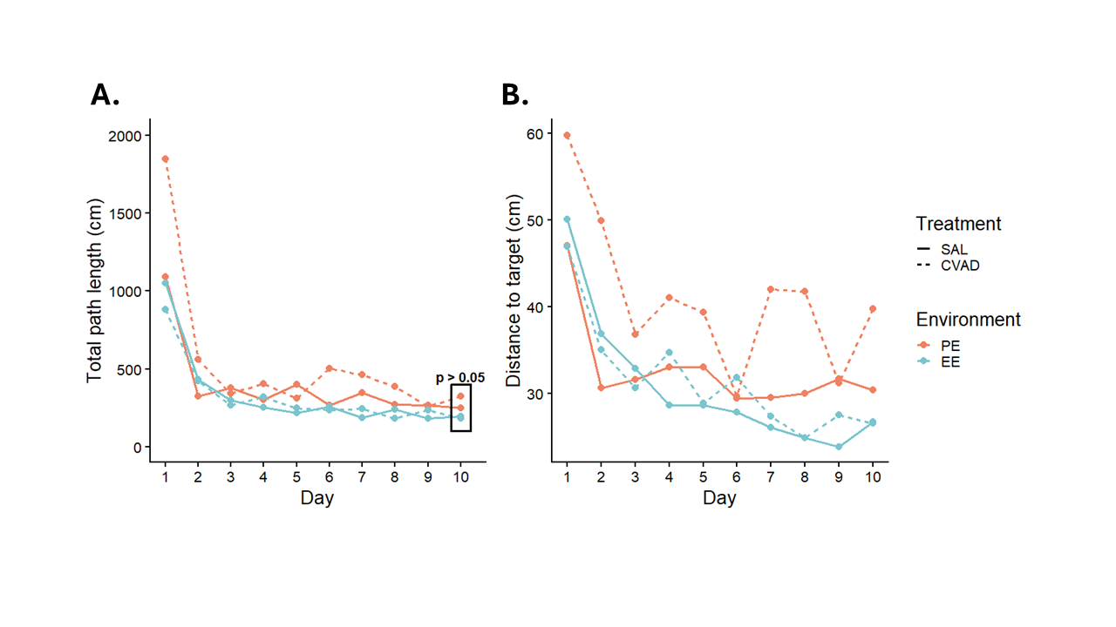
Note. (A) Total path length decreased over days; the black box highlights that no group differences were present on Day 10. (B) Distance-to-target scores also declined over time. Dots represent group means for each day.
To assess differences in learning success, we fitted a mixed-effects model to total path length on the final day of the acquisition phase (Figure 14A). All mice successfully located the platform, and there were no significant main effects of treatment (t(29) = 1.03, p = 0.31, R² = 0.01) or environment (t(29) = -1.22, p = 0.23, R² = 0.02). The interaction term also failed to reach significance (t(29) = -0.96, p = 0.34, R² = 0.01). However, under the Bayesian framework, treatment(${BF}_{01}$= 0.56, ${HDI}_{90\%}$= [-0.16;0.83]), environment (${BF}_{01}$= 0.74, ${HDI}_{90\%}$= [-0.67;0.01]), and their interaction (${BF}_{01}$= 0.62, ${HDI}_{90\%}$= [-0.99;0.23]) all showed only anecdotal evidence for the absence of an effect. This suggests that additional data would be required to draw firmer conclusions. Because total path length may be confounded by overall activity and swim speed, we repeated the analysis using distance to target (Figure 14B). The same main effects emerged as for path length. However, the interaction pattern differed slightly: only the Environment × Treatment and Day × Environment interactions reached significance. The three-way interaction was also non-significant, and the Bayesian analysis provided moderate evidence for the absence of this effect. Taken together, these results suggest that the apparent benefit of PE for chemotherapy-treated mice was not due to improved learning, but was more likely driven by differences in activity levels or swim speed on Day 1. The same applies to the Day × Treatment interaction, which confirms our earlier assumption that the apparent effect was driven by differences in Day 1 activity rather than genuine differences in learning.
Figure 15
Results from target quadrant probe trials
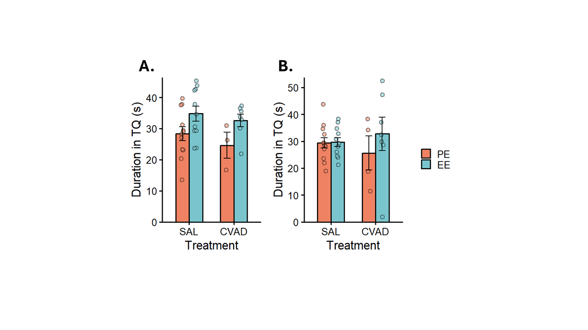
Note. (A) Duration in the target quadrant during the first probe trial (Day 6). (B) Duration in the target quadrant during the second probe trial (Day 11). Bars show means ± SEM; individual points represent raw data.
To quantify spatial memory retention, we measured the time spent in the target quadrant during two probe trials conducted on Day 6 and Day 11. For each probe trial, we fitted a two-way ANOVA to assess treatment and environment effects on retention at two separate time points. During Probe 1, there was a significant main effect of environment (F(1, 29) = 6.12, p = 0.02, η² = 0.17), whereas treatment did not affect time spent in the target quadrant (F(1, 29) =0.96, p = 0.34, η² = 0.03) (Figure 15A). The environment × treatment interaction also failed to reach significance (F(1, 29) = 0.06, p = 0.81, η² = 0.002). Bayesian analysis supported the conclusions for both the treatment (${BF}_{01}$= 0.43, ${HDI}_{90\%}$= [-0.88;0.26]) and interaction effects (${BF}_{01}$= 0.59, ${HDI}_{90\%}$= [-0.82;1.06]), providing only anecdotal evidence for the null. This level of evidence suggests that additional data may be required to draw more robust inferences. Post‑hoc comparisons were conducted to clarify the direction of the environmental effect. Within saline‑treated mice, EE animals spent more time in the target quadrant than PE animals (Δ = -6.49, SE = 3.07, p = 0.04). This difference was not present within chemotherapy-treated mice (Δ = -7.94, SE = 5.07, p = 0.13), and the Bayesian analysis provided no evidence (${BF}_{01}$= 1.01, ${HDI}_{90\%}$= [-0.03;1.73]). Consequently, no firm conclusions can be drawn for this contrast. Analysis of Probe 2 showed no main effect of treatment (F(1, 29) = 0.004, p = 0.95, η² < 0.001), and the previously observed environment effect was no longer significant (F(1, 29) = 0.51, p = 0.48, η² = 0.02) (Figure 15B). This suggests that the environmental advantage in memory retention did not persist. The interaction term again failed to reach significance (F(1, 29) = 0.87, p = 0.36, η² = 0.03). Bayesian analysis provided moderate support for the absence of a treatment effect (${BF}_{01}$= 0.28, ${HDI}_{90\%}$= [-0.56;0.61]) and anecdotal support for the absence of environment (${BF}_{01}$= 1.01, ${HDI}_{90\%}$= [-0.29;0.89]) and interaction effects (${BF}_{01}$= 0.76, ${HDI}_{90\%}$= [-0.51;1.33]). This pattern suggests that the absence of true underlying effects is more likely, although additional data is desirable.
Taken together, the results indicate a clear learning effect across days for all mice. Learning rates differed between treatments, with CVAD-treated mice showing a steeper learning curve, likely due to their elevated starting path length. EE did not provide a protective effect against spatial learning deficits in chemotherapy-treated mice, nor did these mice learn faster, as confirmed by our supplementary analysis. However, there was a protective effect of environment on the chemotherapy-induced deficit in the initial starting value, indicating that EE supported overall activity levels before learning had occurred. By Day 10, all mice successfully learned the platform location. Memory retention did not differ between groups, aside from a small environmental effect during Probe 1 that was no longer present in Probe 2.
- Reversal learning during the reversal acquisition phase
Table 2
Bayesian results from the results of the reversal acquisition phase
 | BF | HDI low | HDI high
Day | 43.9 | -0.22 | -0.09
Treatment | 0.65 | -1.15 | 0.783
Environment | 0.84 | -1.54 | 0.69
Day x Environment | 0.06 | -0.08 | 0.09
Day x Treatment | 0.05 | -0.05 | 0.10
Environment x Treatment | 0.84 | -0.92 | 1.50
Day x Treatment x Environment | 0.07 | -0.123 | 0.07
Note. HDI low and HDI high indicate the bounds of the 90% highest density interval.
During the reversal acquisition phase, the same procedure and analysis used in the initial acquisition phase were applied. In this phase, total path length quantified cognitive flexibility, as mice were required to abandon the previously learned platform location and acquire a new spatial contingency (Figure 16A). The mixed-effects analysis revealed a significant main effect of day (t(652) = -4.94, p < 0.001, R² = 0.01), indicating that all groups improved across sessions. No main effects of treatment (t(652) = -0.33, p = 0.74, R² < 0.001) or environment were observed (t(652) = -1.02, p = 0.31, R² = 0.002), and no interaction effects between Day × Environment (t(652) = 0.67, p = 0.50, R² = 0.001), Day × Treatment (t(652) = 0.46, p = 0.65, R² < 0.001), or Environment × Treatment (t(652) = 0.75, p = 0.45, R² = 0.001) reached significance. The three-way interaction was also non-significant (t(652) = -0.79, p = 0.43, R² = 0.001). The Bayesian results are provided in Table 2. The same analysis was repeated for distance to target, and again only Day reached significance (Figure 16B; see Appendix for detailed results). This means that across both measures, no group differences in learning rate were observed.
Figure 16
Results from the reversal acquisition phase
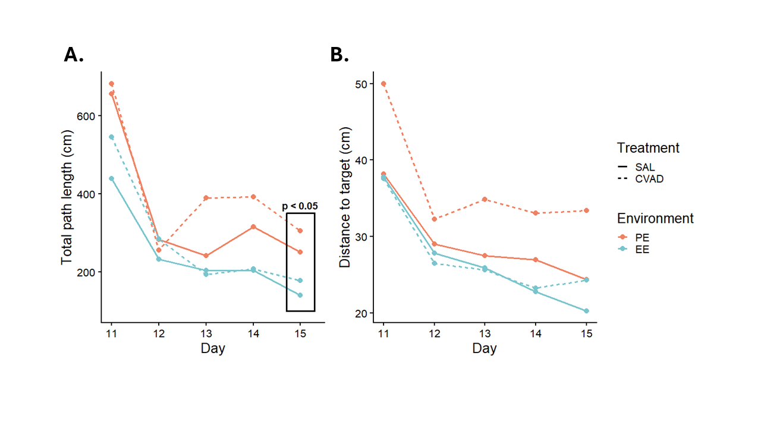
Note. (A) Total path length decreased over days; the black box highlights that only the environment group differences were present on Day 15. (B) Distance-to-target scores also declined over time. Dots represent group means for each day.
To assess learning success during the reversal acquisition phase, a mixed-effects model was fitted to total path length on the final day. This analysis revealed a significant main effect of environment (t(29) = -2.30, p = 0.03, R² = 0.06), with EE mice traveling less than PE mice on the final day, indicating more successful learning. No effect of treatment (t(29) = 0.74, p = 0.47, R² = 0.006) or interaction was observed (t(29) = -0.18, p = 0.86, R² < 0.001). Consistent with this, the Bayesian analysis provided anecdotal evidence for the absence of a treatment (${BF}_{01}$= 0.42, ${HDI}_{90\%}$= [-0.22;0.74]) and interaction effect (${BF}_{01}$= 0.37, ${HDI}_{90\%}$= [-0.67;0.51]). Finally, we assessed retention of the reversal platform by fitting a two‑way ANOVA to time spent in the reversal quadrant during the final probe trial on Day 15. Neither treatment (F(1, 29) = 0.80, p = 0.78, η² = 0.003) nor environment (F(1, 29) = 0.87, p = 0.77, η² = 0.003) showed a significant main effect, and the interaction was also non‑significant (F(1, 29) = 1.54, p = 0.23, η² = 0.05). Together, this indicates that no detectable differences in memory retention are present. Bayesian analyses similarly provided only anecdotal evidence for the absence of treatment (${BF}_{01}$= 0.36, ${HDI}_{90\%}$= [-0.38;0.85]), environment (${BF}_{01}$= 0.41, ${HDI}_{90\%}$= [-0.91;0.32]), and interaction effects (${BF}_{01}$= 0.61, ${HDI}_{90\%}$= [-1.08;0.84]), suggesting that these null findings should be interpreted with caution.
Figure 17
Results from the reversal target quadrant probe trial
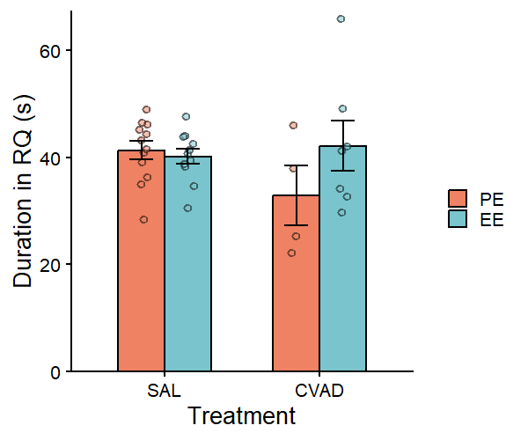
Note. Duration in the reversal target quadrant during the last probe trial (Day 15). Bars show means ± SEM; individual points represent raw data.
- Elevated T-maze
During the Elevated T-maze task, total path length was used as an additional measure of general exploration (fig). We fitted a mixed-effects model with random intercepts to examine the effects of treatment, environment and, stage. We included only the environment × treatment interaction because our focus was on overall differences in stage, rather than on how stage-specific effects varied across groups. Stage-related interactions did not provide additional insight into general exploration and were therefore omitted from the model. We found no significant main effect of stage (t(33) = 1.48, p = 0.15, R² = 0.02), indicating that mice explored equally during the training and testing phases. However, we did find a significant main effect of treatment (t(30) = -2.18, p = 0.04, R² = 0.10), whereas environment did not influence exploration (t(30) = 0.76, p = 0.45, R² = 0.01). Overall, chemotherapy-treated mice explored less than saline-treated mice. The environment × treatment interaction was also non-significant (t(30) = 0.72, p = 0.48, R² = 0.01). Bayes factors provided only anecdotal evidence for the absence of environment (${BF}_{01}$= 0.45, ${HDI}_{90\%}$= [-0.23;0.79]), stage (${BF}_{01}$= 0.45, ${HDI}_{90\%}$= [-0.03;0.48]), and interaction effects (${BF}_{01}$= 0.53, ${HDI}_{90\%}$= [-0.61;1.01]), indicating that additional data would be required to draw robust conclusions.
To assess spatial working memory, we computed the novel arm preference (NAP) as the proportion of time spent in the novel arm relative to the total time spent in both arms (fig). A two‑way ANOVA revealed no significant main effects of treatment (F(1, 30) = 0.05, p = 0.83, η² = 0.002) or environment (F(1, 30) = 0.04, p = 0.83, η² = 0.001), and the interaction was also non‑significant (F(1, 30) = 2.54, p = 0.12, η² = 0.08), indicating no detectable differences in spatial working memory across groups. Accordingly, environmental enrichment did not provide a protective benefit against chemotherapy-induced spatial working memory deficits. However, while the Bayesian analysis provided moderate evidence for the absence of a treatment effect (${BF}_{01}$= 0.29, ${HDI}_{90\%}$= [-0.67;0.51]), it offered only anecdotal evidence for the absence of an environment effect (${BF}_{01}$= 0.35, ${HDI}_{90\%}$= [-0.37;0.80]) and no evidence regarding the interaction (${BF}_{01}$= 1.13, ${HDI}_{90\%}$= [-0.30;1.58]). This pattern suggests that the current dataset is not sufficiently informative, and these effects should therefore be interpreted with caution.
- Passive avoidance
To assess associative learning and contextual memory, latency to enter the dark compartment during the passive avoidance test was analyzed using a mixed effects model with trial as the repeated factor and treatment and environment as between subject factors (fig). The analysis revealed a significant main effect of trial (t(30) = 3.68, p < 0.001, R² = 0.17), indicating that all animals showed learning across the two sessions regardless of treatment or environment. Neither treatment (t(30) = 0.06, p = 0.95, R² < 0.001) nor environment (t(30) = 0.25, p = 0.81, R² = 0.001) showed significant main effects. Bayesian analysis supported these findings, providing moderate evidence for the absence of an environment effect (${BF}_{01}$= 0.31, ${HDI}_{90\%}$= [-0.59;0.39]) and only anecdotal evidence for the absence of a treatment effect (${BF}_{01}$= 0.41, ${HDI}_{90\%}$= [-0.76;0.45]). None of the two way interactions (trial × environment (t(30) = -1.43, p = 0.16, R² = 0.03), trial × treatment (t(30) = -0.52, p = 0.61, R² = 0.004), or environment × treatment (t(30) = -0.10, p = 0.92, R² < 0.001)) reached significance. Bayesian factors similarly indicated anecdotal evidence for the absence of trial x environment (${BF}_{01}$= 0.56, ${HDI}_{90\%}$= [-0.93;0.30]), trial x treatment (${BF}_{01}$= 0.48, ${HDI}_{90\%}$= [-0.67;0.87]) and treatment x environment effects (${BF}_{01}$= 0.53, ${HDI}_{90\%}$= [-0.52;1.00]). The three way interaction (trial × environment × treatment) was also non significant (t(30) = 1.90, p = 0.06, R² = 0.05), suggesting that enriched environment did not reliably protect against potential treatment related impairments in learning. However, the Bayes factor for this interaction indicated anecdotal evidence for the presence of the effect (${BF}_{01}$= 2.25, ${HDI}_{90\%}$= [-0.02;1.88]). Taken together with the relatively small p value, these results suggest that a subtle interaction may be present but the current dataset was insufficient to detect it. Further data is needed to clarify this possibility.

References (still need to check for mistakes!!)
- Kantarjian, H. M., O’Brien, S., Smith, T. L., Cortes, J., Giles, F. J., Beran, M., Pierce, S., Huh, Y., Andreeff, M., Koller, C., Ha, C. S., Keating, M. J., Murphy, S., & Freireich, E. J. (2000). Results of treatment with Hyper-CVAD, a Dose-Intensive regimen, in adult acute lymphocytic leukemia. Journal of Clinical Oncology, 18(3), 547. https://doi.org/10.1200/jco.2000.18.3.547 (hyper-CVAD in adults)
- Fares, R. P., Belmeguenai, A., Sanchez, P. E., Kouchi, H. Y., Bodennec, J., Morales, A., Georges, B., Bonnet, C., Bouvard, S., Sloviter, R. S., & Bezin, L. (2013). Standardized Environmental Enrichment Supports Enhanced Brain Plasticity in Healthy Rats and Prevents Cognitive Impairment in Epileptic Rats. PLoS ONE, 8(1), e53888. https://doi.org/10.1371/journal.pone.0053888
- Khalil, M. H. (2024). Environmental enrichment: a systematic review on the effect of a changing spatial complexity on hippocampal neurogenesis and plasticity in rodents, with considerations for translation to urban and built environments for humans. Frontiers in Neuroscience, 18, 1368411. https://doi.org/10.3389/fnins.2024.1368411
- Çevik, Ö. S., Yıldırım, D. D., Uzun, C., & Horata, E. (2025). Contribution of distinctive outcome measures to the assessment of anxiety in the open field: A meta-analysis of factors mediating open-field test variability in rodent models of anxiety. Behavioural Brain Research, 490, 115612. https://doi.org/10.1016/j.bbr.2025.115612
- Leo, S., Straetemans, R., Dhooge, R., & Meert, T. (2008). Differences in nociceptive behavioral performance between C57BL/6J, 129S6/SvEv, B6 129 F1 and NMRI mice. Behavioural Brain Research, 190(2), 233–242. https://doi.org/10.1016/j.bbr.2008.03.001
- Lueptow, L. M. (2017). Novel Object Recognition Test for the Investigation of Learning and Memory in Mice. Journal Of Visualized Experiments, 126, 55718. https://doi.org/10.3791/55718
- Berlyne, D. (1950). Novelty and curiosity as determinants of exploratory behavior. British Journal of Psychology. General Section, 41(1-2), 68–80.
- Deacon, R. M. (2013). Measuring motor coordination in mice. Journal Of Visualized Experiments, 75, 2609. https://doi.org/10.3791/2609

- Nadler, J. J., Moy, S. S., Dold, G., Trang, D., Simmons, N., Perez, A., Young, N. B., Barbaro, R. P., Piven, J., Magnuson, T. R., & Crawley, J. N. (2004). Automated apparatus for quantitation of social approach behaviors in mice. Genes Brain & Behavior, 3(5), 303–314. https://doi.org/10.1111/j.1601-183x.2004.00071.x

- Machado, C., Reis-Silva, T., Lyra, C., Felicio, L., & Malnic, B. (2018). Buried Food-seeking Test for the Assessment of Olfactory Detection in Mice. BIO-PROTOCOL, 8(12), e2897. https://doi.org/10.21769/bioprotoc.2897

- Morris, R. G. (1981). Spatial localization does not require the presence of local cues. Learning And Motivation, 12(2), 239–260. https://doi.org/10.1016/0023-9690(81)90020-5

- Redish, A. D., & Touretzky, D. S. (1998). The Role of the Hippocampus in Solving the Morris Water Maze. Neural Computation, 10(1), 73–111. https://doi.org/10.1162/089976698300017908

- Othman, M. Z., Hassan, Z., & Has, A. T. C. (2022). Morris water maze: a versatile and pertinent tool for assessing spatial learning and memory. EXPERIMENTAL ANIMALS, 71(3), 264–280. https://doi.org/10.1538/expanim.21-0120

- Florian, C., & Roullet, P. (2004). Hippocampal CA3-region is crucial for acquisition and memory consolidation in Morris water maze task in mice. Behavioural Brain Research, 154(2), 365–374. https://doi.org/10.1016/j.bbr.2004.03.003

- D’Isa, R., Comi, G., & Leocani, L. (2021). Apparatus design and behavioural testing protocol for the evaluation of spatial working memory in mice through the spontaneous alternation T-maze. Scientific Reports, 11(1), 21177. https://doi.org/10.1038/s41598-021-00402-7

- Ögren, S. O., & Stiedl O. (2015). Passive avoidance. In I. P. Stolerman & L. H. Price (Eds.), Encyclopedia of Psychopharmacology (2nd ed., pp. 1220–1228). Springer. https://doi.org/10.1007/978-3-642-36172-2

- Osborne, J. W. (2000). Advantages of hierarchical linear modeling. Practical Assessment, Research & Evaluation, 7(1), 1. https://doi.org/10.7275/pmgn-zx89

- Schmalz, X., Manresa, J. B., & Zhang, L. (2021). What is a Bayes factor? Psychological Methods, 28(3), 705–718. https://doi.org/10.1037/met0000421

- Wagenmakers, E., Love, J., Marsman, M., Jamil, T., Ly, A., Verhagen, J., Selker, R., Gronau, Q. F., Dropmann, D., Boutin, B., Meerhoff, F., Knight, P., Raj, A., Van Kesteren, E., Van Doorn, J., Šmíra, M., Epskamp, S., Etz, A., Matzke, D., . . . Morey, R. D. (2017). Bayesian inference for psychology. Part II: Example applications with JASP. Psychonomic Bulletin & Review, 25(1), 58–76. https://doi.org/10.3758/s13423-017-1323-7

- Jeffreys, H. (1961). Theory of probability (3rd ed.). Oxford University Press.
- Yolanda, S., Redjeki, S., Andraini, T., Santoso, D. I. S., Ibrahim, N., & Mailani, R. (2019). Combination of Aerobic Exercise and Continuous Environmental Enrichment Improves Adult Male Rats’ Spatial Memory: Study on Hippocampal Insulin Like Growth Factor 1 (IGF-1) and Fibroblast Growth Factor 2 (FGF-2) Expression. The Indonesian Biomedical Journal, 11(2), 210–216. https://doi.org/10.18585/inabj.v11i2.731

- Amézaga, J., Alfaro, B., Ríos, Y. et al. Assessing taste and smell alterations in cancer patients undergoing chemotherapy according to treatment. Support Care Cancer 26, 4077–4086 (2018). https://doi.org/10.1007/s00520-018-4277-z

