Team

Project Manager:Sieder Villareal

Graphic Designer: Michael Paraiso

Application Developer: Sieder Villareal

Tester: Bryan Sunga

Implementation Engineer: Michael Parasio/Sieder Villareal

Documentation: Sieder Villareal/Michael Paraiso/Bryan Sunga

Certificate of Completion

Table of Contents

1. Problem Definition
2. Customer Requirement Specification
3. Table Design
4. E-R Diagrams
5. Date Flow Diagram(DFD)
6. Algorithms
7. GUI Standards Document
8. Source Code

Problem Definition

How to submit?

-Click submit a product from navigation.(submitted product goes to the list of submitted products automatically)

How many days will it take for a product to be manufactured?

-It depends on the product. Jot down the ProductID for tracking.

How the product is tested?

-2 types of testing. 1.)Unit checking 2.) CPRI testing

How to track your product?

-Use search the the navigation or go to advance search and enter your productID/TestingID to track your product.

Customer Requirement Specification

Client: SRS Electrical Appliances

Business/Project Objective:

Launch a website by the name SRSLabautomation.com where a user will get relevant information about electrical appliances and submit product to be tested and manufactured.

Hardware Requirements:

* A minimum computer system that will help you access all the tools in the courses is a Pentium 166 or better
* 128 Megabytes of RAM or better

Software Requirements:

* PHP
* MySQL
* PERL
* Apache

Scope of the Project:

` The SRS Electrical appliances are the manufacturers of some electrical products like switch gears, fuses, capacitors, resistors, etc…. These products after manufactured they are sent for testing where the product is subjected to some testing conditions, and then after the testing is successful at their laboratories they are sent to CPRI for further testing process, so that they can get it approved from CPRI and then release the product into the market. If the testing fails then the product is sent back for re-manufacturing it and then they are again subjected to tests.

1. The details of the products and the testing like the product code, product id, testing id, the revise, the testing performed, remarks provided, the result of the testing, etc…. are needed to be maintained in a separate database.
2. Product id should be a unique 10 digit code as described by the manufacturing unit and the testing id should be a unique 12 digit code, which should be automatically generated.
3. An advanced search option is to be included.
4. The application should contain a modular and the sub-modular form based on the type of the product and as well based on the type of the testing.
5. One should be able to capture the detailed description of the remarks that include about the testing and what should be the output for that testing and the result of testing performed and as well the remarks if any for that particular product.
6. One should be able to check the status of the testing.
7. After entering the record, it should even ask for the name of the person (s) who has tested the product.

**Table Design**

**Table: productlist**

**Field Name Data Type Null Key**

ID int(10) No Primary key

Product_Name varchar(40) No

Company_Name varchar(80) No

Details longtext No

image varchar(80) No

**Table: products**

**Field Name Data Type Null Key**

ID int(10) No Primary key

Product_ID bigint(10) No

Testing_ID bigint(12) No

Company_Name varchar(40) No

Product_Name varchar(40) No

Testing_Type varchar(40) No

Status varchar(80) No

Product_Comment longtext No

Tester varchar(30) No

Date_Entered datetime No

Image varchar(40) No

E-R Diagrams

| **Productlist** |
| --- |
| **ID** |
| **Product_Name** |
| **Company_Name** |
| **Details** |
| **image** |

| **Products** |
| --- |
| **ID** |
| **Product_ID** |
| **Testing_ID** |
| **Company_Name** |
| **Product_Name** |
| **Testing_Type** |
| **Status** |
| **Product_Comment** |
| **Tester** |
| **Date_Entered** |
| **Image** |

Data Flow Diagram(DFD)

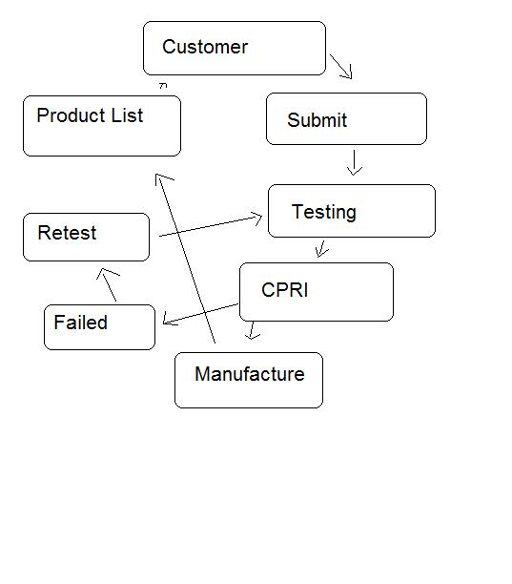

sitemap.php

-HTML/javascript/CSS/images not included

1. Home (index.php)

2. Products menu

a) Product list (ManufacturedProducts.php)

I. view products (view_products.php)

b) List of submitted products (products.php)

I.product page (product_page.php)

3. Search

a) Advanced search (AdvSearch.php)

4. Submit a product (submit.php)

5. Contact us (contact.php)

Algorithms

1.Click Submit A Product

2.Fill up the forms(Provide a Photo of your product)

3.Write the Product or Testing ID for tracking

4.Browse products by using the navigation

User Guide

* Create a database named srslab
* Import the SQL provided
* Open includes/mysql_connection.php
* Edit Server, Username, and Password
* Copy the srslab folder in the appropriate directory
* Deploy the project in apache/LAMP/WAMP/MAMP

(whatever server your using) folder

* Execute the php pages

GUI Standards Document

Index.php

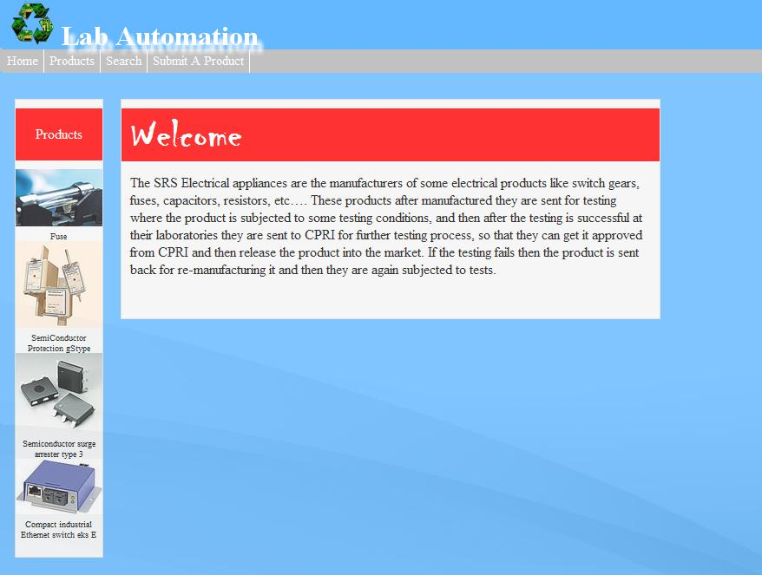

ManufacturedProducts.php

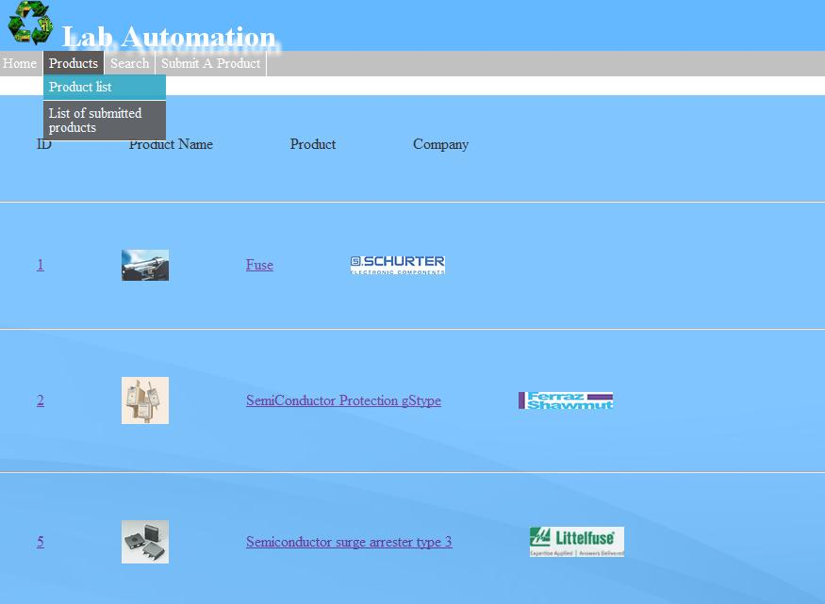

view_products.php?Product_Name=Fuse

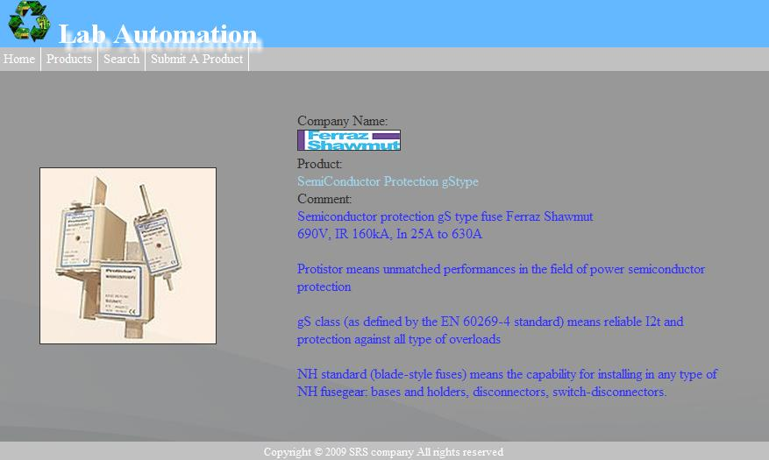

Navigation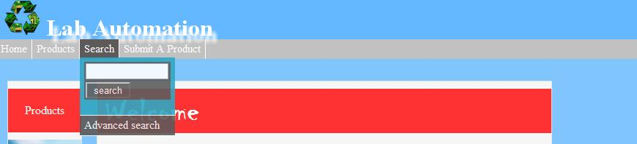

AdvSearch.php

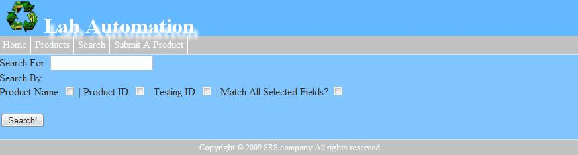

Submit.php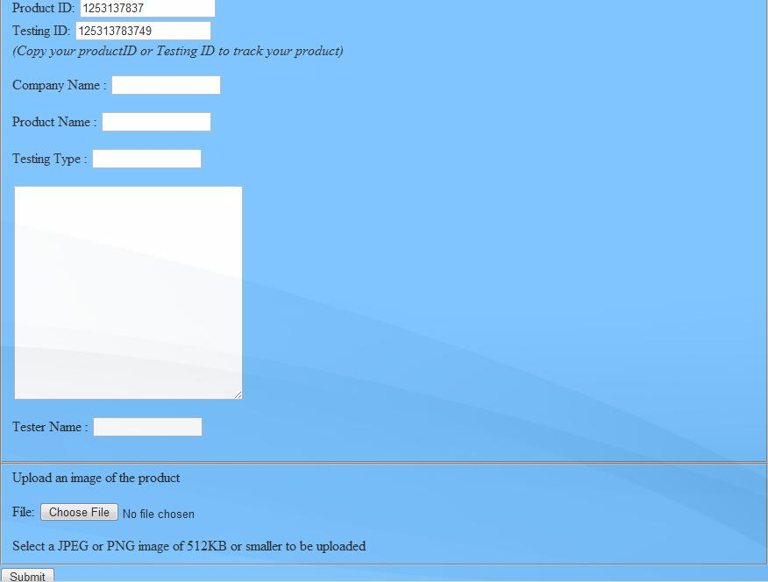

products.php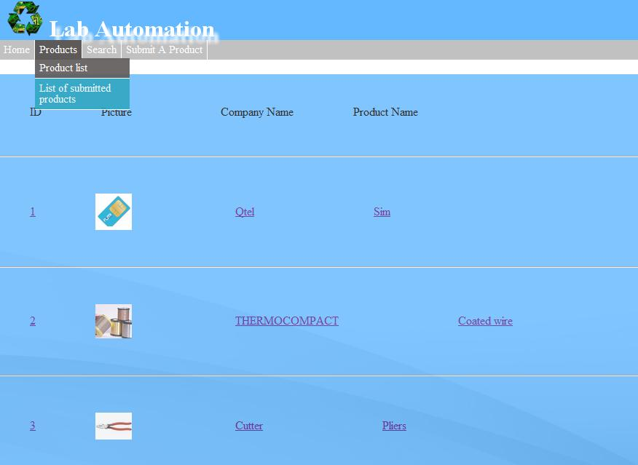

product_page.php?Product_Name=Sim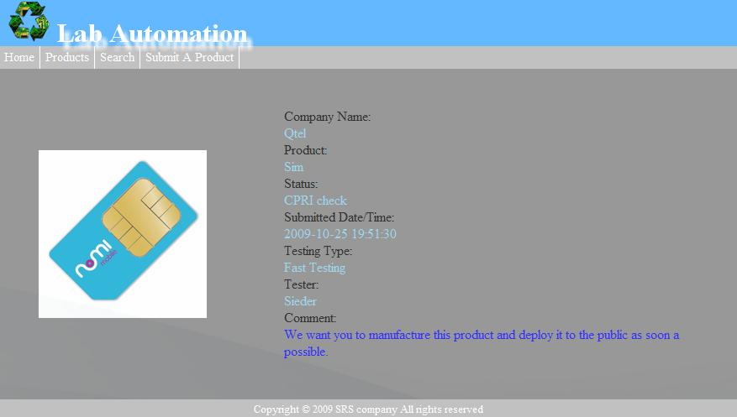

contactUs.php(Not Functional)

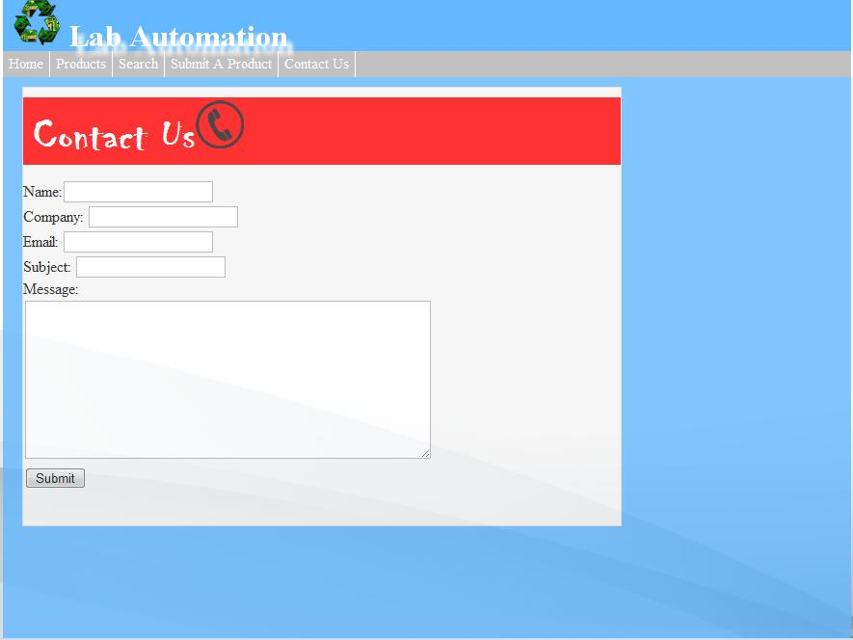

Source Code

Index.php

<?php

$page_title = "Home | Welcome";

include 'template/header.php';

?>

<body >

<div class="trans" style="border:0px solid; width: 880px; background-color: #63B8FF; height:600px "><br>

<div class="box" style="margin-left:15px; width:100px; background-color:#F5F5F5; border: 1px solid #ddd" >

<div class="box" style="width:100px; background-color:red; margin-bottom:10px; padding-top:20px" align=center >

<font color=white>Products</font>

</div>

<?php

include 'includes/mysql_connection.php';

$query = 'SELECT image, Product_Name FROM productlist LIMIT 4';

$result = mysql_query($query, $conn);

while($row = mysql_fetch_array($result, MYSQL_ASSOC)){

echo '<img src="'.$row['image'].'" width="100px" style="margin-bottom:5px;">';

echo '<center><font size=1>'.$row['Product_Name'].'</font></center>';

}

?>

</div>

<div class="box" style=" border:1px solid #ddd; background-color: #F5F5F5; margin-left:20px; width: 620px">

<div class="box" style="background-color:red; width:610px; padding-top:3px; padding-bottom: 2px; margin-bottom: 15px; padding-left: 10px">

<font color="white" face="Chiller" size=8px ><b>Welcome</b></font></div>

<p style="padding:10px 10px 10px 10px" onmouseout="this.style.color = 'black';" onmouseover="this.style.color = '#008B00';">

The SRS Electrical appliances are the manufacturers of some electrical products like switch gears, fuses, capacitors, resistors, etc…. These products after manufactured they are sent for testing where the product is subjected to some testing conditions, and then after the testing is successful at their laboratories they are sent to CPRI for further testing process, so that they can get it approved from CPRI and then release the product into the market. If the testing fails then the product is sent back for re-manufacturing it and then they are again subjected to tests.

</p></div>

<br>

</div>

<?php

include 'template/footer.htm';

?>

ManufacturedProducts.php

<?php

$page_title = 'Submitted Products List';

include'template/header.php';

?>

<head>

<script src='template/javascripts/box.js' type='text/javascript'></script>

<script type='text/javascript'>

popBoxShowRevertBar = false;

popBoxShowRevertText = false;

popBoxShowRevertImage = false;

</script>

</head>

<?php

require 'includes/mysql_connection.php';

//SQL query

$q = 'SELECT * FROM productlist';

echo '<br><div class="trans" style="border:0px solid #ddd; width:880px; background-color:#63B8FF"><table cellpadding="40px"><tr><td>ID</td><td>Product Name</td><td>Product</td><td>Company</td></tr></table><hr>';

$r = mysql_query($q, $conn); //this is the result

while($row = mysql_fetch_array($r, MYSQL_ASSOC)){

echo '<table cellpadding="40px"><tr>';

echo '<td >';

echo '<a href="view_products.php?Product_Name='.$row['Product_Name'].'"><font>' .$row['ID'].'</font> </a>';//lists all ID from the DB

echo '</td>';

echo '<td><a href="view_products.php?Product_Name='.$row['Product_Name'].'"><img src="' .$row['image'].'" width="50px" height"50px"id="imgPopBox"onmouseover="PopEx(this,-50,-25,200,98,20,null)"> </a>'; //lists all images

echo '</td>';

echo '<td>';

echo '<a href="view_products.php?Product_Name='.$row['Product_Name'].'"><font>' .$row['Product_Name'].'</font> </a>'; //product name

echo '</td>';

echo '<td>';

echo '<a href="view_products.php?Product_Name='.$row['Product_Name'].'"></a><img src="' .$row['Company_Name'].'"width="100px" height"100px"> ';//lists all company name from the DB

echo '</td>';

echo '</tr></table><hr>';

}

mysql_free_result($r);

?>

</div>

<?php

echo '<br>';

include 'template/footer.htm';

?>

product_page.php

<?php

$page_title = 'Product View';

include'template/header.php';

?>

<?php

require 'includes/mysql_connection.php';

if(isset($_GET['Product_Name'])){

$Product_Name = mysql_real_escape_string($_GET['Product_Name']);

$q = "SELECT * FROM products WHERE Product_Name = '$Product_Name' LIMIT 1";

if($result = mysql_query($q)){

if(mysql_num_rows($result)){

$row = mysql_fetch_assoc($result);

echo '<div class="trans" style="border: 0px solid gray; background-color:gray"><table cellpadding="45px" ><tr>';

echo '<td><img src="'.$row['Image'].'" width="200px" height="200px"></td>';

echo "<td>Company Name:<br><font color=skyblue>{$row['Company_Name']}</font> <br>";

echo "Product:<br><font color=skyblue>{$row['Product_Name']}</font><br>";

echo "Status:<br><font color=skyblue>{$row['Status']}</font><br>";

echo "Submitted Date/Time:<br><font color=skyblue>{$row['Date_Entered']}</font><br>";

echo "Testing Type:<br><font color=skyblue>{$row['Testing_Type']}</font><br>";

echo "Tester:<br><font color=skyblue>{$row['Tester']}</font><br>";

$contents = $row['Product_Comment'];

echo "Comment:<br><font color=blue border=1px>{$contents}</font></td>";

echo '</tr></table></div>';

}

}

}

?>

<?php

include 'template/footer.htm';

?>

Products.php

<?php

$page_title = 'Product List';

include'template/header.php';

?>

<head>

<script src='template/javascripts/box.js' type='text/javascript'></script>

<script type='text/javascript'>

popBoxShowRevertBar = false;

popBoxShowRevertText = false;

popBoxShowRevertImage = false;

</script>

<?php

require 'includes/mysql_connection.php';

//SQL query

$q = 'SELECT * FROM products';

$r = mysql_query($q, $conn); //this is the result

echo '<br><div class="trans" style="border:0px solid #ddd; width:880px;background-color:#63B8FF"><table cellpadding="40px" ><tr>';

echo '<td>ID</td><td>Picture</td><td style="padding-left:80px">Company Name</td><td>Product Name</td></tr></table><hr>';

while($row = mysql_fetch_array($r, MYSQL_ASSOC)){ //while for the loop

echo '<table cellpadding="40px" ><tr>';

echo "<td>";

echo '<a href="product_page.php?Product_Name='.$row['Product_Name'].'"><font>' .$row['ID'].'</font> </a>';//lists all ID from the DB

echo '</td>';

echo '<td ><a href="product_page.php?Product_Name='.$row['Product_Name'].'"><img src="' .$row['Image'].'" width="50px" height"50px"id="imgPopBox"onmouseover="PopEx(this,-50,-25,200,98,20,null)"> </a>'; //lists all images

echo '</td>';

echo '<td style="padding-left:100px">';

echo '<a href="product_page.php?Product_Name='.$row['Product_Name'].'"><font>' .$row['Company_Name'].'</font> </a>'; //product name

echo '<td>';

echo '<td>';

echo '<a href="product_page.php?Product_Name='.$row['Product_Name'].'"><font>' .$row['Product_Name'].'</font> </a>'; //product name

echo '<td></tr></table><hr>';

}

mysql_free_result($r);

?>

</div>

<br>

<?php

include 'template/footer.htm';

?>

Searchresult.php

<?php

$page_title = 'Product List';

include'template/header.php';

?>

<div class="trans" style=" background-color:#63B8FF; float:left; padding: 10px 10px 10px 10px; border: 1px solid #ddd;margin-left:10px;margin-top:10px;">

<?php

include'includes/mysql_connection.php';

// Set up our error check and result check array

$error = array();

$results = array();

// First check if a form was submitted.

// Since this is a search we will use $_GET

if (isset($_GET['search'])) {

$searchTerms = trim($_GET['search']);

$searchTerms = strip_tags($searchTerms); // remove any html/javascript.

if (strlen($searchTerms) < 3) { //condional for validating more than 3 search

$error[] = "Search terms must be longer than 3 characters.";

}else {

$searchTermDB = mysql_real_escape_string($searchTerms); // prevent sql injection.

}

// If there are no errors, lets get the search going.

if (count($error) < 1) {

$searchSQL = "SELECT Product_Name, Testing_ID, Product_ID, Company_Name, Tester FROM products WHERE ";

// grab the search types.

$types = array();

$types[] = isset($_GET['Product_Name'])?"`Product_Name` LIKE '%{$searchTermDB}%'":'';

$types[] = isset($_GET['Product_ID'])?"`Product_ID` LIKE '%{$searchTermDB}%'":'';

$types[] = isset($_GET['Testing_ID'])?"`Testing_ID` LIKE '%{$searchTermDB}%'":'';

$types = array_filter($types, "removeEmpty"); // removes any item that was empty (not checked)

if (count($types) < 1)

$types[] = "`Product_Name` LIKE '%{$searchTermDB}%'"; // use the body as a default search if none are checked

$andOr = isset($_GET['matchall'])?'AND':'OR';

$searchSQL .= implode(" {$andOr} ", $types) . " ORDER BY `Product_Name`"; // order by title.

$searchResult = mysql_query($searchSQL) or die("There was an error.<br/>" . mysql_error() . "<br />SQL Was: {$searchSQL}");

if (mysql_num_rows($searchResult) < 1) {

$error[] = "The search term provided {$searchTerms} yielded no results.";

}else {

$results = array(); // the result array

$i = 1;

while ($row = mysql_fetch_assoc($searchResult)) {

$results[] = '<table cellpadding="40px" >

<tr><td>ID</td><td>Product Name</td><td>Company Name</td>

</tr>

<tr><td>'.$i.'.</td> <td> <a href="product_page.php?Product_Name='.$row['Product_Name'].'">'.$row['Product_Name'].' </a></td><td> '.$row['Company_Name'].'</td></tr></table><br /><br />';

$i++;

}

}

}

}

function removeEmpty($var) {

return (!empty($var));

}

?>

<?php echo (count($error) > 0)?"The following had errors:<br />" . implode("<br />", $error) . "<br /><br />":""; ?>

<?php echo (count($results) > 0)?"Your search term: {$searchTerms} returned:<br /><br />" . implode("", $results):""; ?>

<?php

//include 'template/footer.htm';

?>

Submit.php

<?php #this is the submit product registration page

$page_title = "Product Registration";

include 'template/header.php';

//Below is the function that automate a 10 digit random number

$number = '1253111111';

$Product_ID = rand() + $number;

//generates number from product_ID and adds 2 digit randomly

$int = rand(10,99);

$Testing_ID = $Product_ID . $int;

//isset — function that determine if a variable is set and is not null

if(isset($_POST['submitted'])){ #check if the form has been submitted

//check for an upload file

if(isset($_FILES['upload'])){ #to validate the file

$allowed = array ('image/pjpeg', #I imposed all image file types into an array called $allowed

'image/jpeg','image/jpeg',

'image/JPG','image/X-PNG',

'image/PNG', 'image/png',

'image/x-png');

if(in_array($_FILES['upload']['type'],$allowed)){

if(move_uploaded_file($_FILES['upload']['tmp_name'],"Uploads/{$_FILES['upload']['name']}")) //moving the file to its permanent place

{

$image = "Uploads/{$_FILES['upload']['name']}"; //Im making a $image variable so I can display it later

echo "<fieldset>The file has been upload!<br>" . '<img style="border:1px solid gray;" src="' .$image .'" width="50px" height="50px"><br>' ; //Finally it works!!! I used <img src and called the $image to display the upload image =)

}//end of IF move

}else{ //invalid file type else

echo 'Please upload a valid image file. JPEG or PNG';

}

}//End of isset($FILES['upload']) IF

if($_FILES['upload']['error'] > 0){ //check for any error =P

echo 'The file could not be uploaded because';

//Switch that prints detailed error

switch($_FILES['upload']['error']){

case 1:

print 'The file exceeds the upload max';

break;

case 2:

print 'File upload stopped';

break;

default:

print 'A system error occured';

break;

}//end of switch : there are several more possible reasons to occur.

//

}//End of IF error

//Delete file is exist

//if file_exists return TRUE unlink will be triggered =P

if( file_exists($_FILES['upload']['tmp_name']) && is_file($_FILES['upload']['tmp_name'])){

//i will use unlink() function to remove the file

unlink($_FILES['upload']['temp_name']);

}

}//End of the submitted conditional

if(isset($_POST['submitted'])){

$errors = array();

//i created an array so I could use it later to validate textfields

require 'includes/mysql_connection.php'; //this is for the function mysql_real_escape_string to refer to....

//check company name if entered

if(empty($_POST['ProdID'])){

}else{

$PID = $_POST['ProdID'];

}

if(empty($_POST['TestID'])){

}else{

$TID = $_POST['TestID'];

}

if(empty($_POST['Company_Name'])){

$errors[] = 'You forgot to enter the Company\'s name';

}else{

$CN = trim(mysql_real_escape_string($_POST['Company_Name']));

}

//check product_title if entered

if(empty($_POST['Product_Name'])){

$errors[] = 'You forgot to enter the product\'s name';

}else{

$PN = trim(mysql_real_escape_string($_POST['Product_Name']));

}

//testing type

if(empty($_POST['Testing_Type'])){

$errors[] = 'Please choose a testing type';

}else{

$TT = trim(mysql_real_escape_string($_POST['Testing_Type']));

}

//check comment

if(empty($_POST['Product_Comment'])){

$errors[] = 'Please populate this field';

}else{

$PC = trim(mysql_real_escape_string($_POST['Product_Comment']));

}

//tester

if(empty($_POST['Tester'])){

$errors[] = 'You forgot to choose a tester';

}else{

$T = trim(mysql_real_escape_string($_POST['Tester']));

}

if(empty($errors)){

//this line means that if everything is ok = execute the following code

//register the infos to the database

require'includes/mysql_connection.php'; //connect to the DB

//select databaes

//make the query

$q = "INSERT INTO products(Product_ID, Testing_ID, Company_Name, Product_Name, Testing_Type, Product_Comment, Tester, Date_Entered, Image)

VALUES('$PID', '$TID', '$CN', '$PN', '$TT', '$PC', '$T',NOW(),'$image')";

$r = @mysql_query($q, $conn); //run the query

if($r){//if it ran ok

Echo 'Thank you for sending! We will run tests as soon as possible<br> We\'ll start after a day or two. ';

echo '<br>Please wait... <meta http-equiv=\'refresh\' content="10;url=index.php"';

echo "Successfuly posted!<br><i>Submitted products are automatically posted <a href=\"products.php\">here</a></i></fieldset>";

}else{ //if didnt run ok

echo '<h1>System Error</h1>';

echo '<p>System Error Occured - '.mysql_error($conn).'<br>Query: '.$q.'</p>';

}//end of if)$r)

mysql_close($conn);

include'template/footer.htm';

exit();

}else //now report the errors from $error array

{

echo '<h1>Error!</h1>';

echo '<p>The following error(s) occured: <br>';

foreach ($errors as $msg){//Print

echo " - $msg<br>\n";

}

echo '<p>Please try again!!!</p>';

} // end of if(empty($errors))

}// end of main conditional

?>

<div class="trans" style= "background-color:#63B8FF; border:0px solid #ddd; width:880px; margin:0 auto">

<form enctype="multipart/form-data" action="submit.php" method="post">

<fieldset>

Product ID: <input type="text" name="ProdID" value="<?php echo $Product_ID; ?>"><br>

<!-- I called the function random() to generate 10 digit as requested =D -->

Testing ID: <input type="text" name="TestID" value="<?php echo $Testing_ID; ?>">

<br><i>(Copy your productID or Testing ID to track your product)</i>

<p>Company Name : <input type="text" name="Company_Name" size="15" maxlength="40" value=""></p>

<p>Product Name : <input type="text" name="Product_Name" size="15" maxlength="40" value=""></p>

<p>Testing Type : <input type="text" name="Testing_Type" size="15" maxlength="40" value=""></p>

<TEXTAREA name="Product_Comment" rows="15" cols="30">

</TEXTAREA>

<p>Tester Name : <input type="text" name="Tester" size="15" maxlength="40" value=""></p>

</fieldset>

<input type="hidden" name="MAX_FILE_SIZE" value="524288">

<fieldset>Upload an image of the product

<p>File: <input type="FILE" name=upload></p>

Select a JPEG or PNG image of 512KB or smaller to be uploaded<br>

</fieldset>

<input type="submit" name="submit" value="Submit">

<input type="hidden" name="submitted" value="TRUE">

</form>

</div>

<?php

include'template/footer.htm';

?>

Testing.php

<?php

$page_title = 'Product List';

include'template/header.php';

?>

<div style="float:left; padding: 10px 10px 10px 10px; border: 1px solid gray;margin-left:10px;margin-top:10px;">

<?php

include'includes/mysql_connection.php';

// Set up our error check and result check array

$error = array();

$results = array();

// First check if a form was submitted.

// Since this is a search we will use $_GET

if (isset($_GET['search'])) {

$searchTerms = trim($_GET['search']);

$searchTerms = strip_tags($searchTerms); // remove any html/javascript.

if (strlen($searchTerms) < 3) { //condional for validating more than 3 search

$error[] = "Search terms must be longer than 3 characters.";

}else {

$searchTermDB = mysql_real_escape_string($searchTerms); // prevent sql injection.

}

// If there are no errors, lets get the search going.

if (count($error) < 1) {

$searchSQL = "SELECT Product_Name, Testing_ID, Product_ID, Company_Name, Tester FROM products WHERE ";

// grab the search types.

$types = array();

$types[] = isset($_GET['Product_Name'])?"`Product_Name` LIKE '%{$searchTermDB}%'":'';

$types[] = isset($_GET['Product_ID'])?"`Product_ID` LIKE '%{$searchTermDB}%'":'';

$types[] = isset($_GET['Testing_ID'])?"`Testing_ID` LIKE '%{$searchTermDB}%'":'';

$types = array_filter($types, "removeEmpty"); // removes any item that was empty (not checked)

if (count($types) < 1)

$types[] = "`Product_Name` LIKE '%{$searchTermDB}%'"; // use the body as a default search if none are checked

$andOr = isset($_GET['matchall'])?'AND':'OR';

$searchSQL .= implode(" {$andOr} ", $types) . " ORDER BY `Product_Name`"; // order by title.

$searchResult = mysql_query($searchSQL) or die("There was an error.<br/>" . mysql_error() . "<br />SQL Was: {$searchSQL}");

if (mysql_num_rows($searchResult) < 1) {

$error[] = "The search term provided {$searchTerms} yielded no results.";

}else {

$results = array(); // the result array

$i = 1;

while ($row = mysql_fetch_assoc($searchResult)) {

$results[] = '<table cellpadding="40px">

<tr><td>ID</td><td>Product Name</td><td>Company Name</td>

</tr>

<tr><td>'.$i.'.</td> <td> <a href="product_page.php?Product_Name='.$row['Product_Name'].'">'.$row['Product_Name'].' </a></td><td> '.$row['Company_Name'].'</td></tr></table><br /><br />';

$i++;

}

}

}

}

function removeEmpty($var) {

return (!empty($var));

}

?>

<style type="text/css">

#error {

color: red;

}

</style>

<body>

<?php echo (count($error) > 0)?"The following had errors:<br /><span id=\"error\">" . implode("<br />", $error) . "</span><br /><br />":""; ?>

<form method="GET" action="<?php echo $_SERVER['PHP_SELF'];?>" name="searchForm">

Search For: <input type="text" name="search" value="<?php echo isset($searchTerms)?$searchTerms:''; ?>" /><br />

Search In:<br />

Product_Name: <input type="checkbox" name="Product_Name" value="on" <?php echo isset($_GET['Product_Name'])?"checked":''; ?> /> |

Product_ID: <input type="checkbox" name="Product_ID" value="on" <?php echo isset($_GET['Product_ID'])?"checked":''; ?> /> |

Testing_ID: <input type="checkbox" name="Testing_ID" value="on" <?php echo isset($_GET['Testing_ID'])?"checked":''; ?> /><br />

Match All Selected Fields? <input type="checkbox" name="matchall" value="on" <?php echo isset($_GET['matchall'])?"checked":''; ?><br /><br />

<input type="submit" name="submit" value="Search!" />

</form>

<?php echo (count($results) > 0)?"Your search term: {$searchTerms} returned:<br /><br />" . implode("", $results):""; ?>

</body>

<?php

echo '<br><br><br><br><br><br><br>';

include 'template/footer.htm';

?>

View_products.php

<?php

$page_title = 'Product View';

include'template/header.php';

?>

<?php

?>

<?php

require 'includes/mysql_connection.php';

if(isset($_GET['Product_Name'])){

$Product_Name = mysql_real_escape_string($_GET['Product_Name']);

$q = "SELECT Product_Name, image, Company_Name, Details FROM productlist WHERE Product_Name = '$Product_Name' LIMIT 1";

if($result = mysql_query($q)){

if(mysql_num_rows($result)){

$row = mysql_fetch_assoc($result);

echo '<div class="trans" style="border: 0px solid #ddd; width: 880px; background-color: gray"><table cellpadding="45px" ><tr>';

echo '<td><img src="'.$row['image'].'" width="200px" height="200px" border="1px"></td>';

echo '<td>Company Name:<br><img src="'.$row['Company_Name'].'" border="1px"> <br>';

echo "Product:<br><font color=skyblue>{$row['Product_Name']}</font><br>";

$notes = "{$row['Details']}";

$handle = fopen($notes, "r");

$contents = fread($handle, filesize($notes));

$contents = nl2br($contents);

echo "Comment:<br><font color=blue border=1px>{$contents}</font></td>";

fclose($handle);

echo '</tr></table></div>';

}

}

}

?>

<?php

include 'template/footer.htm';

?>

ContactUS.php

<?php

$page_title = 'Contact Us';

include'template/header.php';

?>

<div class="trans" style="border:0px solid; width: 880px; background-color: #63B8FF; height:600px ">

<div class="box" style=" border:1px solid #ddd; background-color: #F5F5F5; margin-left:20px; width: 620px">

<div class="box" style="background-color:red; width:610px; padding-top:3px; padding-bottom: 2px; margin-bottom: 15px; padding-left: 10px">

<font color="white" face="Chiller" size=8px ><b>Contact Us</b><img src="Images/phone.png" width=50px height=50px></font></div>

<p style="padding:10px 10px 10px 10px" onmouseout="this.style.color = 'black';" onmouseover="this.style.color = '#008B00';">

<form>

Name:<input type=text name=Name><br>

Company: <input type=text name=company><br>

Email: <input type=text name=email><br>

Subject: <input type=text name=subject><br>

Message: <br><textarea name=description rows=10 cols=50></textarea> <br>

<input type=submit name=submit>

</form>

</p></div>

</div>

<?php

include'template/footer.htm';

?>

Includes/mysql_connection.php

<?php

//mysql_connect.php

//I stored connection to these variables

$server = 'localhost';

$username = 'root';

$password = 'dota';

$conn = mysql_connect($server,$username,$password

);

if($conn)//a conditional that checks if connected to DB or not

{

echo ' ';

}else{

die('Unable to connect');

}

$db_selected = mysql_select_db('srslab', $conn);

if($db_selected){

echo ' ';

}else{

die('such database does not exist');

}

?>

Template/header.php

<html xmlns="http://www.w3.org/1999/xhtml">

<head>

<title>

<?php echo $page_title; ?>

</title>

<LINK REL=StyleSheet HREF="template/style.css" TYPE="text/css" MEDIA=screen>

<script type='text/javascript' src='template/javascripts/jquery.js'></script>

<script type='text/javascript' src='template/javascripts/jquery.droppy.js'></script>

<link rel="stylesheet" href="template/droppy.css" type="text/css">

</head>

<body class="body" >

<div align="right">

</div>

<div align="left" style="width:880px; margin:0 auto; background-color:#63B8FF; height:45px; padding-bottom:10px; " ><font color=white >

<h1 style="padding-left:10px; text-shadow: white 0.2em 0.3em 0.2em "><img src="template/images/recycled_electronics.png" width=50px height=50px> Lab Automation</h1></font>

</div>

<div align="left" >

<?php

include'template/nestedmenu.php';

?>

</div>

</body>

</html>

Template/footer.htm

<!DOCTYPE HTML PUBLIC "-//W3C//DTD HTML 4.01 Transitional//EN" "http://www.w3.org/TR/html4/loose.dtd">

<html>

<body style="float:bot;">

<div >

<div align="center" style="width:880px; margin-top:0 auto; background-color:#c1c1c1; height:20px; padding-top:4px; position:"><font color="white" size=2px > Copyright © 2009 SRS company All rights reserved </font> </div>

</div>

</body>

</html>