Path-Finding:
- The Path Nodes
  - The path nodes are placed when generating the terrain, as shown below:
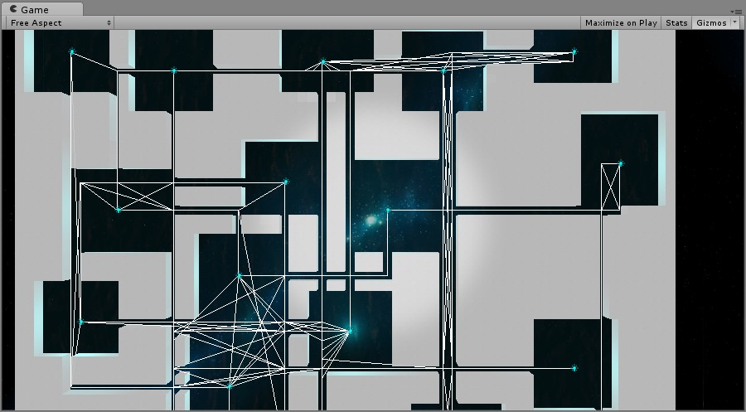
(Fig 1. A line between two path nodes that can be connected)
- A* path-finding algorithm
  - Find the nearest path node to the start position (the Sprite’s current position);
  - Find the nearest path node to the target position;
  - Use the A* algorithm where the Evaluation Function is the distance away from the target position; and A* is [BFS + Priority Queue];
  - Record the path and put it into a variable;
  - Make the Sprite move through the path.

