Project title: Predicting diabetic risk: predicting fasting blood glucose level from diet survey

Goal:

This project will be developing predictive models to predict fasting blood glucose level from dietary and basic demographic information. The idea is to provides a tool to perform a virtual diabetic screening based on one’s diet to identify unaware individuals, who might have pre-diabetes or diabetes, for further testing and consultation.

Targeted client:

Health institutions and doctors that would perform health check and disease screening. The predictive model, which will require inputs from simple dietary surveys, will help to identify patients with potential underlying diabetic conditions for further examination. Compared to measuring fasting blood glucose level from a blood drawn, this virtual screening approach, as the very first pass of screening, could provide a quick and non-invasive assessment of the potential diabetic risk.

Data:

The National Health and Nutrition Examination Survey (NHANES) from 2013 to 2014 as curated on Kaggle will be used for this study. The NHANES is an annual study carried out by the National Center for Health Statistics (NCHS), a part of the Centers for Disease Control and Prevention (CDC), to evaluate the health and nutritional status of those reside in the United States, producing the national health statistics. This annual study, consisted of both interviews and physical examinations, surveys 5000 individuals that represents the national population.

The NHANES collects a wide variety of information. The interview portion includes demographic, socioeconomic, dietary and health questionnaires. The examination portion includes laboratory tests as well as surveys of medical, dental, and physiological measurements. This study, focusing on modeling the relationships between diets and diabetes, utilize the following data from the 2013-2014 survey:

1. Laboratory measurements of fasting blood glucose level. This is not included in the data set available on Kaggle, and was directly downloaded from the NHANES site.
2. Dietary and nutrient information from the dietary survey. Specifically, the data includes i) the types and amounts of food and drinks consumed in the 24-hour period before the interview, and the corresponding energy intake, nutrients and other food components, and ii) diet-related habits, such as salt use in food preparation.
3. Basic demographic information, including age and gender.

The selected data is summarized in Table 1. The selected data columns are extracted from various csv/xpt files and merged based on the participant IDs. The data is relative clean as majority of the data is numerical and ready for modeling. Few are categorical data with “refused” and “don’t known” categories, which are converted as NaN before modeling. Not all participants participated or answered all parts of the survey, and those with missing responses or NaN in any of the selected data fields are excluded. The final data set includes survey data from 1973 participants.

Table 1: Selected data from NHANES 2013-2014 data set.

|  |  |  |  |
| --- | --- | --- | --- |
| Data group | Data label | Description | Variable type |
| Lab | LBXGLU | Fasting Glucose (mg/dL) | Numerical |
| Diet | DR1TKCAL | Energy (kcal) | Numerical |
| Diet | DR1TPROT | Protein (gm) | Numerical |
| Diet | DR1TCARB | Carbohydrate (gm) | Numerical |
| Diet | DR1TSUGR | Total sugars (gm) | Numerical |
| Diet | DR1TFIBE | Dietary fiber (gm) | Numerical |
| Diet | DR1TTFAT | Total fat (gm) | Numerical |
| Diet | DR1TSFAT | Total saturated fatty acids (gm) | Numerical |
| Diet | DR1TMFAT | Total monounsaturated fatty acids (gm) | Numerical |
| Diet | DR1TPFAT | Total polyunsaturated fatty acids (gm) | Numerical |
| Diet | DR1TCHOL | Cholesterol (mg) | Numerical |
| Diet | DR1TATOC | Vitamin E as alpha-tocopherol (mg) | Numerical |
| Diet | DR1TATOA | Added alpha-tocopherol Vitamin E (mg) | Numerical |
| Diet | DR1TRET | Retinol (mcg) | Numerical |
| Diet | DR1TVARA | Vitamin A - RAE (mcg) | Numerical |
| Diet | DR1TACAR | Alpha-carotene (mcg) | Numerical |
| Diet | DR1TBCAR | Beta-carotene (mcg) | Numerical |
| Diet | DR1TCRYP | Beta-cryptoxanthin (mcg) | Numerical |
| Diet | DR1TLYCO | Lycopene (mcg) | Numerical |
| Diet | DR1TLZ | Lutein + zeaxanthin (mcg) | Numerical |
| Diet | DR1TVB1 | Thiamin Vitamin B1 (mg) | Numerical |
| Diet | DR1TVB2 | Riboflavin Vitamin B2 (mg) | Numerical |
| Diet | DR1TNIAC | Niacin (mg) | Numerical |
| Diet | DR1TVB6 | Vitamin B6 (mg) | Numerical |
| Diet | DR1TFOLA | Total folate (mcg) | Numerical |
| Diet | DR1TFA | Folic acid (mcg) | Numerical |
| Diet | DR1TFF | Food folate (mcg) | Numerical |
| Diet | DR1TFDFE | Folate DFE (mcg) | Numerical |
| Diet | DR1TCHL | Total choline (mg) | Numerical |
| Diet | DR1TVB12 | Vitamin B12 (mcg) | Numerical |
| Diet | DR1TB12A | Added vitamin B12 (mcg) | Numerical |
| Diet | DR1TVC | Vitamin C (mg) | Numerical |
| Diet | DR1TVD | Vitamin D - D2 + D3 (mcg) | Numerical |
| Diet | DR1TVK | Vitamin K (mcg) | Numerical |
| Diet | DR1TCALC | Calcium (mg) | Numerical |
| Diet | DR1TPHOS | Phosphorus (mg) | Numerical |
| Diet | DR1TMAGN | Magnesium (mg) | Numerical |
| Diet | DR1TIRON | Iron (mg) | Numerical |
| Diet | DR1TZINC | Zinc (mg) | Numerical |
| Diet | DR1TCOPP | Copper (mg) | Numerical |
| Diet | DR1TSODI | Sodium (mg) | Numerical |
| Diet | DR1TPOTA | Potassium (mg) | Numerical |
| Diet | DR1TSELE | Selenium (mcg) | Numerical |
| Diet | DR1TCAFF | Caffeine (mg) | Numerical |
| Diet | DR1TTHEO | Theobromine (mg) | Numerical |
| Diet | DR1TALCO | Alcohol (gm) | Numerical |
| Diet | DR1TMOIS | Moisture (gm) | Numerical |
| Diet | DR1BWATZ | Total bottled water drank yesterday (gm) | Numerical |
| Diet | DBQ095Z | Type of table salt used | Categorical |
| Diet | DBD100 | How often add salt to food at table | Categorical |
| Diet | DRQSPREP | Salt used in preparation | Categorical |
| Diet | DR1TWS | Tap water source | Categorical |
| Demography | RIDAGEYR | Age in years | Numerical |
| Demography | RIAGENDR | Gender | Categorical |

Exploratory data analysis:

Fasting blood glucose:

Normal fasting blood glucose is <100 mg/dL, whereas values >100 mg/dL are considered as prediabetic (100-125 mg/dL) or diabetic (>126 mg/dL). In this study, data is binary classified into the high fasting blood glucose group (>=100 mg/dL; N=819) or the normal group (<100 mg/dL; N=1154).

The distribution of the fasting blood glucose data is summarized in Table 2 and is plotted in Figure 1. The mean fasting blood glucose is 104 mg/dL which is slight above the 100 mg/dL As shown in Figure 1, the distribution appears to be normal but with a long tail on the right. When grouped the data by gender, the male’s distribution shows a sharp peak at 100 mg/dL, while the female’s distribution has a shoulder on the left, indicating more females have normal blood glucose measurements than the males.

Table 2. Statistics of fasting blood glucose measurements.

|  |  |
| --- | --- |
| count | 1973 |
| mean | 104.2 |
| std | 30.6 |
| min | 51 |
| 25% | 91 |
| 50% | 97 |
| 75% | 105 |
| max | 405 |

Figure 1. Distribution of fasting blood glucose.

Figure 2. The distributions of fasting blood glucose measurements of males and females.

In Figure 3a, fasting blooding glucose values of different age groups are plotted, showing that 1) the participants are evenly distributed across all age groups with a slightly higher population under 20, and 2) all age groups appear to share a similar distribution of fasting blood glucose values, as most measurements are roughly around 100 mg/dL. The detailed boxplot in Figure 3b shows that, as age increases, the means of fasting blood glucose also increases. The inflection point is around age 40, as the means of fasting blood glucose appear to be above for those above 40 and up.

To further examine the relationships between the selected features, the fasting blood glucose measurements and a selected subset of key features, including age, energy intake, and key nutrients consumed, including protein, carbohydrate, sugars and dietary fiber, are plotted against each other in Figure 4. The graph, as colored by the classification mentioned about based on the fasting blood glucose above 100 mg/dL or not, illustrate that there appear to be no clear relationships between most these features. The only exception appears to be age, in which older people appear to have a higher faster blood glucose measurements as discussed above.

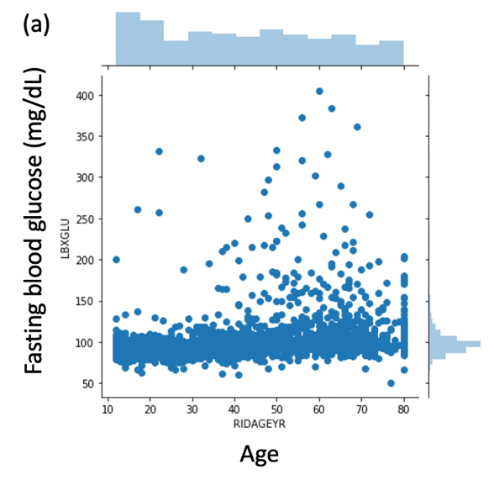

Figure 3. (a) Scatter plot of fasting blood glucose of different age groups. (b) Boxplot of fasting blood glucose measurements grouped by age.

Figure 4. Pair-wise scatter plots of key features.