SUPPLEMENTARY DATA
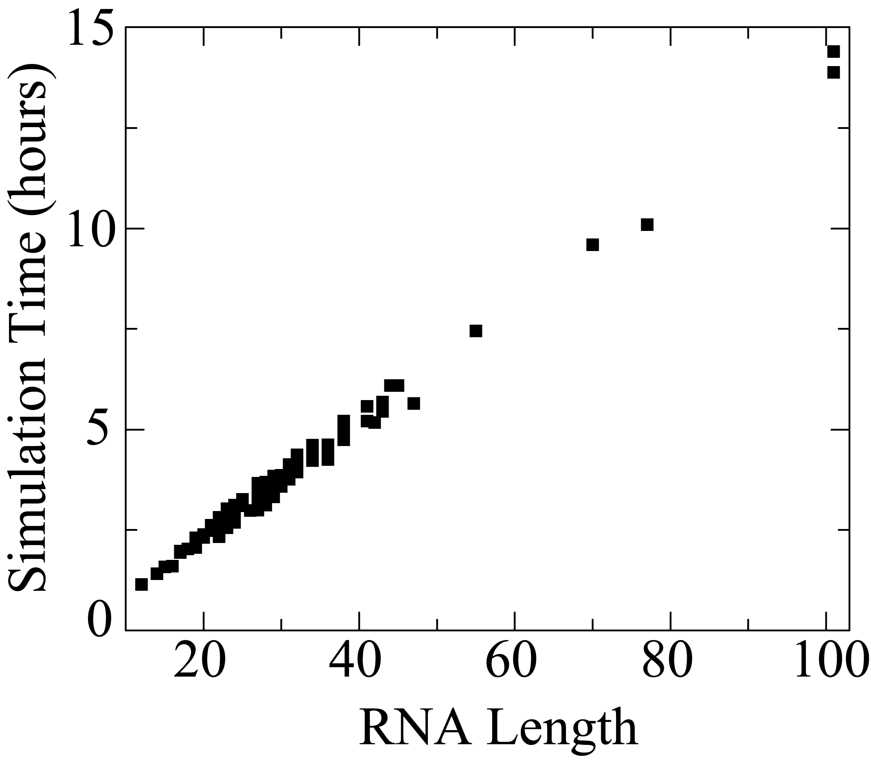
Supplementary Figure 1. Linear scaling of simulation time with increasing length of RNA. Total wall-clock time spent in the simulation of 153 RNA molecules studied is plotted as a function of RNA length (total number of nucleotides). Each replica-exchange DMD simulation is performed on eight 3.6 GHz Intel Xeon compute nodes of the UNC Topsail cluster, communicating over MPI. Ten simulation runs out of 153 total simulations were temporarily suspended by the cluster and are excluded from this graph. A linear scaling in simulation time is observed with increasing size of RNA, demonstrating efficient scalability of DMD simulations for investigating dynamics of long RNA molecules.
Supplemental Table 1: List of the 153 RNA structures whose ab initio folding simulations are performed. Nucleic Acid DataBank records of corresponding RNA molecules, number of nucleotides in the corresponding RNA molecule, predicted Q values (Q_{Pred}), maximum Q value (Q_{Max}), Q value from Mfold (Q_{Mfold}), the backbone RMS deviation of predicted structure from the native structure (RMSD_{Pred}) and minimum RMSD, (RMSD_{Min}) are shown.

Nucleic Acid DataBank | Number of  Nucleotides | Q_{Pred} | Q_{Max} | Q_{Mfold} | RMSD_{Pred} | RMSD_{Min}
17ra | 21 | 1.00 | 1.00 | 1.00 | 2.69 | 1.12
1a51 | 41 | 0.88 | 1.00 | 0.92 | 4.27 | 2.18
1a60 | 44 | 1.00 | 1.00 | 0.77 | 4.58 | 2.03
1a9l | 38 | 1.00 | 1.00 | 1.00 | 7.19 | 2.23
1anr | 29 | 1.00 | 1.00 | 1.00 | 4.90 | 2.31
1aqo | 29 | 0.91 | 1.00 | 0.91 | 3.65 | 1.88
1ato | 19 | 1.00 | 1.00 | 1.00 | 2.35 | 0.95
1atv | 17 | 1.00 | 1.00 | 1.00 | 1.13 | 0.50
1b36 | 38 | 1.00 | 1.00 | 1.00 | 5.17 | 2.13
1bgz | 23 | 1.00 | 1.00 | 0.71 | 1.40 | 1.40
1bn0 | 20 | 1.00 | 1.00 | 1.00 | 1.50 | 0.76
1bvj | 23 | 1.00 | 1.00 | 1.00 | 2.37 | 1.18
1cq5 | 43 | 1.00 | 1.00 | 1.00 | 4.90 | 2.23
1cql | 43 | 1.00 | 1.00 | 1.00 | 5.33 | 2.38
1d0u | 21 | 1.00 | 1.00 | 1.00 | 2.94 | 0.93
1e4p | 24 | 1.00 | 1.00 | 1.00 | 2.44 | 1.46
1e95 | 36 | 1.00 | 1.00 | 0.50 | 3.78 | 2.40
1ebq | 29 | 1.00 | 1.00 | 0.90 | 3.78 | 1.73
1ebr | 30 | 0.78 | 1.00 | 0.90 | 3.66 | 1.70
1ebs | 29 | 1.00 | 1.00 | 0.90 | 3.74 | 1.91
1eor | 22 | 0.98 | 1.00 | 1.00 | 2.58 | 0.78
1esy | 19 | 1.00 | 1.00 | 1.00 | 2.03 | 1.11
1evv | 76 | 0.87 | 0.92 | 0.83 | 7.20 | 5.15
1f1t | 38 | 1.00 | 1.00 | 1.00 | 4.93 | 2.91
1f6z | 27 | 0.90 | 1.00 | 1.00 | 3.72 | 1.50
1f7f | 27 | 0.99 | 1.00 | 1.00 | 3.88 | 1.37
1f7g | 27 | 0.90 | 1.00 | 1.00 | 4.06 | 1.46
1f84 | 29 | 0.86 | 1.00 | 0.86 | 3.60 | 2.34
1f9l | 22 | 0.98 | 1.00 | 1.00 | 2.58 | 0.78
1fqz | 27 | 1.00 | 1.00 | 0.75 | 2.35 | 2.35
1fyo | 27 | 0.88 | 1.00 | 0.89 | 2.46 | 1.00
1hlx | 20 | 1.00 | 1.00 | 1.00 | 2.66 | 0.78
1ie1 | 22 | 0.75 | 1.00 | 0.80 | 3.80 | 1.92
1ie2 | 22 | 1.00 | 1.00 | 0.67 | 3.50 | 1.91
1ikd | 22 | 1.00 | 1.00 | 1.00 | 2.18 | 1.06
1j4y | 17 | 1.00 | 1.00 | 1.00 | 2.82 | 1.00
1jo7 | 31 | 0.88 | 1.00 | 1.00 | 3.42 | 1.55
1jox | 21 | 1.00 | 1.00 | 1.00 | 3.53 | 1.57
1jp0 | 21 | 1.00 | 1.00 | 1.00 | 3.25 | 1.53
1jtj | 23 | 1.00 | 1.00 | 1.00 | 3.44 | 1.51
1jur | 22 | 1.00 | 1.00 | 1.00 | 3.02 | 1.13
1k2g | 22 | 1.00 | 1.00 | 0.50 | 1.71 | 1.71
1k5i | 23 | 1.00 | 1.00 | 1.00 | 2.08 | 0.74
1k6g | 22 | 1.00 | 1.00 | 1.00 | 2.12 | 0.80
1k6h | 22 | 1.00 | 1.00 | 1.00 | 2.20 | 0.83
1kaj | 32 | 1.00 | 1.00 | 0.56 | 6.96 | 1.64
1kka | 17 | 1.00 | 1.00 | 1.00 | 3.45 | 1.04
1kks | 24 | 1.00 | 1.00 | 0.86 | 2.59 | 1.20
1kp7 | 30 | 1.00 | 1.00 | 1.00 | 3.27 | 1.79
1kpd | 32 | 0.90 | 1.00 | 0.50 | 5.75 | 1.94
1kxk | 70 | 0.78 | 1.00 | 0.74 | 8.40 | 4.69
1l1w | 29 | 1.00 | 1.00 | 1.00 | 2.56 | 1.09
1l3d | 28 | 1.00 | 1.00 | 0.00 | 3.03 | 1.93
1lc6 | 24 | 1.00 | 1.00 | 1.00 | 2.73 | 0.94
1ldz | 30 | 1.00 | 1.00 | 1.00 | 5.29 | 1.50
1lvj | 31 | 1.00 | 1.00 | 1.00 | 4.30 | 1.58
1m5l | 38 | 1.00 | 1.00 | 1.00 | 3.97 | 1.76
1m82 | 25 | 1.00 | 1.00 | 1.00 | 1.60 | 0.66
1mfj | 20 | 1.00 | 1.00 | 1.00 | 1.94 | 0.87
1mfk | 23 | 1.00 | 1.00 | 1.00 | 2.82 | 1.09
1mfy | 31 | 1.00 | 1.00 | 1.00 | 3.79 | 1.56
1mnx | 42 | 0.86 | 1.00 | 0.00 | 8.77 | 1.88
1msy | 27 | 0.97 | 1.00 | 0.86 | 3.44 | 2.21
1mt4 | 24 | 0.88 | 1.00 | 0.89 | 2.68 | 1.13
1n8x | 36 | 1.00 | 1.00 | 0.79 | 2.61 | 1.04
1na2 | 30 | 1.00 | 1.00 | 1.00 | 3.28 | 1.50
1nbk | 34 | 0.92 | 0.92 | 0.92 | 4.01 | 1.75
1nbr | 29 | 0.91 | 1.00 | 0.92 | 2.82 | 1.26
1nc0 | 24 | 1.00 | 1.00 | 1.00 | 3.61 | 0.94
1nem | 23 | 1.00 | 1.00 | 1.00 | 2.37 | 1.23
1oq0 | 15 | 1.00 | 1.00 | 0.83 | 1.61 | 0.91
1osw | 23 | 1.00 | 1.00 | 1.00 | 2.62 | 1.00
1ow9 | 23 | 1.00 | 1.00 | 1.00 | 2.78 | 1.07
1p5m | 55 | 0.00 | 0.35 | 0.94 | 20.07 | 8.49
1p5n | 34 | 1.00 | 1.00 | 0.90 | 3.72 | 2.42
1p5o | 77 | 0.00 | 0.24 | 0.52 | 24.10 | 10.99
1pjy | 22 | 1.00 | 1.00 | 1.00 | 2.14 | 0.85
1q8n | 38 | 1.00 | 1.00 | 1.00 | 8.37 | 2.93
1qc8 | 25 | 1.00 | 1.00 | 1.00 | 2.79 | 1.31
1qwa | 21 | 1.00 | 1.00 | 1.00 | 2.81 | 1.21
1qwb | 26 | 0.83 | 1.00 | 0.86 | 4.74 | 1.76
1r2p | 34 | 0.98 | 1.00 | 1.00 | 4.22 | 1.52
1r7w | 34 | 1.00 | 1.00 | 1.00 | 6.33 | 1.86
1r7z | 34 | 1.00 | 1.00 | 1.00 | 7.73 | 1.95
1rfr | 30 | 0.97 | 1.00 | 1.00 | 3.81 | 1.41
1rht | 24 | 1.00 | 1.00 | 1.00 | 3.89 | 1.89
1rnk | 34 | 0.91 | 1.00 | 0.45 | 4.01 | 2.45
1s2f | 23 | 1.00 | 1.00 | 1.00 | 3.01 | 1.17
1s34 | 23 | 1.00 | 1.00 | 1.00 | 2.99 | 1.02
1s9s | 100 | 0.99 | 1.00 | 0.94 | 10.39 | 5.62
1scl | 29 | 0.71 | 1.00 | 0.75 | 6.04 | 1.91
1slo | 19 | 1.00 | 1.00 | 1.00 | 2.88 | 0.97
1slp | 19 | 1.00 | 1.00 | 1.00 | 2.99 | 1.04
1sy4 | 24 | 1.00 | 1.00 | 1.00 | 2.11 | 0.92
1syz | 24 | 1.00 | 1.00 | 1.00 | 2.44 | 1.21
1szy | 21 | 1.00 | 1.00 | 1.00 | 2.90 | 0.86
1t28 | 34 | 1.00 | 1.00 | 1.00 | 5.25 | 2.09
1tbk | 17 | 1.00 | 1.00 | 1.00 | 3.28 | 0.87
1tjz | 22 | 1.00 | 1.00 | 1.00 | 2.42 | 1.12
1tlr | 23 | 1.00 | 1.00 | 1.00 | 2.94 | 1.24
1txs | 38 | 0.97 | 1.00 | 1.00 | 4.88 | 1.77
1u2a | 20 | 1.00 | 1.00 | 1.00 | 1.81 | 0.74
1u3k | 38 | 1.00 | 1.00 | 1.00 | 6.35 | 2.06
1uuu | 19 | 1.00 | 1.00 | 1.00 | 2.48 | 1.16
1wks | 17 | 1.00 | 1.00 | 1.00 | 2.44 | 1.01
1xhp | 32 | 1.00 | 1.00 | 1.00 | 2.83 | 1.05
1xsg | 27 | 1.00 | 1.00 | 1.00 | 3.74 | 1.27
1xsh | 27 | 1.00 | 1.00 | 1.00 | 2.42 | 0.97
1xst | 27 | 1.00 | 1.00 | 1.00 | 3.63 | 1.37
1xsu | 27 | 1.00 | 1.00 | 1.00 | 2.18 | 1.08
1xwp | 15 | 1.00 | 1.00 | 1.00 | 2.24 | 0.84
1xwu | 16 | 0.78 | 1.00 | 0.80 | 2.27 | 0.87
1ylg | 31 | 0.89 | 1.00 | 0.90 | 3.02 | 1.06
1ymo | 47 | 0.94 | 0.94 | 0.63 | 4.00 | 3.19
1yn1 | 17 | 1.00 | 1.00 | 1.00 | 2.84 | 0.95
1yn2 | 17 | 1.00 | 1.00 | 1.00 | 2.33 | 0.86
1ync | 31 | 0.89 | 1.00 | 0.90 | 2.96 | 1.27
1yne | 31 | 0.89 | 1.00 | 0.90 | 2.73 | 1.17
1yng | 31 | 0.89 | 1.00 | 0.89 | 3.87 | 1.22
1ysv | 27 | 1.00 | 1.00 | 1.00 | 2.17 | 0.83
1z2j | 45 | 1.00 | 1.00 | 0.95 | 3.96 | 1.55
1z30 | 18 | 1.00 | 1.00 | 1.00 | 1.90 | 0.58
1z31 | 32 | 0.70 | 1.00 | 1.00 | 4.27 | 2.20
1zc5 | 41 | 1.00 | 1.00 | 0.94 | 3.54 | 1.23
28sp | 28 | 1.00 | 1.00 | 1.00 | 4.26 | 1.33
28sr | 28 | 1.00 | 1.00 | 1.00 | 3.01 | 1.23
2a9l | 38 | 1.00 | 1.00 | 1.00 | 7.33 | 2.36
2aht | 27 | 1.00 | 1.00 | 1.00 | 3.25 | 1.16
2ap0 | 28 | 0.00 | 0.43 | 0.63 | 7.55 | 3.27
2ap5 | 28 | 0.00 | 0.43 | 0.63 | 7.46 | 3.28
2au4 | 41 | 0.90 | 1.00 | 0.91 | 5.71 | 3.23
2b7g | 19 | 1.00 | 1.00 | 1.00 | 1.82 | 0.96
2es5 | 23 | 0.89 | 0.89 | 0.90 | 2.72 | 1.11
2euy | 34 | 0.86 | 1.00 | 0.91 | 4.22 | 1.80
2evy | 14 | 1.00 | 1.00 | 1.00 | 2.32 | 0.76
2f87 | 12 | 1.00 | 1.00 | 1.00 | 1.77 | 0.55
2f88 | 34 | 0.98 | 1.00 | 1.00 | 3.14 | 1.51
2fdt | 36 | 0.91 | 1.00 | 0.92 | 4.00 | 1.57
2fey | 43 | 1.00 | 1.00 | 1.00 | 3.45 | 1.47
2frl | 23 | 1.00 | 1.00 | 1.00 | 3.36 | 0.78
2g1g | 17 | 1.00 | 1.00 | 1.00 | 2.95 | 0.68
2gio | 29 | 0.88 | 1.00 | 0.89 | 3.25 | 1.34
2gv3 | 22 | 0.86 | 1.00 | 0.88 | 3.08 | 1.13
2h2x | 21 | 1.00 | 1.00 | 1.00 | 3.36 | 1.08
2hem | 24 | 1.00 | 1.00 | 1.00 | 2.59 | 1.19
2hns | 22 | 1.00 | 1.00 | 1.00 | 2.56 | 0.85
2ldz | 30 | 1.00 | 1.00 | 1.00 | 4.54 | 1.53
2tpk | 36 | 1.00 | 1.00 | 0.58 | 3.75 | 1.74
2u2a | 20 | 1.00 | 1.00 | 1.00 | 1.81 | 0.88
3php | 23 | 1.00 | 1.00 | 1.00 | 2.52 | 0.90
430d | 29 | 0.83 | 0.83 | 0.75 | 2.33 | 2.33
437d | 28 | 1.00 | 1.00 | 0.00 | 3.09 | 1.89
480d | 27 | 0.90 | 1.00 | 0.86 | 3.53 | 2.32

Supplemental Table 2. The averages and standard deviations of the bonded atom pairs. All the bonds, angles, and dihedrals are effectively model by a bond in the DMD simulations.

P_{i} S_{i} | 4.55 ± 0.09 Å
S_{i} P_{i+1} | 4.10 ± 0.07 Å
S_{i} A_{i} | 4.85 ± 0.15 Å
S_{i} U_{i} | 3.74 ± 0.08 Å
S_{i} G_{i} | 4.81 ± 0.14 Å
S_{i} C_{i} | 3.70 ± 0.13 Å
P_{i} P_{i+1} | 6.25 ± 0.95 Å
S_{i} S_{i+1} | 5.72 ± 0.45 Å
P_{i} A_{i} | 7.45 ± 0.45 Å
P_{i} U_{i} | 5.57 ± 0.37 Å
P_{i} Gi | 7.43 ± 0.43 Å
P_{i} C_{i} | 5.57 ± 0.37 Å
A_{i} P_{i+1} | 7.25 ± 0.42 Å
U_{i} P_{i+1} | 6.40 ± 0.20 Å
G_{i} P_{i+1} | 7.20 ± 0.43 Å
C_{i} P_{i+1} | 6.40 ± 0.20 Å
P_{i-1} S_{i} | 9.25 ± 0.95 Å
S_{i-1} P_{i+1} | 8.96 ± 0.44 Å
A_{i-1} S_{i} | 5.68 ± 0.68 Å
U_{i-1} S_{i} | 6.38 + 0.73 Å
G_{i-1} S_{i} | 5.68 ± 0.68 Å
C_{i-1} S_{i} | 6.38 ± 0.73 Å
S_{i-1} A_{i} | 7.25 ± 0.60 Å
S_{i-1} U_{i} | 5.66 ± 0.54 Å
S_{i-1} G_{i} | 7.25 ± 0.60 Å
S_{i-1} C_{i} | 5.66 ± 0.54 Å

Supplemental Table 3. The parameters for base pairing, modeled by hydrogen bonds between AU, GC and UG. The details of the DMD algorithm for the hydrogen bond can be found in (Ding et al., 2003). The hydrogen bond strengths, E^{HB}, for AU, GC and UG are 0.5, 1.2, and 0.5 Kcal/mol, respectively.

Atom pair | d_{min} | d₀ | d₁ | d_{max}
C_{i} G_{j} | 5.20 Å | 5.46 Å | 5.62 Å | 5.74 Å
Si Gj | 7.70 Å | 8.08 Å | 8.63 Å | 9.00 Å
Ci Sj | 9.74 Å | 10.10 Å | 10.53 Å | 10.82 Å

Ai Uj | 5.00 Å | 5.25 Å | 5.68 Å | 5.84 Å
Si Uj | 9.76 Å | 9.94 Å | 10.50 Å | 10.76 Å
Ai Sj | 7.72 Å | 7.92 Å | 8.82 Å | 9.00 Å

Ui Gj | 5.10 Å | 5.65 Å | 6.10 Å | 6.25 Å
Si Gj | 7.00 Å | 7.44 Å | 8.24 Å | 8.70 Å
Ui Sj | 9.50 Å | 10.25 Å | 10.80 Å | 11.35 Å

Supplemental Table 4. The stacking and hydrophobic interaction strengths, expressed in kcal/mol units. The subscript indicates that the base bead is paired. For example, A_{U} is a base bead A that has been paired with a U bead. The cutoff distances of base stacking are 4.65 Å between purines, 4.60 Å between pyrimidines, and 3.80 Å between purine and pyrimidine. The cutoff distance for hydrophobic interactions is 6.5 Å. The hardcore distance between of all beads is set as 3.3 Å.

E^{Stack} | A_{U} | U_{A} | G_{C} | C_{G} | G_{U} | U_{G}
A_{U} | -0.45 | -0.50 | -0.75 | -0.95 | -0.42 | -0.70
U_{A} | -0.50 | -0.40 | -0.55 | -0.60 | -0.35 | -0.35
G_{C} | -0.75 | -0.55 | -0.81 | -0.95 | -0.48 | -0.92
C_{G} | -0.95 | -0.60 | -0.95 | -1.10 | -0.47 | -0.51
G_{U} | -0.42 | -0.35 | -0.48 | -0.47 | -0.52 | +0.62
U_{G} | -0.70 | -0.35 | -0.51 | -0.51 | +0.62 | -0.44

E^{Hydrophobic} | A_{U} | U_{A} | G_{C} | C_{G} | G_{U} | U_{G}
A_{U} | -0.25 | -0.40 | -0.40 | -0.50 | -0.25 | -0.35
U_{A} | -0.40 | -0.30 | -0.25 | -0.25 | -0.25 | -0.25
G_{C} | -0.40 | -0.25 | -0.25 | -0.45 | -0.25 | -0.41
C_{G} | -0.50 | -0.25 | -0.45 | -0.50 | -0.25 | -0.41
G_{U} | -0.25 | -0.25 | -0.25 | -0.25 | -0.30 | +0.25
U_{G} | -0.35 | -0.25 | -0.41 | -0.41 | +0.25 | -0.25

References

Ding,F., Borreguero,J.M., Buldyrey,S.V., Stanley,H.E., and Dokholyan,N.V. (2003). Mechanism for the alpha-helix to beta-hairpin transition. Proteins 53, 220-228.

