PawMatch Development
OCR A Level Computer Science H446 Programming Project
Iterative development, testing and remedial action

Project | Technical solution | Evidence base
PawMatch animal adoption matching system | Python, Streamlit and SQLite | Implemented source code, automated tests, annotated design prototypes and Git history

This section explains how I developed the solution in distinct, testable iterations. Each iteration starts with a requirement from the analysis, shows the prototype or code produced, records development tests, and explains the decision taken before the next iteration. The evidence is based on the final repository and its version history; it does not replace the separate evaluation of the finished solution.
Assessment focus: OCR H446 sections 3.3.1 and 3.3.2 award marks for evidence at each stage, justified decisions, prototype versions, modular code, meaningful identifiers, validation, stage reviews, testing during development, failed tests and justified remedial action.

Contents
Section | Development evidence
1 | Development method and decomposition
2 | Iteration 1 authentication and role based access
3 | Iteration 2 animal records and administration
4 | Iteration 3 questionnaire and persistence
5 | Iteration 4 compatibility and ranking algorithm
6 | Iteration 5 browsing and animal profiles
7 | Iteration 6 interface integration and navigation
8 | Testing across development and remedial action
9 | Final development review
Appendix A | Automated test evidence
Appendix B | Version history evidence

1 Development method and decomposition
I used an iterative method because PawMatch contains several dependent subsystems. Authentication must work before questionnaire responses can be linked to a user; animals must exist before matches can be calculated; the algorithm must be reliable before the interface can present recommendations. I therefore built a small working vertical slice at each stage, tested it, reviewed it against the analysis and design, and then extended it.

1.1 Problem decomposition
Stage | Problem broken down | Main modules | Completion evidence
1 Authentication | Create accounts, validate credentials, distinguish adopter and administrator access. | pawmatch_auth.py, app.py, 2_Registration.py | Registration validation, salted password hashing and role guards.
2 Animal data | Store, validate, search and maintain animal records. | pawmatch_animals.py, 7_Admin_Dashboard.py | SQLite schema, CRUD functions, boundary validation and migration.
3 Questionnaire | Collect seven answers and store repeatable responses against a user. | pawmatch_matching.py, 3_Questionnaire.py | Server-side validation, foreign keys and persisted response.
4 Matching | Convert welfare constraints into an explainable compatibility percentage and a separate preference order. | pawmatch_matching.py, 6_My_Matches.py | Weighted algorithm, threshold, explanations and deterministic sorting.
5 Browsing | Allow users to locate available animals and inspect a profile. | pawmatch_animals.py, 4_Browse_Animals.py | Search/filter query, status filtering and no-result handling.
6 Integration | Join the modules into a consistent, navigable system. | page modules and pawmatch_style.py | Session state, page guards, responsive layouts and end-to-end flow.

1.2 Architecture and maintainability
I separated interface code from reusable logic. Streamlit page files deal with display and navigation. The auth, animals and matching modules perform validation, database access and calculations. This means the important algorithms can be tested without opening a browser. It also prevents the same rules being copied into several pages, reducing the risk of contradictory behaviour.
Layer | Responsibility | Reason for the decision
Presentation | Streamlit forms, cards, error messages and navigation. | Changes to the interface do not alter the algorithm or database code.
Application logic | Validation, authentication, matching and explanation generation. | Functions are small enough for focused unit tests and use meaningful identifiers.
Data access | Parameterized SQLite queries and transactions. | Centralised queries reduce SQL injection risk and preserve referential integrity.
Data | Users, animals, questionnaire responses and match results. | Persistent relational data supports repeat use and traceable recommendations.

1.3 Evidence sources used in development tests
Source label | Meaning in test tables
Competitor research | A feature or usability expectation identified while reviewing existing adoption services.
Client interview | A functional, safeguarding or usability need established with the intended client.
Stakeholder survey | A preference or accessibility need reported by prospective users and other stakeholders.
Design specification | The algorithms, validation limits, database fields and interface prototypes in Design Draft 2.
Implementation risk | A technical risk discovered while coding, such as schema compatibility or authentication security.

These source labels show why each test exists. They are not presented as quotations: exact interview and survey responses remain in the Analysis section.

2 Iteration 1 Authentication and role based access

2.1 Aim and first prototype
The first usable increment was a login and registration flow. The client requirement was that adopters should have personal accounts while rescue staff should have protected administrative access. I used one users table with a role field because both account types share identity and password data, while the role determines the page reached after authentication.
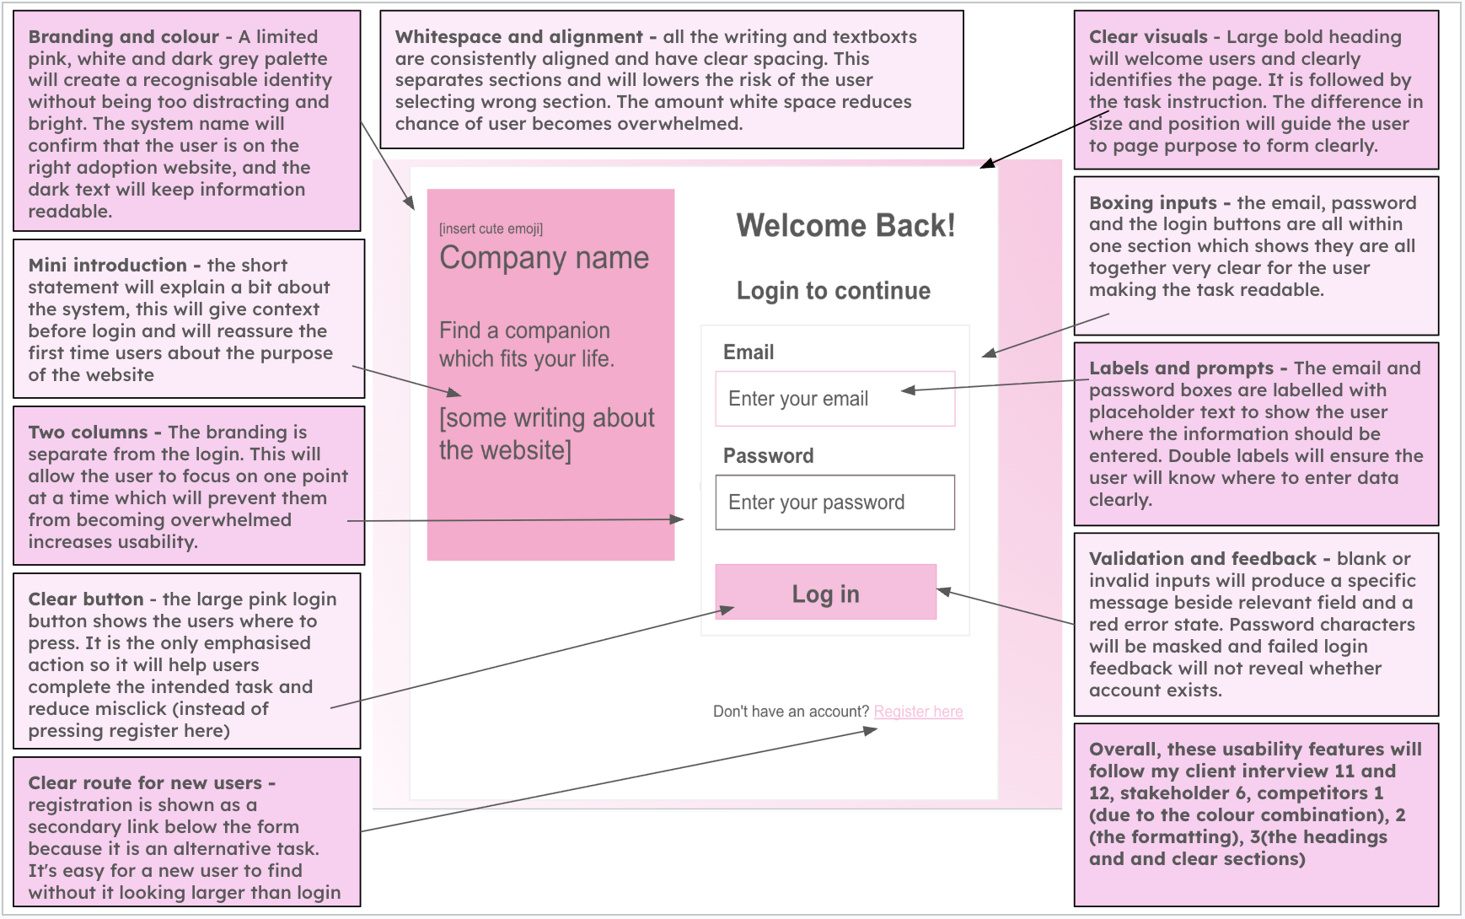
Figure 1 Annotated login prototype used to review validation, navigation and error placement

2.2 Server-side validation
The prototype showed controls, but client-side widgets alone would not protect the database. I implemented the same rules in a reusable validation function. Input is normalised before it is checked, and a case-insensitive parameterized query prevents a duplicate email address. Returning a dictionary of field-specific errors lets the page place feedback beside the relevant control.
def validate_registration(name, email, age, password, confirm_password):
cleaned_name = normalise_name(name)
cleaned_email = normalise_email(email)
errors = {}
if not 2 <= len(cleaned_name) <= 50:
errors["name"] = "Your name must contain 2 to 50 characters."
elif not all(ch.isalpha() or ch in {" ", "-", "'", "."}
for ch in cleaned_name):
errors["name"] = "Use letters, spaces, hyphens or apostrophes only."
existing = connection.execute(
"SELECT 1 FROM users WHERE email = ? COLLATE NOCASE LIMIT 1",
(cleaned_email,),
).fetchone()
if existing is not None:
errors["email"] = "An account already exists for this email address."
if age is None or not 18 <= age <= 120:
errors["age"] = "Enter an age between 18 and 120."
if len(password) <= 8 or len(password) > 128:
errors["password"] = "Password length is invalid."
if password != confirm_password:
errors["confirm_password"] = "The two passwords do not match."
return errors, cleaned_values
Code extract 1 Registration validation in pawmatch_auth.py

2.3 Password security and database access
I never store the original password. A random 16-byte salt is combined with scrypt, and the encoded hash contains the parameters needed for later verification. hmac.compare_digest performs the final comparison. User details are returned only after the password is verified, and the returned dictionary excludes password_hash.
def hash_password(password):
salt = secrets.token_bytes(16)
password_hash = hashlib.scrypt(
password.encode("utf-8"), salt=salt,
n=_SCRYPT_N, r=_SCRYPT_R, p=_SCRYPT_P, dklen=64)
return f"scrypt${_SCRYPT_N}${_SCRYPT_R}${_SCRYPT_P}$" f"{salt.hex()}${password_hash.hex()}"
def create_user(name, email, age, password):
connection.execute(
"INSERT INTO users (name, email, age, password_hash, role) "
"VALUES (?, ?, ?, ?, 'user')",
(name, email, age, hash_password(password)),
)
Code extract 2 Salted password hashing and parameterized insertion

2.4 Development tests
ID | Source within analysis or design | Test data and method | Expected result | Actual result and action
A1 | Client interview; design login algorithm | Valid adopter email and correct password. | Adopter details returned and user pages available. | Pass. Email login succeeds and role is user.
A2 | Client interview; administrator workflow | Username admin123 and valid demonstration password. | Administrator authenticated and redirected to dashboard. | Pass. Username login added without removing adopter email login.
A3 | Design validation rules | Name A; password of eight characters; age 17. | Each invalid value receives a field-specific message and no record is inserted. | Pass. Boundary values are rejected by backend validation.
A4 | Client interview; data integrity | Register the same email twice with different letter case. | Second account rejected. | Pass. Case-insensitive lookup and UNIQUE database constraint both protect the record.
A5 | Implementation risk | Wrong password for an existing account. | Authentication returns no user and does not reveal which credential failed. | Pass. Session is created only after verification.

2.5 Review and decision
The iteration met the functional need, but it also exposed an integration requirement: all protected pages needed identical checks. I added a session-state guard at the top of each adopter page and redirected administrators away from adopter-only routes. This is safer and easier to maintain than relying on hidden navigation links. The authentication functions remained independent of Streamlit so they could be unit tested.

3 Iteration 2 Animal records and administration

3.1 Aim and prototype
The next increment gave an administrator the ability to create and maintain the records used by browsing and matching. I converted the design fields into typed database columns and constrained fields such as species, size, status and maximum hours alone. The administrator form mirrors those fields so there is a direct route from user input to a validated record.
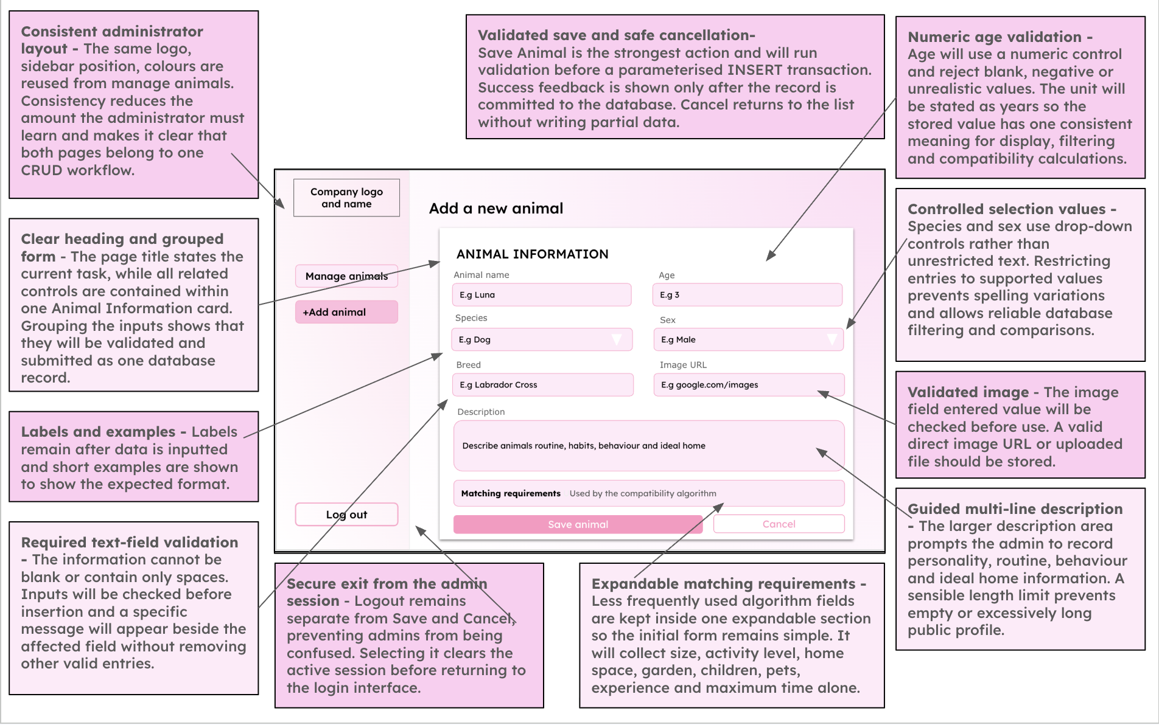
Figure 2 Annotated animal-entry prototype showing validation, constrained choices and feedback

3.2 Validation before CRUD operations
The validate_animal function creates one cleaned dictionary and one error dictionary. Text is trimmed; numeric values are converted inside try/except blocks; enumerated values are checked against shared constants; and the description must be detailed enough to help an adopter. Only a cleaned dictionary with no errors is passed to the create or update function.
def validate_animal(values):
cleaned = {"name": _clean_text(values.get("name")),
"age_years": values.get("age_years"),
"max_hours_alone": values.get("max_hours_alone"), ...}
errors = {}
if _NAME_PATTERN.fullmatch(cleaned["name"]) is None:
errors["name"] = "Use letters, numbers, spaces, hyphens or apostrophes only."
try:
cleaned["age_years"] = float(cleaned["age_years"])
except (TypeError, ValueError):
errors["age_years"] = "Enter the animal's age."
else:
if not 0 <= cleaned["age_years"] <= 40:
errors["age_years"] = "Enter an age between 0 and 40 years."
try:
cleaned["max_hours_alone"] = int(cleaned["max_hours_alone"])
except (TypeError, ValueError):
errors["max_hours_alone"] = "Enter the maximum number of hours alone."
else:
if not 0 <= cleaned["max_hours_alone"] <= 24:
errors["max_hours_alone"] = "Enter a value between 0 and 24 hours."
return errors, cleaned
Code extract 3 Animal data is cleaned and checked before storage

3.3 Parameterized create update and delete operations
Every SQL statement uses placeholders. This prevents user input from being interpreted as SQL and allows SQLite to handle values correctly. The database connection context commits successful writes and rolls back if an exception occurs. The functions return success flags and user-safe messages so database details are not exposed in the interface.
def update_animal(animal_id, animal):
with get_connection() as connection:
cursor = connection.execute(
"""UPDATE animals
SET name = ?, species = ?, breed = ?, age_years = ?, sex = ?,
size = ?, activity_level = ?, home_type = ?,
minimum_housing_level = ?, garden_required = ?,
child_friendly = ?, other_pets = ?, experience_level = ?,
max_hours_alone = ?, status = ?, description = ?, image_url = ?,
updated_at = CURRENT_TIMESTAMP
WHERE animal_id = ?""",
(*_database_values(animal), animal_id))
if cursor.rowcount == 0:
return False, "That animal record no longer exists."
return True, ""
Code extract 4 Parameterized update with missing-record handling

3.4 Remedial action during this iteration
Issue discovered | Why the original version was inadequate | Change made | Justification
Older databases allowed at most 12 hours alone. | The final questionnaire accepts 0 to 24 hours, so an existing database constraint could reject valid design data. | Added a schema migration and regression test for the old constraint. | Preserves users’ existing data while aligning storage with the current design.
Animal names allowed letters only. | A realistic rescue name such as K9 was rejected despite being harmless and meaningful. | Allowed letters, numbers, spaces, hyphens and apostrophes. | Still blocks symbol-only input while supporting real record names.
Age was planned as an integer. | The interface and sample data include young animals represented in half years. | Stored and validated age as a number from 0 to 40, including decimals. | Keeps the visible prototype and database consistent without weakening the range check.

3.5 Development tests
ID | Source within analysis or design | Test data and method | Expected result | Actual result and action
B1 | Client interview; administrator requirements | Valid complete animal record. | Record inserted and assigned an animal_id. | Pass. Record can be fetched immediately.
B2 | Design field validation | Empty name; age -1 and 41; hours -1 and 25. | Invalid fields rejected before SQL executes. | Pass. Boundary validation gives precise messages.
B3 | Stakeholder survey; realistic rescue data | Name K9 and age 0.5. | Valid record accepted. | Initially failed because the name pattern and integer age were too restrictive. Rules were revised and retested successfully.
B4 | Implementation risk | Open a database created with the old 0–12 hours constraint. | Schema upgraded without losing the animal row. | Initially incompatible. Migration now rebuilds the table and regression test passes.
B5 | Client interview; record maintenance | Update and then delete an existing record. | Only the selected animal changes; missing ID produces safe feedback. | Pass. Queries are parameterized and rowcount is checked.

3.6 Review and decision
This iteration established one authoritative animal model for administration, browsing and matching. I retained strict enumerated choices for fields used by the algorithm, but relaxed name and age rules where testing showed that the first version rejected legitimate rescue data. The migration test means the correction is also safe for an existing project database, not only a newly created one.

4 Iteration 3 Questionnaire and persistence

4.1 Aim and interaction design
The questionnaire captures the adopter conditions used by the welfare calculation: housing space, garden access, time left alone, children, activity support, preferred species and preferred size. I used one question per step to reduce cognitive load and added visible progress. The selected values are held in session state until submission, while the most recent saved response can repopulate the form.
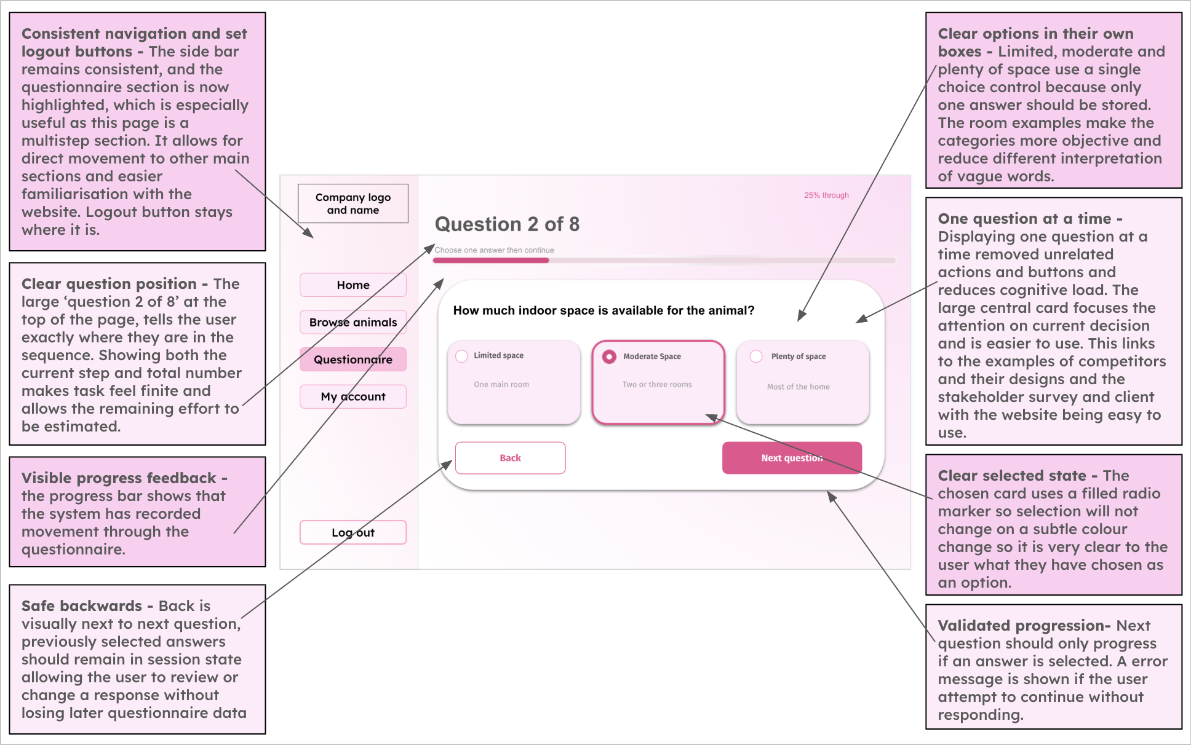
Figure 3 Annotated questionnaire prototype showing progress, selectable answers and navigation

4.2 Validation and persistent relationships
Each response belongs to one user through a foreign key, but a user may submit more than one response. That preserves history and allows the newest answer set to drive current matches. Boolean and integer values are normalised before insertion. The validation function rejects missing answers and values outside the designed ranges even if a request bypasses the Streamlit widgets.
def validate_questionnaire(answers):
cleaned = dict(answers)
errors = {}
if cleaned.get("housing_level") not in {1, 2, 3}:
errors["housing_level"] = "Choose a valid amount of indoor space."
if type(cleaned.get("garden_access")) is not bool:
errors["garden_access"] = "Choose whether you have garden access."
try:
cleaned["hours_left_alone"] = int(cleaned["hours_left_alone"])
except (TypeError, ValueError):
errors["hours_left_alone"] = "Enter a whole number of hours."
else:
if not 0 <= cleaned["hours_left_alone"] <= 24:
errors["hours_left_alone"] = "Enter between 0 and 24 hours."
return errors, cleaned
Code extract 5 Questionnaire rules are enforced outside the interface

4.3 Page integration
The page is protected before any response is read. A user who is not logged in returns to the login page, while an administrator returns to the dashboard. When the last question is submitted, the page validates the complete answer set, stores the response, calculates eligible matches and then displays a completion state. Separating these steps prevents partial or invalid submissions from creating match rows.
Step | State transition | Data effect
Start | Load latest response or initialise unanswered values. | No database write.
Select answer | Update questionnaire_answers in the browser session. | No database write, so Back can safely change an answer.
Next | Clamp the requested step to the valid question range. | No database write.
Submit | Validate all seven values. | Invalid answers show errors; valid answers create one questionnaire_response.
Calculate | Score only currently available animals. | Eligible results are inserted for the new response.
Complete | Set progress to 100 and offer View matches. | Latest response becomes the source for the results page.

4.4 Development tests
ID | Source within analysis or design | Test data and method | Expected result | Actual result and action
C1 | Client interview; matching requirements | Complete all seven answers with valid values. | One response linked to logged-in user. | Pass. response_id returned and foreign key retained.
C2 | Design validation rules | Housing 0 or 4; hours -1 or 25; unsupported species. | Submission rejected with field-specific error. | Pass. Backend accepts only designed ranges and enumerations.
C3 | Stakeholder survey; usability | Move Back and Next after selecting answers. | Answers remain visible and progress remains consistent. | Pass. Session state retains answers and step is clamped.
C4 | Client interview; returning user | Complete questionnaire twice. | Both responses retained; newest response drives current matches. | Pass. One-to-many database relationship supports history.
C5 | Implementation risk | Attempt questionnaire URL without a session. | No data exposed and user sent to login. | Pass. Page guard runs before database access.

5 Iteration 4 Compatibility and ranking algorithm

5.1 Aim and pseudocode alignment
This was the most important algorithmic iteration. I deliberately separated welfare compatibility from user preference. Compatibility represents whether the home can meet the animal’s needs; preference only orders animals that already satisfy the minimum recommendation threshold. This prevents a preferred species or size from making an unsuitable animal appear safe.
Criterion | Maximum points | Reason for relative weighting
Hours left alone | 20 | Direct welfare constraint and strongest single factor.
Children | 15 | Safety and suitability for the household.
Housing space | 15 | Ensures the home meets the animal’s minimum spatial need.
Activity | 12 | Compares the adopter’s supported level with the animal’s need.
Garden | 10 | Essential only for animals marked as requiring secure outdoor access.
Total compatibility | 72 | Converted to a percentage and rounded to one decimal place.
Preference order | +10 species, +5 size | Applied only after compatibility is at least 70 percent.

5.2 Core calculation
compatibility = round((points / MAX_COMPATIBILITY_POINTS) * 100, 1)
preference_score = 0
if compatibility >= MINIMUM_RECOMMENDATION_SCORE:
if (cleaned["preferred_species"] != "No preference" and
cleaned["preferred_species"] == animal["species"]):
preference_score += 10
if (cleaned["preferred_size"] != "No preference" and
cleaned["preferred_size"] == animal["size"]):
preference_score += 5
return {"animal_id": int(animal["animal_id"]),
"compatibility_score": compatibility,
"preference_score": preference_score,
"match_category": _match_category(compatibility),
"matched_requirements": matched,
"unmet_requirements": unmet}
Code extract 6 Compatibility remains independent of preference

5.3 Worked example
Suppose an adopter can leave the animal for 2 hours, has no children, provides housing level 3, supports activity level 2 and has a garden. An available animal can be left for 5 hours, is suitable without children, needs housing level 2, needs activity level 2 and requires a garden. The adopter earns all 72 compatibility points: 20 + 15 + 15 + 12 + 10. Compatibility is round(72 ÷ 72 × 100, 1) = 100.0 percent. If the animal also matches both preferences, its preference score is 15, but the displayed compatibility remains 100.0 percent.

5.4 Filtering sorting and persistence
results = [calculate_match(animal, answers)
for animal in fetch_animals(status="Available")]
results = [result for result in results
if result["compatibility_score"] >= 70]
results.sort(
key=lambda item: (item["preference_score"],
item["compatibility_score"],
-item["animal_id"]),
reverse=True)
connection.executemany(
"INSERT INTO match_results (...) VALUES (?, ?, ?, ?, ?, ?, ?)",
prepared_rows)
Code extract 7 Only eligible animals are stored and ranking is deterministic
The animal_id tie-breaker makes equal results deterministic, which improves repeatability in testing. Storing the results preserves what the system recommended for that response. The results page recalculates the explanation text from the saved response so it can show both the adopter’s value and the animal’s requirement.

5.5 Prototype presentation
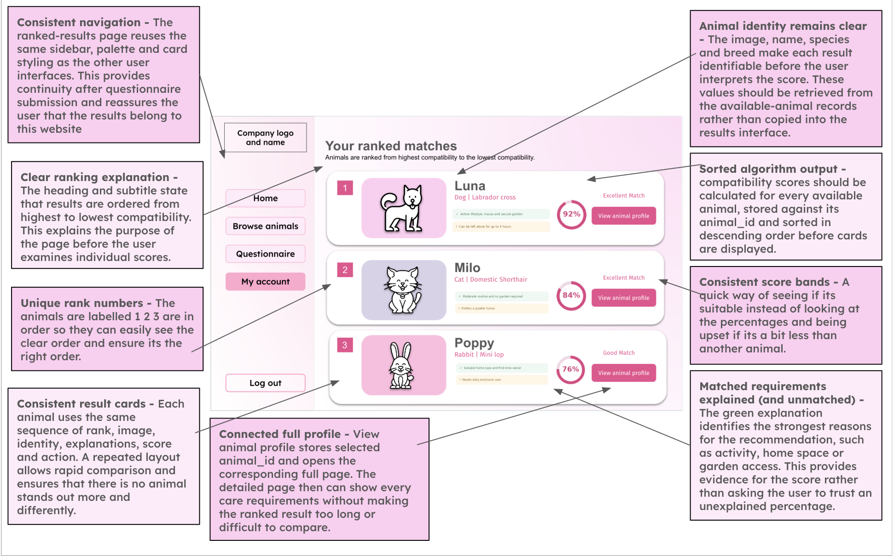
Figure 4 Annotated ranked-results prototype with compatibility, evidence and action controls

5.6 Development tests
ID | Source within analysis or design | Test data and method | Expected result | Actual result and action
D1 | Client interview; welfare-first matching | Animal scores 69 percent but matches both preferences. | Animal excluded and receives no preference points. | Originally a 60 percent threshold and combined score could over-promote it. Corrected to 70 percent and separate preference score; pass.
D2 | Design matching pseudocode | Two eligible animals have equal compatibility; one matches preferred species. | Preferred eligible animal ranks first without changing its visible compatibility. | Pass after separating the two scores.
D3 | Stakeholder survey; explainability | Adopter chooses 2 hours; animal permits 5 hours. | Reason states both selected and required values. | Initial explanation was generic. Revised text now includes both values; pass.
D4 | Client interview; current availability | One Available and one Adopted animal both score above threshold. | Only Available animal stored and displayed. | Pass. Source query filters status before calculation.
D5 | Design scoring rules | Full match on all five welfare criteria. | 72 of 72 becomes 100.0 percent. | Pass. Percentage is rounded to one decimal place.
D6 | Implementation risk | Equal preference and compatibility scores. | Stable repeatable order. | Pass. animal_id is the final deterministic key.

5.7 Review and decision
The final algorithm is safer than the first implementation because its displayed percentage has one clear meaning: welfare compatibility. A separate preference score affects order only after an animal qualifies. Saving matched and unmet reasons also makes each result auditable. I kept the weights as named constants so a justified future change can be made in one place and protected by the same regression tests.

6 Iteration 5 Browsing and animal profiles

6.1 Aim and prototype
Matching is not the only way users locate an animal, so I added browsing by name or breed, species and size. The default adopter view shows only Available records. The profile expands a summary card into the details needed before the user contacts the rescue.
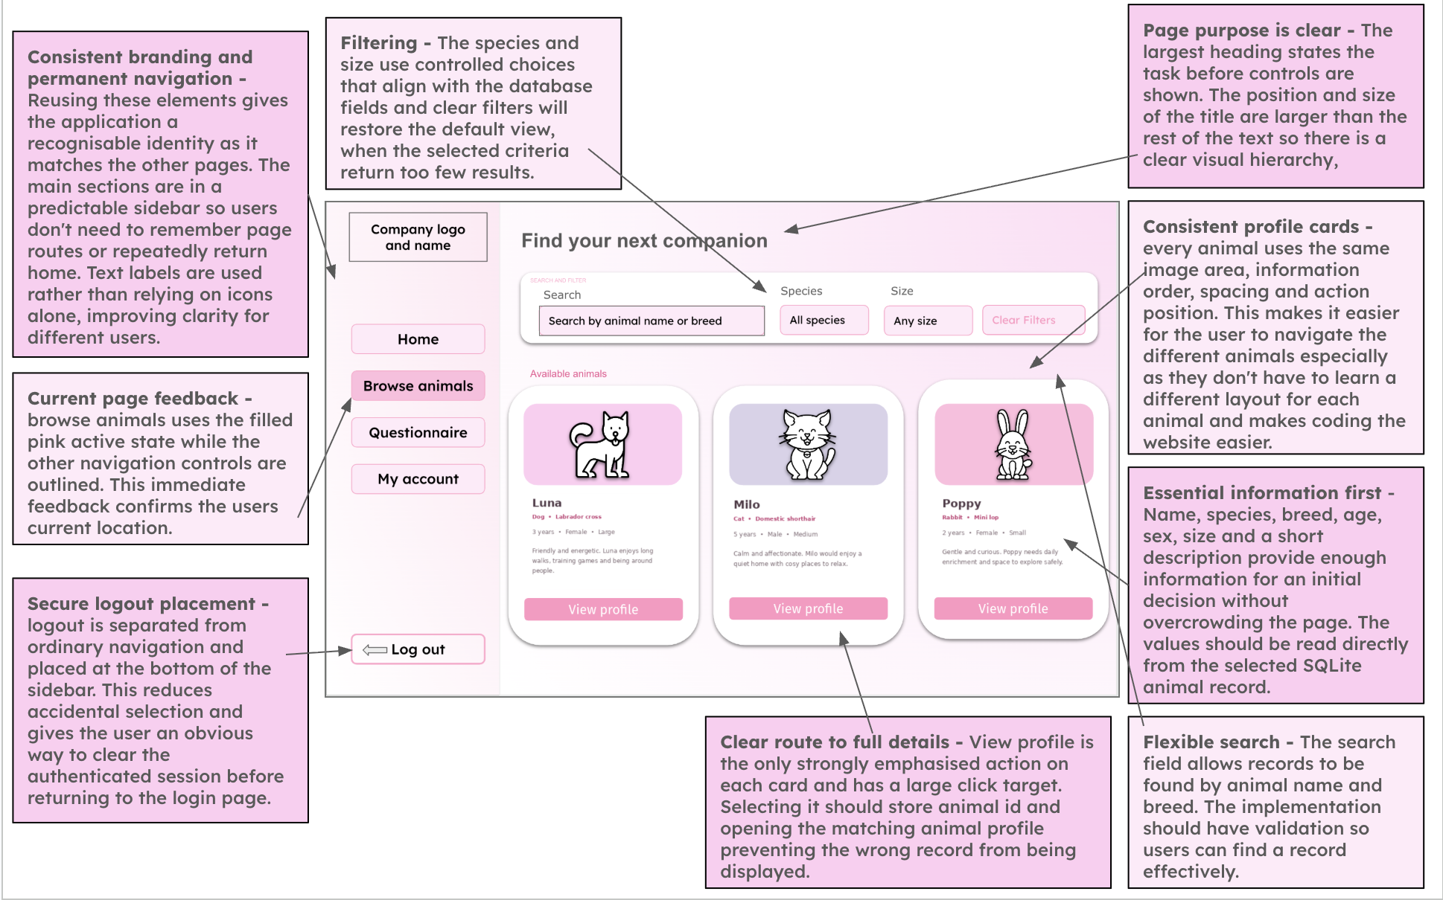
Figure 5 Annotated browse prototype showing search, filters, cards and navigation
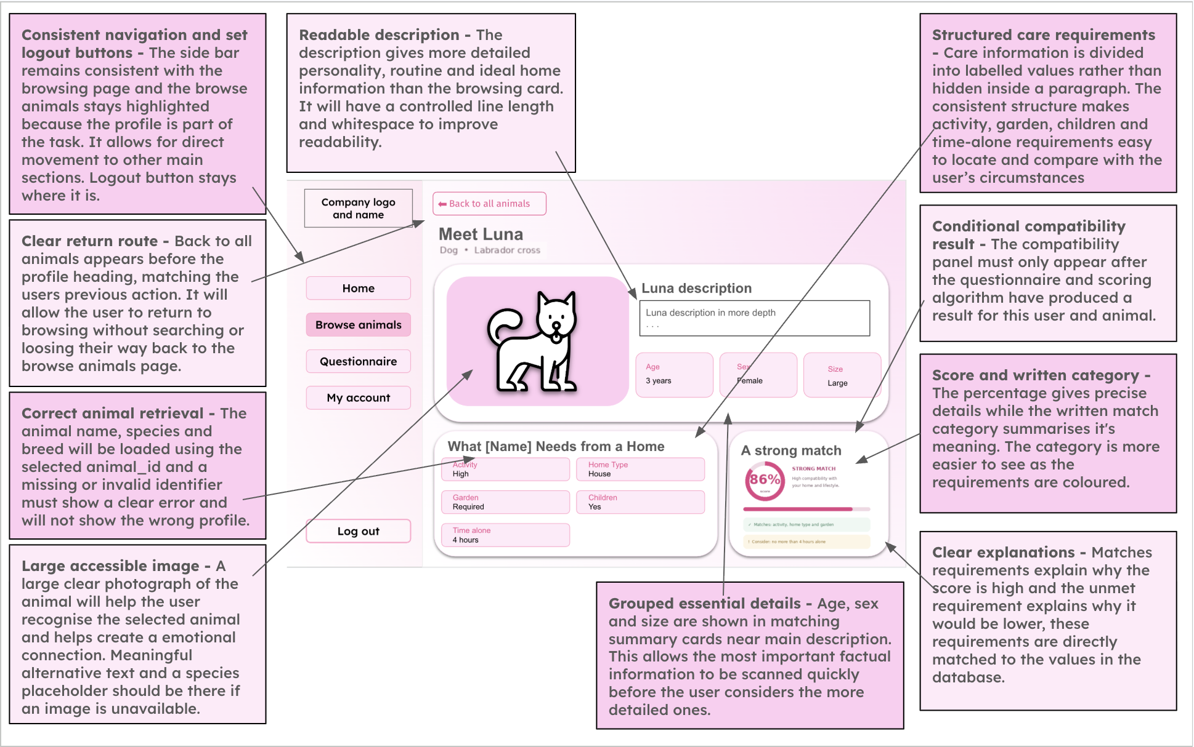
Figure 6 Annotated animal-profile prototype showing requirements and a clear next action

6.2 Dynamic parameterized query
I build the WHERE clause only from valid filters and keep all user values in a parameter list. This allows any combination of search, species, size and status while avoiding string interpolation of raw input. Search text is capped at 20 characters in the server-side validator.
clauses = []
parameters = []
if cleaned_search:
clauses.append("(name LIKE ? COLLATE NOCASE OR breed LIKE ? COLLATE NOCASE)")
pattern = f"%{cleaned_search}%"
parameters.extend((pattern, pattern))
if species in SPECIES:
clauses.append("species = ?")
parameters.append(species)
if status in ANIMAL_STATUSES:
clauses.append("status = ?")
parameters.append(status)
query = "SELECT * FROM animals"
if clauses:
query += " WHERE " + " AND ".join(clauses)
rows = connection.execute(query, parameters).fetchall()
Code extract 8 Flexible search without embedding user input in SQL

6.3 Development tests
ID | Source within analysis or design | Test data and method | Expected result | Actual result and action
E1 | Competitor research; common browse tools | Search a partial animal name and choose species. | Only matching records appear. | Pass. Name and breed use case-insensitive partial matching.
E2 | Design search validation | Search text of 21 characters. | Request rejected with concise feedback. | Pass. Limit enforced outside the widget.
E3 | Client interview; adoption status | Browse while database includes Adopted and Available animals. | Adopters see only Available animals. | Pass. Status is an explicit query filter.
E4 | Stakeholder survey; clear empty state | Search for text matching no record. | Page explains that no animals match and remains usable. | Pass. Empty list is handled rather than producing an error.
E5 | Stakeholder survey; informed choice | Open one animal profile. | Identity, age, breed, needs and availability agree with the selected database row. | Pass. Profile is fetched by parameterized animal_id.

6.4 Review and decision
The browse and match routes now share the same animal data instead of maintaining separate card content. This removed a source of inconsistency: when an administrator updates an animal, both the browse page and match page reflect the change. Local animal images are resolved from the assets folder, and the interface falls back to a species icon if an image is unavailable.

7 Iteration 6 Interface integration and navigation

7.1 Aim
The final development iteration integrated the modules into a coherent journey. An adopter can register, sign in, browse, complete the questionnaire, view ranked matches and revisit an account. An administrator reaches a separate dashboard. I kept page guards in code because visual navigation alone is not an access-control mechanism.
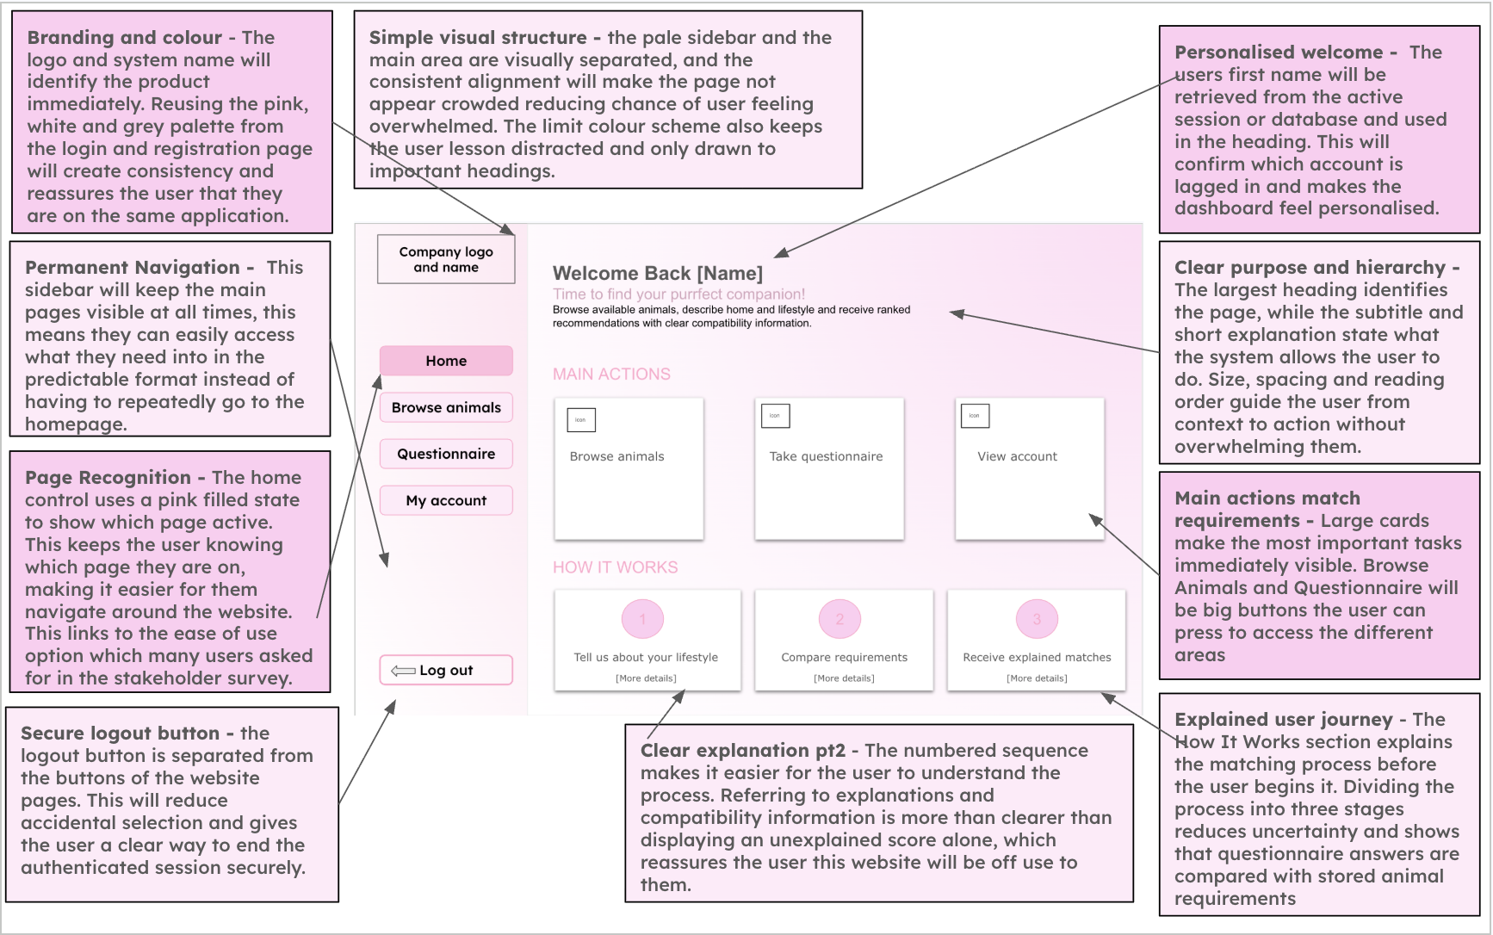
Figure 7 Annotated adopter home prototype used to review hierarchy and navigation

7.2 Iterative interface decisions
Version-history evidence | Observed problem or review | Decision and result
Match sidebar colours to interface design | The first integrated sidebar did not closely follow the established visual language. | Applied the planned palette for consistency.
Rebuild home page from interface mockup | The initial home page did not reflect the hierarchy and actions in the design. | Rebuilt the landing content around main actions and an explanation of the process.
Revert sidebar colour change | The colour revision reduced clarity in the working interface. | Reverted the isolated change rather than retaining it solely because it matched a mockup.
Restore Home navigation with native Streamlit | Custom navigation did not behave as reliably as the framework navigation. | Used native page switching so session and routes remain consistent.
Restore rounded interface version | Review of successive versions showed the rounded card layout communicated grouping more clearly. | Restored the clearer card treatment while preserving corrected navigation.

7.3 State and access control
st.set_page_config(page_title="PawMatch | Questionnaire", layout="wide")
if not st.session_state.get("logged_in", False):
st.switch_page("app.py")
if st.session_state.get("role") == "admin":
st.switch_page("pages/7_Admin_Dashboard.py")
if "questionnaire_answers" not in st.session_state:
st.session_state.questionnaire_answers = _initial_answers()
if "questionnaire_step" not in st.session_state:
st.session_state.questionnaire_step = 0
Code extract 9 Protected routes and explicit questionnaire state

7.4 Development tests
ID | Source within analysis or design | Test data and method | Expected result | Actual result and action
F1 | Client interview; adopter journey | Register, log in, browse, submit questionnaire and open matches. | All actions complete without losing the authenticated user. | Pass through integrated session state and native page switching.
F2 | Client interview; role separation | Administrator tries adopter questionnaire route. | Redirect to admin dashboard. | Pass. Role guard executes before page content.
F3 | Implementation risk | Logged-out browser opens a protected page URL directly. | Redirect to login. | Pass on all protected pages.
F4 | Stakeholder survey; orientation | Use sidebar and Back actions from questionnaire, matches and profile. | User can identify location and return without restarting. | Custom navigation version was unreliable; native switching restored and retested.
F5 | Design interface prototypes | Compare login, home, browse, questionnaire and results against annotated layouts. | Consistent hierarchy, readable cards and visible primary actions. | Successive colour and card versions were reviewed; clearest integrated version retained.

8 Testing across development and remedial action

8.1 Automated regression suite
I kept automated tests at the logic and database layers because these are the areas where an apparently small change can silently damage many pages. Each test creates an isolated temporary database, so it does not depend on or alter the demonstration database. On 22 October 2026 I ran the full suite with unittest discovery. Fourteen tests ran and all passed in 0.611 seconds.
Test group | Tests | What regression would be detected
Authentication and setup | 5 | Broken admin username login, broken adopter email login, duplicated demo data or non-repeatable setup.
Validation and migration | 4 | Incorrect registration limits, duplicate email handling, animal/search limits or failure to upgrade an old schema.
Questionnaire and matching | 5 | Out-of-range answers, preference altering compatibility, vague explanations, below-threshold promotion or incorrect persistence.
Total | 14 | All passed.

8.2 Failed tests and remedial action
A high-quality development record includes problems rather than presenting the final version as if it appeared immediately. The following issues are supported by code changes and regression tests in the repository.
Problem found during development | Evidence of failure or mismatch | Remedial action | Why the change is justified | Retest result
Threshold and preference were combined | A preference bonus could raise an animal that did not meet the intended welfare threshold. | Set minimum compatibility to 70; calculate preference separately and only for eligible animals. | User taste must not override an animal’s welfare constraints. | D1 and D2 pass.
Match explanation was too general | A phrase such as “hours alone matched” did not let the user verify the decision. | Include both the selected answer and the animal requirement in each reason. | Transparent output supports trust and checking. | D3 passes.
Existing 12-hour database constraint | A valid value from 13 to 24 could fail on an older database. | Detect the legacy table and migrate it while copying the data. | Upgrades must preserve records and accept the final questionnaire range. | B4 passes.
Animal validation too restrictive | K9 and half-year ages were rejected despite valid sample and interface data. | Allow numbers in names and numeric ages from 0 to 40. | Rules should reject harmful data, not realistic data. | B3 passes.
Custom navigation was unreliable | The home route did not consistently fit Streamlit’s page model. | Restore native Streamlit navigation and retain session guards. | Reliability and understandable state are more important than a custom control. | F1 and F4 pass.

8.3 Test selection and coverage
The suite uses normal, boundary, invalid and regression data. For example, the design permits 0 and 24 hours, so those boundaries are accepted while -1 and 25 are rejected. Duplicate setup is executed twice because idempotence cannot be proven by one run. Ranking tests compare both compatibility_score and preference_score so a correct order cannot hide a corrupted welfare percentage. Database persistence tests query the stored rows rather than accepting only the function return value.
Technique | Example | Value
Normal data | Valid adopter, complete animal and complete questionnaire. | Shows the intended path works.
Boundary data | Age 18 and 120; hours 0 and 24; description length limits. | Checks comparisons at the exact limits.
Invalid data | Duplicate email, unsupported option and overlong search. | Shows unsafe or contradictory input is rejected.
Regression data | Old schema, repeated setup and preference below threshold. | Prevents a repaired defect from reappearing.
State and role tests | Logged out, adopter and administrator routes. | Checks access decisions around page navigation.

9 Final development review

9.1 How the final solution meets the development criteria
Criterion | Evidence in the final solution
Iterative development | Six staged increments are linked to analysis/design sources, code, tests, review decisions and Git commits.
Prototype evidence | Annotated login, animal entry, questionnaire, browse, profile, results and home designs show intended layout and validation.
Modular structure | Authentication, animal data, matching and styling are separated from Streamlit pages.
Maintainable code | Functions have docstrings, meaningful names, shared constants and narrow responsibilities.
Validation | Backend validation covers registration, animal records, browse filters and all questionnaire values.
Testing at each stage | Every iteration contains sourced tests, expected results, actual results and action.
Failed tests and remedial action | Algorithm, explanation, schema, validation and navigation changes are recorded and regression-tested.

9.2 Technical strengths
- Welfare-first matching: preference can order safe recommendations but cannot make an ineligible animal appear compatible.
- Defence in depth: Streamlit controls improve input, backend validation protects logic, and SQLite constraints protect stored data.
- Explainability: each match records met and unmet requirements instead of returning only a percentage.
- Persistence: users, responses and match results are related through keys, so the latest result can be reproduced.
- Security: salted scrypt password hashes and parameterized SQL avoid storing plain passwords and reduce injection risk.
- Maintainability: page code calls reusable modules, allowing the database and algorithm to be tested separately from the interface.

9.3 Remaining evaluation evidence
This document records implementation and development testing. Final user acceptance, client comments, performance observations on the deployment device and a comparison against every measurable success criterion belong in the separate Evaluation section. Keeping that evidence separate avoids claiming feedback that has not been collected and makes the development account auditable.

9.4 Conclusion
The finished development process is traceable from the original problem breakdown to a working, modular solution. The most significant improvement was separating compatibility from preference and enforcing a 70 percent eligibility threshold. That change makes the recommendation safer and easier to explain. Automated regression tests now protect the authentication, validation, migration, persistence and ranking behaviours that are most likely to be affected by later changes.

Appendix A Automated test evidence
test_adopter_can_still_log_in_by_email ... ok
test_animal_validation_uses_documented_text_and_hour_limits ... ok
test_browse_search_validation_matches_documented_limits ... ok
test_demo_admin_can_log_in_by_username ... ok
test_demo_animals_are_added_only_once ... ok
test_demo_setup_is_repeatable ... ok
test_old_twelve_hour_database_constraint_is_migrated ... ok
test_registration_rejects_an_email_already_in_the_database ... ok
test_registration_uses_documented_name_and_password_limits ... ok
test_below_threshold_score_never_receives_preference_points ... ok
test_preference_score_changes_ranking_not_compatibility ... ok
test_questionnaire_accepts_only_designed_ranges ... ok
test_requirement_explanations_include_selected_and_required_values ... ok
test_response_and_available_matches_are_persisted ... ok
Ran 14 tests in 0.611s
OK
Recorded output from python -m unittest discover -s app/tests -v on 22 October 2026

Appendix A.1 Traceability from automated tests
Automated test | Development-test links
test_demo_admin_can_log_in_by_username | A2
test_adopter_can_still_log_in_by_email | A1
test_registration_uses_documented_name_and_password_limits | A3
test_registration_rejects_an_email_already_in_the_database | A4
test_animal_validation_uses_documented_text_and_hour_limits | B2 and B3
test_browse_search_validation_matches_documented_limits | E1 and E2
test_old_twelve_hour_database_constraint_is_migrated | B4
test_questionnaire_accepts_only_designed_ranges | C2
test_preference_score_changes_ranking_not_compatibility | D2
test_requirement_explanations_include_selected_and_required_values | D3
test_below_threshold_score_never_receives_preference_points | D1
test_response_and_available_matches_are_persisted | C1 and D4

Appendix B Version history evidence
The repository history provides time-stamped evidence that PawMatch was developed in increments rather than assembled as one final submission. The commits below are limited to stages relevant to this development account.
Date | Commit | Development evidence
8 Sep 2026 | dceb925 | Initial project structure and working page modules.
8 Sep 2026 | 514b4e4 | Demonstration database setup and administrator login.
9 Sep 2026 | 5f029f5 | Questionnaire matching and animal data.
9 Sep 2026 | a80bcdb | Questionnaire and results aligned to design.
9 Sep 2026 | d01595f | Animal browsing and fuller interface.
10 Sep 2026 | aca13d1 | Clearer match explanations and display sizing.
10–11 Sep 2026 | 1166e2d–cc483be | Successive sidebar, home, navigation and card-layout revisions, including purposeful reverts.
1 Oct 2026 | 18fbd8c | Page algorithms aligned with the final NEA pseudocode.
1 Oct 2026 | 089d86c | Animal validation alignment and legacy database migration.

Appendix B.1 Reproducibility
The development tests can be rerun from the project root with the command below. The demonstration database is not required for the automated suite because the tests create isolated temporary databases.
python3 -m unittest discover -s app/tests -v
Command used to run the automated regression suite
The application can be started from the app directory with Streamlit. Setup is repeatable: running the setup process again does not duplicate the demonstration administrator or animal records.
streamlit run app.py
Command used to run the PawMatch interface locally

