PawMatch Development Registration and Login
OCR A Level Computer Science H446 Programming Project
Authentication increment development testing and remedial action
Project | Technical solution | Evidence scope
PawMatch animal adoption matching system | Python, Streamlit, SQLite and Argon2id | Registration, login, sessions, roles and pre-development tests R1-R6

This focused Development section records the first usable PawMatch increment. I implemented registration and login separately from the later animal and matching features so that identity, validation, password security and role access could be tested before other records depended on a user account. The evidence is drawn from the development branch and the R1-R6 authentication tests in the pre-development plan.
Assessment focus: the section shows decomposition, annotated prototype evidence, modular code, meaningful identifiers, defensive validation, parameterised SQL, development testing, a genuine correction and a justified review decision.

Contents
Section | Development evidence
1 | Development method and traceability
2 | Registration and login implementation
3 | Development tests R1-R6
4 | Remedial action and review
5 | Evidence capture and reproducibility

1 Development method and traceability
I treated authentication as its own vertical increment. The interface collects credentials, the auth module validates and authenticates them, and the database module owns the SQLite connection and schema. This separation means I can test the security rules without adding animal, questionnaire or matching code prematurely.

1.1 Decomposition
Layer | Responsibility | Implementation evidence | Reason
Interface | Display forms, feedback and authorised destinations. | app.py | Interface changes do not alter password or SQL logic.
Authentication | Normalise, validate, hash, register and authenticate. | auth.py | Security rules can be reused and checked independently.
Data access | Open configured SQLite connections and create tables. | database.py | One connection policy keeps foreign-key behaviour consistent.
Setup | Create a clean database and local demonstration administrator. | setup_database.py | R6 can be reproduced without manually editing a password hash.

1.2 Traceability to the pre-development plan
ID | Requirement tested | Source | Implementation route
R1 | All planned registration fields are visible. | Q6, S6 | Streamlit registration form
R2 | A valid adopter account is saved and can reach the homepage. | Q9, Q12 | register_user and session state
R3 | Invalid and boundary values are rejected individually. | Q9, Q12, Q15 | validate_registration
R4 | Passwords are salted Argon2id hashes, never plaintext. | Q12 | hash_password and verify_password
R5 | Correct login succeeds and invalid credentials fail safely. | Q12 | authenticate_user
R6 | Adopter and administrator access remain separate. | Q5, Q12 | role in session and server-side role check

2 Registration and login implementation

2.1 Aim and first prototype
The first prototype separated branding from the login task, used clearly labelled inputs and gave registration a secondary route. I retained those usability ideas but used native Streamlit controls in the working increment so keyboard behaviour, masking and form submission were handled consistently.
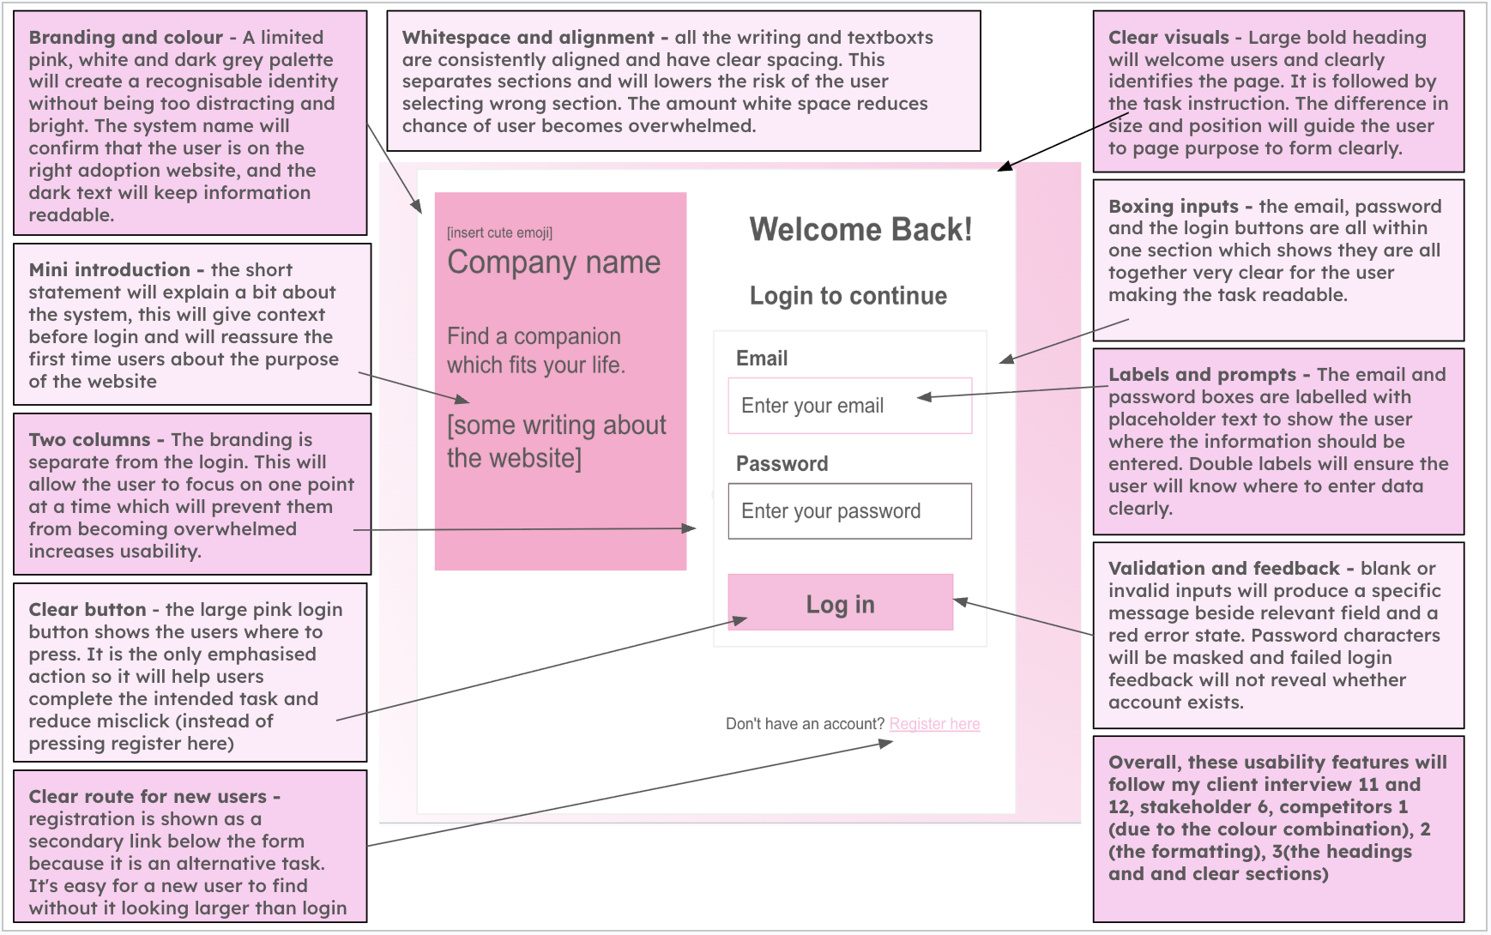
Figure 1 Annotated login prototype used to review hierarchy labels validation and navigation

2.2 Interface implementation
The registration and login forms use st.form so changing one input does not submit a partial record. Registration contains the five planned fields. The age remains a text input during this increment so invalid and boundary values such as 17 can be entered for R3; the backend converts and validates it before storage.
with st.form("registration_form"):
name = st.text_input("Full name", key="registration_name")
email = st.text_input("Email address", key="registration_email")
age = st.text_input("Age", key="registration_age")
password = st.text_input("Password", type="password")
confirmation = st.text_input("Confirm password", type="password")
submitted = st.form_submit_button("Create account")
Code extract 1 All R1 registration fields are submitted as one form in app.py

2.3 Server-side validation
Widgets improve normal use but are not a security boundary, so auth.py repeats every rule before an INSERT. Input is normalised first. Errors are returned by field, allowing the interface to explain the exact correction. A case-insensitive lookup checks for an existing email, and the UNIQUE database constraint provides a second defence.
if not cleaned_name:
errors["name"] = "Enter your full name."
elif len(cleaned_name) < 2:
errors["name"] = "Your name must contain at least 2 characters."
if EMAIL_PATTERN.fullmatch(cleaned_email) is None:
errors["email"] = "Enter a valid email address."
elif _email_exists(cleaned_email):
errors["email"] = "An account already exists for this email address."
if cleaned_age < 18:
errors["age"] = "You must be at least 18."
if len(password) < 8:
errors["password"] = "Use at least 8 characters."
Code extract 2 Backend validation enforces the R3 rules in auth.py

2.4 Password security and parameterised storage
I never store the submitted password. PasswordHasher produces an Argon2id hash with a new random 16-byte salt for every account. The encoded value contains the parameters needed for verification, so the original password is not recoverable. Registration uses SQL placeholders, preventing form text from becoming part of the SQL command.
PASSWORD_HASHER = PasswordHasher(
time_cost=3, memory_cost=65536, parallelism=2,
hash_len=32, salt_len=16,
)
def hash_password(password):
return PASSWORD_HASHER.hash(password)
connection.execute(
"INSERT INTO users (name, email, age, password_hash, role) "
"VALUES (?, ?, ?, ?, 'user')",
(name, email, age, hash_password(password)),
)
Code extract 3 Argon2id hashing and parameterised insertion in auth.py

2.5 Login feedback sessions and role access
Login accepts either an email address or the administrator username. The identifier is normalised before one parameterised query. An unknown identifier and a wrong password produce the same message, so the page does not reveal whether an account exists. Only safe account fields are copied into session state; password_hash is excluded.
row = connection.execute(
"SELECT user_id, name, username, email, password_hash, role "
"FROM users WHERE email = ? COLLATE NOCASE "
"OR username = ? COLLATE NOCASE LIMIT 1",
(identifier, identifier),
).fetchone()
if row is None or not verify_password(password, row["password_hash"]):
return {"credentials": "Incorrect email/username or password."}, None
Code extract 4 Login avoids account disclosure in auth.py
After successful authentication, current_user stores user_id, name, email and role. The interface checks role again before rendering the administrator area. Hiding a link would not be enough because a user could attempt to reach the protected destination by another route.

3 Development tests R1 to R6

3.1 Test method
I started from a clean temporary development database, created the documented local administrator and ran the actual Streamlit app. The real runtime confirmed the visible widgets and session transitions. I also inspected SQLite records to confirm roles and hash properties. These checks were repeated on 11 November 2026 after the final code edit.
ID | Planned input and method | Expected result | Actual result and action
R1 | Open Register and inspect the controls. | Name, email, age, password and confirmation are visible. | Pass. The runtime exposed all five labelled fields and one Create account action.
R2 | Register Test Adopter, adopter1@example.com, age 19, password123 twice. | One user record is saved with adopter access and the homepage opens. | Pass. A role=user record was committed and the adopter homepage rendered in the same session.
R3 | Submit each invalid or boundary value separately. | Each invalid value is rejected with a field-specific message and no invalid row is stored. | Pass. All seven invalid cases were rejected; a valid eight-character password was accepted.
R4 | Create two users with the same password and inspect password_hash. | Both hashes are Argon2id, differ from plaintext and differ from each other; both verify. | Pass. Both values began $argon2id$, were different and authenticated successfully.
R5 | Try correct details, wrong password and unknown email. | Correct details open the homepage; invalid attempts show one generic message. | Pass. Correct login created a session. Both invalid attempts returned the same message.
R6 | Try Admin area as adopter, then log in as admin123. | Adopter is returned to Home; administrator receives access. | Pass. The role check denied the adopter and displayed Administrator access granted for the admin.

3.2 R3 validation and boundary matrix
Case | Input changed | Expected | Verified outcome
R3a | Blank name | Reject name | Rejected; no account returned
R3b | One-character name A | Reject name | Rejected; minimum length message
R3c | Email invalid@ | Reject email | Rejected; format message
R3d | Age 17 | Reject age | Rejected; minimum-age message
R3e | Duplicate adopter1@example.com | Reject duplicate | Rejected case-insensitively
R3f | Confirmation different1 | Reject confirmation | Rejected; mismatch message
R3g | Seven-character Pass123 | Reject password | Rejected; minimum-length message
R3h | Eight-character Pass1234 | Accept password | Accepted and stored

3.3 Security evidence
Check | Observed evidence | Why it matters
Hash algorithm | Stored values began $argon2id$. | Matches R4 and avoids plaintext storage.
Random salt | Identical passwords produced different encoded hashes. | A repeated password does not create a repeated database value.
Generic failure | Unknown email and wrong password returned identical text. | The login page does not disclose registered accounts.
Least privilege | Public registration always inserted role='user'. | A registrant cannot grant themselves administrator access.
Role guard | Adopter selection of Admin area displayed a denial and Home. | Authorisation is checked after authentication.

4 Remedial action and review

4.1 Genuine corrections during this increment
Issue found | Why it mattered | Change made | Retest result
Earlier Development draft described scrypt while pre-development R4 required Argon2id. | The evidence and final design would contradict the implemented security method. | Implemented argon2-cffi PasswordHasher and updated this focused Development account. | R4 passed: two salted $argon2id$ hashes differed and both verified.
A first verification record used the name Hash User 1. | The digit correctly failed the planned person-name character check, so the test data was invalid rather than the code. | Changed the controlled records to Hash User One and Hash User Two without weakening validation. | Both valid users were stored; the name rule still rejects unsuitable characters.
Role separation could have been demonstrated only by hiding navigation. | Hidden controls do not prevent a crafted or direct access attempt. | Kept the Admin area option visible in the isolated increment and applied a server-side role check before rendering it. | R6 passed for both the refused adopter and accepted administrator.

4.2 Review and decision
The increment now meets R1-R6 and establishes the identity needed by later PawMatch features. I retained a separate auth module because password handling and database queries should not be duplicated across Streamlit pages. Registration cannot select a role, invalid login feedback is deliberately generic, and authorisation is checked before protected content is rendered.
The demonstration administrator is intentionally limited to local coursework testing. Its simple documented password makes R6 reproducible, but the setup comments state that a deployed product would use a private setup secret or an external identity provider. Later development should reuse current_user rather than creating another login system.

5 Evidence capture and reproducibility

5.1 What I should capture for the coursework
The verified results above are reproducible. To make the final submission visually auditable, I should collect the following screenshots during my own manual run and label each image with its test ID rather than relying on one large collection of unrelated images.
Evidence label | Screen to capture | What must be visible
R1 | Registration form | All five labelled fields and Create account button
R2 | Adopter homepage and DB Browser users row | Successful session, email, age and role user
R3 | Representative field errors plus the R3 matrix | Exact error text and unchanged user count for invalid submissions
R4 | DB Browser users table | Two different $argon2id$ values; obscure most of each hash if preferred
R5 | Failed login and successful homepage | Generic failure text and successful session destination
R6 | Adopter denial and administrator area | Admin access required followed by Administrator access granted

5.2 Reproduction steps
From the development-branch folder I should run these commands:
python3 -m pip install -r requirements.txt
python3 setup_database.py --fresh
streamlit run app.py
Command sequence used to start the isolated authentication increment
The fresh setup backs up any previous local database, creates the four designed tables and creates the R6 administrator. The documented local credentials are admin123 and password123. I must use fictional example.com adopter addresses in screenshots and avoid placing a real personal email or reusable password in the coursework evidence.

5.3 Completion statement
Registration and login are complete for this development stage. All six associated pre-development tests have verified outcomes, the known documentation mismatch was corrected, and the branch remains intentionally free of the later PawMatch subsystems. The next increment can therefore depend on an authenticated user_id and role without reimplementing identity or password handling.

