Proposed Layout
The system can be decomposed into five main components. Separating the system into smaller components makes it easier to design, develop, test and maintain whilst each section performs a specific function.

Section | Front End Justification | Backend Justification
User/Admin Authentication | Will allow users to register and existing users to login, and allow admins to access their page safely and securely. Registration will collect the users name, email, age and password. The interface should provide clear feedback when details are missing or forgotten from its validation system. It will also show an error message if login details are incorrect | The system will validate entered details, such as:  - email cannot be blank and must be valid and unique  - Password minimum 8 characters  - Age must be a valid number  - Login fields cannot be blank  The passwords will be hashed in order to be kept secure and safe. During login, enter details will be compared against records in the users table. A session will then be created when authentication is successful.  For the admin side, if the login details are incorrect it will not allow them access, which will stop unauthorised users from adding, editing or deleting animal records.
User Homepage/Main Menu | Will provide the main navigation area after the user logs in. It will allow the user to access the questionnaire, browse available animals and view their account. It will also explain the purpose of the adoption matching system. It will be clear and welcoming, and not overwhelming for the user. | The system will check the user's session to make sure they are logged in. It may retrieve the email and recent questionnaire information from the database so that personalised information can be displayed.
Administrator Menu | Provides staff with a dashboard to manage existing animals and their records. Admins will be clearly able to add new animals, edit existing details and remove records. To add animals it will store: Name, species, age, breed, sex, personality and exercise needs, children compatible, garden required, medical notes and an image. Forms will be clearly Labelled and display confirmation or error messages. | The system will check that the logged in account has the admin role before access is allowed. Parameterised SQL commands will insert, update and delete animal records. All inputs will be validated before changes are made to the database. A log out function will clear the admins session and return them to the login page, preventing another person using the same device which will prevent unwanted access to the database.
Animal Viewing | Allows users to browse available animals using clearly presented animal cards. Each card will show information such as the animal name, image, species, breed and age. Users will be able to select a card to view a more detailed animal profile. | Animal records will be retrieved from the animals table. Search and filter selections will be used to change the database query or filter the retrieved records. Selecting an animal will use its unique animal ID to load the correct profile.
Questionnaire and Recommendations | Will use a form in order to allow users to answer questions about their home, lifestyle, experience and preferences. The questionnaire will have questions such as the housing type, access to garden, animal loneliness times, children, pets, experience, activity labels, what species and size preferred. These questions would not appear all at one time to not overwhelm the user and the input type would be drop downs or radio buttons. After submitting the questionnaire, the system will display compatibility scores almost immediately and recommended animals. It will also explain requirements the user does not meet. | Responses will be validated and compared with the requirements of each available animal. A weighted compatibility algorithm will calculate a percentage score for every animal. The animals will then be sorted from highest to lowest score so the top recommendations can be displayed. The questionnaire responses and match results may also be stored within the database with the users ID (email)
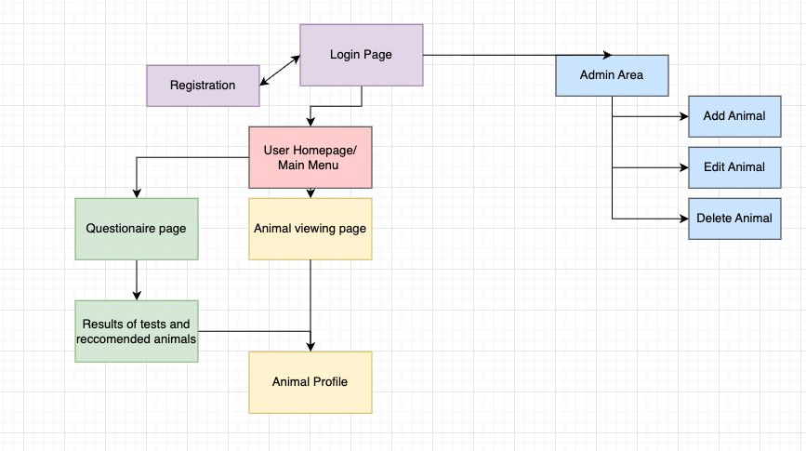

Database structure

Tables | Purpose
Users | Stores registered user and administrator account details
Animals | Stores user profiles, care needs and matching requirements
Questionnaire responses | Stores answers submitted by users
Matchresults | Stores calculated compatibility scores between responses and animals

One user can complete multiple questionnaire responses, each questionnaire can produce multiple compatibility results because it is compared to every available animal. Each animal can therefore appear in multiple match results belonging to different users or questionnaire attempts.
- Users 1 → Many Questionnaire responses
- Questionnaire responses 1 → Many matchresults
- animals 1 → Many matchresults

Validation
All user entered data should be validated before it is processed or stored in the SQLite database. Streamlit controls such as dropdowns radio buttons and number inputs will restrict the range of values users can enter. However, the backend will still validate the submitted values because interface controls alone should not be relied on.
Login and Registration (incl database)

User/Admin Authentication | Will allow users to register and existing users to login, and allow admins to access their page safely and securely. Registration will collect the users name, email, age, address and password. The interface should provide clear feedback when details are missing or forgotten from its validation system. It will also show an error message if login details are incorrect | The system will validate entered details, such as:  - Username cannot be blank  - Password minimum 8 characters  - Required questions cannot be skipped  - Age must be a valid number  - Duplicate usernames not allowed  The passwords will be hashed in order to be kept secure and safe. During login, enter details will be compared against records in the users table. A session will then be created when authentication is successful.  For the admin side, if the login details are incorrect it will not allow them access, which will stop unauthorised users from adding, editing or deleting animal records.

Interface Design
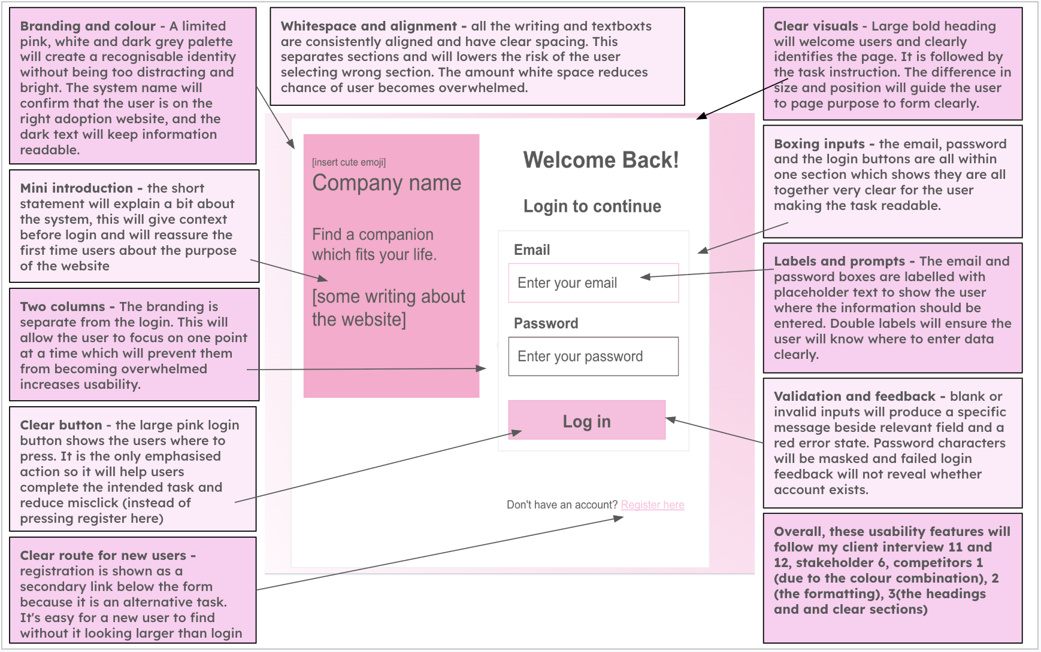
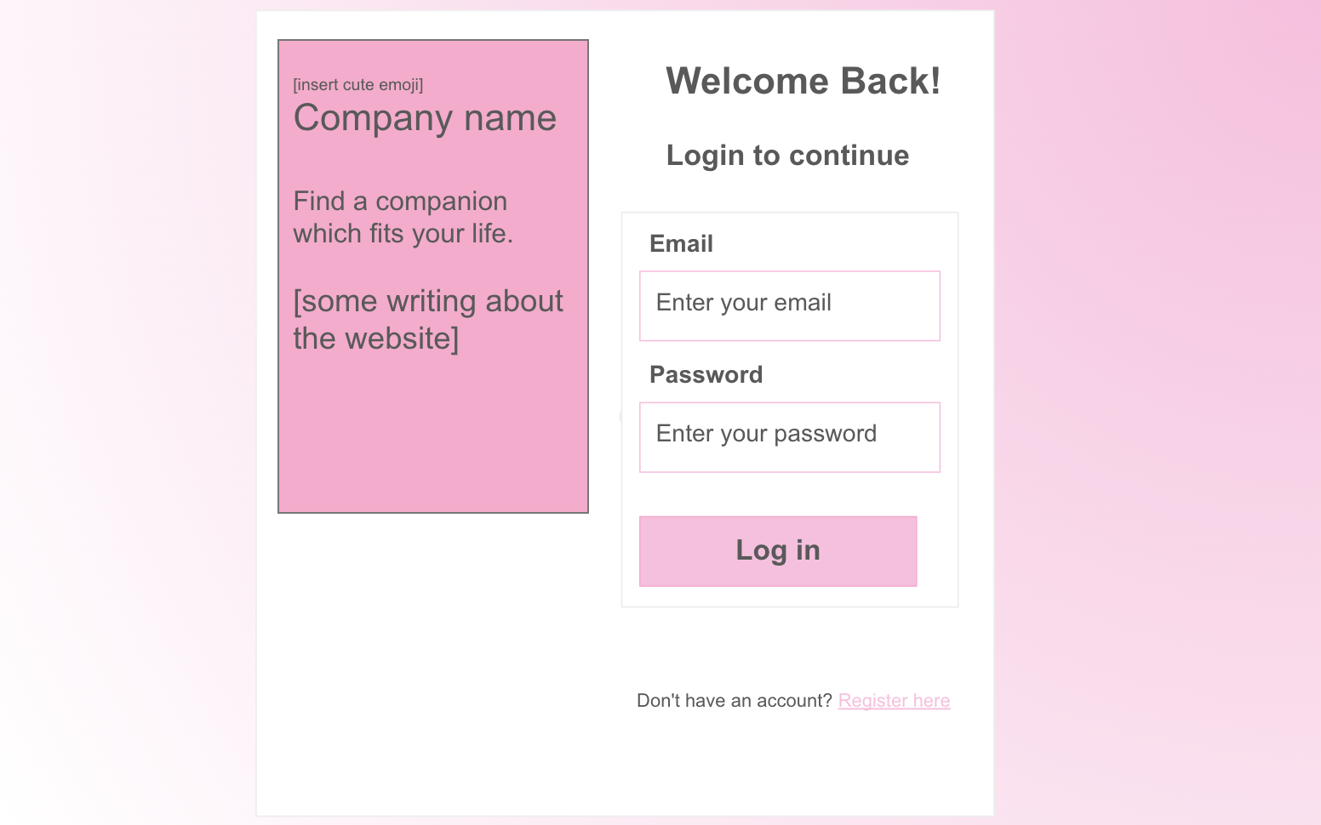
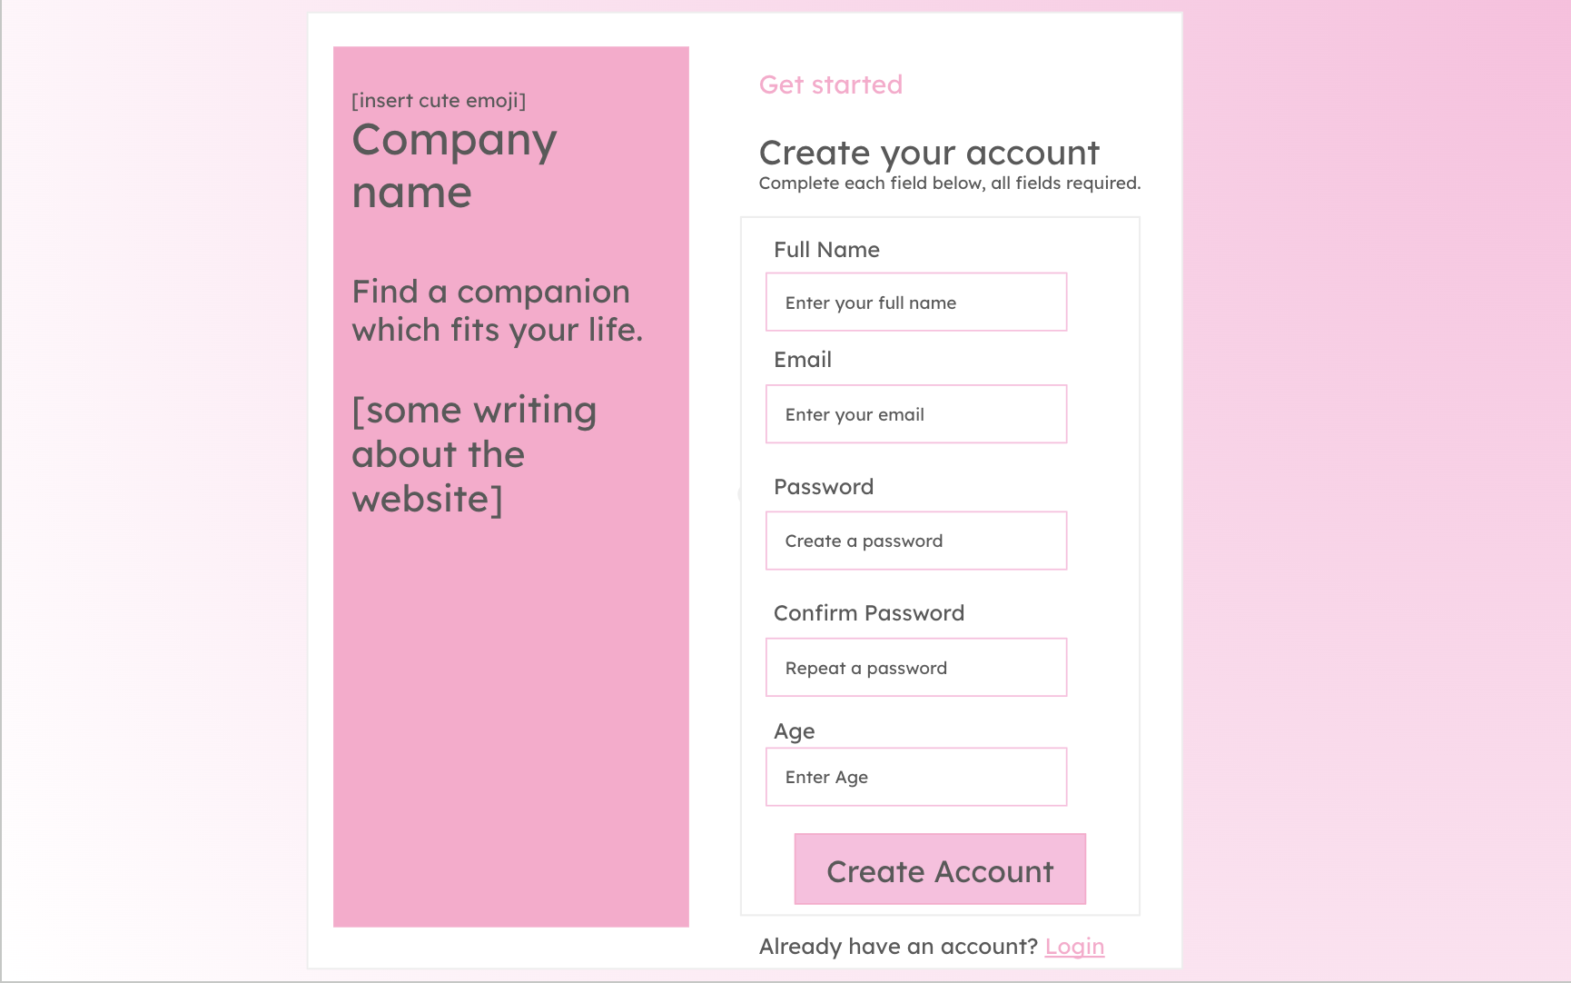
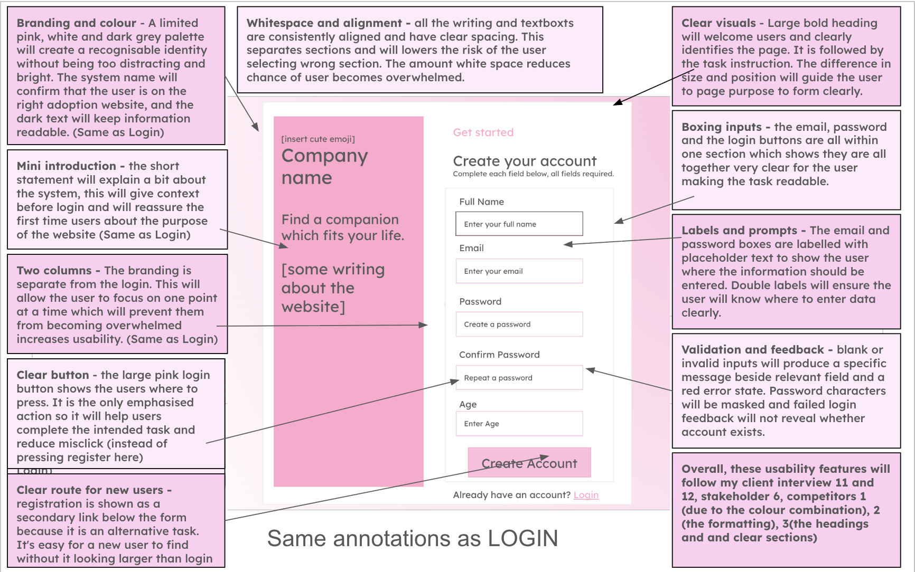

Algorithm (Flow chart, pseudocode)
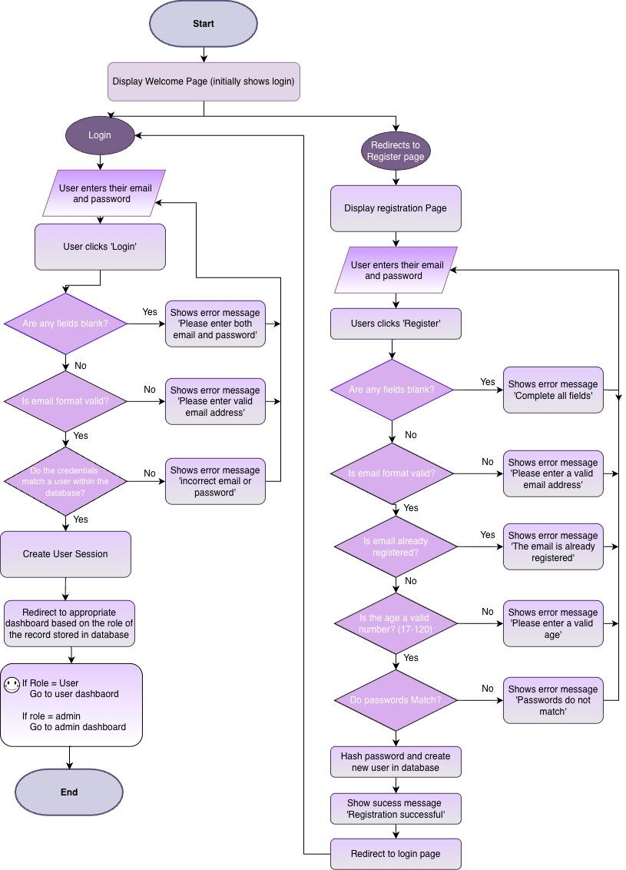
Pseudocode
Code for the Login

def login_page():
email = input_email()
password = input_password()
if login_button_clicked:
email = email.strip().lower()
errors = validate_login(email, password)
if errors is not empty:
for error in errors:
display_error(error)
else:
user = database.find_user_by_email(email)
if user does not exist:
display_error(
"Incorrect email or password"
)
elif verify_password(
password,
user.password_hash
) == False:
display_error(
"Incorrect email or password"
)
else:
create_user_session(
user.user_id,
user.name,
user.role
)
if user.role == "admin":
go_to_admin_dashboard()
else:
go_to_user_dashboard()

Code for the Registration

def registration_page():
name = input_name()
email = input_email()
age = input_age()
password = input_password()
confirm_password = input_confirm_password()
if register_button_clicked:
name = name.strip()
email = email.strip().lower()
age = age.strip()
errors = validate_registration(
name,
email,
age,
password,
confirm_password
)

if errors is not empty:
for error in errors:
display_error(error)
else:
password_hash = hash_password(password)
database.create_user(
name,
email,
integer(age),
password_hash,
role = "user"
)
display_success(
"Registration successful"
)
go_to_login_page()

Database (Table structure)

Field | Data type | Key/validation
user_id | INTEGER | Primary key which will auto increment
name | TEXT | required
email | TEXT | Required and unique
age | INTEGER | required , valid range
password_hash | TEXT | required
user_role | TEXT | ‘User’ or ‘admin’
date_created | DATE | required

Variables

Variable Name | Data Type | Purpose | Justification | E.g or Validation
user_name | String | Stores the name entered during registration | This will allow the system to identify and personalise the account. A string would be required for the datatype as it will contain alphabetic characters and may include spaces and hyphens. | Cannot be blank
email | String | Will store users email address | It will be used as a unique identifier for logging in and contacting the user. It will contain letters and symbols so will be stored as a string. | Must follow a valid email format and be unique
age | integer | Stores the users age | It will be used to ensure the user meets any minimum age requirements. An integer is suitable for this variable as age is represented by a whole number. | Must be a valid positive number.
password | string | Temporarily stores the password entered by the password | It is needed to authenticate the user securely. Passwords usually contain letters, numbers and special characters, so a string is suitable for the data type. | Minimum of eight characters.
confirm_password | string | Stores the repeated password entered during registration | This allows the system to check that the user has mistyped their password before creating the account. | It will have to match password
password_hash | string | Stores the hashed version of the password | Passwords should not be stored as plain text. Storing the hash reduces the risk of passwords being exposed if the database is accessed without permission. | Generated using a secure hashing function
login_email | string | Stores the email entered on the login page | The variable is required so that the system can search for the corresponding account in the database | Cannot be blank
login_password | string | Temporarily stores the password entered during login | The entered password will be checked against the stored password hash in order to verify users identity | Cannot be blank
user_id | integer | Uniquely identifies the logged in user | An integer is efficient for use as a database primary key, it will allow records such as questionnaires and recommendations to be linked to the correct user. | It will be retrieved from the database after login
user_role | String | Stores whether the account is an administrator or a user | This variable is required for access control, so that normal users cannot access the administrator pages Controls access to the administrator area, although normal registrations should automatically receive the role ‘user’, the admin role should not be selectable from the registration form. | Will be stored as ‘user’ or ‘admin’
error_message | string | Stores the error message which will appear when the input or login details are invalid | My system will provide clear feedback and help the user understand what has gone wrong and how to correct it. A string will be suitable for this message as it contains many words in one sentence. | ‘Incorrect email or password, please retry’
is_authenticated | booleen | Records whether login attempt was successful | A boolean data type is suitable as authentication only has two possible values. | True or False

Validation
- Name
- Presence check: Field cannot be empty or contain only spaces
- Length check: name must be between 2 and 50 characters
- Whitespace check: spaces at beginning and end will be removed

- Email address
- Presence check: Field cannot be empty or contain only spaces
- Format check: value must contain a @ and domain
- Uniqueness check: a database query will check the address not already registered
- Whitespace check: spaces at beginning and end will be removed
- Check characters: convert all to lower case

- Age
- Presence check: Field cannot be empty or contain only spaces
- Type check: data must be a whole number
- Range check: age must be 18+

- Password
- Presence check: Field cannot be empty or contain only spaces
- Length check: password must be more than 8 characters
Registration
- Confirmation check: the confirmation field must exactly match original password
- Security processing: the valid password will be hashed before it is inserted into the database and the original password will never be stored.
Login
- The password will be checked against the stored password hash rather than compared as plain text.

Registration outcome
- The account will be created if every field passes validation, individual messages will be shown if one or more fields are invalid.

Session check
- A session will only be created after successful authentication. Invalid information will leave users on the login page and will not allow them to access the user or admin page.

Validation Pseudocode

Check name | pseudocode
- Name — presence check | - if name == "":  - errors.append("Name cannot be blank.")
- Name — length check | - if name != "":  - if len(name) < 2 or len(name) > 50:  - errors.append("Name must be between 2 and 50 characters.")
- Email — presence check | - if email == "":  - errors.append("Email cannot be blank.")
- Email — format check | - email_valid = valid_email_format(email)  - if email != "" and not email_valid:  - errors.append("Enter a valid email address.")
- Email — uniqueness check | - if email_valid:  - user = database.find_user_by_email(email)  - if user is not None:  - errors.append("Email is already registered.")
- Age — presence check | - age_input = age_input.strip()  - if age_input == "":  - errors.append("Age cannot be blank.")
- Age — type check | - age = None  - if age_input != "":  - try:  - age = int(age_input)  - except ValueError:  - errors.append("Age must be a whole number.")
- Age — range check | - if age is not None:  - if age < 18:  - errors.append("You must be at least 18 years old.")
- Password — presence check | - if password.strip() == "":  - errors.append("Password cannot be blank.")
- Password — length check | - if password.strip() != "":  - if len(password) <= 8:  - errors.append("Password must contain more than 8 characters.")
- Password — confirmation check | - if confirm_password == "":  - errors.append("Please confirm your password.")  - elif confirm_password != password:  - errors.append("Passwords do not match.")

Admin Page

Administrator Menu | Provides staff with a dashboard to manage existing animals and their records. Admins will be clearly able to add new animals, edit existing details and remove records. To add animals it will store: Name, species, age, breed, sex, personality and exercise needs, children compatible, garden required, medical notes and an image. Forms will be clearly Labelled and display confirmation or error messages. | The system will check that the loginned in account has the role before access is allowed. Parameterised SQL commands will insert, update and delete animal records. All inputs will be validated before changes are made to the database. Will also include a logout function, to securely log out so no physical access to the system unless its an admin.
Interface
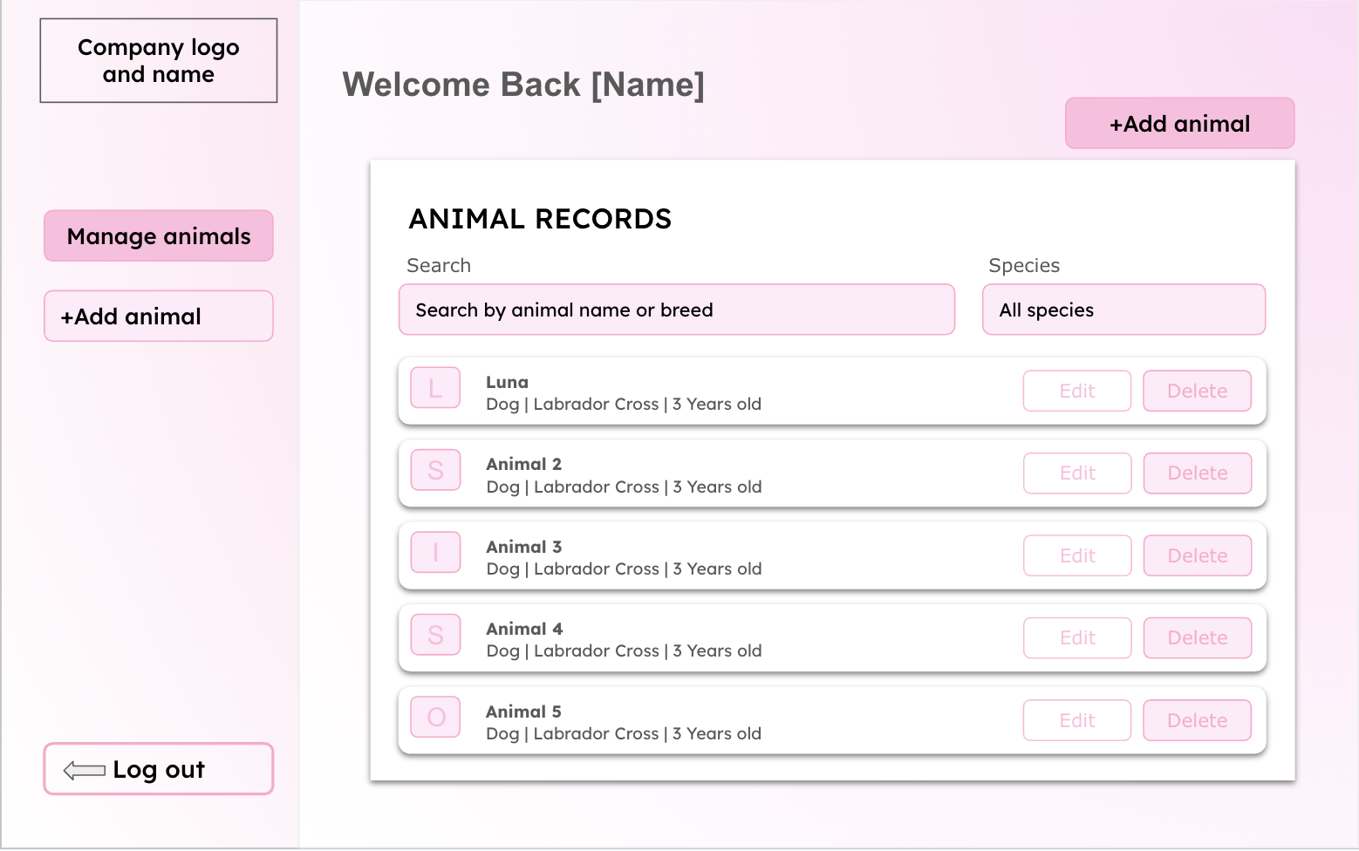
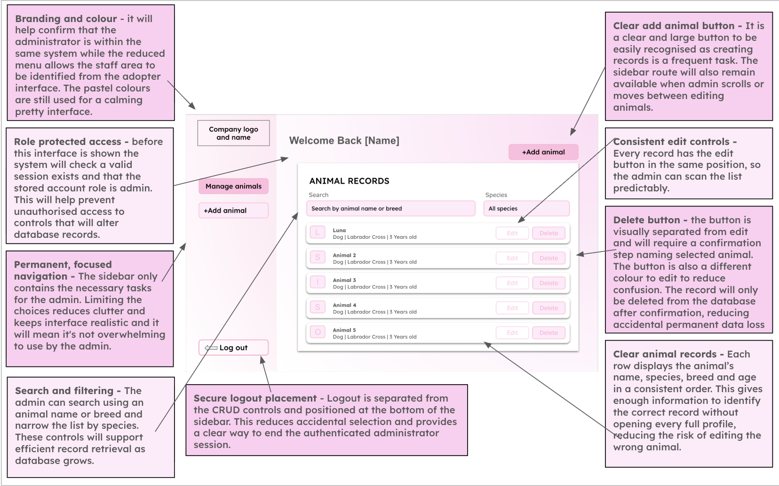
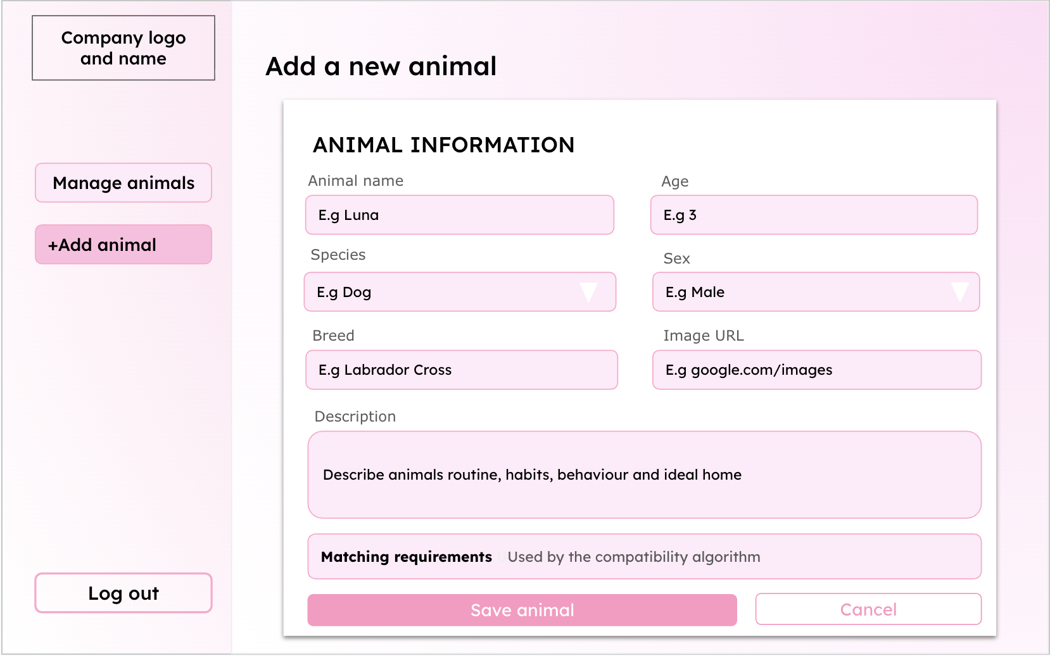
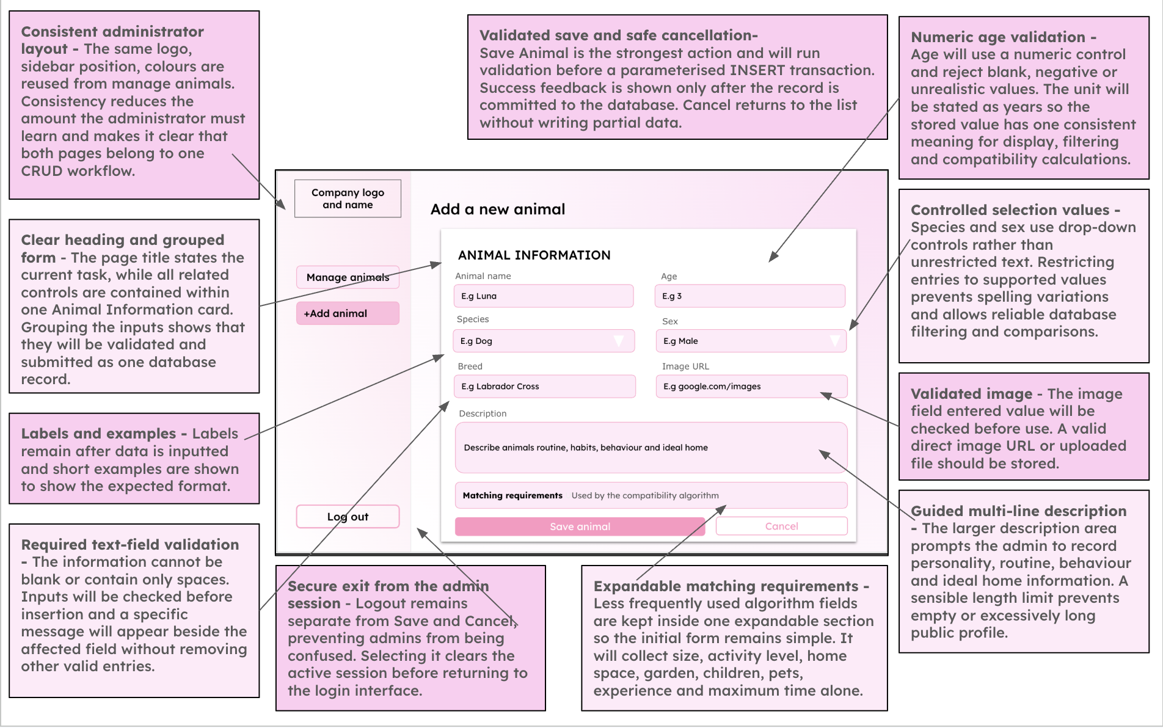

Pseudocode
Admin Page
# logged_in and role come from the existing login session
if logged_in == False or role != "admin":

print("Please log in as an admin")
page = "login"

else:

print("Manage animals")

search = input("Search by animal name")
species = input("Choose a species or All")

animals = find_animals(search, species)
print(animals)

choice = input("Add, View, Edit, Delete or Logout")

# animal_id comes from the animal selected in the list
if choice == "Add":
page = "add"
details = input("Enter the new animal's details")
errors = validate_animal(details)
if len(errors) == 0:
add_animal(details)
print("Animal added successfully")
page = "admin"
else:
for error in errors:
print(error)
elif choice == "View":
page = "view"
animal = get_animal(animal_id)
print(animal)
if input("Select Back to return") == "Back":
page = "admin"

elif choice == "Edit":
page = "edit"
animal = get_animal(animal_id)
# Show the current details in the form
print(animal)
details = input("Submit the updated animal details")
errors = validate_animal(details)
if len(errors) == 0:
update_animal(animal_id, details)
print("Animal updated successfully")
page = "admin"
else:
for error in errors:
print(error)

elif choice == "Delete":
confirm = input("Delete this animal? Yes or No")

if confirm == "Yes":
delete_animal(animal_id)
print("Animal deleted successfully")

page = "admin"
elif choice == "Logout":

confirm = input("Log out? Yes or No")

if confirm == "Yes":
session.clear()
page = "login"
else:
page = "admin"

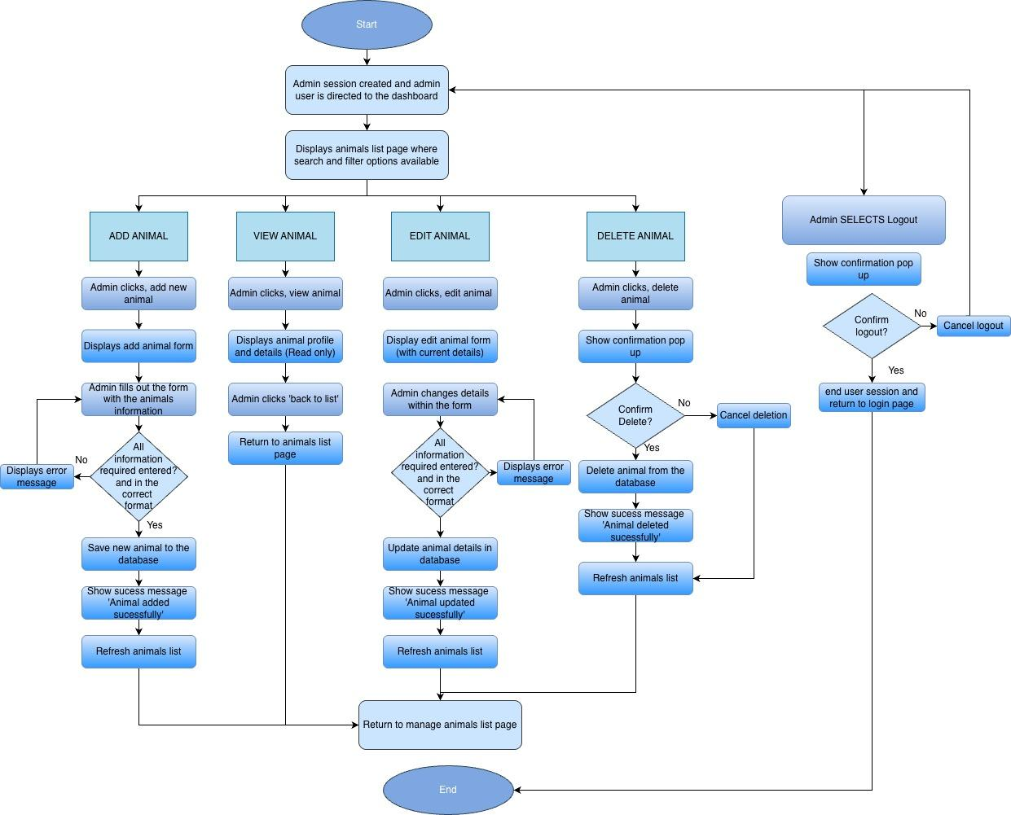

Animal Table
Field | Data type | Key/validation
animal_id | INTEGER | Primary key, autoincrement
name | TEXT | required
species | TEXT | Required - dog, cat or rabbit
breed | TEXT | Required
age | INTEGER | Required, cannot be zero
sex | TEXT | required- male, female or unknown
size | TEXT | Required - small medium or large
personality | TEXT | required
Exercise_needs | INTEGER | Required - 1 to 3
minimum_housing_level | INTEGER | Required - 1 to 3
garden_required | BOOLEAN | Required 0 or 1
child_compatible | BOOLEAN | Required 0 or 1
max_hours_left_alone | INTEGER | required
Medical_notes | TEXT | optional
image | TEXT | Required, an image path
date_added | DATE | required

Variables

Variable Name | Data Type | Purpose | Justification | Validation or e.g
animal_id | INTEGER | Uniquely identifies each animal record | A unique integer stops confusion between animals with similar names and allows the correct to be updated and deleted | Automatically generated
name | string | Stores the animals name | The name is required to identify the animal throughout the interface and allows the user to remember the animal with a specific name. A string is suitable as it allows letters spaces and punctuation. | Can’t be blank
species | string | Stores the type of animal | Species is required for searching, filtering and matching against user preferences. | dog, cat or rabbit
breed | string | Stores the animals breed | Breeds provides users with important information and may help describe likely size or care requirements | Can't be blank or might be ‘unknown’
age | INTEGER | Stores the animals age | Age affects care needs. An integer is suitable as it allows the value to be validated sorted and compared | cannot be zero
sex | string | Stores the animals sex | This is relevant profile information and may be considered by the potential adopters | male, female
size | string | Stores the animals size and is used in filtering | Size affects space requirements and is needed by the filtering and compatibility systems | small medium or large
personality | string | Stores a description of the animals behaviour and personality | A text field will allow the admin to explain the animals personality and background in more detail to help attract possible adopters | Cant be blank but a character limit may be applied
Exercise_needs | INTEGER | Stores whether the animal has low, medium or high exercise needs | This can be compared with the adopters lifestyle to produce a more appropriate compatibility score. An integer is suitability for easier comparison | 1 to 3 (low medium or high)
minimum_housing_level | INTEGER | Stores the amount of living space required | This can be compared with adopters lifestyle to aid the algorithm when creating the compatibility score | 1 to 3
garden_required | boolean | Records whether the animal requires access to a garden | This may act as a compulsory suitability rule. A boolean value is useful as it is simple to input. | True or false
child_compatible | boolean | Records whether the animal is suitable for a household with children | There are only two options which make boolean values suitable. This is very important for the safety and welfare of the children and animals. | True or false
max_hours_left_alone | INTEGER | Stores value for which the animal can be left home alone for, and representing if more independent or clingy | This is important if a user works long hours and the animal requires a lot of attention it may cause neglect of the animal which is a key issue we are trying to prevent. | Cant be blank
Medical_notes | string/list | Stores any medical conditions, treatments or special requirements | Potential adopters need to understand any medical needs before making a decision. A string will allow multiple to be described. | May be blank or ‘N/A’
image | string | Stores the location of the animals image | This allows the correct photo to be displayed without storing the full image directly in database | Must use an accepted file extension
form_action | string | Stores the operation the admin is performing | The same form may be used for adding and editing variables. This variable will allow the program to select the right query. | ‘Add’ or ‘edit’ or ‘delete’ or ‘view’
delete_confirmation | boolean | Records whether the administrator has confirmed deletion | Deletion is permanent so confirmation reduces risk of animal being removed accidentally and not being considered for adoption | True or false
record_found | boolean | Records whether the database has retrieved the animal record successfully | This prevents the program from attempting to edit or delete a record not present in the database | True or false

Validation

- Animal name
- Presence check: Cannot be empty
- Length check: Between 1 and 50 characters
- Format check: Letters, spaces, apostrophes, hyphens and appropriate numbers may be allowed
- Species
- Presence check: Must be selected.
- Lookup check: Must be Dog, Cat or Rabbit.
- A drop-down menu will restrict the choices.
- Breed
- Presence check: Cannot be empty
- Length check: For example, between 2 and 50 characters
- Format check: Must not consist entirely of unsupported symbols

Age
- Presence check: Must be provided
- Type check: Must be a whole number
- Range check: Cannot be negative and must be within the designed maximum animal age

Sex
- Lookup check: Must be Male, Female or Unknown
- A drop-down menu prevents invalid values

Size
- Lookup check: Must be Small, Medium or Large

Personality
- Presence check: A description must be provided
- Length check: For example, between 20 and 1,000 characters
- Whitespace check: A value consisting only of spaces will be rejected

Exercise need
- Presence check: An option must be selected
- Range check: Must be between 1 and 3

Minimum housing requirement
- Presence check: Must be selected
- Range check: Must be between 1 and 3

Maximum hours alone
- Type check: Must be an integer
- Range check: Must be between 0 and 24

Garden required
- Type check: Must be stored as a Boolean value 0 or 1
- Child compatibility
- Type check: Must be stored as a Boolean value 0 or 1
- Medical notes
- This field may be optional
- Type check: it will have a maximum length
- Text will be stored as plain text rather than interpreted as code
- Animal image
- Presence check : An image must be uploaded if every profile requires one
- File-type check : Only approved formats such as JPG, JPEG and PNG will be accepted
- File-size check : The file must not exceed the chosen maximum size
- Filename handling : A safe, unique filename will be generated to avoid overwriting existing images
The animal record will only be inserted after all required fields pass validation. The SQL statement will be parameterised and committed only after successful validation. A success message will then confirm that the record has been created.
Validation Pseudocode

Check name | pseudocode
- Animal name — presence check | - animal_name = animal_name.strip()  - if animal_name == "":  - errors.append("Animal name cannot be blank.")
- Animal name — length check | - if animal_name != "":  - if len(animal_name) < 1 or len(animal_name) > 50:  - errors.append("Animal name must be between 1 and 50 characters.")
- Animal name — format check | - for character in animal_name:  - if not character.isalnum() and character not in " '-":  - errors.append("Animal name contains an unsupported character.")  - break
- Species — presence check | - if species is None:  - errors.append("Please select a species.")
- Species — lookup check | - if species is not None:  - if species not in ["Dog", "Cat", "Rabbit"]:  - errors.append("Species must be Dog, Cat or Rabbit.")
- Breed — presence check | - breed = breed.strip()  - if breed == "":  - errors.append("Breed cannot be blank.")
- Breed — length check | - if breed != "":  - if len(breed) < 2 or len(breed) > 50:  - errors.append("Breed must be between 2 and 50 characters.")
- Breed — format check | - contains_text = False  - for character in breed:  - if character.isalnum():  - contains_text = True  - if breed != "" and contains_text == False:  - errors.append("Breed cannot contain only symbols.")
- Animal age — presence check | - age_input = age_input.strip()  - if age_input == "":  - errors.append("Please enter the animal's age.")
- Animal age — type check | - animal_age = None  - if age_input != "":  - try:  - animal_age = int(age_input)  - except ValueError:  - errors.append("Animal age must be a whole number.")
- Animal age — range check | - if animal_age is not None:  - if animal_age < 0 or animal_age > MAX_ANIMAL_AGE:  - errors.append("Animal age is outside the allowed range.")
- Sex — lookup check | - if sex not in ["Male", "Female", "Unknown"]:  - errors.append("Select Male, Female or Unknown.")
- Size — lookup check | - if size not in ["Small", "Medium", "Large"]:  - errors.append("Select Small, Medium or Large.")
- Personality — presence check | - if personality == "":  - errors.append("Please enter a personality description.")
- Personality — length check | - if personality != "":  - if len(personality) < 20 or len(personality) > 1000:  - errors.append("Personality must be between 20 and 1,000 characters.")

Check name | Python-style pseudocode
- Exercise need — presence check | - if exercise_need is None:  - errors.append("Please select an exercise need.")
- Exercise need — range check | - if exercise_need is not None:  - if exercise_need < 1 or exercise_need > 3:  - errors.append("Exercise need must be between 1 and 3.")
- Minimum housing — presence check | - if minimum_housing is None:  - errors.append("Please select a minimum housing requirement.")
- Minimum housing — range check | - if minimum_housing is not None:  - if minimum_housing < 1 or minimum_housing > 3:  - errors.append("Minimum housing must be between 1 and 3.")
- Maximum hours alone — type check | - maximum_hours_alone = None  - try:  - maximum_hours_alone = int(hours_alone_input)  - except ValueError:  - errors.append("Maximum hours alone must be a whole number.")
- Maximum hours alone — range check | - if maximum_hours_alone is not None:  - if maximum_hours_alone < 0 or maximum_hours_alone > 24:  - errors.append("Maximum hours alone must be between 0 and 24.")
- Garden required — Boolean value check | - if type(garden_required) != int or garden_required not in [0, 1]:  - errors.append("Garden required must be 0 or 1.")
- Child compatibility — Boolean value check | - if type(child_compatibility) != int or child_compatibility not in [0, 1]:  - errors.append("Child compatibility must be 0 or 1.")
- Record — validation outcome and database insertion | - if len(errors) > 0:  - for error in errors:  - print(error)  - else:  - database.execute(insert_query, animal_details)  - database.commit()  - print("Animal added successfully.")

Main Menu

User Homepage/Main Menu | Will provide the main navigation area after the user logs in. It will allow the user to access the questionnaire, browse available animals and view their account. It will also explain the purpose of the adoption matching system. It will be clear and welcoming, and not overwhelming for the user. | The system will check the user's session to make sure they are logged in. It may retrieve the user's name and recent questionnaire information from the database so that personalised information can be displayed.

Interface Design
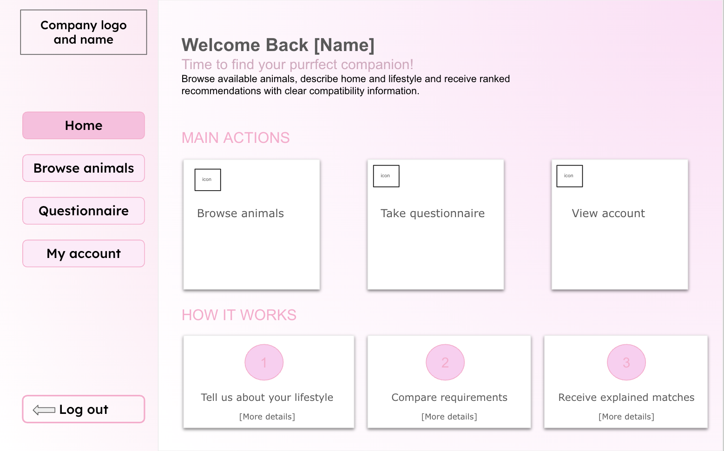
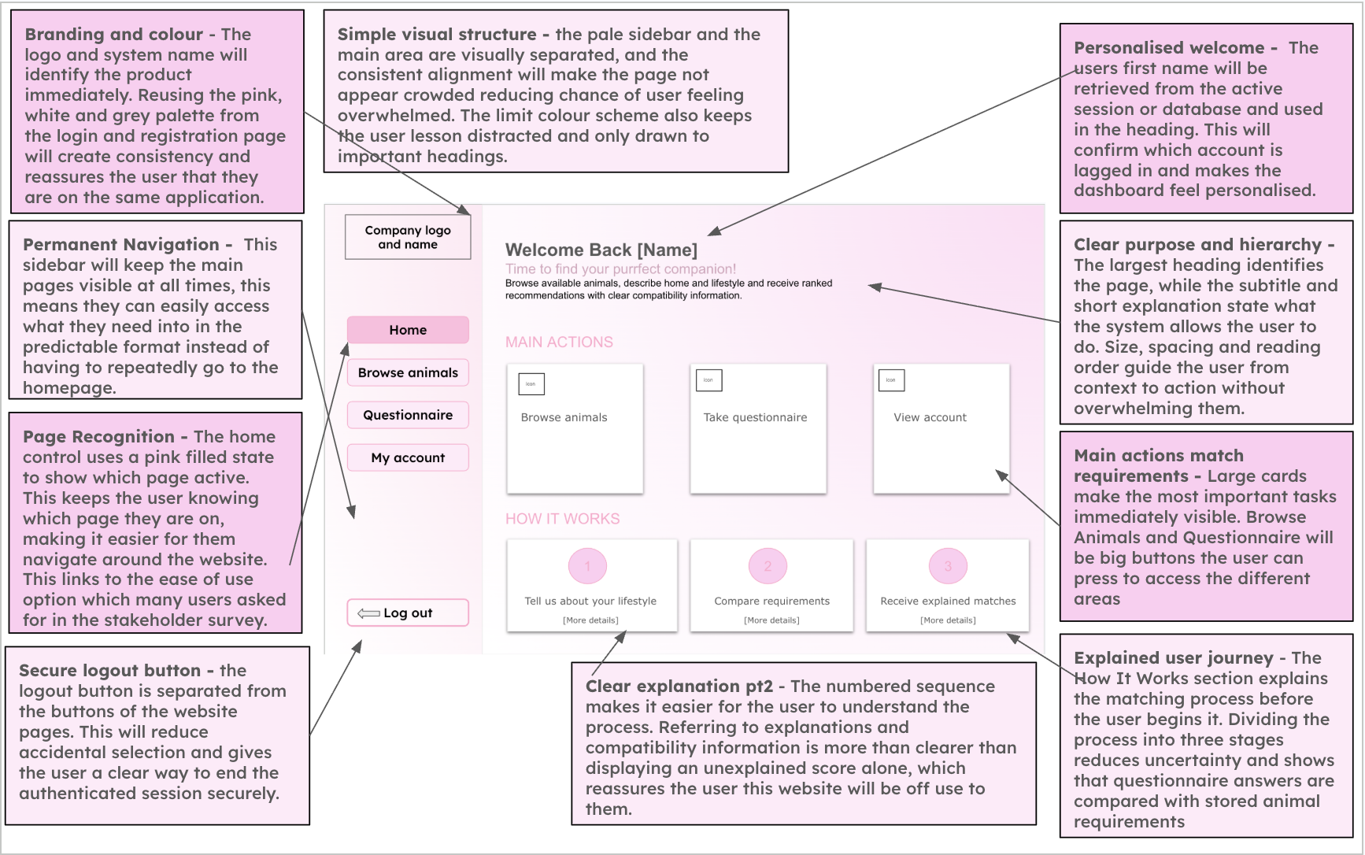

Algorithm (Flow chart, pseudocode)
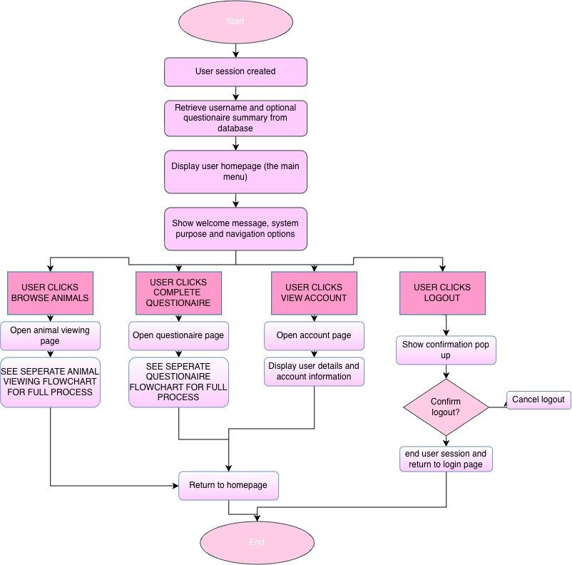

Pseudocode
Main Menu Code

# Use the session already created during login
if logged_in == False:
open_page("Login")

else:
user = get_user(user_id)
print("Welcome", user.name)
print("Find an animal that suits your lifestyle.")
summary = get_questionnaire_summary(user_id)
if summary is not None:
print(summary)
choice = input("Browse animals, Questionnaire, View account or Logout")

if choice == "Browse animals":
open_page("Animal viewing")

elif choice == "Questionnaire":
open_page("Questionnaire")

elif choice == "View account":
open_page("Account")

print("Name:", user.name)
print("Email:", user.email)
print("Age:", user.age)

elif choice == "Logout":

confirm = input("Are you sure you want to log out? Yes or No")

if confirm == "Yes":
clear_session()
open_page("Login")

else:
open_page("Homepage")

Variables

Variable Name | Data Type | Purpose | Justification | E.g or validation
current_user_id | INTEGER | Identifies user currently accessing dashboard | Ensures that the dashboard displays information belonging to the correct account | Retrieved from session
current_user_name | STRING | Stores the logged in users name | This will allow the interface to display personalised information and reassures user they are accessing correct account | ‘Welcome sienna’
animal_count | INTEGER | Stores the number of animals currently available | It will provide a useful summary of information on the dashboard. An integer is a suitable data type as the number of animals is a whole number | Must be zero or larger
questionaire_completed | BOOLEAN | Records whether the user has completed the questionnaire | This variable allows the system to display recommendations or prompt the user to complete the questionnaire. Boolean is suitable as there is only two possible states | True or False
reccomended_animals | LIST | Stores the animals recommended to the users | Multiple animals will need to be displayed in ranked order so a list is a suitable data type | Ordered from lowest to highest compatibility
selected_page | STRING | Stores the page selected from navigation menu | This allows the program to choose which page or section should be selected | Animals or questionaire
notification_message | STRING | Stores confirmation or status feedback | The user will need clear feedback after completing actions such as submitting questionnaire | ‘Questionaire submitted successfully’

Animal Viewing Page

Animal Viewing | Allows users to browse available animals using clearly presented animal cards. Each card will show information such as the animal name, image, species, breed and age. Users will be able to select a card to view a more detailed animal profile. | Animal records will be retrieved from the animals table. Search and filter selections will be used to change the database query or filter the retrieved records. Selecting an animal will use its unique animal ID to load the correct profile.

Interface Design
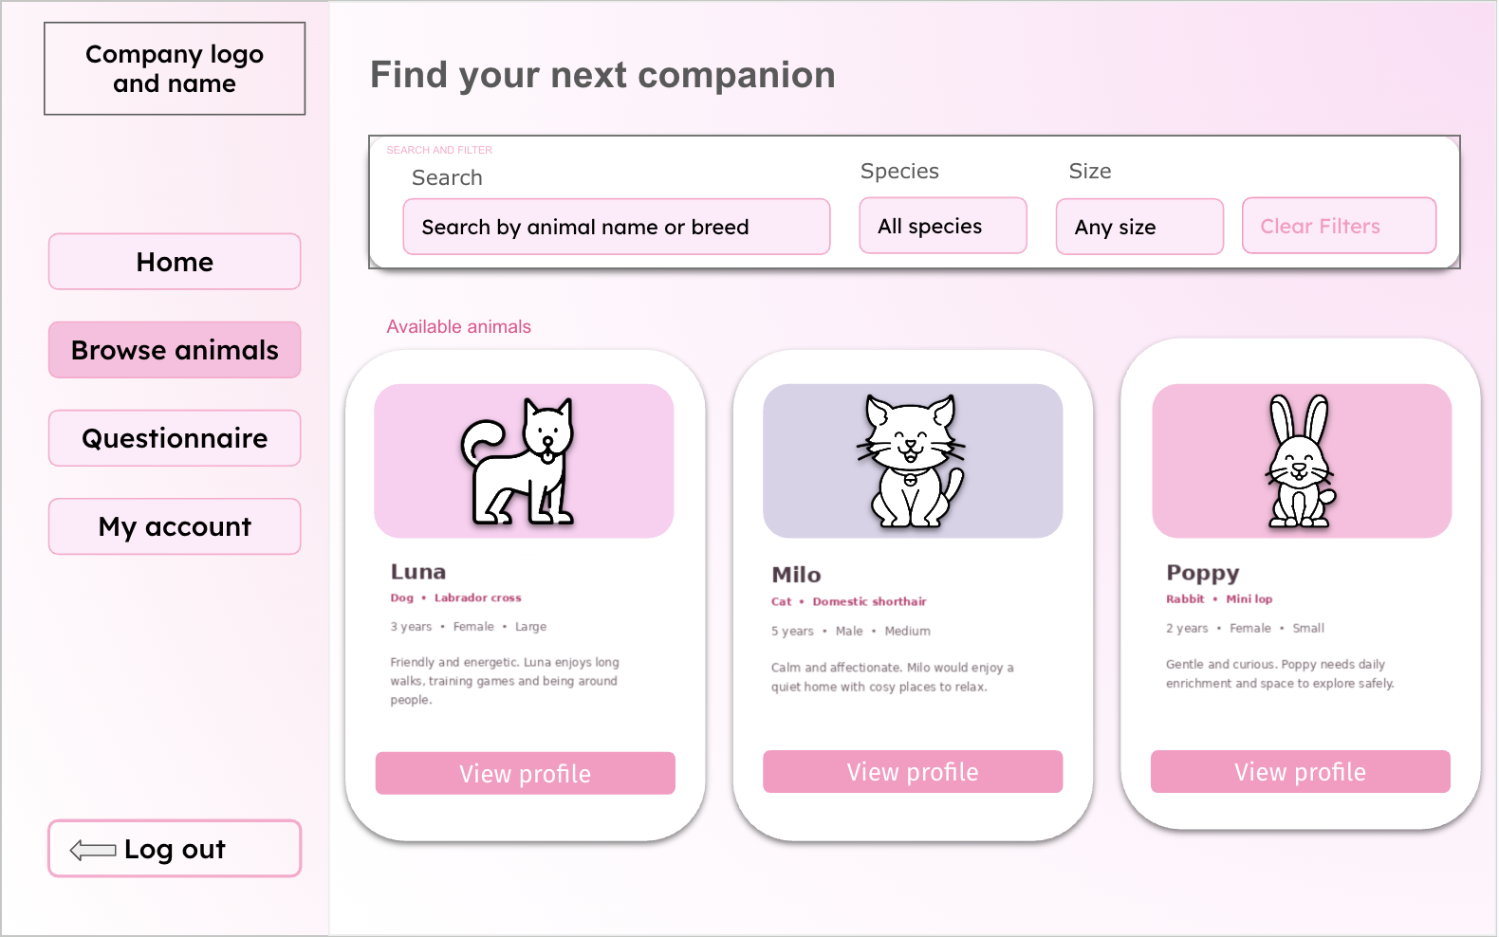
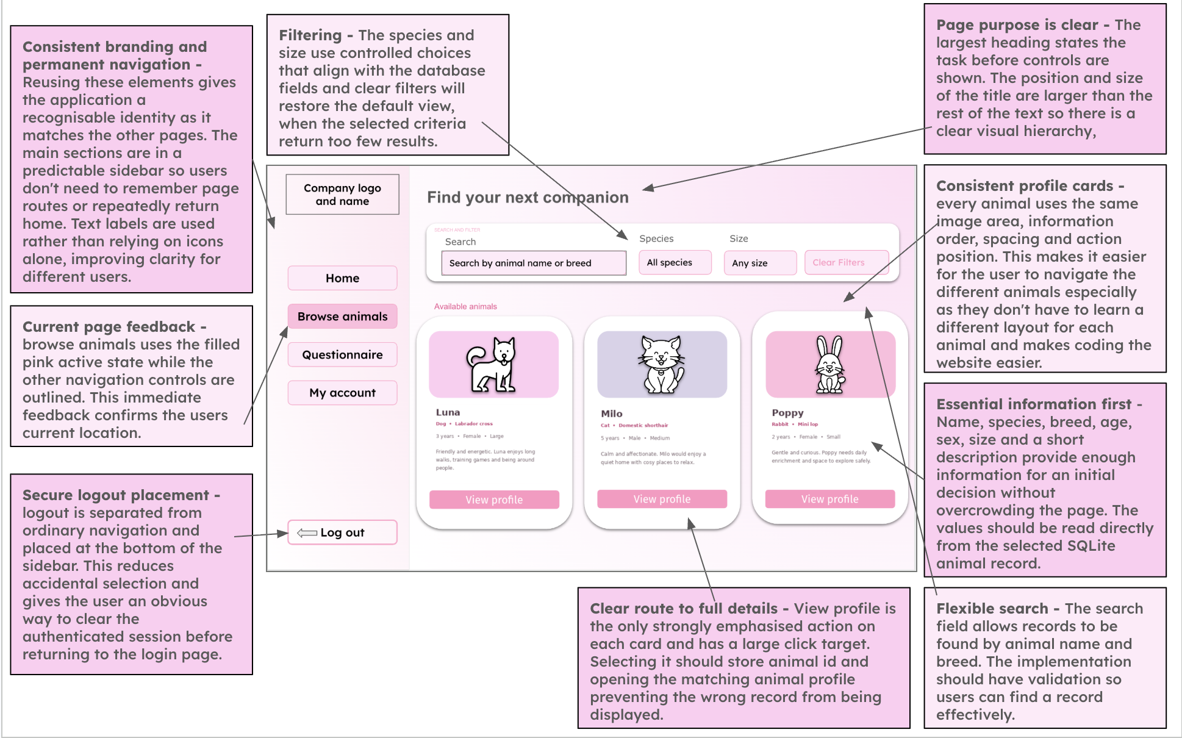
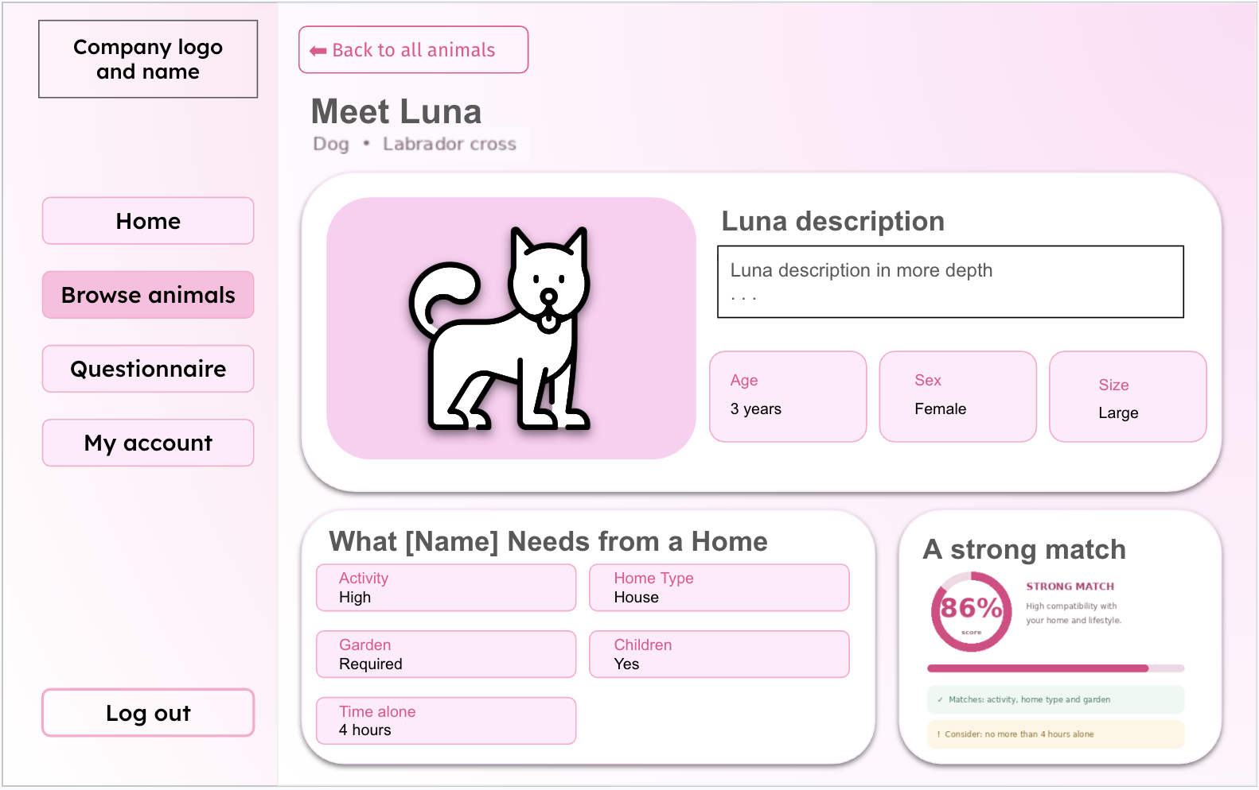
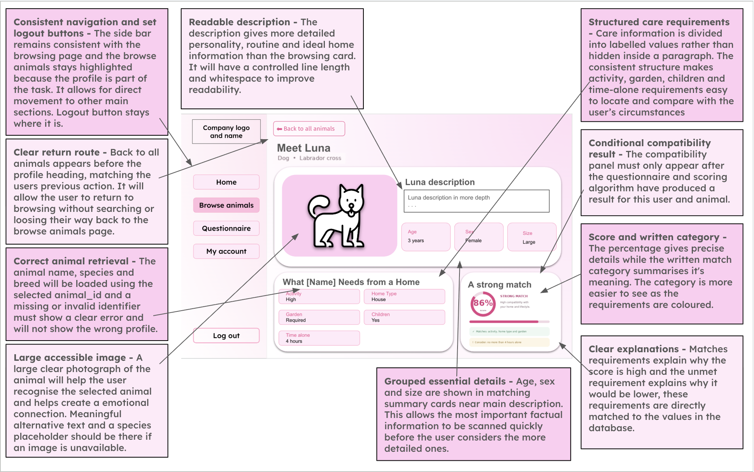

Algorithm (Flow chart, pseudocode)
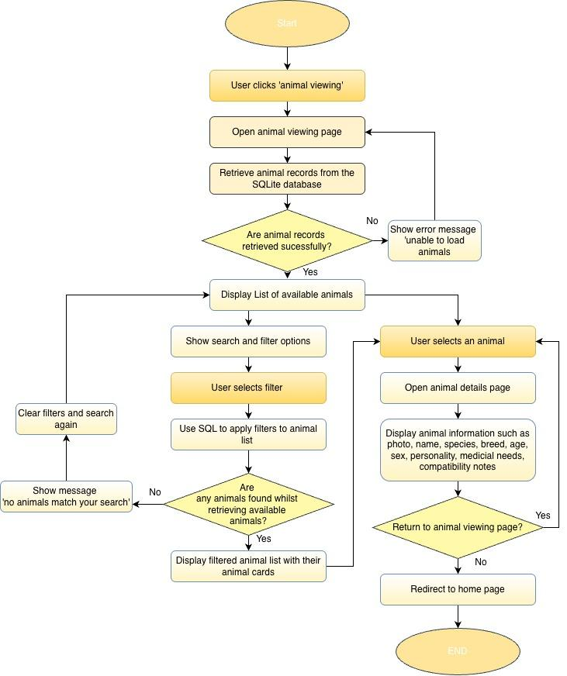

Pseudocode

search = input("Search by animal name")
species = input("Select Dog, Cat, Rabbit or All")

animals = search_animals(search, species)

if animals is None:

print("Unable to load animals.")

if retry_button_clicked:
open_page("Animal viewing")

elif len(animals) == 0:

print("No animals match your search.")

else:

for animal in animals:
show_animal_card(animal)

if animal_selected:

animal_id = selected_animal.animal_id
open_page("Animal details", animal_id)

if clear_filters_button_clicked:

search = ""
species = "All"
open_page("Animal viewing")

if home_button_clicked:

open_page("Homepage")

Variables

Variable Name | Data Type | Purpose | Justification | E.g or validation
search_term | String | Stores text entered into the search bar | A string allows users to search using names, breeds or other information | Leading and trailing spaces should be removed
species_filter | String | Filters animals by species | This is required to reduce the displayed records to animals matching the users chosen species | ‘Dog’, ‘cat’, ‘rabbit’ are the specified filters
size_filter | String | Filters animals by size | Size may affect whether an animal is suitable for the users home so it is suitable for narrowing the results | ‘Small’, ‘medium’, large’
sort_option | String | Determines the order of results | Users may wish to order the results by suitability or animal information. The value determines which sorting operation is applied. | ‘Compatibility’
animal_results | list | Holds the records returned from the database | A list is suitable because a search may return multiple animal records. It can be iterated through to generate animal cards on the interface | May be empty is no matching results
selected_animal_id | integer | Identifies the animal whose profile is opened | Using the unique id ensures the correct animal is retrieved even when animals have the same name | Must match an existing record
compatibility_score | float | Displays or sorts by compatibility | A float is a more suitable data type than an integer as it allows the result to include decimal values, which will produce a more precise % than an integer. | Between 0 and 100
no_results | boolean | Feedback displayed if there is any animals which meet the filters | Without feedback an empty page could appear to be an error, so the message informs the user that they should change the filters | ‘No animals match your search’

Validation

- Search input
- Length check: the text will not exceed 20 characters
- Whitespace check: leading and trailing spaces will be removed
- Empty input handling: an empty search will be treated as a request to display all available animals rather than as an error

- Filter inputs
Drop down menus or selection controls will be used for:
- Species
  - Dog
  - Cat
  - Rabbit
- Size
  - Small
  - Medium
  - Large

Check name | pseudocode
Search — remove surrounding spaces | search = search.strip()
Search — length check | if len(search) > 20:  errors.append("Search cannot exceed 20 characters.")
Species — lookup check | if species not in ["All", "Dog", "Cat", "Rabbit"]:  errors.append("Please select a valid species.")
Size — lookup check | if size not in ["All", "Small", "Medium", "Large"]:  errors.append("Please select a valid size.")

Compatibility algorithm and questionnaire

Questionnaire and Recommendations | Will use a form in order to allow users to answer questions about their home, lifestyle, experience and preferences. The questionnaire will have questions such as the housing type, access to garden, animal loneliness times, children, pets, experience, activity labels, what species and size preferred. These questions would not appear all at one time to not overwhelm the user and the input type would be drop downs or radio buttons. After submitting the questionnaire, the system will display compatibility scores almost immediately and recommended animals. It will also explain requirements the user does not meet. | Responses will be validated and compared with the requirements of each available animal. A weighted compatibility algorithm will calculate a percentage score for every animal. The animals will then be sorted from highest to lowest score so the top recommendations can be displayed. The questionnaire responses and match results may also be stored within the database with the users ID

Interface Design

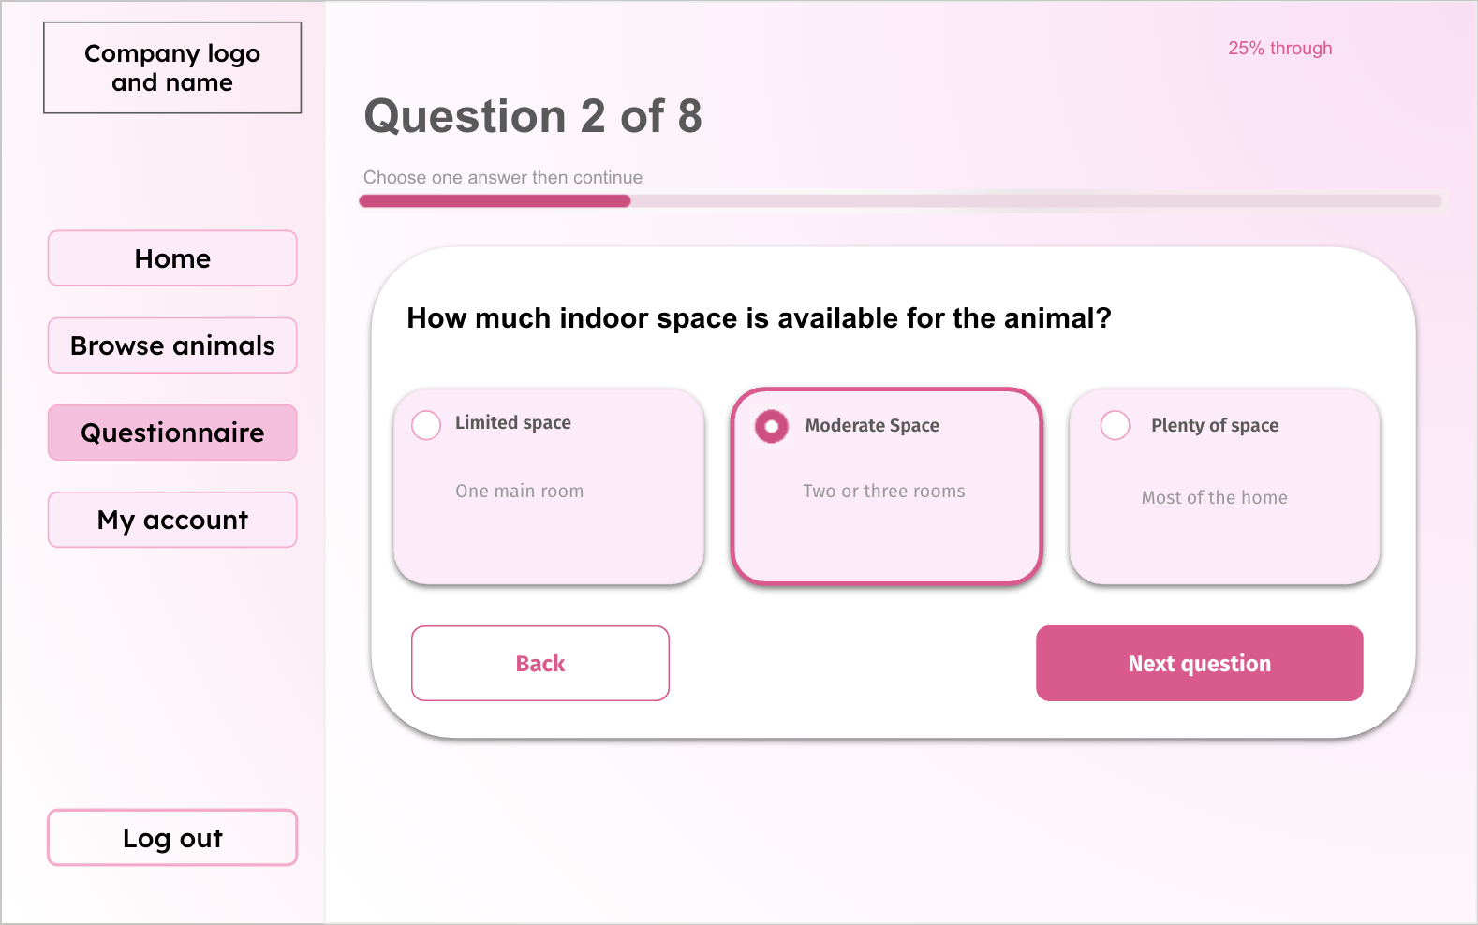
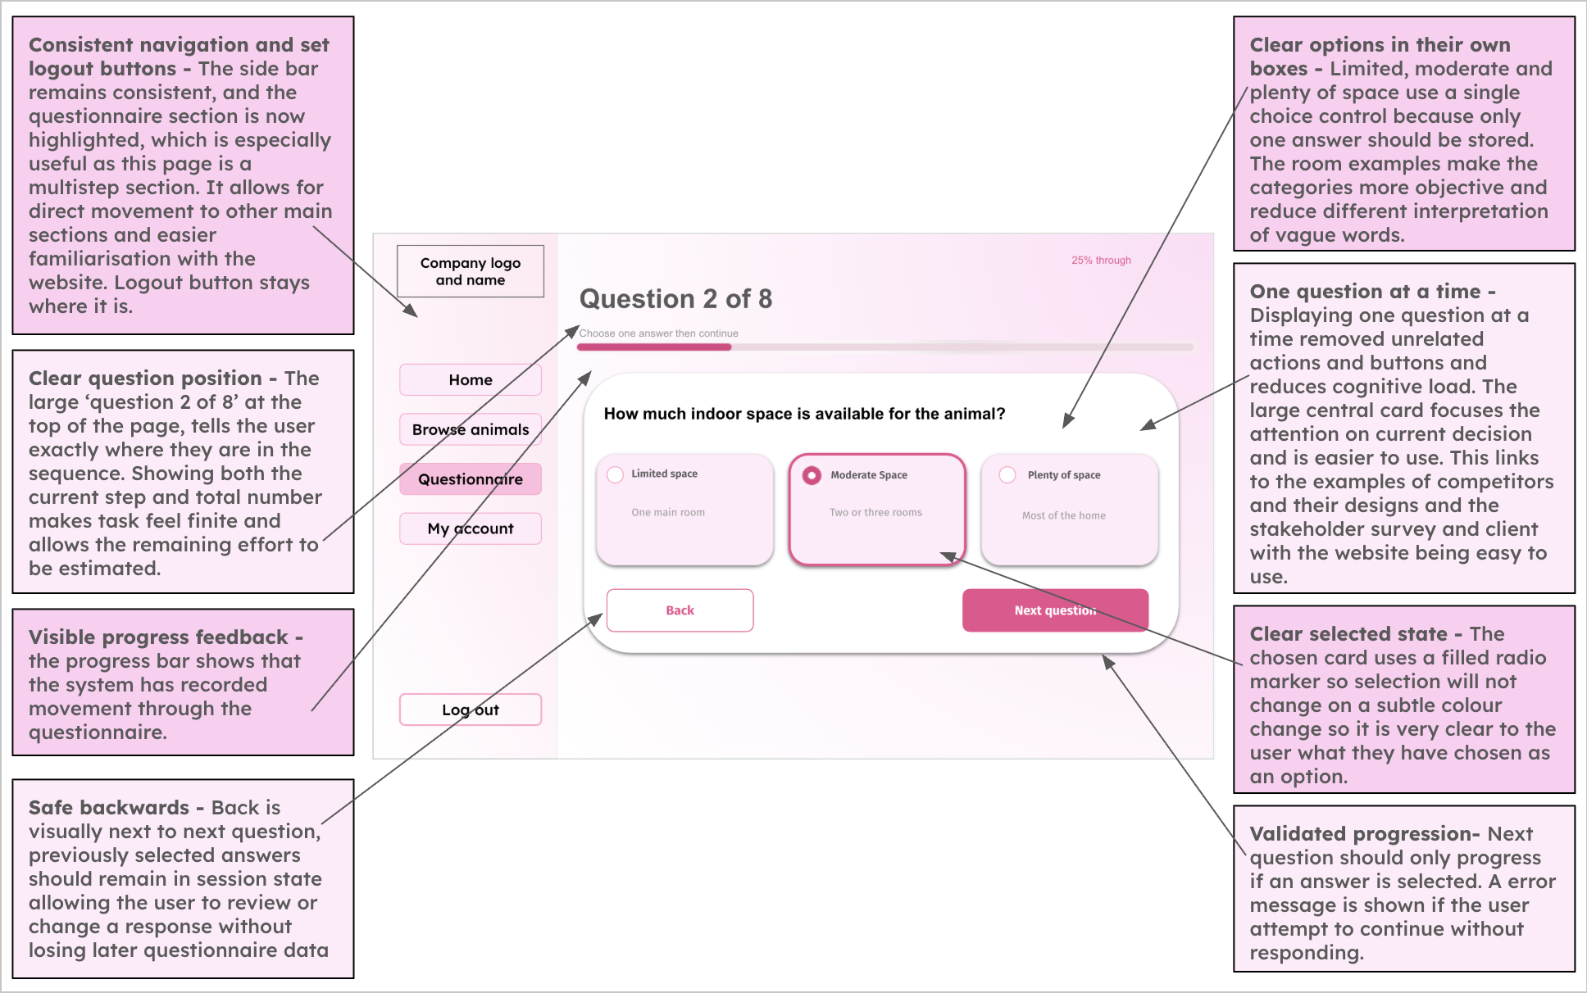
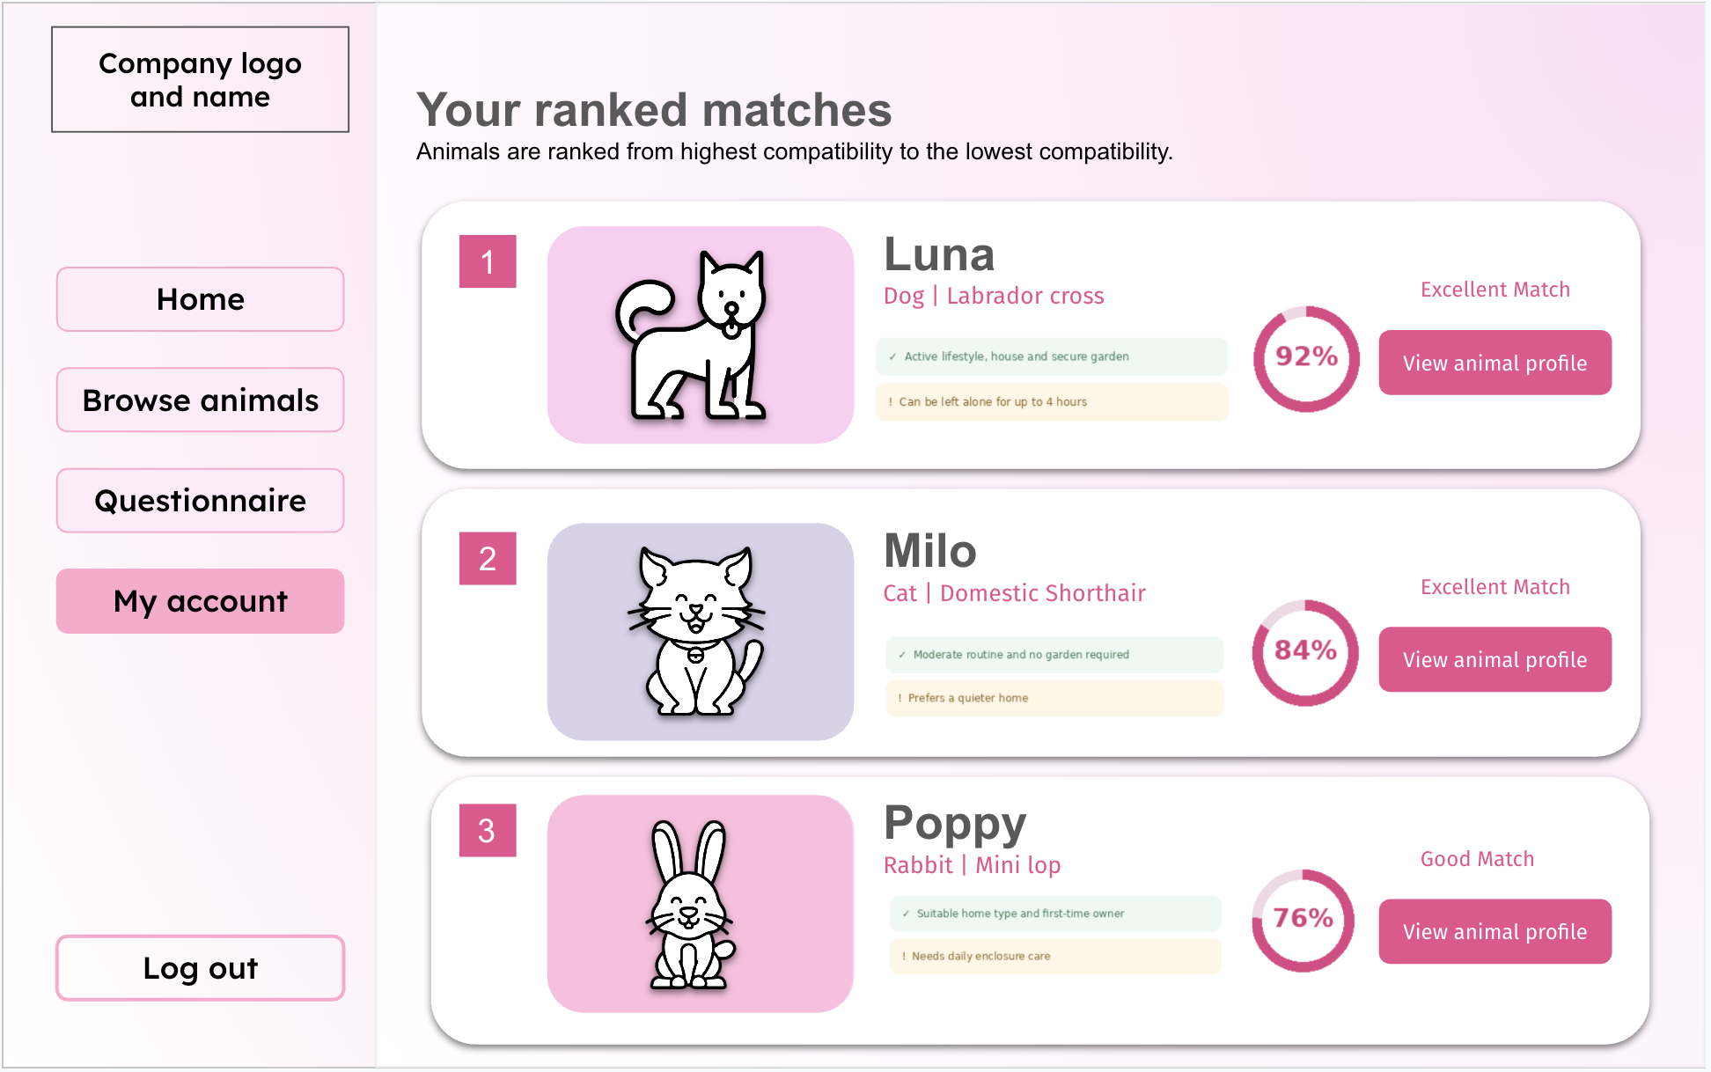
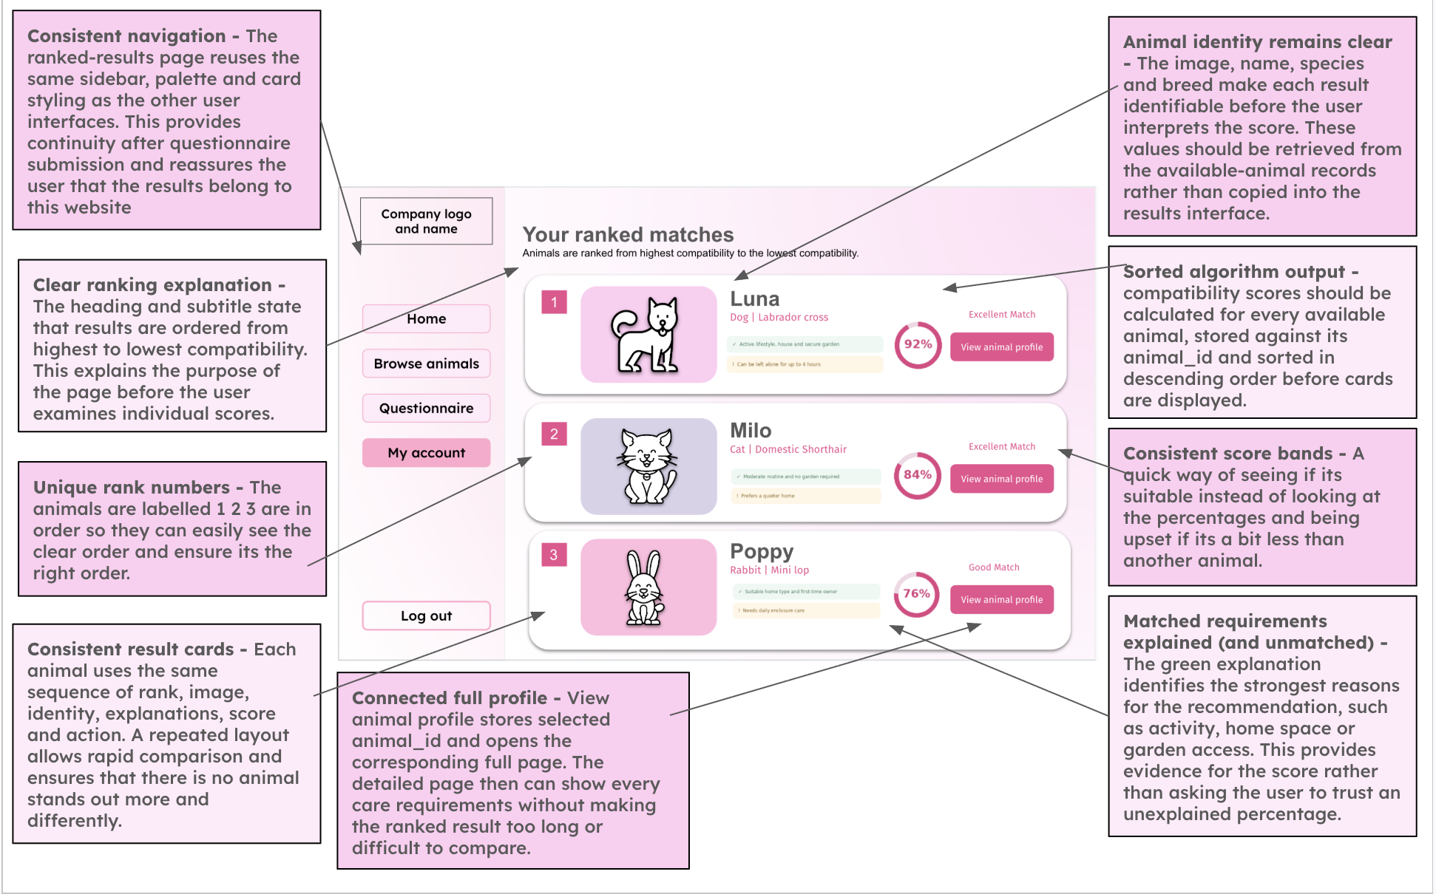

Algorithm (Flow chart, pseudocode)
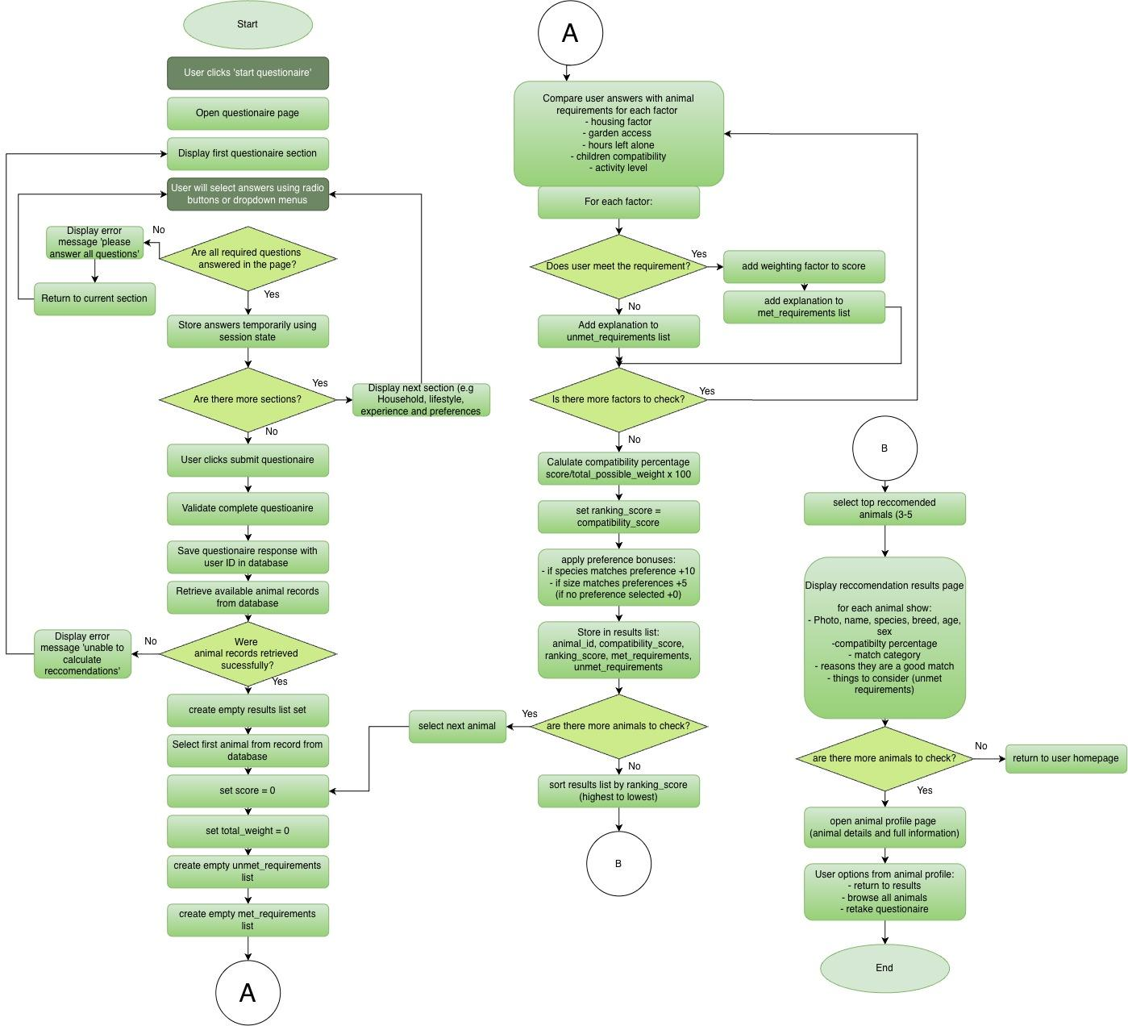
Pseudocode

answers = get_questionnaire_answers(user_id)
animals = get_available_animals()
maximum_score = 72
minimum_recommendation_score = 70

animal_scores = []
for animal in animals:
total_score = 0
unmet_requirements = []

# Hours left alone
if answers.hours_alone <= animal.maximum_hours_alone:
total_score += 20
else:
unmet_requirements.append("Animal would be left alone too long.")

# Children in the home
if answers.children == 0 or animal.child_compatibility == 1:
total_score += 15
else:
unmet_requirements.append("Animal is not suitable for a home with children.")

# Living space
if answers.living_space >= animal.minimum_housing:
total_score += 15
else:
unmet_requirements.append("Animal needs more living space.")

# Activity level
if answers.activity_level >= animal.exercise_need:
total_score += 12
else:
unmet_requirements.append("Animal needs more exercise than you can provide.")

# Garden access
if animal.garden_required == 0 or answers.garden_access == 1:
total_score += 10
else:
unmet_requirements.append("Animal requires access to a garden.")

# Convert the suitability score into a percentage
compatibility_score = (total_score / maximum_score) * 100

# Only include animals that reach the minimum score
if compatibility_score >= minimum_recommendation_score:

preference_score = 0

if answers.preferred_species == animal.species:
preference_score += 10

if answers.preferred_size == animal.size:
preference_score += 5

animal_scores.append({
"animal_id": animal.animal_id,
"name": animal.name,
"compatibility_score": compatibility_score,
"preference_score": preference_score,
"unmet_requirements": unmet_requirements
})
ranked_animals = sort(
animal_scores,
first="preference_score",
then="compatibility_score",
highest_first=True
)

if len(ranked_animals) == 0:
print("No animals currently meet the minimum recommendation score.")
else:
# Show up to five animals
for result in ranked_animals[:5]:
print(result["name"])
print(
"Compatibility:",
round(result["compatibility_score"], 1),
"%"
)
for requirement in result["unmet_requirements"]:
print(requirement)

Validation - questionnaire
- Housing type or housing level
- Presence check: The user must select an answer
- Lookup check: The answer must be one of the permitted housing options
- A radio button or drop-down will prevent unsupported values
1 = Flat or limited space
2 = Small or medium house
3 = Large house

- Garden access
- Presence check: Yes or No must be selected
- Boolean check: The stored result must be 1 or 0

- Hours the animal will be left alone
- Presence check : a value must be provided
- Type check : a whole number
- Range check : between 0 and 24 hours

- Children in the home
- Presence check: Yes or No must be selected
- Boolean check: The stored result must be 1 or 0

- Preferred activity level
- Presence check: an option must be selected
- Boolean check: The stored result must be 1, 2 or 3

After

- Preferred species
- Presence check: The user must select an answer
- Lookup check: The answer must be a dog, cat, rabbit or no preference

- Preferred size
- Presence check: The user must select an answer
- Lookup check: answer must be small, medium, large or no preference

Validation is necessary within this compatibility algorithm to ensure that the recommendations produced are reliable and that invalid data does not cause incorrect results.

Questionnaire Validation

Check name | pseudocode
Housing level — presence check | if living_space is None:  errors.append("Please select your housing level.")
Housing level — lookup check | if living_space is not None:  if living_space not in [1, 2, 3]:  errors.append("Select a valid housing level.")
Garden access — presence check | if garden_access is None:  errors.append("Please select Yes or No for garden access.")
Garden access — Boolean value check | if garden_access is not None:  if garden_access not in [0, 1]:  errors.append("Garden access must be Yes or No.")
Hours alone — presence check | hours_alone_input = hours_alone_input.strip()  if hours_alone_input == "":  errors.append("Please enter the hours left alone.")
Hours alone — type check | hours_alone = None  if hours_alone_input != "":  try:  hours_alone = int(hours_alone_input)  except ValueError:  errors.append("Hours alone must be a whole number.")
Hours alone — range check | if hours_alone is not None:  if hours_alone < 0 or hours_alone > 24:  errors.append("Hours alone must be between 0 and 24.")
Children — presence check | if children is None:  errors.append("Please answer whether children live in your home.")
Children — Boolean value check | if children is not None:  if children not in [0, 1]:  errors.append("Children in the home must be Yes or No.")
Activity level — presence check | if activity_level is None:  errors.append("Please select your activity level.")
Activity level — lookup check | if activity_level is not None:  if activity_level not in [1, 2, 3]:  errors.append("Select a valid activity level.")
Preferred species — presence check | if preferred_species is None:  errors.append("Please select a species or No preference.")
Preferred species — lookup check | if preferred_species is not None:  if preferred_species not in ["Dog", "Cat", "Rabbit", "No preference"]:  errors.append("Select a valid species option.")
Preferred size — presence check | if preferred_size is None:  errors.append("Please select a size or No preference.")
Preferred size — lookup check | if preferred_size is not None:  if preferred_size not in ["Small", "Medium", "Large", "No preference"]:  errors.append("Select a valid size option.")

Questionnaire Response table

Field | Data type | Key/validation
response_id | INTEGER | Primary key, auto increment
user_id | INTEGER | Foreign key linked to Users.userid
housing_level | INTEGER | Required range 1-3
garden_access | BOOLEAN | Required 0 or 1
hours_left_alone | INTEGER | Required valid range
has_children | BOOLEAN | Required 0 or 1
preferred_activity_level | INTEGER | Required range 1 - 3
preffered_species | TEXT | Required dog, cat, rabbit or no preference
preferred_size | TEXT | Required small, medium, large or no preference
completed_at | DATE | required

Match Results Table

Field | Data type | Key/validation
match_id | INTEGER | Primary key autoincrement
response_id | INTEGER | Foreign key linked to QuestionaireReponses.response_id
animal_id | INTEGER | Foreign key linked to animals.animal_id
compatibility_score | REAL | Required range 0 to 100
match_category | TEXT | Required strong, good, possible or low
unmet_requirements | TEXT | optional
Calculated_at | DATE | required

Adoption Questionnaire Variables

Variable Name | Data Type | Purpose | Justification | Validation or e.g
housing_level | integer | Stores amount of living space available | The available space may affect whether or not the home is suitable for different sizes and exercise needs | Required range 1-3
garden_access | boolean | Records whether user has access to a garden | Some animals may require regular access to an outdoor space. A boolean value is suitable as the answer has two possible values | 0 or 1
hours_left_alone | integer | Stores how long the animal would normally be left alone | Time availability can be numerically compared with the animals required attention and exercise time | Required valid range such as 0-24
has_children | boolean | Records whether children live in the household | Some animals may not be suitable for homes with children making this an important safety factor | 0 or 1
preferred_activity_level | integer | Stores the users preferred animal activity level | Matching activity level helps ensure the adopter can meet the animals exercise requirements | range 1 - 3
preffered_species | string | Stores the users preferred species | This ensures that the recommendations remain relevant to the type of animal the user is interested in adopting | Required ‘dog’, ‘cat’, ‘rabbit’ or ‘no preference’
preferred_size | string | Stores the users preferred size | The user may have practical or personal reasons for preferring a particular size. | ‘small’, ‘medium’, ‘large’ or ‘no preference’

Compatibility scoring algorithm variable names

Variable Name | Data Type | Purpose | Justification | Validation or e.g
animal_id | integer | Stores the unique identifier of the animal being assessed | It ensures that each calculated score is linked to the correct animal, even when animals have the same name | Must match an existing record in the animals table e.g 12
maximum_score | integer | Stores the highest possible number of points that can be awarded by the compatibility algorithm | This is required so that the user's raw score can be converted into a percentage. An integer is suitable because the algorithm awards whole number points for each matching factor. | Must be greater than 0
total_score | integer | Stores the total compatibility points awarded for the animal currently being assessed | The value begins at zero and increases whenever the user's answers from the questionnaire match an animal's requirements. It must be reset before the algorithm assesses the next animal. | Begins at 0 and cannot exceed maximum_score
animal_scores | list | Stores the ID and compatibility score for all available animals | This will allow the results to be sorted from highest to lowest compatibility. A list is suitable because the algorithm processes multiple animals | [{"animal_id": 3, "score": 92.5}, {"animal_id": 7, "score": 78.0}]
compatibility_score | float | Stores the calculated compatibility percentage | A percentage is easier for users to understand and compare than a raw points total, a float will allow decimal results to be stored. | Must be between 0-100 and can have decimals
match_category | string | Stores an understandable category for the calculated score | A category makes the numerical result easier for the user to interpret. It is selected according to predefined percentage ranges. | strong, good, possible or low
unmet_requirements | list | Stores explanations of requirements the user did not meet | There may be several reasons why an animal is not fully suitable so a list will allow multiple explanations to be stored and displayed. | Example: "Requires a secure garden", "Not suitable with cats". It may be empty when all essential requirements are met.

Questionnaire Plan

Section 1: House environment
- Amount of living space
- Garden access?

Section 2:
- Children in the home?

Section 3:
- Preferred activity level / time available for exercise and care
- Hours the animal would be left alone

Section 4:
- Preferred species
- Preferred animal size

Section 5:
- Submit

Where it links
- Amount of living space → minimum housing level
- Garden access → garden required
- Children in the home → child compatible
- Preferred activity level → exercise need
- Hours left alone → maximum hours left alone
- Preferred species → animal species
- Preferred size → animal size

First Matching part

Factor | Suggested weight (can be changed) | Justification
Hours Left alone | 20 | Strongly will affect whether the adopter can meet the animals needs
Child compatibility | 15 | Important for safety and suitability
Housing space | 15 | Ensures the home provides enough room
Activity | 12 | Matches exercise needs with users lifestyle and what they can provide
Garden access | 10 | Important for animals requiring outdoor access, but can even use a park so not as important factor

- Calculate the suitability score
- Remove animals with low suitability
- Prioritise animals matching users preferred species
- Prioritise animals matching users preferred size
- Sort remaining animals by suitability score
- Show top 3 or 5 (depending how many animals are in the system)

Factor | Suggested weight
Species | 10
Size | 5

However, these weights will not add to the compatibility percentage as their preferences do not reflect animal suitability. It will influence the order in which suitable animals are displayed. This will prevent an unsuitable animal from receiving a misleading high compatibility percentage as it matches the users preferences, but still ensuring preferred animals are presented as users top choices as this will make them more inclined to adopt. If the user picks ‘no preference’ no animal will receive a bonus.

Development Test Plan

