REVIEW COPY — yellow highlighting marks rewritten or added text. Highlighted IMAGE UPDATE REQUIRED notes identify words inside existing screenshots that must be revised in their source images before final submission.
Proposed Layout
The system can be decomposed into five main components. Separating the system into smaller components makes it easier to design, develop, test and maintain whilst each section performs a specific function.
Justification of the five-part decomposition
I separated PawMatch into authentication, the user homepage, administrator management, animal viewing, and the questionnaire/recommendation system because each solves a distinct task. Authentication establishes who can access records; the homepage connects user tasks; staff maintain the animal information through the admin system; the browsing system presents those records; and the questionnaire matches stored user answers to animal requirements. Development can therefore proceed from the shared database and authentication to animal management, browsing and finally matching, with each part tested individually before full-system testing.
Validation and SQLite database access are shared services, not extra user-facing systems. Validation runs before records are stored or changed in every relevant page, while shared database functions connect the pages through user_id, response_id and animal_id. This reduces duplicate code and helps keep all displayed records consistent.

Section | Front End Justification | Backend Justification
User/Admin Authentication | Will allow users to register and existing users to login, and allow admins to access their page safely and securely. Registration will collect the users name, email, age, and password. The interface should provide clear feedback when details are missing or forgotten from its validation system. It will also show an error message if login details are incorrect | The system will validate entered details, such as:  - email cannot be blank  - Password minimum 8 characters  - Required questions cannot be skipped  - Age must be a valid number  - Duplicate email addresses not allowed  The passwords will be hashed in order to be kept secure and safe. During login, enter details will be compared against records in the users table. A session will then be created when authentication is successful.  For the admin side, if the login details are incorrect it will not allow them access, which will stop unauthorised users from adding, editing or deleting animal records.
User Homepage/Main Menu | Will provide the main navigation area after the user logs in. It will allow the user to access the questionnaire, browse available animals and view their account. It will also explain the purpose of the adoption matching system. It will be clear and welcoming, and not overwhelming for the user. | The system will check the user's session to make sure they are logged in. It may retrieve the email and recent questionnaire information from the database so that personalised information can be displayed.
Administrator Menu | Provides staff with a dashboard to manage existing animals and their records. Admins will be clearly able to add new animals, edit existing details and remove records. To add animals it will store: Name, species, age, breed, sex, personality and exercise needs, children compatible, garden required, medical notes and an image. Forms will be clearly Labelled and display confirmation or error messages. | The system will check that the logged in account has the admin role before access is allowed. Parameterised SQL commands will insert, update and delete animal records. All inputs will be validated before changes are made to the database. A log out function will clear the admins session and return them to the login page, preventing another person using the same device which will prevent unwanted access to the database.
Animal Viewing | Allows users to browse available animals using clearly presented animal cards. Each card will show information such as the animal name, image, species, breed and age. Users will be able to select a card to view a more detailed animal profile. | Animal records will be retrieved from the animals table. Search and filter selections will be used to change the database query or filter the retrieved records. Selecting an animal will use its unique animal ID to load the correct profile.
Questionnaire and Recommendations | Will use a form in order to allow users to answer questions about their home, lifestyle, experience and preferences. The questionnaire will have questions such as the housing type, access to garden, animal loneliness times, children, activity levels, what species and size preferred. These questions would not appear all at one time to not overwhelm the user and the input type would be drop downs or radio buttons. After submitting the questionnaire, the system will display compatibility scores almost immediately and recommended animals. It will also explain requirements the user does not meet. | Responses will be validated and compared with the requirements of each available animal. A weighted compatibility algorithm will calculate a percentage score for every animal. The animals will then be sorted from highest to lowest score so the top recommendations can be displayed. The questionnaire responses and match results will be stored within the database linked to the correct user_id (user_id)
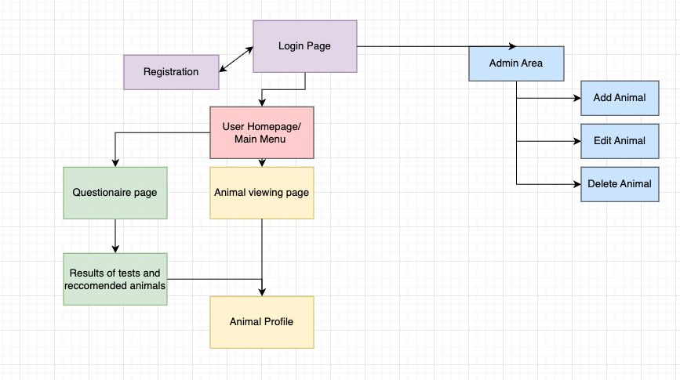

Database structure

Tables | Purpose
Users | Stores registered user and administrator account details
Animals | Stores animal profiles, care needs, adoption availability and matching requirements.
questionnaire_responses | Stores answers submitted by users
match_results | Stores calculated compatibility scores between responses and animals

Each submission creates a new questionnaire_responses record. One user may complete several questionnaires; each response may produce several match_results, one for each available animal checked. An animal may therefore occur in results for different users and questionnaire attempts. The latest response is used for current recommendations, while older attempts remain stored.
- Users 1 → Many Questionnaire responses
- Questionnaire responses 1 → Many match_results
- Animals 1 → Many match_results
Entity relationship diagram (key fields shown; full definitions appear in the data tables)
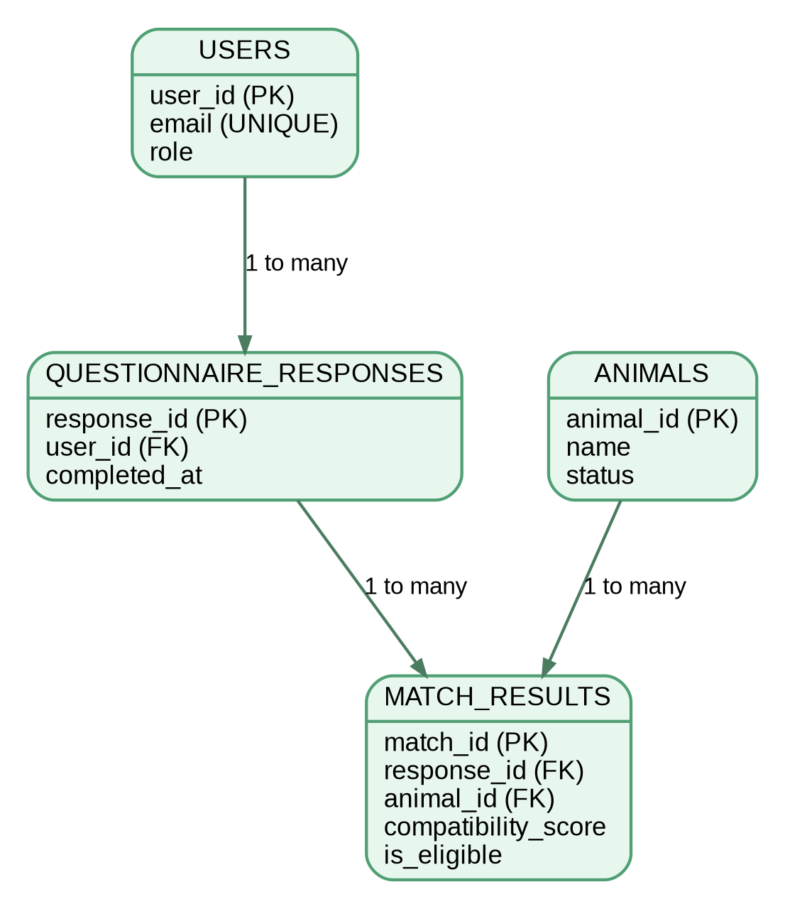
Implementation structure: separate Streamlit pages will handle Login/Registration, Home/My Account, Admin, Browse/Profile and Questionnaire/Results. Shared Python modules will contain input validation, parameterised SQLite queries and compatibility calculations. For example, the questionnaire page validates and saves responses, calls matching functions, and the results page displays the saved ranked matches. The five interfaces use shared functions rather than duplicating database logic.

Validation
All user entered data should be validated before it is processed or stored in the SQLite database. Streamlit controls such as dropdowns radio buttons and number inputs will restrict the range of values users can enter. However, the backend will still validate the submitted values because interface controls alone should not be relied on.

Login and Registration (incl database)

User/Admin Authentication | Will allow users to register and existing users to login, and allow admins to access their page safely and securely. Registration will collect the users name, email, age, and password. The interface should provide clear feedback when details are missing or forgotten from its validation system. It will also show an error message if login details are incorrect | The system will validate entered details, such as:  - email cannot be blank  - Password minimum 8 characters  - Required questions cannot be skipped  - Age must be a valid number  - Duplicate email addresses not allowed  The passwords will be hashed in order to be kept secure and safe. During login, enter details will be compared against records in the users table. A session will then be created when authentication is successful.  For the admin side, if the login details are incorrect it will not allow them access, which will stop unauthorised users from adding, editing or deleting animal records.

Interface Design
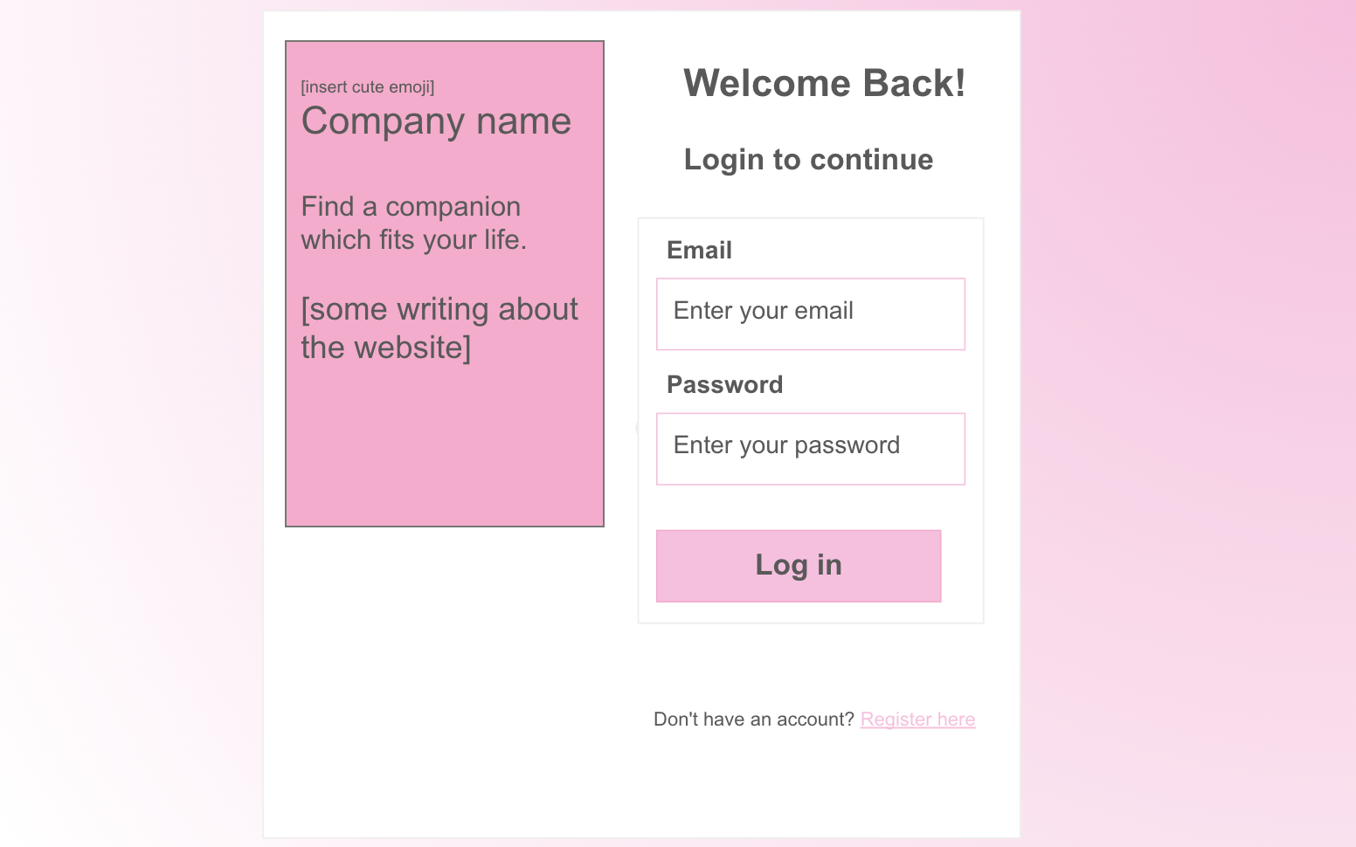
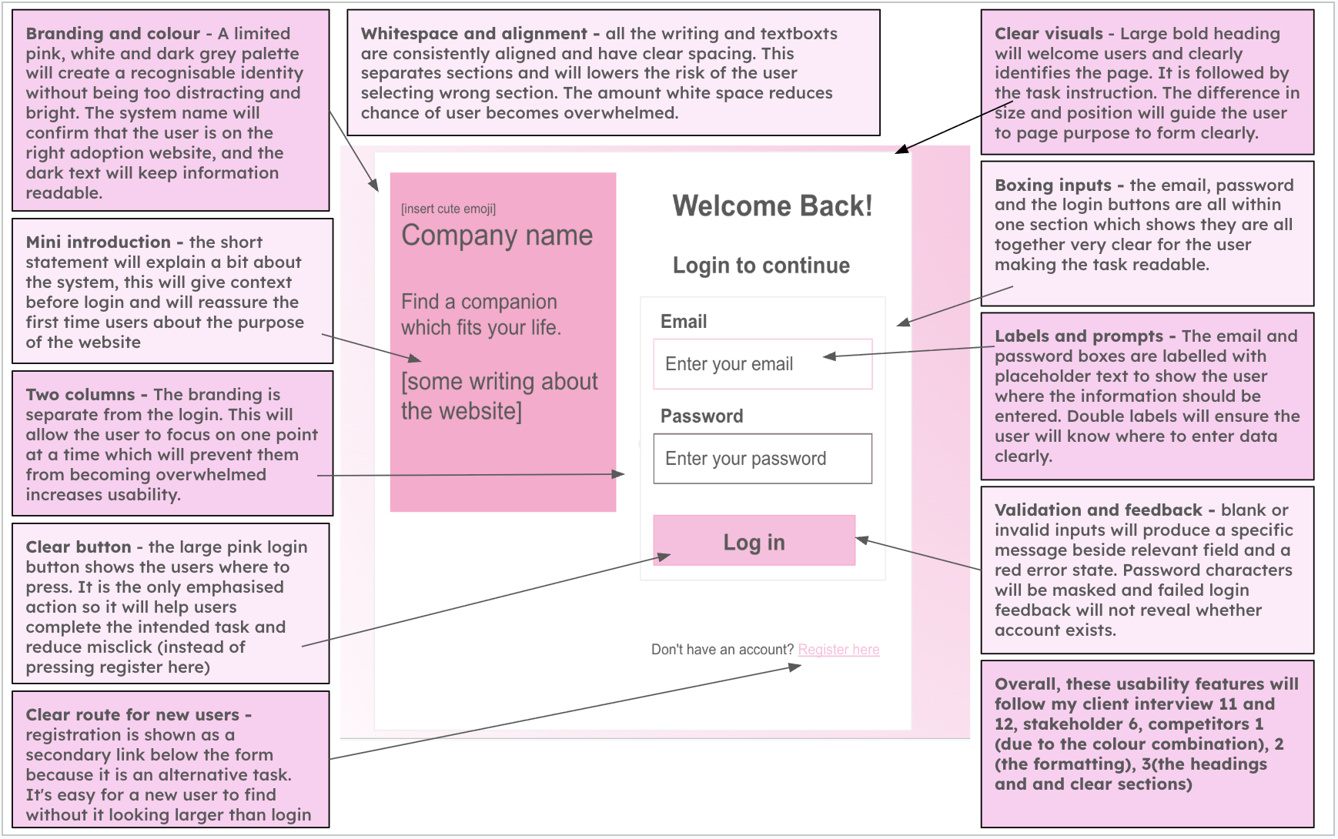
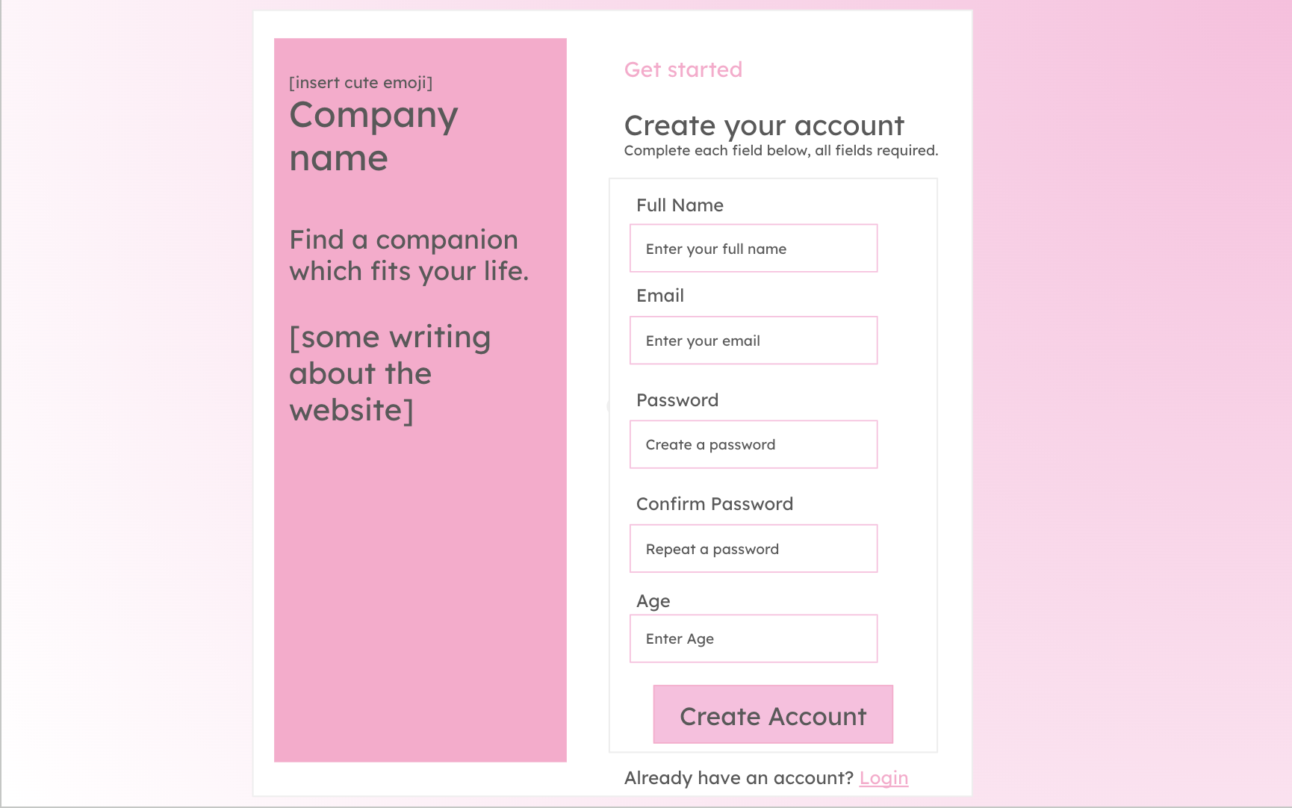
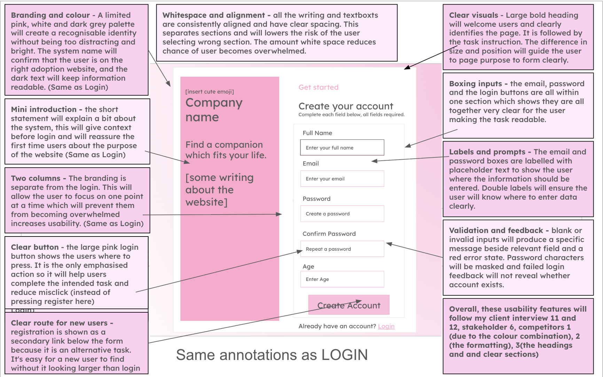

Algorithm (Flow chart, pseudocode)
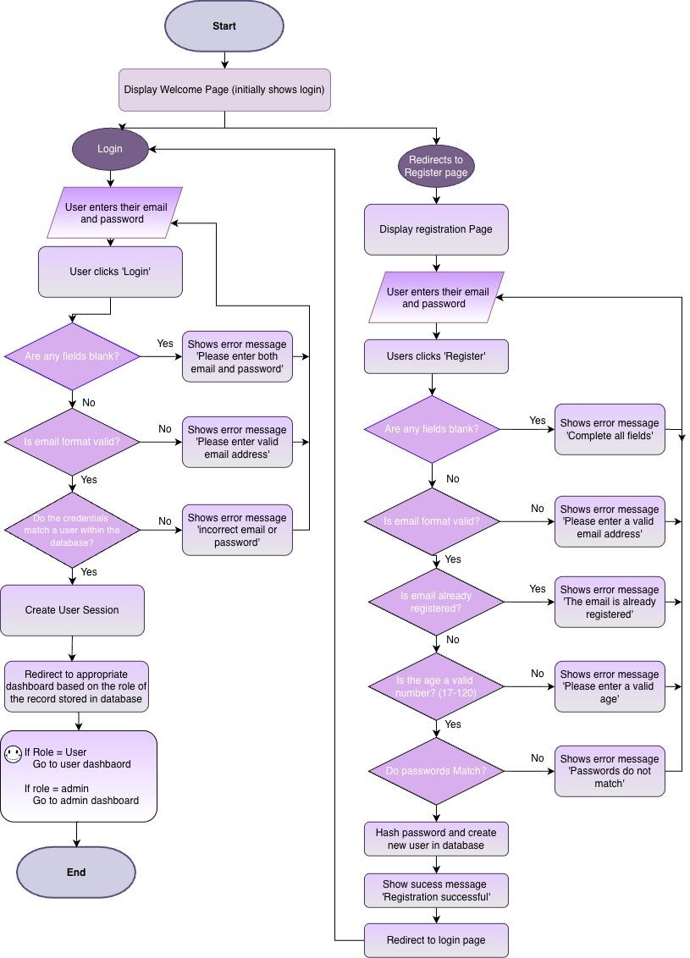
Pseudocode
Code for the Login

def login_page():
email = input_email()
password = input_password()
if login_button_clicked:
email = email.strip().lower()
errors = validate_login(email, password)
if errors is not empty:
for error in errors:
display_error(error)
else:
user = database.find_user_by_email(email)
if user does not exist:
display_error(
"Incorrect email or password"
)
elif verify_password(
password,
user.password_hash
) == False:
display_error(
"Incorrect email or password"
)
else:
create_user_session(
user.user_id,
user.name,
user.role
)
if user.role == "admin":
go_to_admin_dashboard()
else:
go_to_user_dashboard()

Code for the Registration

def registration_page():
name = input_name()
email = input_email()
age_input = input_age()
password = input_password()
confirm_password = input_confirm_password()
if register_button_clicked:
name = name.strip()
email = email.strip().lower()
errors = validate_registration(
name, email, age_input, password, confirm_password
)
if errors:
for error in errors:
display_error(error)
else:
password_hash = hash_password_argon2id(password)
database.create_user(
name, email, int(age_input), password_hash, role="user"
)
display_success("Registration successful")
go_to_login_page()

Database (Table structure)

Field | Data type | Key/validation
user_id | INTEGER | Primary key which will auto increment
name | TEXT | required
email | TEXT | Required and unique
age | INTEGER | required , valid range
password_hash | TEXT | required
role | TEXT | ‘user’ or ‘admin’
date_created | DATE | required

Variables

Variable Name | Data Type | Purpose | Justification | E.g or Validation
user_name | String | Stores the name entered during registration | This will allow the system to identify and personalise the account. A string would be required for the datatype as it will contain alphabetic characters and may include spaces and hyphens. | Cannot be blank
email | String | Will store users email address | It will be used as a unique identifier for logging in and contacting the user. It will contain letters and symbols so will be stored as a string. | Must follow a valid email format and be unique
age | integer | Stores the users age | It will be used to ensure the user meets any minimum age requirements. An integer is suitable for this variable as age is represented by a whole number. | Must be a valid positive number.
password | string | Temporarily stores the password entered by the password | It is needed to authenticate the user securely. Passwords usually contain letters, numbers and special characters, so a string is suitable for the data type. | Minimum of eight characters.
confirm_password | string | Stores the repeated password entered during registration | This allows the system to check that the user has mistyped their password before creating the account. | It will have to match password
password_hash | string | Stores the hashed version of the password | Passwords should not be stored as plain text. Storing the hash reduces the risk of passwords being exposed if the database is accessed without permission. | Argon2id encoded salted password hash; plaintext password is never stored
login_email | string | Stores the email entered on the login page | The variable is required so that the system can search for the corresponding account in the database | Cannot be blank
login_password | string | Temporarily stores the password entered during login | The entered password will be checked against the stored password hash in order to verify users identity | Cannot be blank
user_id | integer | Uniquely identifies the logged in user | An integer is efficient for use as a database primary key, it will allow records such as questionnaires and recommendations to be linked to the correct user. | It will be retrieved from the database after login
role | String | Stores whether the account is an administrator or a user | This variable is required for access control, so that normal users cannot access the administrator pages Controls access to the administrator area, although normal registrations should automatically receive the role ‘user’, the admin role should not be selectable from the registration form. | Will be stored as ‘user’ or ‘admin’
error_message | string | Stores the error message which will appear when the input or login details are invalid | My system will provide clear feedback and help the user understand what has gone wrong and how to correct it. A string will be suitable for this message as it contains many words in one sentence. | ‘Incorrect email or password, please retry’
is_authenticated | boolean | Records whether login attempt was successful | A boolean data type is suitable as authentication only has two possible values. | True or False

Validation
- Name
- Presence check: Field cannot be empty or contain only spaces
- Length check: name must be between 2 and 50 characters
- Whitespace check: spaces at beginning and end will be removed

- Email address
- Presence check: Field cannot be empty or contain only spaces
- Format check: value must contain a @ and domain
- Uniqueness check: a database query will check the address not already registered
- Whitespace check: spaces at beginning and end will be removed
- Check characters: convert all to lower case

- Age
- Presence check: Field cannot be empty or contain only spaces
- Type check: data must be a whole number
- Range check: age must be 18+

- Password
- Presence check: Field cannot be empty or contain only spaces
- Length check: password must contain at least 8 characters.
Password security: Argon2id will hash each password using a unique randomly generated salt. The encoded salted hash, not the plaintext password, will be stored; login verifies the supplied password against that hash.
Registration
- Confirmation check: the confirmation field must exactly match original password
- Security processing: the valid password will be hashed before it is inserted into the database and the original password will never be stored.
Login
- The password will be checked against the stored password hash rather than compared as plain text.

Registration outcome
- The account will be created if every field passes validation, individual messages will be shown if one or more fields are invalid.

Session check
- A session will only be created after successful authentication. Invalid information will leave users on the login page and will not allow them to access the user or admin page.

Validation Pseudocode

Check name | pseudocode
- Name — presence check | - if name == "":  - errors.append("Name cannot be blank.")
- Name — length check | - if name != "":  - if len(name) < 2 or len(name) > 50:  - errors.append("Name must be between 2 and 50 characters.")
- Email — presence check | - if email == "":  - errors.append("Email cannot be blank.")
- Email — format check | - email_valid = valid_email_format(email)  - if email != "" and not email_valid:  - errors.append("Enter a valid email address.")
- Email — uniqueness check | - if email_valid:  - user = database.find_user_by_email(email)  - if user is not None:  - errors.append("Email is already registered.")
- Age — presence check | - age_input = age_input.strip()  - if age_input == "":  - errors.append("Age cannot be blank.")
- Age — type check | - age = None  - if age_input != "":  - try:  - age = int(age_input)  - except ValueError:  - errors.append("Age must be a whole number.")
- Age — range check | - if age is not None:  - if age < 18:  - errors.append("You must be at least 18 years old.")
- Password — presence check | - if password.strip() == "":  - errors.append("Password cannot be blank.")
- Password — length check | - if password.strip() != "":  - if len(password) < 8:  - errors.append("Password must contain at least 8 characters.")
- Password — confirmation check | - if confirm_password == "":  - errors.append("Please confirm your password.")  - elif confirm_password != password:  - errors.append("Passwords do not match.")

Admin Page

Administrator Menu | Provides staff with a dashboard to manage existing animals and their records. Admins will be clearly able to add new animals, edit existing details and remove records. To add animals it will store: Name, species, age, breed, sex, personality and exercise needs, children compatible, garden required, medical notes and an image. Forms will be clearly Labelled and display confirmation or error messages. | The system will check that the loginned in account has the admin role before access is allowed. Parameterised SQL commands will insert, update and delete animal records. All inputs will be validated before changes are made to the database. Will also include a logout function, to securely log out so no physical access to the system unless its an admin.
Interface
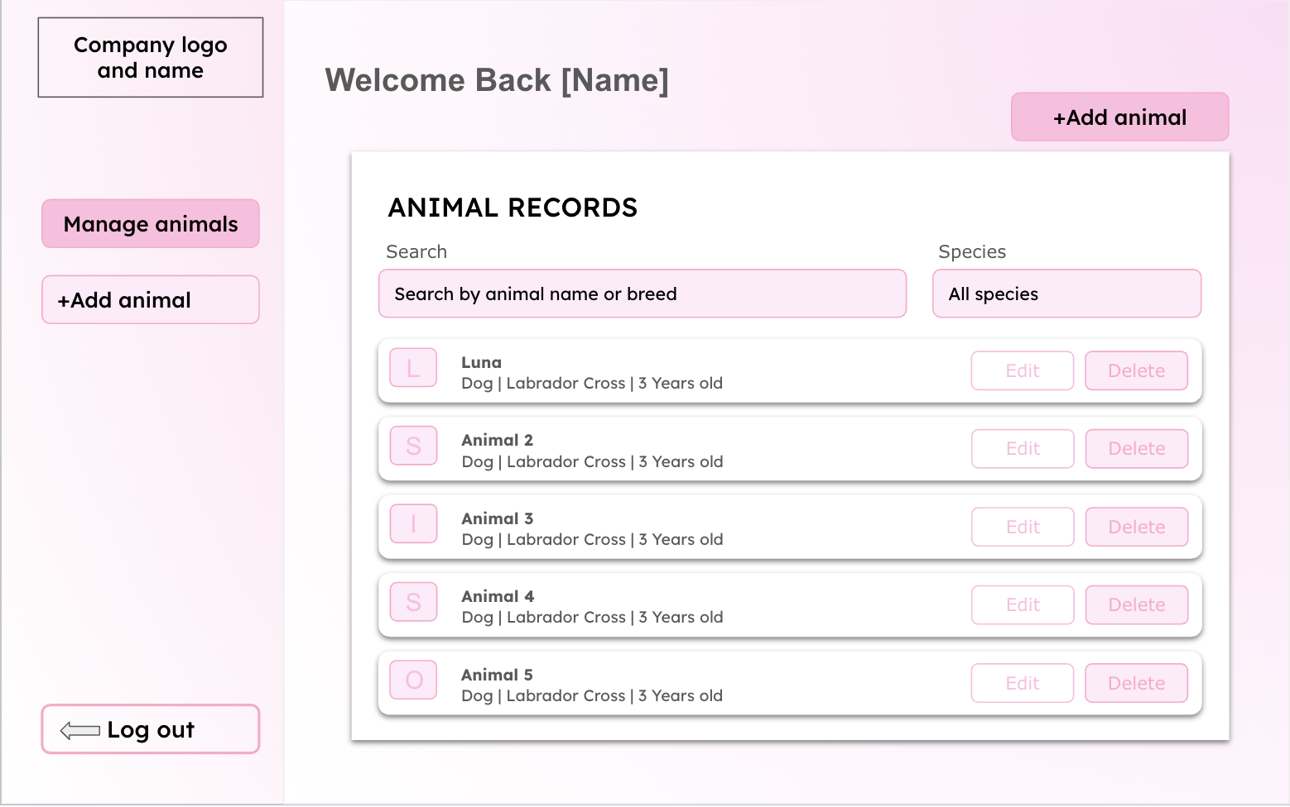
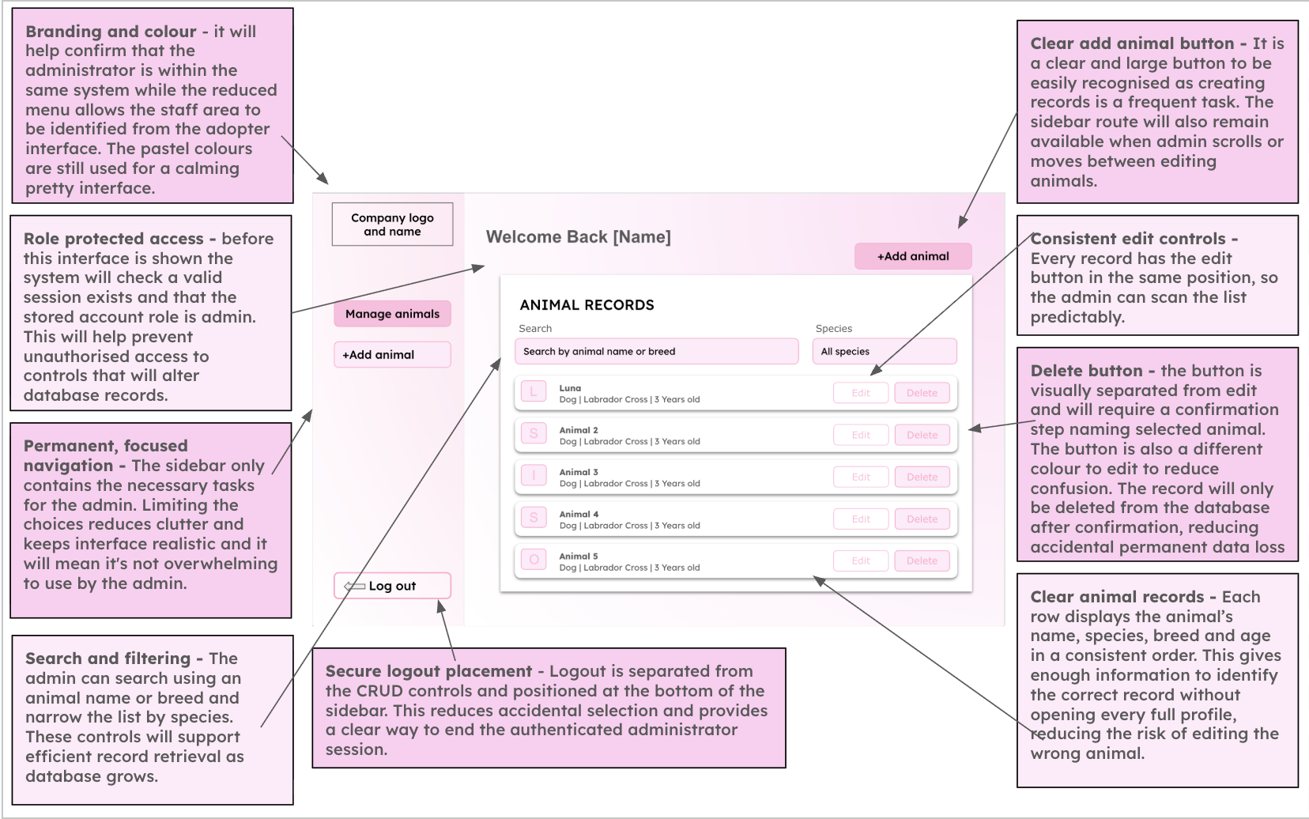
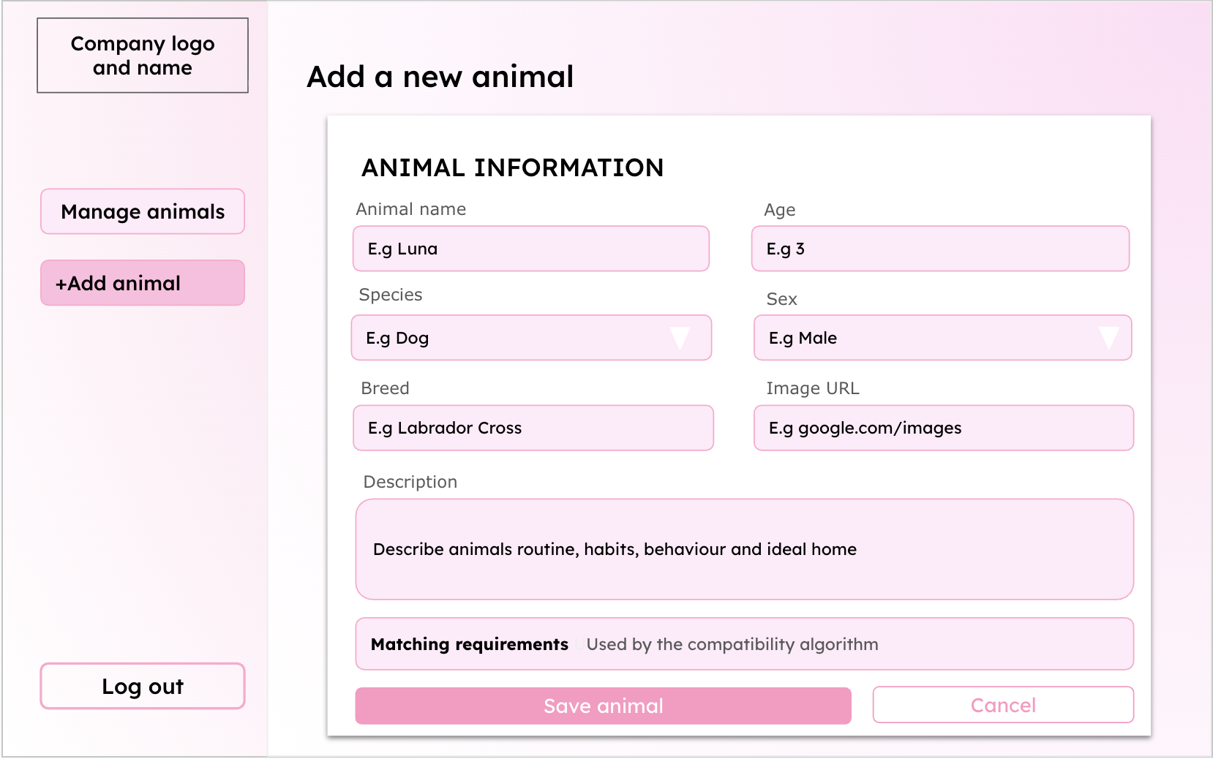
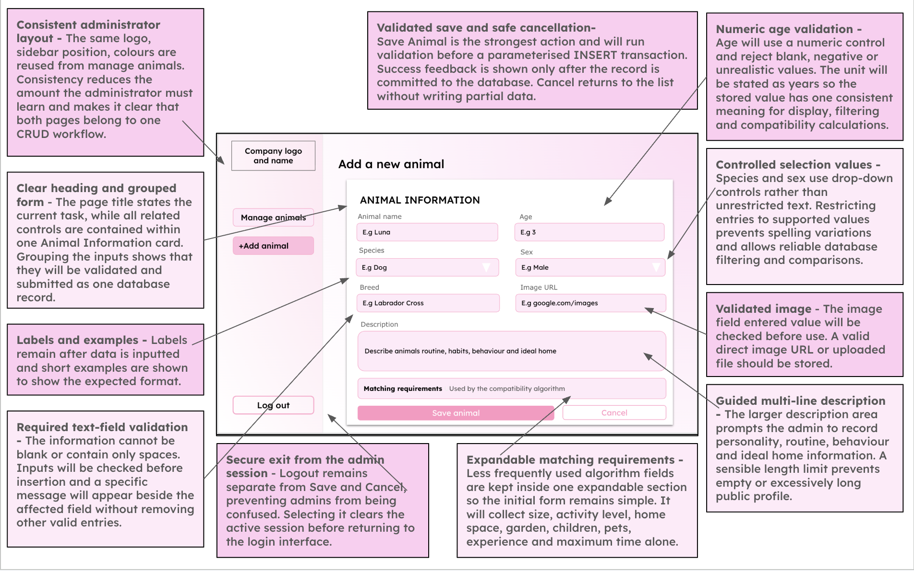
IMAGE UPDATE REQUIRED (embedded artwork): change "Image URL" on the add-animal form to "Upload animal photo" to match the planned JPG/JPEG/PNG file validation. Keep all existing colours and layout.

Pseudocode
Admin Page
# Read logged_in and role from the authenticated session
if not logged_in or role != "admin":
display_error("Admin access required")
open_page("Login")
else:
search_term = input("Search by animal name or breed")
species_filter = select("All, Dog, Cat, Rabbit")
animals = find_animals(search_term, species_filter)
display_animals(animals)
choice = select_action("Add, View, Edit, Delete, Logout")
if choice == "Add":
details = input_animal_details()
errors = validate_animal(details)
if errors:
display_errors(errors)
else:
add_animal(details)
display_success("Animal added successfully")
elif choice == "View":
animal_id = select_animal_id(animals)
display_animal(get_animal(animal_id))
elif choice == "Edit":
animal_id = select_animal_id(animals)
details = edit_existing_details(get_animal(animal_id))
errors = validate_animal(details)
if errors:
display_errors(errors)
else:
update_animal(animal_id, details)
display_success("Animal updated successfully")
elif choice == "Delete":
animal_id = select_animal_id(animals)
if confirm("Delete this animal?"):
delete_animal(animal_id)
display_success("Animal deleted successfully")
elif choice == "Logout":
if confirm("Log out?"):
clear_session()
open_page("Login")

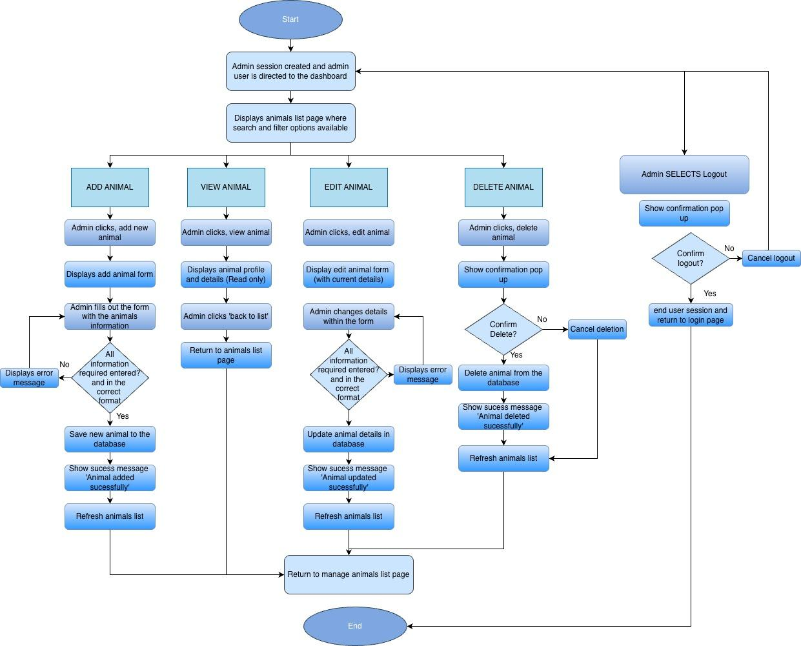

Animal Table
Field | Data type | Key/validation
animal_id | INTEGER | Primary key, autoincrement
name | TEXT | required
species | TEXT | Required - dog, cat or rabbit
breed | TEXT | Required
age | REAL | Required REAL value; 0 < age <= 40 years (for example 0.5).
sex | TEXT | required- male, female or unknown
size | TEXT | Required - small medium or large
personality | TEXT | required
exercise_needs | INTEGER | Required - 1 to 3
recommended_housing_level | INTEGER | Required - 1 to 3
garden_required | BOOLEAN | Required 0 or 1
child_compatible | BOOLEAN | Required 0 or 1
max_hours_left_alone | INTEGER | required
medical_notes | TEXT | optional
image | TEXT | Required, an image path
date_added | DATE | required
status | TEXT | Required: Available or Adopted; default Available. Only Available records are matched.

Variables

Variable Name | Data Type | Purpose | Justification | Validation or e.g
animal_id | INTEGER | Uniquely identifies each animal record | A unique integer stops confusion between animals with similar names and allows the correct to be updated and deleted | Automatically generated
name | string | Stores the animals name | The name is required to identify the animal throughout the interface and allows the user to remember the animal with a specific name. A string is suitable as it allows letters spaces and punctuation. | Can’t be blank
species | string | Stores the type of animal | Species is required for searching, filtering and matching against user preferences. | dog, cat or rabbit
breed | string | Stores the animals breed | Breeds provides users with important information and may help describe likely size or care requirements | Can't be blank or might be ‘unknown’
age | float | Stores the animals age | A float permits decimal ages such as 0.5 years for a six-month-old animal and supports numeric sorting and validation. | Greater than 0 and at most 40 years; e.g. 0.5 for six months.
sex | string | Stores the animals sex | This is relevant profile information and may be considered by the potential adopters | male, female, unknown
size | string | Stores the animals size and is used in filtering | Size affects space requirements and is needed by the filtering and compatibility systems | small medium or large
personality | string | Stores a description of the animals behaviour and personality | A text field will allow the admin to explain the animals personality and background in more detail to help attract possible adopters | Cant be blank but a character limit may be applied
exercise_needs | INTEGER | Stores whether the animal has low, medium or high exercise needs | This can be compared with the adopters lifestyle to produce a more appropriate compatibility score. An integer is suitability for easier comparison | 1 to 3 (low medium or high)
recommended_housing_level | INTEGER | Records the recommended amount of housing space (level 1–3) for the animal. This is a weighted matching factor, not a compulsory exclusion rule. | This can be compared with adopters lifestyle to aid the algorithm when creating the compatibility score | 1 to 3
garden_required | boolean | Records whether the animal requires access to a garden | Garden access is a compulsory requirement whenever the animal requires a garden. A Boolean makes the condition easy to check. | True or false
child_compatible | boolean | Records whether the animal is suitable for a household with children | There are only two options which make boolean values suitable. This is very important for the safety and welfare of the children and animals. | True or false
max_hours_left_alone | INTEGER | Stores value for which the animal can be left home alone for, and representing if more independent or clingy | This is important if a user works long hours and the animal requires a lot of attention it may cause neglect of the animal which is a key issue we are trying to prevent. | Cant be blank
medical_notes | string | Stores any medical conditions, treatments or special requirements | Potential adopters need to understand any medical needs before making a decision. A string will allow multiple to be described. | May be blank or ‘N/A’
image | string | Stores the location of the animals image | This allows the correct photo to be displayed without storing the full image directly in database | Must use an accepted file extension
form_action | string | Stores the operation the admin is performing | The same form may be used for adding and editing variables. This variable will allow the program to select the right query. | ‘Add’ or ‘edit’ or ‘delete’ or ‘view’
delete_confirmation | boolean | Records whether the administrator has confirmed deletion | Deletion is permanent so confirmation reduces risk of animal being removed accidentally and not being considered for adoption | True or false
record_found | boolean | Records whether the database has retrieved the animal record successfully | This prevents the program from attempting to edit or delete a record not present in the database | True or false
status | string | Stores whether the animal is currently available for adoption. | The matching algorithm must exclude already adopted animals. | Available or Adopted; defaults to Available.

Validation

- Animal name
- Presence check: Cannot be empty
- Length check: Between 2 and 50 characters.
- Format check: Letters, spaces, apostrophes, hyphens and appropriate numbers may be allowed
- Species
- Presence check: Must be selected.
- Lookup check: Must be Dog, Cat or Rabbit.
- A drop-down menu will restrict the choices.
- Breed
- Presence check: Cannot be empty
- Length check: between 2 and 50 characters
- Format check: Must not consist entirely of unsupported symbols

Age
- Presence check: Must be provided
- Type check: Must be a number; decimals are accepted (e.g. 0.5 years).
- Range check: Greater than 0 and no more than 40 years.
- Sex
- Lookup check: Must be Male, Female or Unknown
- A drop-down menu prevents invalid values

Size
- Lookup check: Must be Small, Medium or Large

Personality
- Presence check: A description must be provided
- Length check: For example, between 20 and 1,000 characters
- Whitespace check: A value consisting only of spaces will be rejected

Exercise need
- Presence check: An option must be selected
- Range check: Must be between 1 and 3

Recommended housing level
- Presence check: Must be selected
- Range check: Must be between 1 and 3

Maximum hours alone
- Type check: Must be an integer
- Range check: Must be between 0 and 24

Garden required
- Type check: Must be stored as a Boolean value 0 or 1
- Child compatibility
- Type check: Must be stored as a Boolean value 0 or 1
- Medical notes
- This field may be optional
- Type check: it will have a maximum length
- Text will be stored as plain text rather than interpreted as code
- Animal image
- Presence check: An animal image must be uploaded for every profile. The database stores its saved file path.
- File-type check : Only approved formats such as JPG, JPEG and PNG will be accepted
- File-size check : The file must not exceed the chosen maximum size
- Filename handling : A safe, unique filename will be generated to avoid overwriting existing images
The animal record will only be inserted after all required fields pass validation. The SQL statement will be parameterised and committed only after successful validation. A success message will then confirm that the record has been created.
The admin form will use a file uploader restricted to JPG/JPEG/PNG images; the image will be checked, saved with a unique filename and its path stored in the Animals table. Status defaults to Available and may be changed to Adopted during editing. When an animal is edited or deleted, later recommendation views will be recalculated from the current available records.
Validation Pseudocode

Check name | pseudocode
- Animal name — presence check | - animal_name = animal_name.strip()  - if animal_name == "":  - errors.append("Animal name cannot be blank.")
- Animal name — length check | - if animal_name != "":  if len(animal_name) < 2 or len(animal_name) > 50:  errors.append("Animal name must be between 2 and 50 characters.")
- Animal name — format check | - for character in animal_name:  - if not character.isalnum() and character not in " '-":  - errors.append("Animal name contains an unsupported character.")  - break
- Species — presence check | - if species is None:  - errors.append("Please select a species.")
- Species — lookup check | - if species is not None:  - if species not in ["Dog", "Cat", "Rabbit"]:  - errors.append("Species must be Dog, Cat or Rabbit.")
- Breed — presence check | - breed = breed.strip()  - if breed == "":  - errors.append("Breed cannot be blank.")
- Breed — length check | - if breed != "":  - if len(breed) < 2 or len(breed) > 50:  - errors.append("Breed must be between 2 and 50 characters.")
- Breed — format check | - contains_text = False  - for character in breed:  - if character.isalnum():  - contains_text = True  - if breed != "" and contains_text == False:  - errors.append("Breed cannot contain only symbols.")
- Animal age — presence check | - age_input = age_input.strip()  - if age_input == "":  - errors.append("Please enter the animal's age.")
- Animal age — type check | - animal_age = None  - if age_input != "":  - try:  - animal_age = float(age_input)  - except ValueError:  - errors.append("Animal age must be a number.")
- Animal age — range check | - if animal_age is not None:  - if animal_age <= 0 or animal_age > 40:  - errors.append("Animal age is outside the allowed range.")
- Sex — lookup check | - if sex not in ["Male", "Female", "Unknown"]:  - errors.append("Select Male, Female or Unknown.")
- Size — lookup check | - if size not in ["Small", "Medium", "Large"]:  - errors.append("Select Small, Medium or Large.")
- Personality — presence check | - if personality == "":  - errors.append("Please enter a personality description.")
- Personality — length check | - if personality != "":  - if len(personality) < 20 or len(personality) > 1000:  - errors.append("Personality must be between 20 and 1,000 characters.")

Check name | Python-style pseudocode
- Exercise need — presence check | - if exercise_needs is None:  - errors.append("Please select an exercise need.")
- Exercise need — range check | - if exercise_needs is not None:  - if exercise_needs < 1 or exercise_needs > 3:  - errors.append("Exercise need must be between 1 and 3.")
- Recommended housing — presence check | - if recommended_housing_level is None:  errors.append("Please select a recommended housing requirement.")
- Recommended housing — range check | - if recommended_housing_level is not None:  if recommended_housing_level < 1 or recommended_housing_level > 3:  errors.append("Minimum housing must be between 1 and 3.")
- Maximum hours alone — type check | - max_hours_left_alone = None  try:  max_hours_left_alone = int(hours_alone_input)  except (ValueError, TypeError):  errors.append("Maximum hours alone must be a whole number.")
- Maximum hours alone — range check | - if max_hours_left_alone is not None:  - if max_hours_left_alone < 0 or max_hours_left_alone > 24:  - errors.append("Maximum hours alone must be between 0 and 24.")
- Garden required — Boolean value check | - if type(garden_required) != int or garden_required not in [0, 1]:  - errors.append("Garden required must be 0 or 1.")
- Child compatibility — Boolean value check | - if type(child_compatible) != int or child_compatible not in [0, 1]:  - errors.append("Child compatibility must be 0 or 1.")
- Record — validation outcome and database insertion | - if len(errors) > 0:  - for error in errors:  - print(error)  - else:  - database.execute(insert_query, animal_details)  - database.commit()  - print("Animal added successfully.")

Main Menu
My Account — linked sub-page (simple interface design)
A read-only My Account page will show the logged-in user’s name, email and age, with the same sidebar and a return-to-home link. Only the account identified by the active session user_id is retrieved, so other users’ data cannot be displayed. This is a small sub-page of the Home system rather than a sixth main system.
My Account | Display / action
Name | The authenticated user’s full name
Email | The authenticated user’s email address
Age | The authenticated user’s age
Navigation | Back to Home / Log out

User Homepage/Main Menu | Will provide the main navigation area after the user logs in. It will allow the user to access the questionnaire, browse available animals and view their account. It will also explain the purpose of the adoption matching system. It will be clear and welcoming, and not overwhelming for the user. | The system will check the user's session to make sure they are logged in. It may retrieve the user's name and recent questionnaire information from the database so that personalised information can be displayed.

Interface Design
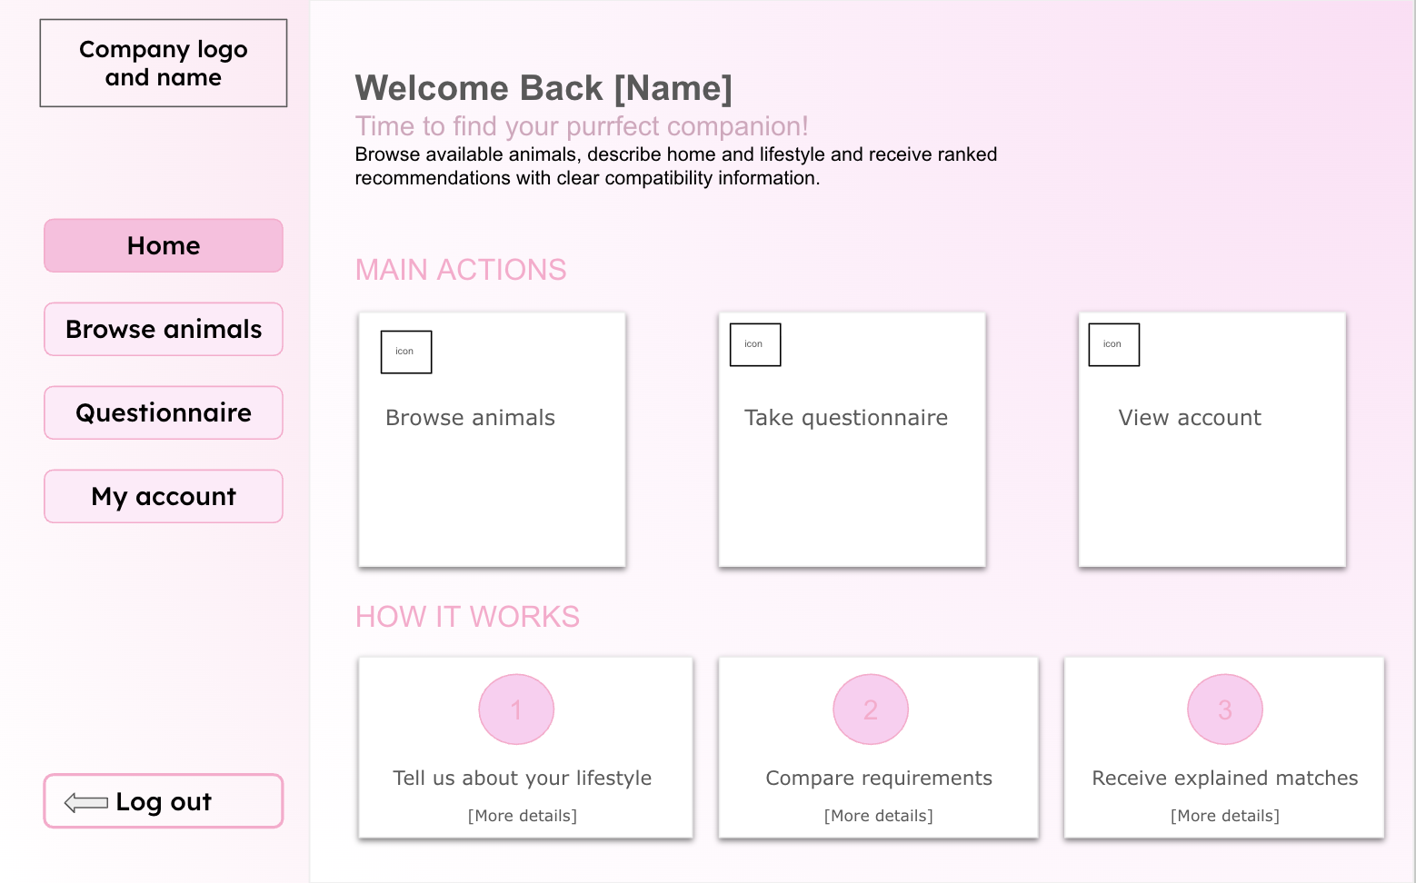
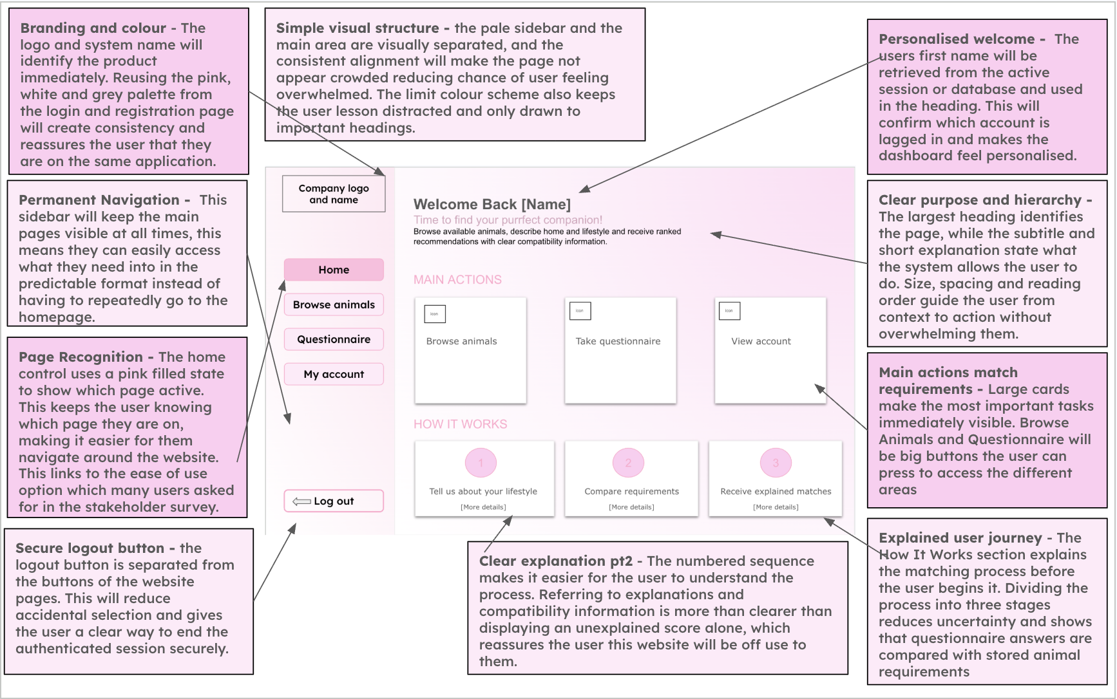

Algorithm (Flow chart, pseudocode)
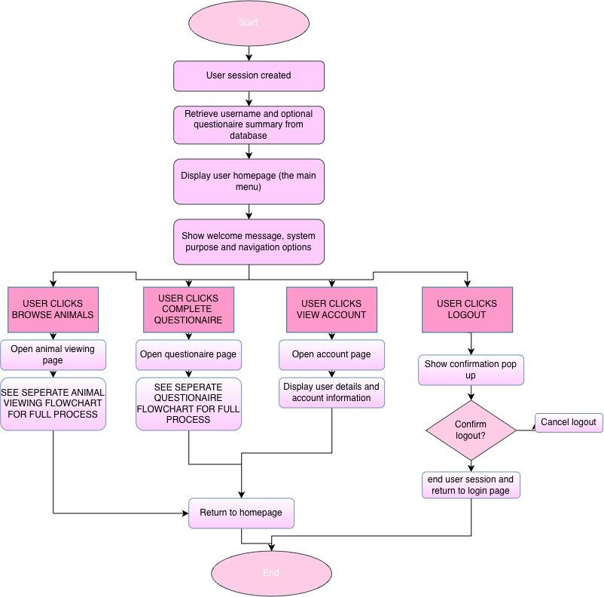

Pseudocode
Main Menu Code

# Use the session already created during login
if logged_in == False:
open_page("Login")

else:
user = get_user(user_id)
print("Welcome", user.name)
print("Find an animal that suits your lifestyle.")
summary = get_questionnaire_summary(user_id)
if summary is not None:
print(summary)
choice = input("Browse animals, Questionnaire, View account or Logout")

if choice == "Browse animals":
open_page("Animal viewing")

elif choice == "Questionnaire":
open_page("Questionnaire")

elif choice == "View account":
open_page("Account")

print("Name:", user.name)
print("Email:", user.email)
print("Age:", user.age)

elif choice == "Logout":

confirm = input("Are you sure you want to log out? Yes or No")

if confirm == "Yes":
clear_session()
open_page("Login")

else:
open_page("Homepage")

Variables

Variable Name | Data Type | Purpose | Justification | E.g or validation
current_user_id | INTEGER | Identifies user currently accessing dashboard | Ensures that the dashboard displays information belonging to the correct account | Retrieved from session
current_user_name | STRING | Stores the logged in users name | This will allow the interface to display personalised information and reassures user they are accessing correct account | ‘Welcome sienna’
questionnaire_completed | INTEGER | Stores the number of animals currently available | It will provide a useful summary of information on the dashboard. An integer is a suitable data type as the number of animals is a whole number | Must be zero or larger
recommended_animals | BOOLEAN | Records whether the user has completed the questionnaire | This variable allows the system to display recommendations or prompt the user to complete the questionnaire. Boolean is suitable as there is only two possible states | Highest compatibility score first; use preference_score only to break ties, then animal_id.
reccomended_animals | LIST | Stores the animals recommended to the users | Multiple animals will need to be displayed in ranked order so a list is a suitable data type | Ordered from lowest to highest compatibility, using preference score to make final decision
selected_page | STRING | Stores the page selected from navigation menu | This allows the program to choose which page or section should be selected | Animals or questionaire
notification_message | STRING | Stores confirmation or status feedback | The user will need clear feedback after completing actions such as submitting questionnaire | ‘Questionaire submitted successfully’

Animal Viewing Page

Animal Viewing | Allows users to browse available animals using clearly presented animal cards. Each card will show information such as the animal name, image, species, breed and age. Users will be able to select a card to view a more detailed animal profile. | Animal records will be retrieved from the animals table. Search and filter selections will be used to change the database query or filter the retrieved records. Selecting an animal will use its unique animal ID to load the correct profile.

Interface Design
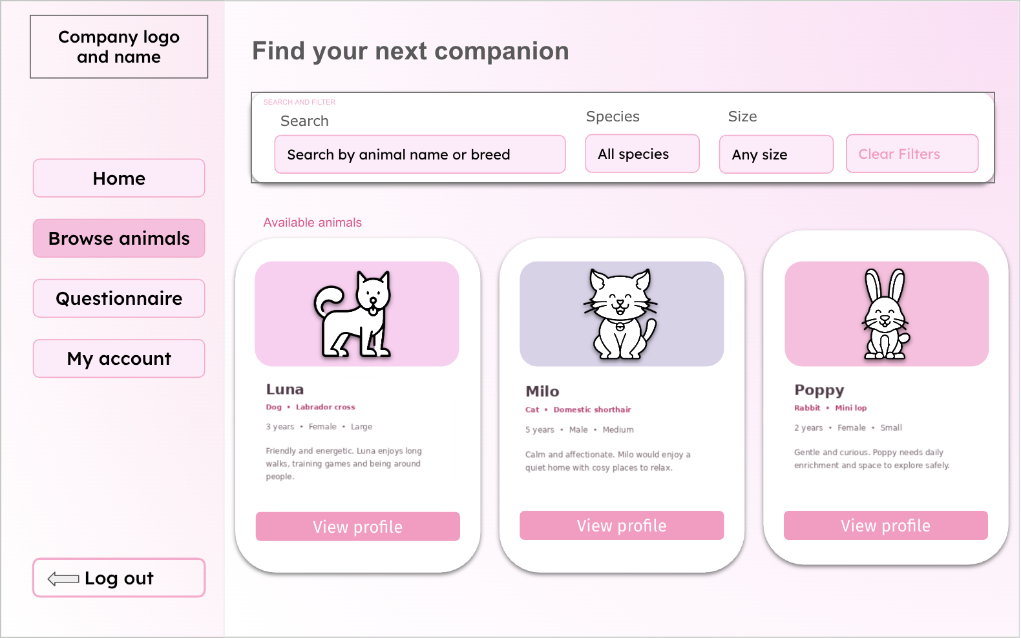
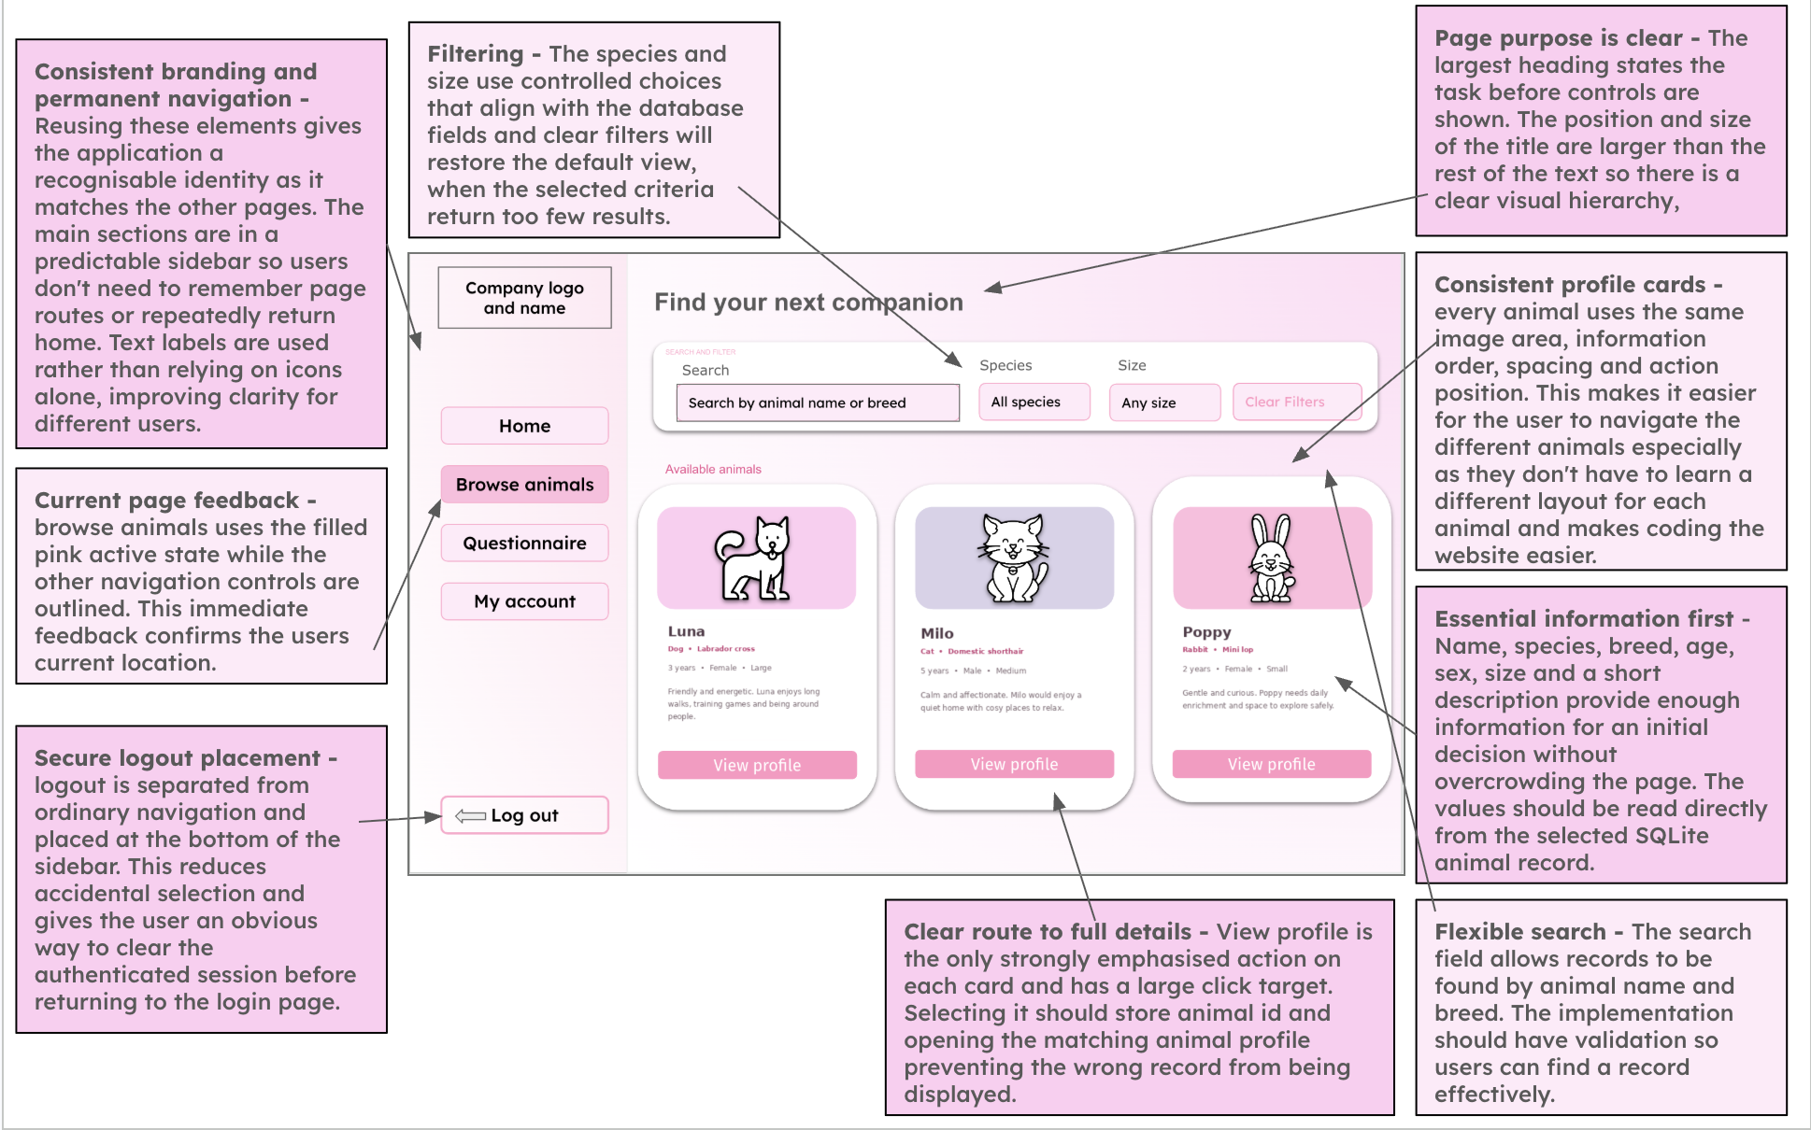
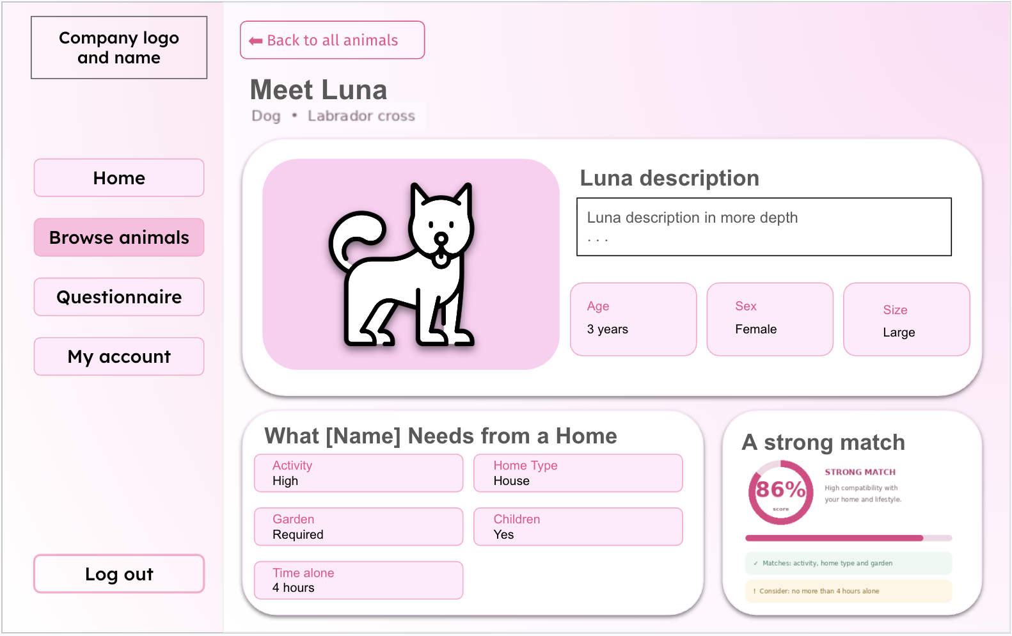
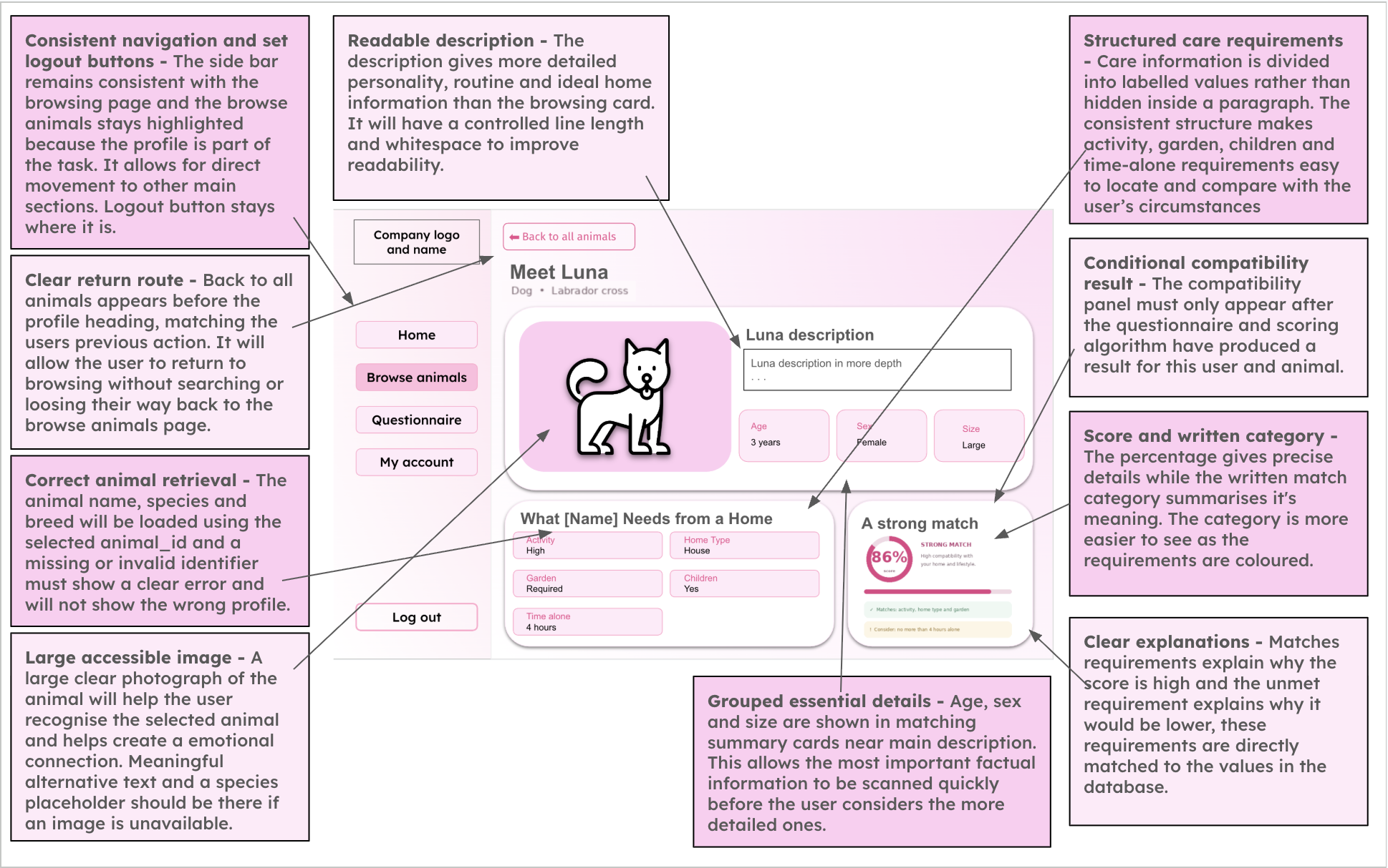
IMAGE UPDATE REQUIRED (embedded artwork): the animal-profile illustration currently shows 86% as Strong; use 83.3% as Good for an eligible partial match (or 100% as Strong). Retain the original pink interface design.

Algorithm (Flow chart, pseudocode)
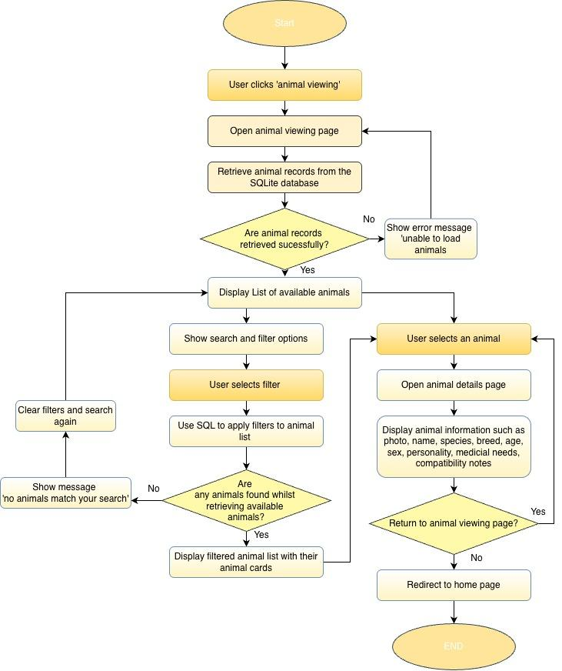

Pseudocode

search_term = input("Search by animal name or breed").strip()
species_filter = select("All, Dog, Cat, Rabbit")
size_filter = select("All, Small, Medium, Large")
animals = database.search_animals(
search_term, species_filter, size_filter, status="Available"
)
if animals is None:
display_error("Unable to load animals.")
elif len(animals) == 0:
display_message("No animals match your filters.")
else:
for animal in animals:
show_animal_card(animal)
if animal_selected:
selected_animal_id = selected_animal.animal_id
open_page("Animal details", selected_animal_id)
if clear_filters_button_clicked:
search_term = ""
species_filter = "All"
size_filter = "All"
open_page("Animal viewing")
if home_button_clicked:
open_page("Homepage")

Variables

Variable Name | Data Type | Purpose | Justification | E.g or validation
search_term | String | Stores text entered into the search bar | A string allows users to search using names, breeds or other information | Leading and trailing spaces should be removed
species_filter | String | Filters animals by species | This is required to reduce the displayed records to animals matching the users chosen species | ‘Dog’, ‘cat’, ‘rabbit’ are the specified filters
size_filter | String | Filters animals by size | Size may affect whether an animal is suitable for the users home so it is suitable for narrowing the results | ‘Small’, ‘medium’, large’
browse_status | string | Records the availability state used when browsing the animal database. | The browse page only displays animals currently available for adoption, matching its user-facing purpose. | Available
animal_results | list | Holds the records returned from the database | A list is suitable because a search may return multiple animal records. It can be iterated through to generate animal cards on the interface | May be empty is no matching results
selected_animal_id | integer | Identifies the animal whose profile is opened | Using the unique id ensures the correct animal is retrieved even when animals have the same name | Must match an existing record
compatibility_score | float | Displays or sorts by compatibility | A float is a more suitable data type than an integer as it allows the result to include decimal values, which will produce a more precise % than an integer. | Between 0 and 100
no_results | boolean | Feedback displayed if there is any animals which meet the filters | Without feedback an empty page could appear to be an error, so the message informs the user that they should change the filters | ‘No animals match your search’

Validation

- Search input
- Length check: the text will not exceed 20 characters
- Whitespace check: leading and trailing spaces will be removed
- Empty input handling: an empty search will be treated as a request to display all available animals rather than as an error

- Filter inputs
Drop down menus or selection controls will be used for:
- Species
  - Dog
  - Cat
  - Rabbit
- Size
  - Small
  - Medium
  - Large

Check name | pseudocode
Search — remove surrounding spaces | search_term = search_term.strip()
Search — length check | if len(search_term) > 20:  errors.append("Search cannot exceed 20 characters.")
Species — lookup check | if species_filter not in ["All", "Dog", "Cat", "Rabbit"]:  errors.append("Please select a valid species.")
Size — lookup check | if size_filter not in ["All", "Small", "Medium", "Large"]:  errors.append("Please select a valid size.")

Compatibility algorithm and questionnaire
Usability and accessibility decisions
The same labelled navigation, clear headings and pastel branding are reused across login, the homepage, browsing, admin and questionnaire screens to reduce the need to relearn controls. The login annotation references client interviews Q11–Q12, stakeholder S6 and competitor examples E1–E2; the browsing and questionnaire tests reference S6–S7 and Q13–Q14. These evidence references should be checked against the final Analysis so each justification matches what respondents actually said.
For accessibility, I will aim for body text of at least 16 px, visible keyboard focus indicators, descriptive labels and image alternative text. Text will be checked against WCAG contrast targets (4.5:1 normal text, 3:1 large text); the pastel colour palette alone must not indicate whether an answer is correct. On mobile, the sidebar will become a compact navigation control, animal cards will form a single column, and questionnaire option cards will stack vertically. These are planned behaviours to verify, not claims that the screens are already responsive.

Questionnaire and Recommendations | Will use a form in order to allow users to answer questions about their home, lifestyle, experience and preferences. The questionnaire will have questions such as the housing type, access to garden, animal loneliness times, children, activity levels, what species and size preferred. These questions would not appear all at one time to not overwhelm the user and the input type would be drop downs or radio buttons. After submitting the questionnaire, the system will display compatibility scores almost immediately and recommended animals. It will also explain requirements the user does not meet. | Responses will be validated and compared with the requirements of each available animal. A weighted compatibility algorithm will calculate a percentage score for every animal. The animals will then be sorted from highest to lowest score so the top recommendations can be displayed. The questionnaire responses and match results will be stored within the database linked to the correct user_id

Interface Design

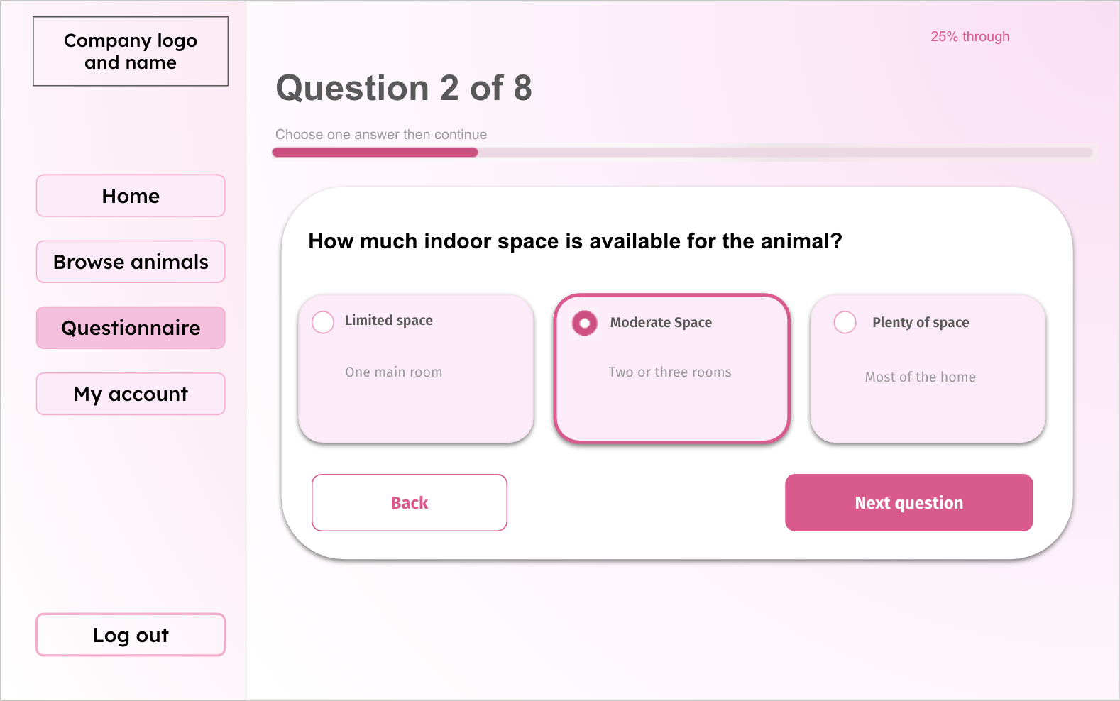
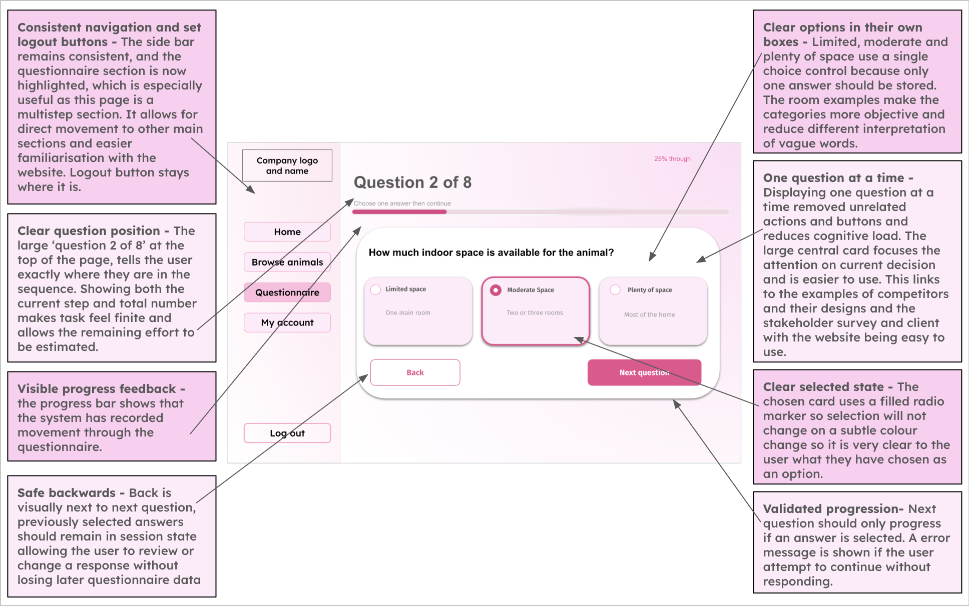
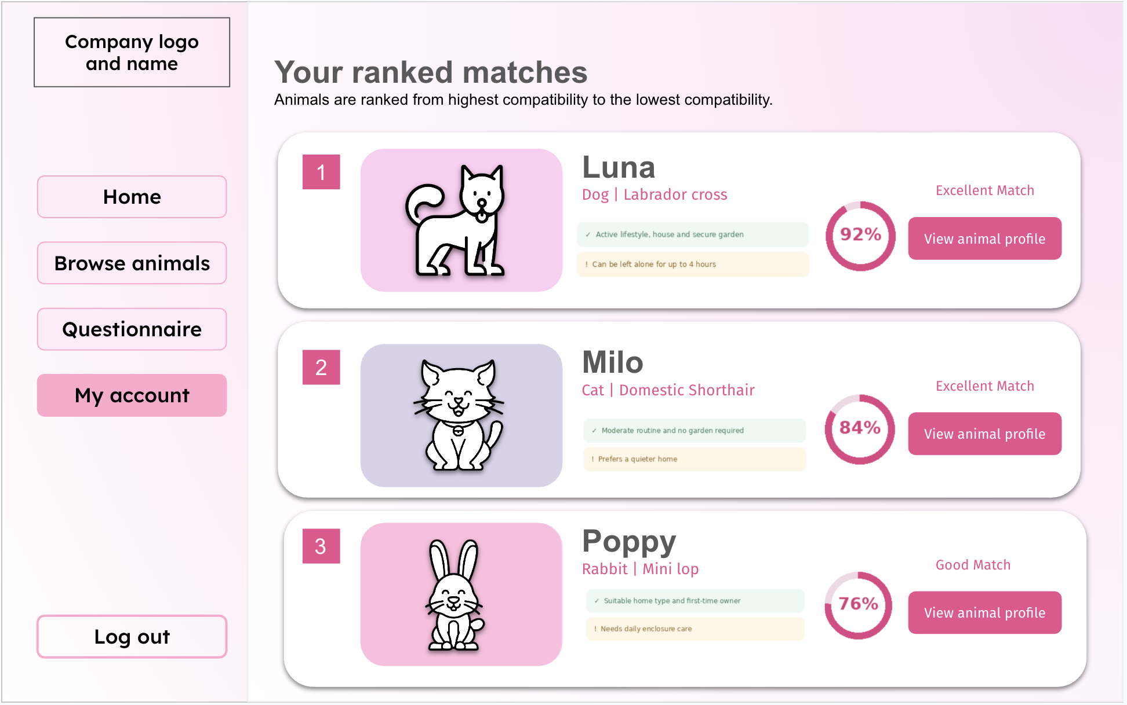
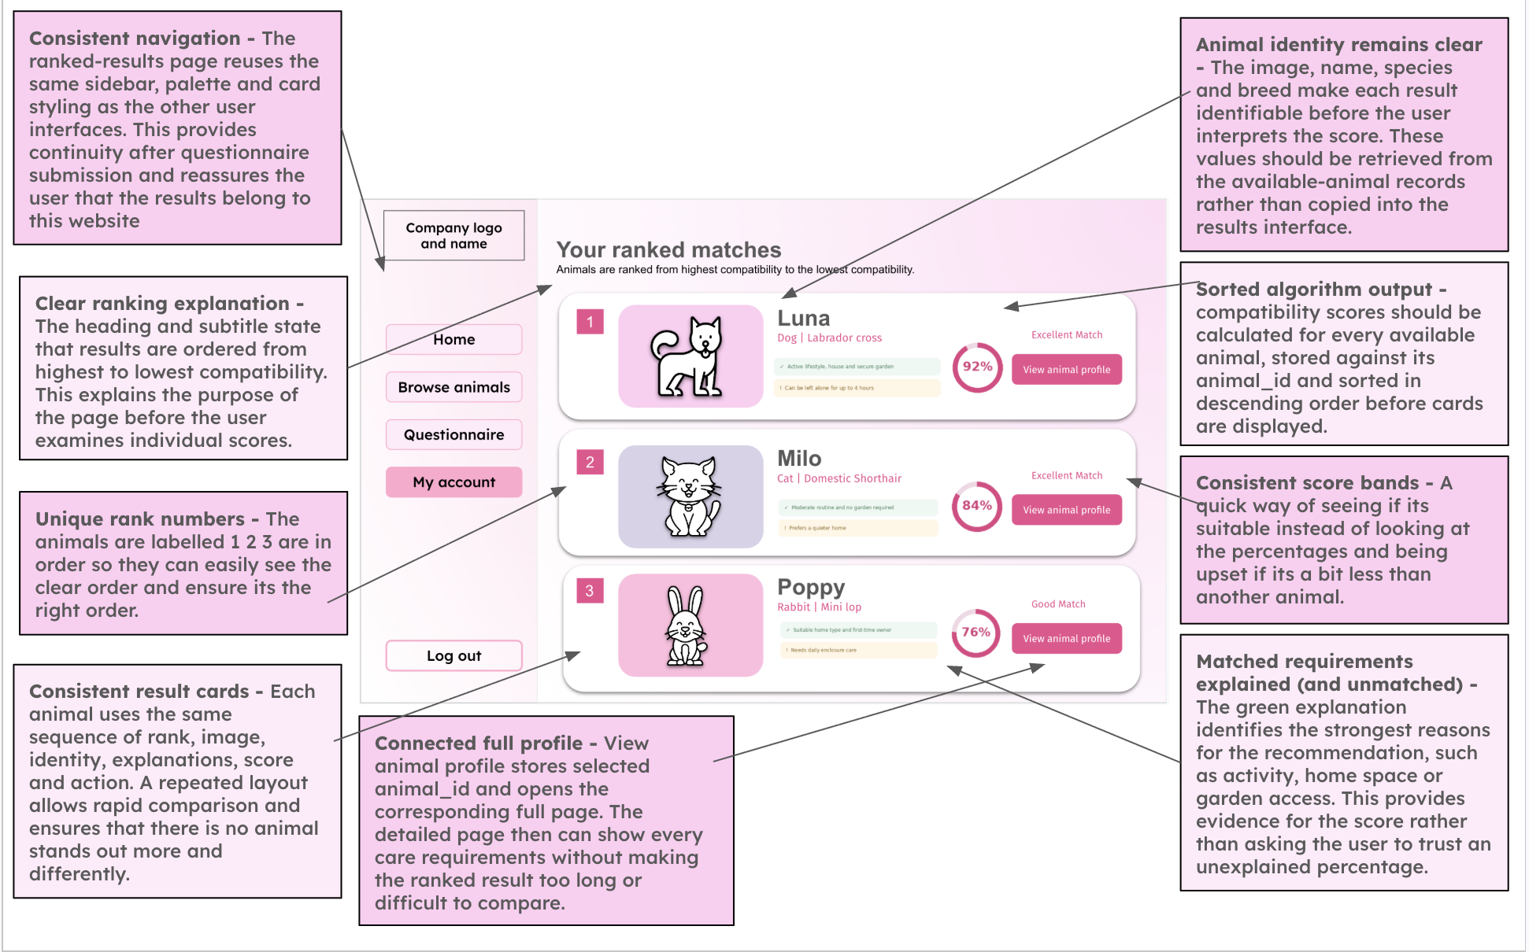
IMAGE UPDATE REQUIRED (embedded artwork): change "Question 2 of 8" to "Question 2 of 7" in both the questionnaire mock-up and its annotation. Replace example compatibility percentages with calculated examples: 100% (Strong), 83.3% (Good), 79.2% (Possible). The original artwork is preserved for you to update directly.

Algorithm (Flow chart, pseudocode)
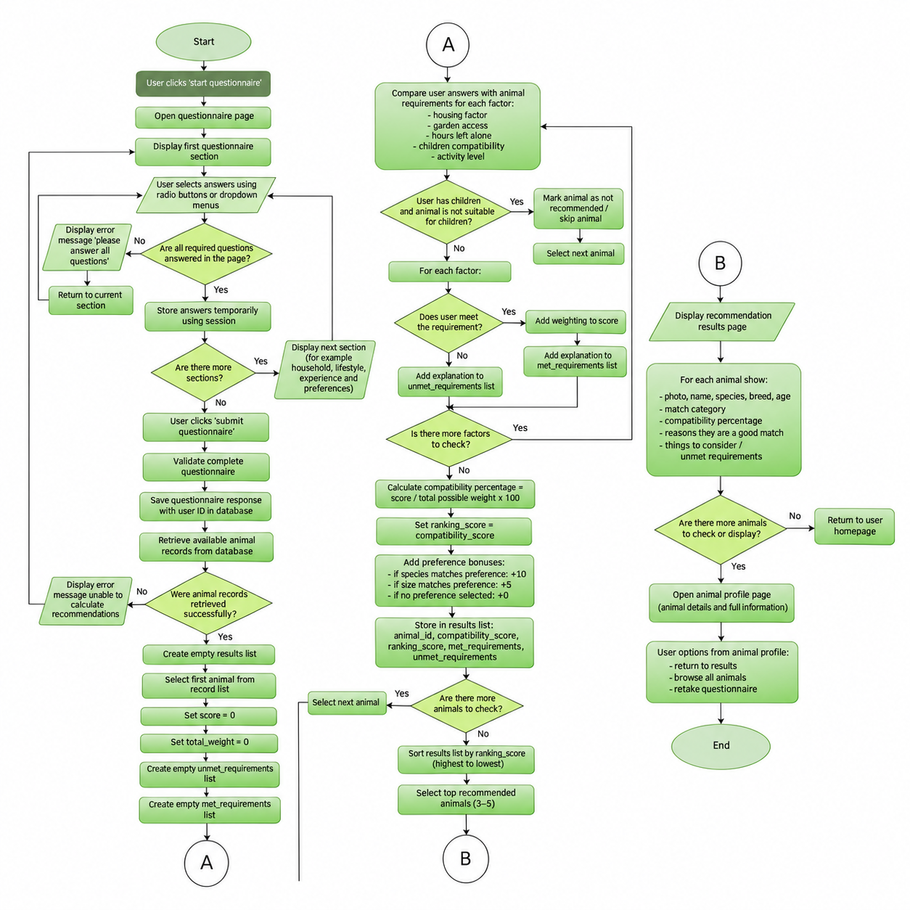
IMAGE UPDATE REQUIRED (green matching flowchart): replace the child-only skip diamond with a three-rule compulsory check (children, hours alone, garden). Record failed requirements and still calculate/store the score; filter out Ineligible or below-70% records before sorting by compatibility, then preference. Use a parallelogram for inputs/outputs and a diamond for decisions. Keep your original green formatting.

Pseudocode

response = get_latest_questionnaire_response(user_id)
animals = get_available_animals()

maximum_score = 72
minimum_recommendation_score = 70
animal_scores = []

for animal in animals:
total_score = 0
compulsory_failures = []
unmet_requirements = []

# Hours left alone - compulsory
if response.hours_left_alone <= animal.max_hours_left_alone:
total_score += 20
else:
compulsory_failures.append(
"Animal would be left alone too long."
)

# Children - compulsory
if response.has_children == 0 or animal.child_compatible == 1:
total_score += 15
else:
compulsory_failures.append(
"Animal is not suitable for children."
)

# Housing recommendation - weighted
if response.housing_level >= animal.recommended_housing_level:
total_score += 15
else:
unmet_requirements.append(
"Animal would benefit from more living space."
)

# Activity level - weighted
if response.activity_level >= animal.exercise_needs:
total_score += 12
else:
unmet_requirements.append(
"Animal needs more exercise than you can provide."
)

# Garden access - compulsory
if animal.garden_required == 0 or response.garden_access == 1:
total_score += 10
else:
compulsory_failures.append(
"Animal requires garden access."
)

compatibility_score = round(
(total_score / maximum_score) * 100, 1
)

# Assign category
if len(compulsory_failures) > 0:
match_category = "Ineligible"
elif compatibility_score >= 90:
match_category = "Strong"
elif compatibility_score >= 80:
match_category = "Good"
elif compatibility_score >= 70:
match_category = "Possible"
else:
match_category = "Low"

# Preferences do not change compatibility
preference_score = 0

if response.preferred_species == animal.species:
preference_score += 10

if response.preferred_size == animal.size:
preference_score += 5

is_eligible = (
len(compulsory_failures) == 0
and compatibility_score >= minimum_recommendation_score
)

animal_scores.append({
"animal_id": animal.animal_id,
"compatibility_score": compatibility_score,
"preference_score": preference_score,
"match_category": match_category,
"is_eligible": is_eligible,
"unmet_requirements":
compulsory_failures + unmet_requirements
})

# Replace saved results for this questionnaire attempt
database.replace_match_results(
response.response_id, animal_scores
)

# Only recommend eligible animals
eligible_animals = [
result for result in animal_scores
if result["is_eligible"]
]

# Highest compatibility first
ranked_animals = sorted(
eligible_animals,
key=lambda result: (
-result["compatibility_score"],
-result["preference_score"],
result["animal_id"]
)
)

if len(ranked_animals) == 0:
print("No suitable animals currently available.")
else:
for result in ranked_animals[:5]:
display_match(result)

Worked example
Controlled adopter: housing_level=2, garden_access=1, hours_left_alone=4, has_children=1, activity_level=2, preferred_species=Cat, preferred_size=Small. Animal A: Dog/Medium, recommended_housing_level=2, garden_required=1, max_hours_left_alone=5, child_compatible=1, exercise_needs=2. Animal B: Cat/Small, recommended_housing_level=3, garden_required=0, max_hours_left_alone=6, child_compatible=1, exercise_needs=2. Both animals have status Available.
Calculation | Animal A | Animal B
Hours alone /20 | 20 | 20
Children /15 | 15 | 15
Housing /15 | 15 | 0
Activity /12 | 12 | 12
Garden /10 | 10 | 10
Total /72 | 72 | 57
Compatibility | 100% | 79.2%
Compulsory checks | Pass | Pass
Preference points | 0 | 15
Category | Strong | Possible
Final rank | 1 | 2

Animal A achieves 72 out of 72 points, so 100% compatibility. Animal B achieves 57 out of 72 points, giving 79.2%, because its recommended housing level is higher than the adopter's available space.
Both animals pass the compulsory checks and achieve at least 70%, so both can be recommended. Although Animal B matches the preferred species and size, Animal A is ranked first because it has the higher compatibility percentage.
This demonstrates that personal preferences do not override suitability. If either animal failed a compulsory requirement, it would be excluded from recommendations regardless of its score.
Validation - questionnaire
- Housing type or housing level
- Presence check: The user must select an answer
- Lookup check: The answer must be one of the permitted housing options
- A radio button or drop-down will prevent unsupported values
1 = Flat or limited space
2 = Small or medium house
3 = Large house

- Garden access
- Presence check: Yes or No must be selected
- Boolean check: The stored result must be 1 or 0

- Hours the animal will be left alone
- Presence check : a value must be provided
- Type check : a whole number
- Range check : between 0 and 24 hours

- Children in the home
- Presence check: Yes or No must be selected
- Boolean check: The stored result must be 1 or 0

- Preferred activity level
- Presence check: an option must be selected
- Lookup check: The stored result must be 1, 2 or 3

- Preferred species
- Presence check: The user must select an answer
- Lookup check: The answer must be a dog, cat, rabbit or no preference

- Preferred size
- Presence check: The user must select an answer
- Lookup check: answer must be small, medium, large or no preference

Validation is necessary within this compatibility algorithm to ensure that the recommendations produced are reliable and that invalid data does not cause incorrect results.

Questionnaire Validation

Check name | pseudocode
Housing level — presence check | if housing_level is None:  errors.append("Please select your housing level.")
Housing level — lookup check | if housing_level is not None:  if housing_level not in [1, 2, 3]:  errors.append("Select a valid housing level.")
Garden access — presence check | if garden_access is None:  errors.append("Please select Yes or No for garden access.")
Garden access — Boolean value check | if garden_access is not None:  if garden_access not in [0, 1]:  errors.append("Garden access must be Yes or No.")
Hours alone — presence check | hours_left_alone_input = hours_left_alone_input.strip()  if hours_left_alone_input == "":  errors.append("Please enter the hours left alone.")
Hours alone — type check | hours_left_alone = None  if hours_left_alone_input != "":  try:  hours_left_alone = int(hours_left_alone_input)  except ValueError:  errors.append("Hours alone must be a whole number.")
Hours alone — range check | if hours_left_alone is not None:  if hours_left_alone < 0 or hours_left_alone > 24:  errors.append("Hours alone must be between 0 and 24.")
Children — presence check | if has_children is None:  errors.append("Please answer whether children live in your home.")
Children — Boolean value check | if has_children is not None:  if has_children not in [0, 1]:  errors.append("Children in the home must be Yes or No.")
Activity level — presence check | if activity_level is None:  errors.append("Please select your activity level.")
Activity level — lookup check | if activity_level is not None:  if activity_level not in [1, 2, 3]:  errors.append("Select a valid activity level.")
Preferred species — presence check | if preferred_species is None:  errors.append("Please select a species or No preference.")
Preferred species — lookup check | if preferred_species is not None:  if preferred_species not in ["Dog", "Cat", "Rabbit", "No preference"]:  errors.append("Select a valid species option.")
Preferred size — presence check | if preferred_size is None:  errors.append("Please select a size or No preference.")
Preferred size — lookup check | if preferred_size is not None:  if preferred_size not in ["Small", "Medium", "Large", "No preference"]:  errors.append("Select a valid size option.")

Questionnaire Response table

Field | Data type | Key/validation
response_id | INTEGER | Primary key, auto increment
user_id | INTEGER | Foreign key linked to Users.user_id
housing_level | INTEGER | Required range 1-3
garden_access | BOOLEAN | Required 0 or 1
hours_left_alone | INTEGER | Required valid range
has_children | BOOLEAN | Required 0 or 1
activity_level | INTEGER | Required range 1 - 3
preferred_species | TEXT | Required dog, cat, rabbit or no preference
preferred_size | TEXT | Required small, medium, large or no preference
completed_at | DATE | required

Match Results Table

Field | Data type | Key/validation
match_id | INTEGER | Primary key autoincrement
response_id | INTEGER | Foreign key to questionnaire_responses.response_id (ON DELETE CASCADE).
animal_id | INTEGER | Foreign key to animals.animal_id (ON DELETE CASCADE).
compatibility_score | REAL | Required range 0 to 100
match_category | TEXT | Required: Strong, Good, Possible, Low or Ineligible.
unmet_requirements | TEXT | JSON-encoded list of unmet requirements; may be empty.
calculated_at | DATE | required
is_eligible | BOOLEAN | Boolean 0 or 1; true only when all compulsory checks pass and score >=70%.
preference_score | INTEGER | Required 0-15

Match Categories

Compatibility | Category
90–100% | Strong
80–89.9% | Good
70–79.9% | Possible
Below 70% | Low
Any score failing a compulsory rule | Ineligible

Adoption Questionnaire Variables

Variable Name | Data Type | Purpose | Justification | Validation or e.g
housing_level | integer | Stores amount of living space available | The available space may affect whether or not the home is suitable for different sizes and exercise needs | Required range 1-3
garden_access | boolean | Records whether user has access to a garden | Some animals may require regular access to an outdoor space. A boolean value is suitable as the answer has two possible values | 0 or 1
hours_left_alone | integer | Stores how long the animal would normally be left alone | Time availability can be numerically compared with the animals required attention and exercise time | Required valid range such as 0-24
has_children | boolean | Records whether children live in the household | Some animals may not be suitable for homes with children making this an important safety factor | 0 or 1
activity_level | integer | Stores the users preferred animal activity level | Matching activity level helps ensure the adopter can meet the animals exercise requirements | range 1 - 3
preferred_species | string | Stores the users preferred species | This ensures that the recommendations remain relevant to the type of animal the user is interested in adopting | Required ‘dog’, ‘cat’, ‘rabbit’ or ‘no preference’
preferred_size | string | Stores the users preferred size | The user may have practical or personal reasons for preferring a particular size. | ‘small’, ‘medium’, ‘large’ or ‘no preference’

Compatibility scoring algorithm variable names

Variable Name | Data Type | Purpose | Justification | Validation or e.g
animal_id | integer | Stores the unique identifier of the animal being assessed | It ensures that each calculated score is linked to the correct animal, even when animals have the same name | Must match an existing record in the animals table e.g 12
maximum_score | integer | Stores the highest possible number of points that can be awarded by the compatibility algorithm | This is required so that the user's raw score can be converted into a percentage. An integer is suitable because the algorithm awards whole number points for each matching factor. | Must be greater than 0
total_score | integer | Stores the total compatibility points awarded for the animal currently being assessed | The value begins at zero and increases whenever the user's answers from the questionnaire match an animal's requirements. It must be reset before the algorithm assesses the next animal. | Begins at 0 and cannot exceed maximum_score
animal_scores | list | Stores the ID and compatibility score for all available animals | This will allow the results to be sorted from highest to lowest compatibility. A list is suitable because the algorithm processes multiple animals | [{"animal_id": 3, "score": 92.5}, {"animal_id": 7, "score": 79.2}]
compatibility_score | float | Stores the calculated compatibility percentage | A percentage is easier for users to understand and compare than a raw points total, a float will allow decimal results to be stored. | Strong, Good, Possible, Low or Ineligible.
match_category | string | Stores an understandable category for the calculated score | A category makes the numerical result easier for the user to interpret. It is selected according to predefined percentage ranges. | Examples: "Requires a garden" or "Not suitable for children"; an empty list means no unmet requirements.
unmet_requirements | list | Stores explanations of requirements the user did not meet | There may be several reasons why an animal is not fully suitable so a list will allow multiple explanations to be stored and displayed. | Example: "Requires a secure garden", "Not suitable with cats". It may be empty when all essential requirements are met.

Questionnaire Plan
Integration between systems

- Registration/Login - Identify the user using user_id
- Questionnaire - Validate and save a new response
- Matching algorithm - Retrieve available animals and calculate scores
- Match results table - saves scores, categories and explanations
- Recommendations page - retrieve and display top 5 animals
- Animal profile - use animal_id to open correct animal

After the user submits the questionnaire, the validated answers are saved in the questionnaire responses table with the user's ID. The compatibility algorithm will retrieve the available animal records and will compare their requirements with saved answers,
This data will be stored within the Match Results table using questionnaire response ID and animal ID.
The recommendations page then displays the eligible animals in ranked order. Selecting an animal opens its full profile using a unique animal ID. This links the authentication, questionnaire, matching, database and animal viewing systems together.

Section 1: House environment
- Amount of living space
- Garden access?

Section 2:
- Children in the home?

Section 3:
- Preferred activity level / time available for exercise and care
- Hours the animal would be left alone

Section 4:
- Preferred species
- Preferred animal size

Section 5:
- Submit

Where it links
- Amount of living space → recommended_housing_level
- Garden access → garden required
- Children in the home → child compatible
- Activity level → exercise_needs
- Hours left alone → max_hours_left_alone
- Preferred species → animal species
- Preferred size → animal size

First Matching part

Factor | Suggested weight (can be changed) | Justification
Hours Left alone | 20 | Strongly will affect whether the adopter can meet the animals needs
Child compatibility | 15 | Important for safety and suitability  Compulsory
Housing space | 15 | Ensures the home provides enough room
Activity | 12 | Matches exercise needs with users lifestyle and what they can provide
Garden access | 10 | Important when an animal explicitly requires a garden; this is a compulsory requirement when garden_required is true.

- Calculate the suitability score
- Exclude animals that fail a compulsory requirement or score below 70%
- Calculate preference points without changing compatibility percentage
- Rank by compatibility percentage first, then preference score to break ties
- Keep eligible animals in descending compatibility order
- Display up to 5 eligible animals

Factor | Suggested weight
Species | 10
Size | 5

Species and size preferences do not add to the compatibility percentage: they reflect adopter preferences rather than welfare suitability. They only break ties when two eligible animals have the same compatibility score. If No preference is selected, no bonus is awarded.
Children, maximum hours alone and garden access are compulsory checks. An animal that fails any of these is recorded as Ineligible and excluded from recommendations even if its weighted score reaches 70%. Housing space is a recommended rather than compulsory level, so it contributes to the weighted score instead.

The suitability score is out of 72 points. I chose 70% as an initial minimum because failing both the housing recommendation (15 points) and activity factor (12 points) produces only 45/72 = 62.5%; the threshold is also checked using controlled testing. Results are sorted by compatibility descending, preference points descending as a tie-breaker, then animal_id ascending for a repeatable order. Up to five eligible animals are shown.

Prefixes: | Q—Client Interview|S—Stakeholder Survey
Pre-development Test Plan (Iterative)

Login and Registration (Authentication)

Test No. | Test | Planned Input | Expected output | Source | Success?
R1 | Check registration form contains all the planned fields, so the user can provide all data | Open the registration page | The boxes for Name, email, age, password, confirmation are visible. | Q6, S6
R2 | Register with valid inputs to check data is saved as a new adopter account. | Name - Sienna Sisodia  email - siennasisodia@gmail.com  age 19  Password - password123 (confirmation matches)  Using valid details will allow us to check successful registration and adopter access | One user record is saved with adopter access and they can access the homepage. | Q9, Q12
R3 | Check invalid registration entries individually to prevent incorrect or duplicate accounts. | Blank name; 1-character name; invalid email; age 17; duplicate email; non-matching confirmation; and passwords of exactly 7 and 8 characters. Test each separately. | Each invalid entry is rejected with a field-specific message and no record is created. A 7-character password fails; an otherwise valid 8-character password succeeds. | Q9, Q12, Q15
R4 | Check that passwords are hashed rather than being saved as readable text. | Create two separate users using the same valid password. Inspect the saved password_hash values and test login verification for each. | Both hashes use Argon2id and do not equal the plaintext password. Random salts produce different stored hashes; both passwords verify successfully. | Q12
R5 | Check Valid and invalid login behaviour with exposing account details | Enter the correct password or email and incorrect password and email. This allows us to test login and check the error messages. | The correct details open the homepage but otherwise an error message is displayed | Q12
R6 | Check an admin can access the admin area | Sign in using admin login details and sign in using user details, allows us to test the security of the admin area for no unauthorised access. | The user is redirected to only the homepage whereas the admin can access the admin page. | Q5, Q12

Adopter Homepage and Navigation
Test No. | Test | Planned Input | Expected output | source | Success?
N1 | Make sure protected pages do not show personal data before login | Log out and open Home, Browse, Questionnaire, Matches | Every route redirects to login without showing private data | Q12
N2 | Check that navigation keeps the same active account across pages | Sign in once, use every main navigation link.  This allows us to check if session stays the same | Each link reaches the correct page without losing the logged in user | E1, E2, E3, S6
N3 | Check logout removes access even after browser navigation. | Log out, press back | The session should remain logged out and protected pages will return to login | Q12
N4 | Siderbar stays on the edge throughout the program | Use the navigation on the sidebar, go into the questionnaire | The sidebar should remain on the side | S6

Admin page
Test No. | Test | Planned Input | Expected output | source | Success?
A1 | Store an animal with the fields needed for browsing and compatibility | Nova: Dog; Labrador; age 2.5; Medium; activity 2; housing need 2; garden required Yes; max alone 5h; children allowed Yes; status Available. Mixed data types check that all animal fields save successfully | A new animal ID is assigned, all fields can be fetched correctly after saving. | Q2, Q5, Q15
A2 | Use valid and invalid boundaries to check that unsuitable animal data is rejected | Name lengths 1, 2, 50, 51; age Test -1, 0, 0.5, 2.5, 40, 41; activity 0, 1, 3, 4; alone hours -1, 0, 24, 25. Boundary values test the limits and tests decimal support | Valid: name lengths 2 and 50, animal ages 0.5, 2.5 and 40, activity 1 or 3, hours 0 or 24. Invalid: name 1 or 51, age -1, 0 or 41, activity 0 or 4, hours -1 or 25; invalid records are not saved. | Q2, Q15
A3 | Check editing changes only the selected animal and the change is saved | Change novas activity from 2 to 3 and edit its description then save and reload, editing one animal will allow us to check targeted updates and permanent saving | Novas shows the news values, other records remain unchanged. | Q5, Q15
A4 | Check removal works and has confirmation to reduce accident | Select Delete on Nova, cancel, repeat and confirm. This allows us to test accidental deletions and updates | Cancel will stop the deletion but confirming it will remove it from the list | Q5, Q12, Q15

Animal viewing
Test No. | Test | Planned Input | Expected output | source | Success?
V1 | Check the page can handle zero animals instead of crashing | Use a database with no animals, it checks safe handling of empty results | A no results message is displayed and page remains usable | E1, E2, E3
V2 | Check the search and filters use actual planned fields | Search "Nov" by name and "Labr" by breed; filter species Dog and size Medium; try "zzzzz", allows us to test partial searches, combined filters and unmatched text test search behaviour | Matching name/breed results appear with the chosen species/size; unknown search gives no-results feedback. | E1, E2, E3, Q8
V3 | Check the selected profile always uses the correct current database record. | Open Nova and a second animal with different needs. Allows us to use two separate ones to show selected animals | Name, photo , age, breed, description and requirements agree with each selected record. | E1, E2, E3, Q2

Questionnaire and Compatibility Algorithm

ID | Test | Planned Input | Expected output | source | Success?
Q1 | Normal: Check a complete valid questionnaire can be submitted. | Housing 2; garden Yes; hours alone 4; children Yes; activity 2; species No preference; size Medium (seven valid answers). | The questionnaire should be accepted and saved in the database for the logged in user, and the compatibility algorithm should begin using these answers. | Q1, S3, S5
Q2 | Check presence validation prevents incomplete answers being used to produce matches. | Leave garden access unanswered, attempt submission, then complete all seven answers. One missing answer will isolate the validation for the required field | Incomplete submission is rejected with feedback a completed questionnaire is accepted. | Q1, Q10, S5
Q3 | Check the exact valid ranges and invalid boundaries from the design. | Hours -1, 0, 24, 25 housing 0, 1, 3, 4 activity 0, 1, 3, 4 wrong species "Bird". The boundary values will check limits and the bird will check rejection of unsupported choices. | Hours 0–24, housing 1–3 and activity 1–3 are accepted. Outside values and unsupported choices are rejected and not stored. | Q12, Q15
Q4 | Database: Checking questionnaire answers are saved and updated. | User A submits hours - 4 User A changes this to 6 Restart or log out and back in User B logs in, checks privacy and account persistence Changing 4 to 6 checks that new answers are saved. Two users test data privacy. | User A's latest questionnaire response stores 6 hours, while the previous response containing 4 hours remains in the database. The system uses the latest response for recommendations after logging back in. User B cannot access User A's saved responses. | Q12, Q15
Q5 | Normal / upper boundary: Check a perfect animal match. | Use a controlled animal of my choice matching every essential requirement and preference in the test questionnaire in order to get 72/72, Adopter: Housing 2, garden Yes, hours alone 4, children Yes, activity 2. Animal: Housing requirement 2, garden required Yes, maximum hours alone 5, child-friendly Yes, activity 2. Preferences shouldn't alter compatibility | Total score equals maximum score. Compatibility is exactly 100%. The highest match category is assigned and there are no unmet requirements. | Q10, Q15, S5, S7
Q6 | Calculation: Check a manually calculated partial score. | Controlled animal total score - 60 Maximum possible score - 72, changing the activity category should change the weighting and calculated percentage | Compatibility should be 83.3%. The displayed percentage, total and match category agree with the manual calculation. | Q3, Q10, S9
Q7 | Controlled comparison: Check preference weighting and essential requirements. | Animals A and B have equal welfare compatibility. A matches the species preference but B does not. Animal C satisfies every factor except child compatibility, giving 57/72 = 79.2%, and matches both preferences. | A ranks above B only because their compatibility scores are equal. C is Ineligible and excluded despite its 79.2% score and matching preferences. | Q10, Q14, S7
Q8 | Ordering / robustness: Check ranking, equal scores, repeatability and no-match handling | Known scores, Two animals with equal scores Run the same data twice Make all animals unavailable or below threshold | Eligible results are ranked by compatibility descending, then preference score descending, then animal_id ascending. Repeating identical input produces identical order. No eligible animals shows a clear explanation. | Q10, Q15, S9

Database and Setup

Test no | Test | Planned input | Expected output | Source | Pass?
DB1 | Structure: check the designed database is created from a clean start. | Initialise a new empty SQLite file. Inspect for users, animals, questionnaire_responses and match_results. | All planned tables, columns, primary keys and foreign keys exist as recorded in the final data dictionary. | Q5, Q12, Q15
DB2 | Integrity: ensure questionnaire records link only to valid user records. | Add valid user and response then attempt a response with a nonexistent user_id while foreign keys are enabled. | Valid record is linked to its owner; invalid foreign-key reference is rejected and no orphan response exists. | Q12, Q15
DB3 | Persistence: confirm stored information remains available across sessions. | Save animal and questionnaire records; close Streamlit and restart the application. | Records can be retrieved with their original values; session-only values are not mistaken for saved data. | Q2, Q12, Q15
DB4 | Saved match-result integrity after updates | Submit a questionnaire twice, inspect match_results; edit one animal and refresh results; delete an animal and verify references. | The latest answers are used; recalculation replaces results for the same response without duplicates; deleted animals leave no orphan match_results. | Q10, Q12, Q15

Post Development Test Plan

Test No. | Test | Planned Input | Expected output | Justification | Source | Success?
PD1 | Complete an new adopter journey | Create a test adopter (age 19), sign in, and submit:  housing 2, garden Yes, alone 4h, children Yes,  activity 2, preferred Dog, size Medium. Browse and  open an available animal meeting all five welfare  needs. | The user completes registration, questionnaire,  browsing and results in one session. Answers  are saved to the correct account; the fully  compatible animal shows 72/72 = 100% (if the  final scoring rules match the design) | One realistic journey checks  that all main modules work  together. | Q9, Q10,  Q12, Q14,  Q15, S6
PD2 | An established users journey | Add one available Dog and Cat with equal welfare  requirements. User A first saves preferred species  = Dog, log out/in, change to Cat, and view the  matches again. Keep the other five welfare  answers unchanged | The latest preference is used on return. Both  animals keep their welfare compatibility  percentages, the ranking changes to  reflect the new preference, with no other user's  answers shown | Changing only one answer  isolates the effect of  preferences across a saved  session. | Q10, Q12,  Q14, S7
PD3 | Complete Admin Journey | As admin, add Nova, edit its description  and maximum hours alone from 5 to 3, then check  its Browse card, profile and matches as an adopter  with 4h alone. FInally delete Nova | The saved edit appears on all relevant pages. Changing Nova’s maximum alone time from 5 to 3 hours makes it ineligible for an adopter leaving it alone for 4 hours; refreshed recommendations exclude it. After deletion, Nova no longer appears in browsing or new matches. | This allows us to see if one change is replicated everywhere else in the system. | Q2, Q5,  Q10, Q15
PD4 | Check that the complete system can handle unexpected situations without crashing, | Complete questionnaire when there are no suitable animals available and add an invalid answer of 25h then change it to a normal value like 24h, then return to browning and navigate between pages. Reopen matches to see the page to make sure it hasn't crashed. | Invalid input is rejected without creating an  incorrect record. The user can recover and  complete the journey. Empty results show  suitable messages, pages should remain usable without  crashing. | Combines testing of interrupted use, recovery and empty results rather than testing it individually. | Q1, Q12,  Q14, Q15,  S9
PD5 | Check that intended users can understand and navigate the finished website. | Ask three representative users who have not used  PawMatch to register with test accounts, complete  the seven questions, browse and interpret one  match. Observe without helping, record  completion, errors and feedback | All three complete the  key tasks independently and can explain at least  one matching reason. Record actual findings and  compare with the final Analysis success criteria | Independent users can reveal  unclear steps and results  missed. | Q6, Q13,  Q14 S6, S7
PD6 | Check that Pawmatch can remain readable and usable on different screen sizes | Repeat Browse, Questionnaire, Profile and  Matches on mobile and on  desktop. Use keyboard navigation as well as  pointer input; include a long animal description and  a missing photo. | Main controls remain visible and usable, text is  readable, the page does not lose information,  and the missing image has an appropriate  fallback. Record any problems | Different screen sizes, input  methods and unusual content  test practical usability | Q6, Q13,  S6
Further post-development test data and justification
Test | Further data | Why this data is appropriate
PD1 | One valid adopter, seven answers and one animal meeting all five criteria | Checks a complete cross-page journey and verifies 72/72 = 100%.
PD2 | A Dog and a Cat with equal suitability; two saved responses differing only in preferred species | Shows that updated preferences change ranking without changing welfare percentages.
PD3 | An available animal whose max hours alone changes from 5 to 3, then is removed | Tests propagation of admin updates, recalculation and deletion across pages.
PD4 | 25-hour invalid input corrected to 24 hours; no eligible animals | Tests validation, recovery and empty-result handling.
PD5 | Three unfamiliar representative users and observation records | Provides independent evidence on clarity, navigation and explanations.
PD6 | Desktop and mobile widths, keyboard-only actions, long text and missing image | Tests readability, responsiveness, focus, overflow and fallback content.
Record actual outcomes, error screenshots and any client/stakeholder comments after development. Test examples are planned evidence, not results already achieved.

