PawMatch: Animal Adoption and Maintenance Tool
OCR A Level Computer Science (H446) Programming Project
Sienna Sisodia

Contents
1 Analysis
2 Design
3 Development (iterative development and testing to inform development)
4 Testing to inform evaluation
5 Evaluation
Appendix A AI use log
Appendix B References

Model version. This copy keeps Sienna's analysis and design text as written and fills every gap with work produced by an AI (Claude Opus 5.5, Anthropic) on 23 October 2026 from her analysis and design, as a comparison. It is not her work and must not be handed in as hers (JCQ AI rules). Each addition is marked 'Model version addition'. The code it describes is in the rebuild/ folder.

Paw Match

By
Sienna Sisodia

Problem definition + Stakeholders

According to BBC On average, the RSPCA received 374 reports of animal cruelty every day in June to August 2024. The Royal Society for the Prevention of Cruelty to Animals (RSPCA) received 34,401 cruelty reports between June and August 2024, up from 25,887 in the same period the year before (BBC, 2024). These statistics show us how the number of mistreated animals is increasing each year. I want to help reduce the likelihood of an animal receiving mistreatment from its owner.

My client is a friend at St Dominics called Matilde, who has a part time job looking after animals when their owners are away. She looks after a range of different animals from dogs and cats to chickens. We have various conversations about her work where she has made me aware how common it is for animals to be in unsafe environments, where signs of neglect are seen from the owners.

I aim to make an adoption management system which is for one adoption agency, which will allow the staff to manage the animals up for adoption and their personal details and will allow any potential rescuers to see if they are suitable to adopt an animal.

Adoption agency staff are a key stakeholder for this project. This application will have a private part using an admin login for staff and requires an interface to allow them to interact with this software. This will contain details of all the animals, and it will allow the staff to delete, modify, edit and add different animals. This system should reduce the amount of manual administration required and allows for a consistent form of assessing potential applicants.

Another key stakeholder is potential adopters who are the primary users of this system. Their experience with animals may vary significantly, ranging from first time pet owners to experienced animal carers. They will be using the public side accessed by a user's own login details stored within a large database, with hashing in order to keep the passwords safe if the database is breached. My system will also require a simple and easy to use interface allowing them to browse available animals, view information about each animal and complete an adoption questionnaire. This system will gather user information which will be processed by a compatibility scoring algorithm which will rank the right animals according to their suitability.

Another possible stakeholder is the animals. Although animals do not directly interact with the system, they are an important stakeholder as they are affected by the outcome of adoption decisions. This system's key aim is to improve animal welfare by encouraging more informed adoption choices and reducing likelihood of animals being placed in unsuitable homes.

Due to my client’s experience caring for a variety of animals, she is skilled and knowledgeable about the environments required for an animal to live happily and safely and has asked me to incorporate the compatibility matcher with questions and a set criteria to examine whether they are suitable. Examples of the set criteria may include: the amount of available living space, access to a garden, experience with animals, income and more. Her feedback will be used throughout development to ensure the system meets the needs of animal welfare professionals.

Although many adoption websites allow users to browse animals, they often rely on their own judgement whether or not they are fit to adopt. This may lead to adoptions where the owner does not fully understand the commitment required which may lead to neglect. In some cases, unsuitable adoptions may result in animals being returned to shelters, creating additional pressure on adoption agencies and causing unnecessary stress for animals involved. This application should provide guidance whether a particular animal is compatible with their lifestyle, living arrangements, financial situation or previous experience. Additionally, current adoption agencies may use manual assessments and application forms by staff to which this may be time consuming and influenced by subjective judgement. My system will differ as it provides a consistent method of evaluating applicants through a scoring algorithm.

Use of Computational Methods

The most suitable solution for a problem like this is to create a computer based adoption matching system. This is because the problem includes storing animal data, adopter information, comparing different factors and producing recommendations. A manual system may require staff to compare each adopter with each animal individually, which could take significantly longer and will require more effort. Using a manual way of storing data may also lead to inconsistencies, missing information and errors, whereas using a database allows data to be searched efficiently and stored consistently. A computational solution allows this problem to be solved more efficiently by using algorithms, data validation, automated scoring and ensuring consistent data handling

Thinking Abstractly
The process of abstraction is removing unnecessary details in order to simplify the approach of a problem, making it easier to understand and solve. Ignoring insignificant details will reduce the amount of unnecessary coding and make the system easier to maintain. Within my system, it will be used in order to focus specifically on matching an adopter with an animal.
For example, the system does not need to store every detail about an adopter's personal life. It will only need to collect information that affects animal suitability such as the living space, garden access, experience with animals. Similarly, with the animal profiles it will only store useful information. It won't include its nicknames, or minor habits or favourite toy as this is not as important for the matching system.
This will make the system easier to design and implement as irrelevant details are ignored. This will also make the system more efficient by focusing on the most important factors that affect suitability.

Thinking Ahead
During the development of this system, I will need to think ahead in order to identify the requirements of my user and relate to the issues they might face or be facing.
I have to anticipate how users would like their information to be presented in order to attract them to adopting an animal, it must also be fully accessible and easy to use.
I will also need to plan how the data will be stored before implementation. For example, animal records and adopter records must be stored persistently so information is not lost when the program closes. I will also need to consider validation as users should not be able to leave empty fields or enter invalid data. This will help ensure that the matching algorithm is using accurate and correct information.
I will also need to think about the structures and designs that can be reused on different pages before I start developing my project. I also have to consider the technologies I will use to develop my system, as there are many different technologies I can use with each their own pros and cons.
Another key part of my system to which I will need to think ahead is the compatibility scoring system. This system should not simply recommend animals based on experience or breed. Instead, it should compare multiple factors such as living space, experience, time available, children and animal requirements.

Thinking Concurrently
Processing multiple tasks at once will reduce the processing time of my app, reduce waiting time for my user and increase the overall efficiency of my system. When the user completes the adoption questionnaire, the system may need to retrieve animal records, compare the adopter answers with requirements, calculate compatibility scores and display results.
It is also important within the login page, where the credentials that are entered need to be validated and sanitised to prevent any injection attacks, whilst finding user profile. After this stage is cleared, multiple elements will need to be loaded at the same time.
The system also needs to be able to handle different users carrying out tasks at the same time. For example, an adopter could be viewing suitable animal matches while an admin user updates or adds an animal profile. I will need to design the system, so these processes are independent, and the data is able to remain consistent.
Concurrency may not be a main focus of my project, but it will allow me to design a system which is responsive and efficient as more animal records and adopter applications are added.

Thinking Procedurally with Decomposition
Decomposition is the process of splitting a large process into small more manageable sections. This will make the system easier to design, implement, test and improve. Instead of trying to build the whole system at once, I can separate it into different components.
The main components which build up my system will include animal records with their different cards, the adopter questionnaire with the matching algorithm, compatibility score calculation, results page, validation and the admin control page. The animal records section will store details about each animal and the adopter’s questionnaire collects information about users home and lifestyle. The matching algorithm will compare adopter answers with each animal's requirements and calculate compatibility score.
I will also split the application into the front end and back end sections. The front end is what the user or the admin user will experience, which will have the login forms and present the different features of the application. The backend is where all the logic will be processed and will include a relational database for secure storage of user data.
By using decomposition on my system, it will allow each section to be developed and tested separately. For example, I can first test whether the animal records are being stored and added correctly, and if all the information is shown in the correct format. I can then test whether the adopter questionnaire collects all the information required and validates the inputs. Then I can test whether the matching algorithm calculates scores correctly. This way of testing will make errors easier to identify and fix.
Procedural thinking will allow me to further separate each function of front and backend and allow me to design my application using modules of reusable and readable code. The different subprograms will be kept in their own areas so I can work on them without affecting other areas. I will use this method in both the front and back ends of this project.

Thinking Logically
My program needs to be designed to make it simple to use but also logical to follow. This is important as users are guided through the adoption process clearly, from logging in to receiving suitable animal recommendations.
My system should hopefully follow a sequential process, for the user to view:
- User creates an account or logs in using username and password
- Once logins, users directed to main page, with the animals
- The adopter will then complete a questionnaire
- A compatibility score is shown for animals and ranked from suitable to least suitable and the user can browse.

For the admin to view:
- Admin user will login in using their username and passwords
- The user will be directed to the admin control page
- The animal is able to add, edit or delete records similar to a CRUD interface.
- The system will validate the animal record to make sure required fields are completed and data in correct format and if it is valid will be saved to the database.
- The updated animal information is then available for adopters to view and matching algorithms to use.

The system will also use logical decision making. For example, if the username or password is incorrect, the user cannot access their account. If required questionnaires fields are left blank, the system should display an error message. In the compatibility scoring algorithm, if an animal cannot live with children and the adopter has children then the compatibility score should decrease. If an animal requires a garden and the adopter has one, then the score should increase.
This also shows that my system will use sequencing, selection, validation, iteration and sorting. It is not simply just displaying the animal profiles but processing data logically to produce suitable recommendations.

Research - Approach and Objectives

I will take a structured approach to my research by using both primary and secondary research in order to understand the problem from different perspectives and ensure my final system meets user needs and expectations:

- I will inspect existing adoption websites, analyse their design, structure, features and adoption process, while looking at features I may want to include or avoid.
- I will conduct an interview with my client (Matilde) to get a better understanding of what she wants within this project and reflect this in the design of my system.
- I will carry out a stakeholder survey to find out more about their preferences. I will use google forms and this will help me see if my problem is important and worth solving and will help me in developing parts of the system such as the questionnaire.
- I will assess the different technologies that can be used to produce my application.
- I will identify software and hardware requirements for my project to run effectively.

My research objectives are:

- Understand current problems with adoption systems.
- Identify which information needs to be stored about each animal
- Identify which information needs to be collected from adopters
- Find out what factors are most important when matching an adopter to an animal
- Understand and take inspiration from existing adoption websites
- Understand user expectations for the interface
- Use the research findings to help decide the final features and requirements of my system

Research of Competitors
Example 1 - Dogs Trust
Dogs trust ‘offer practical solutions and support to help owners and dogs stay together wherever possible’ (Dogs Trust, 2026). They allow users to complete an application form which describes their home, lifestyle and preferences. Staff at the adoption home then compare applications with suitable dogs.

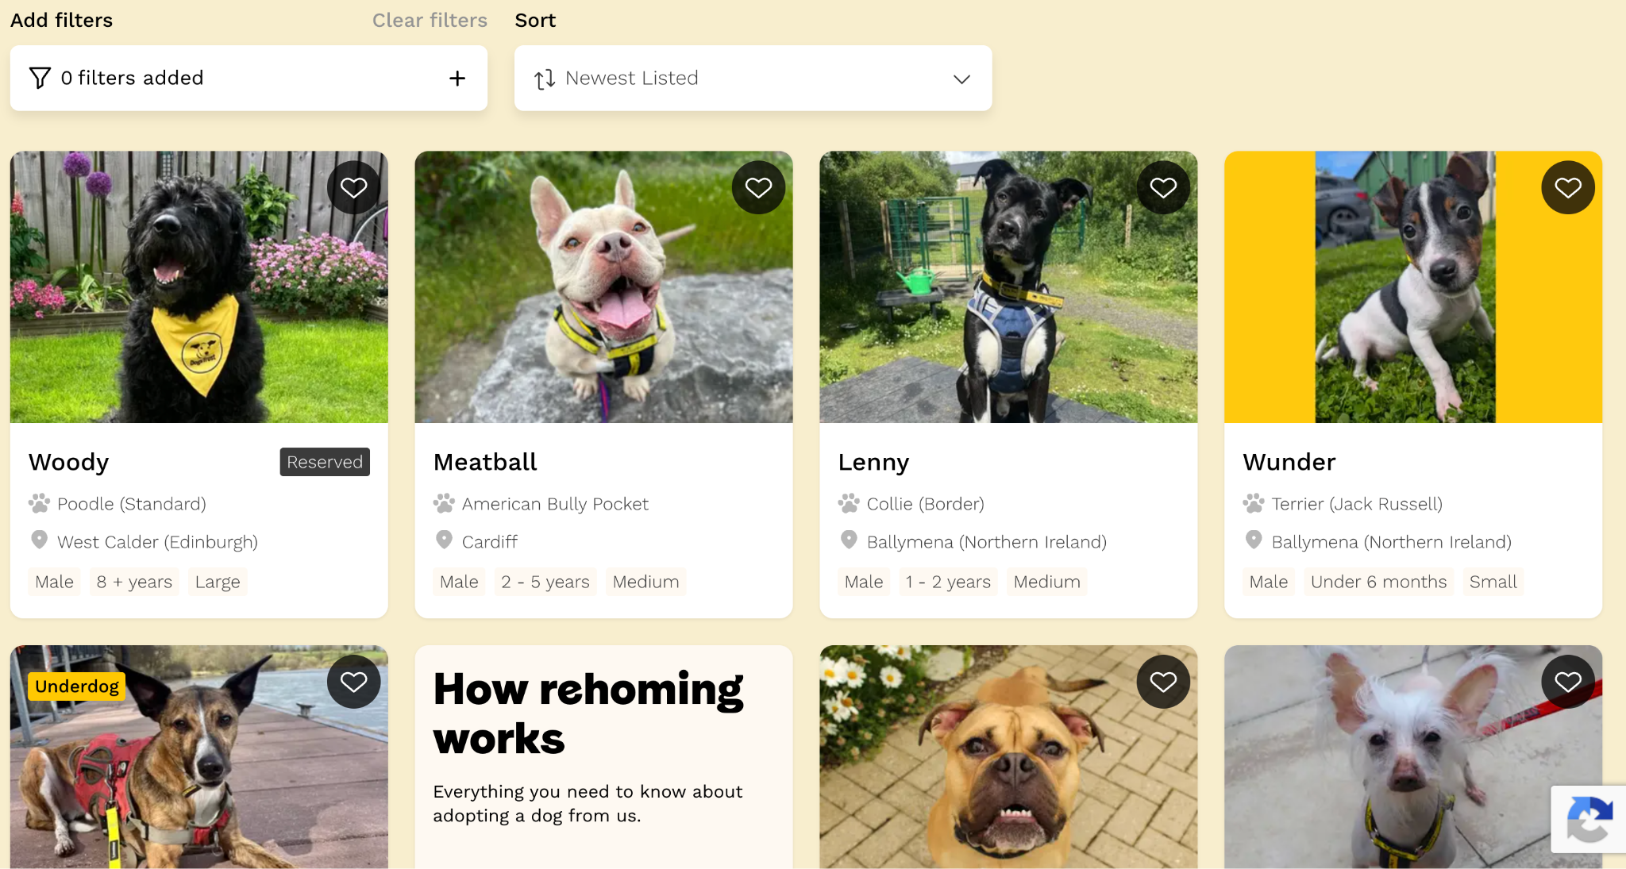
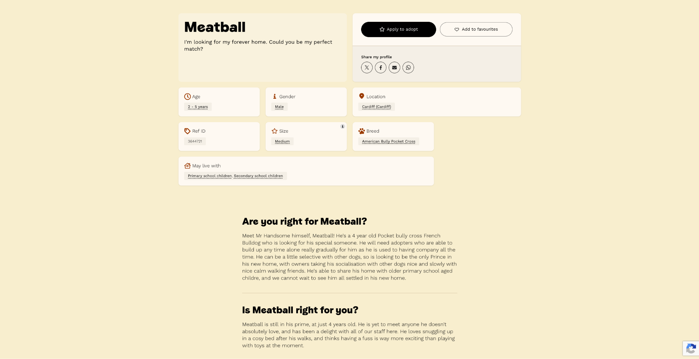
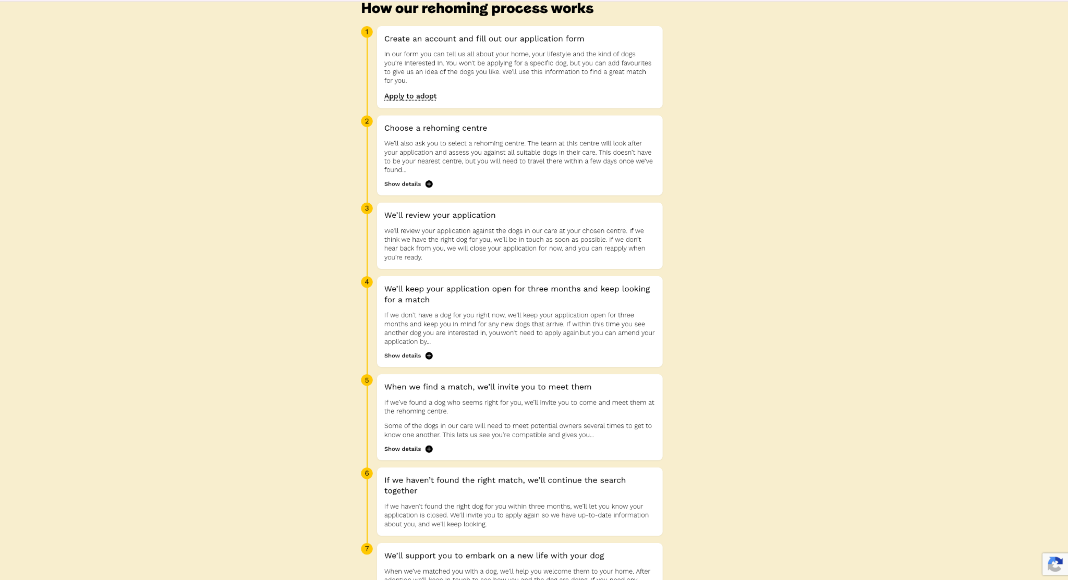
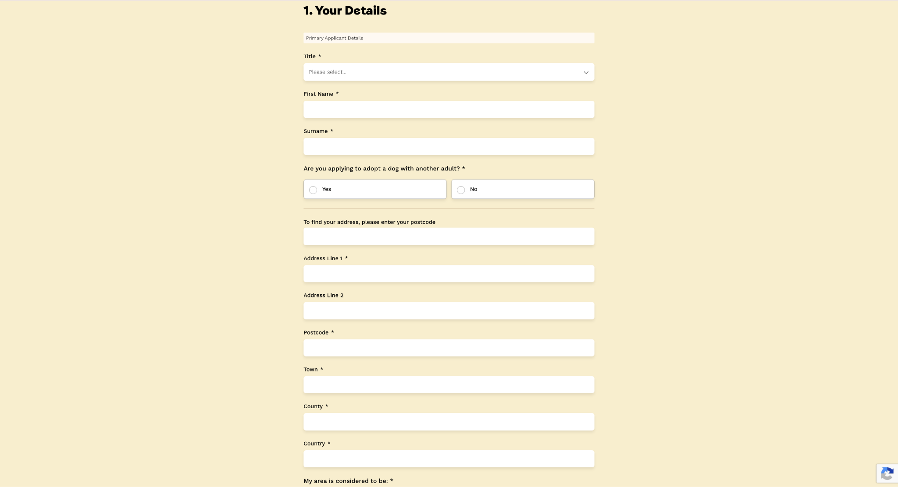

Positives | Negatives
Dog profiles display clear information about the dog such as the age, gender, breed, size, location and whether the dog can live with children. | The system only supports dogs so people interested in different animals must use another service.
The profile also includes the dog’s personality, behaviour and required home environment. This helps the user with making a decision on how the dog acts rather than from looks. | Users are not immediately told how well they match. Especially as suitability is assessed manually, so users have to wait.
Users only have to complete the application once rather than for each dog | The system does not explain which individual requirements the adopter meets or fails to meet
Users can add up to four favourite dogs. | The user must select a particular rehoming centre and be able to travel there when a match is found
Applications remain active for three months, so the user can be considered for dogs that arrive later. | Not every available dog is shown on the website meaning users cannot browse the complete set of possible matches themselves
Dogs are assessed by behavioural and veterinary staff before being matched, making the final decision more credible. | The bright yellow colour may be distracting and make it harder to read.
There is a strong yellow, black and white colour scheme making their branding recognisable. | The large photographs and sections mean that only a small amount of information is visible at once, so users must scroll frequently.
Large photographs are used for each dog to make it more appealing to adopt | Some pages are very long and contain several sections such as the ‘About us’ page, which may feel overwhelming.
There is plenty of white space between sections, preventing pages from appearing cluttered | The similar appearance of every dog card may make results look repetitive.
Important buttons such as apply to adopt and add to favourites stand out. | On smaller screens, the large images and vertically arranged content could require significantly more scrolling.

IMPACT ON MY SOLUTION
Dogs trust has influenced me to collect information about the adopter’s home, lifestyle and preferences only once and reuse it when comparing with different animals. I will also create similar animal cards which have detailed information about each animal. It will also contain another section with personality, behaviour and home requirements.
However, my system will differ as it allows for many different species and will automatically give partial feedback whether they are suitable but ultimately leave the final decision to staff.
They have also influenced me to use a consistent colour scheme, clear headings with organised animal cards. I will make buttons easy to identify.
I will avoid bright colours, long pages and make mine less overwhelming and simple to use.

Example 2 - RSPCA
The RPSCA Find a pet website allows a user to search for several different types of animals. Its pages use photographs, clear heading and separate content sections to present animal information.

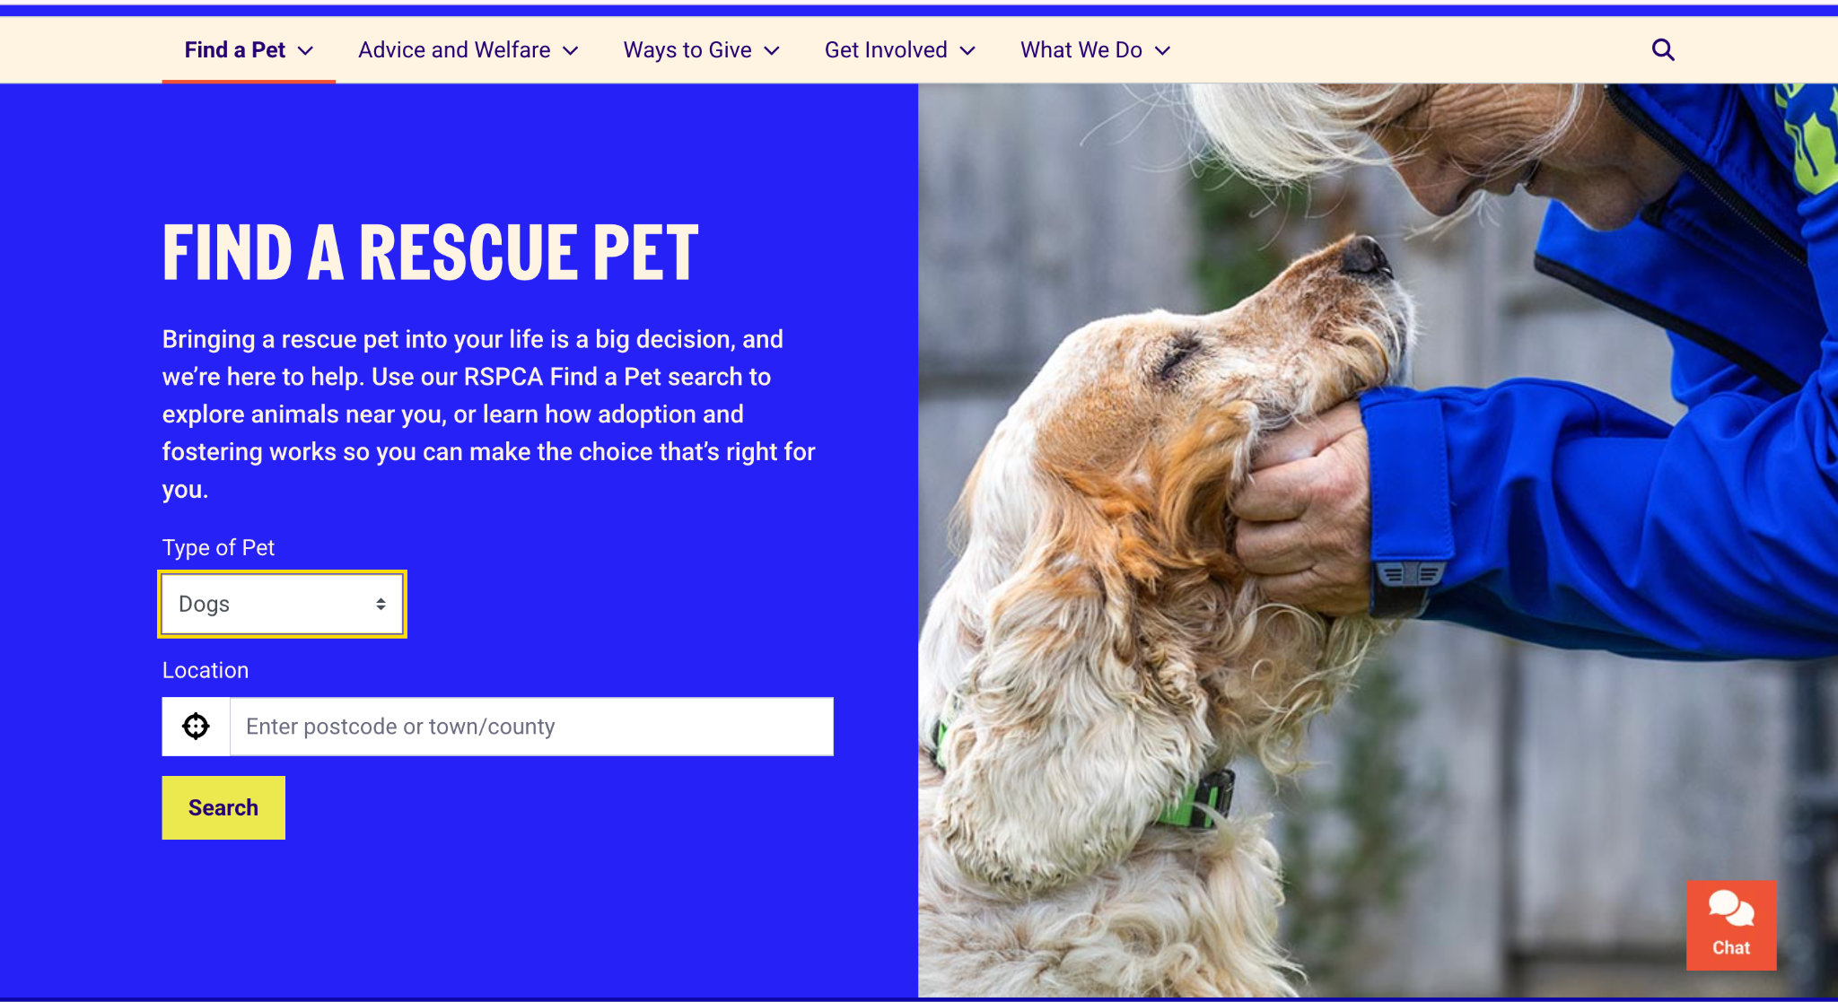
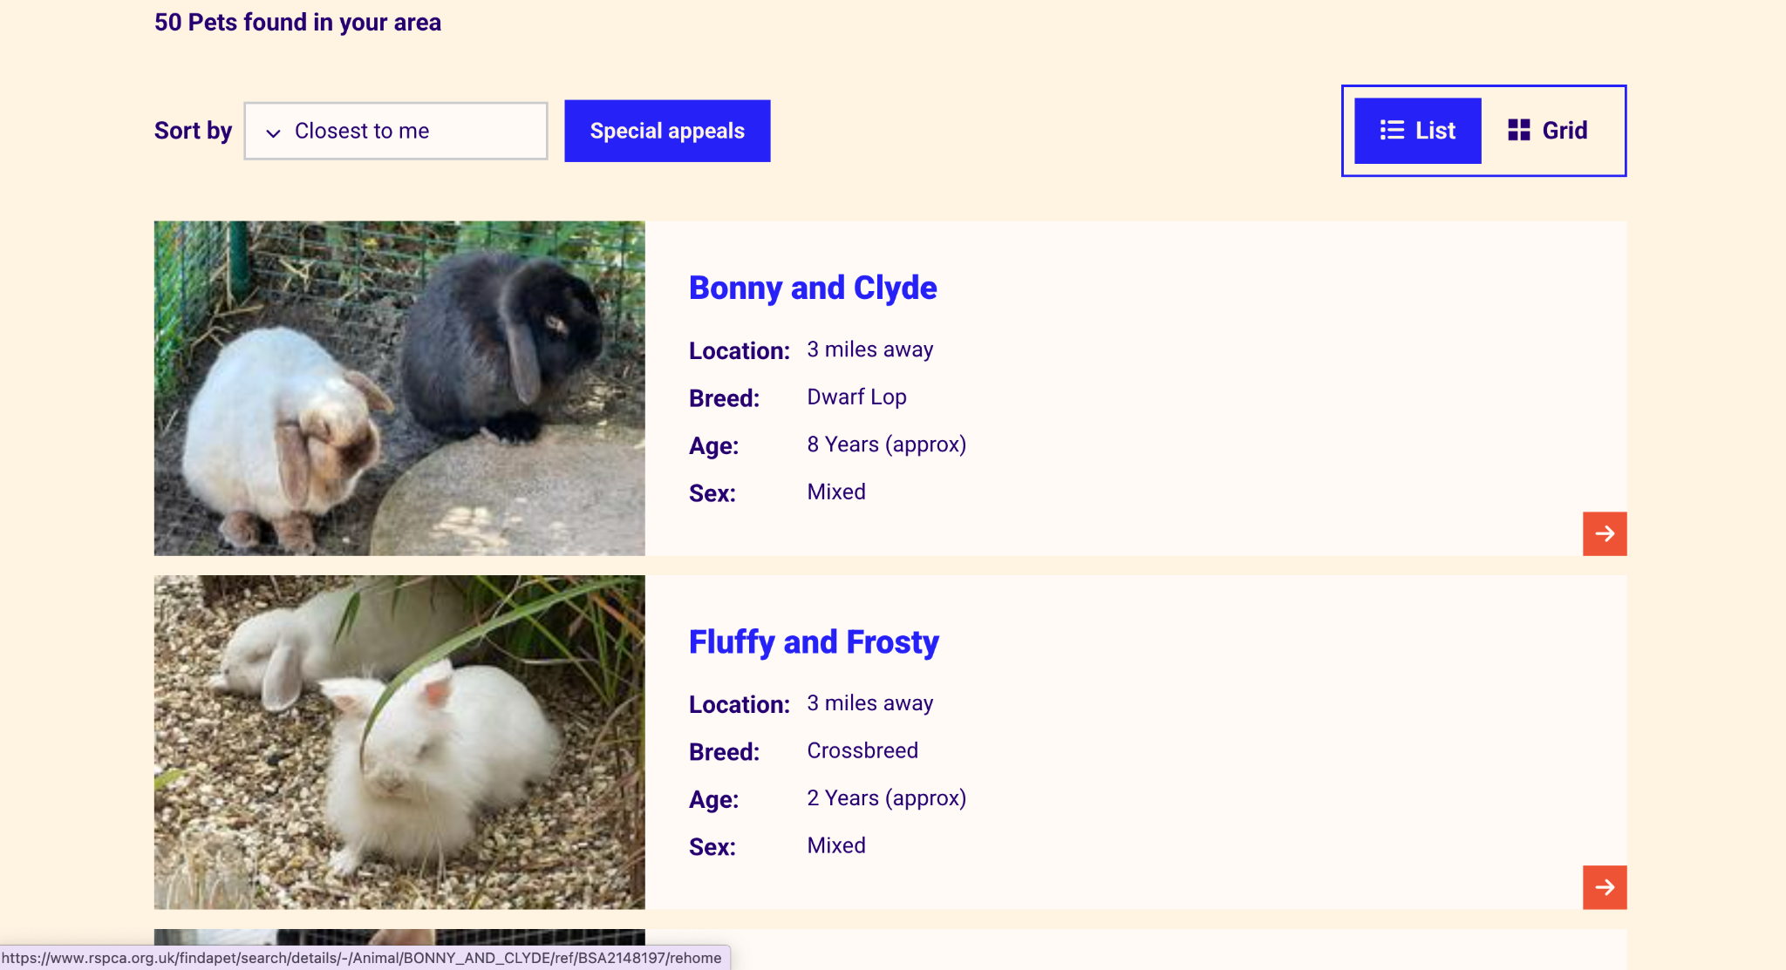
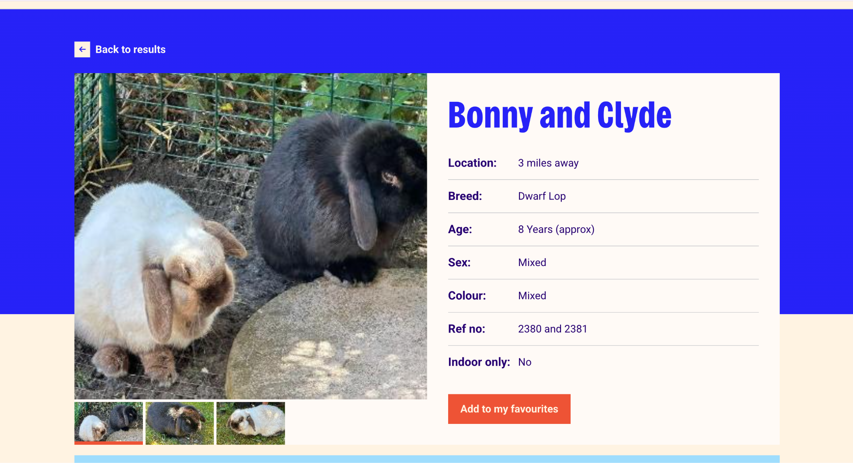
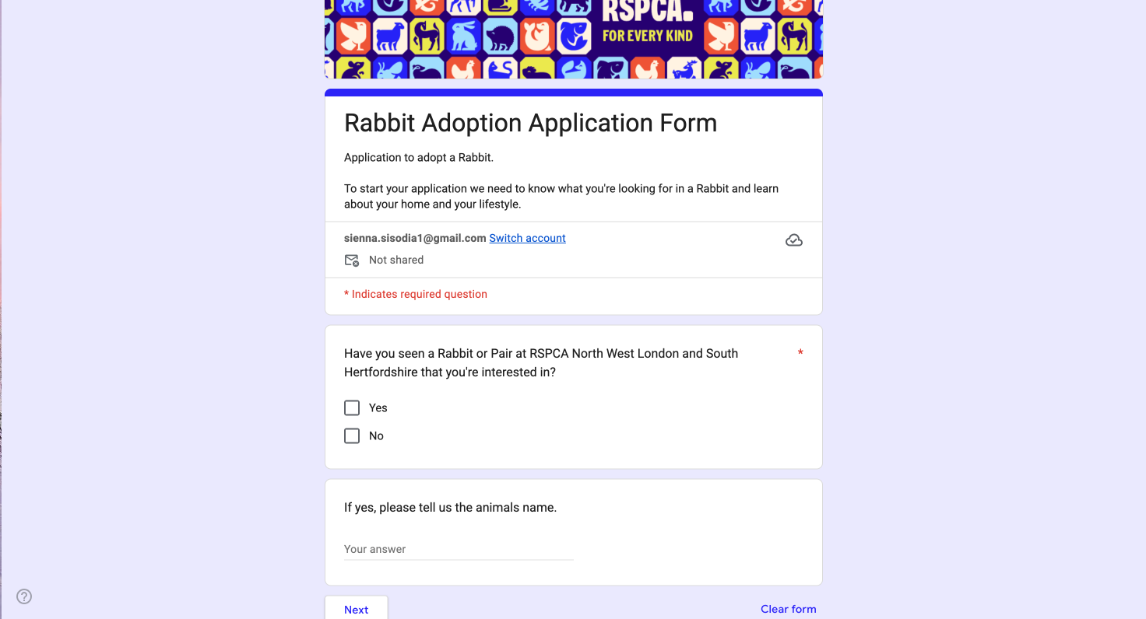

Positives | Negatives
Large animal photographs make the website visually appealing and immediately attract users' attention. | Applications are all reviewed manually by staff. The user does not receive an immediate result and should normally wait up to 48hours for a response. (Although this may vary between branches)
The colour scheme fonts and button styles remain consistent which allows the website to appear professional | The website contains many navigation options as it covers more than adoption, which may overwhelm some users. The number of filters and controls may make the search area appear crowded.
They support a wide range of species, rabbits, hamsters, guinea pigs. This is more similar to what I want within my system as it doesn't just support cats and dogs. | Some sections which are important and not important have a similar appearance which may make it hard to show what is important and allow it to stand out.
Each animal has an individual profile explaining needs, allowing adopters to consider suitability before applying. Applications also are reviewed by trained staff meaning factors for a computer to assess still can be considered. | Some important details are only available after opening the full animal profile.
They also have a feature for support after adoption, including behaviour services and pet care advice. This also could reduce chances of adoption failing after the animal entered a new home. | It may be hard to objectively analyse if they are suitable for the animal due to the lack of numeracy.
RSPCA may suggest alternative animals when the selected animal is unsuitable. | Procedures and costs may differ between RSPCA centres and branches, which does not allow for consistency which may confuse the user.
Search controls and filters are clearly labelled helping users understand what information they need to enter. | The published process requires applications to be started from an animal's profile. This may cause users to repeat parts of the process when interested in another animal.
Information is divided into sections with headings, helping users distinguish between different types of contexts. | Some centres only allow people to view animals by appointment after choosing a pet, this reduces the ability to visit freely and compare animals in person before applying.

IMPACT ON MY SOLUTION
The RSPCA has influenced me to support a wide range of animal species and organise them into clear categories. I may include simple species categories, but the main method of finding suitable animals will be the compatibility questionnaire and ranked recommendations. It has also inspired me with its layout and visual design. I like its consistent colour scheme with clear headings.
However, unlike the RSPCA, my system will calculate a numerical suitability score, explaining which requirements have and have not been met. It will also use a simpler navigation system focused solely on adoption, preventing users from becoming overwhelmed.

Example 3 - Petfinder
Pet finder is my closest competitor to my proposed system as it provides a short adopter questionnaire, and the system displays compatible pets. This website also includes a “See how you match” option. Animal listings contain information of the dogs such as age, housetrained ability and whether it can live with other animals. Users can also favourite animals.

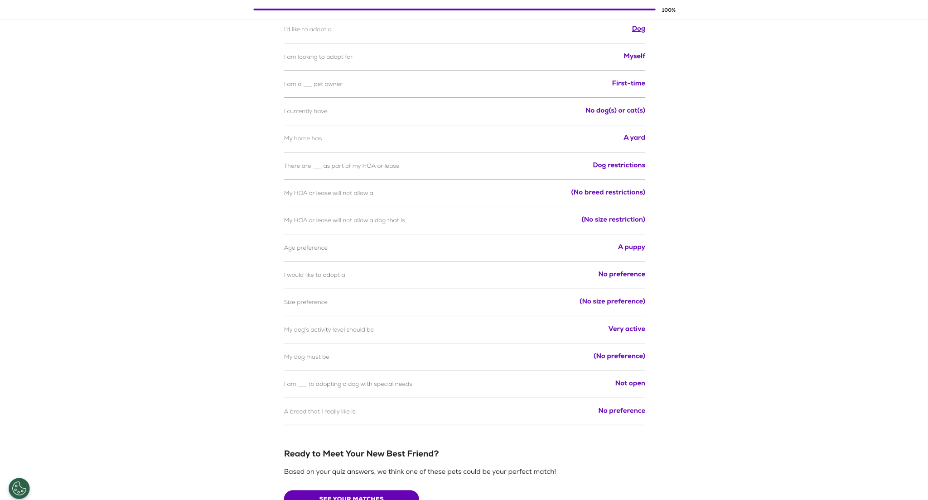
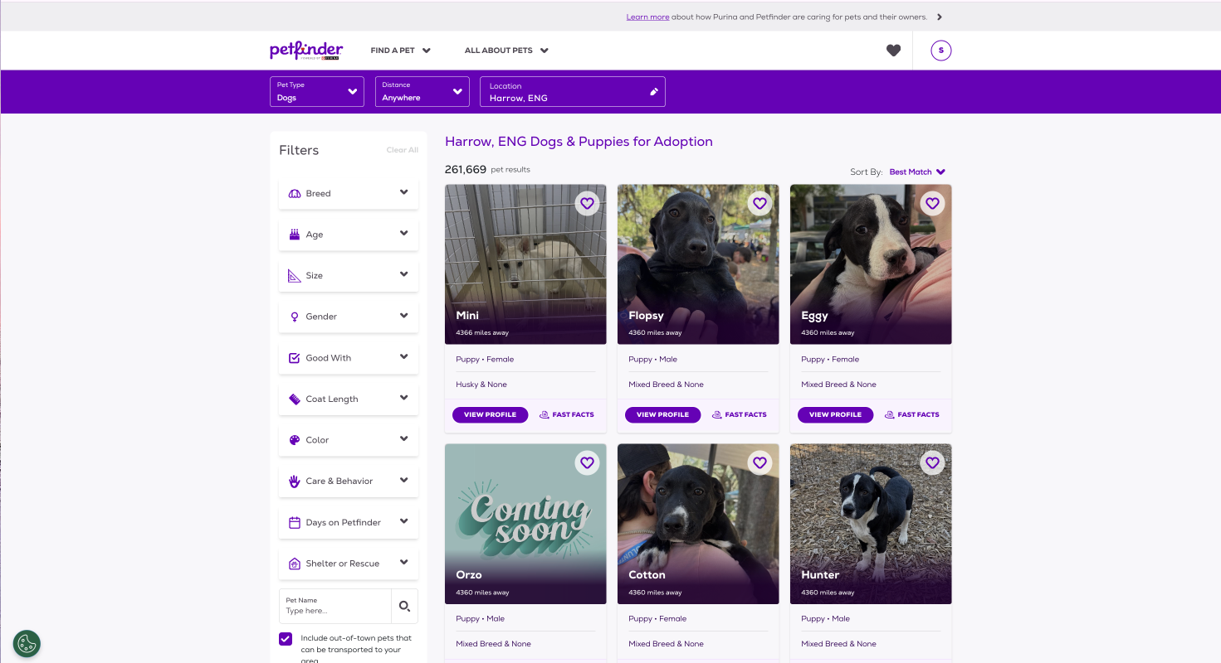
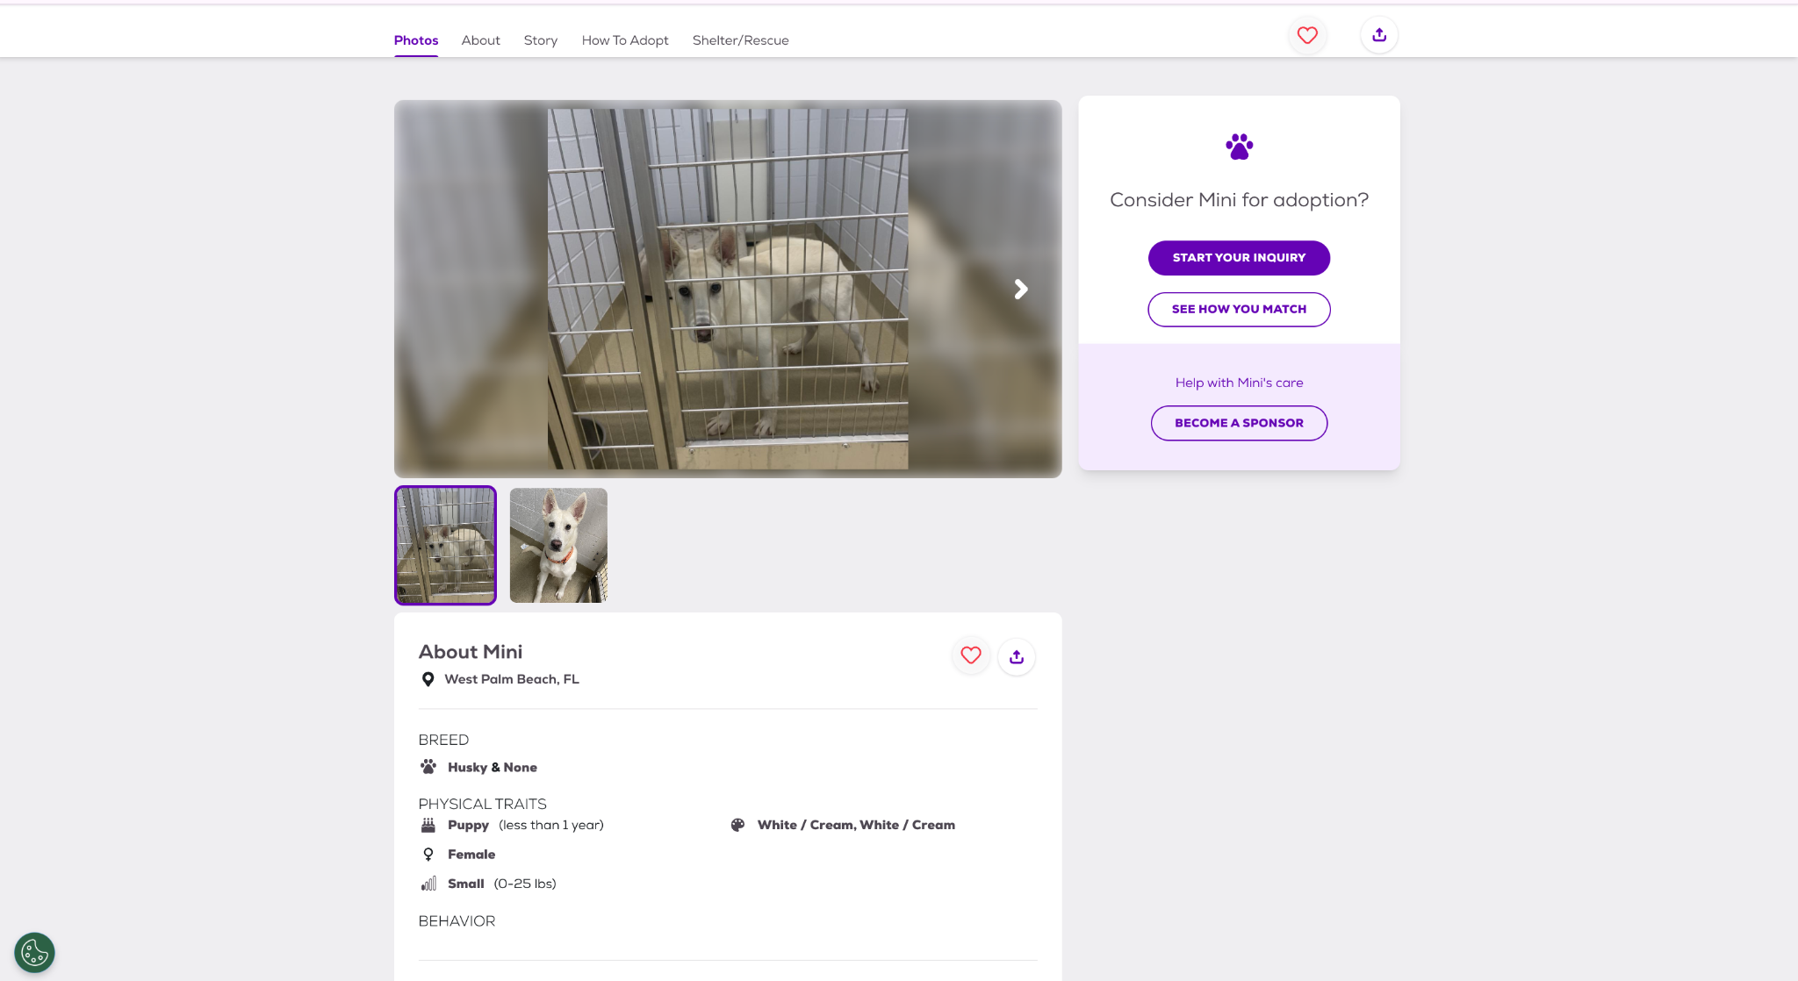
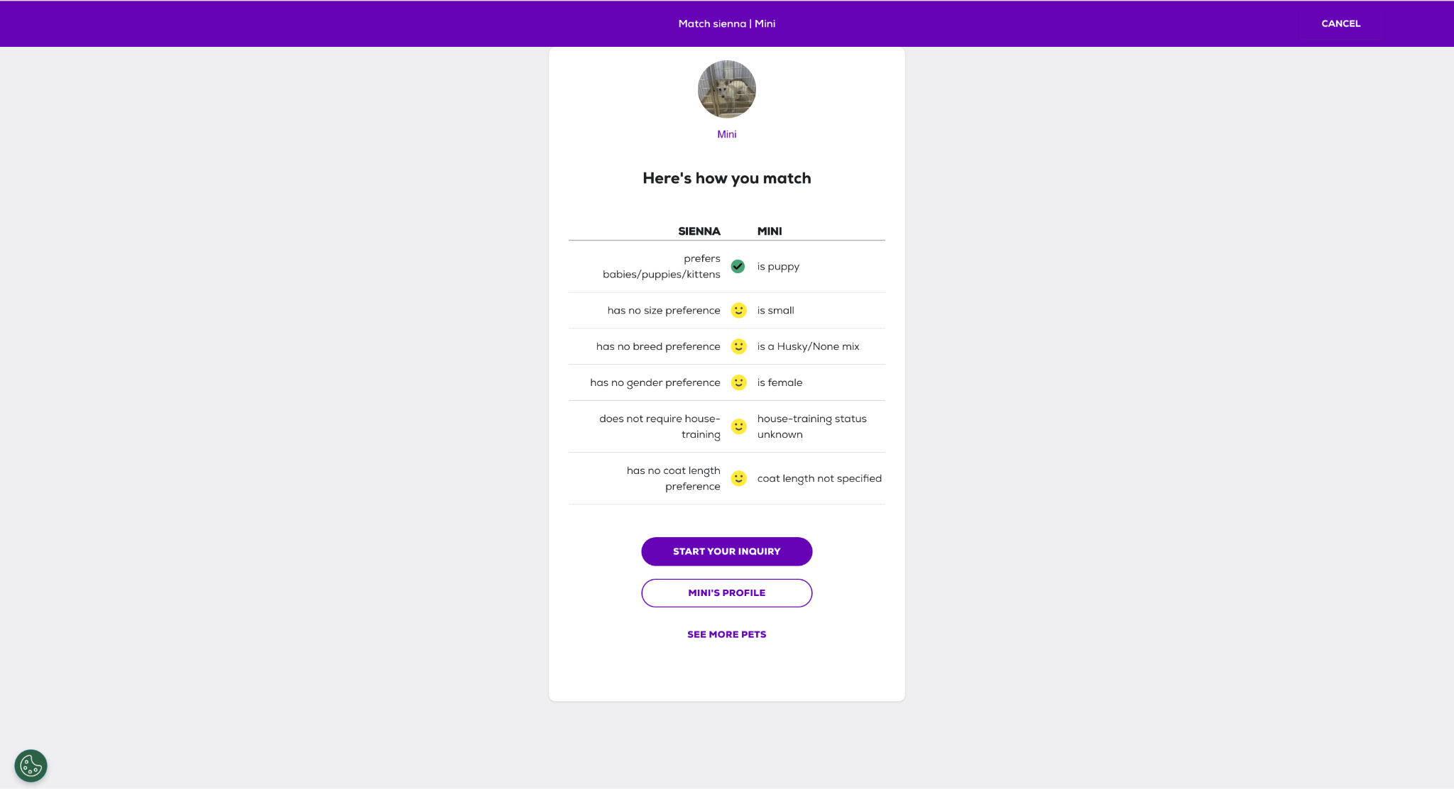

Positives | Negatives
The search filters allow users to quickly narrow down the large number of available animals | The large number of filters and listings could overwhelm some users.
Animal cards are very clear and display a photo and important information such as the name, age and breed | It may not be as colourful and bright as the other examples.
The animal profiles are detailed and show information about the personality, medical needs and compatibility with children or other pets. | The automated matching appears to focus mainly on cats and dogs rather than equal support for every species.
Users can save animals as favourites so they can return to them later. | A visible suitability percentage is not provided making it harder for users to compare matches
The adopter questionnaire can provide more personalised recommendations then a basic search. | Information can be incomplete or marked as ‘unknown’ as each shelter is responsible for entering its own animal data
Important actions such as ‘start your enquiry’ and ‘see how you match’ are clearly labelled and easy to identify, allowing ease of use for the user. | The rescue organisation may ask the user to complete another official application, causing information to be entered more than once. This also may mean the information provided may be inconsistent as different rescue organisations manage their own listings.
Pet finder brings listings from thousands of different shelters and rescues into one website. | Several actions appear on the same profile, including enquiring, matching and sponsoring which may compete for users’ attention.
Data can be saved by creating a login. | Some less important promotional content may distract users from main adoption features.
Bold headings divide profiles into clear sections such as behaviour, health compatibility and adoption information. | As individual shelters manage their own listings, an animal's availability may not be updated immediately. Users might need to contact the shelter to confirm whether an animal is still available which may be an inconvenience for the user.

IMPACT ON MY SOLUTION
Petfinder’s system has strongly influenced the design of my system. I am inspired how the survey is divided into clear manageable questions rather than displaying a long form at once. I will use a similar step by step structure with clearly labelled answer options and progress indicator, so the user knows how much of the questionnaire remains. I also like how it compares the adopters' preferences with animal characteristics in a clear table with visual symbols to show if each factor is compatible.
However, my system will provide more detailed feedback by displaying a numerical compatibility score and explaining which animal requirements have and have not been met. This will allow the several animals to be compared more objectively.

Overall Conclusion
My research shows that each competitor contains useful features, but none fully have all the requirements I want for my own system. Considering the design of dogs' trust, it has a recognisable and consistent interface where the information is presented very clearly. Dogs trust has a thorough application process even though it is only for dogs and does not provide immediate feedback. However, the frequent bright yellow may be visually distracting and long pages which can require excessive scrolling.
The RSPCA supports several species and organises animals into clear categories, but users must browse and select an animal before suitability is assessed. Their professional colour scheme makes it very recognisable and trustworthy, which may make people more intrigued to adopt. However, because the website contains services beyond adoption, its navigation can appear crowded and some important information may not stand out. Users will not be given instant or numerical feedback as they browse for an animal then begin the application. Only after staff are able to manually assess the suitability.
Petfinder is the closest competitor to my proposed system as it uses an adopter questionnaire and compares the user’s preferences with individual animals. However, it does not provide a clear numerical score making it harder to compare with many animals. Information may also be inconsistent because individual rescue organisations maintain their own animal records.

Client Interview

- What factors do people fail to consider before adopting an animal?
“I think a lot of people choose animals based on how cute they are without thinking how much work they can be. They often forget to consider things like how much space they have, how much time they can spend with their animal, how much it costs to look after, and whether they have experience caring for that type of animal. Some people also do not think about whether their home is suitable for the animal’s needs.”

- What information should be stored about each animal?
“Each animal should have basic information such as its name, age, breed, species, sex and a photo of the animal. It can also contain an extra information section such as personality, medical conditions, exercise needs, whether it gets along with children or other pets and special requirements other adopters should know about.”

- How should the system respond if the user is not suitable for the particular animal?
“I don't think the system should completely stop someone from adopting an animal, but it should warn them they might not be a good match. It should explain which requirements they don't meet and recommend other animals. This helps people make better decisions and reduce chances of animals ending up in the wrong home, but also not diverting people from adopting.”

- Do you think users should be able to apply for adoption directly through the system?
“No, I don't think users should be able to apply for adoption directly through the system. Although the system can help identify suitable animals, I still think adoption agencies should still carry out further checks in person. If staff are able to meet the adopter face-to-face they can assess personality, commitment and understanding of responsibility in owning a pet. It should aid the original process not completely take over that decision”
- What key tasks should the staff have on their side of the system?
“The key features the staff should have is being able to add, edit and remove animal records, update animal information, upload photos and mark animals as available and unavailable for adoption by deleting. The database should also be kept up to date.”

- What features would make the system easy to use for both staff and adopters?
“I think the main thing is that it should be simple and not confusing. People should be able to find what they are looking for quickly without clicking through loads of pages. It should be easy to browse animals and use the questionnaire, and for staff it should be straightforward to update animal information. Clear buttons, a clean layout and simple instructions.”

- What features should be displayed on the homepage?
“I think the homepage should show information about how the adoption process works and a button to complete the questionnaire. The homepage should be welcoming and make it clear what the website is for.”

- Should users be able to search for animals, if so, what filters should be available?
“Yes, I think users should be able to search for animals as it makes it much easier to find a suitable pet. Filter categories could be the type of animal, breed, age, size and activity level, but mainly type of animal and size.”

- What information should users provide when creating an account?
“Basic information such as name, email, address, phone number and a password when creating an account. You could also include the age to ensure they are old enough to adopt the animal.”

- Should some factors have a greater impact on the compatibility algorithm than others and if so which factors?
“Yes, I think some factors should matter more than others. Things like available space, allergies and whether there are young children in the house should have a bigger impact. For example, if someone is allergic to cats, they should not be strongly matched with a cat, even if the rest of their answers are suitable. Less serious factors such as preferred age or breed, should not be considered as important as the animal’s safety and wellbeing.”

- Do you want the website to look a specific way? Any colours, fonts etc. It would also help if you gave specific examples of apps, you like
“I would like the website to have a cute and friendly look rather than it being too serious. Soft pink and pastel colours would make it feel more welcoming and enjoyable to use. I think the design should be simple but visually appealing, with lots of photos of the animals and clear buttons. The main thing is that it feels approachable and encourages people to engage with the adoption process.”

- Do you have any security concerns regarding the app?
“Yes, I think security is important because the system will store users' accounts and animal records. Passwords should be protected, and only staff should be able to add, edit or delete animal information. Regular users should only be able to browse animals and complete questionnaires, not change anything in the database.”

- Which devices do you want it to work on?
“I want the system to work on both laptop and desktop computers, as these will be mostly used by adoption agency staff.”

- What should happen after a user receives their compatibility results?
“I think the system should show users the results in a clear way and provide them with more information about any animals that are a good match. What happens after that would depend on how the adoption agency wants to use the system.”

- Are there any features that you believe are essential for the success of this system?
“The compatibility scoring system is probably the most important feature as it helps match animals with suitable owners. Additionally, the animal profiles need to be detailed and up to date so the users will have all the information they need before making a decision”

Overall, the client interview provided valuable insight into the function and design requirements for this system. The client identified that many people fail to consider factors such as available space, time commitment, allergies and previous experience before adopting an animal. Therefore, these factors will be incorporated into the compatibility questionnaire and scoring algorithm. The compatibility algorithm should use weighted factors so that important requirements such as allergies, children, other pets and living space have a greater impact than softer preferences such as preferred breed or age. The client also highlighted the importance of maintaining and up to date detailed animal profiles and providing staff with ability to edit, add and remove animals through an administrative interface. For the design, the client wants a simple, easy to use interface with clear navigation, animal photographs and soft pastel colours to make it a friendly interface. The client also is very focused on security ensuring only staff can change details within the database regarding the animals.

Stakeholder Survey
This stakeholder survey received 27 responses, which gave me feedback from a range of potential users.
QUESTIONS:

- Have you ever owned a pet before?
- Yes
- No

- If you did own a pet, did you adopt it from a centre?
- Yes
- No
- N/A

- How would you normally choose a pet?
- Appearance
- Personality
- Breed
- Lifestyle Compatibility
- Advice from experts

- How important do you think it is to research an animal before adopting?
- Very Important
- Important
- Neither
- Not Important
- Not very important

- Which factors do you think should be considered when matching an animal to an adopter? (Select many)
- Living Space
- Garden Access
- Income
- Experience with animals
- Time available
- Presence of Children
- Other pets

- How important is it that an adoption website is easy to use?
- Very important (1)
- Slightly important (5)

- Would a compatibility score influence your decision when adopting an animal?
- Yes
- No

- Do you think adoption agencies should use a compatibility scoring system?
- Yes
- No

- How concerned are you about the welfare of adopted animals?
- Concerned (1)
- Not Concerned (5)

RESPONSES:

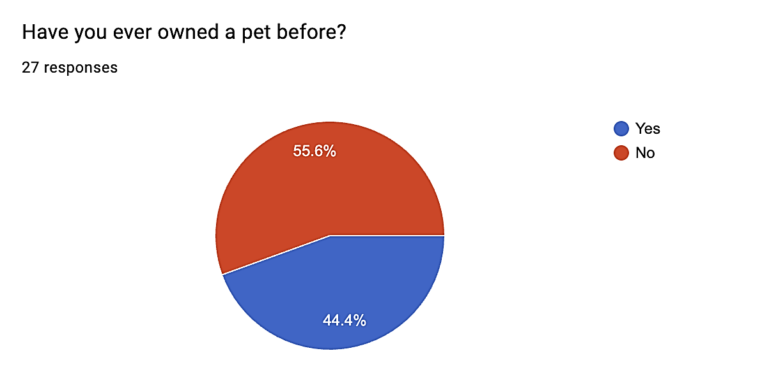
Analysis:
44.4% of respondents said yes, while 55.6% said no. This shows that my survey consists of a mixture of people with and without pet ownership experience. This is useful as my system needs to be able to support experienced and inexperienced adopters. This means the system should not assume that users will already understand animal care or adoption requirements.

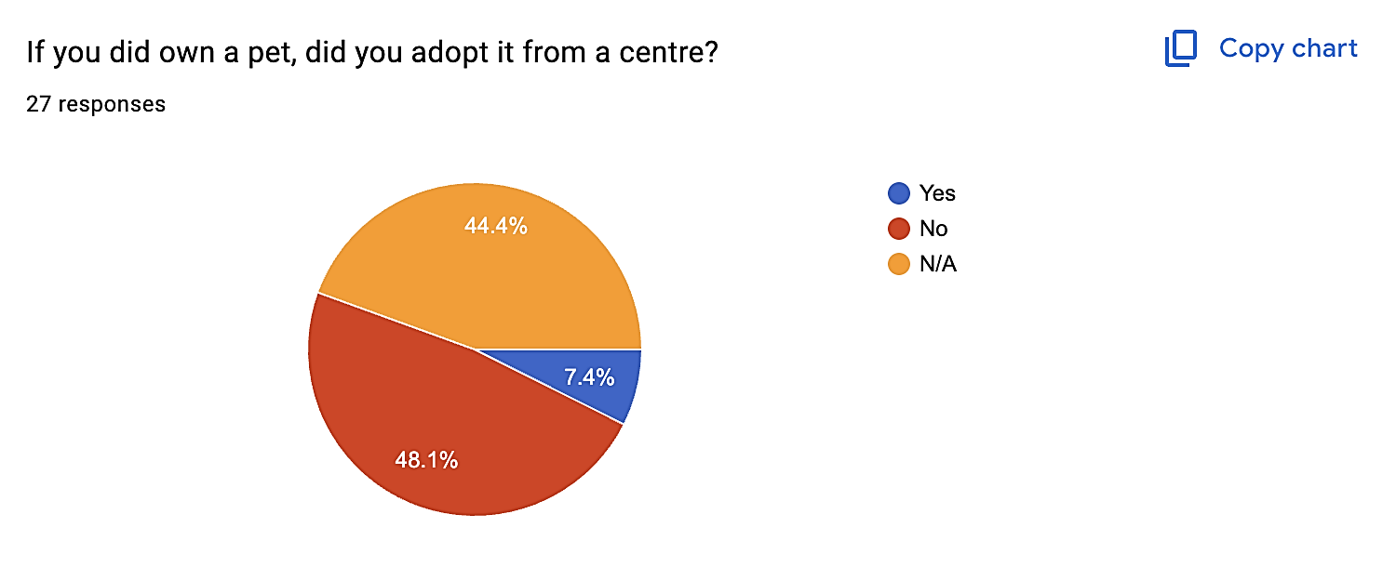

Analysis:
These results show that very few respondents have experience adopting from an adoption centre. This means my solution should clearly explain the adoption process and avoid making it confusing for users who have no experience.

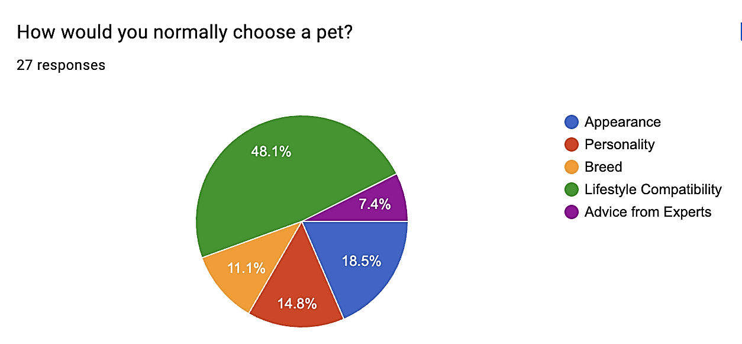
Analysis:
The most common answer was lifestyle compatibility, chosen by 48.1% of respondents. This shows most users already do care about which animal fits their lifestyle rather than just how the animal looks, even though a few care about the aesthetics of the animal. This will allow my system to be suitable for those looking to adopt.

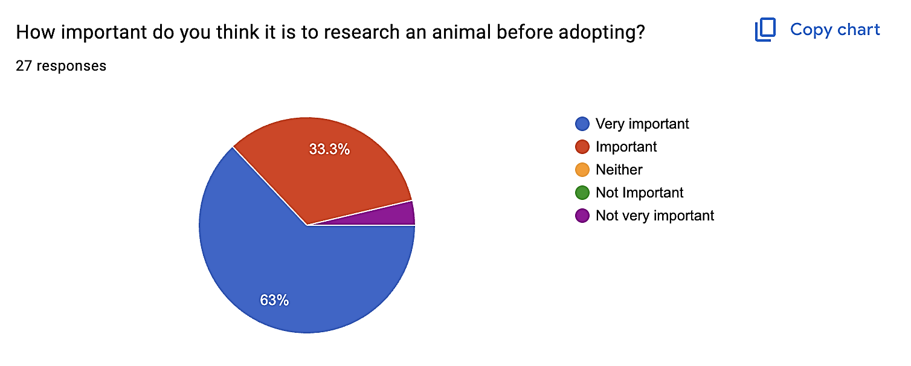

Analysis:
63% of respondents said it was very important, and 33.3% said it was important. This means that 96.3% of respondents agreed that research is important before adopting an animal. This supports my idea that websites should include detailed animal information.

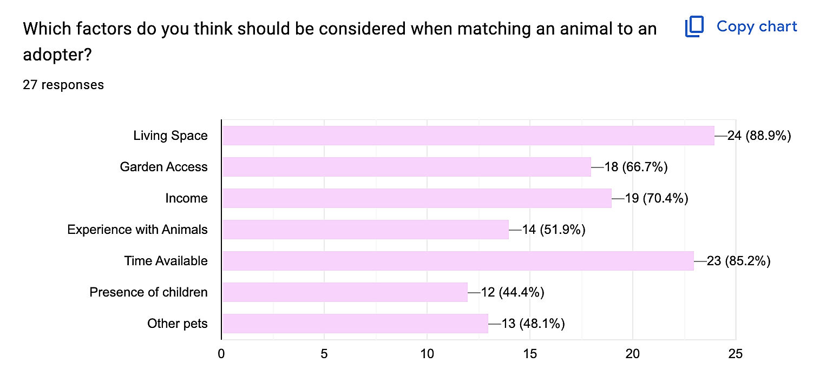
Analysis:
The most selected factors were living space at 88.9% and time available at 85.2% showing that respondents think an adopter’s environment and lifestyle are the most important parts of a successful match. Income and garden access were also highly chosen showing that practical care needs should be considered primarily.

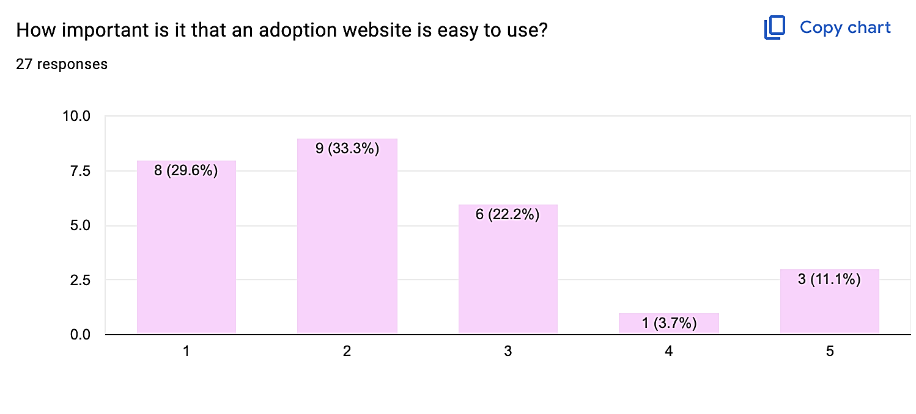
Analysis:
Most responses were grouped around the higher end of the scale, which suggests that ease of use is important to users. As a result, I would like my website to have a simple layout, clear navigation, readable text and easy process. I aim to make it as accessible as possible.

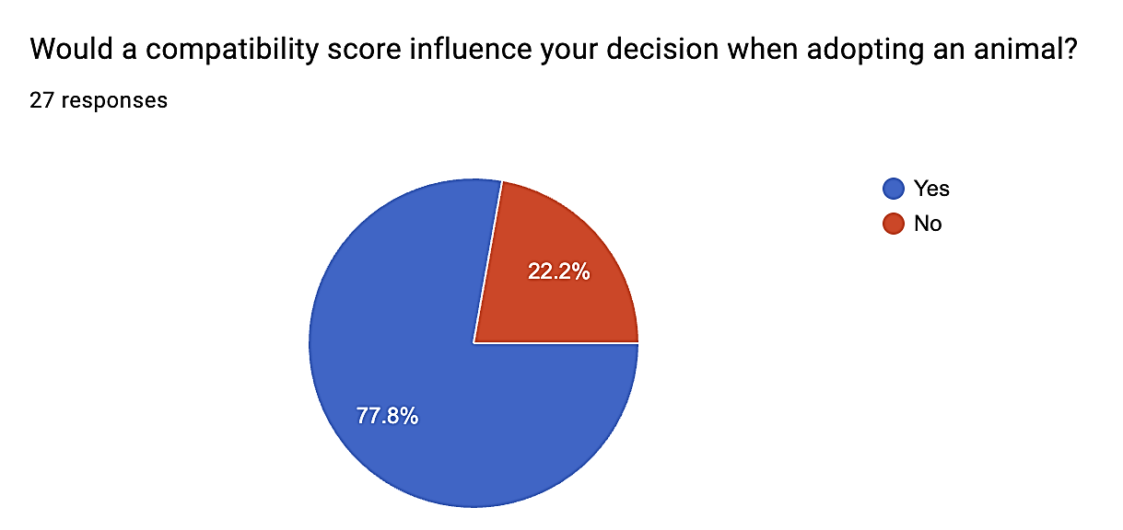
Analysis:
77.8% of respondents said yes and 22.2% said no. This shows that most users may find a compatibility score helpful when deciding whether an animal would be suitable for them.

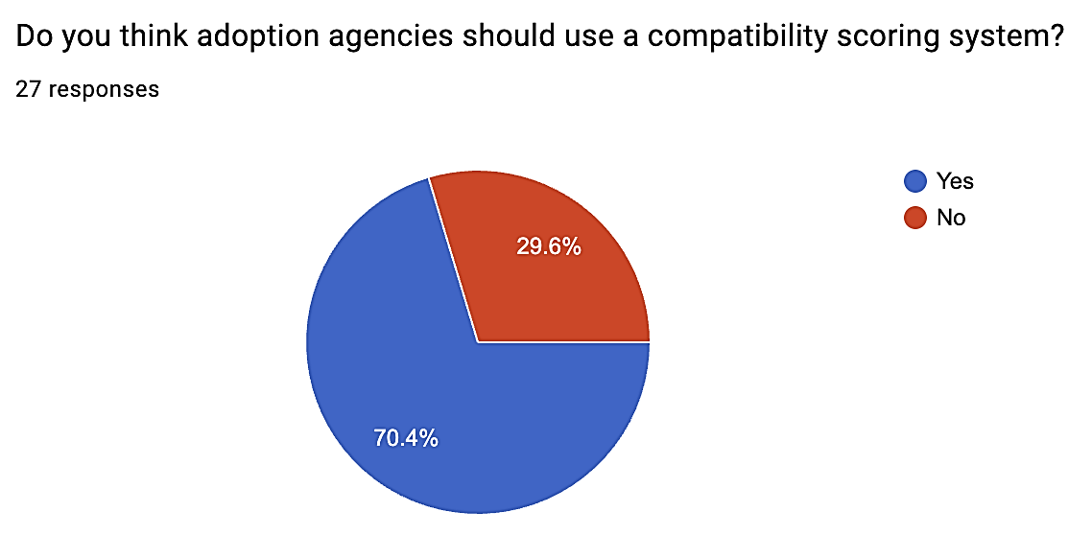

Analysis:
70.4% of respondents said yes, while 29.6% said no. This shows that respondents support the idea of adoption centres using this scoring system, but not everyone agrees. Therefore, the compatibility score should be used as a guidance but not as the deciding factor.

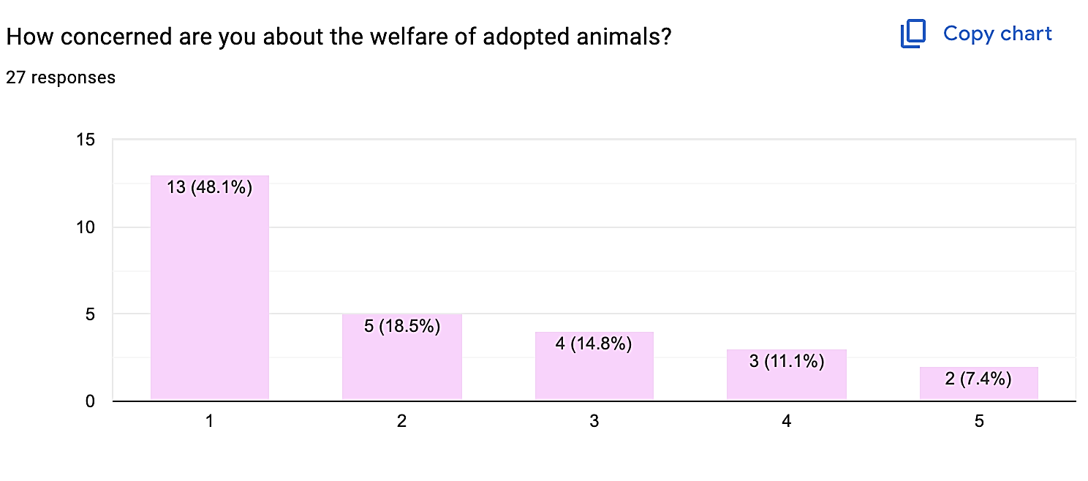
Analysis:
The largest group of respondents selected 1, with 48.1% and 18.5% selected 2. This shows that many respondents are concerned about animal welfare. This supports the purpose of this system as it aims to reduce unsuitable adoptions by helping users find animals and reduce chances of animals being placed in unsuitable homes.

Overall:
Overall, the survey shows that there is a clear need for a pet adoption system that helps users make informed decisions. Most respondents have shown that they agree that research is important before adopting an animal and would be influenced by the compatibility score. This survey also shows that the important factors include living space, time available, income, garden access and experience with animals.

My solution should include detailed animal profiles, a user questionnaire with a compatibility scoring system, where lifestyle compatibility will be the most important and popular factor in choosing an animal. This system should also be easy to use as users will have different levels of experiences with pet ownership and adoption.

However, one limitation of this survey is that it only received 27 responses, so it may not represent all potential adopters, and some respondents may have limited experience with adoption centres. It still provided me with guidance about common user expectations, especially importance of ease of use, animal welfare and compatibility scoring.
This survey was insightful to help me understand what potential users would expect from an animal adoption system, especially the need for clear information, lifestyle based matching and a compatibility score.

Prefixes: E—Examples | Q—Client Interview |S—Stakeholder Survey

Features
# | Feature | Notes | Justification | Source
1 | Clean user interface | Calm colour scheme, clear headings, identifiable buttons and a clear layout | Makes system easier to understand and use, especially for those not confident with technology | S6, E3, E1, E2
2 | Navigation bar across different pages | Allows users to move between pages easily | Competitor websites used simple navigation, which helps reduce confusion and makes system more user friendly | E1, E2, E3, S6
3 | User Home page | This system will include a clear home page introducing the purpose of adoption matching system | Simple starting point, and helps user understand system is focused on adoption suitability rather than browsing animals | E1, E2, E3
4 | Animal preview Page | Users will be able to view available animals using compact animal cards. Each card will show key information such as name, species, breed, age and image. | Compact cards will make it easier for users to compare animals without needing to open every profile individually | E1, E2, E3
5 | Animal Profile Page | Each animal will have a detailed profile page containing information such as name, species, breed, age, sex, personality, medical needs, exercise need and suitability requirements | The client stated that the animal profiles should show key details about the animal, which is also required for the matching algorithm | Q2, E1, E2
6 | Multi Species Categories | Animals will be organised by species such as dogs, cats and rabbits | The RSPCA also has different animal categories, whereas dogs trust is just based around dogs. | E1, E2
7 | Adopter Questionnaire | Users complete a questionnaire about their lifestyle and animal experience and will include many other answers which will contribute to the compatibility scoring algorithm. | The client stated that adopters often fail to consider important factors before adopting, this will allow them to reflect on their suitability before decisions are made. | Q1, S4, S5
8 | Step by step questionnaire layout | This questionnaire will be split question by question instead of being displayed as one long form, with dropdown options. | This makes the process easier to complete and reduces the chance of users feeling overwhelmed. | E3, S6
9 | Input Validation | To check if data that is required is not left blank and the data is valid. | Preventing the incomplete or incorrect data being used by the matching algorithm, recommendations more reliable | Q15, S8
10 | Compatibility scoring algorithm | The system will compare the adopter's answers with each animals requirements and calculate a numerical score. | The main computational feature, allows animals to be recommended on suitability | E3, S7, Q10
11 | Ranked animal recommendations | After the questionnaire is submitted, animals will be displayed in order from most suitable to least suitable | Removes need for user to manually search through every animal | Q14
12 | Requirements Breakdown | The system will show which requirements the adopters meet and which requirements they do not meet for each animal. | Helps users understand why an animal has received a particular score. | E3, Q3
13 | Unsuitable match warning | If the user does not meet the requirements, the system will display a clear warning | The client said the system should not completely stop a user from adoption but warn them if they are unsuitable and why | Q3
14 | User registration system | Users can create an account by registering with personal details such as name, email and password | Users can save progress, access their questionnaire and personalise their own experience | Q9
15 | User and Admin Login and Logout system | Registered users will be able to securely login and logout their accounts and staff can login securely to access management side of the system | User login ensures data is only accessible to the correct user and  admin login prevents normal user from changing animal records and protects accuracy over database | Q12
16 | Admin animal management | Admins should be able to add, edit and delete animal records | Animal information should be kept up to date when new animals arrive, details change or animals are adopted | Q5
17 | Database Storage | System will need to have a database alongside to store animal records, user accounts, admin login details and adopter questionnaire details | So data can be stored, searched, updated and used by the matching algorithm | Q15
18 | Responsive streamlit design | I will use Streamlit layout tools so pages remain clear on different screen sizes. | This makes system easier to use on different laptops or tablets without information being cut off or difficult to read | Q6, E1, E2, E3, S6

Hardware and Software Requirements

The technology used to build this system is based on the features that my client requires. The list of requirements is as follows:
- Clean user interface
- User registration and login
- Admin login
- Database storage for animal records, user accounts and questionnaire answers
- CRUD functionality for admins
- Input validation
- Compatibility scoring algorithm
- Ranked animal recommendations
For this project, I will develop my system on my MacBook, which has the required hardware and software capabilities to develop, run and test my system.

Developer
Hardware:
Device: MacBook Air, 13 Inch, M3 2024
Processor: Apple M3 Chip
RAM: 8GB
Display: I will use the 13.6 inch built in retina display alongside a 13 inch monitor
Input: Keyboard and Trackpad
Internet Connection: This is required in order to install packages, access documentation and test deployment.
This hardware is suitable as my system will not require advanced graphics processing or a powerful server. The main processing will be form input, database queries, validation and the algorithm, which is perfectly suited for my laptop.

Software:
Operating system: MacOS Sequoia 15.0
IDE: Visual studio code
Programming Language: Python
User interface framework: Streamlit
Database: SQLite
Database module: sqlite3
Browser: Chrome
I will use some additional libraries such as pandas which may be used to organise and display data in tables.

I have chosen python as my main programming language as it is the one I am most confident in, therefore I will not have to spend as much time trying to learn another language when python is suitable enough. It is suitable to create the matching algorithm, validating user inputs and all the functionalities my system requires. It allows me to be more efficient and focus on the computational parts of the system such as the comparison between adopter answers and animal requirements producing compatibility scores.

For my user and admin interface I will be using streamlit. It is simpler to use than using tkinter and it provides built in tools such as buttons, forms, dropdowns, columns, containers and page navigation. This allows me to create the pages without using a full HTML, CSS and JS website.

For data storage I will use SQLite as it is what I have the most experience in. It is suitable and easy to use to store data required for my system such as animal records, user accounts, admin login details, questionnaire answers and compatibility results.

User + Admins
My product will be a streamlit application, so users and admins will only require a device that accesses the system through any web browser., If deployed online, users will require an internet connection and they do not need to install any modules. They could access from a laptop, desktop computer or tablet, which may require a mouse, keyboard and a monitor to present the graphical user interface or even touchscreen if using a tablet.

Limitations

The system will be built in order for one specific animal shelter rather than a large organisation such as the RSPCA. This means that the database will only need to store the animals, users and admin accounts linked to that shelter. This is a large limitation as creating a system for multiple shelters would require extra features such as shelter admin accounts and location based searching and overall a larger database structure. This will be extremely difficult with the experience I have and would increase the complexity of my project. Furthermore, this would make development and testing less realistic within the time available.

The system will only be focusing on common adoption animals such as dogs, cats and rabbits rather than every possible species. This is due to different animals having different care requirements, and every possible animal would make the matching algorithm too broad and difficult to test within the time available. By focusing on a smaller number of species it will allow the compatibility algorithm to be more accurate and relevant. More species could be added within the future by expanding the animal requirements stored in the database.

Additionally the compatibility score is only there to provide guidance and will not replace the core decision making of adoption staff within the centre. Although it's able to compare adopters answers it will not be able to take in external factors such as personal circumstance or behavioural detail. It will also not be able to receive evidence to match their answers on the questionnaire. Therefore, the final adoption decision is made by staff, whilst the questionnaire is a guide in order to help those looking to adopt make a better decision.

The system will also not be able to complete the full adoption process as it cannot handle legal contracts, home checks, payments and final adoption approval. This would require more security, data protection and verification processes which widens the scope increasing development time. My system's main focus is helping users consider suitability before choosing an animal.

I cannot ensure the accuracy of the recommendations will be perfect every time, but rather they depend on the users answering the questionnaire honestly. If a user gives inaccurate answers on the questionnaire it will not reflect their true suitability. I will try to reduce this by using clear wording and validation but it cannot fully prevent users from entering inaccurate information.

The matching algorithm is rule based rather than using AI or ML. As a rule based algorithm is easier to explain, test and justify within the project. It will also be clearer to break down and show a user why an animal has or has not been recommended to the users. Additionally, machine learning would require a large dataset of previous adoptions which is not realistic for this project.

Animal records will need to be updated manually by admin users. This may lead to inconsistencies, or animals showing available when they are not. This is not something I can control but rather within the staff's responsibility to add edit and delete records so the database can be kept up to date.

Some advanced features such as animations, live chats would not be included and some of the formatting and design will be simplified. It would increase development and testing time without improving the main purpose of the system.

Success Criteria

Prefixes: E—Examples | Q—Client Interview|S—Stakeholder Survey

# | Feature |  | Requirements | Source
1 | Navigation and Clean user interface |  | Pages must use a calm colour scheme, clear headings and identifiable buttons | S6, E1, E2, E3
1 |  |  | The interface must remain readable on laptop and tablet sized screens | Q6, S6
1 |  |  | The system must include a navigation menu to access home page, animal preview page, profile page, and login page | E1, E2, E3, S6
1 |  |  | The menu and interface style must remain consistent across all the pages | E1, E2, E3, S6
2 | Home Page |  | Should explain the purpose of the animal adoption matching system, especially including that the system focuses on suitability rather than only appearance | Q1, Q3, E1, E2, E3
2 |  |  | Should have a clear button or navigation option that directs users to complete the adoption questionnaire | Q1, S5, S6
3 | Animal preview page |  | The page should display every available animal using compact animal cards | E1, E2, E3
3 |  |  | Each card should show the species, name, breed, age and image | Q2, E1, E2
3 |  |  | The system must support at least 3 animal species including dogs, cat and rabbits | E2
3 |  |  | Users must be able to open a full animal profile from the preview page | E1, E2, E3
4 | Animal Profile Page |  | Each profile must display the animals name, species, breed, age and sex | E1, E2, Q2
4 |  |  | Each profile also must include personality, medical needs, exercise needs and suitability requirements | Q2
4 |  |  | Animal profile information must be retrieved from the database | Q15
4 |  |  | Users must be able to return to the animal preview page or results page | S6, E1, E2, E3
5 | User and Admin registration and login page |  | Users must be able to create an account, using name, email and password and it can include other features such as age to ensure they are at a suitable age | Q9, Q12
5 |  |  | The system must reject registration if required fields are empty and the email format is invalid, by validating inputs | Q12, Q15
5 |  |  | Registered users must be able to login and logout using their correct account details | Q12
5 |  |  | The admin login details should allow admins to access their own section with the CRUD interface | Q12, Q5
5 |  |  | Incorrect Login details must display an error message and prevent access to the account | Q12, S6
6 |  | Adopter Quest’naire Page | The questionnaire must collect information about the user’s home, lifestyle, garden access, children, other pets, time available and previous animal experience | Q1, S5
 |  | Adopter Quest’naire Page | The questionnaire must be split into clear sections or individual questions rather than appearing as one long form | E3, S6
 |  | Adopter Quest’naire Page | The questionnaire must use suitable input methods such as dropdowns, radio buttons or selection boxes but preferably dropdowns. | E3, S6
 |  | Adopter Quest’naire Page | The system must prevent the questionnaire from being submitted if important questions are unanswered | Q15, S8
7 |  | Results and recomm’ns page | The system must compare adopter’s questionnaire with each animal’s requirements | Q10, Q1, S5
 |  | Results and recomm’ns page | The system must calculate a numerical compatibility score for each animal | Q10, S7
 |  | Results and recomm’ns page | The top 4 animals must be displayed from highest compatibility score to lowest at a minimum | Q14, S7
 |  | Results and recomm’ns page | The results page must show which key requirements the user meets and does not meet for each animal | Q3, E3
 |  | Results and recomm’ns page | The system must display a warning if the user does not meet important requirements for an animal | Q3
 |  | Results and recomm’ns page | The results page must explain that the compatibility scores are guidance, and the adoption staff have the final say | Q3
8 |  | Admin manage’t page | This page should be accessed separately with a separate admin login | Q12
 |  | Admin manage’t page | Admin users must be able to add a new animal record with all the information required | Q5, Q2
 |  | Admin manage’t page | Admin users must be able to edit existing animal records and save the updated information to the database | Q5, Q15
 |  | Admin manage’t page | Admin users must be able to delete animal records when animals adopted or no longer available | Q5
 |  | Admin manage’t page | Normal users must not be able to access the admin management page | Q12
9 |  | Database system | The database must store animal records, user account details, admin login details and questionnaire answers | Q15
 |  | Database system | The database must allow animal records to be added, viewed, edited and deleted through the admin system | Q5, Q15
 |  | Database system | Questionnaire answers must be stored or processed so that they can be used by the compatibility scoring algorithm | Q10, Q15
 |  | Database system | Data must be retrieved correctly so animal profiles and recommendations display accurate information | Q15, Q2, Q10

Model version addition

How each success criterion will be measured
Each requirement in the table above is numbered by group and row: 5.2 is the second requirement of group 5. Where possible the measure is a number (a count, a time, a capacity or a rating), so the evaluation can say met, partly met or not met. Tests named T are timing and capacity checks in the post-development plan.
# | Requirement (from the table above) | How it will be measured
1.1 | Pages must use a calm colour scheme, clear headings and identifiable buttons | One theme file sets every colour; body text contrast at least 4.5 : 1 (WCAG AA); every action is a labelled button
1.2 | The interface must remain readable on laptop and tablet sized screens | At 1280 px and 820 px (tablet) wide: no sideways scrolling and no text cut off
1.3 | The system must include a navigation menu to access home page, animal preview page, profile page, and login page | The top menu holds Home, Animals, Questionnaire, My matches and Log in / My account on 7 of 7 pages
1.4 | The menu and interface style must remain consistent across all the pages | 0 pages with their own colours or CSS
2.1 | Should explain the purpose of the animal adoption matching system, especially including that the system focuses on suitability rather than only appearance | The home page states the purpose and the word 'suitability'
2.2 | Should have a clear button or navigation option that directs users to complete the adoption questionnaire | 1 click from Home to the questionnaire
3.1 | The page should display every available animal using compact animal cards | Number of cards = number of animal records (13 of 13; 500 of 500 in the load test)
3.2 | Each card should show the species, name, breed, age and image | 5 of 5 facts on every card: species, name, breed, age, image
3.3 | The system must support at least 3 animal species including dogs, cat and rabbits | At least 3 species stored and shown
3.4 | Users must be able to open a full animal profile from the preview page | 1 click from a card to its profile
4.1 | Each profile must display the animals name, species, breed, age and sex | 5 of 5 shown: name, species, breed, age, sex
4.2 | Each profile also must include personality, medical needs, exercise needs and suitability requirements | Personality, medical needs, exercise needs and suitability all shown
4.3 | Animal profile information must be retrieved from the database | Profile is loaded by animal_id from SQLite; editing the record changes the page
4.4 | Users must be able to return to the animal preview page or results page | 1 click back to the list or to My matches
5.1 | Users must be able to create an account, using name, email and password and it can include other features such as age to ensure they are at a suitable age | A valid sign-up stores 1 user row with a hashed password
5.2 | The system must reject registration if required fields are empty and the email format is invalid, by validating inputs | 100 % of the blank and invalid cases A2-A6 and A11 are rejected with a message
5.3 | Registered users must be able to login and logout using their correct account details | Correct details log in; Log out clears the session
5.4 | The admin login details should allow admins to access their own section with the CRUD interface | A staff account sees 'Manage animals'; an adopter sees no staff link
5.5 | Incorrect Login details must display an error message and prevent access to the account | Wrong password and unknown email give the same message and no session
6.1 | The questionnaire must collect information about the user’s home, lifestyle, garden access, children, other pets, time available and previous animal experience | 9 questions cover home, garden, children, other pets, activity, hours alone, experience, species, size
6.2 | The questionnaire must be split into clear sections or individual questions rather than appearing as one long form | 4 steps and a review step; 4 of 5 testers rate the layout 8/10 or more for clarity
6.3 | The questionnaire must use suitable input methods such as dropdowns, radio buttons or selection boxes but preferably dropdowns. | 0 free-text boxes in the questionnaire
6.4 | The system must prevent the questionnaire from being submitted if important questions are unanswered | A blank answer blocks Next; an incomplete set saves 0 rows
7.1 | The system must compare adopter’s questionnaire with each animal’s requirements | Every animal gets a result (N results for N animals)
7.2 | The system must calculate a numerical compatibility score for each animal | A percentage from 0 to 100 (1 decimal place); 500 animals scored and stored in under 2 seconds
7.3 | The top 4 animals must be displayed from highest compatibility score to lowest at a minimum | At least 4 shown, best first
7.4 | The results page must show which key requirements the user meets and does not meet for each animal | Every result lists what is met and what is not
7.5 | The system must display a warning if the user does not meet important requirements for an animal | An unmet hours-alone, children or space requirement shows a warning
7.6 | The results page must explain that the compatibility scores are guidance, and the adoption staff have the final say | The results page says scores are guidance and staff decide
8.1 | This page should be accessed separately with a separate admin login | The staff page is reached only through a staff login
8.2 | Admin users must be able to add a new animal record with all the information required | A complete add form stores a record; any invalid field stores nothing
8.3 | Admin users must be able to edit existing animal records and save the updated information to the database | An edit is saved and shown on the profile
8.4 | Admin users must be able to delete animal records when animals adopted or no longer available | Delete only after the confirmation box is ticked; the record and its results are removed
8.5 | Normal users must not be able to access the admin management page | An adopter is refused every staff action, even if the page is bypassed
9.1 | The database must store animal records, user account details, admin login details and questionnaire answers | Stores users, animals, responses and results; at least 500 animals and 100 users
9.2 | The database must allow animal records to be added, viewed, edited and deleted through the admin system | Animals can be added, viewed, edited and deleted
9.3 | Questionnaire answers must be stored or processed so that they can be used by the compatibility scoring algorithm | Answers are saved and used for the score
9.4 | Data must be retrieved correctly so animal profiles and recommendations display accurate information | Values read back equal the values stored

References

BBC News (2024) RSPCA receives record number of animal cruelty reports. Available at: https://www.bbc.co.uk/news/articles/cwyrnlj5632o (Accessed: 19 June 2026).
Dogs Trust (n.d.) About us. Available at: https://www.dogstrust.org.uk/about-us (Accessed: 25 June 2026).
Dogs Trust (n.d.) How to adopt a dog. Available at: https://www.dogstrust.org.uk/rehoming/how-to-adopt (Accessed: 25 June 2026).
Petfinder (n.d.) Adopter profile: Finding your perfect pet. Available at: https://www.petfinder.com/pet-adopter-profile/ (Accessed: 25 June 2026).
Petfinder (n.d.) Pet Finder Quiz. Available at: https://www.petfinder.com/user/profile/create/ (Accessed: 25 June 2026).
RSPCA (n.d.) Find a pet. Available at: https://www.rspca.org.uk/findapet (Accessed: 25 June 2026).
RSPCA (n.d.) Pet adoption process guide. Available at: https://www.rspca.org.uk/findapet/adopt (Accessed: 25 June 2026).
sienna

Design

✔️ Introduction/Overall

Proposed Layout

Model version addition

Hierarchy chart
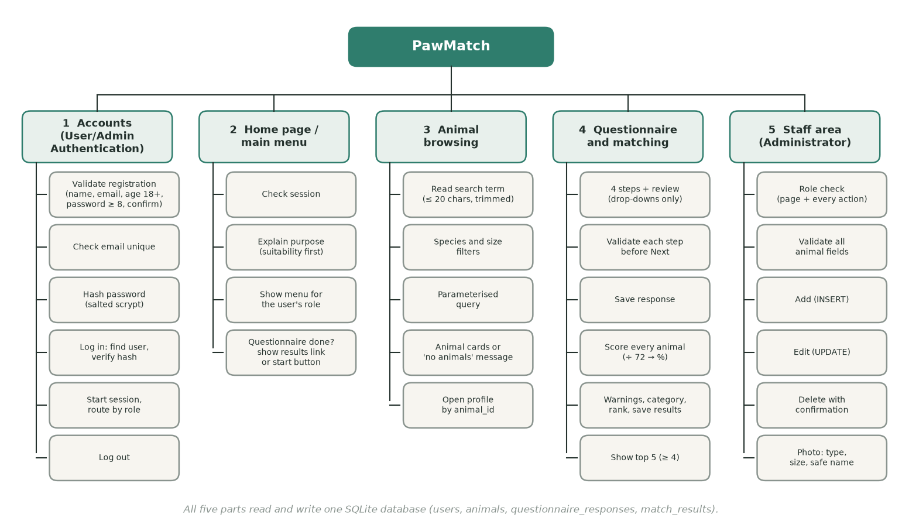
Diagram D1: PawMatch broken down into its five components and their sub-tasks.
Why this breakdown: each box is small enough to build and test on its own, and the order follows what each part needs. Accounts and the database come first because every other part needs a logged-in user and stored animals; browsing needs animals; matching needs both the questionnaire answers and the animals. The scoring and validation boxes need no screen at all, so they can be built and fully tested before any page exists (Development, stage 1).

Structure of the solution
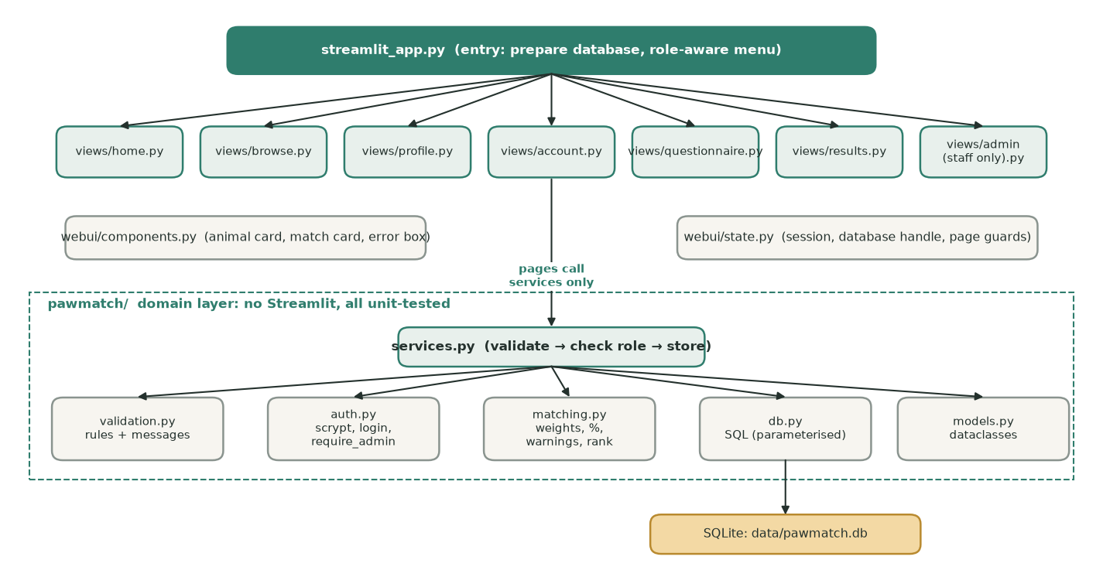
Diagram D2: modules and layers. Pages only call services; only db.py runs SQL.
Two layers. The pawmatch package holds all rules and data access and never imports Streamlit, so every rule can be unit-tested. The webui pages read input, call one service and show the result. This means a change to a rule happens in one place, and a page cannot skip a check because the check is inside the service, not the page.

The system can be decomposed into five main components. Separating the system into smaller components makes it easier to design, develop, test and maintain whilst each section performs a specific function.
Section | Front End Justification | Backend Justification
User/Admin  Authentication | Will allow users to register and existing  users to login, and allow admins to access their page safely and securely. Registration will collect the users name, email, age and password. The interface should provide clear feedback when details are missing or  forgotten from its validation system. It will also show an error message if login details are incorrect | The system will validate entered details, such as:  -​ email cannot be blank and must be valid and unique  -​ Password minimum 8 characters -​  Age must be a valid number -​ Login fields cannot be blank  The passwords will be hashed in order to be kept secure and safe. During login,  enter details will be compared against records in the users table. A session will then be created when authentication is successful.  For the admin side, if the login details are incorrect it will not allow them access, which will stop unauthorised users from adding, editing or deleting animal records.
User  Homepage/Main Menu | Will provide the main navigation area after the user logs in. It will allow the user to access the questionnaire, browse available animals and view their account. It will also explain the purpose of the adoption  matching system. It will be clear and  welcoming, and not overwhelming for the user. | The system will check the user's session to make sure they are logged in. It may retrieve the email and recent questionnaire information from the database so that  personalised information can be displayed.
Administrator Menu | Provides staff with a dashboard to manage existing animals and their records. Admins will be clearly able to add new animals, edit existing details and remove records. To add animals it will store: Name, species, age, breed, sex, personality and exercise needs, | The system will check that the logged in account has the admin role before access is allowed. Parameterised SQL commands will insert, update and delete animal  records. All inputs will be validated before changes are made to the database. A log

 | children compatible, garden required,  medical notes and an image. Forms will be clearly Labelled and display confirmation or error messages. | out function will clear the admins session and return them to the login page,  preventing another person using the same device which will prevent unwanted  access to the database.
Animal Viewing | Allows users to browse available animals using clearly presented animal cards. Each card will show information such as the  animal name, image, species, breed and age. Users will be able to select a card to view a more detailed animal profile. | Animal records will be retrieved from the animals table. Search and filter selections will be used to change the database query or filter the retrieved records. Selecting an animal will use its unique animal ID to  load the correct profile.
Questionnaire and Recommendations | Will use a form in order to allow users to answer questions about their home, lifestyle, experience and preferences. The  questionnaire will have questions such as the housing type, access to garden, animal loneliness times, children, pets, experience, activity labels, what species and size  preferred. These questions would not appear all at one time to not overwhelm the user and the input type would be drop downs or radio buttons. After submitting the  questionnaire, the system will display  compatibility scores almost immediately and recommended animals. It will also explain requirements the user does not meet. | Responses will be validated and  compared with the requirements of each available animal. A weighted compatibility algorithm will calculate a percentage  score for every animal. The animals will then be sorted from highest to lowest  score so the top recommendations can be displayed. The questionnaire responses and match results may also be stored  within the database with the users ID  (email)

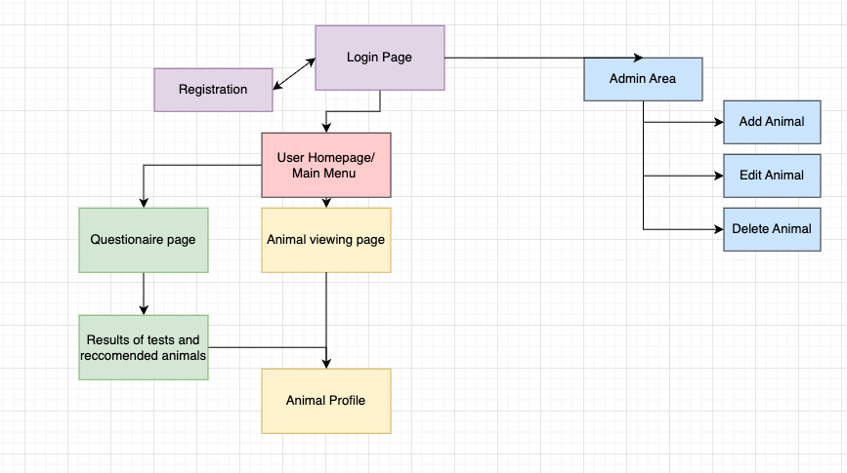

Database structure
Tables | Purpose
Users | Stores registered user and administrator account details
Animals | Stores user profiles, care needs and matching requirements
Questionnaire responses | Stores answers submitted by users
Matchresults | Stores calculated compatibility scores between responses and animals
One user can complete multiple questionnaire responses, each questionnaire can produce multiple compatibility results because it is compared to every available animal. Each animal can therefore appear in multiple match results belonging to different users or questionnaire attempts.
-​Users 1 → Many Questionnaire responses
-​Questionnaire responses 1 → Many matchresults -​animals 1 → Many matchresults

Model version addition

Entity relationship diagram
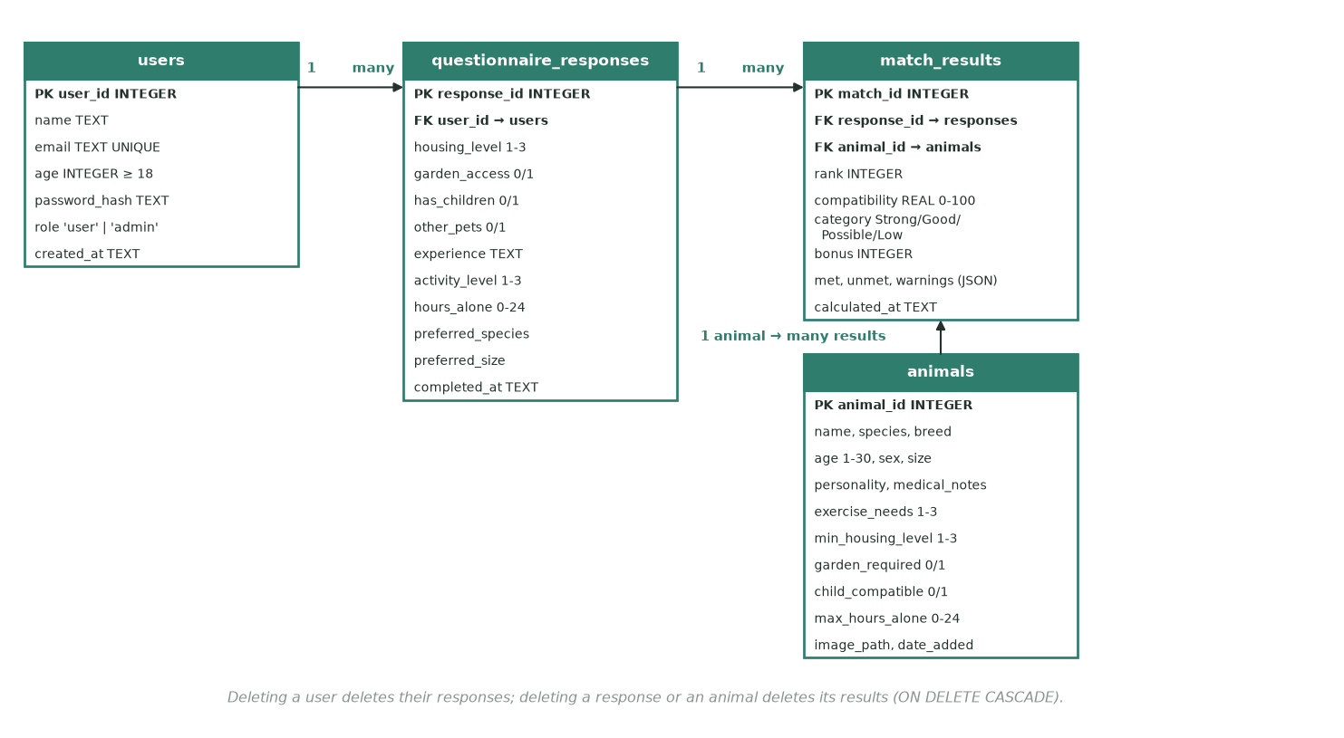
Diagram D3: the four tables, their keys and the one-to-many links.
Two fields are added to the questionnaire table (other_pets, experience) so the answers to those questions are stored even though the Design does not score them, and match_results also stores the met / unmet lists and the bonus, so the results page can be shown again without re-scoring. Foreign keys use ON DELETE CASCADE so no result can point to an animal or response that no longer exists.

Data structures and classes
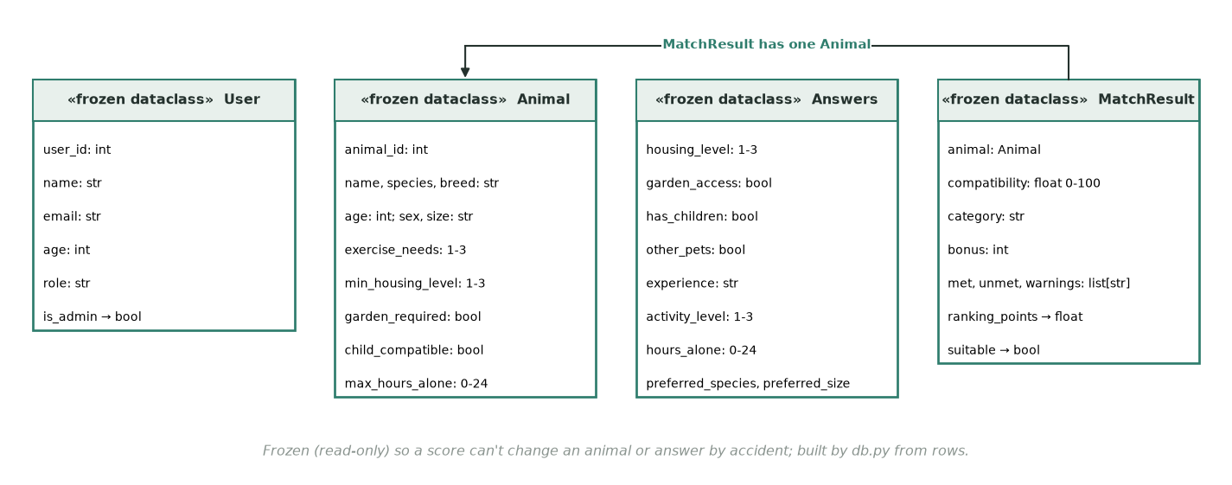
Diagram D4: the four data classes passed between the modules.
Structure | Type | Why this structure | Validation
User, Animal, Answers, MatchResult | Frozen dataclasses | Named fields instead of loose tuples; frozen so scoring cannot change an animal or answer by mistake | Only built from validated or stored values
WEIGHTS | Dictionary factor → points | The Design's weight table in one place; MAX_POINTS = sum of WEIGHTS | Test E1 checks 20/15/15/12/10
QUESTION_STEPS | Tuple of (title, question names) | The questionnaire plan as data: the page and the validator both use it | Test D1: every question once
errors | Dictionary field → message | Every validator returns one, so a page can show all problems at once | Empty dictionary means valid
session.user_id, session.q_step, session.q_answers | Streamlit session state | Who is logged in, and progress through the questionnaire | user_id re-checked against the database on every page
results | List of MatchResult, sorted | Ranked order is the output; a list keeps it | Every animal appears once

Validation
All user entered data should be validated before it is processed or stored in the SQLite database. Streamlit controls such as dropdowns radio buttons and number inputs will restrict the range of values users can enter. However, the backend will still validate the submitted values because interface controls alone should not be relied on.

🩷 Login + Adminitration

Login and Registration
User/Admin  Authentication | Will allow users to register and existing users to login, and allow admins to access their page safely and securely. Registration will collect the users name, email, age,  address and password. The interface should provide clear feedback when details are  missing or forgotten from its validation  system. It will also show an error message if login details are incorrect | The system will validate entered details, such as:  -​ Username cannot be blank  -​ Password minimum 8 characters -​ Required questions cannot be  skipped  -​ Age must be a valid number  -​ Duplicate usernames not allowed The passwords will be hashed in order to be kept secure and safe. During login, enter details will be compared against records in the users table. A session will then be created when authentication is successful.  For the admin side, if the login details are incorrect it will not allow them access, which will stop unauthorised users from adding, editing or deleting animal records.
Interface Design

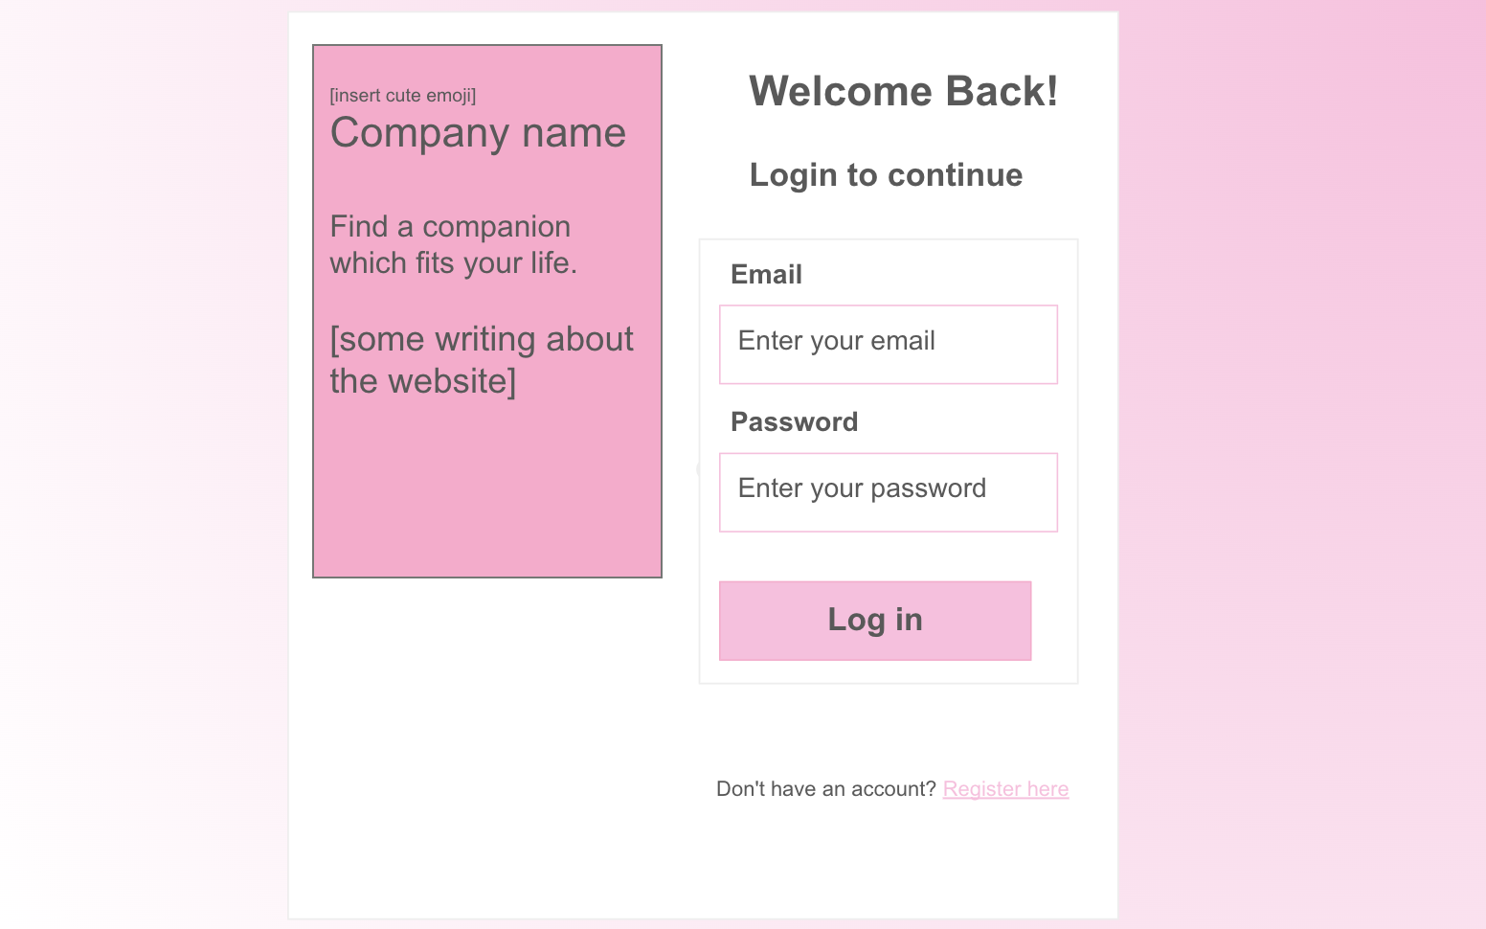
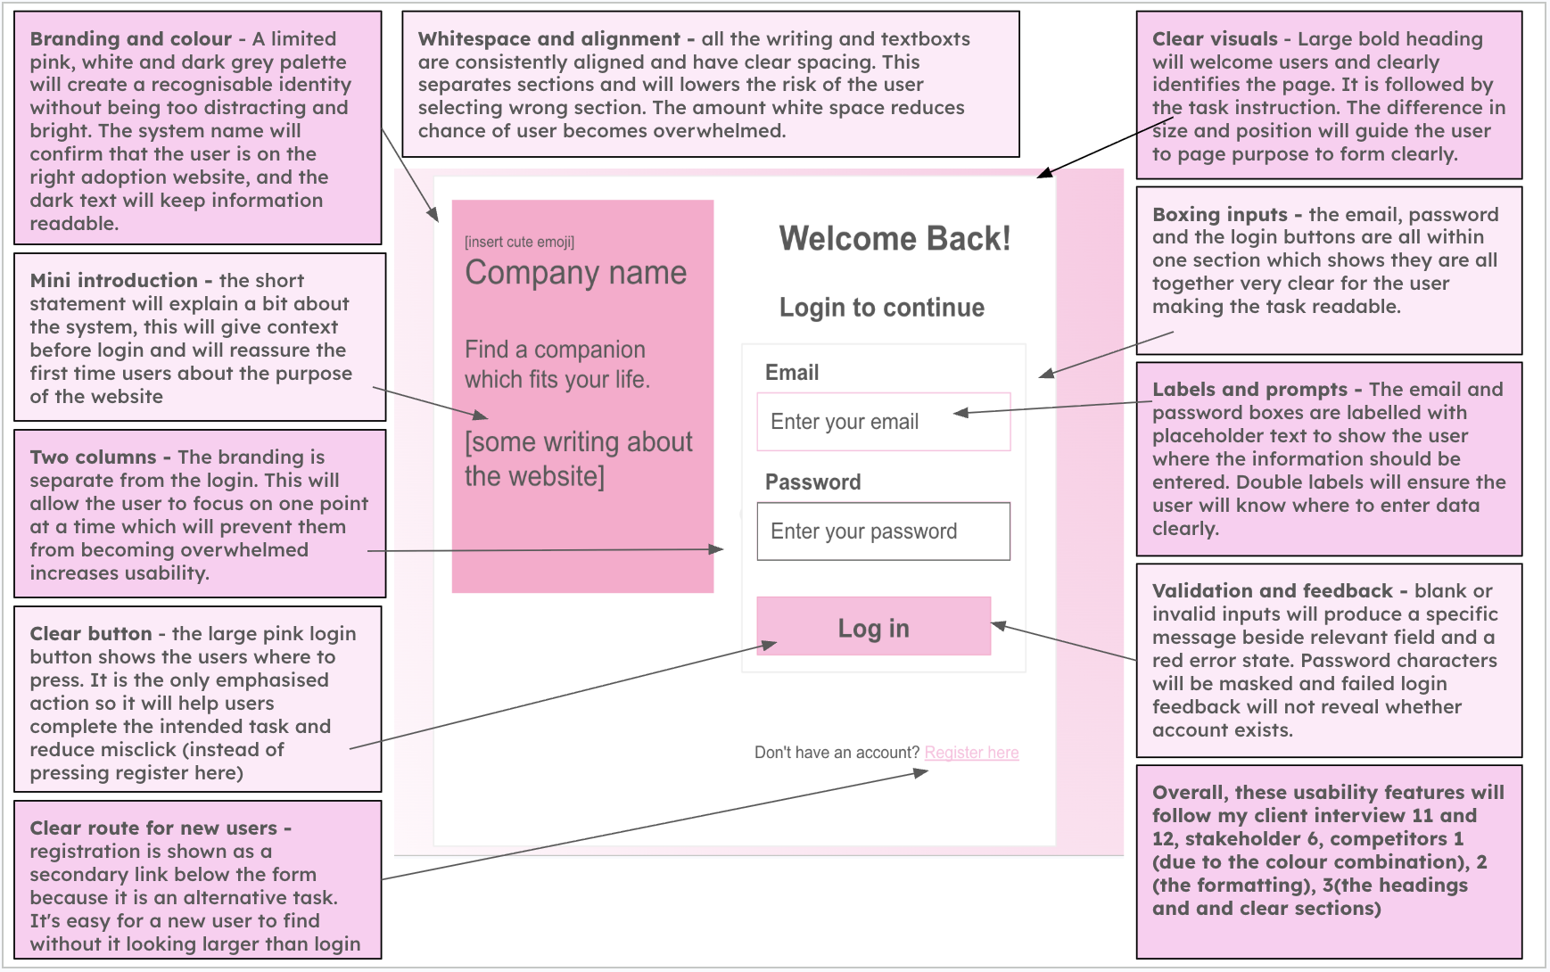

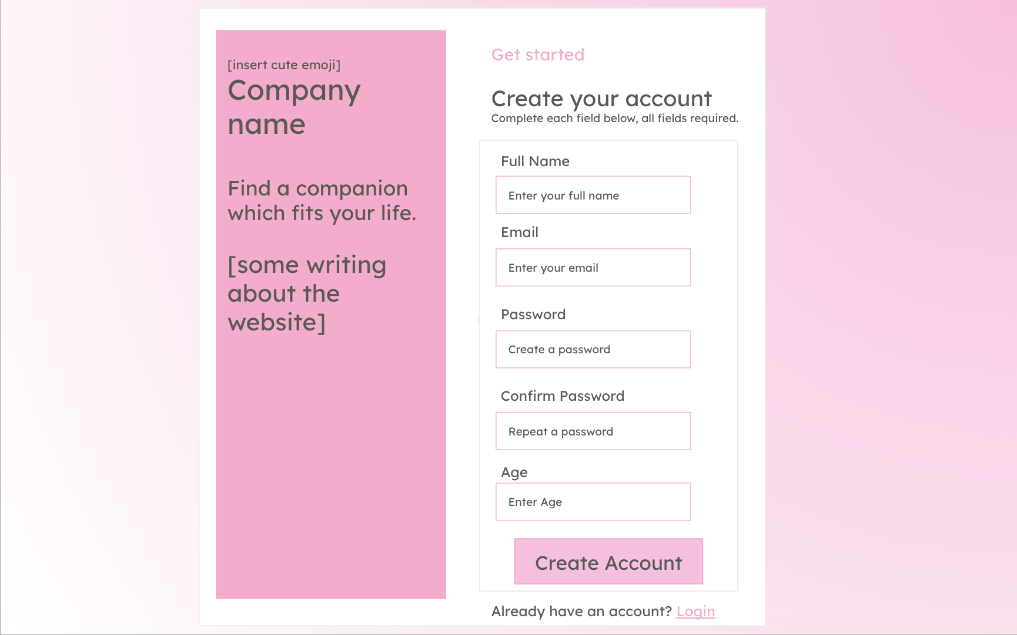
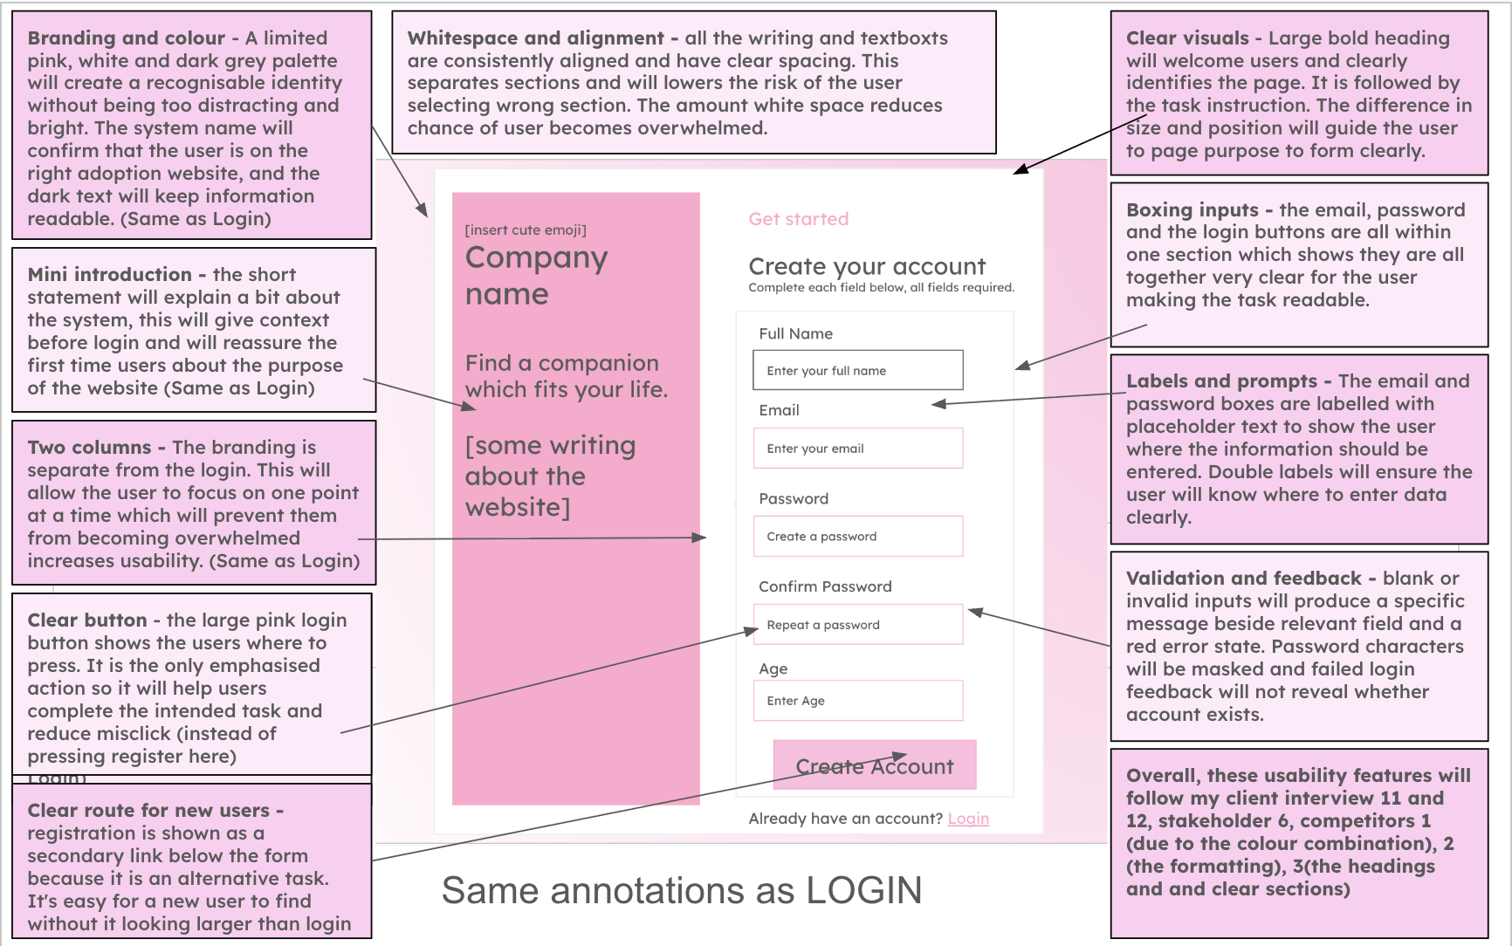

Algorithm (Flow chart, pseudocode)
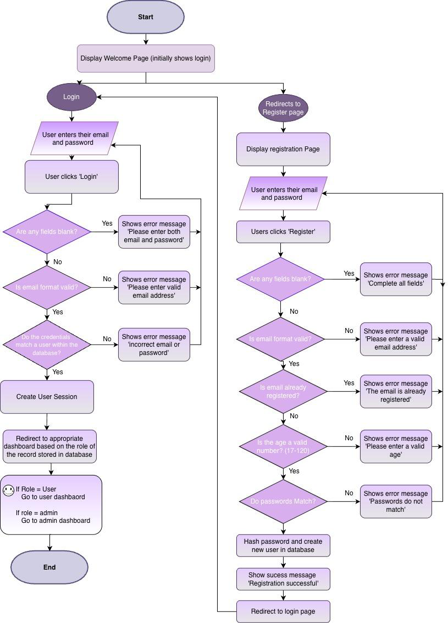

Pseudocode

Model version addition

Pseudocode: registration, login, session and role check, logout
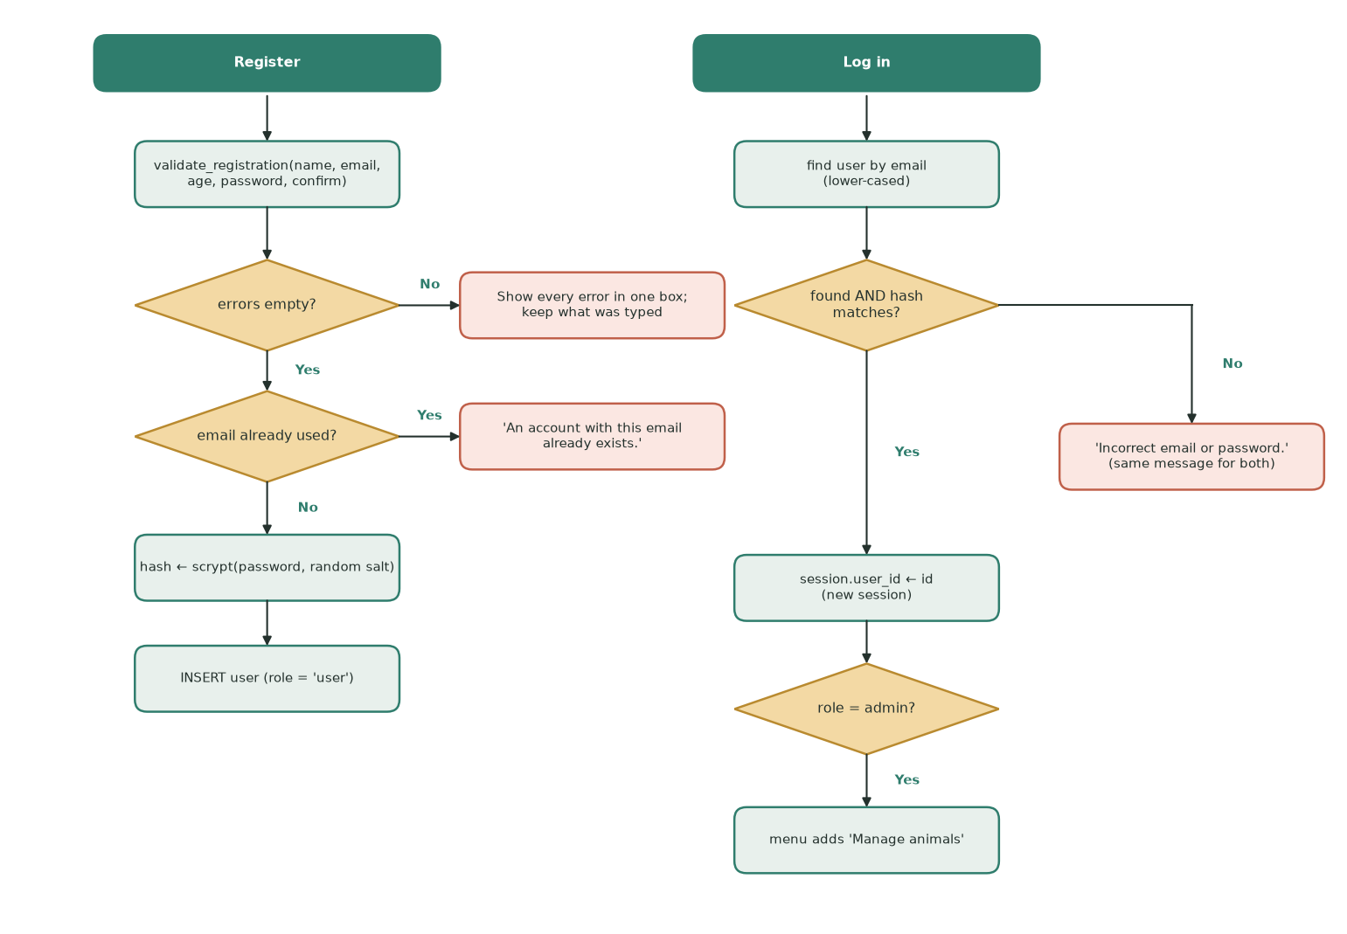
Diagram D5: registration and login flowchart (model version).
FUNCTION Register(user_name, email, age, password, confirm_password)
errors ← empty dictionary // field name → message
user_name ← TRIM(user_name)
IF user_name = "" THEN
errors["name"] ← "Enter a name."
ELSE IF LENGTH(user_name) < 2 OR LENGTH(user_name) > 50 THEN
errors["name"] ← "Name must be 2 to 50 characters."
ELSE IF user_name has a character that is not a letter, space, hyphen or apostrophe THEN
errors["name"] ← "Name can only use letters, spaces, hyphens and apostrophes."
ENDIF
email ← LOWER(TRIM(email))
IF email = "" THEN
errors["email"] ← "Enter an email address."
ELSE IF email does not match text "@" text "." letters THEN
errors["email"] ← "Enter a valid email address, like name@domain.com."
ENDIF
IF age is blank THEN
errors["age"] ← "Age is required."
ELSE IF age is not a whole number THEN
errors["age"] ← "Age must be a whole number."
ELSE IF age < 18 THEN
errors["age"] ← "You must be 18 or over to adopt."
ELSE IF age > 120 THEN
errors["age"] ← "Age must be between 18 and 120."
ENDIF
IF TRIM(password) = "" THEN
errors["password"] ← "Enter a password."
ELSE IF LENGTH(password) < 8 THEN
errors["password"] ← "Password must be at least 8 characters."
ELSE IF password ≠ confirm_password THEN
errors["confirm"] ← "The two passwords do not match."
ENDIF
IF errors is empty AND EmailExists(email) THEN // SELECT 1 FROM users WHERE email = ?
errors["email"] ← "An account with this email already exists."
ENDIF
IF errors is not empty THEN
RETURN NULL, errors // page shows all messages in one box
ENDIF
salt ← 16 random bytes
password_hash ← "scrypt$16384$8$1$" + HEX(salt) + "$" + HEX(SCRYPT(password, salt))
user_id ← INSERT INTO users (name, email, age, password_hash, role, created_at)
VALUES (?, ?, ?, ?, 'user', NOW()) // parameterised
RETURN user, empty dictionary
ENDFUNCTION

FUNCTION Login(login_email, login_password)
login_email ← LOWER(TRIM(login_email))
IF login_email = "" OR login_password = "" THEN
RETURN NULL, "Enter your email address." / "Enter your password."
ENDIF
record ← SELECT * FROM users WHERE email = ? // login_email bound, never joined into SQL
is_authenticated ← FALSE
IF record ≠ NULL THEN
salt, stored_digest ← SPLIT(record.password_hash)
is_authenticated ← CONSTANT_TIME_EQUAL(SCRYPT(login_password, salt), stored_digest)
ENDIF
IF NOT is_authenticated THEN
error_message ← "Incorrect email or password." // same message: no hint which part was wrong
RETURN NULL, error_message
ENDIF
CLEAR session
session.user_id ← record.user_id
RETURN record, empty dictionary
ENDFUNCTION
FUNCTION CurrentUser() // runs at the top of every page
IF session.user_id is not set THEN
RETURN NULL
ENDIF
RETURN SELECT * FROM users WHERE user_id = session.user_id
ENDFUNCTION // user_role is re-read on every page
FUNCTION RequireStaff() // the session/role check
user ← CurrentUser()
IF user = NULL THEN
SHOW "Please log in or register to use this page." and a login link
STOP page
ELSE IF user.user_role ≠ "admin" THEN
SHOW "This page is for shelter staff only."
STOP page
ENDIF
RETURN user
ENDFUNCTION
PROCEDURE Logout()
CLEAR session // user_id and any half-finished questionnaire
GO TO Home
ENDPROCEDURE

How it fits the whole solution. Register and Login are the only ways to get a session. Every other page starts with CurrentUser() or RequireStaff(), so the role check written here protects the whole system. Uniqueness is checked only after the cheap checks pass, so the database is not queried for a form that is already invalid.

Database (Table structure)
Field | Data type | Key/validation
user_id | INTEGER | Primary key which will auto increment
name | TEXT | required
email | TEXT | Required and unique
age | INTEGER | required , valid range
password_hash | TEXT | required
user_role | TEXT | ‘User’ or ‘admin’
date_created | DATE | required
Variables
Variable Name | Data  Type | Purpose | Justification | E.g or  Validation
user_name | String | Stores the name entered during registration | This will allow the system to  identify and personalise the  account. A string would be required for the datatype as it will contain | Cannot be blank

 |  |  | alphabetic characters and may include spaces and hyphens.
email | String | Will store users email address | It will be used as a unique identifier for logging in and contacting the user. It will contain letters and  symbols so will be stored as a  string. | Must follow a  valid email format and be unique
age | integer | Stores the users age | It will be used to ensure the user meets any minimum age  requirements. An integer is suitable for this variable as age is  represented by a whole number. | Must be a valid positive number.
password | string | Temporarily  stores the  password  entered by the password | It is needed to authenticate the user securely. Passwords usually contain letters, numbers and special  characters, so a string is suitable for the data type. | Minimum of eight characters.
confirm_passwo rd | string | Stores the  repeated  password  entered during registration | This allows the system to check that the user has mistyped their password before creating the account. | It will have to  match password
password_hash | string | Stores the  hashed version of the password | Passwords should not be stored as plain text. Storing the hash reduces the risk of passwords being  exposed if the database is accessed without permission. | Generated using a secure hashing  function
login_email | string | Stores the email entered on the login page | The variable is required so that the system can search for the  corresponding account in the  database | Cannot be blank
login_password | string | Temporarily  stores the  password  entered during login | The entered password will be checked against the stored  password hash in order to verify users identity | Cannot be blank
user_id | integer | Uniquely | An integer is efficient for use as a | It will be retrieved

 |  | identifies the logged in user | database primary key, it will allow records such as questionnaires and recommendations to be linked to the correct user. | from the database after login
user_role | String | Stores whether the account is an administrator or a user | This variable is required for access control, so that normal users cannot access the administrator pages  Controls access to the administrator area, although normal registrations should automatically receive the  role ‘user’, the admin role should not be selectable from the  registration form. | Will be stored as ‘user’ or ‘admin’
error_message | string | Stores the error message which  will appear when the input or login details are  invalid | My system will provide clear  feedback and help the user  understand what has gone wrong and how to correct it. A string will be suitable for this message as it contains many words in one  sentence. | ‘Incorrect email or password, please retry’
is_authenticated | booleen | Records whether login attempt  was successful | A boolean data type is suitable as authentication only has two  possible values. | True or False
Validation
1.​Name
-​ Presence check: Field cannot be empty or contain only spaces
-​ Length check: name must be between 2 and 50 characters
-​ Whitespace check: spaces at beginning and end will be removed
2.​Email address
-​  -​  -​  -​  -​ | Presence check: Field cannot be empty or contain only spaces  Format check: value must contain a @ and domain  Uniqueness check: a database query will check the address not already registered Whitespace check: spaces at beginning and end will be removed  Check characters: convert all to lower case
3.​Age

-​  -​  -​ | Presence check: Field cannot be empty or contain only spaces Type check: data must be a whole number  Range check: age must be 18+
4.​Password
-​ Presence check: Field cannot be empty or contain only spaces
-​ Length check: password must be more than 8 characters
Registration
-​ Confirmation check: the confirmation field must exactly match original password -​ Security processing: the valid password will be hashed before it is inserted into the database and the original password will never be stored.
Login
-​ The password will be checked against the stored password hash rather than compared as plain text.
Registration outcome
-​ The account will be created if every field passes validation, individual messages will be shown if one or more fields are invalid.
Session check
-​ A session will only be created after successful authentication. Invalid information will leave users on the login page and will not allow them to access the user or admin page.

🩷 Admin Page

Admin Page
Administrator Menu | Provides staff with a dashboard to manage existing animals and their records. Admins will be clearly able to add new animals, edit existing details and remove records. To add animals it will store: Name, species, age, breed, sex, personality and exercise needs, children compatible, garden required,  medical notes and an image. Forms will be clearly Labelled and display confirmation or error messages. | The system will check that the loginned in account has the role before access is  allowed. Parameterised SQL commands will insert, update and delete animal  records. All inputs will be validated before changes are made to the database. Will also include a logout function, to securely log out so no physical access to the  system unless its an admin.
Interface
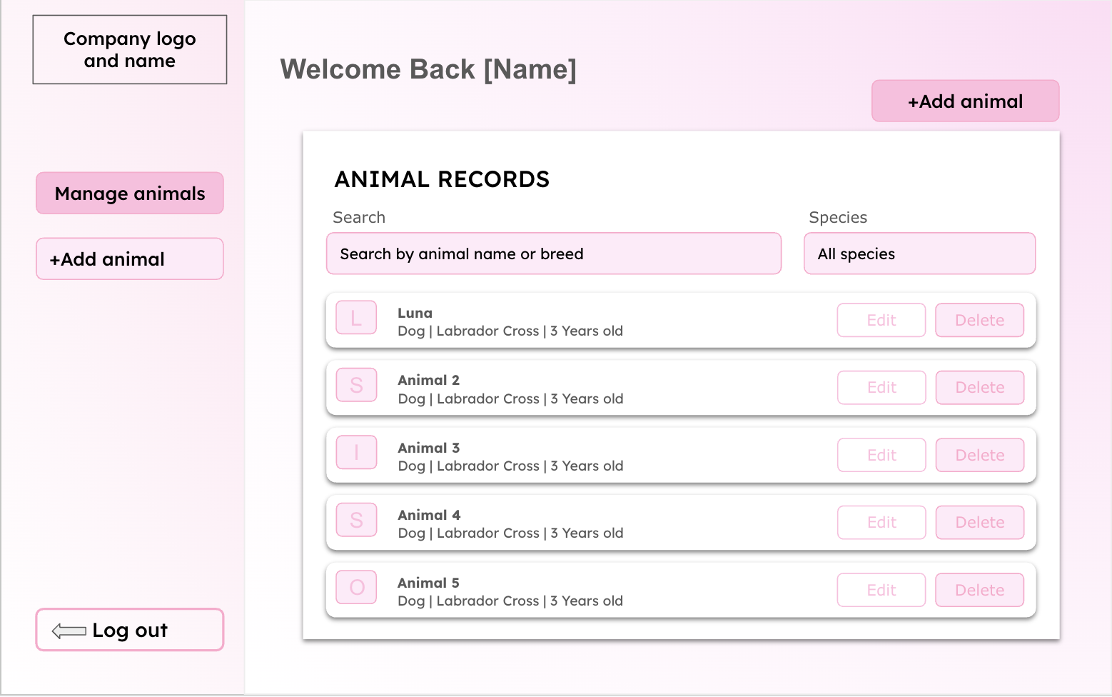

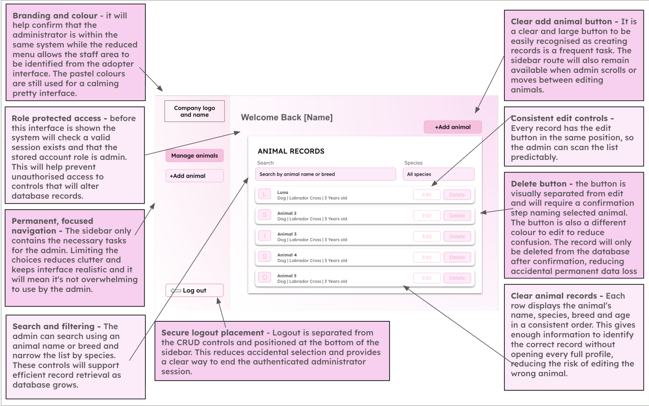
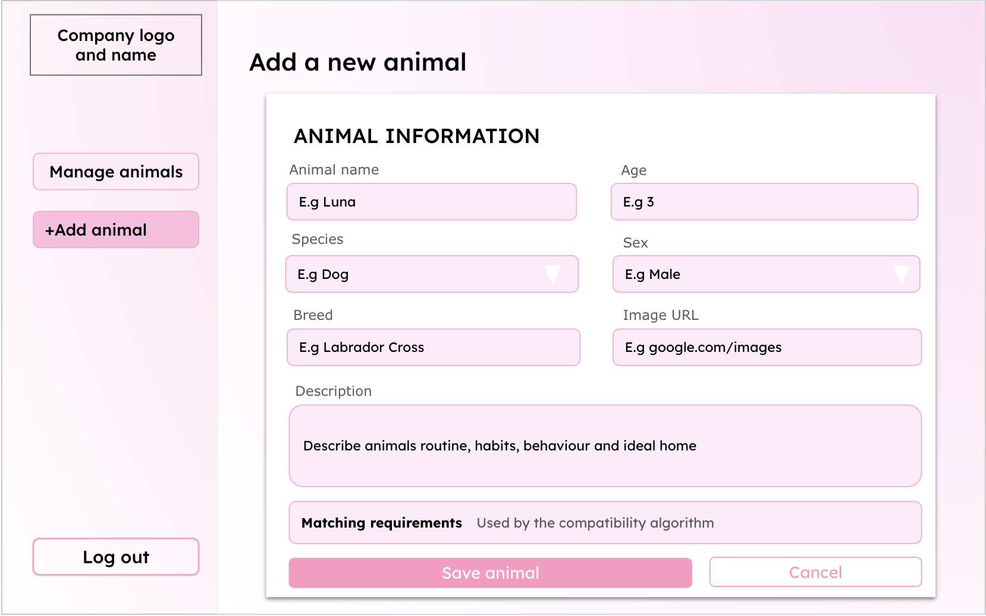

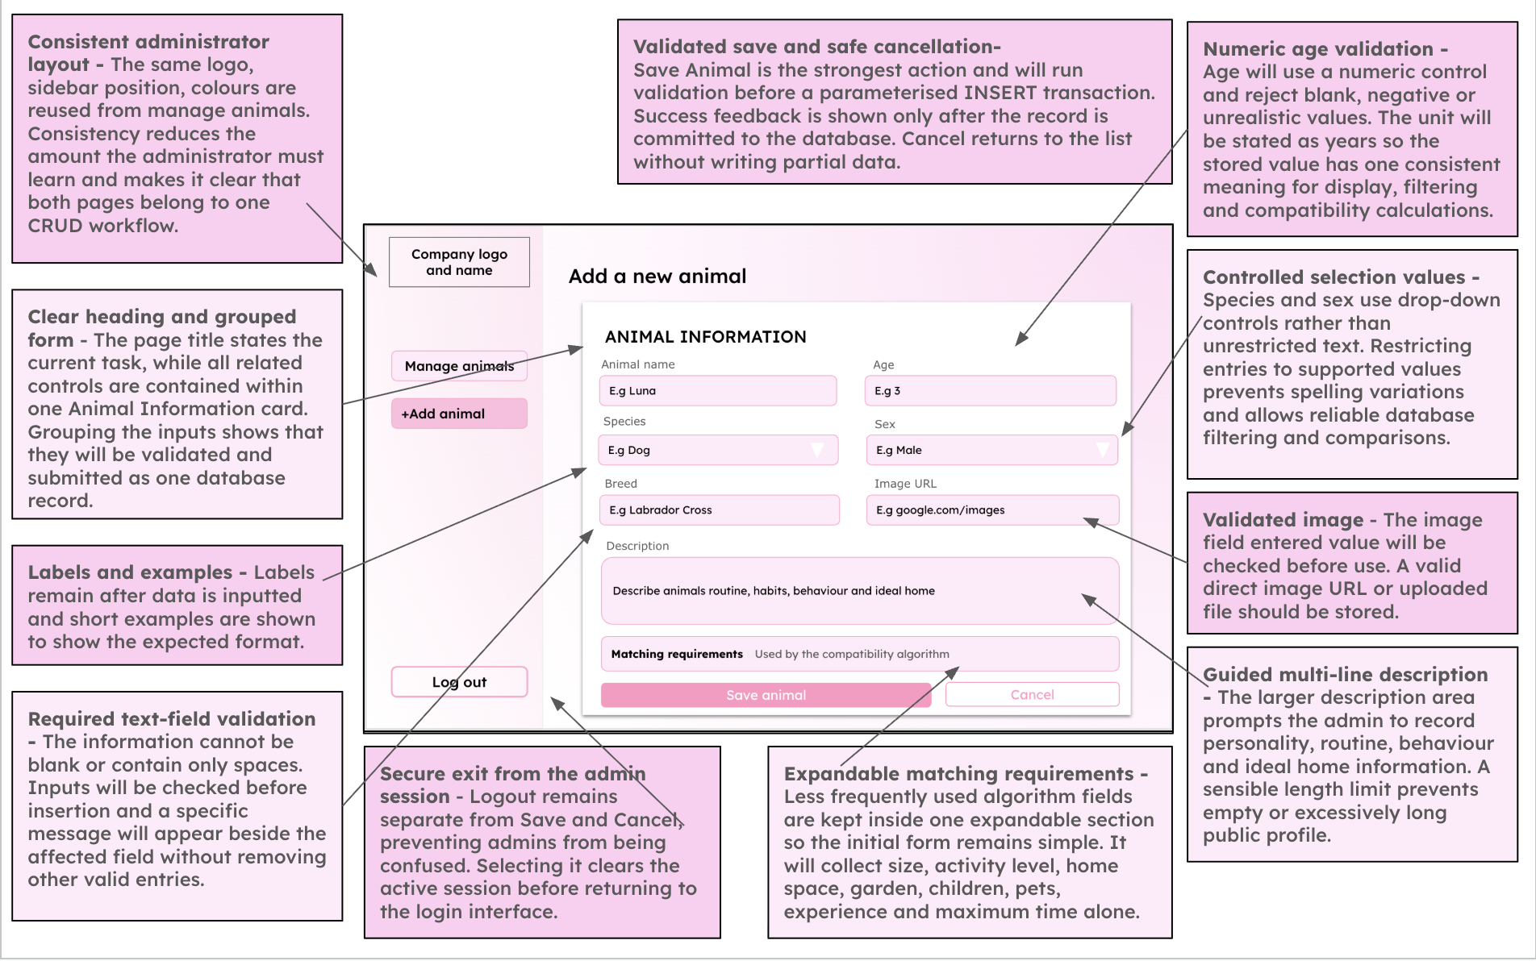
Pseudocode

Model version addition

Pseudocode: staff add, edit and delete animal
FUNCTION ValidateAnimal(form)
errors ← empty dictionary
name ← TRIM(form.name)
IF name = "" OR LENGTH(name) NOT IN 2..50 OR name has no letter
OR name has a character other than letters, digits, spaces, ' and - THEN
errors["name"] ← message
ENDIF
IF form.species NOT IN ["Dog", "Cat", "Rabbit"] THEN errors["species"] ← "Choose a species."
breed ← TRIM(form.breed)
IF breed = "" OR LENGTH(breed) NOT IN 2..50 OR breed has no letter THEN errors["breed"] ← message
IF form.age is not a whole number OR form.age NOT IN 1..30 THEN errors["age"] ← message
IF form.sex NOT IN ["Male", "Female", "Unknown"] THEN errors["sex"] ← "Choose a sex."
IF form.size NOT IN ["Small", "Medium", "Large"] THEN errors["size"] ← "Choose a size."
IF TRIM(form.personality) = "" OR LENGTH > 500 THEN errors["personality"] ← message
IF form.exercise_needs NOT IN 1..3 THEN errors["exercise_needs"] ← message
IF form.min_housing_level NOT IN 1..3 THEN errors["min_housing_level"] ← message
IF form.garden_required NOT IN [Yes, No] THEN errors["garden_required"] ← message
IF form.child_compatible NOT IN [Yes, No] THEN errors["child_compatible"] ← message
IF form.max_hours_alone NOT IN 0..24 THEN errors["max_hours_alone"] ← message
IF LENGTH(form.medical_notes) > 500 THEN errors["medical_notes"] ← message
RETURN cleaned values, errors
ENDFUNCTION
FUNCTION StoreUpload(upload) // optional photo
IF upload = NULL THEN RETURN NULL
IF EXTENSION(upload.name) NOT IN ["png", "jpg", "jpeg"] THEN RETURN "Images must be PNG or JPG."
IF upload.size > 2 MB THEN RETURN "Images must be 2 MB or smaller."
safe_name ← RANDOM_HEX(32) + "." + EXTENSION(upload.name) // never the user's file name
WRITE upload TO "data/uploads/" + safe_name
form.image_path ← "data/uploads/" + safe_name
RETURN NULL
ENDFUNCTION
FUNCTION AddAnimal(actor, form)
IF actor = NULL OR actor.user_role ≠ "admin" THEN RAISE AccessDenied // checked again here, not only on the page
values, errors ← ValidateAnimal(form)
IF errors is not empty THEN RETURN NULL, errors
animal_id ← INSERT INTO animals (...14 fields..., date_added) VALUES (?, ?, ...)
RETURN animal_id, empty dictionary
ENDFUNCTION
FUNCTION EditAnimal(actor, animal_id, form)
IF actor.user_role ≠ "admin" THEN RAISE AccessDenied
values, errors ← ValidateAnimal(form)
IF errors is not empty THEN RETURN errors
rows ← UPDATE animals SET name = ?, ... WHERE animal_id = ?
IF rows = 0 THEN RETURN {"animal": "That animal no longer exists."}
RETURN empty dictionary
ENDFUNCTION
FUNCTION DeleteAnimal(actor, animal_id, confirmed)
IF actor.user_role ≠ "admin" THEN RAISE AccessDenied
IF NOT confirmed THEN RETURN // Delete button disabled until the box is ticked
DELETE FROM animals WHERE animal_id = ? // its stored match results go too (CASCADE)
ENDFUNCTION

How it fits the whole solution. The staff page calls AddAnimal, EditAnimal and DeleteAnimal. Each one checks the role itself, so even if the page guard were bypassed nothing could be changed. ValidateAnimal is also used for the demo animals, so seed data obeys the same rules as staff input.

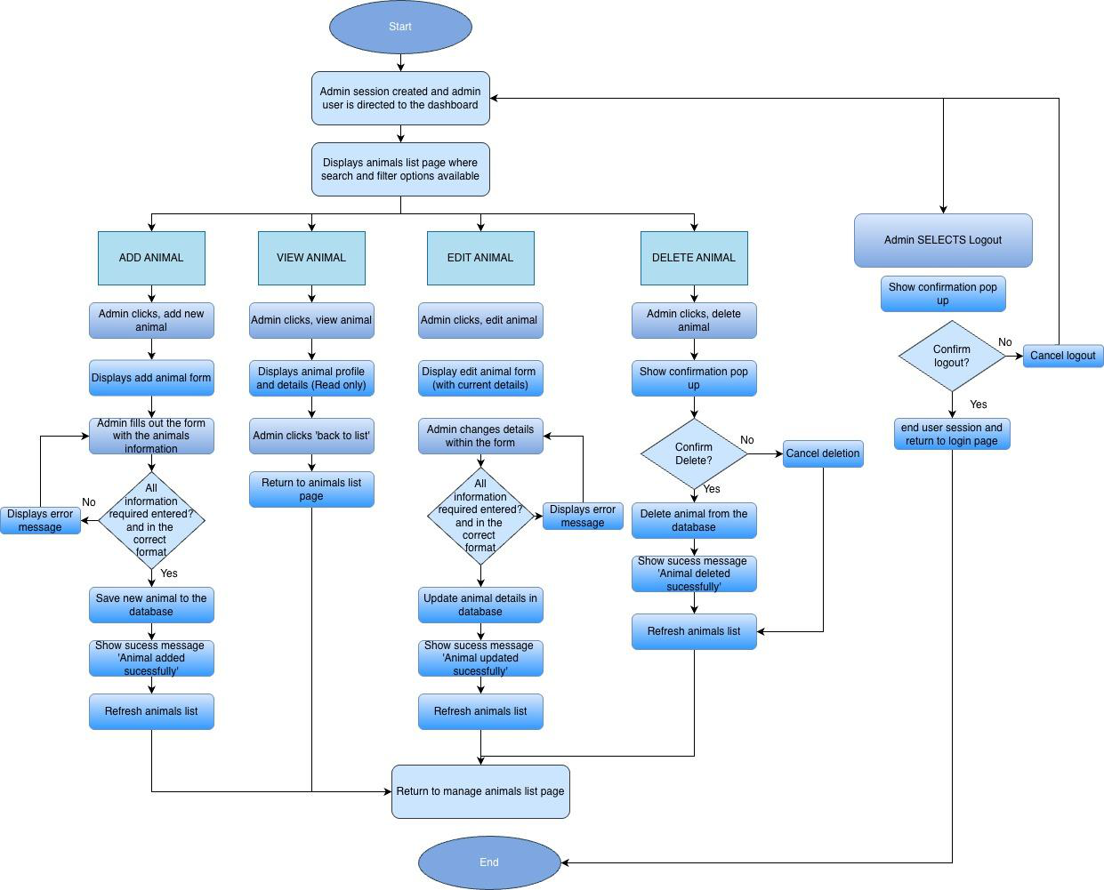
Animal Table
Field | Data type | Key/validation
animal_id | INTEGER | Primary key, autoincrement
name | TEXT | required
species | TEXT | Required - dog, cat or rabbit

breed | TEXT | Required
age | INTEGER | Required, cannot be zero
sex | TEXT | required- male, female or unknown
size | TEXT | Required - small medium or large
personality | TEXT | required
Exercise_needs | INTEGER | Required - 1 to 3
minimum_housing_level | INTEGER | Required - 1 to 3
garden_required | BOOLEAN | Required 0 or 1
child_compatible | BOOLEAN | Required 0 or 1
max_hours_left_alone | INTEGER | required
Medical_notes | TEXT | optional
image | TEXT | Required, an image path
date_added | DATE | required
Variables
Variable Name | Data Type | Purpose | Justification | Validation or e.g
animal_id | INTEGER | Uniquely identifies | A unique integer | Automatically

 |  | each animal record | stops confusion  between animals with similar names and  allows the correct to be updated and  deleted | generated
name | string | Stores the animals name | The name is required to identify the animal throughout the  interface and allows the user to remember the animal with a  specific name. A  string is suitable as it allows letters spaces and punctuation. | Can’t be blank
species | string | Stores the type of animal | Species is required for searching, filtering  and matching against user preferences. | dog, cat or rabbit
breed | string | Stores the animals breed | Breeds provides users with important  information and may help describe likely  size or care  requirements | Can't be blank or  might be ‘unknown’
age | INTEGER | Stores the animals age | Age affects care  needs. An integer is suitable as it allows the value to be  validated sorted and compared | cannot be zero
sex | string | Stores the animals sex | This is relevant profile information and may be considered by the potential adopters | male, female
size | string | Stores the animals | Size affects space | small medium or large

 |  | size and is used in filtering | requirements and is needed by the  filtering and  compatibility systems
personality | string | Stores a description of the animals  behaviour and  personality | A text field will allow the admin to explain the animals  personality and  background in more detail to help attract possible adopters | Cant be blank but a  character limit may be applied
Exercise_needs | INTEGER | Stores whether the animal has low,  medium or high  exercise needs | This can be compared with the adopters  lifestyle to produce a more appropriate  compatibility score.  An integer is  suitability for easier comparison | 1 to 3 (low medium or high)
minimum_housing_level | INTEGER | Stores the amount of living space  required | This can be compared with adopters  lifestyle to aid the  algorithm when  creating the  compatibility score | 1 to 3
garden_required | boolean | Records whether  the animal requires access to a garden | This may act as a  compulsory suitability rule. A boolean value is useful as it is  simple to input. | True or false
child_compatible | boolean | Records whether the animal is  suitable for a  household with children | There are only two  options which make boolean values  suitable. This is very important for the  safety and welfare of the children and  animals. | True or false

max_hours_left_alone | INTEGER | Stores value for  which the animal  can be left home  alone for, and  representing if more independent or  clingy | This is important if a user works long hours and the animal  requires a lot of  attention it may cause neglect of the animal which is a key issue  we are trying to  prevent. | Cant be blank
Medical_notes | string/list | Stores any medical conditions,  treatments or  special  requirements | Potential adopters  need to understand any medical needs  before making a  decision. A string will allow multiple to be described. | May be blank or ‘N/A’
image | string | Stores the location of the animals  image | This allows the  correct photo to be  displayed without  storing the full image directly in database | Must use an accepted file extension
form_action | string | Stores the operation the admin is  performing | The same form may be used for adding  and editing variables.  This variable will  allow the program to select the right query. | ‘Add’ or ‘edit’ or ‘delete’ or ‘view’
delete_confirmation | boolean | Records whether the administrator has confirmed  deletion | Deletion is permanent so confirmation  reduces risk of animal being removed  accidentally and not being considered for adoption | True or false
record_found | boolean | Records whether  the database has  retrieved the animal record successfully | This prevents the  program from  attempting to edit or delete a record not | True or false

present in the database
Validation
1.​Animal name
-​ | Presence check: Cannot be empty
-​ | Length check: Between 1 and 50 characters
-​ | Format check: Letters, spaces, apostrophes, hyphens and appropriate numbers may be
allowed
2.​Species
-​ | Presence check: Must be selected.
-​ | Lookup check: Must be Dog, Cat or Rabbit.
-​ | A drop-down menu will restrict the choices.
3.​Breed
-​ | Presence check: Cannot be empty
-​ | Length check: For example, between 2 and 50 characters
-​ | Format check: Must not consist entirely of unsupported symbols
4.​Age
-​ | Presence check: Must be provided
-​ | Type check: Must be a whole number
-​ | Range check: Cannot be negative and must be within the designed maximum animal
age
5.​Sex
-​ | Lookup check: Must be Male, Female or Unknown
-​ | A drop-down menu prevents invalid values
6.​Size
-​ | Lookup check: Must be Small, Medium or Large
7.​Personality
-​ Presence check: A description must be provided
-​ Length check: For example, between 20 and 1,000 characters
-​ Whitespace check: A value consisting only of spaces will be rejected
8.​Exercise need
-​  -​ | Presence check: An option must be selected Range check: Must be between 1 and 3

9.​Minimum housing requirement
-​ Presence check: Must be selected
-​ Range check: Must be between 1 and 3
10.​Maximum hours alone
-​ Type check: Must be an integer
-​ Range check: Must be between 0 and 24
11.​Garden required
-​ Type check: Must be stored as a Boolean value 0 or 1
12.​Child compatibility
-​ Type check: Must be stored as a Boolean value 0 or 1
13.​Medical notes
-​ This field may be optional
-​ Type check: it will have a maximum length
-​ Text will be stored as plain text rather than interpreted as code
14.​Animal image
-​ Presence check : An image must be uploaded if every profile requires one
-​ File-type check : Only approved formats such as JPG, JPEG and PNG will be accepted
-​ File-size check : The file must not exceed the chosen maximum size
-​ Filename handling : A safe, unique filename will be generated to avoid overwriting
existing images
The animal record will only be inserted after all required fields pass validation. The SQL
statement will be parameterised and committed only after successful validation. A success
message will then confirm that the record has been created.

🩷 Main Menu/INterface

Main Menu
User  Homepage/Main Menu | Will provide the main navigation area after the user logs in. It will allow the user to access the questionnaire, browse available animals and view their account. It will also explain the purpose of the adoption  matching system. It will be clear and  welcoming, and not overwhelming for the user. | The system will check the user's session to make sure they are logged in. It may retrieve the user's name and recent  questionnaire information from the  database so that personalised information can be displayed.
Interface Design
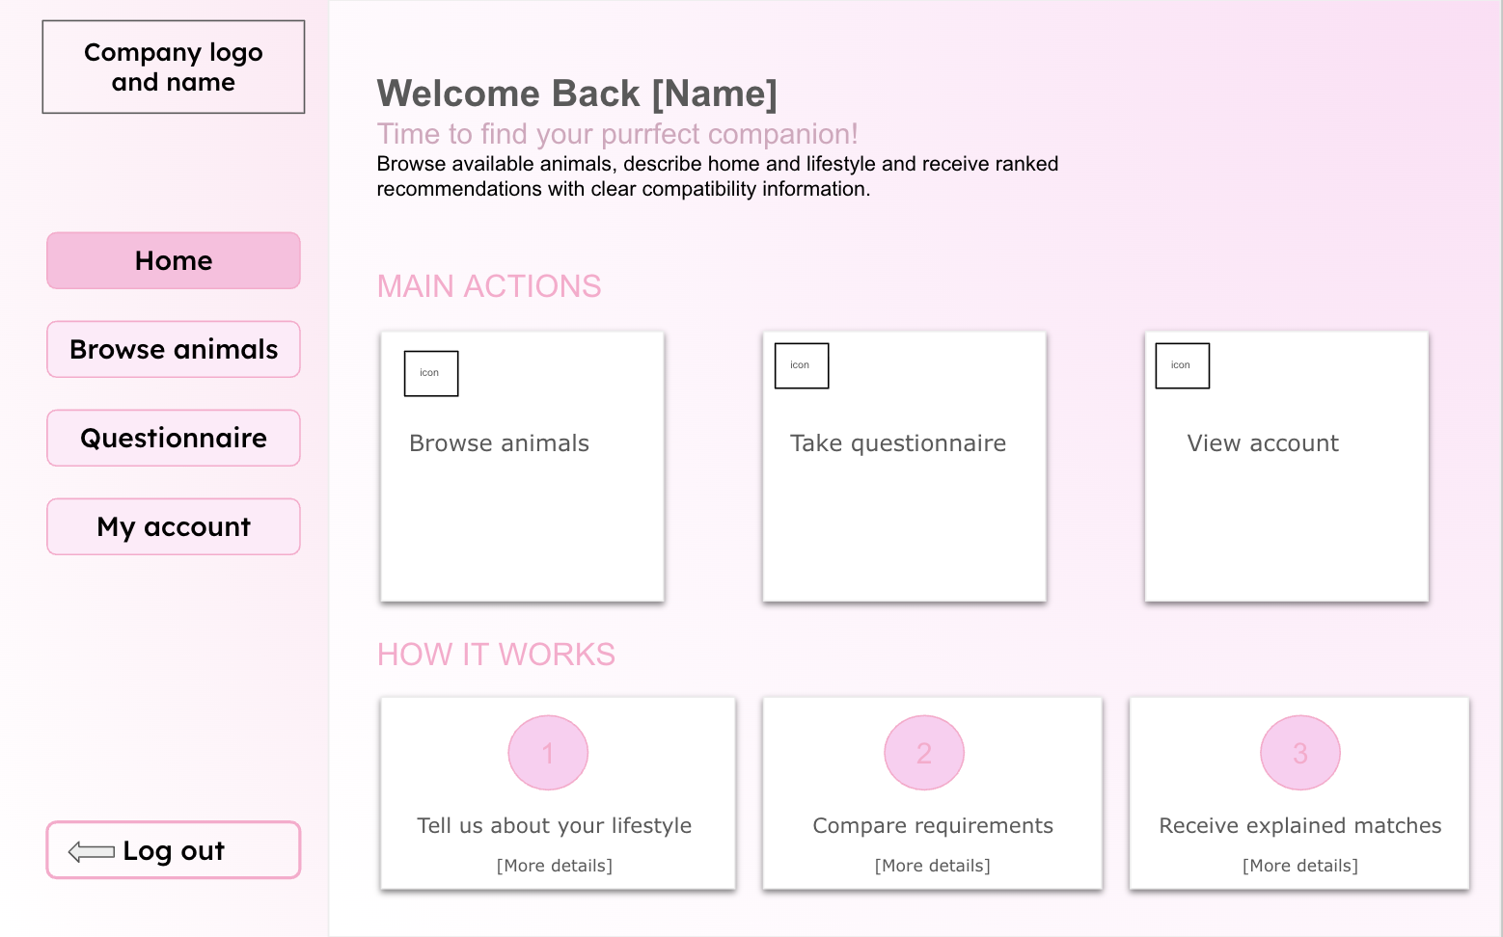

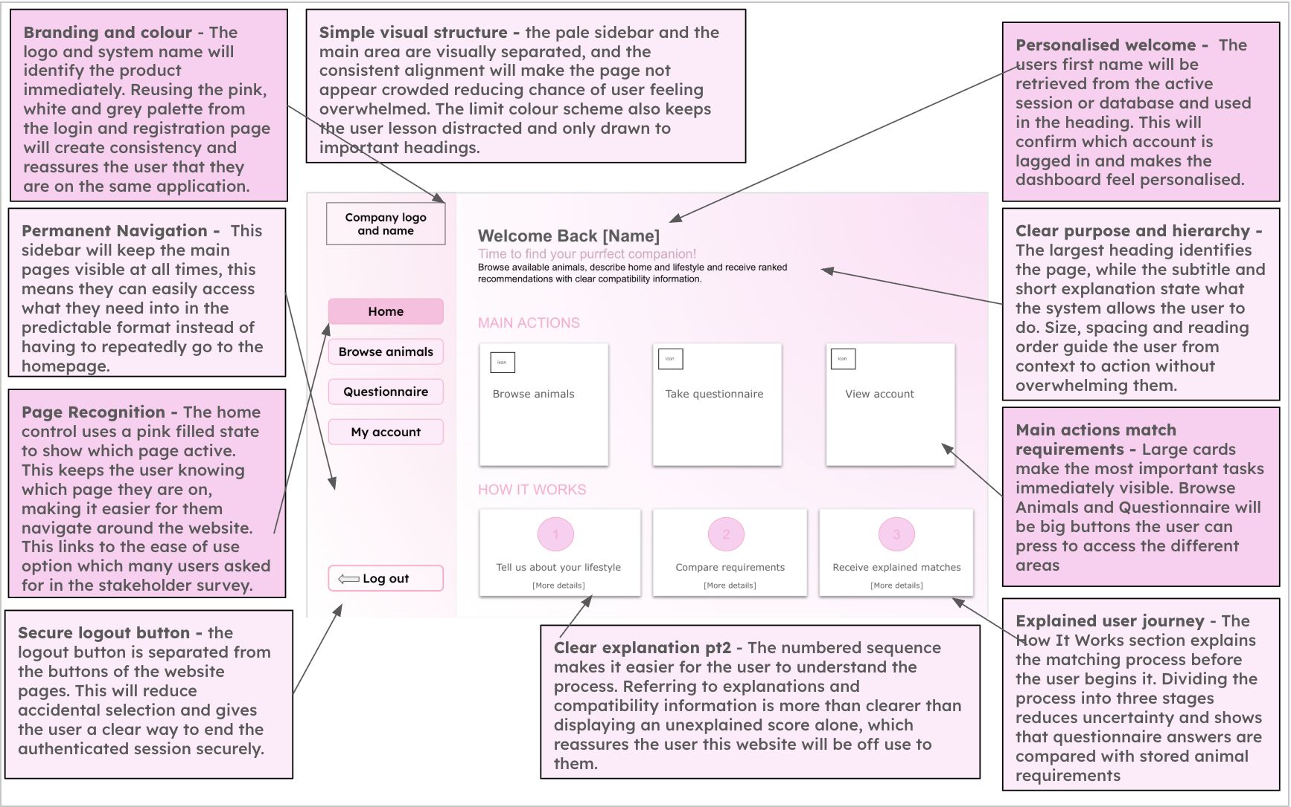
Algorithm (Flow chart, pseudocode)

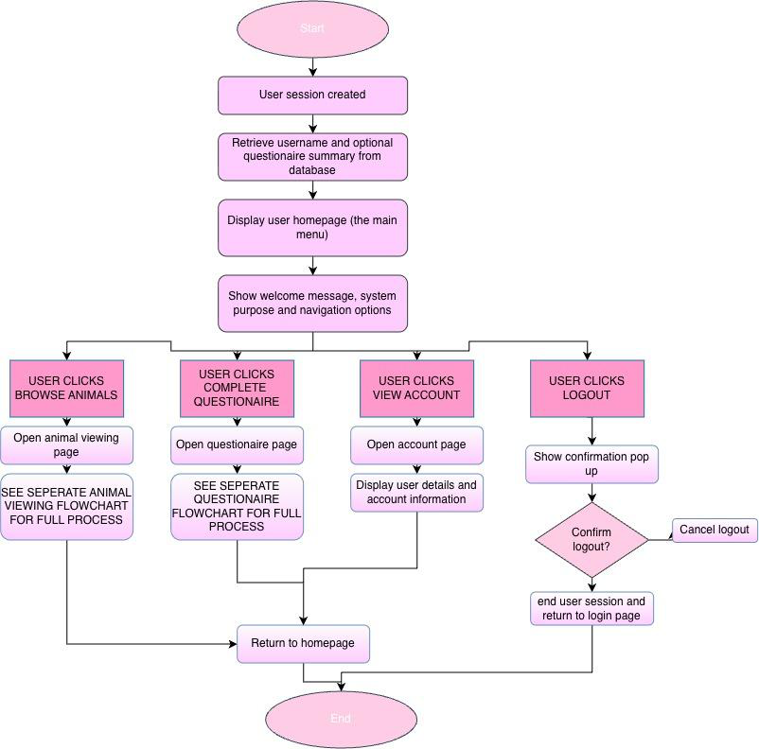
Pseudocode

Model version addition

Pseudocode: menu, home page and 'My matches' entry
// streamlit_app.py runs first on every page load
PROCEDURE BuildMenu()
PrepareDatabaseOnce() // create tables and demo animals if missing
user ← CurrentUser()
pages ← [Home, Animals, Animal profile (hidden), Questionnaire, My matches]
IF user = NULL THEN
APPEND "Log in" TO pages
ELSE
APPEND "My account" TO pages
ENDIF
IF user ≠ NULL AND user.user_role = "admin" THEN
APPEND "Manage animals" TO pages // the staff page does not exist for anyone else
ENDIF
selected_page ← page chosen in the top menu (Home by default)
RUN selected_page
ENDPROCEDURE
PROCEDURE HomePage()
SHOW title, purpose and "Scores are guidance only. Shelter staff make the final decision."
IF "Start the questionnaire" clicked THEN GO TO Questionnaire
animal_results ← SELECT * FROM animals
FOR species IN ["Dog", "Cat", "Rabbit"]
SHOW COUNT of animal_results with that species
NEXT species
IF CurrentUser() = NULL THEN SHOW link "Log in or register"
ENDPROCEDURE
PROCEDURE MyMatchesPage()
user ← RequireLogin()
latest ← SELECT newest response FROM questionnaire_responses WHERE user_id = ?
IF latest = NULL THEN // questionnaire not completed yet
SHOW "You haven't completed the questionnaire yet." and a link to it
STOP
ENDIF
results ← stored match_results for latest, ORDER BY rank
SHOW first MAX(4, 5) results (all of them if "Show every animal" is on)
ENDPROCEDURE

How it fits the whole solution. BuildMenu runs on every page load. Because the staff page is only added for admins, adopters never see a link they cannot use. The questionnaire-completed check sits on the My matches page: users who have not finished it are sent to it.

Variables

Variable Name | Data Type | Purpose | Justification | E.g or  validation
current_user_id | INTEGER | Identifies user currently  accessing  dashboard | Ensures that the  dashboard displays information  belonging to the  correct account | Retrieved  from session
current_user_name | STRING | Stores the logged in users name | This will allow the interface to display personalised  information and  reassures user they are accessing  correct account | ‘Welcome sienna’
animal_count | INTEGER | Stores the  number of  animals currently available | It will provide a  useful summary of information on the dashboard. An  integer is a suitable data type as the  number of animals is a whole number | Must be zero or larger
questionaire_compl eted | BOOLEAN | Records whether the user has  completed the  questionnaire | This variable allows the system to  display  recommendations or prompt the user to complete the  questionnaire.  Boolean is suitable as there is only two possible states | True or False
reccomended_anim als | LIST | Stores the  animals  recommended to the users | Multiple animals  will need to be  displayed in ranked order so a list is a suitable data type | Ordered from lowest to  highest  compatibility

selected_page | STRING | Stores the page selected from  navigation menu | This allows the  program to choose which page or  section should be selected | Animals or  questionaire
notification_messag e | STRING | Stores  confirmation or status feedback | The user will need clear feedback after completing actions such as submitting questionnaire | ‘Questionaire submitted  successfully’

🩷 Animal Viewing Page

Animal Viewing Page
Animal Viewing | Allows users to browse available animals using clearly presented animal cards. Each card will show information such as the  animal name, image, species, breed and age. Users will be able to select a card to view a more detailed animal profile. | Animal records will be retrieved from the animals table. Search and filter selections will be used to change the database query or filter the retrieved records. Selecting an animal will use its unique animal ID to  load the correct profile.
Interface Design
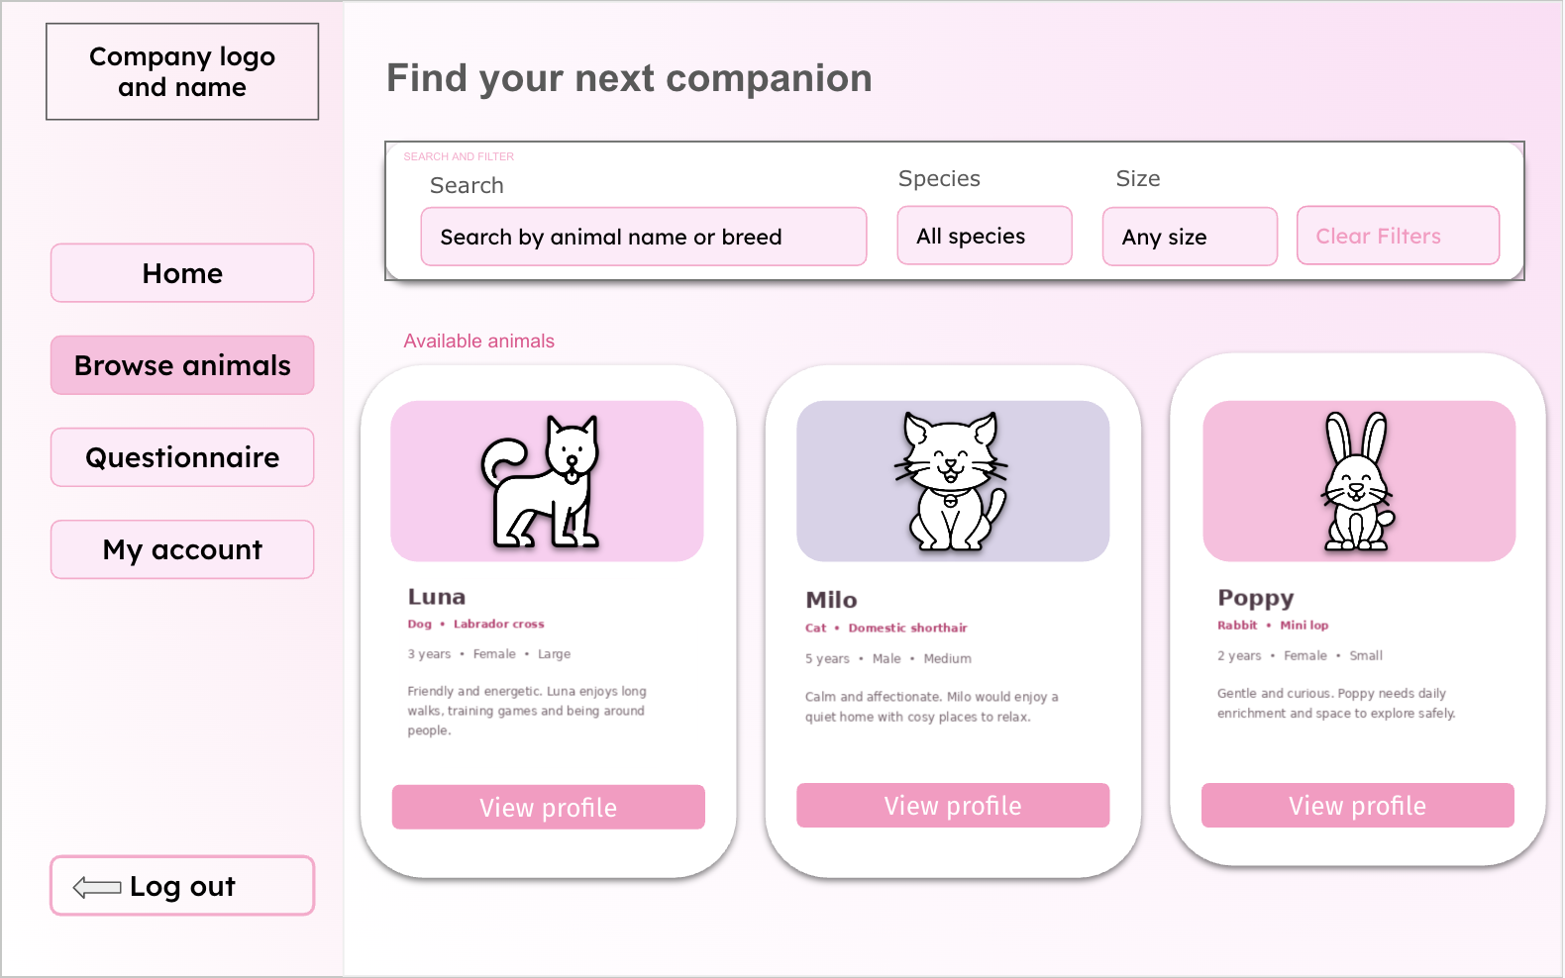

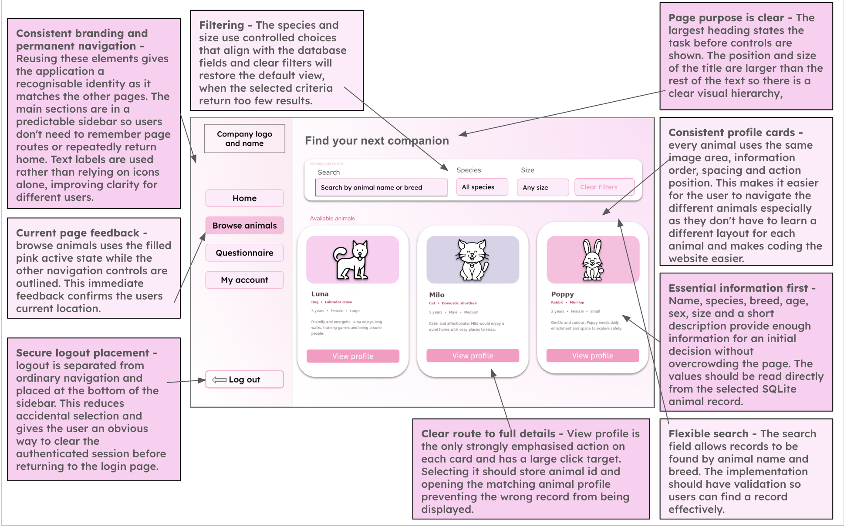
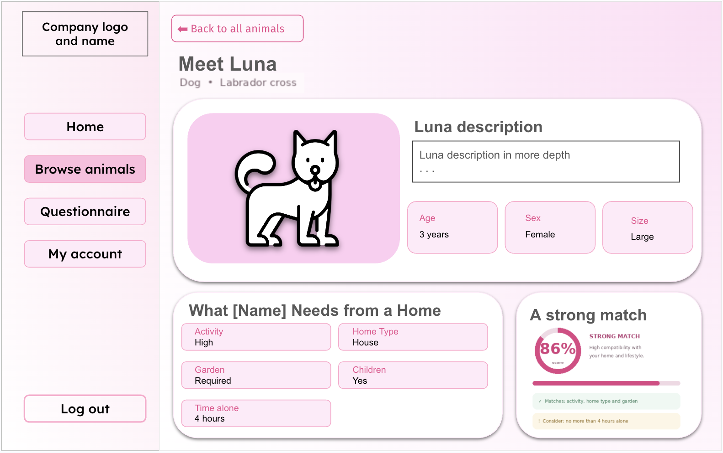

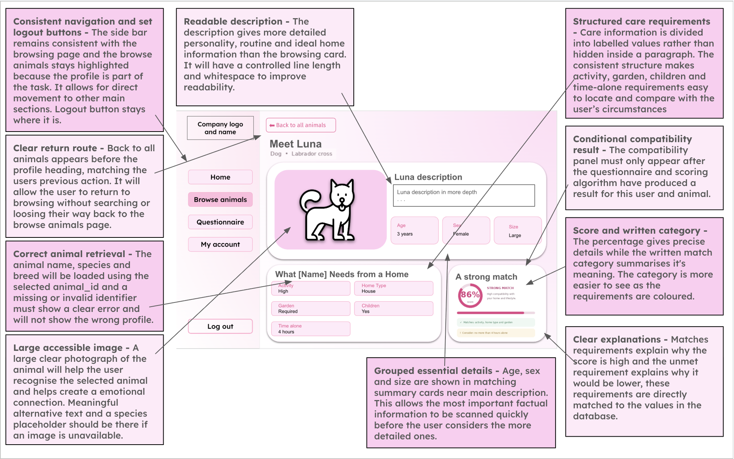
Algorithm (Flow chart, pseudocode)

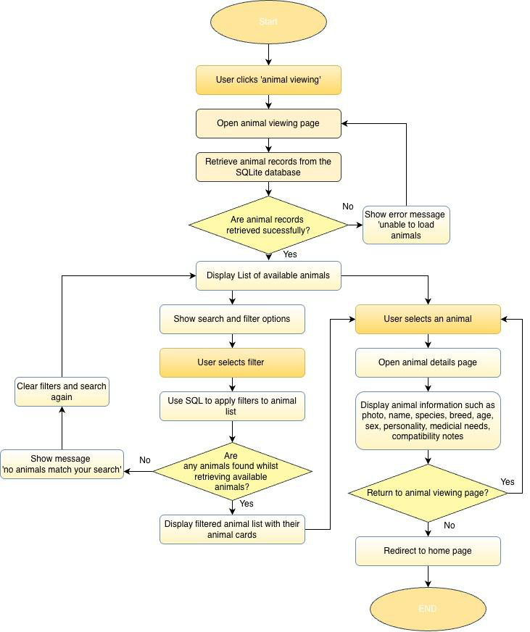
Pseudocode

Model version addition

Pseudocode: browse, filter, search and open a profile
PROCEDURE AnimalViewingPage()
species_filter ← drop-down: All species / Dog / Cat / Rabbit
size_filter ← drop-down: All sizes / Small / Medium / Large
search_term ← text box (at most 20 characters)
animal_results ← ListAnimals(species_filter, size_filter, search_term)
no_results ← LENGTH(animal_results) = 0
IF no_results THEN SHOW "No animals match those filters."
FOR EACH animal IN animal_results // 4 cards per row
SHOW card: image, name, species, breed, age, "View profile" button
IF "View profile" clicked THEN
selected_animal_id ← animal.animal_id
GO TO ProfilePage(id = selected_animal_id, back = "browse")
ENDIF
NEXT animal
ENDPROCEDURE
FUNCTION ListAnimals(species_filter, size_filter, search_term)
sql ← "SELECT * FROM animals WHERE 1 = 1"
params ← empty list
IF species_filter chosen THEN sql ← sql + " AND species = ?"; APPEND species_filter TO params
IF size_filter chosen THEN sql ← sql + " AND size = ?"; APPEND size_filter TO params
search_term ← TRIM(search_term)
IF search_term ≠ "" THEN // empty search = show every animal
sql ← sql + " AND (name LIKE ? OR breed LIKE ?)"
APPEND "%" + search_term + "%" TO params (twice) // the text is data, never part of the SQL
ENDIF
RETURN EXECUTE(sql + " ORDER BY species, name", params)
ENDFUNCTION
PROCEDURE ProfilePage(id, back)
SHOW link "Back to animals" (or "Back to my matches" if back = "results")
IF id is not a whole number THEN animal ← NULL ELSE animal ← SELECT * FROM animals WHERE animal_id = ?
IF animal = NULL THEN SHOW "That animal could not be found. It may have been adopted."; STOP
SHOW image, name, species, breed, age, sex, size, personality, medical needs
SHOW needs: exercise level, minimum home, garden, children, maximum hours alone
ENDPROCEDURE

How it fits the whole solution. The same ListAnimals function serves Home (counts), the animal list and the staff list. The profile is opened by animal_id, so two animals with the same name can never be confused.

Variables
Variable Name | Data Type | Purpose | Justification | E.g or validation
search_term | String | Stores text entered into the search bar | A string allows users to search using  names, breeds or  other information | Leading and trailing spaces should be  removed
species_filter | String | Filters animals by species | This is required to  reduce the displayed records to animals  matching the users chosen species | ‘Dog’, ‘cat’, ‘rabbit’ are the specified filters
size_filter | String | Filters animals by size | Size may affect  whether an animal is suitable for the users home so it is suitable for narrowing the  results | ‘Small’, ‘medium’, large’
sort_option | String | Determines the order of results | Users may wish to order the results by suitability or animal information. The  value determines  which sorting  operation is applied. | ‘Compatibility’
animal_results | list | Holds the records returned from the database | A list is suitable  because a search may return multiple animal records. It can be  iterated through to  generate animal cards on the interface | May be empty is no matching results
selected_animal_id | integer | Identifies the  animal whose  profile is opened | Using the unique id ensures the correct animal is retrieved | Must match an existing record

 |  |  | even when animals have the same name
compatibility_score | float | Displays or sorts by compatibility | A float is a more  suitable data type than an integer as it allows the result to include decimal  values, which will produce a more  precise % than an integer. | Between 0 and 100
no_results | boolean | Feedback  displayed if there is any animals  which meet the  filters | Without feedback an empty page could  appear to be an error, so the message  informs the user that they should change  the filters | ‘No animals match your search’
Validation
1.​Search input
-​ Length check: the text will not exceed 20 characters
-​ Whitespace check: leading and trailing spaces will be removed
-​ Empty input handling: an empty search will be treated as a request to display all available animals rather than as an error
2.​Filter inputs
Drop down menus or selection controls will be used for:
-​  -​ | Species
-​  -​ | -​ | Dog
-​  -​ | -​ | Cat
-​  -​ | -​ | Rabbit
-​  -​ | Size
-​  -​ | -​ | Small
-​  -​ | -​ | Medium

-​ | Large

🩷 Compatibility algorithms

Compatibility algorithm and questionnaire
Questionnaire and Recommendations | Will use a form in order to allow users to answer questions about their home, lifestyle, experience and preferences. The  questionnaire will have questions such as the housing type, access to garden, animal loneliness times, children, pets, experience, activity labels, what species and size  preferred. These questions would not appear all at one time to not overwhelm the user and the input type would be drop downs or radio buttons. After submitting the  questionnaire, the system will display  compatibility scores almost immediately and recommended animals. It will also explain requirements the user does not meet. | Responses will be validated and  compared with the requirements of each available animal. A weighted compatibility algorithm will calculate a percentage  score for every animal. The animals will then be sorted from highest to lowest  score so the top recommendations can be displayed. The questionnaire responses and match results may also be stored  within the database with the users ID
Interface Design

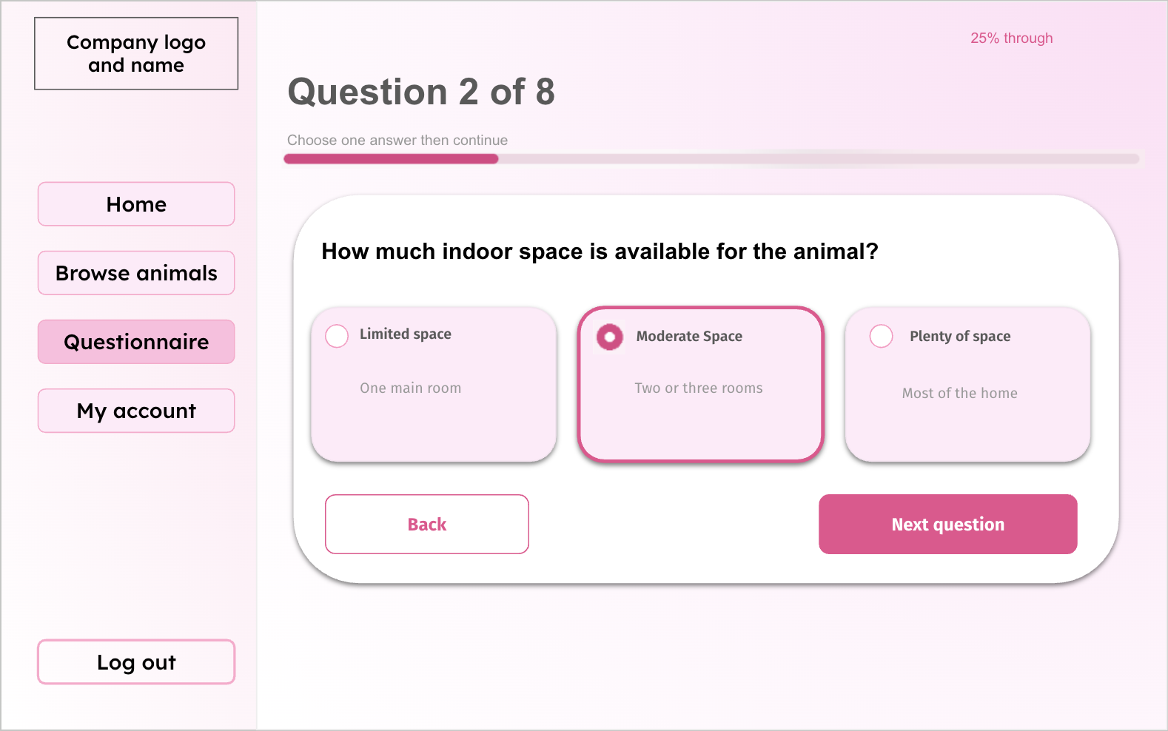
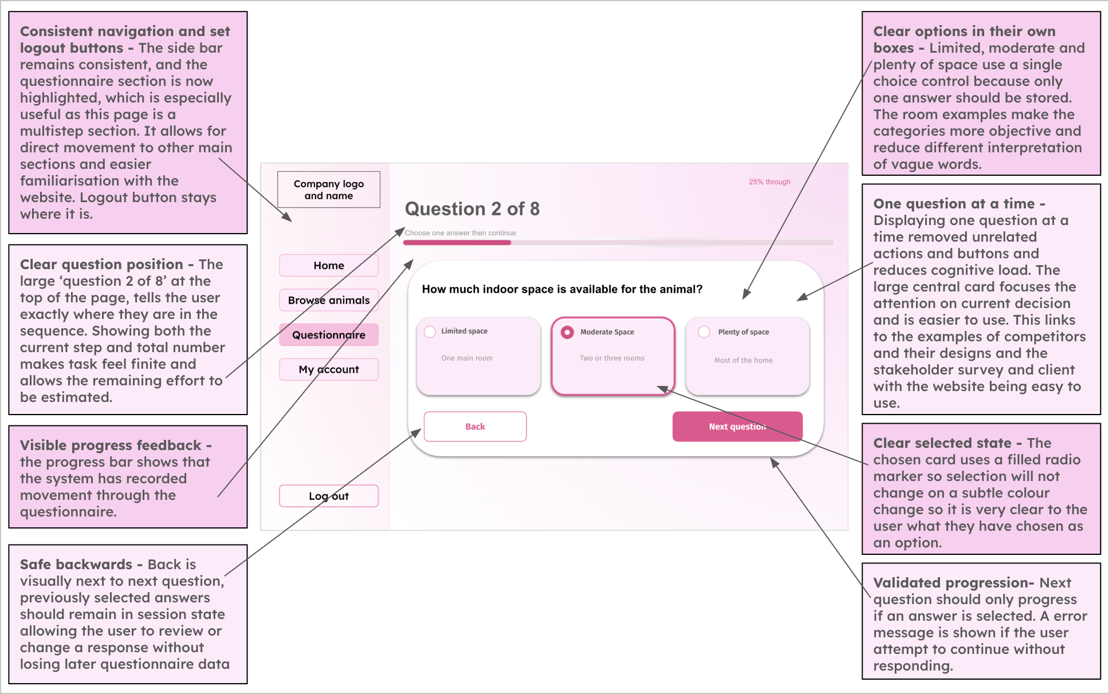

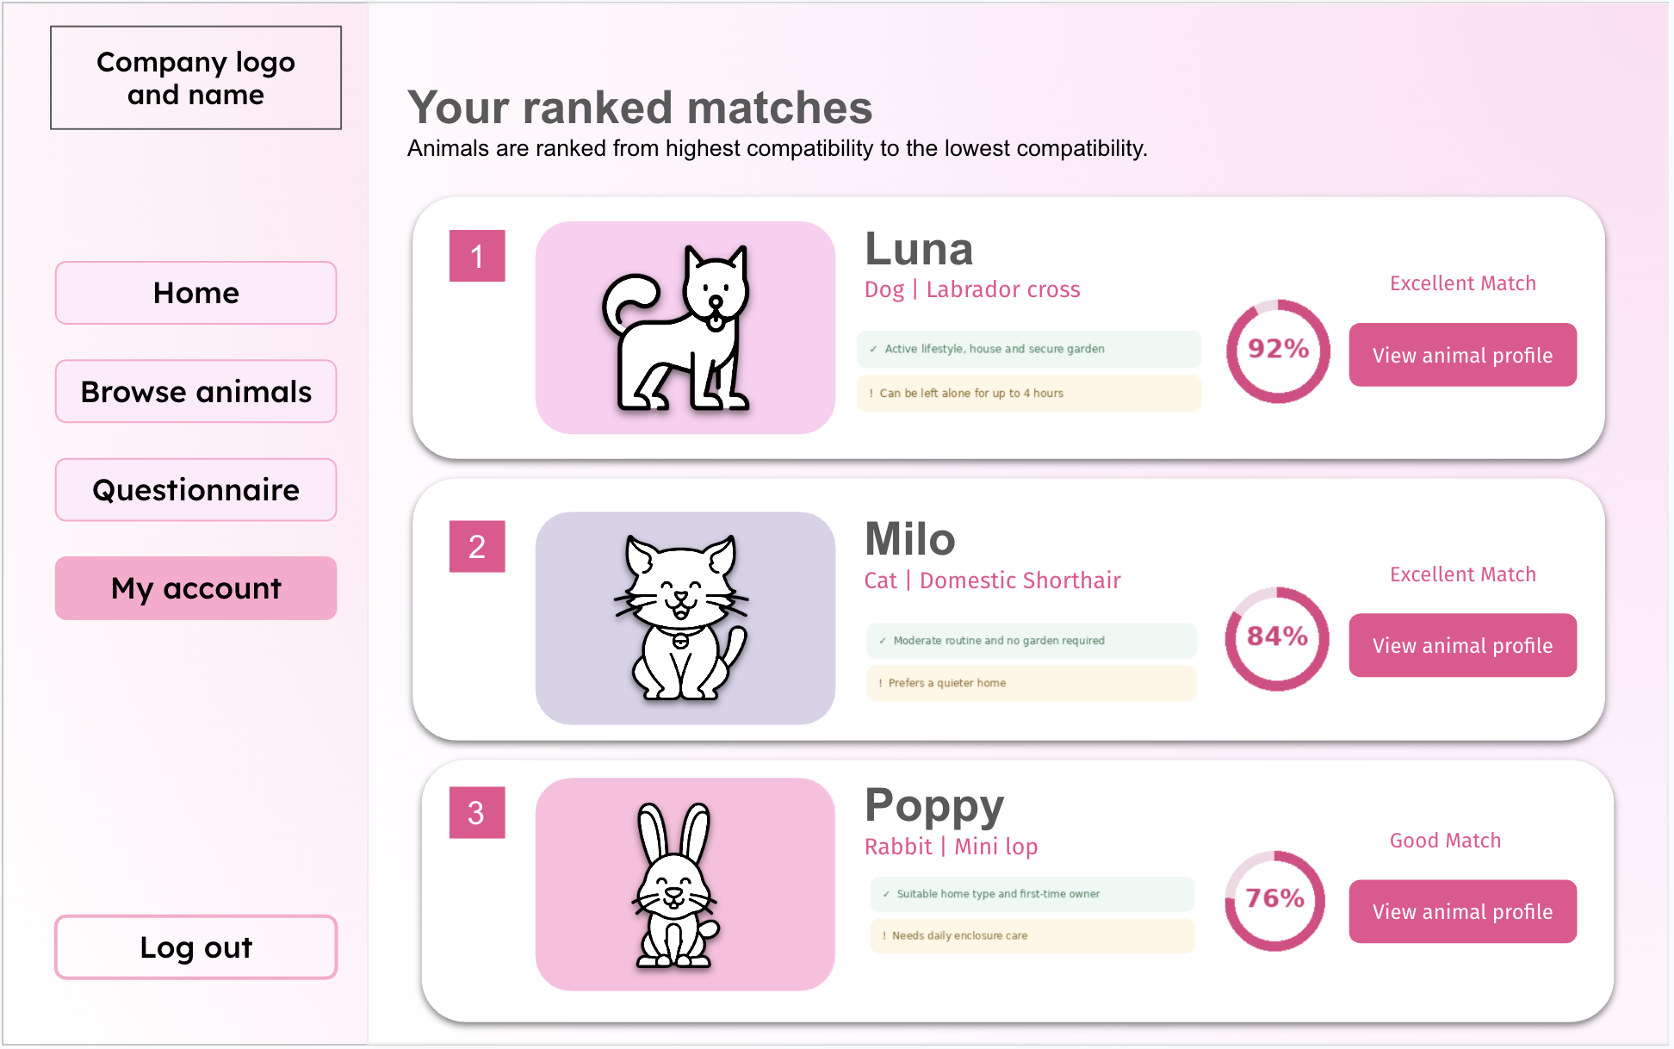
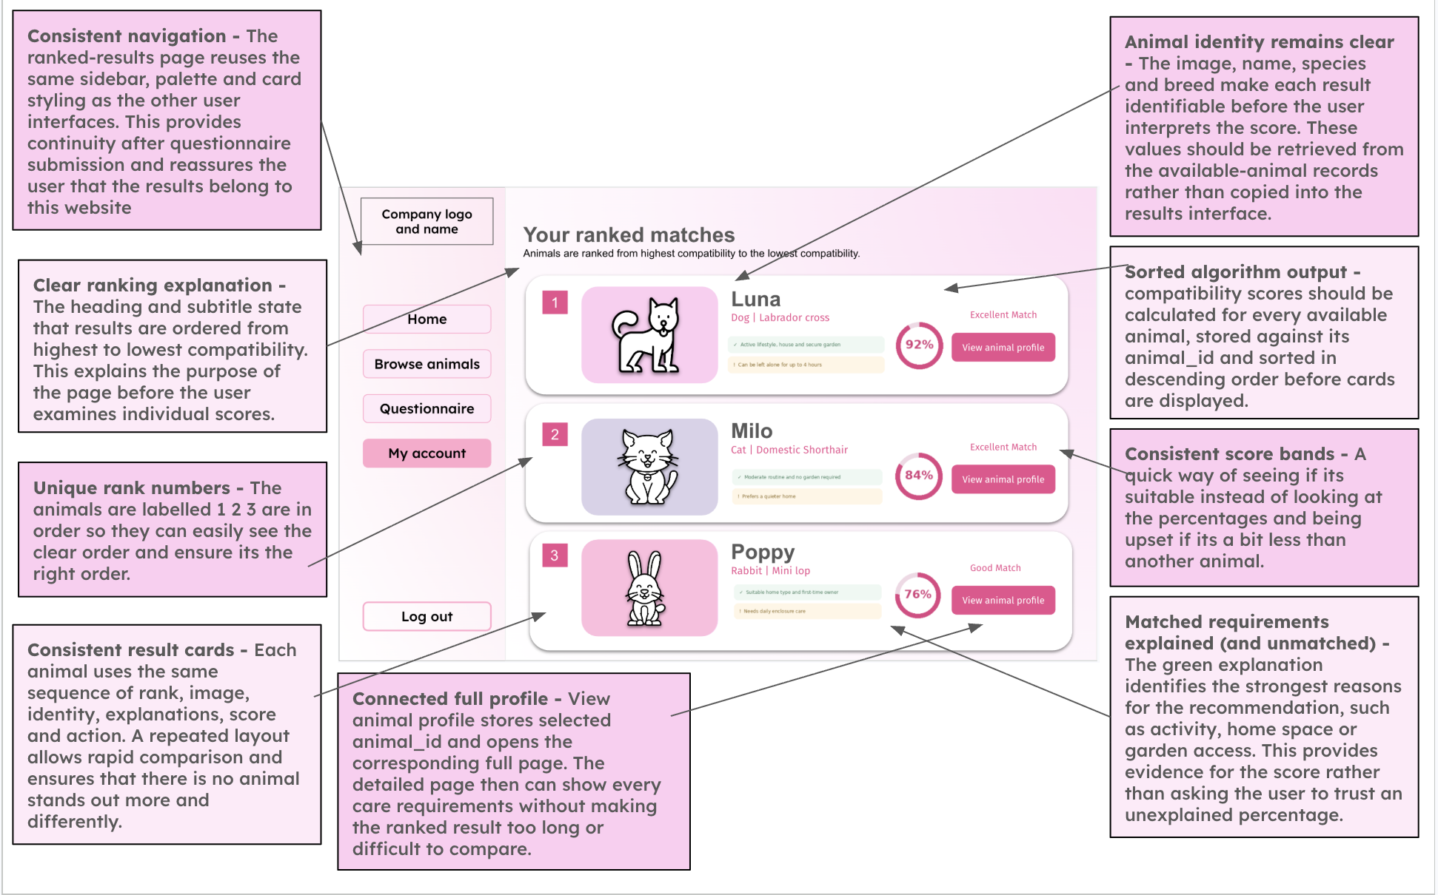

Algorithm (Flow chart, pseudocode)

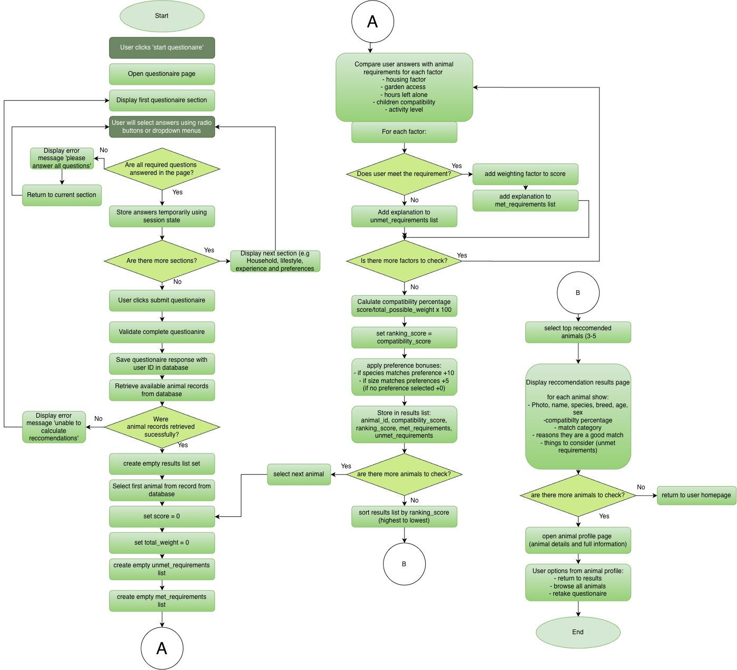
Pseudocode

Model version addition

Pseudocode: questionnaire, compatibility score and ranking
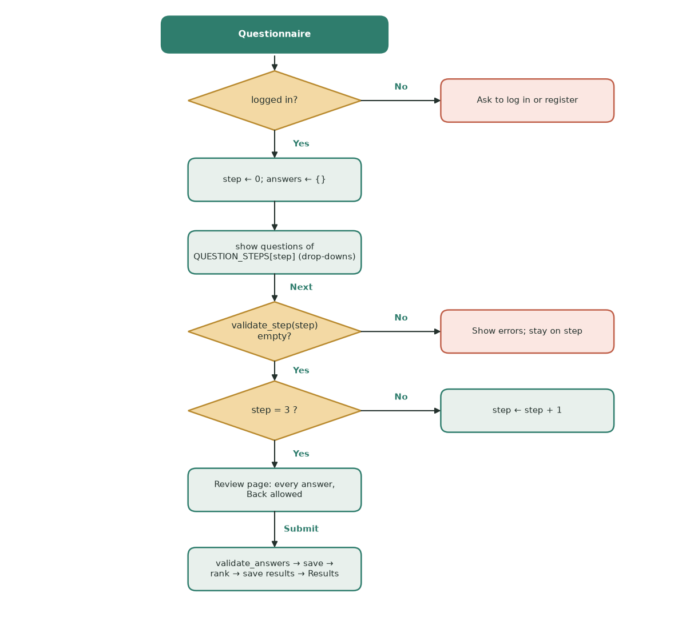
Diagram D6: questionnaire flowchart (model version).
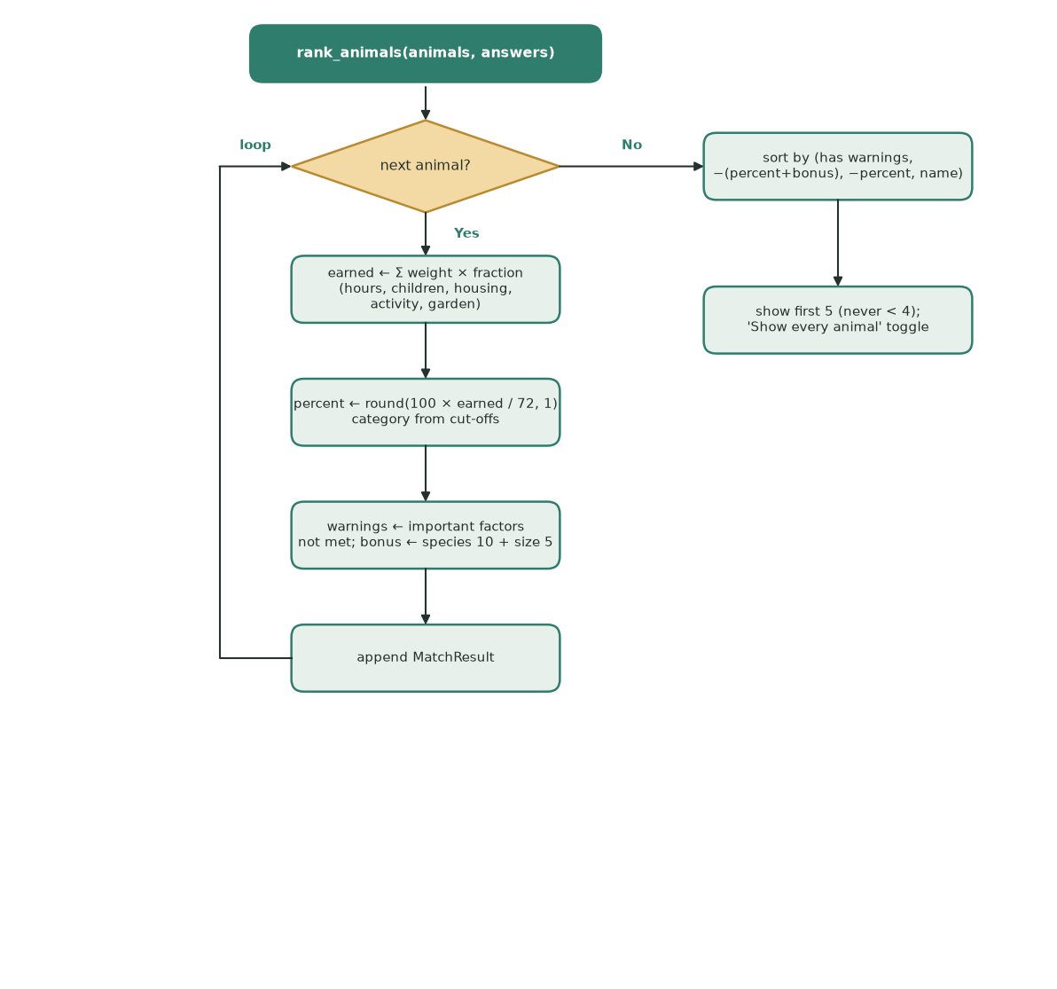
Diagram D7: scoring and ranking flowchart (model version).
CONSTANT QUESTION_STEPS ← [
("Your home", [housing_level, garden_access]),
("Your household", [has_children, other_pets]),
("Your lifestyle", [activity_level, hours_alone, experience]),
("Your preferences", [preferred_species, preferred_size]) ]
PROCEDURE QuestionnairePage()
user ← RequireLogin()
step ← session.q_step (0 if not set)
answers ← session.q_answers (empty if not set)
IF step < 4 THEN
SHOW progress "Step (step + 1) of 5" and the questions of QUESTION_STEPS[step] as drop-downs
IF "Back" clicked AND step > 0 THEN session.q_step ← step − 1
IF "Next" clicked THEN
errors ← ValidateStep(step, answers)
IF errors is empty THEN session.q_step ← step + 1 ELSE SHOW errors
ENDIF
ELSE
SHOW every question with its answer // review step
IF "Change answers" clicked THEN session.q_step ← 0
IF "Submit and see my matches" clicked THEN SubmitQuestionnaire(user, answers)
ENDIF
ENDPROCEDURE
FUNCTION ValidateStep(step, answers)
errors ← empty dictionary
FOR EACH question IN QUESTION_STEPS[step]
CHECK answers[question] with that question's rule:
housing_level, activity_level: one of 1, 2, 3
garden_access, has_children, other_pets: Yes or No
hours_alone: whole number 0 to 24
experience: one of the three listed levels
preferred_species: Dog, Cat, Rabbit or No preference
preferred_size: Small, Medium, Large or No preference
IF it fails THEN errors[question] ← that question's message
NEXT question
RETURN errors
ENDFUNCTION
FUNCTION ValidateAnswers(answers) // all nine questions again before saving
errors ← ValidateStep(0) ∪ ValidateStep(1) ∪ ValidateStep(2) ∪ ValidateStep(3)
IF errors is empty THEN RETURN Answers(answers), errors ELSE RETURN NULL, errors
ENDFUNCTION

CONSTANT WEIGHTS ← {hours_alone: 20, children: 15, housing: 15, activity: 12, garden: 10} // total 72
CONSTANT IMPORTANT ← {hours_alone, children, housing} // unmet → warning
FUNCTION ScoreAnimal(animal, answers)
total_score ← 0
met ← empty list; unmet ← empty list; warnings ← empty list
fraction["hours_alone"] ← 1 IF answers.hours_alone ≤ animal.max_hours_alone ELSE 0
fraction["children"] ← 1 IF animal.child_compatible OR NOT answers.has_children ELSE 0
fraction["housing"] ← 1 IF answers.housing_level ≥ animal.min_housing_level ELSE 0
gap ← MAX(0, animal.exercise_needs − answers.activity_level)
fraction["activity"] ← MAX(0, 1 − gap / 2) // 1, 0.5 or 0
fraction["garden"] ← 1 IF answers.garden_access OR NOT animal.garden_required ELSE 0
FOR EACH factor IN WEIGHTS
total_score ← total_score + WEIGHTS[factor] × fraction[factor]
IF fraction[factor] = 1 THEN
APPEND reason TO met
ELSE
APPEND reason TO unmet
IF factor IN IMPORTANT THEN APPEND reason TO warnings
ENDIF
NEXT factor
compatibility_score ← ROUND(100 × total_score / 72, 1)
IF compatibility_score ≥ 80 THEN match_category ← "Strong"
ELSE IF compatibility_score ≥ 60 THEN match_category ← "Good"
ELSE IF compatibility_score ≥ 40 THEN match_category ← "Possible"
ELSE match_category ← "Low"
ENDIF
bonus ← 0 // preferences order the list but never change the %
IF answers.preferred_species = animal.species THEN bonus ← bonus + 10
IF answers.preferred_size = animal.size THEN bonus ← bonus + 5
RETURN compatibility_score, match_category, bonus, met, unmet, warnings
ENDFUNCTION
FUNCTION RankAnimals(animal_results, answers)
results ← empty list
FOR EACH animal IN animal_results
APPEND ScoreAnimal(animal, answers) TO results
NEXT animal
SORT results BY, in order:
1. animals with no warnings first
2. (compatibility_score + bonus), highest first
3. compatibility_score, highest first
4. name A-Z, then animal_id // ties always come out in the same order
RETURN results
ENDFUNCTION
FUNCTION SubmitQuestionnaire(user, raw_answers)
answers, errors ← ValidateAnswers(raw_answers)
IF errors is not empty THEN RETURN errors // nothing is saved
response_id ← INSERT INTO questionnaire_responses (...) VALUES (?, ...)
results ← RankAnimals(SELECT * FROM animals, answers)
DELETE FROM match_results WHERE response_id = ?
calculated_at ← NOW()
FOR rank ← 1 TO LENGTH(results)
INSERT INTO match_results (response_id, animal_id, rank, compatibility, category, bonus,
met, unmet, warnings, calculated_at) VALUES (?, ...)
NEXT rank
GO TO My matches
ENDFUNCTION

How it fits the whole solution. ValidateStep stops gaps step by step; ValidateAnswers checks the whole set again before anything is stored. SubmitQuestionnaire then joins the parts: it stores the response, calls RankAnimals (which calls ScoreAnimal for every animal) and stores the ranked results that the My matches page shows.

Validation - questionnaire
1.​Housing type or housing level
-​ | Presence check: The user must select an answer
-​ | Lookup check: The answer must be one of the permitted housing options
-​ | A radio button or drop-down will prevent unsupported values
1 = Flat or limited space
2 = Small or medium house
3 = Large house
2.​Garden access
-​ | Presence check: Yes or No must be selected
-​ | Boolean check: The stored result must be 1 or 0
3.​Hours the animal will be left alone
-​ | Presence check : a value must be provided
-​ | Type check : a whole number
-​ | Range check : between 0 and 24 hours
4.​Children in the home
-​ | Presence check: Yes or No must be selected
-​ | Boolean check: The stored result must be 1 or 0
5.​Preferred activity level
-​ | Presence check: an option must be selected
-​ | Boolean check: The stored result must be 1, 2 or 3
After
6.​Preferred species
-​ | Presence check: The user must select an answer
-​ | Lookup check: The answer must be a dog, cat, rabbit or no preference
7.​Preferred size
-​ | Presence check: The user must select an answer
-​ | Lookup check: answer must be small, medium, large or no preference
Validation is necessary within this compatibility algorithm to ensure that the recommendations produced are reliable and that invalid data does not cause incorrect results.

Questionnaire Response table
Field | Data type | Key/validation
response_id | INTEGER | Primary key, auto increment
user_id | INTEGER | Foreign key linked to Users.userid
housing_level | INTEGER | Required range 1-3
garden_access | BOOLEAN | Required 0 or 1
hours_left_alone | INTEGER | Required valid range
has_children | BOOLEAN | Required 0 or 1
preferred_activity_level | INTEGER | Required range 1 - 3
preffered_species | TEXT | Required dog, cat, rabbit or no preference
preferred_size | TEXT | Required small, medium, large or no preference
completed_at | DATE | required
Match Results Table
Field | Data type | Key/validation
match_id | INTEGER | Primary key autoincrement
response_id | INTEGER | Foreign key linked to  QuestionaireReponses.response_id
animal_id | INTEGER | Foreign key linked to animals.animal_id
compatibility_score | REAL | Required range 0 to 100
match_category | TEXT | Required strong, good, possible or low
unmet_requirements | TEXT | optional

Calculated_at | DATE | required
Adoption Questionnaire Variables
Variable Name | Data  Type | Purpose | Justification | Validation or e.g
housing_level | integer | Stores amount of living space available | The available space may affect whether or not the home is  suitable for different sizes and exercise  needs | Required range 1-3
garden_access | boolean | Records  whether user  has access to a garden | Some animals may require regular  access to an outdoor space. A boolean  value is suitable as the answer has two possible values | 0 or 1
hours_left_alone | integer | Stores how long the animal  would normally be left alone | Time availability can be numerically  compared with the animals required  attention and  exercise time | Required valid range such as 0-24
has_children | boolean | Records  whether  children live in the household | Some animals may not be suitable for  homes with children making this an  important safety  factor | 0 or 1
preferred_activity_level | integer | Stores the users preferred  animal activity | Matching activity  level helps ensure  the adopter can meet | range 1 - 3

 |  | level | the animals exercise requirements
preffered_species | string | Stores the users preferred  species | This ensures that the recommendations  remain relevant to  the type of animal  the user is interested in adopting | Required ‘dog’, ‘cat’,  ‘rabbit’ or ‘no preference’
preferred_size | string | Stores the users preferred size | The user may have  practical or personal reasons for preferring a particular size. | ‘small’, ‘medium’, ‘large’ or ‘no preference’
Compatibility scoring algorithm variable names
Variable Name | Data Type | Purpose | Justification | Validation or e.g
animal_id | integer | Stores the  unique identifier of the animal  being assessed | It ensures that each calculated score is linked to the correct animal, even when animals have the  same name | Must match an  existing record in the animals table e.g 12
maximum_score | integer | Stores the  highest possible number of  points that can be awarded by the  compatibility  algorithm | This is required so  that the user's raw  score can be  converted into a  percentage. An  integer is suitable  because the  algorithm awards  whole number points for each matching  factor. | Must be greater than 0

total_score | integer | Stores the total compatibility  points awarded for the animal  currently being assessed | The value begins at zero and increases  whenever the user's answers from the  questionnaire match an animal's  requirements. It must be reset before the  algorithm assesses the next animal. | Begins at 0 and cannot exceed  maximum_score
animal_scores | list | Stores the ID and  compatibility score for all available  animals | This will allow the results to be sorted from highest to  lowest compatibility.  A list is suitable  because the  algorithm processes multiple animals | [{"animal_id": 3, "score": 92.5},  {"animal_id": 7, "score": 78.0}]
compatibility_score | float | Stores the  calculated  compatibility percentage | A percentage is  easier for users to  understand and  compare than a raw points total, a float will allow decimal results to be stored. | Must be between  0-100 and can have decimals
match_category | string | Stores an  understandable category for the calculated score | A category makes  the numerical result easier for the user to interpret. It is  selected according to predefined  percentage ranges. | strong, good,  possible or low
unmet_requirements | list | Stores  explanations of requirements  the user did not meet | There may be several reasons why an  animal is not fully  suitable so a list will allow multiple  explanations to be  stored and displayed. | Example: "Requires a secure garden", "Not suitable with cats". It may be empty when all essential  requirements are  met.

Questionnaire Plan
Section 1: House environment
-​ Amount of living space
-​ Garden access?
Section 2:
-​ Children in the home?
Section 3:
-​ Preferred activity level / time available for exercise and care
-​ Hours the animal would be left alone
Section 4:
-​ Preferred species
-​ Preferred animal size
Section 5:
-​ Submit
Where it links
-​  -​  -​  -​  -​  -​  -​ | Amount of living space → minimum housing level Garden access → garden required  Children in the home → child compatible  Preferred activity level → exercise need  Hours left alone → maximum hours left alone Preferred species → animal species  Preferred size → animal size
First Matching part
Factor | Suggested weight (can be changed) | Justification
Hours Left alone | 20 | Strongly will affect whether the adopter can meet the animals needs

Child compatibility | 15 | Important for safety and suitability
Housing space | 15 | Ensures the home provides enough room
Activity | 12 | Matches exercise needs with users lifestyle and what they can provide
Garden access | 10 | Important for animals  requiring outdoor access, but can even use a park so not as important factor

-​  -​  -​  -​  -​  -​ | Calculate the suitability score  Remove animals with low suitability  Prioritise animals matching users preferred species  Prioritise animals matching users preferred size  Sort remaining animals by suitability score  Show top 3 or 5 (depending how many animals are in the system)

Factor | Suggested weight
Species | 10
Size | 5
However, these weights will not add to the compatibility percentage as their preferences do not reflect animal suitability. It will influence the order in which suitable animals are displayed.
This will prevent an unsuitable animal from receiving a misleading high compatibility percentage as it matches the users preferences, but still ensuring preferred animals are presented as users top choices as this will make them more inclined to adopt. If the user picks ‘no preference’ no animal will receive a bonus.

Model version addition

Compatibility score, exactly
- Each factor gives a fraction: 1 if met, 0 if not. Activity can also give 0.5: fraction = max(0, 1 − gap ÷ 2), where gap = the animal's exercise level minus the adopter's activity level (never below 0). Being more active than needed is not penalised.
- points = 20 × hours + 15 × children + 15 × housing + 12 × activity + 10 × garden (maximum 72).
- compatibility % = round(100 × points ÷ 72, 1).
- Hard rules (children, hours alone, space) lose their points and give a warning; they do not remove the animal. Animals with a warning are listed after every animal without one. Garden and activity lose points only.
- Categories: Strong 80 % or more; Good 60 to 79.9 %; Possible 40 to 59.9 %; Low below 40 %.
- Preferences (species 10, size 5) are added only to the sorting points, never to the percentage, as the Design says.
Worked example. Adopter: lives in a flat (housing 1), no garden, has children, can offer activity level 2, leaves an animal 6 hours a day, prefers dogs, no size preference.
Factor (weight) | Milo, cat: needs housing 1, no garden, child-safe, exercise 1, up to 8 h alone | Oscar, dog: needs housing 1, no garden, child-safe, exercise 2, up to 4 h alone
Hours alone (20) | 6 ≤ 8: met → 20 | 6 > 4: not met → 0, warning
Children (15) | child-safe: met → 15 | child-safe: met → 15
Housing (15) | 1 ≥ 1: met → 15 | 1 ≥ 1: met → 15
Activity (12) | gap max(0, 1 − 2) = 0 → 12 | gap max(0, 2 − 2) = 0 → 12
Garden (10) | not needed: met → 10 | not needed: met → 10
Points | 72 | 52
Percentage | 100 × 72 ÷ 72 = 100.0 % (Strong) | 100 × 52 ÷ 72 = 72.2 % (Good)
Preference bonus | cat ≠ dog → 0 | dog = dog → 10
Sorting points | 100.0 | 82.2, but has a warning

Result: Milo is listed above Oscar, and Oscar comes after every animal without a warning even though his sorting points (82.2) are higher than some of theirs. Running the real code on the same answers gives the same numbers (Milo 100.0, Oscar 72.2 with one warning); this example is reused as test data (E2, E7, E9).

Model version addition

Usability features
Feature | Where it appears | Why it is included
Calm colour scheme from one theme file (green, cream, dark text) | Every page | Survey and examples asked for a calm, clean look (S6, E1-E3). One theme file means every page matches (criterion 1.4).
The same top menu on every page, showing only the pages the user may open | Every page | All three example sites keep one menu (E1-E3, S6). Hiding the staff page from adopters avoids a confusing 'no access' link (Q12).
Questionnaire in four short steps plus a review step, with a progress bar | Questionnaire | E3 and S6: long forms put people off. The progress bar shows how much is left; the review step lets users check before submitting.
Drop-downs for every answer (no typing) | Questionnaire, filters, staff form | E3, S6: quicker on a tablet, and the answer can only be one of the allowed values, so fewer errors (Q15).
All errors for a form shown together in one red box, in plain words | Register, log in, questionnaire, staff form | Q12, S6: users should see everything to fix at once instead of one message per attempt.
Compact animal cards (photo, name, species, breed, age, 'View profile') | Animals, Home | Q2, E1, E2: the examples use cards; the card holds the five facts adopters said they check first.
Score bar, category word and met / not met list on each match | My matches | Q3, E3: the client wants adopters to see why an animal suits them, not just a number.
Orange warning when an important need (time alone, children, space) is not met | My matches | Q3: welfare first. The warning cannot be missed and these animals are listed after the safer matches.
'Guidance only: staff make the final decision' note | Home, My matches | Q3: sets the right expectation.
Delete needs a tick-box confirmation; the button is disabled until then | Staff area | Q5: deleting is permanent, so a slip of the mouse must not remove an animal.
Back links that return to where the user came from | Animal profile | S6, E1-E3: a profile opened from the results goes back to the results, not to the start.

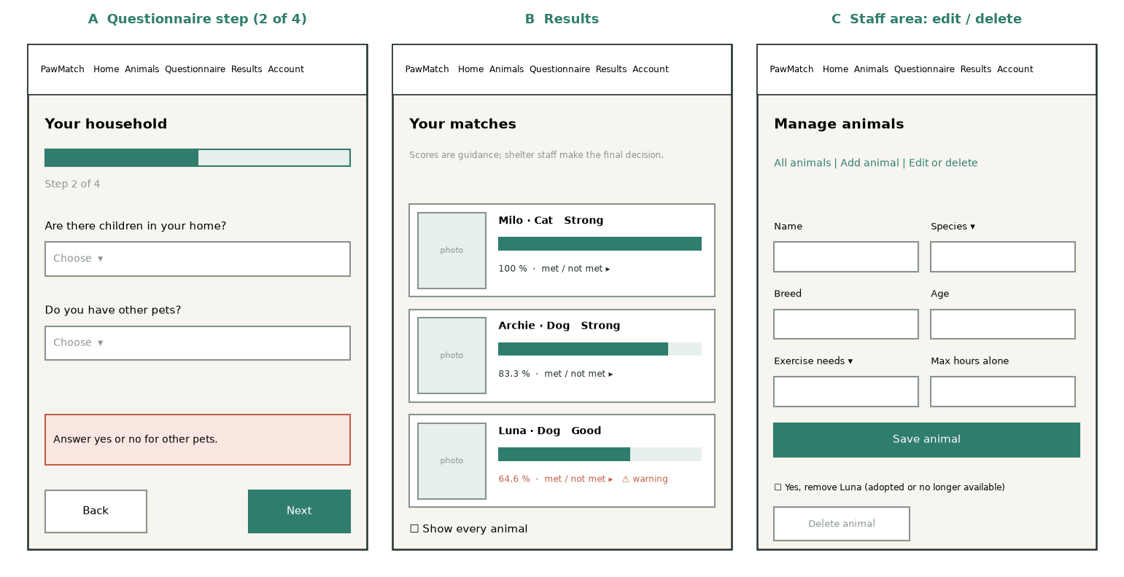
Diagram D8: wireframes for the questionnaire step, results and staff edit screens (model version).

Development Test plan

Development Test Plan

Model version addition

Development test plan
Five components, 8 to 11 tests each, mixing normal, boundary and invalid data. Each test is chosen to prove a rule from the Design works on both sides of its edge. These numbers are used in the Development section.
Test | What is tested and why | Input data | Expected result | Type
A1 | Valid sign-up: the main path must work | Sam Lee, sam@x.com, 30, 'longenough' twice | Account stored, logged in | Normal
A2 | Blank fields: presence checks | name ' ', email '', age '', password '' | One message per field | Invalid
A3 | Email format | no-at-sign.com, a@b, two@@x.com | 'Enter a valid email address' | Invalid
A4 | Age boundary: 18+ rule | 17 / 18 / 120 / 121 | 17 and 121 rejected; 18 and 120 accepted | Boundary
A5 | Age type check | 2.5, abc | 'Age must be a whole number.' | Invalid
A6 | Password boundary (at least 8) | 7 characters / 8 characters | 7 rejected, 8 accepted | Boundary
A7 | Duplicate email, any case | SAM@x.com after sam@x.com | 'already exists', nothing stored | Invalid
A8 | Login with right details; email case ignored | ' SAM@X.COM ' + password | Logged in | Normal
A9 | Wrong password and unknown email | right email + wrong password; unknown email | Same message for both | Invalid
A10 | Password stored only as a salted hash | same password twice | Two different hashes; no plain text | Normal
A11 | Name format from the Design variables table | Mary-Jane, Siobhan O'Neill / 12345, Sam3, Sam! | Letters, spaces, hyphens, apostrophes only | Invalid
B1 | Every animal shown as a card | 13 demo animals | 13 cards | Normal
B2 | Species and size filters | Rabbit; Small | Only matching animals | Normal
B3 | Search text is data, not SQL | ' OR 1=1 -- | No animals, no error | Invalid
B4 | Empty search shows everything | '' | All animals | Boundary
B5 | Search length limit | 21 characters typed | Box stops at 20 | Boundary
B6 | Profile loads from the database by id | id of Luna | Luna's details | Normal
B7 | Profile with a missing or bad id | id=999, id=abc | 'could not be found' | Invalid
B8 | Back link returns to where the user came from | open from results | 'Back to my matches' | Normal
C1 | Adopter calls add, edit or delete | adopter account | Refused (AccessDenied) | Invalid
C2 | Add a complete animal | every field valid | Stored; listed | Normal
C3 | Animal age range | 0 / 1 / 30 / 31 | 0 and 31 rejected | Boundary
C4 | Hours alone range | -1 / 0 / 24 / 25 | -1 and 25 rejected | Boundary
C5 | Edit and save | new breed | Breed changed on the profile | Normal
C6 | Edit an animal deleted meanwhile | stale id | 'no longer exists' | Invalid
C7 | Delete needs confirmation | box not ticked | Button disabled | Invalid
C8 | Staff page hidden from adopters | adopter opens the page by name | No such page | Invalid
C9 | Photo type and size | a.gif; 2 MB + 1 byte / exactly 2 MB | Rejected / accepted | Boundary
C10 | Database repeats the rules | direct INSERT with species 'Hamster' | Database refuses it | Invalid
C11 | Breed length and content (Design) | Mixed / X, ### | X and ### rejected | Boundary
D1 | Each question in exactly one step | the four steps | 9 questions, none twice | Normal
D2 | A blank answer blocks Next | step 1 with one blank | Error, stays on step | Invalid
D3 | A step only checks its own questions | step 1 answered, rest blank | Next allowed | Normal
D4 | Hours alone range | -1 / 0 / 24 / 25 | -1 and 25 rejected | Boundary
D5 | Answer outside the list | species 'Hamster' | Rejected | Invalid
D6 | Incomplete set cannot be saved | 8 of 9 answers | Nothing stored | Invalid
D7 | Must be logged in | no session | 'Please log in' | Invalid
D8 | Full valid set | 9 valid answers | Saved; results page opens | Normal
E1 | Weights equal the Design | WEIGHTS | 20, 15, 15, 12, 10 = 72 | Normal
E2 | Perfect match | every need met | 100 %, Strong | Boundary
E3 | Nothing met | every need failed | 0 %, Low | Boundary
E4 | Each factor loses its own weight | fail one factor at a time | −20, −15, −15, −12, −10 points | Normal
E5 | Exactly at a limit counts as met | hours = max hours; housing = minimum | Met | Boundary
E6 | Category cut-offs | 79.9 / 80 / 59.9 / 60 / 39.9 / 40 | Possible/Strong/Possible/Good/Low/Possible | Boundary
E7 | Warnings only for important factors | fail garden vs fail children | Warning only for children | Normal
E8 | Preferences change order, not % | preferred species | Same %, higher place | Normal
E9 | Unsuitable animals rank after suitable ones | high score with warning vs lower without | Lower one first | Normal
E10 | At least 4 results shown | 13 animals | 5 shown, toggle for all | Normal
E11 | Results record when they were calculated (Design table) | any submission | calculated_at stored | Normal

Post-development test plan
One test per success criterion, using the measure from the Analysis, plus timing (T), robustness (R) and usability tests (U). The usability tests need real people from the stakeholder groups (adopters from the survey group and the shelter client).
Test | Criterion | Measure / expected result
P1.1 | Pages must use a calm colour scheme, clear headings and identifiable buttons | One theme file sets every colour; body text contrast at least 4.5 : 1 (WCAG AA); every action is a labelled button
P1.2 | The interface must remain readable on laptop and tablet sized screens | At 1280 px and 820 px (tablet) wide: no sideways scrolling and no text cut off
P1.3 | The system must include a navigation menu to access home page, animal preview page, profil… | The top menu holds Home, Animals, Questionnaire, My matches and Log in / My account on 7 of 7 pages
P1.4 | The menu and interface style must remain consistent across all the pages | 0 pages with their own colours or CSS
P2.1 | Should explain the purpose of the animal adoption matching system, especially including th… | The home page states the purpose and the word 'suitability'
P2.2 | Should have a clear button or navigation option that directs users to complete the adoptio… | 1 click from Home to the questionnaire
P3.1 | The page should display every available animal using compact animal cards | Number of cards = number of animal records (13 of 13; 500 of 500 in the load test)
P3.2 | Each card should show the species, name, breed, age and image | 5 of 5 facts on every card: species, name, breed, age, image
P3.3 | The system must support at least 3 animal species including dogs, cat and rabbits | At least 3 species stored and shown
P3.4 | Users must be able to open a full animal profile from the preview page | 1 click from a card to its profile
P4.1 | Each profile must display the animals name, species, breed, age and sex | 5 of 5 shown: name, species, breed, age, sex
P4.2 | Each profile also must include personality, medical needs, exercise needs and suitability … | Personality, medical needs, exercise needs and suitability all shown
P4.3 | Animal profile information must be retrieved from the database | Profile is loaded by animal_id from SQLite; editing the record changes the page
P4.4 | Users must be able to return to the animal preview page or results page | 1 click back to the list or to My matches
P5.1 | Users must be able to create an account, using name, email and password and it can include… | A valid sign-up stores 1 user row with a hashed password
P5.2 | The system must reject registration if required fields are empty and the email format is i… | 100 % of the blank and invalid cases A2-A6 and A11 are rejected with a message
P5.3 | Registered users must be able to login and logout using their correct account details | Correct details log in; Log out clears the session
P5.4 | The admin login details should allow admins to access their own section with the CRUD inte… | A staff account sees 'Manage animals'; an adopter sees no staff link
P5.5 | Incorrect Login details must display an error message and prevent access to the account | Wrong password and unknown email give the same message and no session
P6.1 | The questionnaire must collect information about the user’s home, lifestyle, garden access… | 9 questions cover home, garden, children, other pets, activity, hours alone, experience, species, size
P6.2 | The questionnaire must be split into clear sections or individual questions rather than ap… | 4 steps and a review step; 4 of 5 testers rate the layout 8/10 or more for clarity
P6.3 | The questionnaire must use suitable input methods such as dropdowns, radio buttons or sele… | 0 free-text boxes in the questionnaire
P6.4 | The system must prevent the questionnaire from being submitted if important questions are … | A blank answer blocks Next; an incomplete set saves 0 rows
P7.1 | The system must compare adopter’s questionnaire with each animal’s requirements | Every animal gets a result (N results for N animals)
P7.2 | The system must calculate a numerical compatibility score for each animal | A percentage from 0 to 100 (1 decimal place); 500 animals scored and stored in under 2 seconds
P7.3 | The top 4 animals must be displayed from highest compatibility score to lowest at a minimu… | At least 4 shown, best first
P7.4 | The results page must show which key requirements the user meets and does not meet for eac… | Every result lists what is met and what is not
P7.5 | The system must display a warning if the user does not meet important requirements for an … | An unmet hours-alone, children or space requirement shows a warning
P7.6 | The results page must explain that the compatibility scores are guidance, and the adoption… | The results page says scores are guidance and staff decide
P8.1 | This page should be accessed separately with a separate admin login | The staff page is reached only through a staff login
P8.2 | Admin users must be able to add a new animal record with all the information required | A complete add form stores a record; any invalid field stores nothing
P8.3 | Admin users must be able to edit existing animal records and save the updated information … | An edit is saved and shown on the profile
P8.4 | Admin users must be able to delete animal records when animals adopted or no longer availa… | Delete only after the confirmation box is ticked; the record and its results are removed
P8.5 | Normal users must not be able to access the admin management page | An adopter is refused every staff action, even if the page is bypassed
P9.1 | The database must store animal records, user account details, admin login details and ques… | Stores users, animals, responses and results; at least 500 animals and 100 users
P9.2 | The database must allow animal records to be added, viewed, edited and deleted through the… | Animals can be added, viewed, edited and deleted
P9.3 | Questionnaire answers must be stored or processed so that they can be used by the compatib… | Answers are saved and used for the score
P9.4 | Data must be retrieved correctly so animal profiles and recommendations display accurate i… | Values read back equal the values stored

Test | What | Who | Expected
T1 | Theme and contrast | Developer | Text contrast at least 4.5 : 1
T2 | Width check | Developer, headless browser | No sideways scrolling at 1280 and 820 px
T3 | Menu on every page | AppTest | Same menu on 7 of 7 pages
T4 | Scoring time | Developer | 500 animals scored and stored in under 2 s
T5 | Capacity | Developer | 500 animals and 100 users stored and listed
U1 | Usability: register and log in without help | Adopter (survey group), first visit | Done in under 2 minutes; rates it 8/10+
U2 | Usability: complete the questionnaire | Adopter | No help needed; rates clarity 8/10+
U3 | Usability: explain your top match and any warning | Adopter | Can say why the top animal suits them
U4 | Usability: add, then edit, then delete an animal | Shelter staff (client) | All three done without help
U5 | Usability: use the site on a tablet | Adopter with a tablet | No zooming or sideways scrolling

3 Development
Model version addition
Development was done in five stages, each saved as a commit on the opus-rebuild branch, so every prototype can be restored. The stages follow the hierarchy chart: rules first, then storage, then pages, then a whole-system run, then a re-check against the Design. Each module was written with its tests, and the full test suite was run at the end of every stage; the output of each run is kept in docs/evidence.
Stage | Commit (prototype) | What it added | Tests after
1 | ffd0ad5 | models.py, validation.py, matching.py | 73 passed
2 | 10e84e7 | db.py, auth.py, services.py, seed.py, animal photos | 103 passed
3 | b76527c | streamlit_app.py, webui/ pages, page tests, screenshot script | 117 passed
4 | 213e208 | README, write-up, comparison page, 16 screenshots | 117 passed
5 | fdef5a0 | Design re-check: name and breed rules, calculated_at | 134 passed

Reviews: no client or stakeholder was available for this model version, so each review below is a developer review against the Design and success criteria, and says so. In a real project each one would also be shown to the client.

Stage 1: Data model, validation and matching rules

Aim
Builds the parts with no screens: the data classes (Design: variables tables), every validation rule (Design: the Validation lists for login, registration, animals and the questionnaire) and the compatibility algorithm (Design: Compatibility algorithm and questionnaire, First Matching part). These come first because every later stage uses them, and they can be fully tested without a database or a browser. Commit ffd0ad5; components A, C, D and E of the hierarchy chart.

Code
Weights and normalisation (pawmatch/matching.py). The weights are the Design's table. MAX_POINTS is worked out from them, so changing a weight cannot break the percentage.
WEIGHTS: dict[str, int] = {
"hours_alone": 20,
"children": 15,
"housing": 15,
"activity": 12,
"garden": 10,
}
MAX_POINTS = sum(WEIGHTS.values()) # 72
PREFERENCE_BONUS: dict[str, int] = {"species": 10, "size": 5}
# Unmet requirements on these factors are welfare risks, so they raise a warning.
IMPORTANT_FACTORS = frozenset({"hours_alone", "children", "housing"})
CATEGORY_THRESHOLDS: tuple[tuple[float, str], ...] = (
(80.0, "Strong"),
(60.0, "Good"),
(40.0, "Possible"),
(0.0, "Low"),
)
MIN_RESULTS_SHOWN = 4

Scoring one animal. Each factor gives a fraction (1, 0.5 or 0) times its weight. Unmet important factors also go into warnings. The percentage is rounded to one decimal place.
def score_animal(animal: Animal, answers: Answers) -> MatchResult:
"""Score one animal: percentage, category, met/unmet lists and warnings."""
earned = 0.0
met: list[str] = []
unmet: list[str] = []
warnings: list[str] = []
for factor, fraction, reason in _factor_checks(animal, answers):
earned += WEIGHTS[factor] * fraction
if fraction == 1.0:
met.append(reason)
else:
unmet.append(reason)
if factor in IMPORTANT_FACTORS:
warnings.append(reason)
compatibility = round(100 * earned / MAX_POINTS, 1)
return MatchResult(
animal=animal,
compatibility=compatibility,
category=category_for(compatibility),
bonus=preference_bonus(animal, answers),
met=met,
unmet=unmet,
warnings=warnings,
)

Ranking: warnings last, then points. Sorting by a tuple applies the rules in order: warnings, points with bonus, percentage, then name and id, so ties always come out the same way.
def rank_key(result: MatchResult) -> tuple[int, float, float, str, int]:
"""Suitable animals first, then ranking points, compatibility, name and id (all deterministic)."""
return (
0 if result.suitable else 1,
-result.ranking_points,
-result.compatibility,
result.animal.name.lower(),
result.animal.animal_id,
)
def rank_animals(animals: Iterable[Animal], answers: Answers) -> list[MatchResult]:
"""Score every animal and return them best first."""
return sorted((score_animal(a, answers) for a in animals), key=rank_key)

One validator per questionnaire step (pawmatch/validation.py). Each step validates only its own questions, so users get messages for the step they are on.
def validate_step(step: int, raw: dict[str, Any]) -> Errors:
"""Validate only the questions on one step, so users can't move on with gaps."""
errors: Errors = {}
for name in QUESTION_STEPS[step][1]:
QUESTION_VALIDATORS[name](raw.get(name), errors)
return errors

Prototype evidence. Ev 1: the stage 1 test run (docs/evidence/stage1-pytest.txt):
tests/test_validation.py::test_steps_cover_every_question_once PASSED [100%]
============================== 73 passed in 0.04s ==============================

Testing
Test no. | Description | Input | Expected | Actual | Pass / Fail | Evidence (figure)
A2-A6 | Registration validation | see test plan | Rejected with the right message | As expected | Pass | test_registration_* (Ev 1)
C3, C4 | Animal ranges | 0/1/30/31 and -1/0/24/25 | Ends rejected | As expected | Pass | test_invalid_animal_fields_are_rejected
D1-D5 | Questionnaire steps and rules | see test plan | As planned | As expected | Pass | test_steps_cover_every_question_once, test_step_validation_only_checks_that_step
E1-E9 | Scoring and ranking | see test plan | As planned | As expected | Pass | test_matching.py, 29 cases
A11 | Name format | 12345 | Rejected | Accepted (not yet checked) | Fail (found in stage 5) | Ev 5a
C11 | Breed length and content | X, ### | Rejected | Accepted | Fail (found in stage 5) | Ev 5a

Failed test and remedial action
Test no. | What happened | Cause | Fix made | Re-test result
A11, C11 | '12345' was accepted as a person's name, and 'X' and '###' as breeds. Found when the Design was re-checked in stage 5. | The validator only checked presence and length; the Design's format rules (letters, spaces and hyphens; breed 2-50 and not only symbols) were missed. | Added a letters-only rule for people (digits allowed for animal names such as 'R2', as the Design allows) and a 2-50, must-contain-letters rule for breeds. Tests written first from the Design wording. | Pass: 134 passed (Ev 5b)

Review
Developer review against the Design and success criteria, after the stage 1 tests passed (no client or stakeholder was shown this stage, as it has no screens). Checked: weights 20/15/15/12/10 match the Design table (test E1); preferences do not change the percentage, as the Design says; every validation list has at least one test. Open question found: the Design does not say whether failing children or garden makes an animal unsuitable or only loses points.

Changes made after review
Decided and wrote down the rule: every unmet factor loses its points; unmet hours alone, children or space also gives a warning, and those animals are listed after all animals without warnings (tests E7 and E9). Reason: a high score must never put an unsafe match at the top (Q3). Added a fixed tie-break (name, then id) so equal scores always appear in the same order.

Stage 2: Database, login and staff-only actions

Aim
Builds the SQLite database (Design: Database structure and the four table designs), registration and login with hashed passwords (Design: Login and Registration), the role check and the add / edit / delete services (Design: Admin Page), and the demo animals. Commit 10e84e7; components A, C and E (storing results).

Code
Salted scrypt hashing and constant-time check (pawmatch/auth.py). A new 16-byte salt for every password; the parameters are stored with the hash so they can be raised later. compare_digest takes the same time whether the first or last character differs.
def hash_password(password: str) -> str:
"""Return 'scrypt$n$r$p$salt$hash' with a fresh 16-byte salt."""
salt = secrets.token_bytes(16)
digest = hashlib.scrypt(password.encode(), salt=salt, n=SCRYPT_N, r=SCRYPT_R, p=SCRYPT_P)
return f"scrypt${SCRYPT_N}${SCRYPT_R}${SCRYPT_P}${salt.hex()}${digest.hex()}"
def verify_password(password: str, stored: str) -> bool:
"""Recompute the hash with the stored salt and compare in constant time."""
try:
scheme, n, r, p, salt_hex, digest_hex = stored.split("$")
except ValueError:
return False
if scheme != "scrypt":
return False
digest = hashlib.scrypt(password.encode(), salt=bytes.fromhex(salt_hex), n=int(n), r=int(r), p=int(p))
return hmac.compare_digest(digest.hex(), digest_hex)

Login: one message for every failure. Validation, then lookup, then hash check. Any failure returns the same message.
def login(conn: sqlite3.Connection, email: Any, password: Any) -> tuple[User | None, Errors]:
"""Return the user for correct details; one generic message otherwise (no account probing)."""
cleaned, errors = validate_login(email, password)
if errors:
return None, errors
found = db.find_user_with_hash(conn, cleaned["email"])
if found is None or not verify_password(cleaned["password"], found[1]):
return None, {"login": LOGIN_FAILED}
return found[0], {}

Role checked inside the service. require_admin raises AccessDenied before anything is validated or stored.
def add_animal(conn: sqlite3.Connection, actor: User | None, raw: dict[str, Any]) -> tuple[int | None, Errors]:
require_admin(actor)
values, errors = validate_animal(raw)
if errors:
return None, errors
return db.insert_animal(conn, values), {}
def remove_animal(conn: sqlite3.Connection, actor: User | None, animal_id: int) -> bool:
require_admin(actor)
return db.delete_animal(conn, animal_id)

Browse query: values bound, never joined into SQL (pawmatch/db.py). Filters add '?' placeholders; the user's text only ever goes into params.
def list_animals(
conn: sqlite3.Connection, species: str | None = None, size: str | None = None, search: str = ""
) -> list[Animal]:
"""Browse query with optional filters; the search term is bound, never concatenated."""
sql = "SELECT * FROM animals WHERE 1 = 1"
params: list[Any] = []
if species:
sql += " AND species = ?"
params.append(species)
if size:
sql += " AND size = ?"
params.append(size)
if search.strip():
sql += " AND (name LIKE ? OR breed LIKE ?)"
term = f"%{search.strip()}%"
params += [term, term]
sql += " ORDER BY species, name"
return [_animal(r) for r in conn.execute(sql, params)]

Prototype evidence. Ev 2: the stage 2 test run (docs/evidence/stage2-pytest.txt):
tests/test_validation.py::test_steps_cover_every_question_once PASSED [100%]
============================= 103 passed in 1.33s ==============================

Testing
Test no. | Description | Input | Expected | Actual | Pass / Fail | Evidence (figure)
A1, A7 | Register; duplicate email in another case | sam@x.com then SAM@x.com | Second refused | As expected | Pass | test_register_rejects_duplicate_email_case_insensitively
A8, A9 | Login right / wrong | see test plan | Logged in / same message | As expected | Pass | test_login_success..., test_wrong_password_and_unknown_email_give_the_same_message
A10 | Salted hash | same password twice | Different hashes | As expected | Pass | test_hash_is_salted_and_not_plain_text
B3 | SQL injection in search | ' OR 1=1 -- | No rows, no error | As expected | Pass | test_search_text_is_treated_as_data_not_sql
C1 | Adopter calls staff actions | adopter account | AccessDenied | As expected | Pass | test_non_admins_are_refused_every_change
C10 | Database CHECKs | species 'Hamster' | IntegrityError | As expected | Pass | test_database_constraints_back_up_validation
E11 | calculated_at stored | any submission | Timestamp stored | No such column | Fail (found in stage 5) | Ev 5a

Failed test and remedial action
Test no. | What happened | Cause | Fix made | Re-test result
E11 | Match results had no calculated_at column. Found when the Design's Match Results table was re-checked in stage 5. | The table was built from the scoring needs (rank, score, reasons) and the Design's calculated_at field was left out. | Added the column, one timestamp per ranking, and an in-place upgrade (ALTER TABLE) so databases made before the fix keep working; a second test builds an old database and checks it is upgraded. | Pass: 134 passed (Ev 5b)

Review
Developer review against the Design and criteria 5 and 8-9. Checked: passwords never stored or logged in plain text; every SQL statement uses ? placeholders (search included, test B3); deleting an animal also removes its stored results. Found two risks: a login message that says 'no such email' would let anyone test which emails have accounts; and hiding the staff page alone would not stop a determined user.

Changes made after review
One message for any failed login (A9). The role is checked inside every add, edit and delete service as well as on the page (C1), so even code that bypasses the page is refused. Staff accounts can only be created from the command line (python -m pawmatch.seed --admin), so nobody can register as staff.

Stage 3: The pages (home, animals, profile, questionnaire, results, staff area)

Aim
Builds every screen from the Design's interface designs: Home and menu (Design: Main Menu), the animal list and profile (Design: Animal Viewing Page), the four-step questionnaire and results (Design: Compatibility algorithm and questionnaire, Questionnaire Plan) and the staff page (Design: Admin Page). Pages only call the stage 1-2 code. Also adds headless page tests. Commit b76527c; all five components.

Code
Role-aware menu (streamlit_app.py). The staff page is only added to the menu for admin users, so for anyone else its address does not exist.
pages = [
st.Page(PAGES["home"], title="Home", icon=":material/home:", default=True),
st.Page(PAGES["browse"], title="Animals", icon=":material/pets:"),
st.Page(PAGES["profile"], title="Animal profile", visibility="hidden"),
st.Page(PAGES["questionnaire"], title="Questionnaire", icon=":material/checklist:"),
st.Page(PAGES["results"], title="My matches", icon=":material/favorite:"),
st.Page(PAGES["account"], title="My account" if user else "Log in", icon=":material/person:"),
]
if user and user.is_admin: # staff page is not even routable for anyone else
pages.append(st.Page(PAGES["admin"], title="Manage animals", icon=":material/admin_panel_settings:"))
st.navigation(pages, position="top").run()

Questionnaire step logic (webui/views/questionnaire.py). The step number and answers live in the session, so Back keeps earlier answers. validate_step runs before moving on.
user = require_login()
step: int = st.session_state.setdefault("q_step", 0)
answers: dict = st.session_state.setdefault("q_answers", {})
last = len(QUESTION_STEPS) # the review step comes after the question steps
st.title("Adoption questionnaire")
st.progress(step / last, text=f"Step {min(step + 1, last + 1)} of {last + 1}")
if step < last:
title, names = QUESTION_STEPS[step]
st.subheader(title)
for name in names:
label, options, fmt = QUESTIONS[name]
saved = answers.get(name)
answers[name] = st.selectbox(
label, options, format_func=fmt, placeholder="Choose an answer",
index=options.index(saved) if saved in options else None, key=f"q-{name}",
)
back, nxt, _ = st.columns([1, 1, 4])
if step > 0 and back.button("Back", icon=":material/arrow_back:"):
st.session_state["q_step"] = step - 1
st.rerun()
if nxt.button("Next", type="primary", icon=":material/arrow_forward:"):
errors = validate_step(step, answers)
show_errors(errors)
if not errors:
st.session_state["q_step"] = step + 1
st.rerun()
else:
st.subheader("Check your answers")

Page guards (webui/state.py). Every protected page starts with one of these; require_staff builds on require_login.
def require_login() -> User:
user = current_user()
if user is None:
st.info("Please log in or register to use this page.")
st.page_link(PAGES["account"], label="Log in or register", icon=":material/login:")
st.stop()
return user
def require_staff() -> User:
"""Page-level guard; the services also check the role, so this is defence in depth."""
user = require_login()
if not user.is_admin:
st.error("This page is for shelter staff only.")
st.stop()
return user

Prototype evidence. Ev 3: the stage 3 test run (docs/evidence/stage3-pytest.txt):
tests/test_validation.py::test_image_type_and_size[d.jpg-2097153-False] PASSED [100%]
============================= 117 passed in 3.68s ==============================

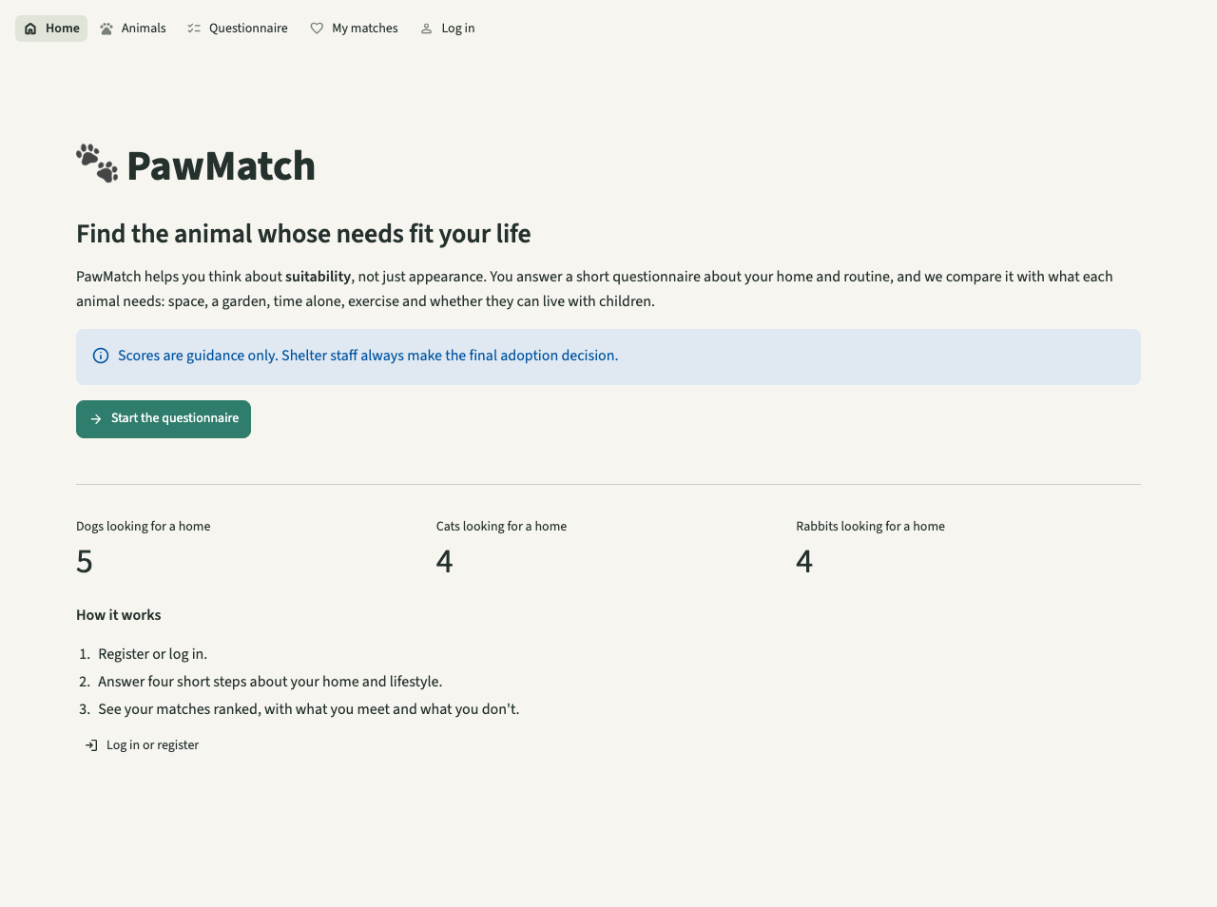
Screen 01: Home. Purpose, suitability focus, guidance note and the questionnaire button (2.1, 2.2, 7.6).
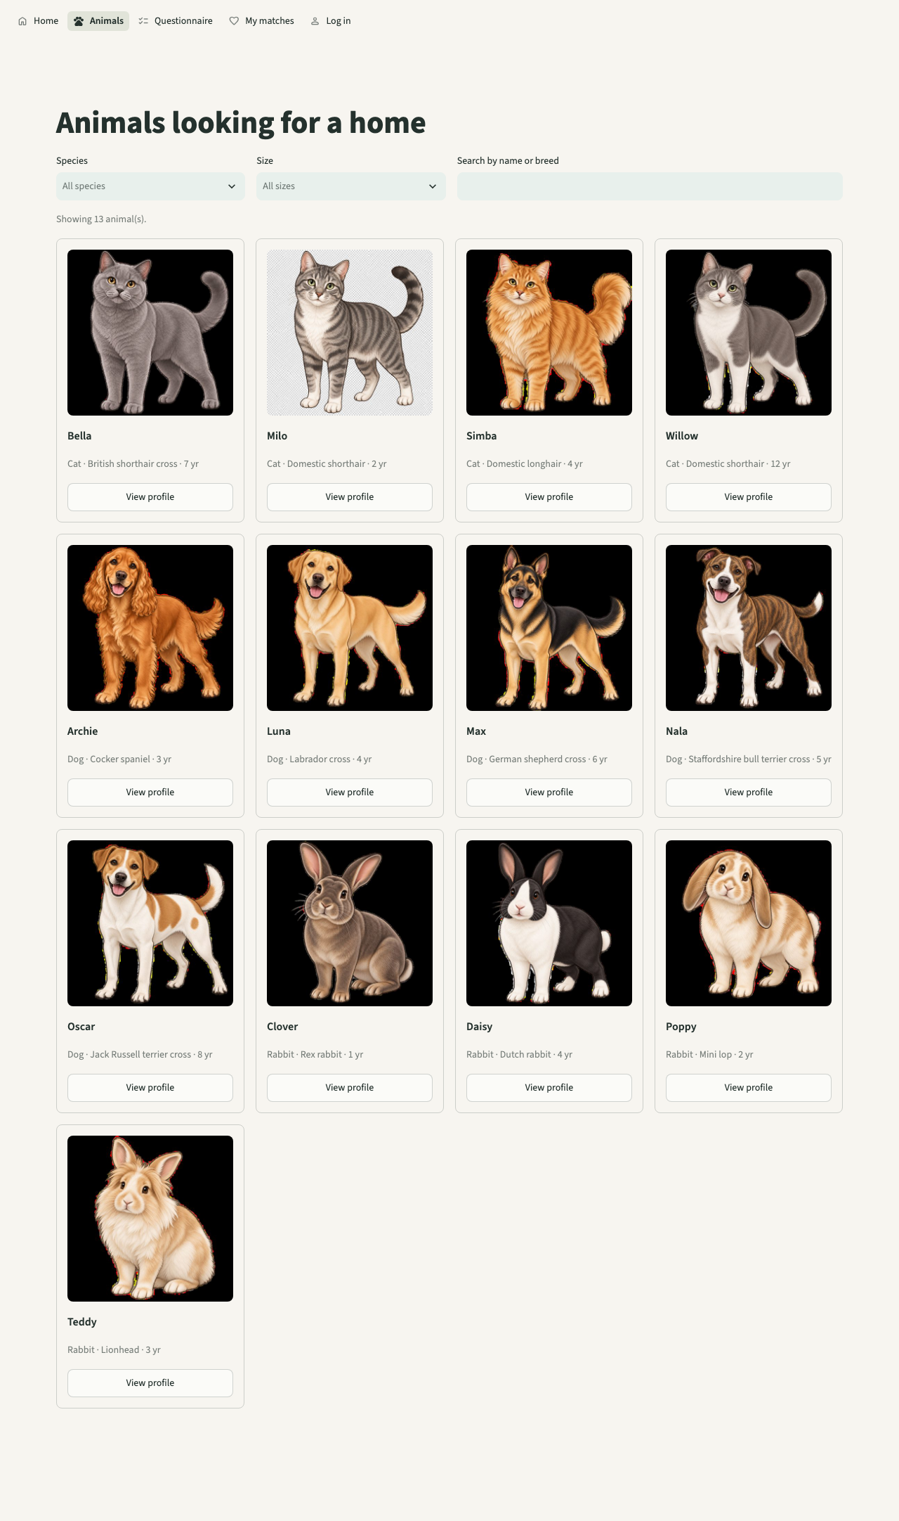
Screen 02: Animals. 13 cards with photo, name, species, breed and age; filters and search (3.1-3.3).
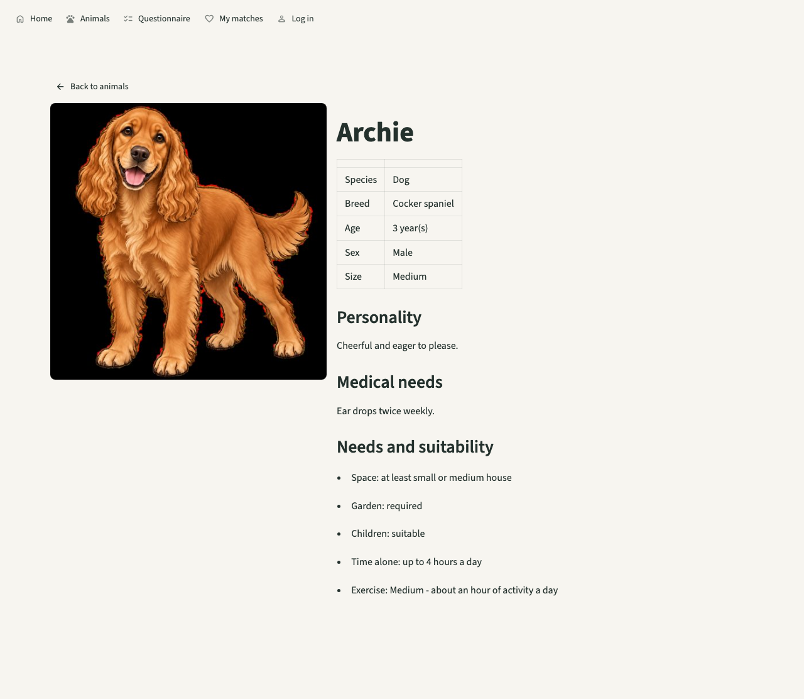
Screen 04: Profile read from the database, with the back link (4.1-4.4).
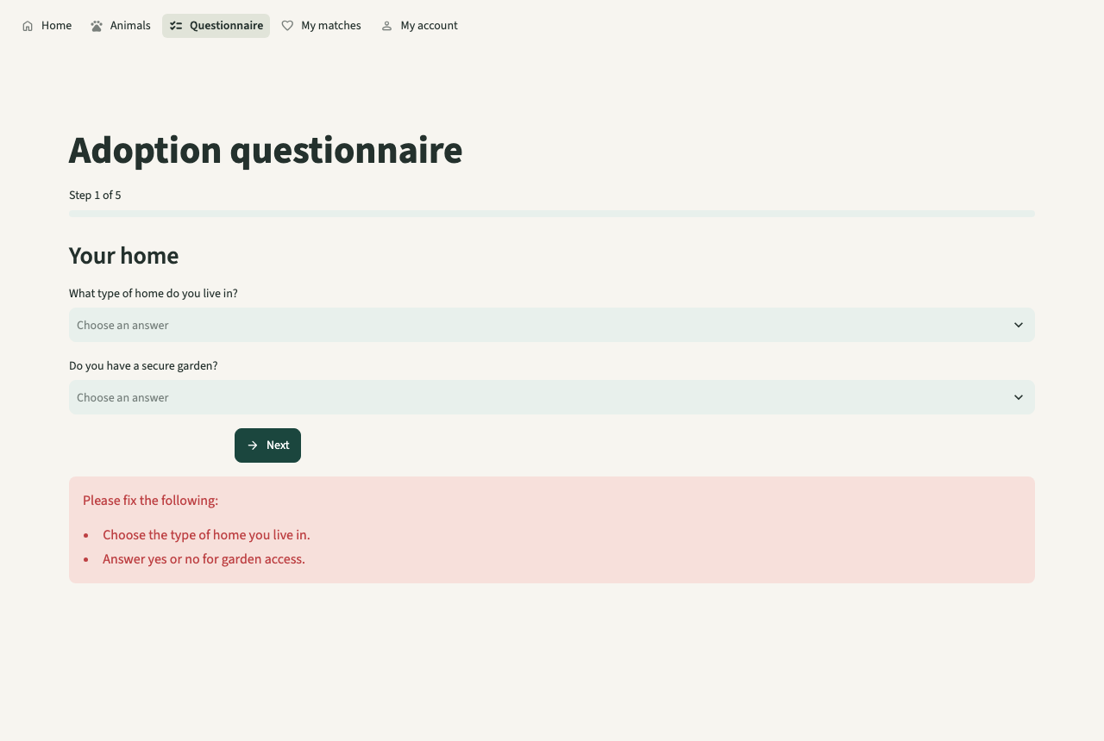
Screen 07: Next pressed with a blank answer: one box lists what is missing (6.4).
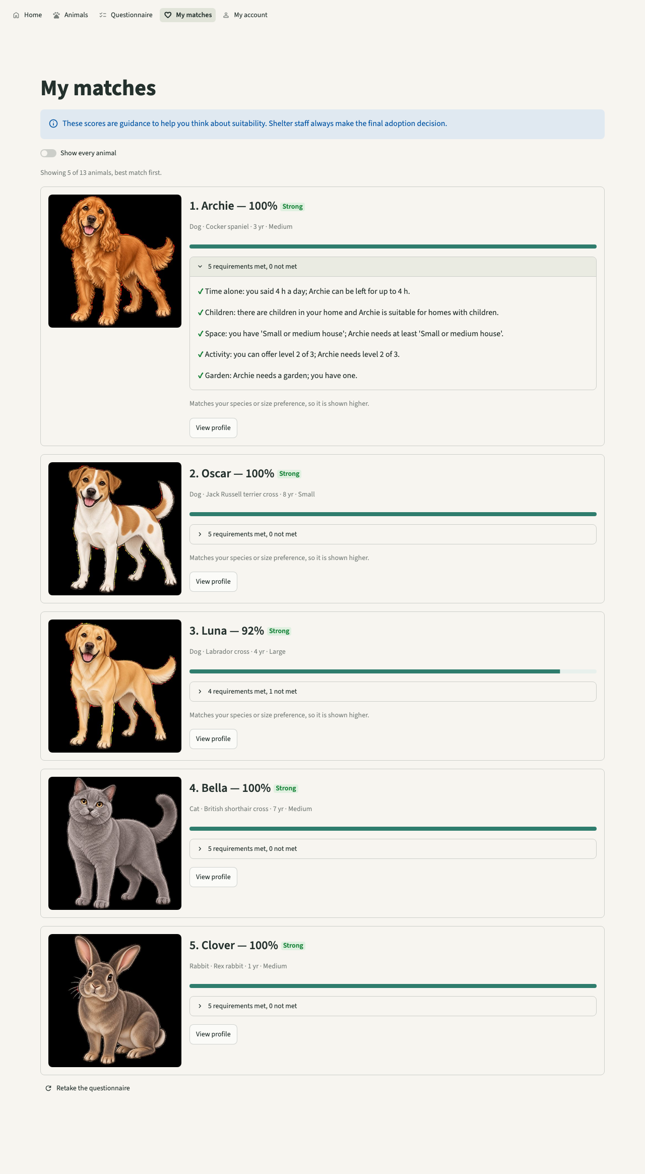
Screen 10: My matches: score, category, met / not met and the guidance note (7.2-7.6).
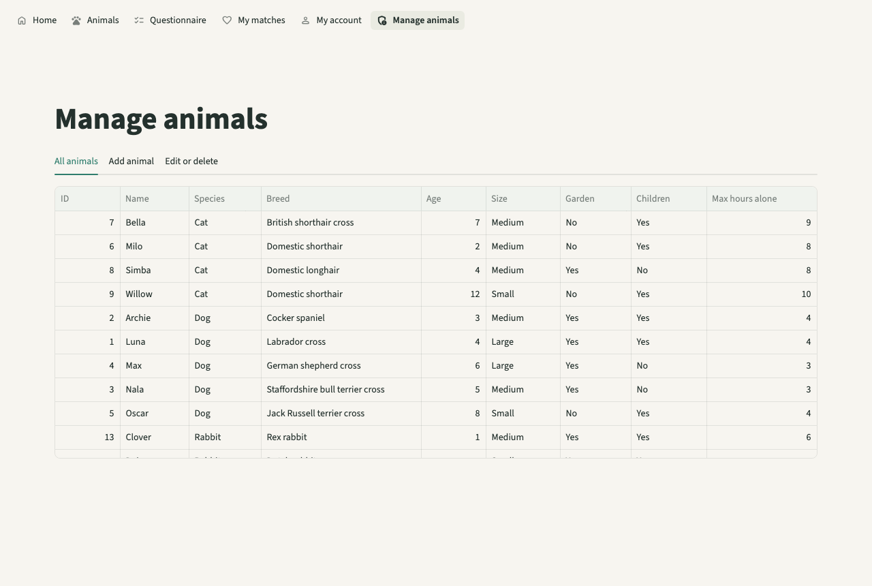
Screen 13: Staff area for a staff account: list, add, edit or delete (8.1-8.4).

Testing
Test no. | Description | Input | Expected | Actual | Pass / Fail | Evidence (figure)
B1 | A card for every animal | 13 animals | 13 cards | As expected | Pass | test_browse_shows_a_card_for_every_animal; Screen 02
B2 | Filter rabbits | Species = Rabbit | 4 rabbits | As expected | Pass | Screen 03
B6 | Profile from database | Luna's id | Luna's details | As expected | Pass | test_profile_reads_from_database; Screen 04
D2 | Blank answer blocks Next | step 1, one blank | Error, same step | First run: test crashed; later: 1 box not 2 | Fail, then Pass | Ev 3a, 3b; Screen 07
D7 | Questionnaire needs login | no session | 'Please log in' | As expected | Pass | test_questionnaire_needs_login
E10 | At least 4 results | submitted answers | 5 cards, best first | As expected | Pass | test_results_show_at_least_four_ranked_matches; Screen 10
C8 | Staff page not routable for adopters | adopter opens it by name | No such page | As expected | Pass | test_admin_page_is_not_routable_for_adopters

Failed test and remedial action
Test no. | What happened | Cause | Fix made | Re-test result
All 9 page tests | Every page test failed at once: 'AppTest script not found at .../tests/streamlit_app.py'. | AppTest.from_file resolves a relative path from the test file's folder, not the folder pytest runs from. | Gave the entry script as an absolute path built from the test file's location (ENTRY), so the tests run from any folder. | Pass: 9 of 9 (later 117 in all)
D2 | After errors were merged into one box, test D2 failed: 'assert 1 == 2' (it counted two error boxes). | The test checked the old design (one box per error), not the behaviour that matters. | Changed the test to expect one box that contains both messages; the behaviour is what users see. | Pass: 117 passed (Ev 3)
Ev 3a, the first failure (docs/evidence/stage3-fail1-apptest-path.txt):
E FileNotFoundError: AppTest script not found at rebuild/tests/streamlit_app.py. Relative paths are resolved against the file that calls AppTest.from_file().
E FileNotFoundError: AppTest script not found at rebuild/tests/streamlit_app.py. Relative paths are resolved against the file that calls AppTest.from_file().
E FileNotFoundError: AppTest script not found at rebuild/tests/streamlit_app.py. Relative paths are resolved against the file that calls AppTest.from_file().

Ev 3b, the second failure (docs/evidence/stage3-fail2-error-box.txt):
E + where 1 = len(ElementList(_list=[Error()]))
E + where ElementList(_list=[Error()]) = AppTest(\n _script_path='rebuild/streamlit_app.py',\n...SpecialBlock(\n type='sidebar'\n ),\n 2: SpecialBlock(\n type='event'\n )\n }\n).error
1 failed in 0.67s

Review
Developer review: each page compared with its interface design and its criteria, in a browser at laptop width. Found: one red box per error made long forms noisy; after logging in, a staff user was sent to the staff page before the menu had registered it; the first test for 'adopters cannot open the staff page' caught any error, so it would have passed for the wrong reason.

Changes made after review
All errors for a form now show in one box (usability, S6), which caused the second failed test above. After login every user goes to Home and staff find 'Manage animals' in the menu. The staff-page test now expects the exact 'Could not find a navigation page' error, and a second test checks that the page's own guard stops an adopter who reaches it directly.

Stage 4: End-to-end run, screenshots and documentation

Aim
Runs the whole system as a user would, in a real browser driven by a script (docs/tools/capture_screens.py), at laptop (1280 px) and tablet (820 px) widths. It produces the 16 screenshots used as evidence, plus the README, a short write-up and a comparison page. Commit 213e208; checks criteria 1-9 together.

Code
Browser script: one screenshot step (docs/tools/capture_screens.py). The page height is measured first, so each screenshot shows the whole page.
def shot(page: Page, out: Path, name: str, full: bool = True) -> None:
"""Streamlit scrolls an inner container, so grow the viewport to the content for a full shot."""
settle(page)
if full:
height = page.evaluate("() => document.querySelector('[data-testid=stMain]').scrollHeight")
page.set_viewport_size({"width": 1280, "height": min(max(int(height), 860), 3000)})
page.wait_for_timeout(300)
page.screenshot(path=str(out / f"{name}.png"))
page.set_viewport_size({"width": 1280, "height": 860})
print("saved", name, flush=True)
def choose(page: Page, label: str, option: str) -> None:
page.get_by_label(label, exact=True).click()
page.get_by_role("option", name=option, exact=True).click()
settle(page)

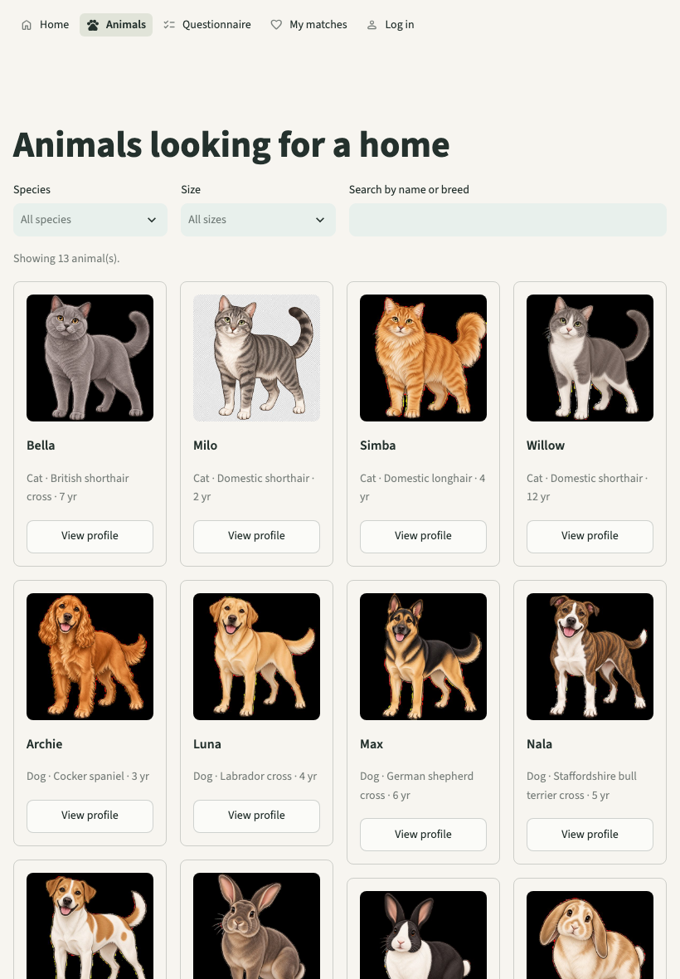
Screen 16: The animal list at tablet width (820 px): cards rearrange, nothing is cut off (1.2).
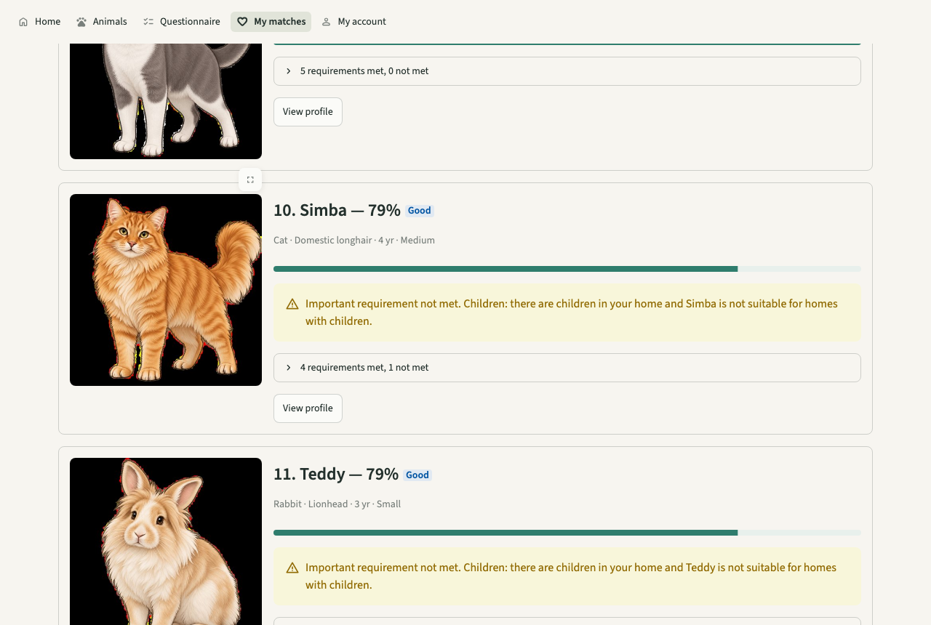
Screen 11: A match with an important requirement not met: orange warning (7.5).

Testing
Test no. | Description | Input | Expected | Actual | Pass / Fail | Evidence (figure)
T2 | Tablet width | 820 px wide | No sideways scrolling | As expected | Pass | Screen 16
F4-F5 | Register with errors, then log in | invalid then valid details | Errors, then logged in | As expected | Pass | Screens 05, 12
F6-F9 | Questionnaire to results | full answers | Ranked results with warnings | As expected | Pass | Screens 06-11
F10-F12 | Staff list, add with errors, edit | staff account | As planned | As expected | Pass | Screens 13-15
E2E-1 | Fill the Age box | label 'Age' | Box filled | Script stopped: 2 elements matched | Fail, then Pass | capture_screens.py
E2E-2 | Open My matches after login | go to its address | Results page | Logged out | Fail, then Pass | capture_screens.py

Failed test and remedial action
Test no. | What happened | Cause | Fix made | Re-test result
E2E-1 | The browser script stopped: the label 'Age' matched two elements (the box and its 'Help for Age' button). | Finding by label matches any label that contains the word unless told to match exactly. | Used an exact label match (exact=True). | Pass: all 16 screenshots produced
E2E-2 | After logging in, opening a page by its address showed the login page again. | Typing an address reloads the page, which starts a new Streamlit session, so the login is lost. | The script now moves between pages with the menu, as a user would. The behaviour itself is a real limitation, recorded in the evaluation (5.3, 5.4). | Pass: all 16 screenshots produced

Review
Developer review of the 16 screenshots against criteria 1-9 (no client was available to review them). Everything needed was visible, at both widths. Found: a full page reload logs the user out (E2E-2), and nothing on screen says so.

Changes made after review
Not changed in code: fixing it needs a signed browser cookie, which Streamlit does not provide; recorded as a limitation with a planned fix (5.5) instead of a rushed change. The README explains how to run and test the system so someone else can maintain it.

Stage 5: Design re-check and fixes

Aim
Re-reads every validation list and table design in the Design and compares each with the code, writing a test first for anything missing. Commit fdef5a0; components A, C and E.

Code
Name and breed rules (pawmatch/validation.py). One function serves people and animals; animals may also use digits. Every name must contain a letter.
def _check_name(value: Any, errors: Errors, field: str = "name", allow_digits: bool = False) -> str:
"""Person names: letters, spaces, hyphens, apostrophes. Animal names may also use digits ("R2")."""
name = _text(value)
allowed = " '-" + ("0123456789" if allow_digits else "")
if not name:
errors[field] = "Enter a name."
elif not NAME_MIN <= len(name) <= NAME_MAX:
errors[field] = f"Name must be {NAME_MIN} to {NAME_MAX} characters."
elif not _has_letter(name) or any(not (ch.isalpha() or ch in allowed) for ch in name):
errors[field] = "Name can only use letters, spaces, hyphens and apostrophes" + (
" (and numbers)." if allow_digits else ".")
return name
breed = _text(raw.get("breed"))
if not breed:
errors["breed"] = "Enter a breed (use 'Mixed' if unknown)."
elif not NAME_MIN <= len(breed) <= NAME_MAX:
errors["breed"] = f"Breed must be {NAME_MIN} to {NAME_MAX} characters."
elif not _has_letter(breed):
errors["breed"] = "Breed must contain letters."
cleaned["breed"] = breed

Upgrading an older database (pawmatch/db.py). CREATE TABLE IF NOT EXISTS leaves old tables alone, so the new column is added by hand when it is missing.
def init_schema(conn: sqlite3.Connection) -> None:
conn.executescript(SCHEMA)
# Databases made before stage 5 lack calculated_at (Design, Match Results table): add it in place.
columns = {row[1] for row in conn.execute("PRAGMA table_info(match_results)")}
if "calculated_at" not in columns:
conn.execute("ALTER TABLE match_results ADD COLUMN calculated_at TEXT NOT NULL DEFAULT ''")

Prototype evidence. Ev 5b: the stage 5 run after the fixes (docs/evidence/stage5-pytest.txt):
........................................................................ [ 53%]
.............................................................. [100%]
134 passed in 3.85s

Testing
Test no. | Description | Input | Expected | Actual | Pass / Fail | Evidence (figure)
A11 | Name format | Mary-Jane, O'Neill / 12345, Sam3, Sam! | Letters only | First: 3 accepted | Fail, then Pass | Ev 5a, 5b
C11 | Breed rules | Mixed / X, ### | X, ### rejected | First: accepted | Fail, then Pass | Ev 5a, 5b
C11b | Animal name format | R2 / 123, Luna! | 123, Luna! rejected | First: accepted | Fail, then Pass | Ev 5a, 5b
E11 | calculated_at stored | submission | Timestamp | First: no column | Fail, then Pass | Ev 5a, 5b
E11b | Old database upgraded | database without the column | Column added | First: missing | Fail, then Pass | Ev 5a, 5b
A7 | Older duplicate-email test | 'Sam 2', SAM@example.com | 'already exists' | KeyError 'email' | Fail, then Pass | Ev 5c

Failed test and remedial action
Test no. | What happened | Cause | Fix made | Re-test result
A11, C11, E11 (9 cases) | 9 new tests failed on their first run, as expected for tests written before the fix. | Design rules missing from the code (see stages 1 and 2). | Added the rules and the column. | Pass
A7 | After the fix, an older test failed with KeyError 'email'. | Its second user was called 'Sam 2'. The new name rule rejected that before the duplicate-email check ran, so the test no longer tested what its name says. | Changed the test's name to 'Sam Two' so it again tests the duplicate email; the rule itself is right. | Pass: 134 passed (Ev 5b)
Ev 5a, the tests written first, before the fix (docs/evidence/stage5-fail-design-recheck.txt):
=========================== short test summary info ============================
FAILED tests/test_repository.py::test_saved_results_record_when_they_were_calculated
FAILED tests/test_repository.py::test_old_database_gains_calculated_at_column
FAILED tests/test_validation.py::test_registration_name_is_letters_spaces_and_hyphens[12345-False]
FAILED tests/test_validation.py::test_registration_name_is_letters_spaces_and_hyphens[Sam3-False]
FAILED tests/test_validation.py::test_registration_name_is_letters_spaces_and_hyphens[Sam!-False]
FAILED tests/test_validation.py::test_animal_name_format[123-False] - Asserti...
FAILED tests/test_validation.py::test_animal_name_format[Luna!-False] - Asser...
FAILED tests/test_validation.py::test_breed_length_and_not_only_symbols[X-False]
FAILED tests/test_validation.py::test_breed_length_and_not_only_symbols[###-False]
9 failed, 125 passed in 5.32s

Ev 5c, the older test that the new rule broke (docs/evidence/stage5-fail-regression-auth.txt):
=========================== short test summary info ============================
FAILED tests/test_auth.py::test_register_rejects_duplicate_email_case_insensitively
1 failed, 9 passed in 0.53s

Review
Developer review: listed every rule in the Design's validation sections and variables tables and ticked each against a test. After the fixes every listed rule has a test. Two Design points were kept as decisions rather than changes: login is by email (the Design mentions both), and passwords need at least 8 characters (the Design says both 'minimum of eight' and 'more than 8').

Changes made after review
None beyond the fixes: the full suite was run again (134 passed) and the screenshots still match, because the screens did not change.

4 Testing to inform evaluation
Model version addition
All tests below were run on the finished system (commit fdef5a0). Function tests (F) follow the main paths; robustness tests (R) try wrong, extreme or hostile input; T tests are measured. 'Actual' is what happened. Screens are in docs/img and the automated tests are in tests/.
Measured results. Scoring and storing 500 animals: mean 0.01 s over 5 runs, slowest 0.011 s (target under 2 s). Listing 500 animals from the database: 0.003 s. Rendering the animal page with 500 animals: 0.4 s at worst over 3 headless runs, with 500 cards. Capacity: 500 animals and 100 users stored and read back. Contrast: text 12.4 : 1, button text 4.9 : 1.
.............................................................. [100%]
134 passed in 3.85s

4.1 Function and robustness
Test no. | Success criterion | Input | Expected | Actual | Evidence (figure)
F1 | 2.1, 2.2 | Open Home; click the button | Purpose shown; questionnaire opens | As expected | Screen 01
F2 | 3.1-3.3 | Open Animals; filter Rabbit | 13 cards; 4 rabbits | As expected | Screens 02, 03
F3 | 3.4, 4.1-4.4 | View Luna's profile, then Back | All details; back to list | As expected | Screen 04
F4 | 5.1, 5.2 | Register with errors, then correctly | All errors in one box; then account made | As expected | Screen 05
F5 | 5.3 | Log in, then log out | Menu shows My account; then Log in | As expected | auth tests
F6 | 6.1-6.3 | Answer steps 1-4 | Progress bar, drop-downs, review | As expected | Screens 06, 08, 09
F7 | 7.1, 7.2, 9.3 | Submit the answers | Every animal scored and stored | As expected | test_adopter_submission_stores_ranked_results
F8 | 7.3, 7.4, 7.6 | Open My matches | 5 shown, best first, met / not met, guidance note | As expected | Screen 10
F9 | 7.5 | Answers that fail hours alone | Orange warning | As expected | Screen 11
F10 | 5.4, 8.1 | Log in as staff | 'Manage animals' in the menu | As expected | Screen 13
F11 | 8.2, 9.2 | Add an animal | Stored and listed | As expected | test_admin_can_add_edit_and_delete
F12 | 8.3, 4.3, 9.4 | Edit the breed | New breed on the profile | As expected | Screen 15
F13 | 8.4 | Tick confirm, Delete | Animal and its results removed | As expected | test_delete_removes_animal_and_its_stored_results
R1 | 5.2 | Age 17, 2.5, abc; email two@@x.com | Each rejected with its message | As expected | test_registration_age_boundaries
R2 | 5.5 | Wrong password; unknown email | Same message; no session | As expected | Screen 12
R3 | 6.4 | Next with a blank answer | Stays on step, error shown | As expected | Screen 07
R4 | 6.4 | Submit 8 of 9 answers | Nothing stored | As expected | test_incomplete_submission_saves_nothing
R5 | 8.1, 8.5 | Adopter asks for the staff page by name | No such page | As expected | test_admin_page_is_not_routable_for_adopters
R6 | 8.2 | Add with blanks and age 31 | Every error listed; nothing stored | As expected | Screen 14
R7 | 8.3 | Edit an animal deleted in another tab | 'That animal no longer exists.' | As expected | test_edit_of_deleted_animal_reports_error
R8 | 8.5 | Adopter reaches the staff page directly | 'This page is for shelter staff only.' | As expected | test_admin_page_guard_stops_adopters_even_if_reached_directly
R9 | 9.1 | Search ' OR 1=1 -- | No animals, no error | As expected | test_search_text_is_treated_as_data_not_sql
R10 | 8.2 | Upload a .gif; a 2 MB + 1 byte file | Rejected | As expected | test_image_type_and_size
R11 | 9.1 | Insert species 'Hamster' directly into SQLite | Database refuses it | As expected | test_database_constraints_back_up_validation
R12 | 5.3 | Reload the browser page while logged in | Still logged in | Logged out | Capture run (E2E-2)
T4 | 7.2 | 500 animals, 5 submissions | Under 2 s | Mean 0.01 s | Measured above
T5 | 9.1 | 500 animals, 100 users | All stored and listed | 500 / 100 | Measured above
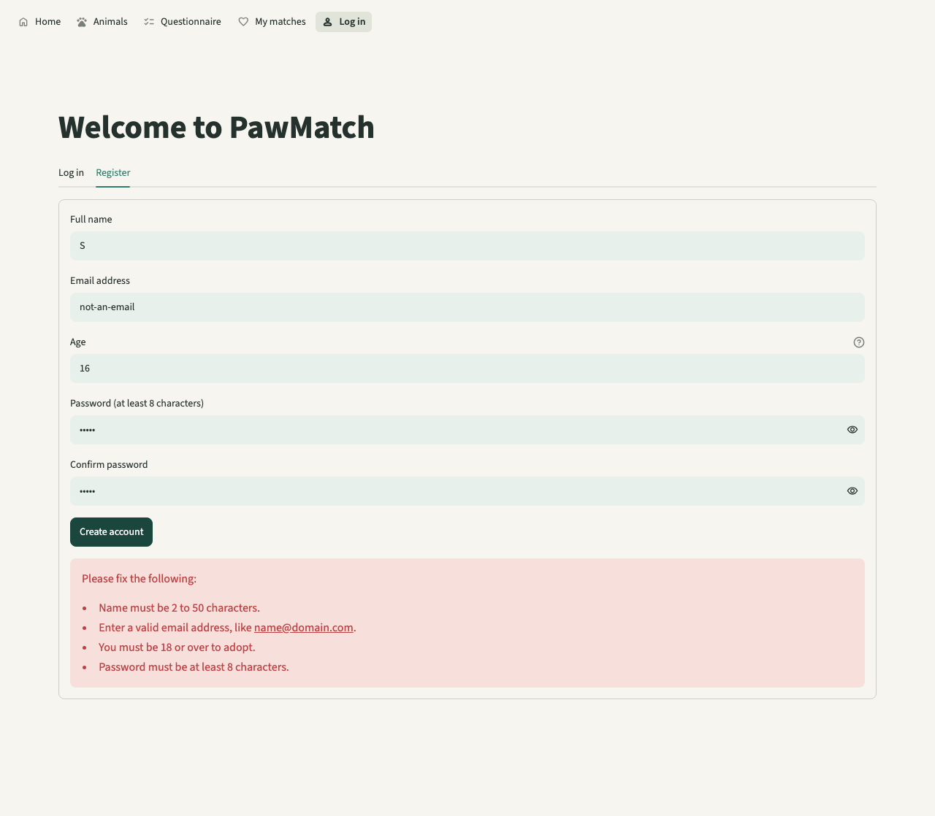
Screen 05 (F4, R1): registration with several mistakes. Every problem is listed in one box and the typed values stay.
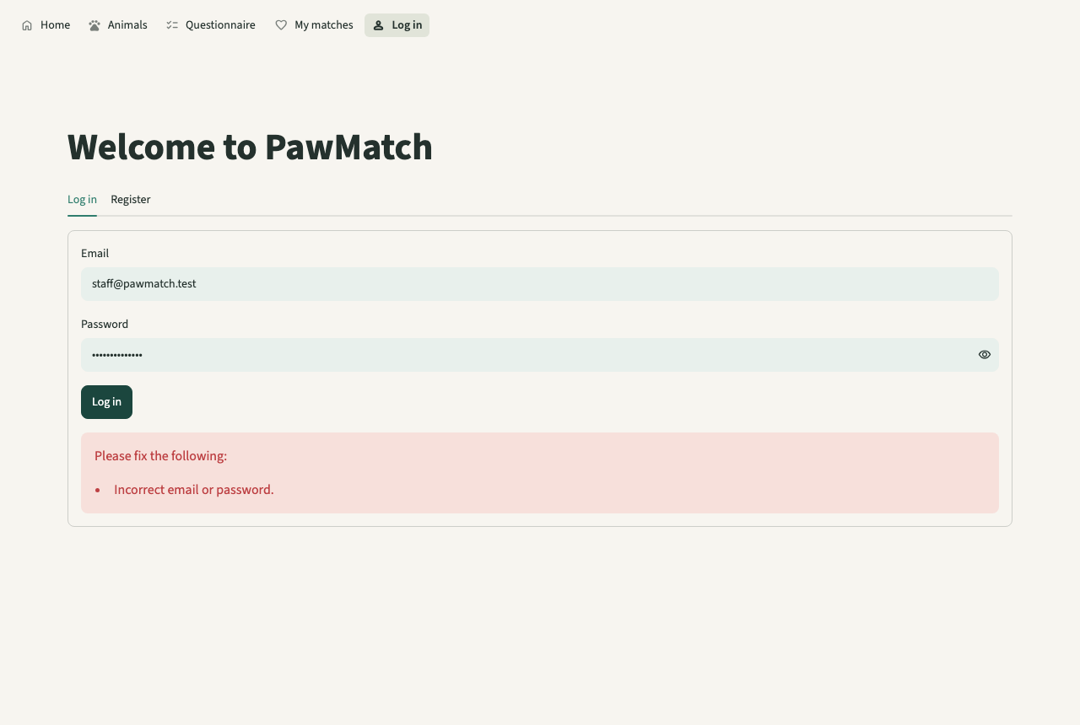
Screen 12 (R2): a wrong password gives the same message as an unknown email.
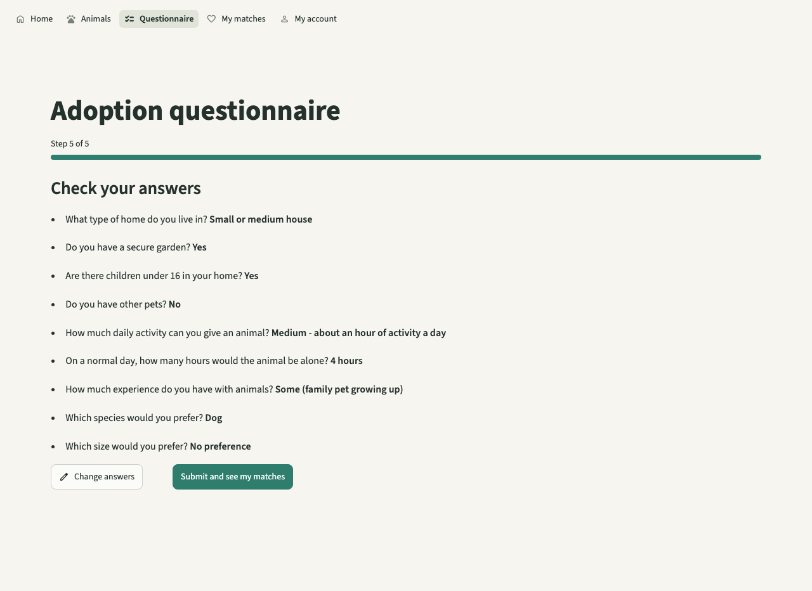
Screen 09 (F6): the review step lists every answer before submitting.
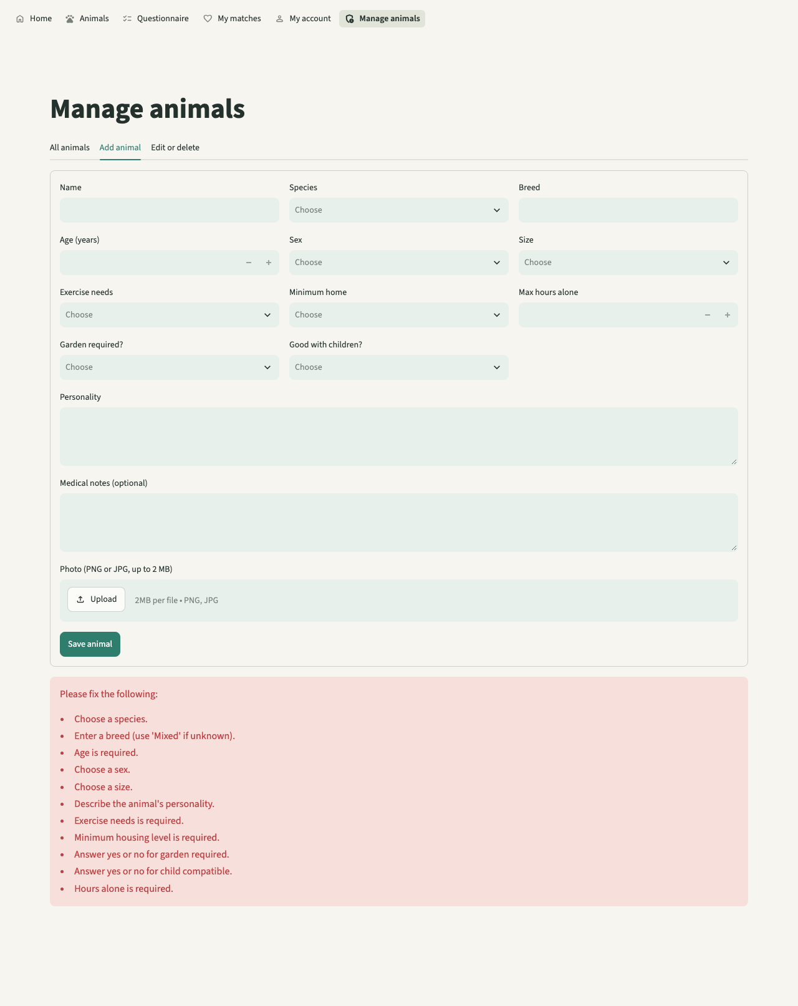
Screen 14 (R6): the staff form refuses an incomplete animal and lists each field to fix.
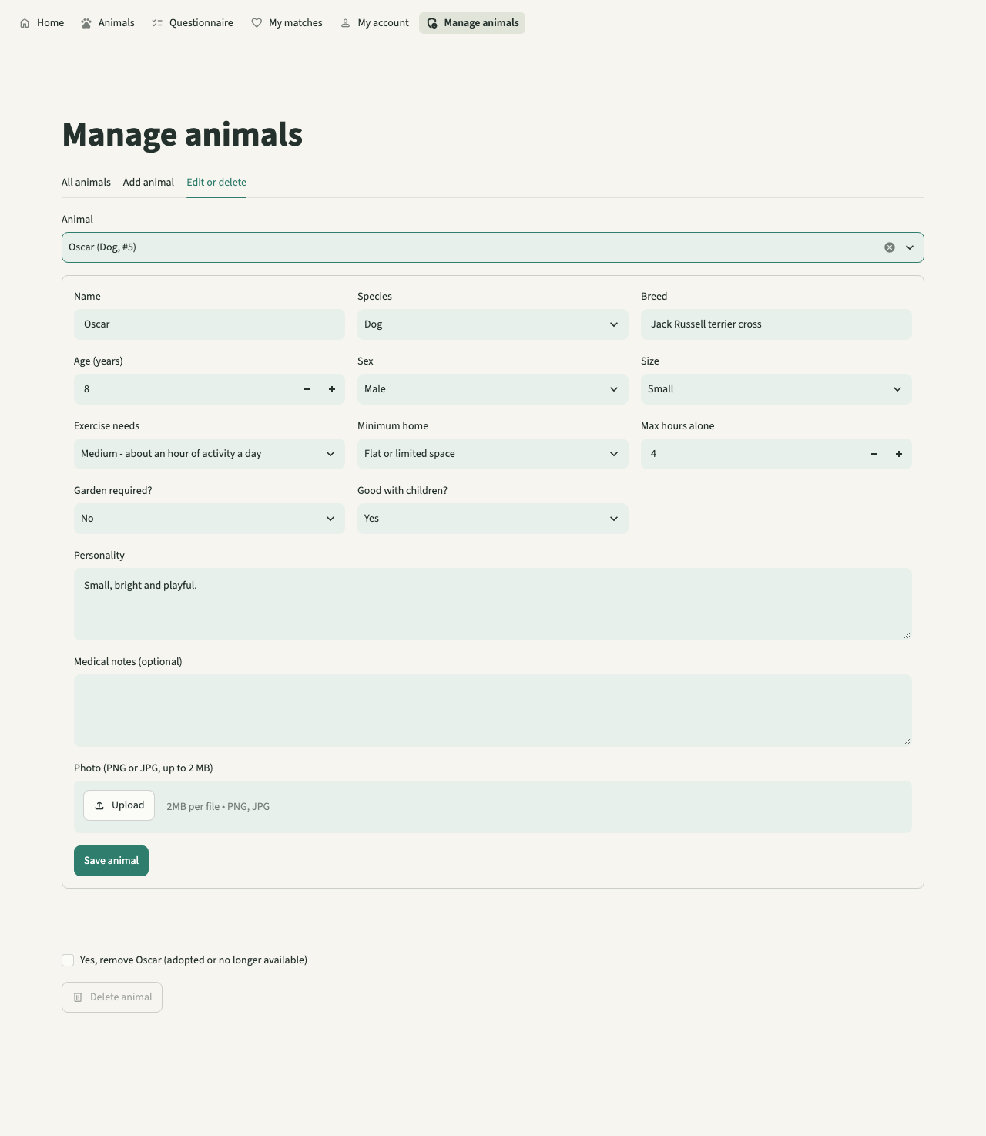
Screen 15 (F12, F13): editing an animal; Delete stays disabled until the confirmation is ticked.

4.2 Usability testing
Tester | Task given | What happened | Rating /10 | Comment
Developer (not a stakeholder) | U1: register and log in | Done in 4 screens; errors clear (Screen 05) | Not collected | Needs a real adopter
Developer (not a stakeholder) | U2: complete the questionnaire | 4 steps + review; blank answer blocked (Screens 06-09) | Not collected | Needs a real adopter
Developer (not a stakeholder) | U3: explain the top match | Met / not met list and warning are readable (Screens 10, 11) | Not collected | Needs a real adopter
Developer (not a stakeholder) | U4: add, edit, delete an animal | All three done; delete needs the tick (Screens 13-15) | Not collected | Needs the shelter client
Developer (not a stakeholder) | U5: use it at tablet width | No sideways scrolling at 820 px (Screen 16) | Not collected | Real tablet not tried
What this shows and what it does not. The walkthrough was done by the developer in a headless browser using the planned usability tasks. It shows every task can be completed and the usability features are present. It is not usability testing with stakeholders: no adopter or member of shelter staff tried the system, so there are no ratings. This is why criterion 6.2 is only partly met; running U1-U5 with five adopters and the client is the first item in Future development.

5 Evaluation
Model version addition
Each requirement is cross-referenced to the tests in section 4 (F, R, T) and to the development tests. Of 38 requirements, 36 are met and 2 are partly met (6.2, 8.1); none are unmet. 'Met' is only used where a test or screenshot shows the measure from the Analysis was reached.

5.1 Success criteria
Criterion | Requirement | Evidence (test no.) | Met / Partly / Not met | Explanation
1 Navigation and clean interface | 4 requirements, below |  | Met
1.1 | Pages must use a calm colour scheme, clear headings and identifiable buttons | T1; contrast 12.4 : 1 text, 4.9 : 1 buttons; Screens 01-15 | Met | Contrast is well above 4.5 : 1. Headings and buttons are the theme's own; no page adds its own styling.
1.2 | The interface must remain readable on laptop and tablet sized screens | T2; Screens 02 and 16 | Met | Checked in a headless browser at both widths. Not checked on a real tablet or phone; see 5.3.
1.3 | The system must include a navigation menu to access home page, animal preview page, profile page, and login page | T3; every page test opens pages through the one menu | Met | The menu is built once in streamlit_app.py, so no page can leave it out.
1.4 | The menu and interface style must remain consistent across all the pages | T1; .streamlit/config.toml | Met | All styling comes from one 15-line theme file.
2 Home page | 2 requirements, below |  | Met
2.1 | Should explain the purpose of the animal adoption matching system, especially including that the system focuses on suitability rather than only appearance | F1; test_home_page_explains_purpose; Screen 01 | Met | The test reads the rendered page text.
2.2 | Should have a clear button or navigation option that directs users to complete the adoption questionnaire | F1; Screen 01 | Met | 'Start the questionnaire' is the first button.
3 Animal preview page | 4 requirements, below |  | Met
3.1 | The page should display every available animal using compact animal cards | F2, T5; test_browse_shows_a_card_for_every_animal; 500 cards for 500 animals | Met | Every record in the table appears. There is no 'adopted' status, so every stored animal counts as available.
3.2 | Each card should show the species, name, breed, age and image | F2; Screen 02 | Met | The card is one function, so every card is the same.
3.3 | The system must support at least 3 animal species including dogs, cat and rabbits | F2; test_seed_has_three_species_and_is_idempotent; Screen 03 | Met | Dogs, cats and rabbits; the database CHECK only allows these three.
3.4 | Users must be able to open a full animal profile from the preview page | F3; test_profile_reads_from_database; Screen 04 | Met | 'View profile' on every card.
4 Animal profile page | 4 requirements, below |  | Met
4.1 | Each profile must display the animals name, species, breed, age and sex | F3; Screen 04 | Met | Shown in a table at the top of the profile.
4.2 | Each profile also must include personality, medical needs, exercise needs and suitability requirements | F3; Screen 04 | Met | Suitability is listed as plain sentences (garden, children, hours alone, home size).
4.3 | Animal profile information must be retrieved from the database | F3, F12; round-trip tests | Met | The page reads the id from the address and queries the database each time.
4.4 | Users must be able to return to the animal preview page or results page | F3; Screen 04 | Met | The back link remembers whether the user came from the list or the results.
5 User and admin registration and login | 5 requirements, below |  | Met
5.1 | Users must be able to create an account, using name, email and password and it can include other features such as age to ensure they are at a suitable age | F4; test_register_stores_hash_not_password | Met | Age is also collected so the 18+ rule can be checked.
5.2 | The system must reject registration if required fields are empty and the email format is invalid, by validating inputs | F4, R1; test_registration_*; Screen 05 | Met | Every rule in the Design's validation list has a test, including the name format added in stage 5.
5.3 | Registered users must be able to login and logout using their correct account details | F5; test_login_success_and_email_is_normalised | Met | Limitation: reloading the browser page also logs the user out (5.3).
5.4 | The admin login details should allow admins to access their own section with the CRUD interface | F10; test_admin_page_lists_animals_for_staff | Met | Staff use the same login form; the menu changes by role.
5.5 | Incorrect Login details must display an error message and prevent access to the account | R2; test_wrong_password_and_unknown_email_give_the_same_message; Screen 12 | Met | The same message means nobody can find out which emails have accounts.
6 Adopter questionnaire page | 4 requirements, below |  | Partly met
6.1 | The questionnaire must collect information about the user’s home, lifestyle, garden access, children, other pets, time available and previous animal experience | F6; test_steps_cover_every_question_once; Screens 06-09 | Met | Other pets and experience are stored but not scored, because the Design gives them no weight.
6.2 | The questionnaire must be split into clear sections or individual questions rather than appearing as one long form | F6; Screens 06-09; tester ratings not collected | Partly met | The sections are built and tested, but the planned tester rating was not carried out (5.3).
6.3 | The questionnaire must use suitable input methods such as dropdowns, radio buttons or selection boxes but preferably dropdowns. | F6; Screens 06, 08 | Met | Every answer is a drop-down.
6.4 | The system must prevent the questionnaire from being submitted if important questions are unanswered | R3, R4; test_questionnaire_blocks_unanswered_step; test_incomplete_submission_saves_nothing; Screen 07 | Met | Checked on each step and again for the whole set before saving.
7 Results and recommendations page | 6 requirements, below |  | Met
7.1 | The system must compare adopter’s questionnaire with each animal’s requirements | F7; test_adopter_submission_stores_ranked_results | Met | Nothing is filtered out before scoring.
7.2 | The system must calculate a numerical compatibility score for each animal | F7, T4; test_matching.py (29 cases); mean 0.01 s, slowest 0.011 s | Met | The formula is in the Design (worked example) and each factor has its own test.
7.3 | The top 4 animals must be displayed from highest compatibility score to lowest at a minimum | F8; test_results_show_at_least_four_ranked_matches; Screen 10 | Met | Five are shown by default and a toggle shows every animal. Animals with a welfare warning come after those without.
7.4 | The results page must show which key requirements the user meets and does not meet for each animal | F8; Screens 10, 11 | Met | In the 'requirements met / not met' list on each card.
7.5 | The system must display a warning if the user does not meet important requirements for an animal | F9; test_important_unmet_requirements_raise_warnings; Screen 11 | Met | Garden and activity lose points but do not warn.
7.6 | The results page must explain that the compatibility scores are guidance, and the adoption staff have the final say | F8; Screen 10 | Met | Shown above the results and on Home.
8 Admin management page | 5 requirements, below |  | Partly met
8.1 | This page should be accessed separately with a separate admin login | F10, R5; test_admin_page_is_not_routable_for_adopters | Partly met | Only staff accounts reach it, but staff use the same login form as adopters, not a separate one.
8.2 | Admin users must be able to add a new animal record with all the information required | F11, R6; test_admin_can_add_edit_and_delete; Screen 14 | Met | Every field is validated and the database CHECKs repeat the rules.
8.3 | Admin users must be able to edit existing animal records and save the updated information to the database | F12; test_update_changes_the_stored_record; Screen 15 | Met | Editing an animal that was deleted meanwhile gives a clear error (R7).
8.4 | Admin users must be able to delete animal records when animals adopted or no longer available | F13; test_delete_removes_animal_and_its_stored_results | Met | The record is deleted rather than marked 'adopted' (5.4).
8.5 | Normal users must not be able to access the admin management page | R5, R8; test_non_admins_are_refused_every_change; test_admin_page_guard_stops_adopters_even_if_reached_directly | Met | Checked three times: menu, page guard, and inside each service.
9 Database | 4 requirements, below |  | Met
9.1 | The database must store animal records, user account details, admin login details and questionnaire answers | T5; 500 animals and 100 users stored and read back | Met | Four tables with keys and CHECK constraints.
9.2 | The database must allow animal records to be added, viewed, edited and deleted through the admin system | F11-F13 | Met | Through the staff page and the services.
9.3 | Questionnaire answers must be stored or processed so that they can be used by the compatibility scoring algorithm | F7; test_responses_and_results_are_stored_and_reloaded_in_rank_order | Met | Each submission is a new response row; results point to it and record when they were calculated.
9.4 | Data must be retrieved correctly so animal profiles and recommendations display accurate information | F12; test_insert_then_get_round_trips_every_field | Met | Checked for every animal field.

5.2 Usability features
Usability feature | Evidence | Worked? | How to improve
Calm theme, one file | Screens 01-16; contrast 12.4 : 1 | Yes | Ask testers about the colours (U1-U5)
Same menu on every page, by role | T3; R5; Screens 10, 13 | Yes | Show who is logged in next to the menu
Questionnaire in steps with progress bar | F6; Screens 06-09 | Yes, but not rated by users | Run U2 with five adopters
Drop-downs only | F6; R3 | Yes: no invalid answer can be typed | Radio buttons for short lists may be quicker on tablets
All errors in one box | F4, R6; Screens 05, 14 | Yes | Also mark the field itself red
Animal cards | F2; Screens 02, 16 | Yes, also at tablet width | Add 'good with children' icons on the card
Score bar, category, met / not met | F8; Screen 10 | Yes | Open the met / not met list for the top result by default
Warnings for important needs | F9; Screen 11 | Yes | Link the warning to the profile section it refers to
Guidance note | Screens 01, 10 | Yes | None needed
Delete confirmation | F13; Screen 15 | Yes | Offer 'mark as adopted' instead of deleting (5.5)
Back links | F3; test B8 | Yes | None needed

5.3 Partly met and unmet criteria
Criterion | Why it is not fully met | How further development would address it
6.2 Clear sections (rated 8/10 by testers) | The sections are built and tested, but the rating needs real users and none were available for this model version. | Run U2 with five adopters from the survey group; change wording where the score is below 8.
8.1 Separate admin login | Staff log in on the same form as adopters; the system then gives them the staff page. Access is safe (R5, R8) but the login itself is not separate. | Add a 'Staff login' page that only accepts admin accounts and remove staff access from the normal form.

Also noted although the criterion is met: 5.3 (log in and out) works, but a full page reload logs the user out (R12). 1.2 was checked at tablet width in a browser, not on a real tablet or phone.

5.4 Maintenance and limitations
Maintenance. The code is split so each change has one place to go: weights and cut-offs at the top of matching.py; every validation rule in validation.py; all SQL in db.py; colours in one 15-line theme file. Each function has a comment saying what it does and why. 134 automated tests run in about 5 seconds, so a maintainer can change a rule and know at once whether anything broke; this is how the stage 5 regression was caught. The README explains how to run, test and add a staff account, and the database upgrades itself when a column is added (stage 5).
Limitations.
- One shelter only, and three species, as the Analysis planned.
- A page reload logs the user out (Streamlit keeps the login in the browser session).
- No animal status: removing an adopted animal deletes the record and the results that mention it.
- Other pets and experience are asked and stored but not scored, because animals have no matching fields yet.
- No password reset and no limit on login attempts.
- Not tested with real users or on a real tablet or phone.
- Animal photos are stored as files on the same computer; a hosted version would need shared storage.

5.5 Future development
Improvement | How
Stay logged in after a page reload | Store a signed, expiring token in a browser cookie and check it in CurrentUser(); Streamlit has no built-in sign-in cookie, so this needs a small extra package or a reverse proxy.
Animal status (Available / Reserved / Adopted) | Add a status column; browse and matching only use Available animals; staff change status instead of deleting, so match history and records are kept.
Separate staff entrance | A 'Staff login' page that only accepts admin accounts, to meet requirement 8.1 to the letter.
Score other pets and experience | Add 'good with other animals' and 'suits first-time owners' to each animal, then two more weighted factors; the weights table and tests change, nothing else does.
Password reset and login limits | Email a one-time link (needs an email service); lock an account for a few minutes after 5 wrong passwords.
More than one shelter | A shelters table and a shelter_id on animals and staff, so each shelter manages only its own animals.
User testing | Run the planned usability tests U1-U5 with five adopters and the shelter client and record their ratings.

Appendix A AI use log
This whole model version was produced with AI, as listed below. A record of every change is the git history of the opus-rebuild branch.
Date | Tool | What I asked | What I used | Where in the project | Screenshot
23 Oct 2026 | Claude Opus 5.5 (Anthropic) | Rebuild the app from Sienna's analysis and design | All code and tests | rebuild/ | Git history
23 Oct 2026 | Claude Opus 5.5 | Fill every gap in the NEA document | All model additions | Sections 1-5 | This document
23 Oct 2026 | Claude Opus 5.5 (script) | Draw the diagrams | Diagrams D1-D8 | Design | docs/tools/make_diagrams.py
23 Oct 2026 | Claude Opus 5.5 (script) | Take the screenshots | Screens 01-16 | Development, Testing | docs/tools/capture_screens.py
23 Oct 2026 | Claude Haiku 5.5 | Summarise the document structure | Planning only | None | None

Appendix B References
Sienna's Analysis references (above) are kept unchanged.
Streamlit (2026) Streamlit documentation: st.navigation, st.Page and AppTest. Available at: https://docs.streamlit.io/ (Accessed: 23 October 2026).
Python Software Foundation (2026) hashlib: scrypt. Available at: https://docs.python.org/3/library/hashlib.html (Accessed: 23 October 2026).
SQLite (2026) SQLite foreign key support. Available at: https://www.sqlite.org/foreignkeys.html (Accessed: 23 October 2026).
OWASP (2026) Password storage cheat sheet. Available at: https://cheatsheetseries.owasp.org/cheatsheets/Password_Storage_Cheat_Sheet.html (Accessed: 23 October 2026).
W3C (2018) Web Content Accessibility Guidelines 2.1: contrast (minimum). Available at: https://www.w3.org/TR/WCAG21/#contrast-minimum (Accessed: 23 October 2026).
pytest (2026) pytest documentation. Available at: https://docs.pytest.org/ (Accessed: 23 October 2026).
Microsoft (2026) Playwright for Python. Available at: https://playwright.dev/python/ (Accessed: 23 October 2026).

