PawMatch: Animal Adoption and Maintenance Tool
OCR A Level Computer Science (H446) Programming Project
Sienna Sisodia

Contents
1 Analysis
2 Design
3 Development (iterative development and testing to inform development)
4 Testing to inform evaluation
5 Evaluation
Appendix A AI use log
Appendix B References

[HOW THIS DOCUMENT WORKS] Sections 1 and 2 are your analysis and design, carried over word for word from your PDFs.
Every yellow box marks something still to write, and says what the marksheet wants there.
Delete each yellow box once you have written that part. None should be left at hand-in.
Before hand-in, also: pick email OR username for login; pick 'at least 8' OR 'more than 8' password characters;
pick top 3, 4 or 5 results to match your success criteria; fix spellings in names (booleen, preffered_species,
questionaire_completed, reccomended_animals, QuestionaireReponses); update the contents page numbers.

Paw Match

By
Sienna Sisodia

Problem definition + Stakeholders

According to BBC On average, the RSPCA received 374 reports of animal cruelty every day in June to August 2024. The Royal Society for the Prevention of Cruelty to Animals (RSPCA) received 34,401 cruelty reports between June and August 2024, up from 25,887 in the same period the year before (BBC, 2024). These statistics show us how the number of mistreated animals is increasing each year. I want to help reduce the likelihood of an animal receiving mistreatment from its owner.

My client is a friend at St Dominics called Matilde, who has a part time job looking after animals when their owners are away. She looks after a range of different animals from dogs and cats to chickens. We have various conversations about her work where she has made me aware how common it is for animals to be in unsafe environments, where signs of neglect are seen from the owners.

I aim to make an adoption management system which is for one adoption agency, which will allow the staff to manage the animals up for adoption and their personal details and will allow any potential rescuers to see if they are suitable to adopt an animal.

Adoption agency staff are a key stakeholder for this project. This application will have a private part using an admin login for staff and requires an interface to allow them to interact with this software. This will contain details of all the animals, and it will allow the staff to delete, modify, edit and add different animals. This system should reduce the amount of manual administration required and allows for a consistent form of assessing potential applicants.

Another key stakeholder is potential adopters who are the primary users of this system. Their experience with animals may vary significantly, ranging from first time pet owners to experienced animal carers. They will be using the public side accessed by a user's own login details stored within a large database, with hashing in order to keep the passwords safe if the database is breached. My system will also require a simple and easy to use interface allowing them to browse available animals, view information about each animal and complete an adoption questionnaire. This system will gather user information which will be processed by a compatibility scoring algorithm which will rank the right animals according to their suitability.

Another possible stakeholder is the animals. Although animals do not directly interact with the system, they are an important stakeholder as they are affected by the outcome of adoption decisions. This system's key aim is to improve animal welfare by encouraging more informed adoption choices and reducing likelihood of animals being placed in unsuitable homes.

Due to my client’s experience caring for a variety of animals, she is skilled and knowledgeable about the environments required for an animal to live happily and safely and has asked me to incorporate the compatibility matcher with questions and a set criteria to examine whether they are suitable. Examples of the set criteria may include: the amount of available living space, access to a garden, experience with animals, income and more. Her feedback will be used throughout development to ensure the system meets the needs of animal welfare professionals.

Although many adoption websites allow users to browse animals, they often rely on their own judgement whether or not they are fit to adopt. This may lead to adoptions where the owner does not fully understand the commitment required which may lead to neglect. In some cases, unsuitable adoptions may result in animals being returned to shelters, creating additional pressure on adoption agencies and causing unnecessary stress for animals involved. This application should provide guidance whether a particular animal is compatible with their lifestyle, living arrangements, financial situation or previous experience. Additionally, current adoption agencies may use manual assessments and application forms by staff to which this may be time consuming and influenced by subjective judgement. My system will differ as it provides a consistent method of evaluating applicants through a scoring algorithm.

Use of Computational Methods

The most suitable solution for a problem like this is to create a computer based adoption matching system. This is because the problem includes storing animal data, adopter information, comparing different factors and producing recommendations. A manual system may require staff to compare each adopter with each animal individually, which could take significantly longer and will require more effort. Using a manual way of storing data may also lead to inconsistencies, missing information and errors, whereas using a database allows data to be searched efficiently and stored consistently. A computational solution allows this problem to be solved more efficiently by using algorithms, data validation, automated scoring and ensuring consistent data handling

Thinking Abstractly
The process of abstraction is removing unnecessary details in order to simplify the approach of a problem, making it easier to understand and solve. Ignoring insignificant details will reduce the amount of unnecessary coding and make the system easier to maintain. Within my system, it will be used in order to focus specifically on matching an adopter with an animal.
For example, the system does not need to store every detail about an adopter's personal life. It will only need to collect information that affects animal suitability such as the living space, garden access, experience with animals. Similarly, with the animal profiles it will only store useful information. It won't include its nicknames, or minor habits or favourite toy as this is not as important for the matching system.
This will make the system easier to design and implement as irrelevant details are ignored. This will also make the system more efficient by focusing on the most important factors that affect suitability.

Thinking Ahead
During the development of this system, I will need to think ahead in order to identify the requirements of my user and relate to the issues they might face or be facing.
I have to anticipate how users would like their information to be presented in order to attract them to adopting an animal, it must also be fully accessible and easy to use.
I will also need to plan how the data will be stored before implementation. For example, animal records and adopter records must be stored persistently so information is not lost when the program closes. I will also need to consider validation as users should not be able to leave empty fields or enter invalid data. This will help ensure that the matching algorithm is using accurate and correct information.
I will also need to think about the structures and designs that can be reused on different pages before I start developing my project. I also have to consider the technologies I will use to develop my system, as there are many different technologies I can use with each their own pros and cons.
Another key part of my system to which I will need to think ahead is the compatibility scoring system. This system should not simply recommend animals based on experience or breed. Instead, it should compare multiple factors such as living space, experience, time available, children and animal requirements.

Thinking Concurrently
Processing multiple tasks at once will reduce the processing time of my app, reduce waiting time for my user and increase the overall efficiency of my system. When the user completes the adoption questionnaire, the system may need to retrieve animal records, compare the adopter answers with requirements, calculate compatibility scores and display results.
It is also important within the login page, where the credentials that are entered need to be validated and sanitised to prevent any injection attacks, whilst finding user profile. After this stage is cleared, multiple elements will need to be loaded at the same time.
The system also needs to be able to handle different users carrying out tasks at the same time. For example, an adopter could be viewing suitable animal matches while an admin user updates or adds an animal profile. I will need to design the system, so these processes are independent, and the data is able to remain consistent.
Concurrency may not be a main focus of my project, but it will allow me to design a system which is responsive and efficient as more animal records and adopter applications are added.

Thinking Procedurally with Decomposition
Decomposition is the process of splitting a large process into small more manageable sections. This will make the system easier to design, implement, test and improve. Instead of trying to build the whole system at once, I can separate it into different components.
The main components which build up my system will include animal records with their different cards, the adopter questionnaire with the matching algorithm, compatibility score calculation, results page, validation and the admin control page. The animal records section will store details about each animal and the adopter’s questionnaire collects information about users home and lifestyle. The matching algorithm will compare adopter answers with each animal's requirements and calculate compatibility score.
I will also split the application into the front end and back end sections. The front end is what the user or the admin user will experience, which will have the login forms and present the different features of the application. The backend is where all the logic will be processed and will include a relational database for secure storage of user data.
By using decomposition on my system, it will allow each section to be developed and tested separately. For example, I can first test whether the animal records are being stored and added correctly, and if all the information is shown in the correct format. I can then test whether the adopter questionnaire collects all the information required and validates the inputs. Then I can test whether the matching algorithm calculates scores correctly. This way of testing will make errors easier to identify and fix.
Procedural thinking will allow me to further separate each function of front and backend and allow me to design my application using modules of reusable and readable code. The different subprograms will be kept in their own areas so I can work on them without affecting other areas. I will use this method in both the front and back ends of this project.

Thinking Logically
My program needs to be designed to make it simple to use but also logical to follow. This is important as users are guided through the adoption process clearly, from logging in to receiving suitable animal recommendations.
My system should hopefully follow a sequential process, for the user to view:
- User creates an account or logs in using username and password
- Once logins, users directed to main page, with the animals
- The adopter will then complete a questionnaire
- A compatibility score is shown for animals and ranked from suitable to least suitable and the user can browse.

For the admin to view:
- Admin user will login in using their username and passwords
- The user will be directed to the admin control page
- The animal is able to add, edit or delete records similar to a CRUD interface.
- The system will validate the animal record to make sure required fields are completed and data in correct format and if it is valid will be saved to the database.
- The updated animal information is then available for adopters to view and matching algorithms to use.

The system will also use logical decision making. For example, if the username or password is incorrect, the user cannot access their account. If required questionnaires fields are left blank, the system should display an error message. In the compatibility scoring algorithm, if an animal cannot live with children and the adopter has children then the compatibility score should decrease. If an animal requires a garden and the adopter has one, then the score should increase.
This also shows that my system will use sequencing, selection, validation, iteration and sorting. It is not simply just displaying the animal profiles but processing data logically to produce suitable recommendations.

Research - Approach and Objectives

I will take a structured approach to my research by using both primary and secondary research in order to understand the problem from different perspectives and ensure my final system meets user needs and expectations:

- I will inspect existing adoption websites, analyse their design, structure, features and adoption process, while looking at features I may want to include or avoid.
- I will conduct an interview with my client (Matilde) to get a better understanding of what she wants within this project and reflect this in the design of my system.
- I will carry out a stakeholder survey to find out more about their preferences. I will use google forms and this will help me see if my problem is important and worth solving and will help me in developing parts of the system such as the questionnaire.
- I will assess the different technologies that can be used to produce my application.
- I will identify software and hardware requirements for my project to run effectively.

My research objectives are:

- Understand current problems with adoption systems.
- Identify which information needs to be stored about each animal
- Identify which information needs to be collected from adopters
- Find out what factors are most important when matching an adopter to an animal
- Understand and take inspiration from existing adoption websites
- Understand user expectations for the interface
- Use the research findings to help decide the final features and requirements of my system

Research of Competitors
Example 1 - Dogs Trust
Dogs trust ‘offer practical solutions and support to help owners and dogs stay together wherever possible’ (Dogs Trust, 2026). They allow users to complete an application form which describes their home, lifestyle and preferences. Staff at the adoption home then compare applications with suitable dogs.

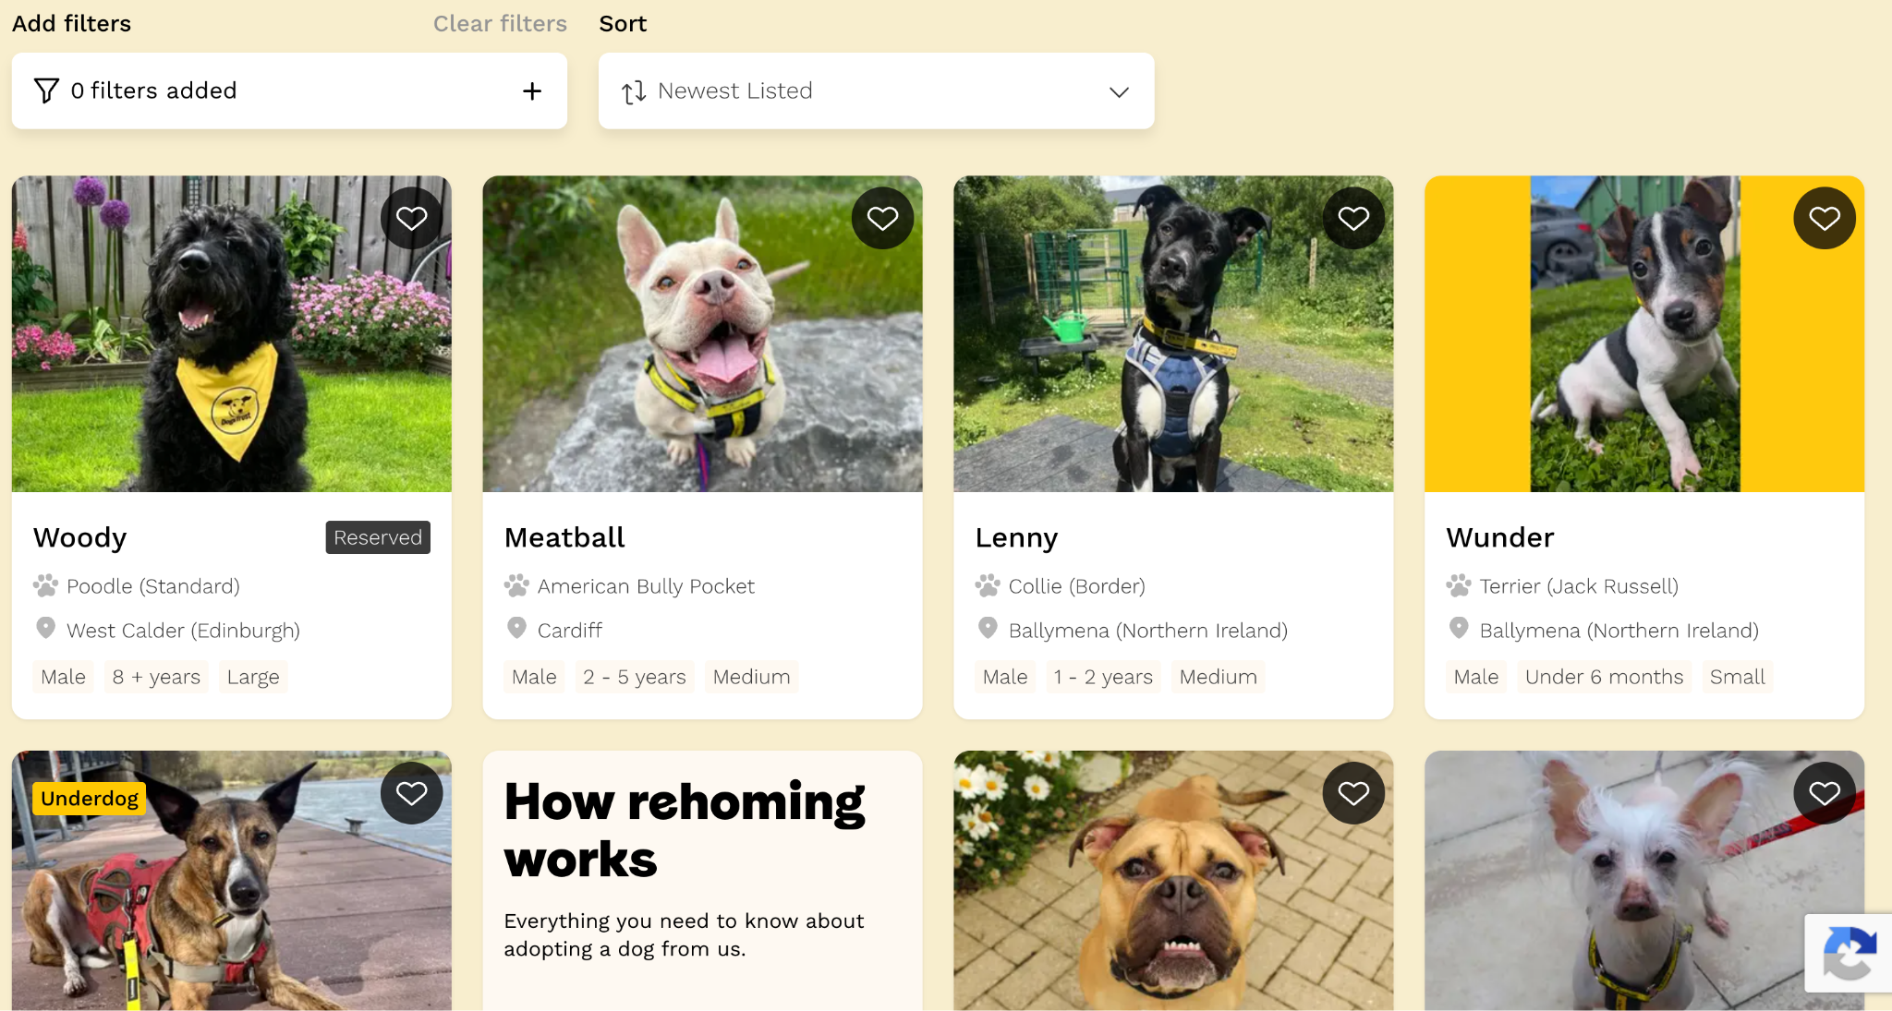
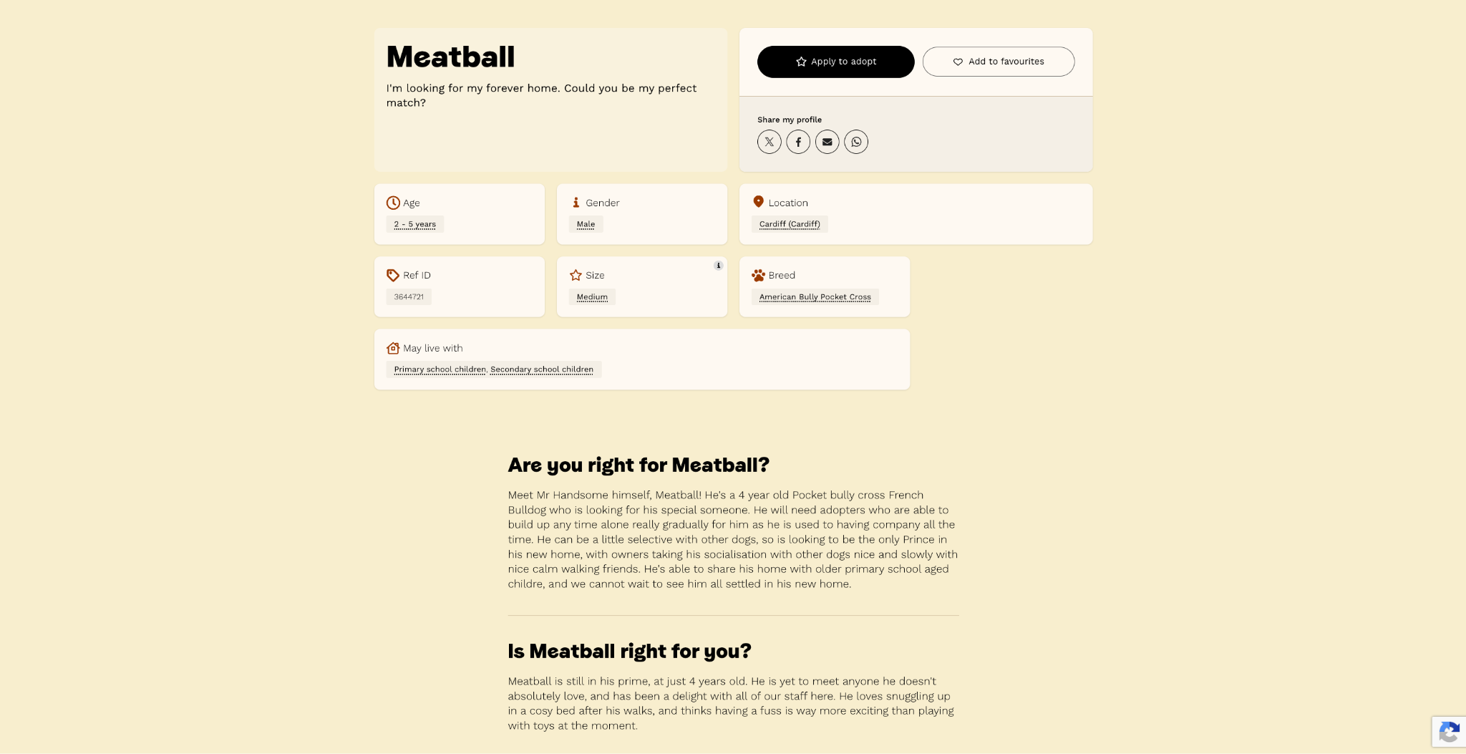
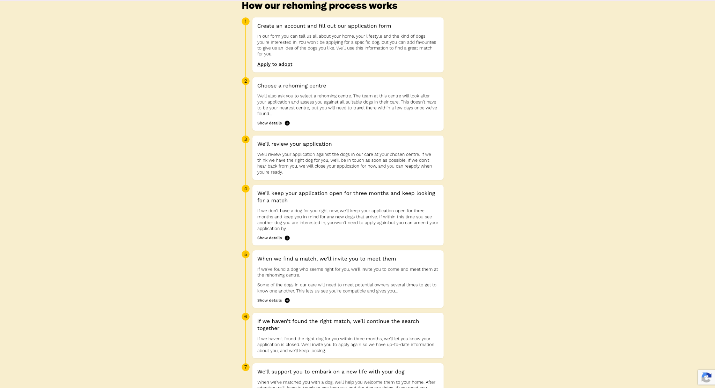
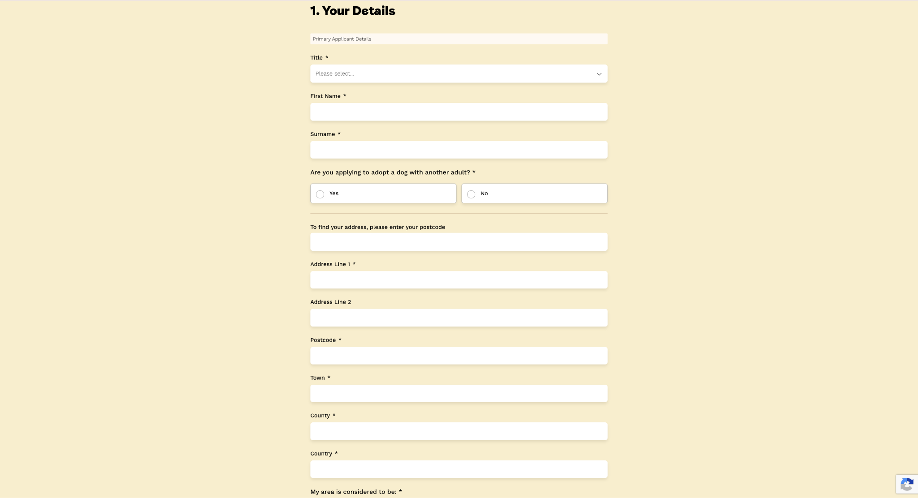

Positives | Negatives
Dog profiles display clear information about the dog such as the age, gender, breed, size, location and whether the dog can live with children. | The system only supports dogs so people interested in different animals must use another service.
The profile also includes the dog’s personality, behaviour and required home environment. This helps the user with making a decision on how the dog acts rather than from looks. | Users are not immediately told how well they match. Especially as suitability is assessed manually, so users have to wait.
Users only have to complete the application once rather than for each dog | The system does not explain which individual requirements the adopter meets or fails to meet
Users can add up to four favourite dogs. | The user must select a particular rehoming centre and be able to travel there when a match is found
Applications remain active for three months, so the user can be considered for dogs that arrive later. | Not every available dog is shown on the website meaning users cannot browse the complete set of possible matches themselves
Dogs are assessed by behavioural and veterinary staff before being matched, making the final decision more credible. | The bright yellow colour may be distracting and make it harder to read.
There is a strong yellow, black and white colour scheme making their branding recognisable. | The large photographs and sections mean that only a small amount of information is visible at once, so users must scroll frequently.
Large photographs are used for each dog to make it more appealing to adopt | Some pages are very long and contain several sections such as the ‘About us’ page, which may feel overwhelming.
There is plenty of white space between sections, preventing pages from appearing cluttered | The similar appearance of every dog card may make results look repetitive.
Important buttons such as apply to adopt and add to favourites stand out. | On smaller screens, the large images and vertically arranged content could require significantly more scrolling.

IMPACT ON MY SOLUTION
Dogs trust has influenced me to collect information about the adopter’s home, lifestyle and preferences only once and reuse it when comparing with different animals. I will also create similar animal cards which have detailed information about each animal. It will also contain another section with personality, behaviour and home requirements.
However, my system will differ as it allows for many different species and will automatically give partial feedback whether they are suitable but ultimately leave the final decision to staff.
They have also influenced me to use a consistent colour scheme, clear headings with organised animal cards. I will make buttons easy to identify.
I will avoid bright colours, long pages and make mine less overwhelming and simple to use.

Example 2 - RSPCA
The RPSCA Find a pet website allows a user to search for several different types of animals. Its pages use photographs, clear heading and separate content sections to present animal information.

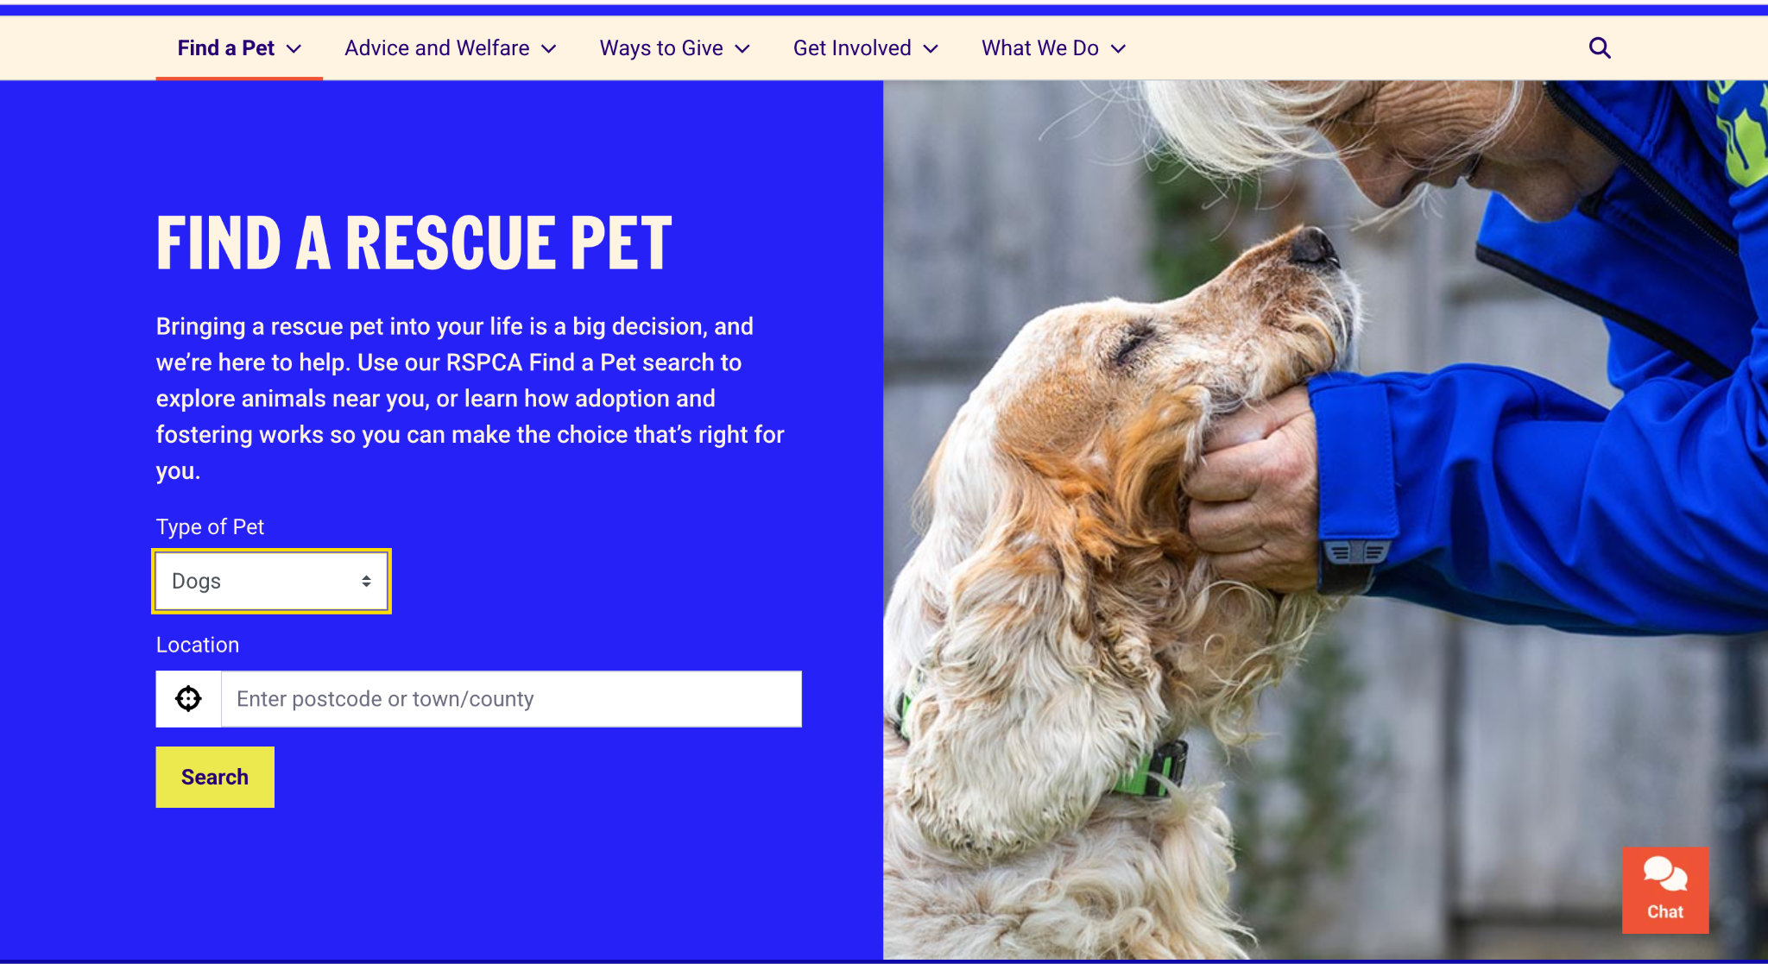
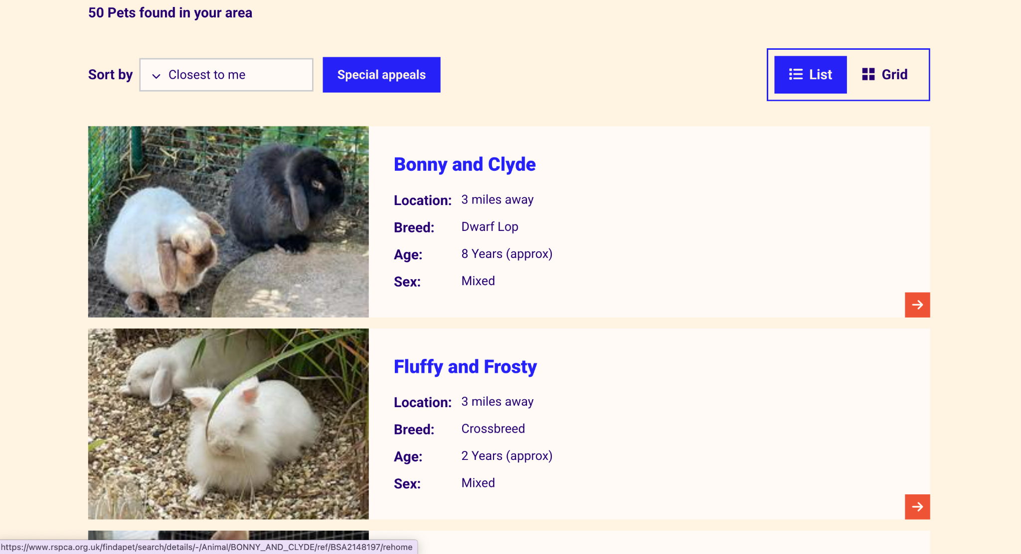
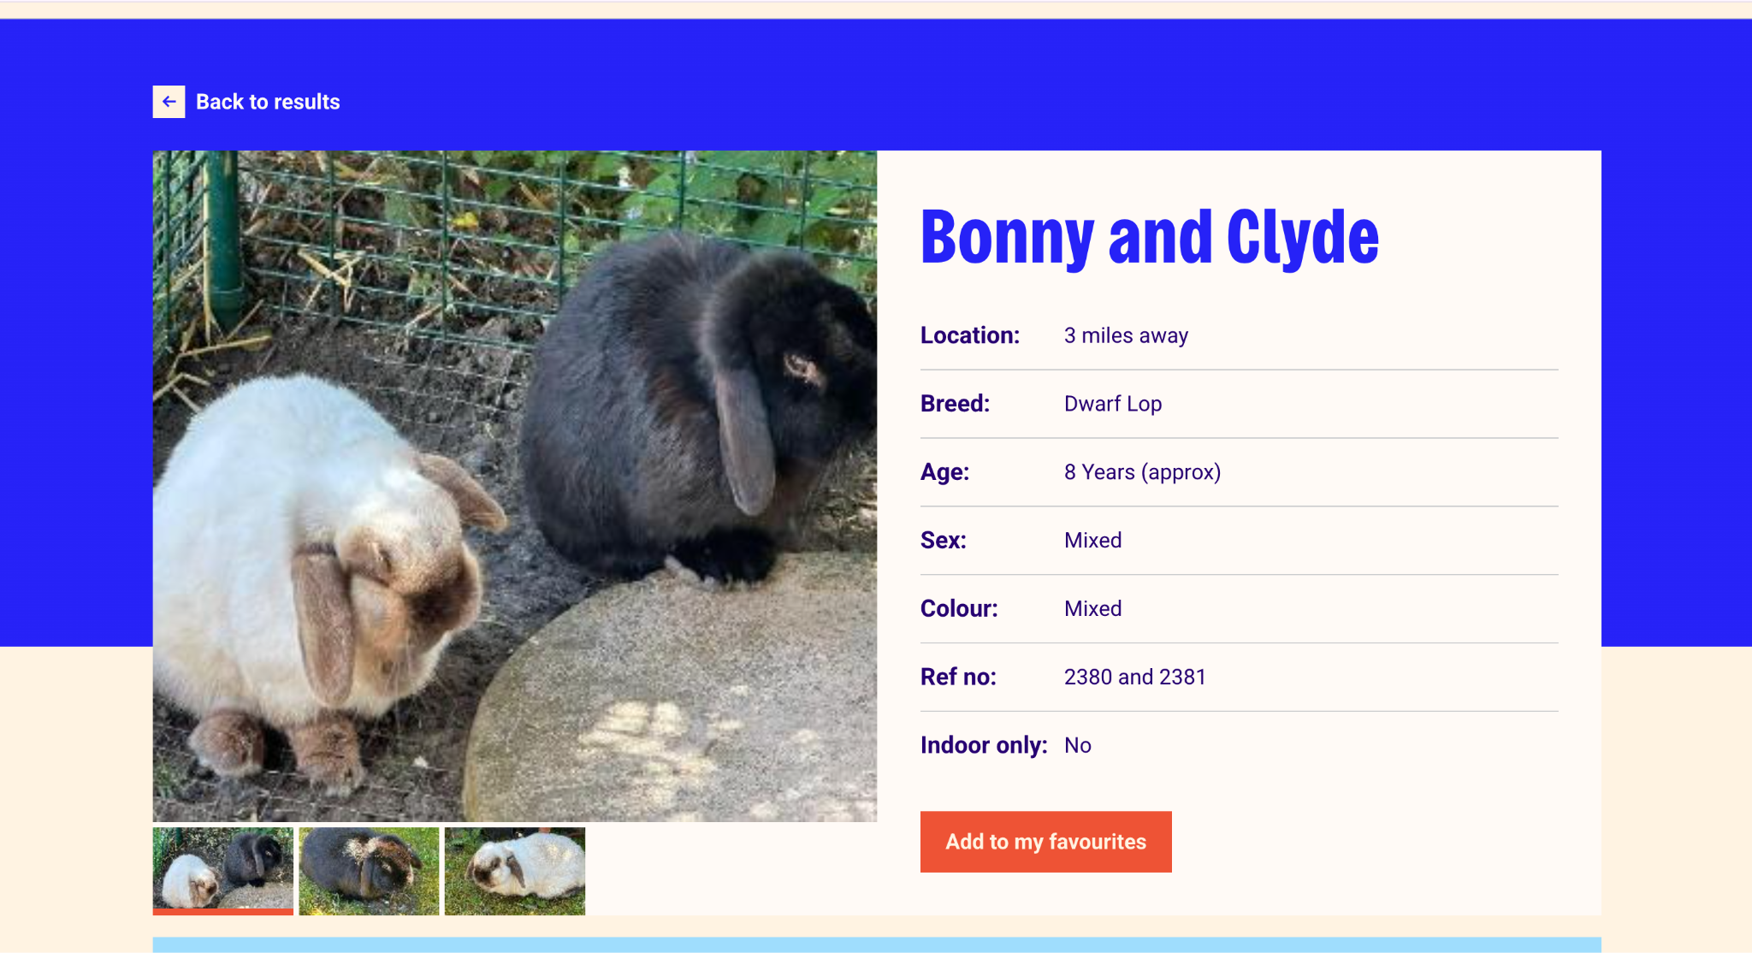
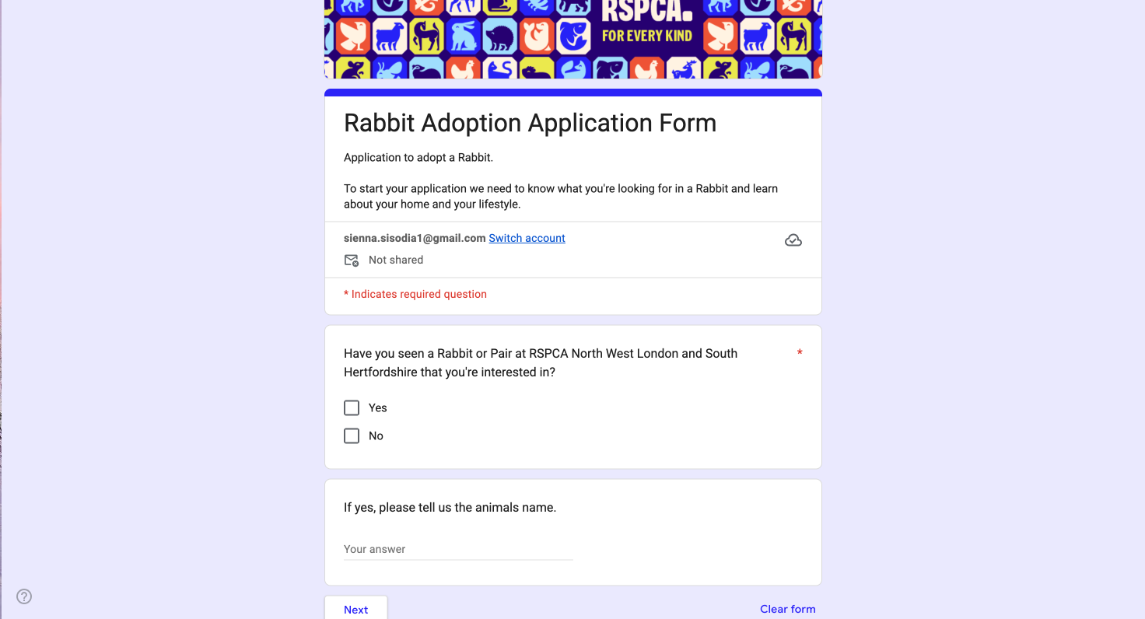

Positives | Negatives
Large animal photographs make the website visually appealing and immediately attract users' attention. | Applications are all reviewed manually by staff. The user does not receive an immediate result and should normally wait up to 48hours for a response. (Although this may vary between branches)
The colour scheme fonts and button styles remain consistent which allows the website to appear professional | The website contains many navigation options as it covers more than adoption, which may overwhelm some users. The number of filters and controls may make the search area appear crowded.
They support a wide range of species, rabbits, hamsters, guinea pigs. This is more similar to what I want within my system as it doesn't just support cats and dogs. | Some sections which are important and not important have a similar appearance which may make it hard to show what is important and allow it to stand out.
Each animal has an individual profile explaining needs, allowing adopters to consider suitability before applying. Applications also are reviewed by trained staff meaning factors for a computer to assess still can be considered. | Some important details are only available after opening the full animal profile.
They also have a feature for support after adoption, including behaviour services and pet care advice. This also could reduce chances of adoption failing after the animal entered a new home. | It may be hard to objectively analyse if they are suitable for the animal due to the lack of numeracy.
RSPCA may suggest alternative animals when the selected animal is unsuitable. | Procedures and costs may differ between RSPCA centres and branches, which does not allow for consistency which may confuse the user.
Search controls and filters are clearly labelled helping users understand what information they need to enter. | The published process requires applications to be started from an animal's profile. This may cause users to repeat parts of the process when interested in another animal.
Information is divided into sections with headings, helping users distinguish between different types of contexts. | Some centres only allow people to view animals by appointment after choosing a pet, this reduces the ability to visit freely and compare animals in person before applying.

IMPACT ON MY SOLUTION
The RSPCA has influenced me to support a wide range of animal species and organise them into clear categories. I may include simple species categories, but the main method of finding suitable animals will be the compatibility questionnaire and ranked recommendations. It has also inspired me with its layout and visual design. I like its consistent colour scheme with clear headings.
However, unlike the RSPCA, my system will calculate a numerical suitability score, explaining which requirements have and have not been met. It will also use a simpler navigation system focused solely on adoption, preventing users from becoming overwhelmed.

Example 3 - Petfinder
Pet finder is my closest competitor to my proposed system as it provides a short adopter questionnaire, and the system displays compatible pets. This website also includes a “See how you match” option. Animal listings contain information of the dogs such as age, housetrained ability and whether it can live with other animals. Users can also favourite animals.

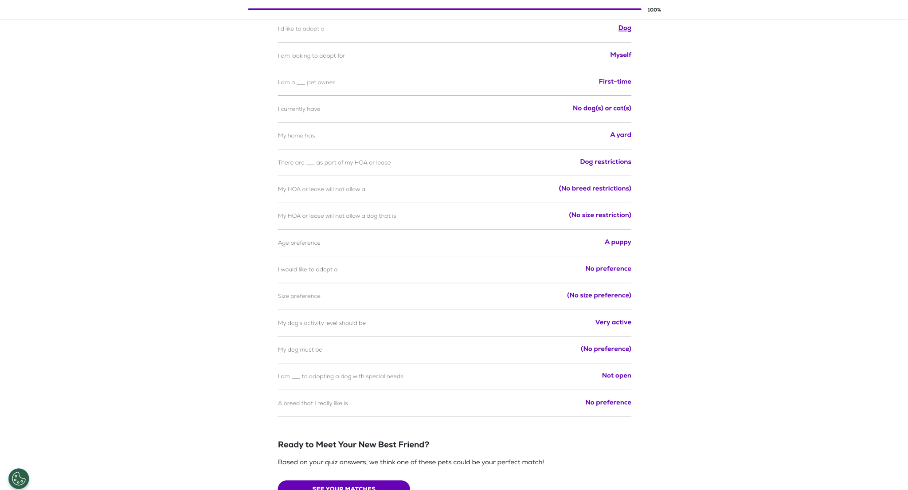
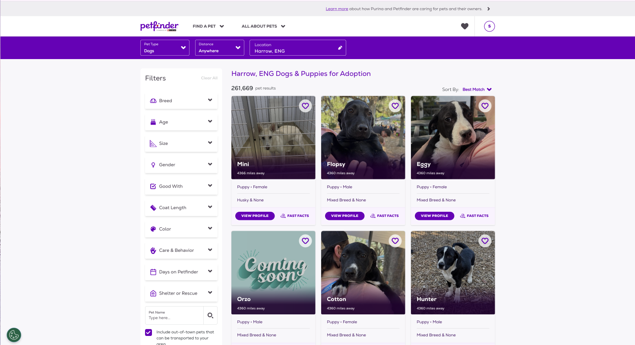
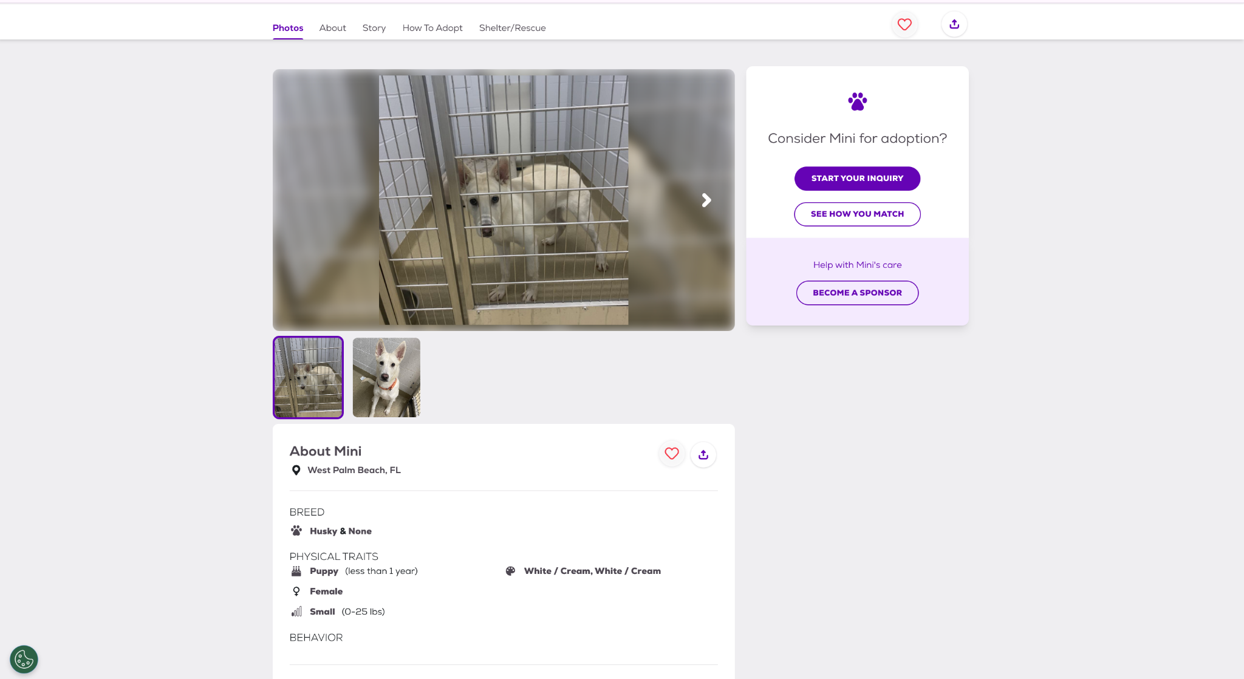
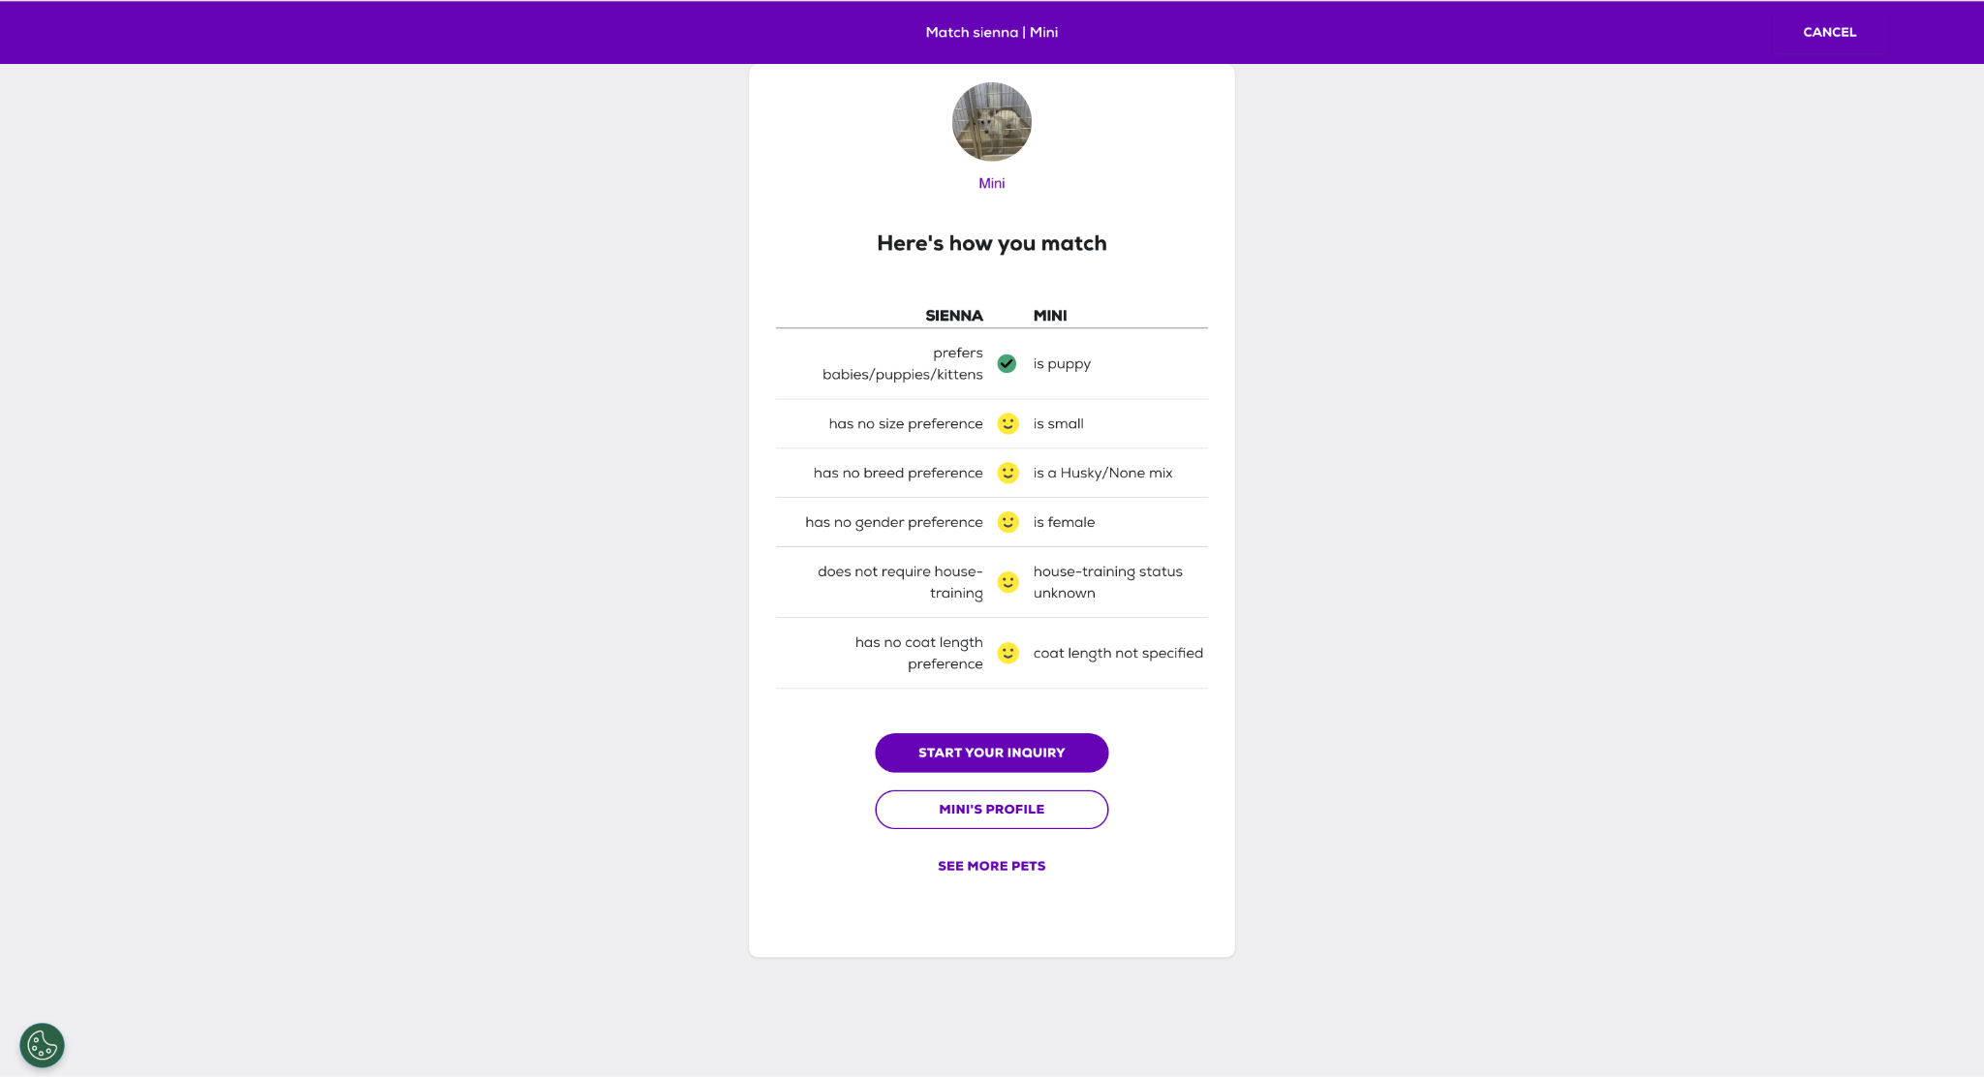

Positives | Negatives
The search filters allow users to quickly narrow down the large number of available animals | The large number of filters and listings could overwhelm some users.
Animal cards are very clear and display a photo and important information such as the name, age and breed | It may not be as colourful and bright as the other examples.
The animal profiles are detailed and show information about the personality, medical needs and compatibility with children or other pets. | The automated matching appears to focus mainly on cats and dogs rather than equal support for every species.
Users can save animals as favourites so they can return to them later. | A visible suitability percentage is not provided making it harder for users to compare matches
The adopter questionnaire can provide more personalised recommendations then a basic search. | Information can be incomplete or marked as ‘unknown’ as each shelter is responsible for entering its own animal data
Important actions such as ‘start your enquiry’ and ‘see how you match’ are clearly labelled and easy to identify, allowing ease of use for the user. | The rescue organisation may ask the user to complete another official application, causing information to be entered more than once. This also may mean the information provided may be inconsistent as different rescue organisations manage their own listings.
Pet finder brings listings from thousands of different shelters and rescues into one website. | Several actions appear on the same profile, including enquiring, matching and sponsoring which may compete for users’ attention.
Data can be saved by creating a login. | Some less important promotional content may distract users from main adoption features.
Bold headings divide profiles into clear sections such as behaviour, health compatibility and adoption information. | As individual shelters manage their own listings, an animal's availability may not be updated immediately. Users might need to contact the shelter to confirm whether an animal is still available which may be an inconvenience for the user.

IMPACT ON MY SOLUTION
Petfinder’s system has strongly influenced the design of my system. I am inspired how the survey is divided into clear manageable questions rather than displaying a long form at once. I will use a similar step by step structure with clearly labelled answer options and progress indicator, so the user knows how much of the questionnaire remains. I also like how it compares the adopters' preferences with animal characteristics in a clear table with visual symbols to show if each factor is compatible.
However, my system will provide more detailed feedback by displaying a numerical compatibility score and explaining which animal requirements have and have not been met. This will allow the several animals to be compared more objectively.

Overall Conclusion
My research shows that each competitor contains useful features, but none fully have all the requirements I want for my own system. Considering the design of dogs' trust, it has a recognisable and consistent interface where the information is presented very clearly. Dogs trust has a thorough application process even though it is only for dogs and does not provide immediate feedback. However, the frequent bright yellow may be visually distracting and long pages which can require excessive scrolling.
The RSPCA supports several species and organises animals into clear categories, but users must browse and select an animal before suitability is assessed. Their professional colour scheme makes it very recognisable and trustworthy, which may make people more intrigued to adopt. However, because the website contains services beyond adoption, its navigation can appear crowded and some important information may not stand out. Users will not be given instant or numerical feedback as they browse for an animal then begin the application. Only after staff are able to manually assess the suitability.
Petfinder is the closest competitor to my proposed system as it uses an adopter questionnaire and compares the user’s preferences with individual animals. However, it does not provide a clear numerical score making it harder to compare with many animals. Information may also be inconsistent because individual rescue organisations maintain their own animal records.

Client Interview

- What factors do people fail to consider before adopting an animal?
“I think a lot of people choose animals based on how cute they are without thinking how much work they can be. They often forget to consider things like how much space they have, how much time they can spend with their animal, how much it costs to look after, and whether they have experience caring for that type of animal. Some people also do not think about whether their home is suitable for the animal’s needs.”

- What information should be stored about each animal?
“Each animal should have basic information such as its name, age, breed, species, sex and a photo of the animal. It can also contain an extra information section such as personality, medical conditions, exercise needs, whether it gets along with children or other pets and special requirements other adopters should know about.”

- How should the system respond if the user is not suitable for the particular animal?
“I don't think the system should completely stop someone from adopting an animal, but it should warn them they might not be a good match. It should explain which requirements they don't meet and recommend other animals. This helps people make better decisions and reduce chances of animals ending up in the wrong home, but also not diverting people from adopting.”

- Do you think users should be able to apply for adoption directly through the system?
“No, I don't think users should be able to apply for adoption directly through the system. Although the system can help identify suitable animals, I still think adoption agencies should still carry out further checks in person. If staff are able to meet the adopter face-to-face they can assess personality, commitment and understanding of responsibility in owning a pet. It should aid the original process not completely take over that decision”
- What key tasks should the staff have on their side of the system?
“The key features the staff should have is being able to add, edit and remove animal records, update animal information, upload photos and mark animals as available and unavailable for adoption by deleting. The database should also be kept up to date.”

- What features would make the system easy to use for both staff and adopters?
“I think the main thing is that it should be simple and not confusing. People should be able to find what they are looking for quickly without clicking through loads of pages. It should be easy to browse animals and use the questionnaire, and for staff it should be straightforward to update animal information. Clear buttons, a clean layout and simple instructions.”

- What features should be displayed on the homepage?
“I think the homepage should show information about how the adoption process works and a button to complete the questionnaire. The homepage should be welcoming and make it clear what the website is for.”

- Should users be able to search for animals, if so, what filters should be available?
“Yes, I think users should be able to search for animals as it makes it much easier to find a suitable pet. Filter categories could be the type of animal, breed, age, size and activity level, but mainly type of animal and size.”

- What information should users provide when creating an account?
“Basic information such as name, email, address, phone number and a password when creating an account. You could also include the age to ensure they are old enough to adopt the animal.”

- Should some factors have a greater impact on the compatibility algorithm than others and if so which factors?
“Yes, I think some factors should matter more than others. Things like available space, allergies and whether there are young children in the house should have a bigger impact. For example, if someone is allergic to cats, they should not be strongly matched with a cat, even if the rest of their answers are suitable. Less serious factors such as preferred age or breed, should not be considered as important as the animal’s safety and wellbeing.”

- Do you want the website to look a specific way? Any colours, fonts etc. It would also help if you gave specific examples of apps, you like
“I would like the website to have a cute and friendly look rather than it being too serious. Soft pink and pastel colours would make it feel more welcoming and enjoyable to use. I think the design should be simple but visually appealing, with lots of photos of the animals and clear buttons. The main thing is that it feels approachable and encourages people to engage with the adoption process.”

- Do you have any security concerns regarding the app?
“Yes, I think security is important because the system will store users' accounts and animal records. Passwords should be protected, and only staff should be able to add, edit or delete animal information. Regular users should only be able to browse animals and complete questionnaires, not change anything in the database.”

- Which devices do you want it to work on?
“I want the system to work on both laptop and desktop computers, as these will be mostly used by adoption agency staff.”

- What should happen after a user receives their compatibility results?
“I think the system should show users the results in a clear way and provide them with more information about any animals that are a good match. What happens after that would depend on how the adoption agency wants to use the system.”

- Are there any features that you believe are essential for the success of this system?
“The compatibility scoring system is probably the most important feature as it helps match animals with suitable owners. Additionally, the animal profiles need to be detailed and up to date so the users will have all the information they need before making a decision”

Overall, the client interview provided valuable insight into the function and design requirements for this system. The client identified that many people fail to consider factors such as available space, time commitment, allergies and previous experience before adopting an animal. Therefore, these factors will be incorporated into the compatibility questionnaire and scoring algorithm. The compatibility algorithm should use weighted factors so that important requirements such as allergies, children, other pets and living space have a greater impact than softer preferences such as preferred breed or age. The client also highlighted the importance of maintaining and up to date detailed animal profiles and providing staff with ability to edit, add and remove animals through an administrative interface. For the design, the client wants a simple, easy to use interface with clear navigation, animal photographs and soft pastel colours to make it a friendly interface. The client also is very focused on security ensuring only staff can change details within the database regarding the animals.

Stakeholder Survey
This stakeholder survey received 27 responses, which gave me feedback from a range of potential users.
QUESTIONS:

- Have you ever owned a pet before?
- Yes
- No

- If you did own a pet, did you adopt it from a centre?
- Yes
- No
- N/A

- How would you normally choose a pet?
- Appearance
- Personality
- Breed
- Lifestyle Compatibility
- Advice from experts

- How important do you think it is to research an animal before adopting?
- Very Important
- Important
- Neither
- Not Important
- Not very important

- Which factors do you think should be considered when matching an animal to an adopter? (Select many)
- Living Space
- Garden Access
- Income
- Experience with animals
- Time available
- Presence of Children
- Other pets

- How important is it that an adoption website is easy to use?
- Very important (1)
- Slightly important (5)

- Would a compatibility score influence your decision when adopting an animal?
- Yes
- No

- Do you think adoption agencies should use a compatibility scoring system?
- Yes
- No

- How concerned are you about the welfare of adopted animals?
- Concerned (1)
- Not Concerned (5)

RESPONSES:

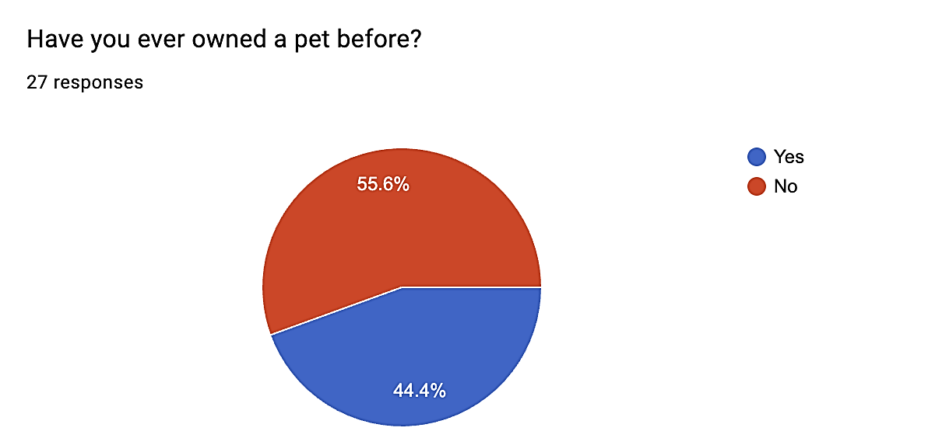
Analysis:
44.4% of respondents said yes, while 55.6% said no. This shows that my survey consists of a mixture of people with and without pet ownership experience. This is useful as my system needs to be able to support experienced and inexperienced adopters. This means the system should not assume that users will already understand animal care or adoption requirements.

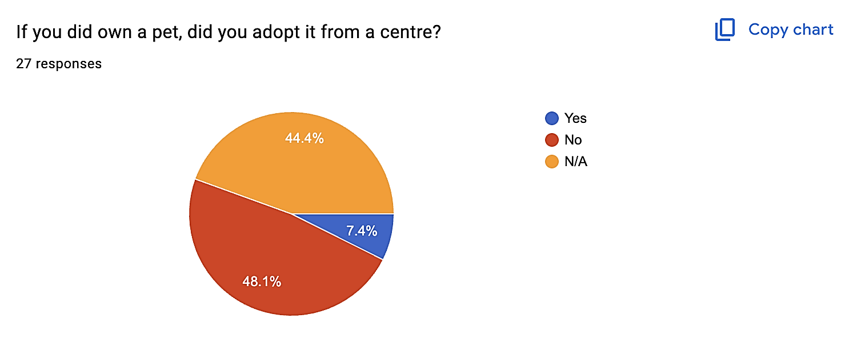

Analysis:
These results show that very few respondents have experience adopting from an adoption centre. This means my solution should clearly explain the adoption process and avoid making it confusing for users who have no experience.

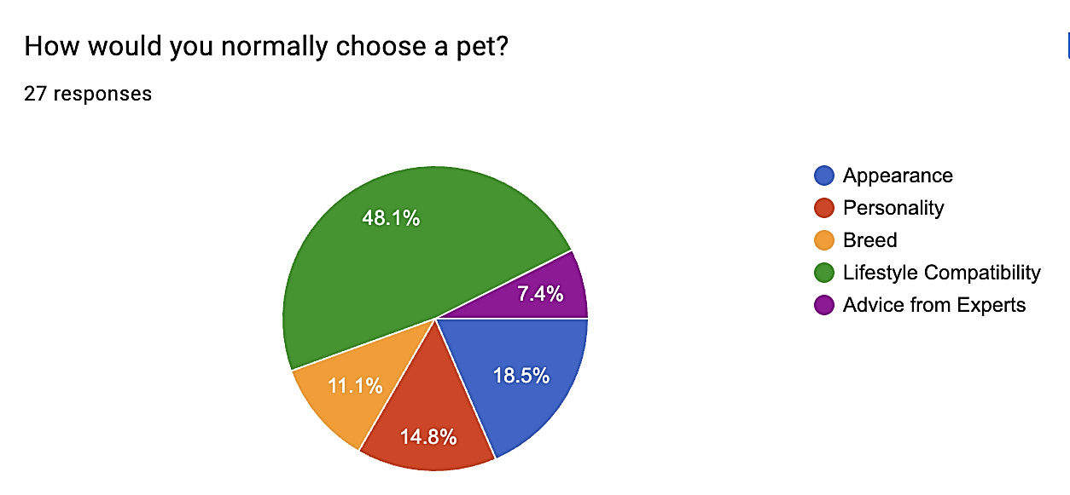
Analysis:
The most common answer was lifestyle compatibility, chosen by 48.1% of respondents. This shows most users already do care about which animal fits their lifestyle rather than just how the animal looks, even though a few care about the aesthetics of the animal. This will allow my system to be suitable for those looking to adopt.

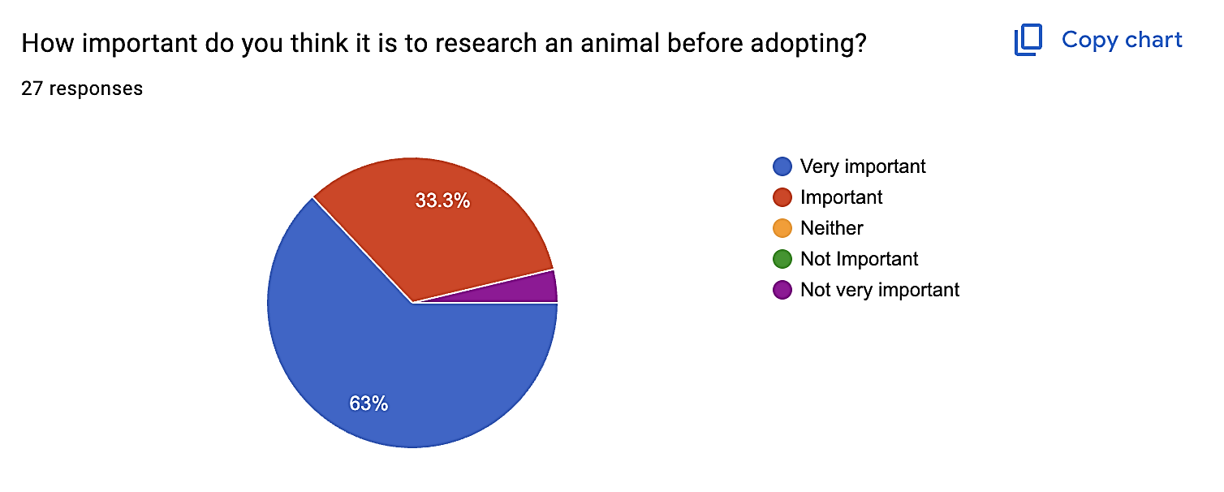

Analysis:
63% of respondents said it was very important, and 33.3% said it was important. This means that 96.3% of respondents agreed that research is important before adopting an animal. This supports my idea that websites should include detailed animal information.

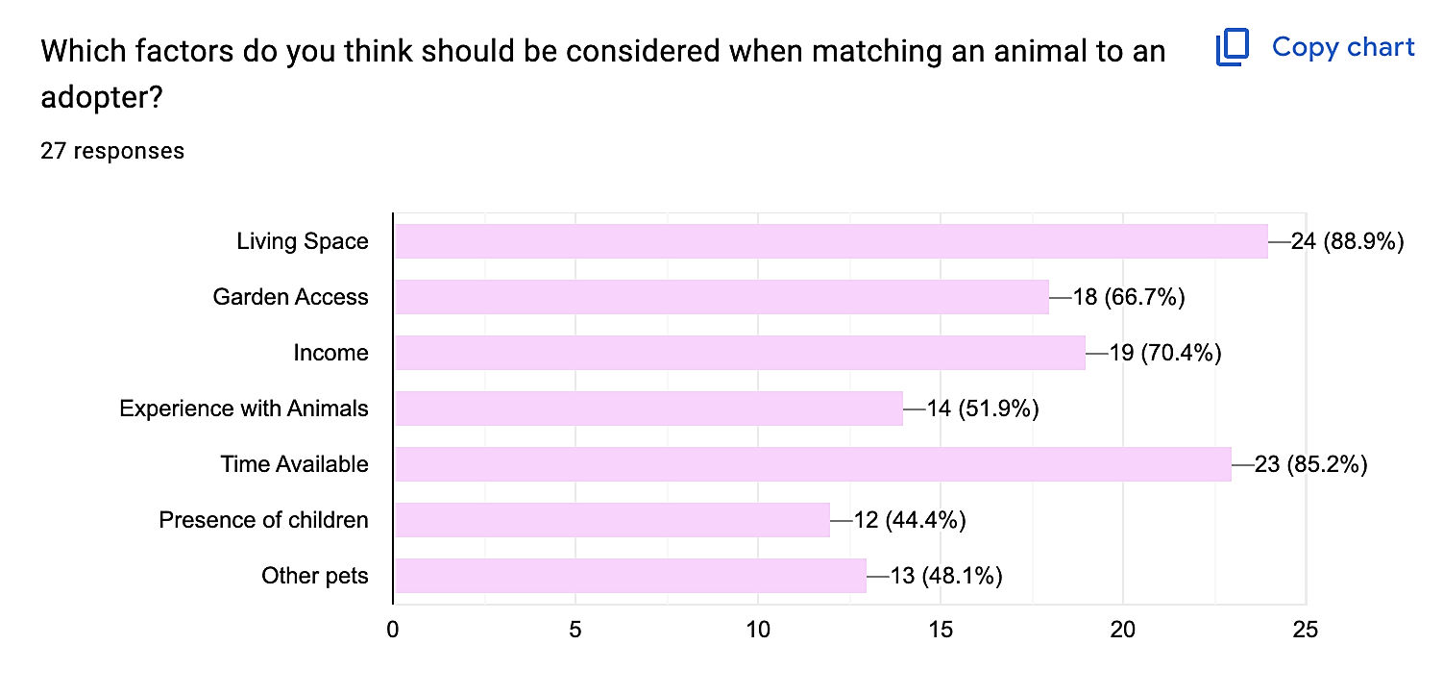
Analysis:
The most selected factors were living space at 88.9% and time available at 85.2% showing that respondents think an adopter’s environment and lifestyle are the most important parts of a successful match. Income and garden access were also highly chosen showing that practical care needs should be considered primarily.

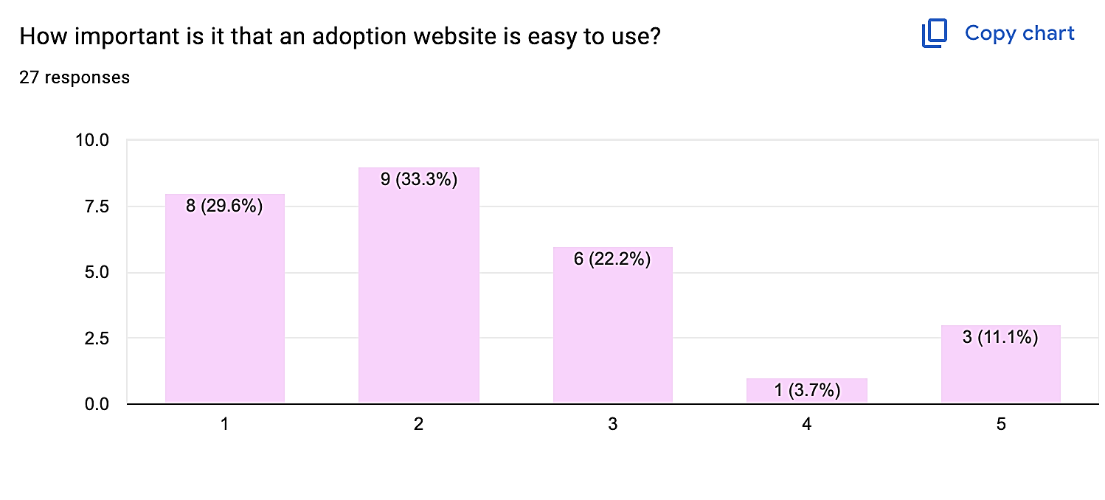
Analysis:
Most responses were grouped around the higher end of the scale, which suggests that ease of use is important to users. As a result, I would like my website to have a simple layout, clear navigation, readable text and easy process. I aim to make it as accessible as possible.

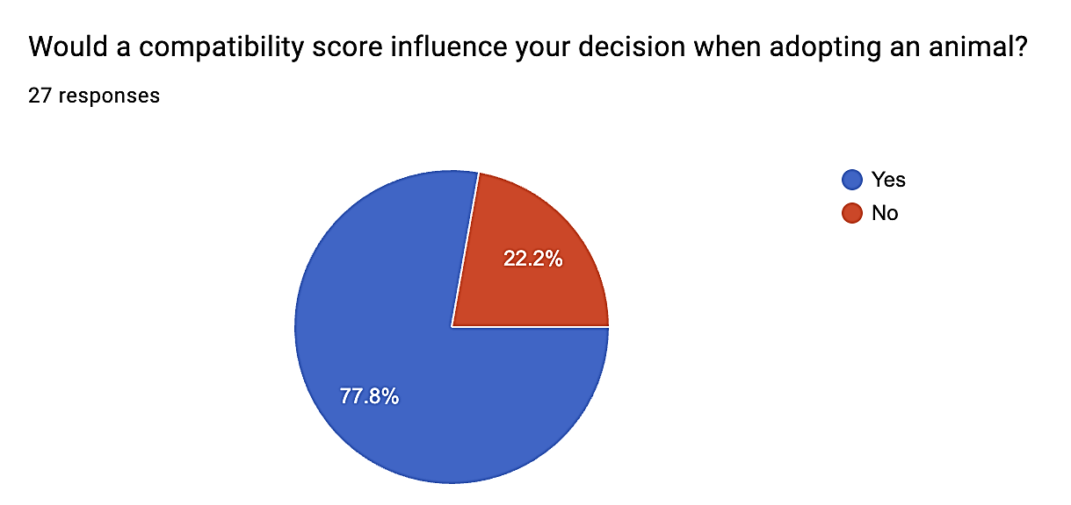
Analysis:
77.8% of respondents said yes and 22.2% said no. This shows that most users may find a compatibility score helpful when deciding whether an animal would be suitable for them.

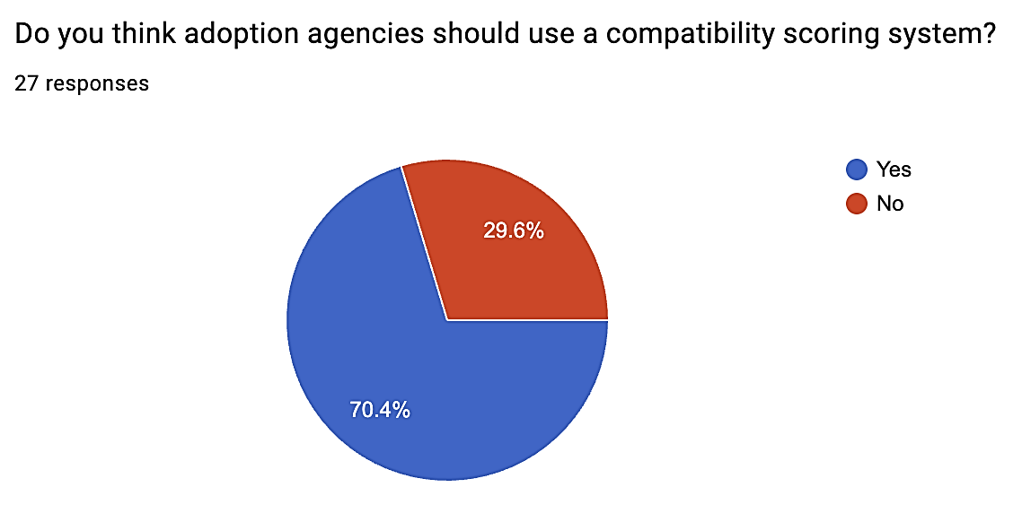

Analysis:
70.4% of respondents said yes, while 29.6% said no. This shows that respondents support the idea of adoption centres using this scoring system, but not everyone agrees. Therefore, the compatibility score should be used as a guidance but not as the deciding factor.

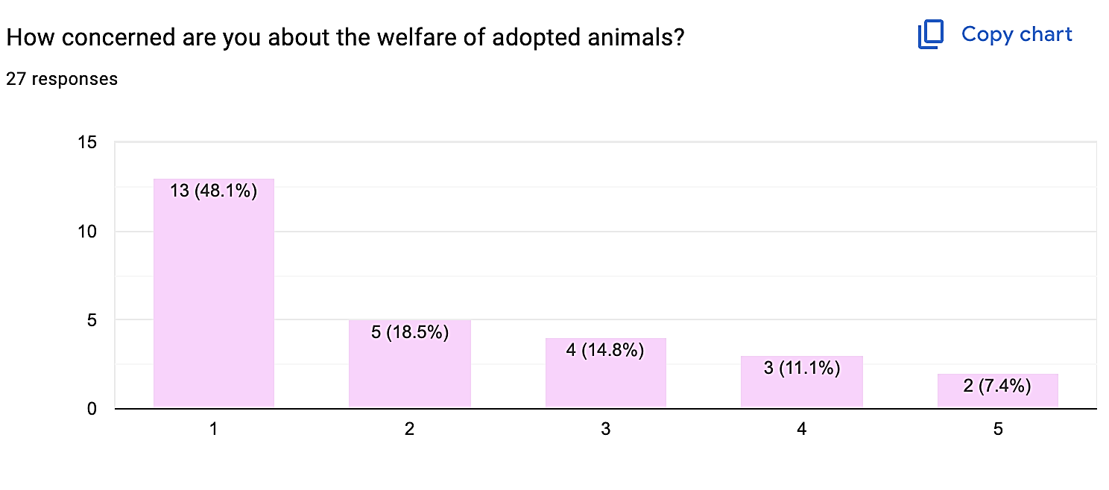
Analysis:
The largest group of respondents selected 1, with 48.1% and 18.5% selected 2. This shows that many respondents are concerned about animal welfare. This supports the purpose of this system as it aims to reduce unsuitable adoptions by helping users find animals and reduce chances of animals being placed in unsuitable homes.

Overall:
Overall, the survey shows that there is a clear need for a pet adoption system that helps users make informed decisions. Most respondents have shown that they agree that research is important before adopting an animal and would be influenced by the compatibility score. This survey also shows that the important factors include living space, time available, income, garden access and experience with animals.

My solution should include detailed animal profiles, a user questionnaire with a compatibility scoring system, where lifestyle compatibility will be the most important and popular factor in choosing an animal. This system should also be easy to use as users will have different levels of experiences with pet ownership and adoption.

However, one limitation of this survey is that it only received 27 responses, so it may not represent all potential adopters, and some respondents may have limited experience with adoption centres. It still provided me with guidance about common user expectations, especially importance of ease of use, animal welfare and compatibility scoring.
This survey was insightful to help me understand what potential users would expect from an animal adoption system, especially the need for clear information, lifestyle based matching and a compatibility score.

Prefixes: E—Examples | Q—Client Interview |S—Stakeholder Survey

Features
# | Feature | Notes | Justification | Source
1 | Clean user interface | Calm colour scheme, clear headings, identifiable buttons and a clear layout | Makes system easier to understand and use, especially for those not confident with technology | S6, E3, E1, E2
2 | Navigation bar across different pages | Allows users to move between pages easily | Competitor websites used simple navigation, which helps reduce confusion and makes system more user friendly | E1, E2, E3, S6
3 | User Home page | This system will include a clear home page introducing the purpose of adoption matching system | Simple starting point, and helps user understand system is focused on adoption suitability rather than browsing animals | E1, E2, E3
4 | Animal preview Page | Users will be able to view available animals using compact animal cards. Each card will show key information such as name, species, breed, age and image. | Compact cards will make it easier for users to compare animals without needing to open every profile individually | E1, E2, E3
5 | Animal Profile Page | Each animal will have a detailed profile page containing information such as name, species, breed, age, sex, personality, medical needs, exercise need and suitability requirements | The client stated that the animal profiles should show key details about the animal, which is also required for the matching algorithm | Q2, E1, E2
6 | Multi Species Categories | Animals will be organised by species such as dogs, cats and rabbits | The RSPCA also has different animal categories, whereas dogs trust is just based around dogs. | E1, E2
7 | Adopter Questionnaire | Users complete a questionnaire about their lifestyle and animal experience and will include many other answers which will contribute to the compatibility scoring algorithm. | The client stated that adopters often fail to consider important factors before adopting, this will allow them to reflect on their suitability before decisions are made. | Q1, S4, S5
8 | Step by step questionnaire layout | This questionnaire will be split question by question instead of being displayed as one long form, with dropdown options. | This makes the process easier to complete and reduces the chance of users feeling overwhelmed. | E3, S6
9 | Input Validation | To check if data that is required is not left blank and the data is valid. | Preventing the incomplete or incorrect data being used by the matching algorithm, recommendations more reliable | Q15, S8
10 | Compatibility scoring algorithm | The system will compare the adopter's answers with each animals requirements and calculate a numerical score. | The main computational feature, allows animals to be recommended on suitability | E3, S7, Q10
11 | Ranked animal recommendations | After the questionnaire is submitted, animals will be displayed in order from most suitable to least suitable | Removes need for user to manually search through every animal | Q14
12 | Requirements Breakdown | The system will show which requirements the adopters meet and which requirements they do not meet for each animal. | Helps users understand why an animal has received a particular score. | E3, Q3
13 | Unsuitable match warning | If the user does not meet the requirements, the system will display a clear warning | The client said the system should not completely stop a user from adoption but warn them if they are unsuitable and why | Q3
14 | User registration system | Users can create an account by registering with personal details such as name, email and password | Users can save progress, access their questionnaire and personalise their own experience | Q9
15 | User and Admin Login and Logout system | Registered users will be able to securely login and logout their accounts and staff can login securely to access management side of the system | User login ensures data is only accessible to the correct user and  admin login prevents normal user from changing animal records and protects accuracy over database | Q12
16 | Admin animal management | Admins should be able to add, edit and delete animal records | Animal information should be kept up to date when new animals arrive, details change or animals are adopted | Q5
17 | Database Storage | System will need to have a database alongside to store animal records, user accounts, admin login details and adopter questionnaire details | So data can be stored, searched, updated and used by the matching algorithm | Q15
18 | Responsive streamlit design | I will use Streamlit layout tools so pages remain clear on different screen sizes. | This makes system easier to use on different laptops or tablets without information being cut off or difficult to read | Q6, E1, E2, E3, S6

Hardware and Software Requirements

The technology used to build this system is based on the features that my client requires. The list of requirements is as follows:
- Clean user interface
- User registration and login
- Admin login
- Database storage for animal records, user accounts and questionnaire answers
- CRUD functionality for admins
- Input validation
- Compatibility scoring algorithm
- Ranked animal recommendations
For this project, I will develop my system on my MacBook, which has the required hardware and software capabilities to develop, run and test my system.

Developer
Hardware:
Device: MacBook Air, 13 Inch, M3 2024
Processor: Apple M3 Chip
RAM: 8GB
Display: I will use the 13.6 inch built in retina display alongside a 13 inch monitor
Input: Keyboard and Trackpad
Internet Connection: This is required in order to install packages, access documentation and test deployment.
This hardware is suitable as my system will not require advanced graphics processing or a powerful server. The main processing will be form input, database queries, validation and the algorithm, which is perfectly suited for my laptop.

Software:
Operating system: MacOS Sequoia 15.0
IDE: Visual studio code
Programming Language: Python
User interface framework: Streamlit
Database: SQLite
Database module: sqlite3
Browser: Chrome
I will use some additional libraries such as pandas which may be used to organise and display data in tables.

I have chosen python as my main programming language as it is the one I am most confident in, therefore I will not have to spend as much time trying to learn another language when python is suitable enough. It is suitable to create the matching algorithm, validating user inputs and all the functionalities my system requires. It allows me to be more efficient and focus on the computational parts of the system such as the comparison between adopter answers and animal requirements producing compatibility scores.

For my user and admin interface I will be using streamlit. It is simpler to use than using tkinter and it provides built in tools such as buttons, forms, dropdowns, columns, containers and page navigation. This allows me to create the pages without using a full HTML, CSS and JS website.

For data storage I will use SQLite as it is what I have the most experience in. It is suitable and easy to use to store data required for my system such as animal records, user accounts, admin login details, questionnaire answers and compatibility results.

User + Admins
My product will be a streamlit application, so users and admins will only require a device that accesses the system through any web browser., If deployed online, users will require an internet connection and they do not need to install any modules. They could access from a laptop, desktop computer or tablet, which may require a mouse, keyboard and a monitor to present the graphical user interface or even touchscreen if using a tablet.

Limitations

The system will be built in order for one specific animal shelter rather than a large organisation such as the RSPCA. This means that the database will only need to store the animals, users and admin accounts linked to that shelter. This is a large limitation as creating a system for multiple shelters would require extra features such as shelter admin accounts and location based searching and overall a larger database structure. This will be extremely difficult with the experience I have and would increase the complexity of my project. Furthermore, this would make development and testing less realistic within the time available.

The system will only be focusing on common adoption animals such as dogs, cats and rabbits rather than every possible species. This is due to different animals having different care requirements, and every possible animal would make the matching algorithm too broad and difficult to test within the time available. By focusing on a smaller number of species it will allow the compatibility algorithm to be more accurate and relevant. More species could be added within the future by expanding the animal requirements stored in the database.

Additionally the compatibility score is only there to provide guidance and will not replace the core decision making of adoption staff within the centre. Although it's able to compare adopters answers it will not be able to take in external factors such as personal circumstance or behavioural detail. It will also not be able to receive evidence to match their answers on the questionnaire. Therefore, the final adoption decision is made by staff, whilst the questionnaire is a guide in order to help those looking to adopt make a better decision.

The system will also not be able to complete the full adoption process as it cannot handle legal contracts, home checks, payments and final adoption approval. This would require more security, data protection and verification processes which widens the scope increasing development time. My system's main focus is helping users consider suitability before choosing an animal.

I cannot ensure the accuracy of the recommendations will be perfect every time, but rather they depend on the users answering the questionnaire honestly. If a user gives inaccurate answers on the questionnaire it will not reflect their true suitability. I will try to reduce this by using clear wording and validation but it cannot fully prevent users from entering inaccurate information.

The matching algorithm is rule based rather than using AI or ML. As a rule based algorithm is easier to explain, test and justify within the project. It will also be clearer to break down and show a user why an animal has or has not been recommended to the users. Additionally, machine learning would require a large dataset of previous adoptions which is not realistic for this project.

Animal records will need to be updated manually by admin users. This may lead to inconsistencies, or animals showing available when they are not. This is not something I can control but rather within the staff's responsibility to add edit and delete records so the database can be kept up to date.

Some advanced features such as animations, live chats would not be included and some of the formatting and design will be simplified. It would increase development and testing time without improving the main purpose of the system.

Success Criteria
[TO WRITE] Add a column 'How it will be measured' to this table, with a number for each criterion where possible:
a time (results appear within 2 seconds), a capacity (stores at least 50 animals) or an approval score
(ease of use rated 8/10 or more by 5 testers). Measurable criteria are what the top band asks for,
and your evaluation will mark each one met, partly met or not met.

Prefixes: E—Examples | Q—Client Interview|S—Stakeholder Survey

# | Feature |  | Requirements | Source
1 | Navigation and Clean user interface |  | Pages must use a calm colour scheme, clear headings and identifiable buttons | S6, E1, E2, E3
1 |  |  | The interface must remain readable on laptop and tablet sized screens | Q6, S6
1 |  |  | The system must include a navigation menu to access home page, animal preview page, profile page, and login page | E1, E2, E3, S6
1 |  |  | The menu and interface style must remain consistent across all the pages | E1, E2, E3, S6
2 | Home Page |  | Should explain the purpose of the animal adoption matching system, especially including that the system focuses on suitability rather than only appearance | Q1, Q3, E1, E2, E3
2 |  |  | Should have a clear button or navigation option that directs users to complete the adoption questionnaire | Q1, S5, S6
3 | Animal preview page |  | The page should display every available animal using compact animal cards | E1, E2, E3
3 |  |  | Each card should show the species, name, breed, age and image | Q2, E1, E2
3 |  |  | The system must support at least 3 animal species including dogs, cat and rabbits | E2
3 |  |  | Users must be able to open a full animal profile from the preview page | E1, E2, E3
4 | Animal Profile Page |  | Each profile must display the animals name, species, breed, age and sex | E1, E2, Q2
4 |  |  | Each profile also must include personality, medical needs, exercise needs and suitability requirements | Q2
4 |  |  | Animal profile information must be retrieved from the database | Q15
4 |  |  | Users must be able to return to the animal preview page or results page | S6, E1, E2, E3
5 | User and Admin registration and login page |  | Users must be able to create an account, using name, email and password and it can include other features such as age to ensure they are at a suitable age | Q9, Q12
5 |  |  | The system must reject registration if required fields are empty and the email format is invalid, by validating inputs | Q12, Q15
5 |  |  | Registered users must be able to login and logout using their correct account details | Q12
5 |  |  | The admin login details should allow admins to access their own section with the CRUD interface | Q12, Q5
5 |  |  | Incorrect Login details must display an error message and prevent access to the account | Q12, S6
6 |  | Adopter Quest’naire Page | The questionnaire must collect information about the user’s home, lifestyle, garden access, children, other pets, time available and previous animal experience | Q1, S5
 |  | Adopter Quest’naire Page | The questionnaire must be split into clear sections or individual questions rather than appearing as one long form | E3, S6
 |  | Adopter Quest’naire Page | The questionnaire must use suitable input methods such as dropdowns, radio buttons or selection boxes but preferably dropdowns. | E3, S6
 |  | Adopter Quest’naire Page | The system must prevent the questionnaire from being submitted if important questions are unanswered | Q15, S8
7 |  | Results and recomm’ns page | The system must compare adopter’s questionnaire with each animal’s requirements | Q10, Q1, S5
 |  | Results and recomm’ns page | The system must calculate a numerical compatibility score for each animal | Q10, S7
 |  | Results and recomm’ns page | The top 4 animals must be displayed from highest compatibility score to lowest at a minimum | Q14, S7
 |  | Results and recomm’ns page | The results page must show which key requirements the user meets and does not meet for each animal | Q3, E3
 |  | Results and recomm’ns page | The system must display a warning if the user does not meet important requirements for an animal | Q3
 |  | Results and recomm’ns page | The results page must explain that the compatibility scores are guidance, and the adoption staff have the final say | Q3
8 |  | Admin manage’t page | This page should be accessed separately with a separate admin login | Q12
 |  | Admin manage’t page | Admin users must be able to add a new animal record with all the information required | Q5, Q2
 |  | Admin manage’t page | Admin users must be able to edit existing animal records and save the updated information to the database | Q5, Q15
 |  | Admin manage’t page | Admin users must be able to delete animal records when animals adopted or no longer available | Q5
 |  | Admin manage’t page | Normal users must not be able to access the admin management page | Q12
9 |  | Database system | The database must store animal records, user account details, admin login details and questionnaire answers | Q15
 |  | Database system | The database must allow animal records to be added, viewed, edited and deleted through the admin system | Q5, Q15
 |  | Database system | Questionnaire answers must be stored or processed so that they can be used by the compatibility scoring algorithm | Q10, Q15
 |  | Database system | Data must be retrieved correctly so animal profiles and recommendations display accurate information | Q15, Q2, Q10

References

BBC News (2024) RSPCA receives record number of animal cruelty reports. Available at: https://www.bbc.co.uk/news/articles/cwyrnlj5632o (Accessed: 19 June 2026).
Dogs Trust (n.d.) About us. Available at: https://www.dogstrust.org.uk/about-us (Accessed: 25 June 2026).
Dogs Trust (n.d.) How to adopt a dog. Available at: https://www.dogstrust.org.uk/rehoming/how-to-adopt (Accessed: 25 June 2026).
Petfinder (n.d.) Adopter profile: Finding your perfect pet. Available at: https://www.petfinder.com/pet-adopter-profile/ (Accessed: 25 June 2026).
Petfinder (n.d.) Pet Finder Quiz. Available at: https://www.petfinder.com/user/profile/create/ (Accessed: 25 June 2026).
RSPCA (n.d.) Find a pet. Available at: https://www.rspca.org.uk/findapet (Accessed: 25 June 2026).
RSPCA (n.d.) Pet adoption process guide. Available at: https://www.rspca.org.uk/findapet/adopt (Accessed: 25 June 2026).
sienna

Design

✔️ Introduction/Overall

Proposed Layout
[TO WRITE] Hierarchy chart: draw a top-down decomposition diagram here. PawMatch at the top, your five components
below it, and each component broken into its sub-tasks (e.g. Login -> validate input, check database,
verify hash, create session). Then one or two sentences on why breaking it down this way helps.
The system can be decomposed into five main components. Separating the system into smaller components makes it easier to design, develop, test and maintain whilst each section performs a specific function.
Section | Front End Justification | Backend Justification
User/Admin  Authentication | Will allow users to register and existing  users to login, and allow admins to access their page safely and securely. Registration will collect the users name, email, age and password. The interface should provide clear feedback when details are missing or  forgotten from its validation system. It will also show an error message if login details are incorrect | The system will validate entered details, such as:  -​ email cannot be blank and must be valid and unique  -​ Password minimum 8 characters -​  Age must be a valid number -​ Login fields cannot be blank  The passwords will be hashed in order to be kept secure and safe. During login,  enter details will be compared against records in the users table. A session will then be created when authentication is successful.  For the admin side, if the login details are incorrect it will not allow them access, which will stop unauthorised users from adding, editing or deleting animal records.
User  Homepage/Main Menu | Will provide the main navigation area after the user logs in. It will allow the user to access the questionnaire, browse available animals and view their account. It will also explain the purpose of the adoption  matching system. It will be clear and  welcoming, and not overwhelming for the user. | The system will check the user's session to make sure they are logged in. It may retrieve the email and recent questionnaire information from the database so that  personalised information can be displayed.
Administrator Menu | Provides staff with a dashboard to manage existing animals and their records. Admins will be clearly able to add new animals, edit existing details and remove records. To add animals it will store: Name, species, age, breed, sex, personality and exercise needs, | The system will check that the logged in account has the admin role before access is allowed. Parameterised SQL commands will insert, update and delete animal  records. All inputs will be validated before changes are made to the database. A log

 | children compatible, garden required,  medical notes and an image. Forms will be clearly Labelled and display confirmation or error messages. | out function will clear the admins session and return them to the login page,  preventing another person using the same device which will prevent unwanted  access to the database.
Animal Viewing | Allows users to browse available animals using clearly presented animal cards. Each card will show information such as the  animal name, image, species, breed and age. Users will be able to select a card to view a more detailed animal profile. | Animal records will be retrieved from the animals table. Search and filter selections will be used to change the database query or filter the retrieved records. Selecting an animal will use its unique animal ID to  load the correct profile.
Questionnaire and Recommendations | Will use a form in order to allow users to answer questions about their home, lifestyle, experience and preferences. The  questionnaire will have questions such as the housing type, access to garden, animal loneliness times, children, pets, experience, activity labels, what species and size  preferred. These questions would not appear all at one time to not overwhelm the user and the input type would be drop downs or radio buttons. After submitting the  questionnaire, the system will display  compatibility scores almost immediately and recommended animals. It will also explain requirements the user does not meet. | Responses will be validated and  compared with the requirements of each available animal. A weighted compatibility algorithm will calculate a percentage  score for every animal. The animals will then be sorted from highest to lowest  score so the top recommendations can be displayed. The questionnaire responses and match results may also be stored  within the database with the users ID  (email)

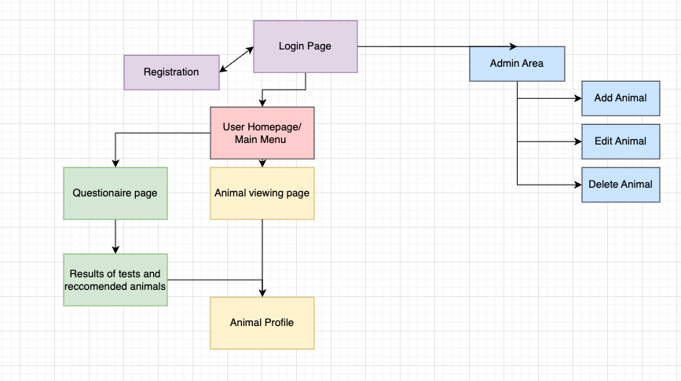

Database structure
Tables | Purpose
Users | Stores registered user and administrator account details
Animals | Stores user profiles, care needs and matching requirements
Questionnaire responses | Stores answers submitted by users
Matchresults | Stores calculated compatibility scores between responses and animals
One user can complete multiple questionnaire responses, each questionnaire can produce multiple compatibility results because it is compared to every available animal. Each animal can therefore appear in multiple match results belonging to different users or questionnaire attempts.
-​Users 1 → Many Questionnaire responses
-​Questionnaire responses 1 → Many matchresults -​animals 1 → Many matchresults
Validation
All user entered data should be validated before it is processed or stored in the SQLite database. Streamlit controls such as dropdowns radio buttons and number inputs will restrict the range of values users can enter. However, the backend will still validate the submitted values because interface controls alone should not be relied on.

🩷 Login + Adminitration

Login and Registration
User/Admin  Authentication | Will allow users to register and existing users to login, and allow admins to access their page safely and securely. Registration will collect the users name, email, age,  address and password. The interface should provide clear feedback when details are  missing or forgotten from its validation  system. It will also show an error message if login details are incorrect | The system will validate entered details, such as:  -​ Username cannot be blank  -​ Password minimum 8 characters -​ Required questions cannot be  skipped  -​ Age must be a valid number  -​ Duplicate usernames not allowed The passwords will be hashed in order to be kept secure and safe. During login, enter details will be compared against records in the users table. A session will then be created when authentication is successful.  For the admin side, if the login details are incorrect it will not allow them access, which will stop unauthorised users from adding, editing or deleting animal records.
Interface Design

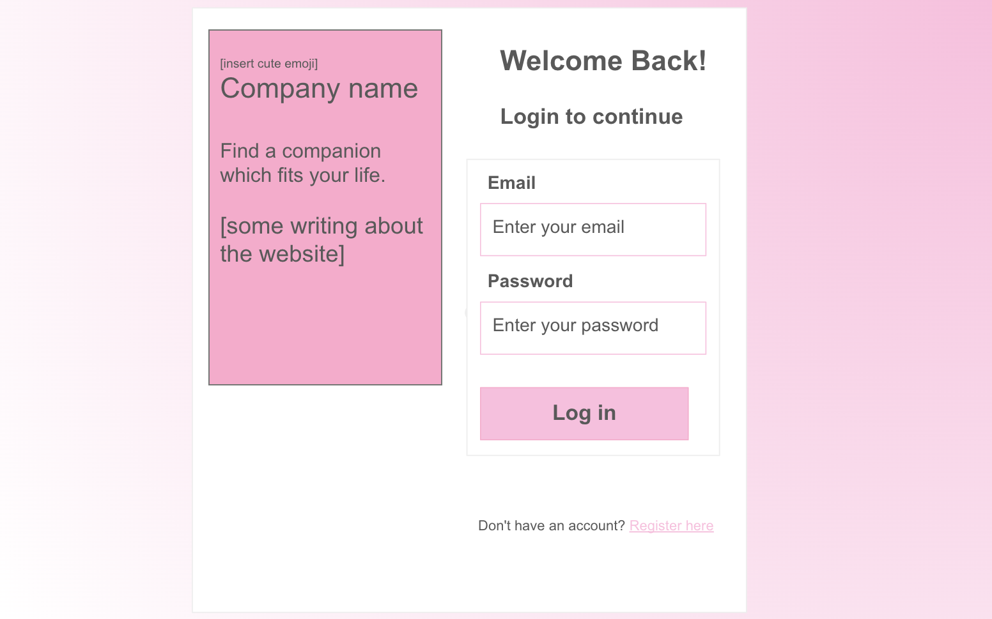
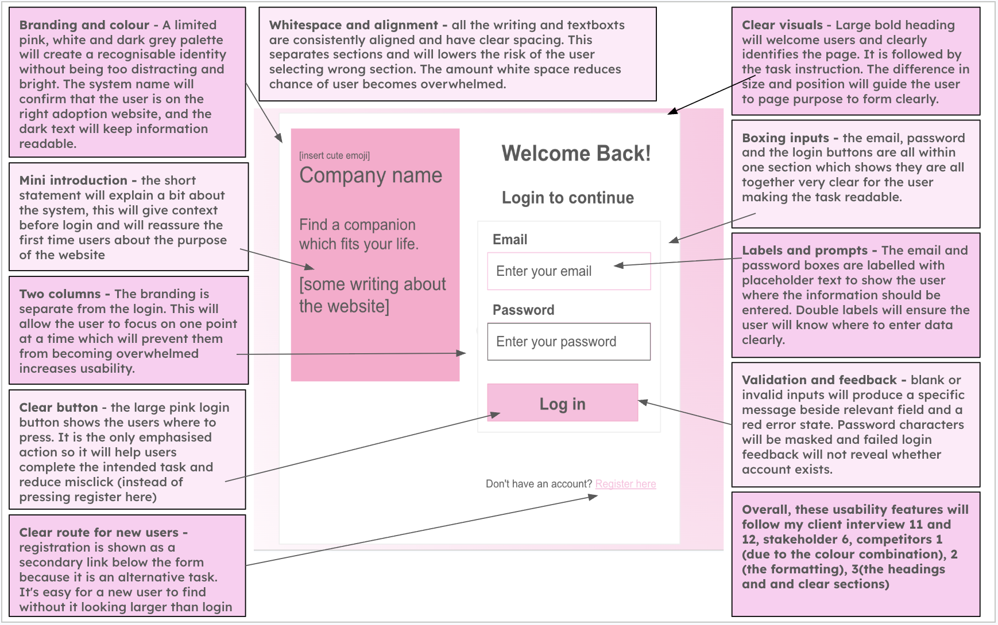

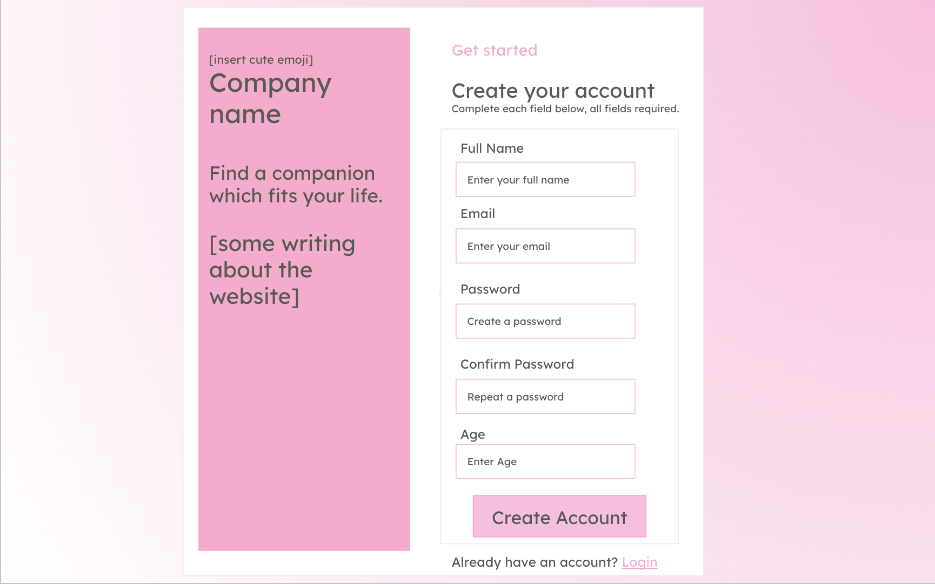
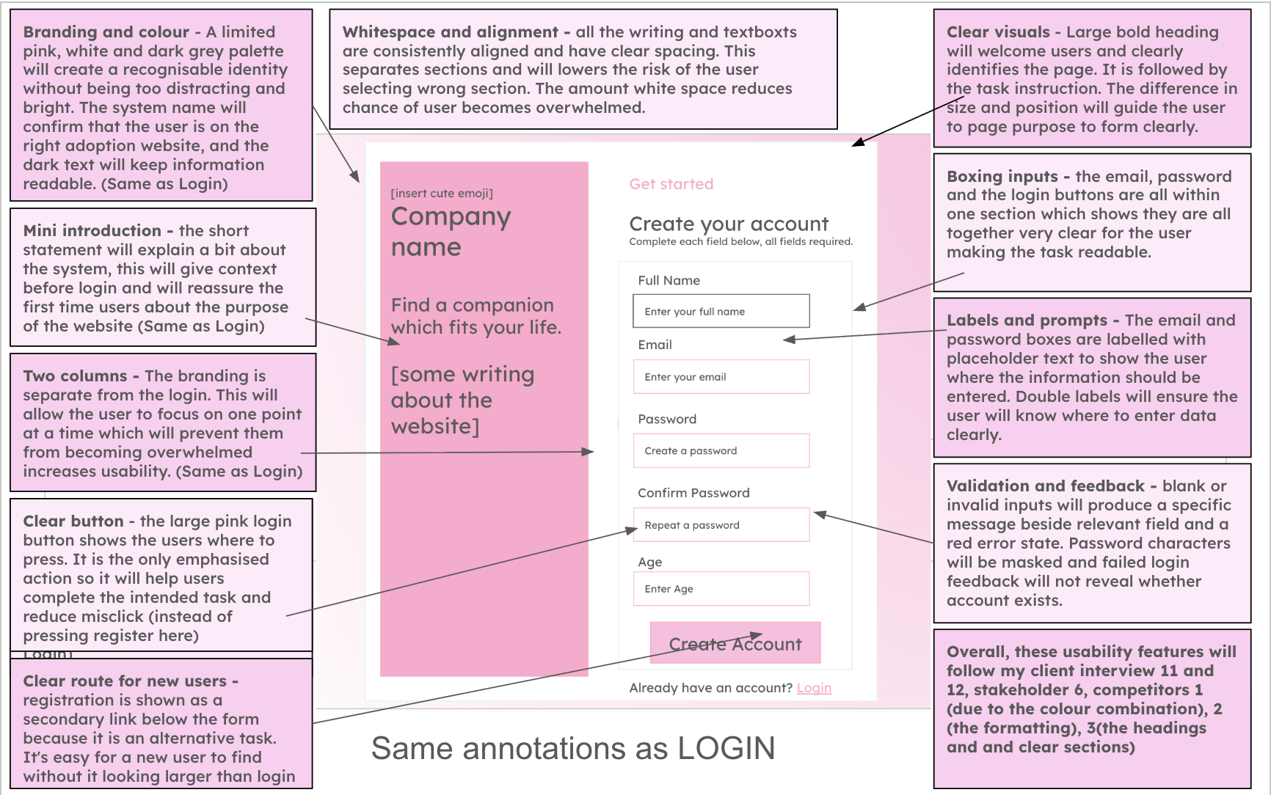

Algorithm (Flow chart, pseudocode)
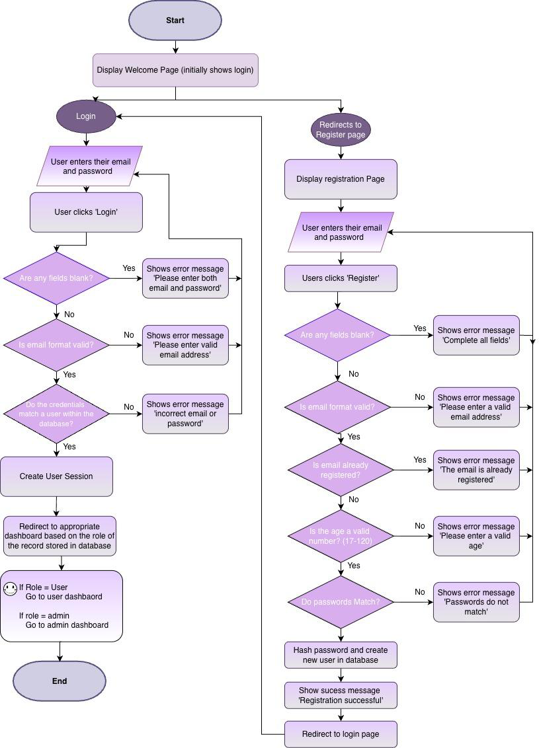

Pseudocode
[TO WRITE] Pseudocode for login and registration (follow your flowchart: validate inputs, check uniqueness, hash, insert; login: find user, verify hash, create session, route by role).
Turn your flowchart on the previous page into pseudocode, using the variable names from your variables table.
Under it, one or two sentences on how this algorithm fits into the whole solution.
Database (Table structure)
Field | Data type | Key/validation
user_id | INTEGER | Primary key which will auto increment
name | TEXT | required
email | TEXT | Required and unique
age | INTEGER | required , valid range
password_hash | TEXT | required
user_role | TEXT | ‘User’ or ‘admin’
date_created | DATE | required
Variables
Variable Name | Data  Type | Purpose | Justification | E.g or  Validation
user_name | String | Stores the name entered during registration | This will allow the system to  identify and personalise the  account. A string would be required for the datatype as it will contain | Cannot be blank

 |  |  | alphabetic characters and may include spaces and hyphens.
email | String | Will store users email address | It will be used as a unique identifier for logging in and contacting the user. It will contain letters and  symbols so will be stored as a  string. | Must follow a  valid email format and be unique
age | integer | Stores the users age | It will be used to ensure the user meets any minimum age  requirements. An integer is suitable for this variable as age is  represented by a whole number. | Must be a valid positive number.
password | string | Temporarily  stores the  password  entered by the password | It is needed to authenticate the user securely. Passwords usually contain letters, numbers and special  characters, so a string is suitable for the data type. | Minimum of eight characters.
confirm_passwo rd | string | Stores the  repeated  password  entered during registration | This allows the system to check that the user has mistyped their password before creating the account. | It will have to  match password
password_hash | string | Stores the  hashed version of the password | Passwords should not be stored as plain text. Storing the hash reduces the risk of passwords being  exposed if the database is accessed without permission. | Generated using a secure hashing  function
login_email | string | Stores the email entered on the login page | The variable is required so that the system can search for the  corresponding account in the  database | Cannot be blank
login_password | string | Temporarily  stores the  password  entered during login | The entered password will be checked against the stored  password hash in order to verify users identity | Cannot be blank
user_id | integer | Uniquely | An integer is efficient for use as a | It will be retrieved

 |  | identifies the logged in user | database primary key, it will allow records such as questionnaires and recommendations to be linked to the correct user. | from the database after login
user_role | String | Stores whether the account is an administrator or a user | This variable is required for access control, so that normal users cannot access the administrator pages  Controls access to the administrator area, although normal registrations should automatically receive the  role ‘user’, the admin role should not be selectable from the  registration form. | Will be stored as ‘user’ or ‘admin’
error_message | string | Stores the error message which  will appear when the input or login details are  invalid | My system will provide clear  feedback and help the user  understand what has gone wrong and how to correct it. A string will be suitable for this message as it contains many words in one  sentence. | ‘Incorrect email or password, please retry’
is_authenticated | booleen | Records whether login attempt  was successful | A boolean data type is suitable as authentication only has two  possible values. | True or False
Validation
1.​Name
-​ Presence check: Field cannot be empty or contain only spaces
-​ Length check: name must be between 2 and 50 characters
-​ Whitespace check: spaces at beginning and end will be removed
2.​Email address
-​  -​  -​  -​  -​ | Presence check: Field cannot be empty or contain only spaces  Format check: value must contain a @ and domain  Uniqueness check: a database query will check the address not already registered Whitespace check: spaces at beginning and end will be removed  Check characters: convert all to lower case
3.​Age

-​  -​  -​ | Presence check: Field cannot be empty or contain only spaces Type check: data must be a whole number  Range check: age must be 18+
4.​Password
-​ Presence check: Field cannot be empty or contain only spaces
-​ Length check: password must be more than 8 characters
Registration
-​ Confirmation check: the confirmation field must exactly match original password -​ Security processing: the valid password will be hashed before it is inserted into the database and the original password will never be stored.
Login
-​ The password will be checked against the stored password hash rather than compared as plain text.
Registration outcome
-​ The account will be created if every field passes validation, individual messages will be shown if one or more fields are invalid.
Session check
-​ A session will only be created after successful authentication. Invalid information will leave users on the login page and will not allow them to access the user or admin page.

🩷 Admin Page

Admin Page
Administrator Menu | Provides staff with a dashboard to manage existing animals and their records. Admins will be clearly able to add new animals, edit existing details and remove records. To add animals it will store: Name, species, age, breed, sex, personality and exercise needs, children compatible, garden required,  medical notes and an image. Forms will be clearly Labelled and display confirmation or error messages. | The system will check that the loginned in account has the role before access is  allowed. Parameterised SQL commands will insert, update and delete animal  records. All inputs will be validated before changes are made to the database. Will also include a logout function, to securely log out so no physical access to the  system unless its an admin.
Interface
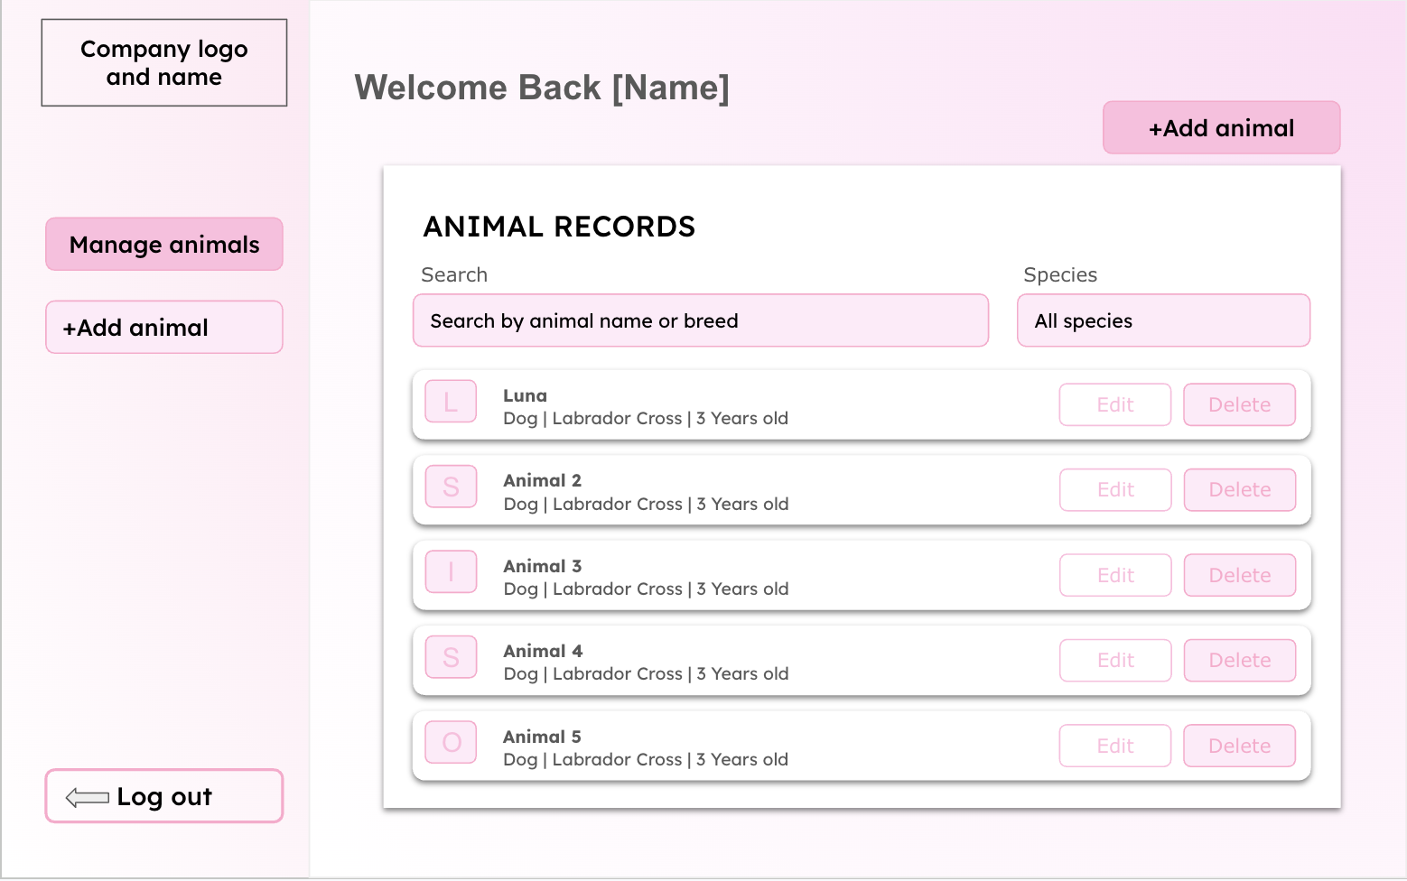

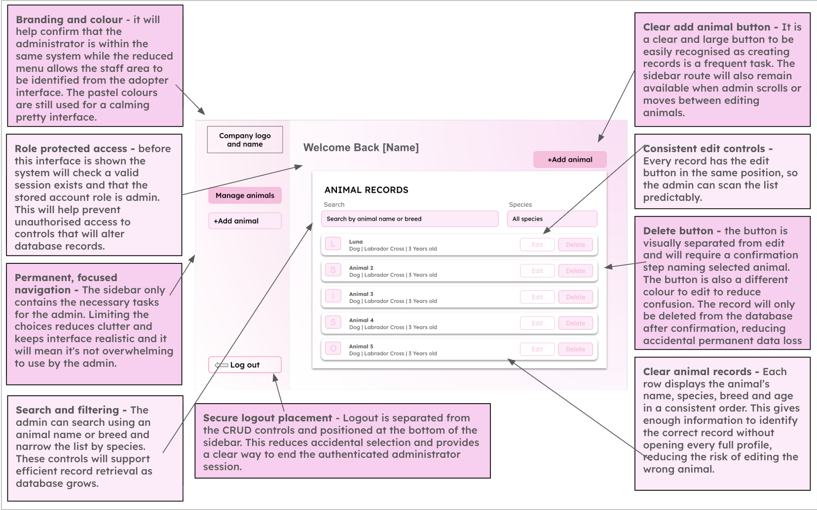
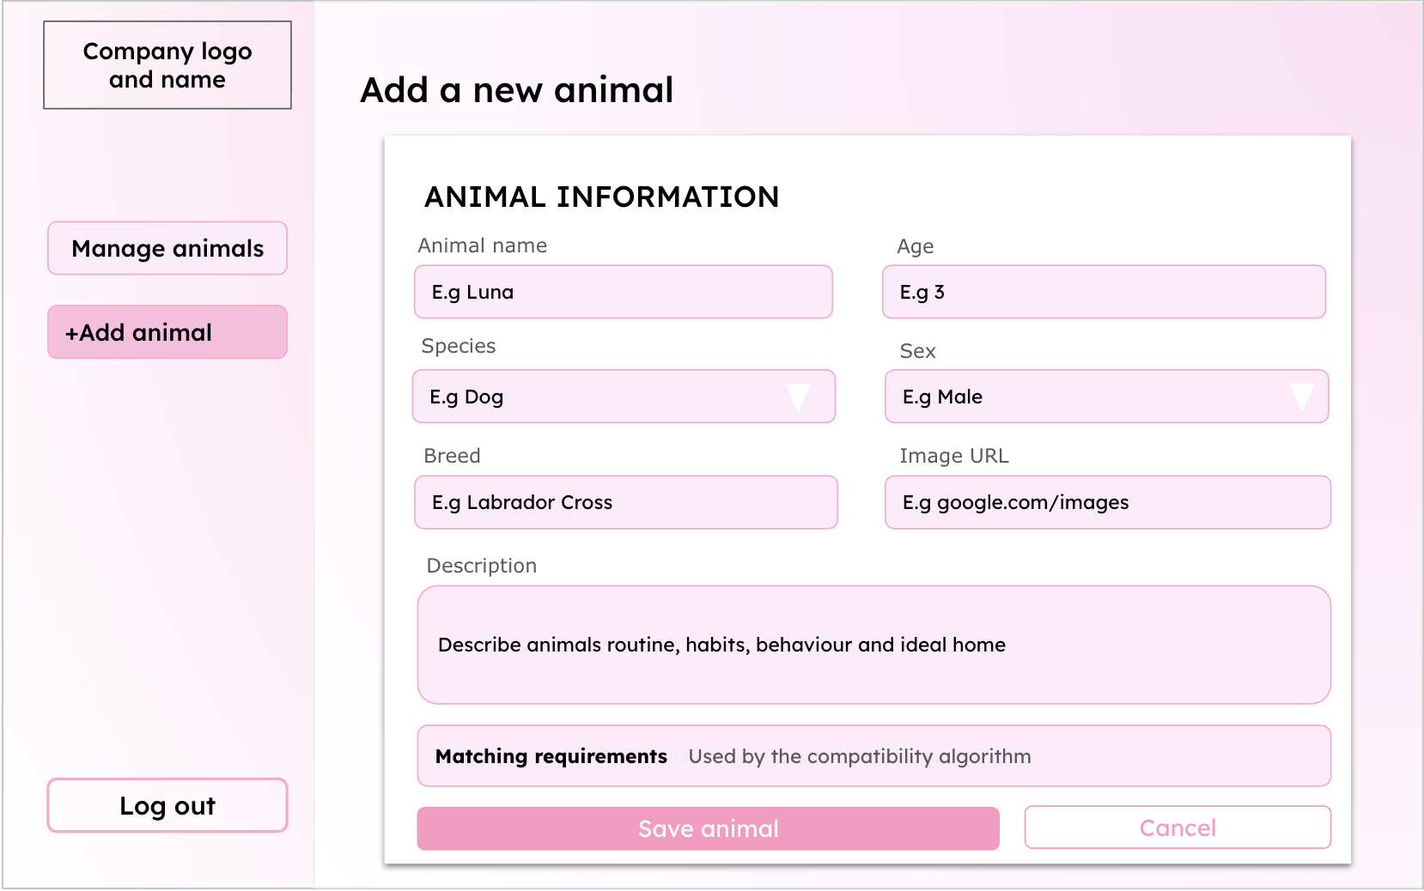

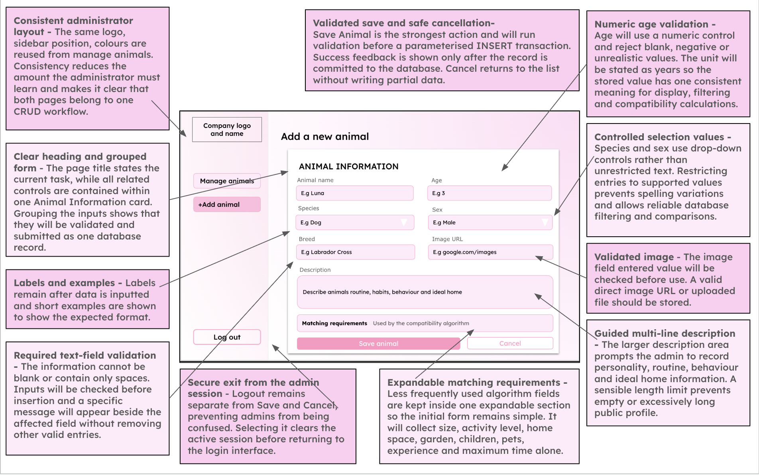
Pseudocode
[TO WRITE] Pseudocode for admin add / edit / delete animal (role check, validation of every field, parameterised INSERT / UPDATE / DELETE, delete confirmation).
Turn your flowchart on the previous page into pseudocode, using the variable names from your variables table.
Under it, one or two sentences on how this algorithm fits into the whole solution.

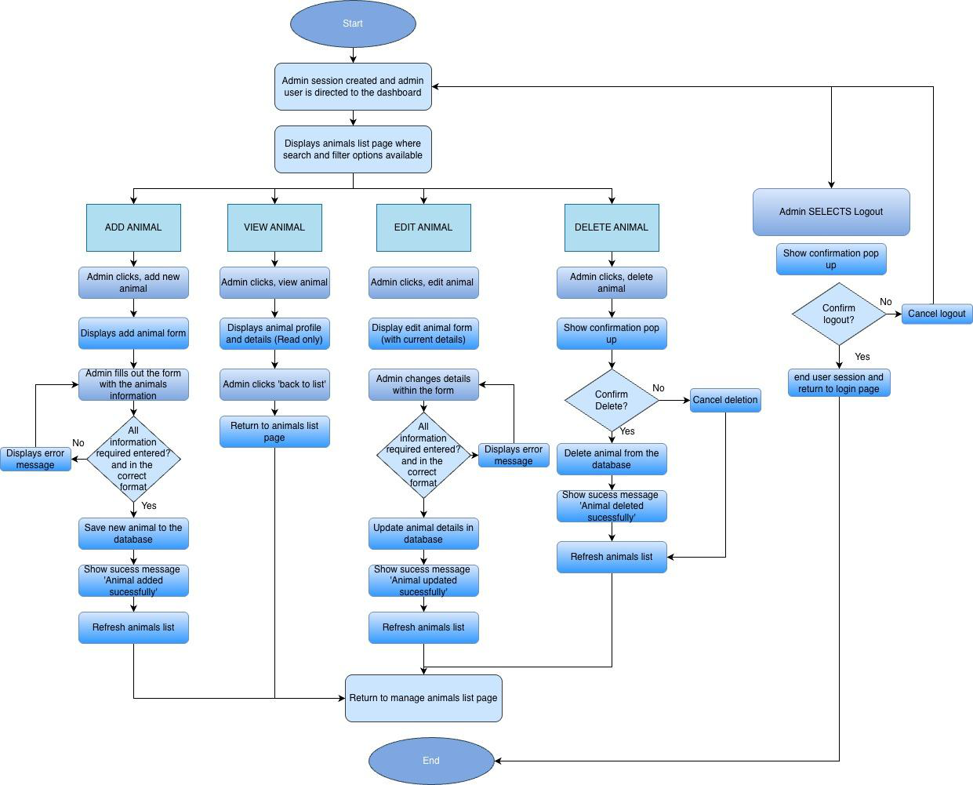
Animal Table
Field | Data type | Key/validation
animal_id | INTEGER | Primary key, autoincrement
name | TEXT | required
species | TEXT | Required - dog, cat or rabbit

breed | TEXT | Required
age | INTEGER | Required, cannot be zero
sex | TEXT | required- male, female or unknown
size | TEXT | Required - small medium or large
personality | TEXT | required
Exercise_needs | INTEGER | Required - 1 to 3
minimum_housing_level | INTEGER | Required - 1 to 3
garden_required | BOOLEAN | Required 0 or 1
child_compatible | BOOLEAN | Required 0 or 1
max_hours_left_alone | INTEGER | required
Medical_notes | TEXT | optional
image | TEXT | Required, an image path
date_added | DATE | required
Variables
Variable Name | Data Type | Purpose | Justification | Validation or e.g
animal_id | INTEGER | Uniquely identifies | A unique integer | Automatically

 |  | each animal record | stops confusion  between animals with similar names and  allows the correct to be updated and  deleted | generated
name | string | Stores the animals name | The name is required to identify the animal throughout the  interface and allows the user to remember the animal with a  specific name. A  string is suitable as it allows letters spaces and punctuation. | Can’t be blank
species | string | Stores the type of animal | Species is required for searching, filtering  and matching against user preferences. | dog, cat or rabbit
breed | string | Stores the animals breed | Breeds provides users with important  information and may help describe likely  size or care  requirements | Can't be blank or  might be ‘unknown’
age | INTEGER | Stores the animals age | Age affects care  needs. An integer is suitable as it allows the value to be  validated sorted and compared | cannot be zero
sex | string | Stores the animals sex | This is relevant profile information and may be considered by the potential adopters | male, female
size | string | Stores the animals | Size affects space | small medium or large

 |  | size and is used in filtering | requirements and is needed by the  filtering and  compatibility systems
personality | string | Stores a description of the animals  behaviour and  personality | A text field will allow the admin to explain the animals  personality and  background in more detail to help attract possible adopters | Cant be blank but a  character limit may be applied
Exercise_needs | INTEGER | Stores whether the animal has low,  medium or high  exercise needs | This can be compared with the adopters  lifestyle to produce a more appropriate  compatibility score.  An integer is  suitability for easier comparison | 1 to 3 (low medium or high)
minimum_housing_level | INTEGER | Stores the amount of living space  required | This can be compared with adopters  lifestyle to aid the  algorithm when  creating the  compatibility score | 1 to 3
garden_required | boolean | Records whether  the animal requires access to a garden | This may act as a  compulsory suitability rule. A boolean value is useful as it is  simple to input. | True or false
child_compatible | boolean | Records whether the animal is  suitable for a  household with children | There are only two  options which make boolean values  suitable. This is very important for the  safety and welfare of the children and  animals. | True or false

max_hours_left_alone | INTEGER | Stores value for  which the animal  can be left home  alone for, and  representing if more independent or  clingy | This is important if a user works long hours and the animal  requires a lot of  attention it may cause neglect of the animal which is a key issue  we are trying to  prevent. | Cant be blank
Medical_notes | string/list | Stores any medical conditions,  treatments or  special  requirements | Potential adopters  need to understand any medical needs  before making a  decision. A string will allow multiple to be described. | May be blank or ‘N/A’
image | string | Stores the location of the animals  image | This allows the  correct photo to be  displayed without  storing the full image directly in database | Must use an accepted file extension
form_action | string | Stores the operation the admin is  performing | The same form may be used for adding  and editing variables.  This variable will  allow the program to select the right query. | ‘Add’ or ‘edit’ or ‘delete’ or ‘view’
delete_confirmation | boolean | Records whether the administrator has confirmed  deletion | Deletion is permanent so confirmation  reduces risk of animal being removed  accidentally and not being considered for adoption | True or false
record_found | boolean | Records whether  the database has  retrieved the animal record successfully | This prevents the  program from  attempting to edit or delete a record not | True or false

present in the database
Validation
1.​Animal name
-​ | Presence check: Cannot be empty
-​ | Length check: Between 1 and 50 characters
-​ | Format check: Letters, spaces, apostrophes, hyphens and appropriate numbers may be
allowed
2.​Species
-​ | Presence check: Must be selected.
-​ | Lookup check: Must be Dog, Cat or Rabbit.
-​ | A drop-down menu will restrict the choices.
3.​Breed
-​ | Presence check: Cannot be empty
-​ | Length check: For example, between 2 and 50 characters
-​ | Format check: Must not consist entirely of unsupported symbols
4.​Age
-​ | Presence check: Must be provided
-​ | Type check: Must be a whole number
-​ | Range check: Cannot be negative and must be within the designed maximum animal
age
5.​Sex
-​ | Lookup check: Must be Male, Female or Unknown
-​ | A drop-down menu prevents invalid values
6.​Size
-​ | Lookup check: Must be Small, Medium or Large
7.​Personality
-​ Presence check: A description must be provided
-​ Length check: For example, between 20 and 1,000 characters
-​ Whitespace check: A value consisting only of spaces will be rejected
8.​Exercise need
-​  -​ | Presence check: An option must be selected Range check: Must be between 1 and 3

9.​Minimum housing requirement
-​ Presence check: Must be selected
-​ Range check: Must be between 1 and 3
10.​Maximum hours alone
-​ Type check: Must be an integer
-​ Range check: Must be between 0 and 24
11.​Garden required
-​ Type check: Must be stored as a Boolean value 0 or 1
12.​Child compatibility
-​ Type check: Must be stored as a Boolean value 0 or 1
13.​Medical notes
-​ This field may be optional
-​ Type check: it will have a maximum length
-​ Text will be stored as plain text rather than interpreted as code
14.​Animal image
-​ Presence check : An image must be uploaded if every profile requires one
-​ File-type check : Only approved formats such as JPG, JPEG and PNG will be accepted
-​ File-size check : The file must not exceed the chosen maximum size
-​ Filename handling : A safe, unique filename will be generated to avoid overwriting
existing images
The animal record will only be inserted after all required fields pass validation. The SQL
statement will be parameterised and committed only after successful validation. A success
message will then confirm that the record has been created.

🩷 Main Menu/INterface

Main Menu
User  Homepage/Main Menu | Will provide the main navigation area after the user logs in. It will allow the user to access the questionnaire, browse available animals and view their account. It will also explain the purpose of the adoption  matching system. It will be clear and  welcoming, and not overwhelming for the user. | The system will check the user's session to make sure they are logged in. It may retrieve the user's name and recent  questionnaire information from the  database so that personalised information can be displayed.
Interface Design
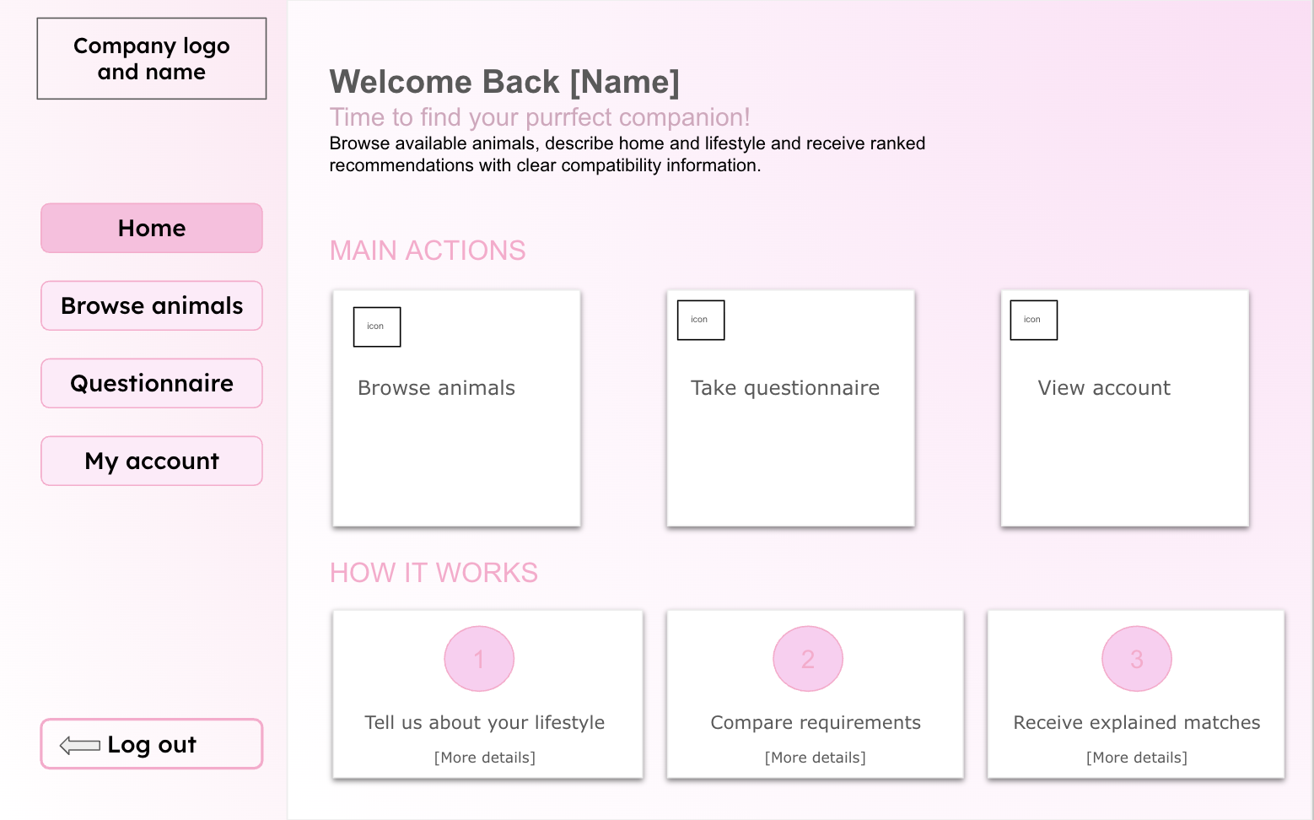

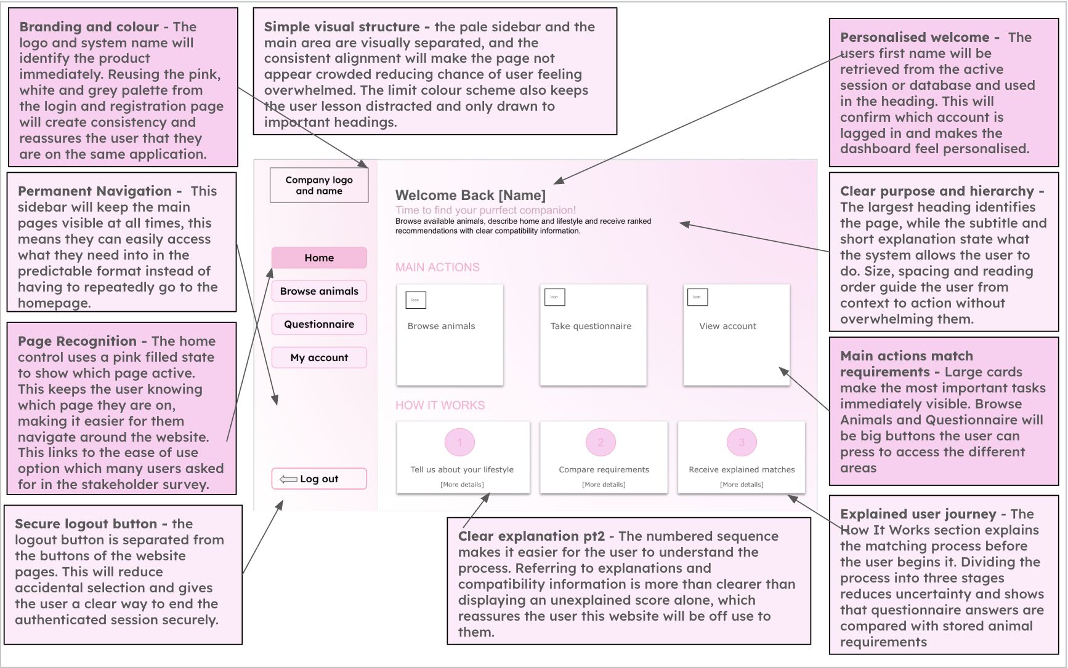
Algorithm (Flow chart, pseudocode)

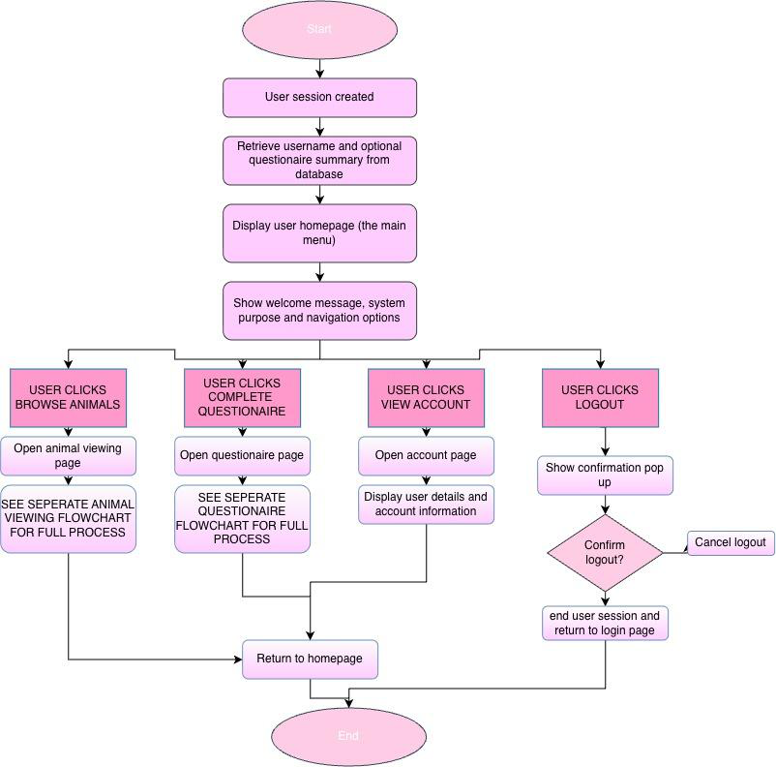
Pseudocode
[TO WRITE] Pseudocode for main menu / user homepage (session check, load user name, questionnaire completed?, show recommendations or prompt).
Turn your flowchart on the previous page into pseudocode, using the variable names from your variables table.
Under it, one or two sentences on how this algorithm fits into the whole solution.
Variables

Variable Name | Data Type | Purpose | Justification | E.g or  validation
current_user_id | INTEGER | Identifies user currently  accessing  dashboard | Ensures that the  dashboard displays information  belonging to the  correct account | Retrieved  from session
current_user_name | STRING | Stores the logged in users name | This will allow the interface to display personalised  information and  reassures user they are accessing  correct account | ‘Welcome sienna’
animal_count | INTEGER | Stores the  number of  animals currently available | It will provide a  useful summary of information on the dashboard. An  integer is a suitable data type as the  number of animals is a whole number | Must be zero or larger
questionaire_compl eted | BOOLEAN | Records whether the user has  completed the  questionnaire | This variable allows the system to  display  recommendations or prompt the user to complete the  questionnaire.  Boolean is suitable as there is only two possible states | True or False
reccomended_anim als | LIST | Stores the  animals  recommended to the users | Multiple animals  will need to be  displayed in ranked order so a list is a suitable data type | Ordered from lowest to  highest  compatibility

selected_page | STRING | Stores the page selected from  navigation menu | This allows the  program to choose which page or  section should be selected | Animals or  questionaire
notification_messag e | STRING | Stores  confirmation or status feedback | The user will need clear feedback after completing actions such as submitting questionnaire | ‘Questionaire submitted  successfully’

🩷 Animal Viewing Page

Animal Viewing Page
Animal Viewing | Allows users to browse available animals using clearly presented animal cards. Each card will show information such as the  animal name, image, species, breed and age. Users will be able to select a card to view a more detailed animal profile. | Animal records will be retrieved from the animals table. Search and filter selections will be used to change the database query or filter the retrieved records. Selecting an animal will use its unique animal ID to  load the correct profile.
Interface Design
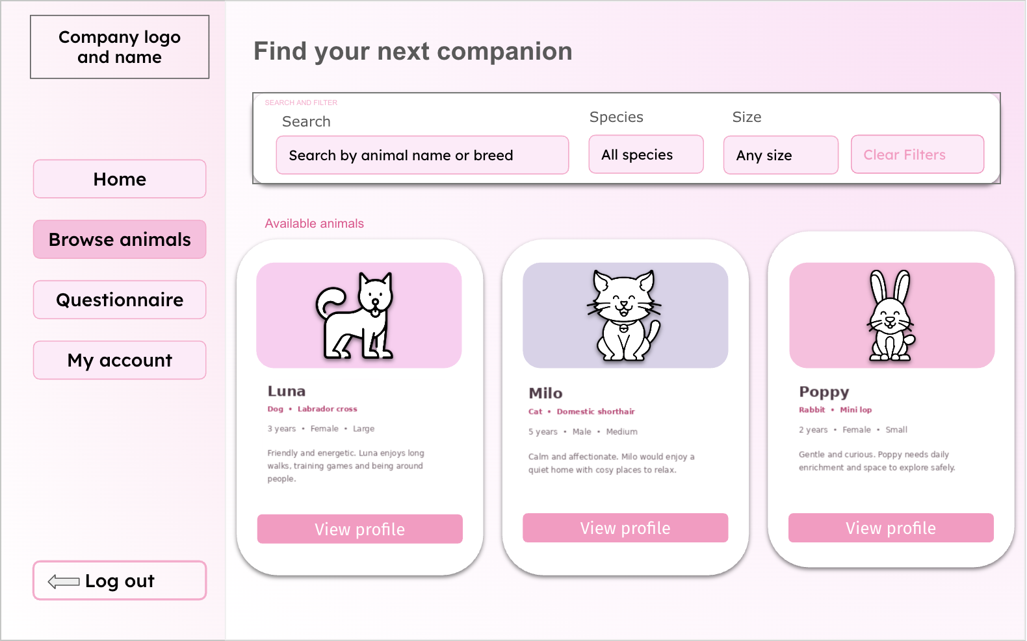

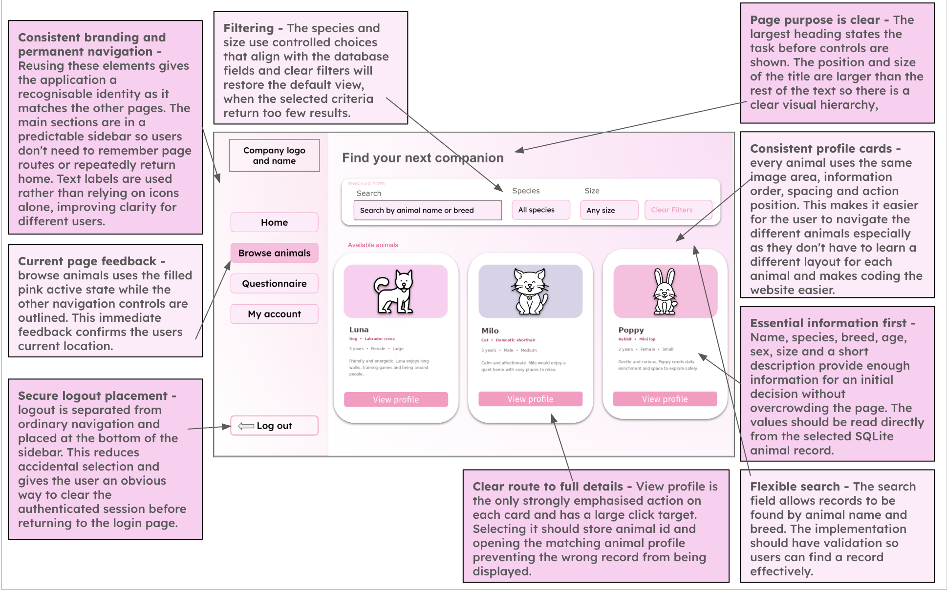
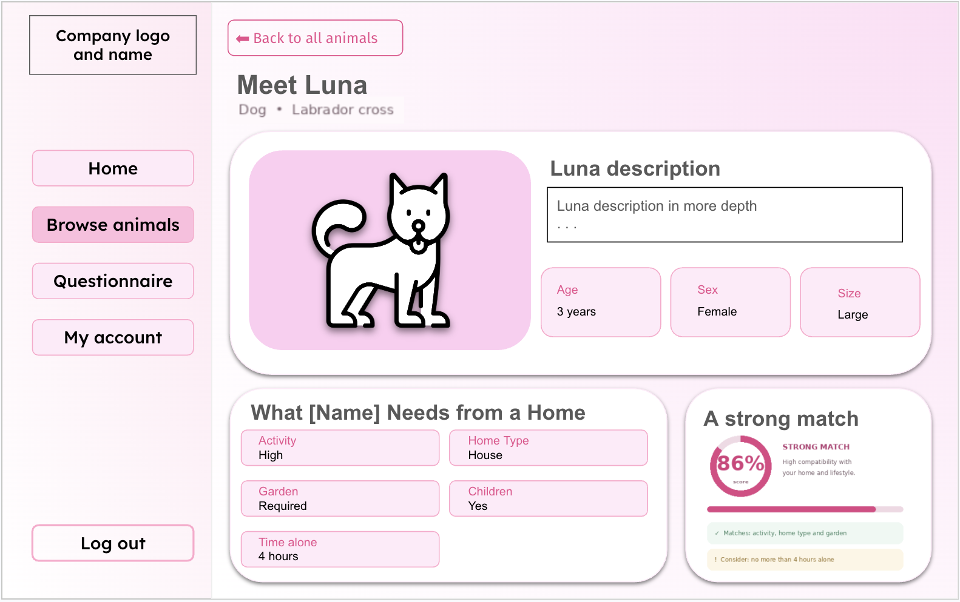

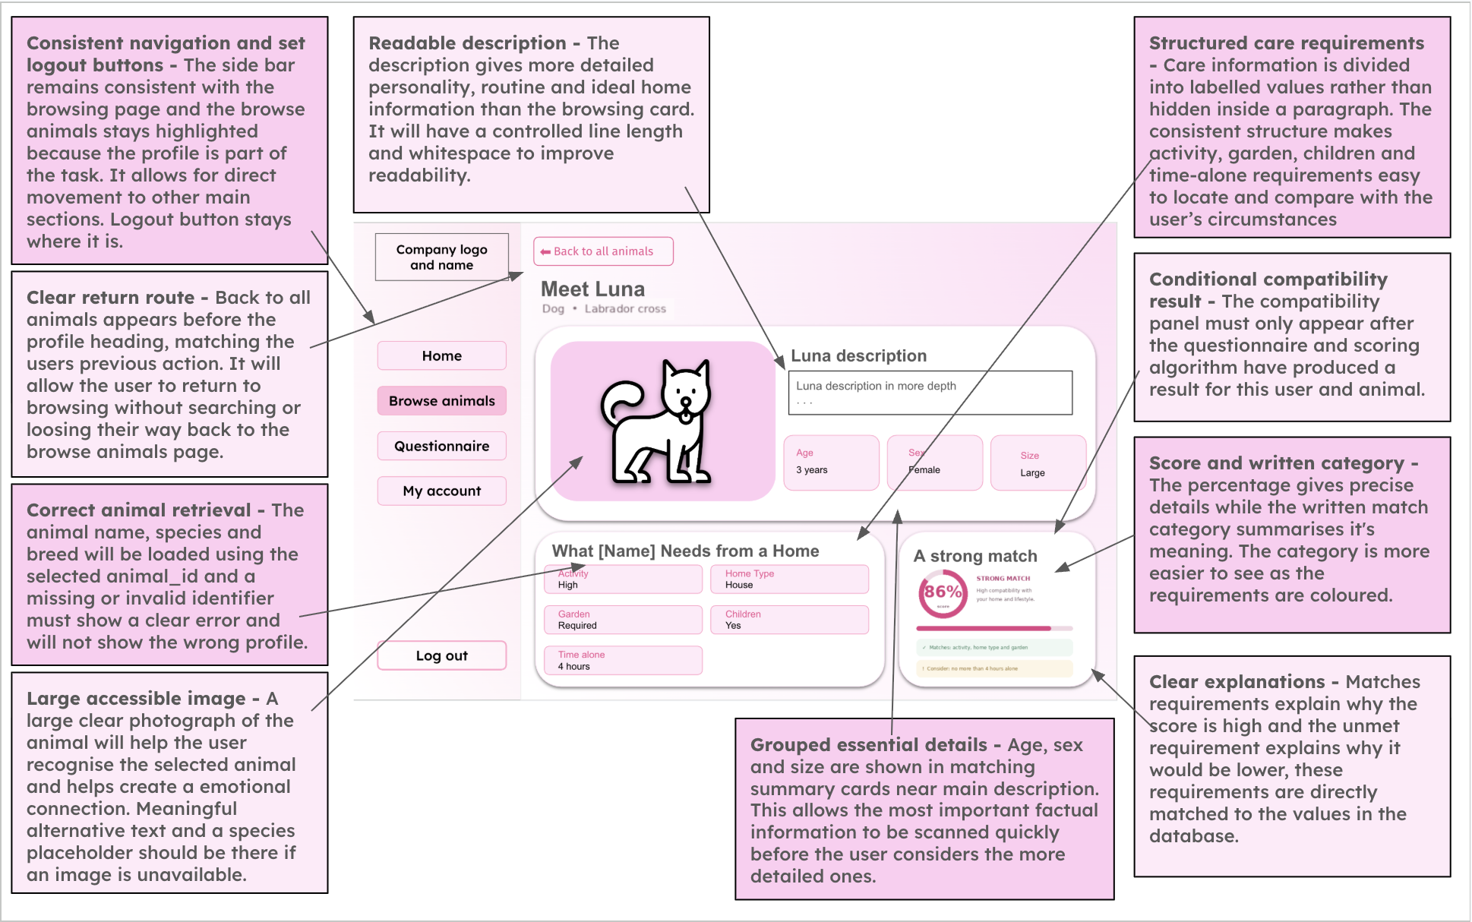
Algorithm (Flow chart, pseudocode)

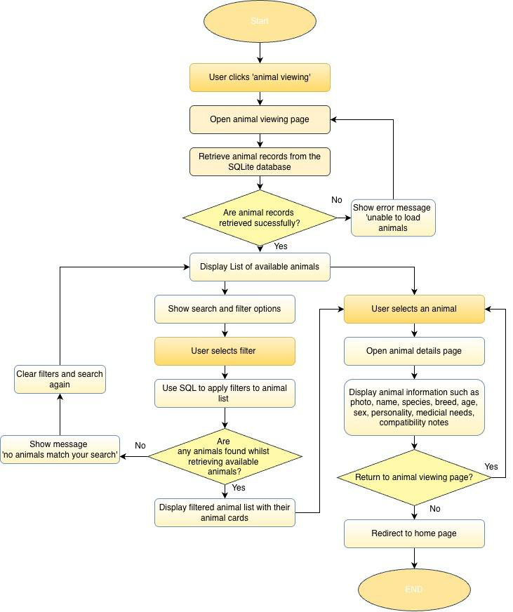
Pseudocode
[TO WRITE] Pseudocode for browse and filter animals (read search term and filters, build query, empty-results message, open profile by animal_id).
Turn your flowchart on the previous page into pseudocode, using the variable names from your variables table.
Under it, one or two sentences on how this algorithm fits into the whole solution.

Variables
Variable Name | Data Type | Purpose | Justification | E.g or validation
search_term | String | Stores text entered into the search bar | A string allows users to search using  names, breeds or  other information | Leading and trailing spaces should be  removed
species_filter | String | Filters animals by species | This is required to  reduce the displayed records to animals  matching the users chosen species | ‘Dog’, ‘cat’, ‘rabbit’ are the specified filters
size_filter | String | Filters animals by size | Size may affect  whether an animal is suitable for the users home so it is suitable for narrowing the  results | ‘Small’, ‘medium’, large’
sort_option | String | Determines the order of results | Users may wish to order the results by suitability or animal information. The  value determines  which sorting  operation is applied. | ‘Compatibility’
animal_results | list | Holds the records returned from the database | A list is suitable  because a search may return multiple animal records. It can be  iterated through to  generate animal cards on the interface | May be empty is no matching results
selected_animal_id | integer | Identifies the  animal whose  profile is opened | Using the unique id ensures the correct animal is retrieved | Must match an existing record

 |  |  | even when animals have the same name
compatibility_score | float | Displays or sorts by compatibility | A float is a more  suitable data type than an integer as it allows the result to include decimal  values, which will produce a more  precise % than an integer. | Between 0 and 100
no_results | boolean | Feedback  displayed if there is any animals  which meet the  filters | Without feedback an empty page could  appear to be an error, so the message  informs the user that they should change  the filters | ‘No animals match your search’
Validation
1.​Search input
-​ Length check: the text will not exceed 20 characters
-​ Whitespace check: leading and trailing spaces will be removed
-​ Empty input handling: an empty search will be treated as a request to display all available animals rather than as an error
2.​Filter inputs
Drop down menus or selection controls will be used for:
-​  -​ | Species
-​  -​ | -​ | Dog
-​  -​ | -​ | Cat
-​  -​ | -​ | Rabbit
-​  -​ | Size
-​  -​ | -​ | Small
-​  -​ | -​ | Medium

-​ | Large

🩷 Compatibility algorithms

Compatibility algorithm and questionnaire
Questionnaire and Recommendations | Will use a form in order to allow users to answer questions about their home, lifestyle, experience and preferences. The  questionnaire will have questions such as the housing type, access to garden, animal loneliness times, children, pets, experience, activity labels, what species and size  preferred. These questions would not appear all at one time to not overwhelm the user and the input type would be drop downs or radio buttons. After submitting the  questionnaire, the system will display  compatibility scores almost immediately and recommended animals. It will also explain requirements the user does not meet. | Responses will be validated and  compared with the requirements of each available animal. A weighted compatibility algorithm will calculate a percentage  score for every animal. The animals will then be sorted from highest to lowest  score so the top recommendations can be displayed. The questionnaire responses and match results may also be stored  within the database with the users ID
Interface Design

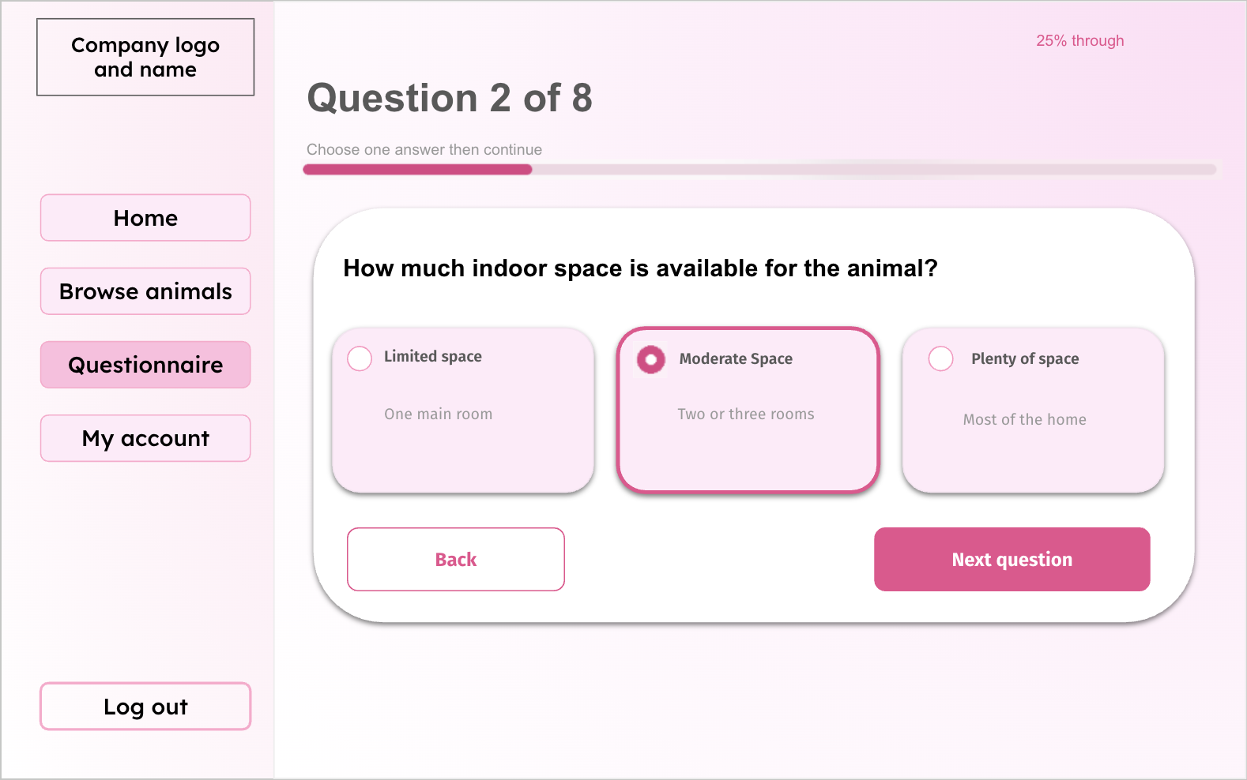
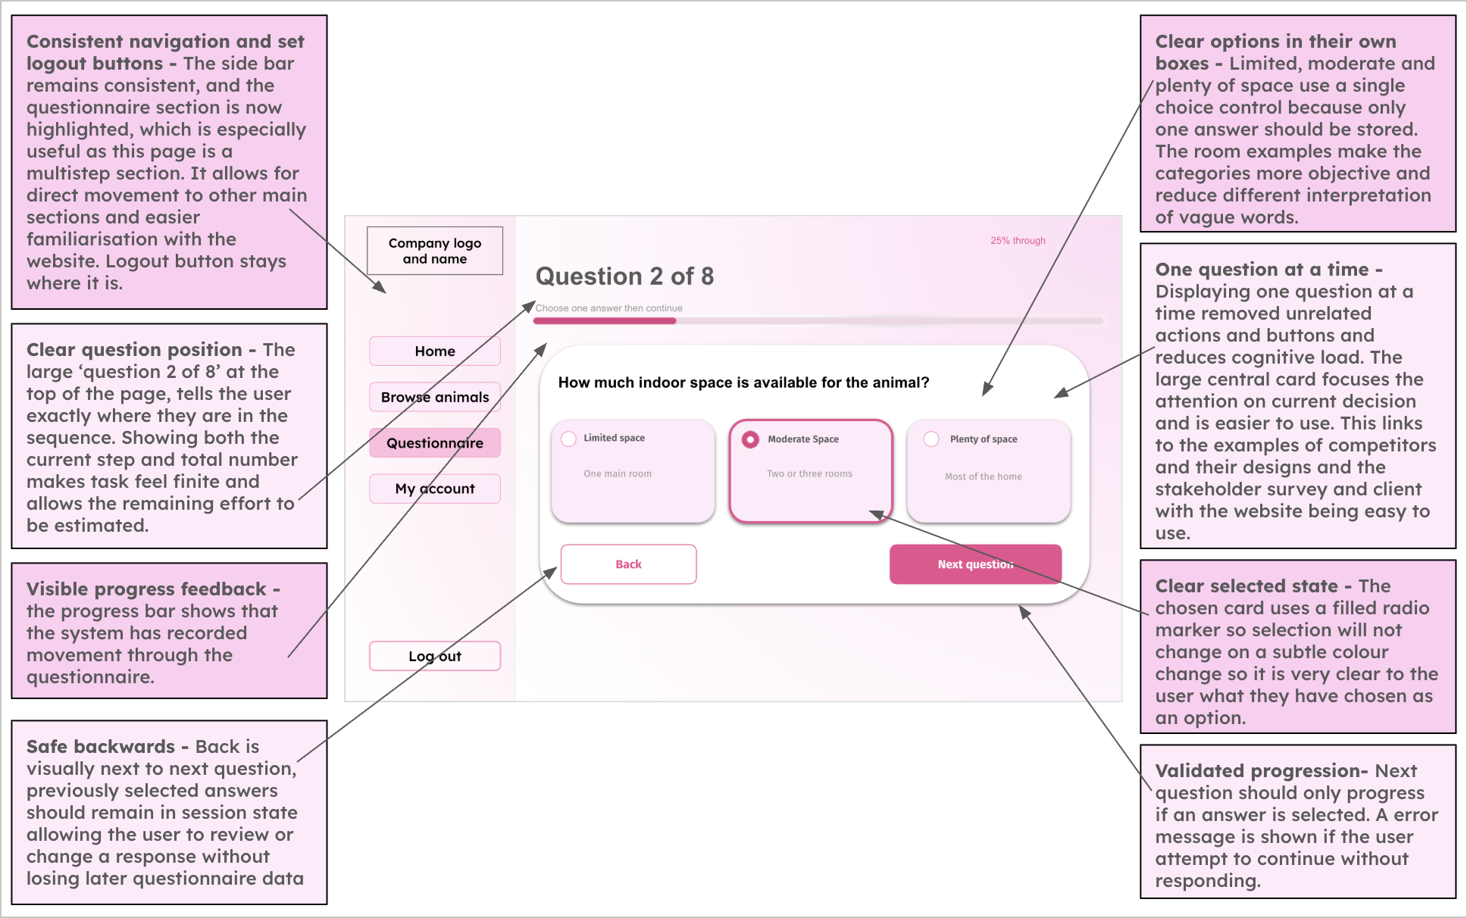

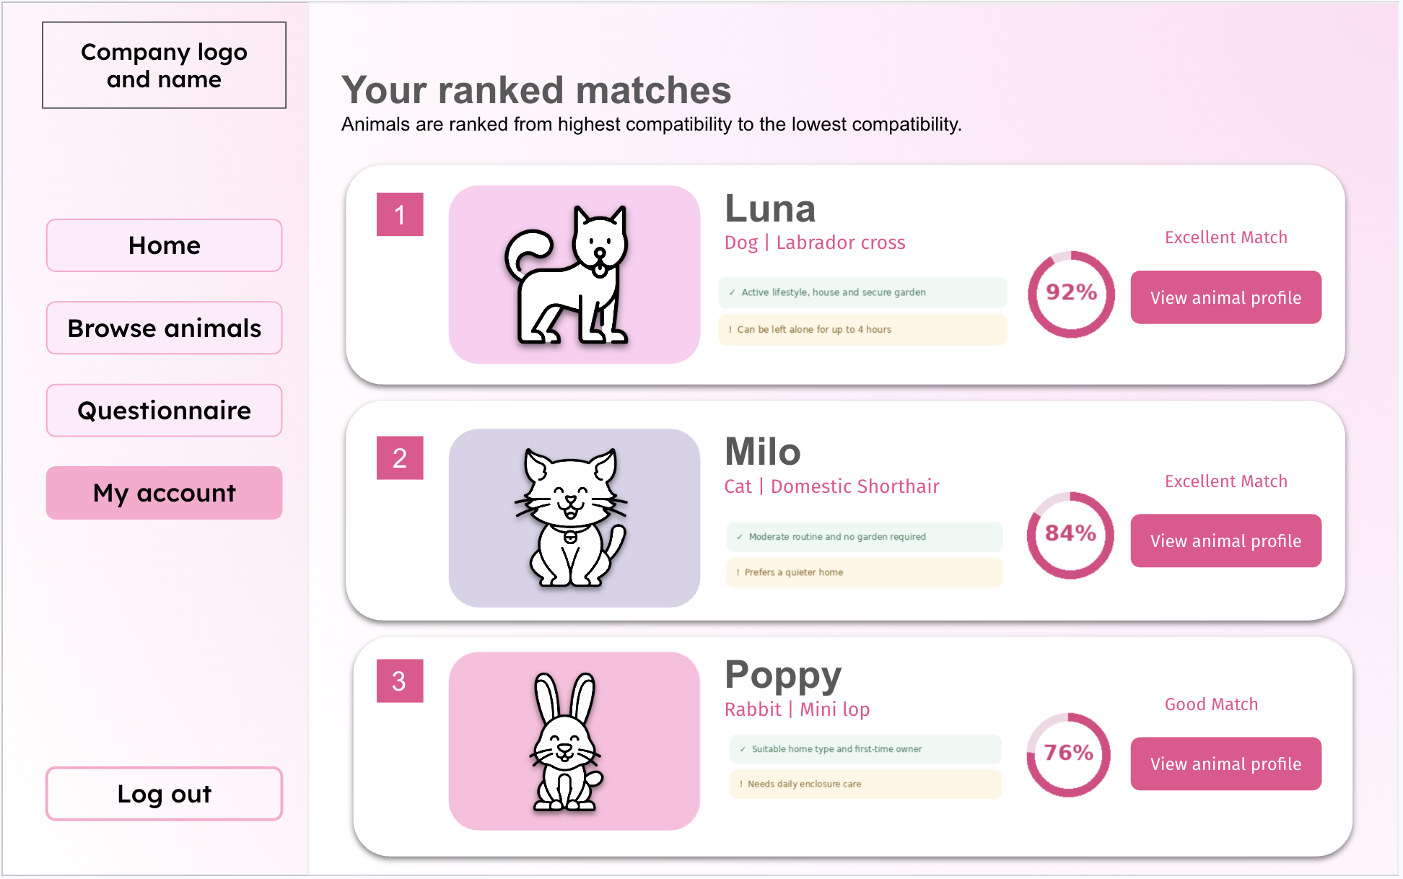
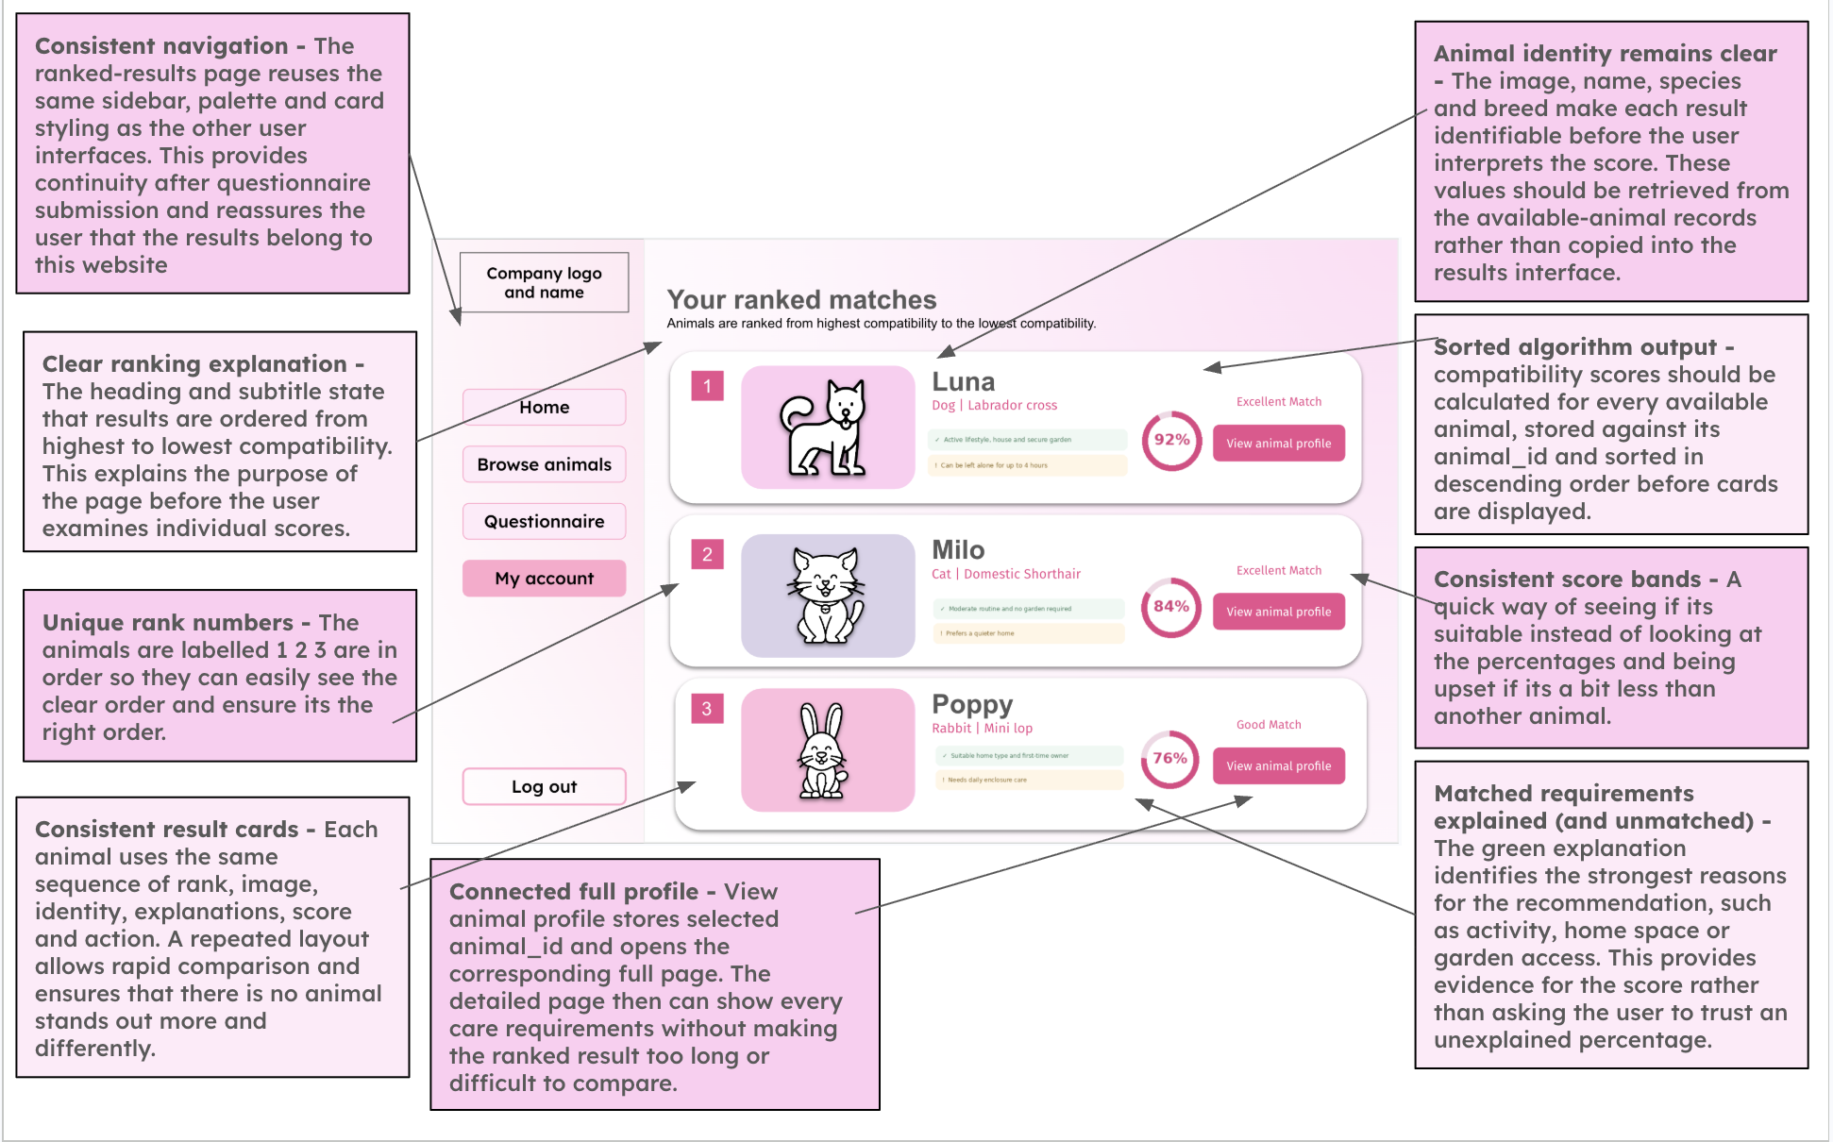

Algorithm (Flow chart, pseudocode)

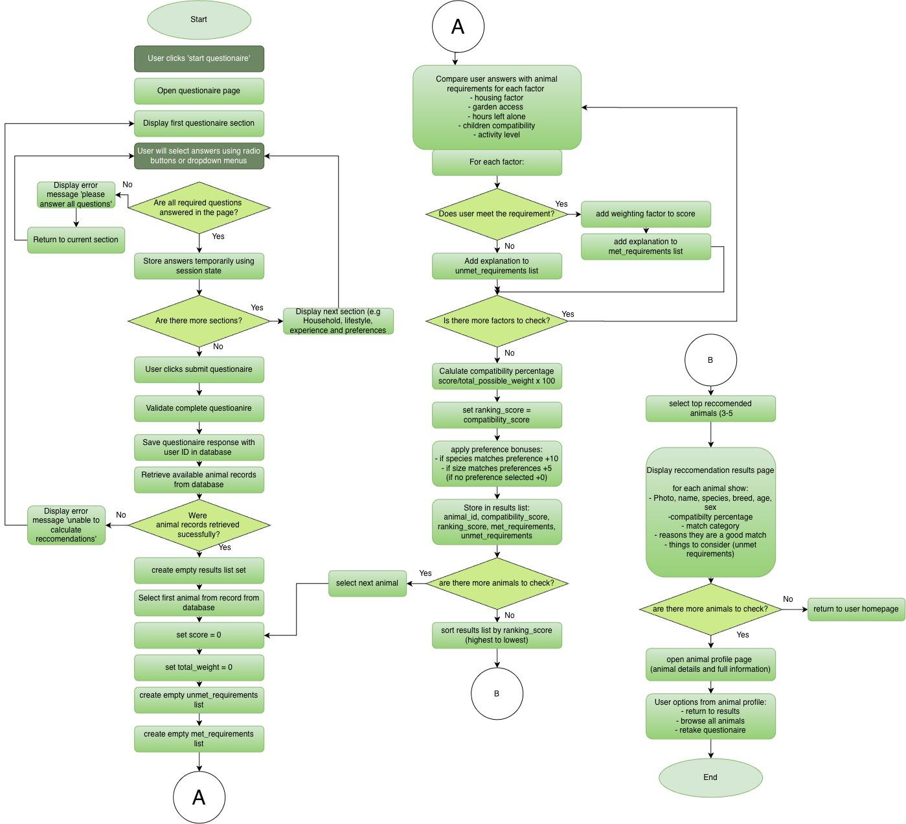
Pseudocode
[TO WRITE] Pseudocode for compatibility score (for each animal: reset total, add each weighted factor, convert to percentage, category, unmet requirements; then sort and pick top results).
Turn your flowchart on the previous page into pseudocode, using the variable names from your variables table.
Under it, one or two sentences on how this algorithm fits into the whole solution.

Validation - questionnaire
1.​Housing type or housing level
-​ | Presence check: The user must select an answer
-​ | Lookup check: The answer must be one of the permitted housing options
-​ | A radio button or drop-down will prevent unsupported values
1 = Flat or limited space
2 = Small or medium house
3 = Large house
2.​Garden access
-​ | Presence check: Yes or No must be selected
-​ | Boolean check: The stored result must be 1 or 0
3.​Hours the animal will be left alone
-​ | Presence check : a value must be provided
-​ | Type check : a whole number
-​ | Range check : between 0 and 24 hours
4.​Children in the home
-​ | Presence check: Yes or No must be selected
-​ | Boolean check: The stored result must be 1 or 0
5.​Preferred activity level
-​ | Presence check: an option must be selected
-​ | Boolean check: The stored result must be 1, 2 or 3
After
6.​Preferred species
-​ | Presence check: The user must select an answer
-​ | Lookup check: The answer must be a dog, cat, rabbit or no preference
7.​Preferred size
-​ | Presence check: The user must select an answer
-​ | Lookup check: answer must be small, medium, large or no preference
Validation is necessary within this compatibility algorithm to ensure that the recommendations produced are reliable and that invalid data does not cause incorrect results.

Questionnaire Response table
Field | Data type | Key/validation
response_id | INTEGER | Primary key, auto increment
user_id | INTEGER | Foreign key linked to Users.userid
housing_level | INTEGER | Required range 1-3
garden_access | BOOLEAN | Required 0 or 1
hours_left_alone | INTEGER | Required valid range
has_children | BOOLEAN | Required 0 or 1
preferred_activity_level | INTEGER | Required range 1 - 3
preffered_species | TEXT | Required dog, cat, rabbit or no preference
preferred_size | TEXT | Required small, medium, large or no preference
completed_at | DATE | required
Match Results Table
Field | Data type | Key/validation
match_id | INTEGER | Primary key autoincrement
response_id | INTEGER | Foreign key linked to  QuestionaireReponses.response_id
animal_id | INTEGER | Foreign key linked to animals.animal_id
compatibility_score | REAL | Required range 0 to 100
match_category | TEXT | Required strong, good, possible or low
unmet_requirements | TEXT | optional

Calculated_at | DATE | required
Adoption Questionnaire Variables
Variable Name | Data  Type | Purpose | Justification | Validation or e.g
housing_level | integer | Stores amount of living space available | The available space may affect whether or not the home is  suitable for different sizes and exercise  needs | Required range 1-3
garden_access | boolean | Records  whether user  has access to a garden | Some animals may require regular  access to an outdoor space. A boolean  value is suitable as the answer has two possible values | 0 or 1
hours_left_alone | integer | Stores how long the animal  would normally be left alone | Time availability can be numerically  compared with the animals required  attention and  exercise time | Required valid range such as 0-24
has_children | boolean | Records  whether  children live in the household | Some animals may not be suitable for  homes with children making this an  important safety  factor | 0 or 1
preferred_activity_level | integer | Stores the users preferred  animal activity | Matching activity  level helps ensure  the adopter can meet | range 1 - 3

 |  | level | the animals exercise requirements
preffered_species | string | Stores the users preferred  species | This ensures that the recommendations  remain relevant to  the type of animal  the user is interested in adopting | Required ‘dog’, ‘cat’,  ‘rabbit’ or ‘no preference’
preferred_size | string | Stores the users preferred size | The user may have  practical or personal reasons for preferring a particular size. | ‘small’, ‘medium’, ‘large’ or ‘no preference’
Compatibility scoring algorithm variable names
Variable Name | Data Type | Purpose | Justification | Validation or e.g
animal_id | integer | Stores the  unique identifier of the animal  being assessed | It ensures that each calculated score is linked to the correct animal, even when animals have the  same name | Must match an  existing record in the animals table e.g 12
maximum_score | integer | Stores the  highest possible number of  points that can be awarded by the  compatibility  algorithm | This is required so  that the user's raw  score can be  converted into a  percentage. An  integer is suitable  because the  algorithm awards  whole number points for each matching  factor. | Must be greater than 0

total_score | integer | Stores the total compatibility  points awarded for the animal  currently being assessed | The value begins at zero and increases  whenever the user's answers from the  questionnaire match an animal's  requirements. It must be reset before the  algorithm assesses the next animal. | Begins at 0 and cannot exceed  maximum_score
animal_scores | list | Stores the ID and  compatibility score for all available  animals | This will allow the results to be sorted from highest to  lowest compatibility.  A list is suitable  because the  algorithm processes multiple animals | [{"animal_id": 3, "score": 92.5},  {"animal_id": 7, "score": 78.0}]
compatibility_score | float | Stores the  calculated  compatibility percentage | A percentage is  easier for users to  understand and  compare than a raw points total, a float will allow decimal results to be stored. | Must be between  0-100 and can have decimals
match_category | string | Stores an  understandable category for the calculated score | A category makes  the numerical result easier for the user to interpret. It is  selected according to predefined  percentage ranges. | strong, good,  possible or low
unmet_requirements | list | Stores  explanations of requirements  the user did not meet | There may be several reasons why an  animal is not fully  suitable so a list will allow multiple  explanations to be  stored and displayed. | Example: "Requires a secure garden", "Not suitable with cats". It may be empty when all essential  requirements are  met.

Questionnaire Plan
Section 1: House environment
-​ Amount of living space
-​ Garden access?
Section 2:
-​ Children in the home?
Section 3:
-​ Preferred activity level / time available for exercise and care
-​ Hours the animal would be left alone
Section 4:
-​ Preferred species
-​ Preferred animal size
Section 5:
-​ Submit
Where it links
-​  -​  -​  -​  -​  -​  -​ | Amount of living space → minimum housing level Garden access → garden required  Children in the home → child compatible  Preferred activity level → exercise need  Hours left alone → maximum hours left alone Preferred species → animal species  Preferred size → animal size
First Matching part
Factor | Suggested weight (can be changed) | Justification
Hours Left alone | 20 | Strongly will affect whether the adopter can meet the animals needs

Child compatibility | 15 | Important for safety and suitability
Housing space | 15 | Ensures the home provides enough room
Activity | 12 | Matches exercise needs with users lifestyle and what they can provide
Garden access | 10 | Important for animals  requiring outdoor access, but can even use a park so not as important factor

-​  -​  -​  -​  -​  -​ | Calculate the suitability score  Remove animals with low suitability  Prioritise animals matching users preferred species  Prioritise animals matching users preferred size  Sort remaining animals by suitability score  Show top 3 or 5 (depending how many animals are in the system)

Factor | Suggested weight
Species | 10
Size | 5
However, these weights will not add to the compatibility percentage as their preferences do not reflect animal suitability. It will influence the order in which suitable animals are displayed.
This will prevent an unsuitable animal from receiving a misleading high compatibility percentage as it matches the users preferences, but still ensuring preferred animals are presented as users top choices as this will make them more inclined to adopt. If the user picks ‘no preference’ no animal will receive a bonus.

[TO WRITE] Compatibility score, exactly: your five weights total 72 points (20 + 15 + 15 + 12 + 10).
Write the formula for the percentage, say whether failing a hard rule (children, garden) makes an animal
unsuitable or only loses points, and give the percentage cut-offs for strong / good / possible / low.
Then one worked example: one adopter and two animals, scored by hand step by step (reuse it as test data).
[TO WRITE] Usability Features (new section): a table of Feature | Where it appears | Why it is included, with each reason
linked to your survey or client interview (S/Q codes), e.g. sectioned questionnaire, drop-downs instead of
free text, animal cards, error messages beside the field, the same menu on every page, calm colour scheme.
Development Test plan

Development Test Plan
[TO WRITE] Development test plan: 8 to 12 tests per component, mixing normal, boundary and invalid data.
Columns: Test no. | What is tested and why | Input data | Expected result | Type (normal / boundary / invalid).
Then a Post-Development Test Plan: one test per success criterion, plus usability tests with named stakeholders.

3 Development
[TO WRITE] Iterative development (15 marks) and testing to inform development (10 marks).
Top band: evidence of every prototype at each stage, linked to the design; well-structured modular code
annotated to help future maintenance; sensible names; validation on all key elements; review at every stage;
testing at every stage, with each failed test and its fix fully justified.

Stage 1: Database and login

Aim
[TO WRITE] What this stage builds (SQLite tables, registration, password hashing, login, logout) and which part of your Design it implements (page numbers).

Code
[TO WRITE] Screenshots of your own annotated code for this stage, with a short explanation of each key part.
Screenshot the running prototype at the end of the stage too: that is your prototype evidence.

Testing
Test no. | Description | Input | Expected | Actual | Pass / Fail | Evidence (figure)

Failed test and remedial action
Test no. | What happened | Cause | Fix made | Re-test result

Review
[TO WRITE] Who you showed it to and when, what you asked, and what they said (short interview notes).

Changes made after review
[TO WRITE] What you changed because of the review, and why.

Stage 2: Administration dashboard

Aim
[TO WRITE] What this stage builds (role check, add / edit / delete animal, image upload) and which part of your Design it implements (page numbers).

Code
[TO WRITE] Screenshots of your own annotated code for this stage, with a short explanation of each key part.
Screenshot the running prototype at the end of the stage too: that is your prototype evidence.

Testing
Test no. | Description | Input | Expected | Actual | Pass / Fail | Evidence (figure)

Failed test and remedial action
Test no. | What happened | Cause | Fix made | Re-test result

Review
[TO WRITE] Who you showed it to and when, what you asked, and what they said (short interview notes).

Changes made after review
[TO WRITE] What you changed because of the review, and why.

Stage 3: Home page and animal browsing

Aim
[TO WRITE] What this stage builds (animal cards, profile page, search, species and size filters) and which part of your Design it implements (page numbers).

Code
[TO WRITE] Screenshots of your own annotated code for this stage, with a short explanation of each key part.
Screenshot the running prototype at the end of the stage too: that is your prototype evidence.

Testing
Test no. | Description | Input | Expected | Actual | Pass / Fail | Evidence (figure)

Failed test and remedial action
Test no. | What happened | Cause | Fix made | Re-test result

Review
[TO WRITE] Who you showed it to and when, what you asked, and what they said (short interview notes).

Changes made after review
[TO WRITE] What you changed because of the review, and why.

Stage 4: Adoption questionnaire

Aim
[TO WRITE] What this stage builds (sectioned questions, validation, saving responses) and which part of your Design it implements (page numbers).

Code
[TO WRITE] Screenshots of your own annotated code for this stage, with a short explanation of each key part.
Screenshot the running prototype at the end of the stage too: that is your prototype evidence.

Testing
Test no. | Description | Input | Expected | Actual | Pass / Fail | Evidence (figure)

Failed test and remedial action
Test no. | What happened | Cause | Fix made | Re-test result

Review
[TO WRITE] Who you showed it to and when, what you asked, and what they said (short interview notes).

Changes made after review
[TO WRITE] What you changed because of the review, and why.

Stage 5: Compatibility matching and results

Aim
[TO WRITE] What this stage builds (weighted score, hard rules, sorting, top results, unmet requirements) and which part of your Design it implements (page numbers).

Code
[TO WRITE] Screenshots of your own annotated code for this stage, with a short explanation of each key part.
Screenshot the running prototype at the end of the stage too: that is your prototype evidence.

Testing
Test no. | Description | Input | Expected | Actual | Pass / Fail | Evidence (figure)

Failed test and remedial action
Test no. | What happened | Cause | Fix made | Re-test result

Review
[TO WRITE] Who you showed it to and when, what you asked, and what they said (short interview notes).

Changes made after review
[TO WRITE] What you changed because of the review, and why.

4 Testing to inform evaluation
[TO WRITE] 5 marks. Top band: annotated evidence of post-development testing for function AND robustness,
and annotated evidence of usability testing (best done with your client and stakeholders).

4.1 Function and robustness
Test no. | Success criterion | Input | Expected | Actual | Evidence (figure)

4.2 Usability testing
Tester | Task given | What happened | Rating /10 | Comment

5 Evaluation
[TO WRITE] 15 marks. Top band: use the test evidence to explain, for each success criterion, how it is fully, partly or
not met; say how partly met or unmet ones could be fixed; justify each usability feature's success;
discuss maintenance and limitations; describe how the program could be developed further.
The rows below are your nine success-criteria groups from the Analysis: add one row per requirement.

5.1 Success criteria
Criterion | Requirement | Evidence (test no.) | Met / Partly / Not met | Explanation
1 Navigation and clean interface
2 Home page
3 Animal preview page
4 Animal profile page
5 User and admin registration and login
6 Adopter questionnaire page
7 Results and recommendations page
8 Admin management page
9 Database

5.2 Usability features
[TO WRITE] For each usability feature from your Design: the evidence, whether it worked, and how to improve it.

5.3 Partly met and unmet criteria
[TO WRITE] For each one: why it was not fully met and how further development would address it.

5.4 Maintenance and limitations
[TO WRITE] How easy the system is to maintain and update, and its limitations (one shelter only, and so on).

5.5 Future development
[TO WRITE] How the program could be developed to deal with the limitations, and other improvements.

Appendix A AI use log
[NOTE] JCQ (AI Use in Assessments, from 30 April 2025): name the tool and date of every AI use, keep a non-editable
copy (screenshot or PDF) of prompts and answers, and say how you used them. AI-produced work is not credited
as yours even when acknowledged. Check with your teacher what the school allows.
Date | Tool | What I asked | What I used | Where in the project | Screenshot

Appendix B References
[TO WRITE] Copy your references list from the end of the Analysis here, plus any sources used in later sections.

