0x03. C - Debugging

**CDebugging**

* By: Carrie Ybay
* Weight: 1
* Project over - took place from Sep 12, 2022 6:00 AM to Sep 16, 2022 6:00 AM
* An auto review will be launched at the deadline

In a nutshell…

* **Auto QA review:** 7.0/40 mandatory
* **Altogether:**  **17.5%**
  + Mandatory: 17.5%
  + Optional: no optional tasks

Resources

**Read or watch:**

* [Debugging](https://intranet.alxswe.com/rltoken/faGcpiJiejHH6GhqpmbhUw)
* [Rubber Duck Debugging](https://intranet.alxswe.com/rltoken/RaecqJBNkmZ92vLMpNDuGg)

Debugging is the process of finding and fixing errors in software that prevents it from running correctly. As you become a more advanced programmer and an industry engineer, you will learn how to use debugging tools such as gdb or built-in tools that IDEs have. However, it’s important to understand the concepts and processes of debugging manually.

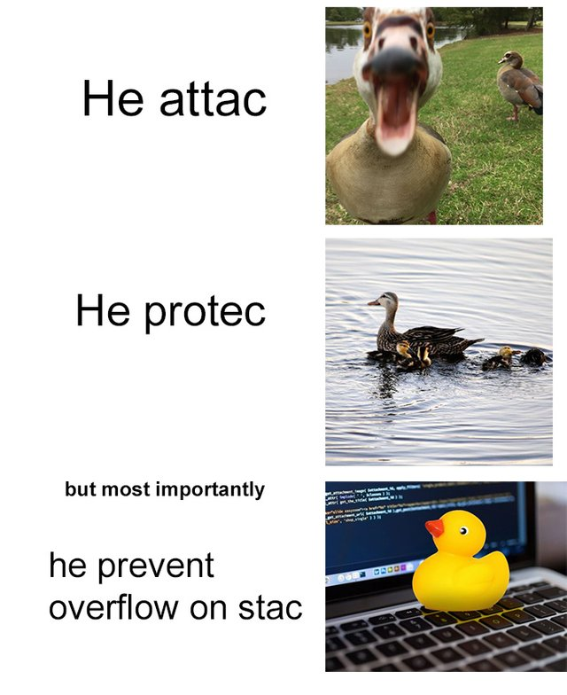

Learning Objectives

At the end of this project, you are expected to be able to [explain to anyone](https://intranet.alxswe.com/rltoken/b8uX1nIy0A55tWVlIRTaHQ), without the help of Google:

General

* What is debugging
* What are some methods of debugging manually
* How to read the error messages

Copyright - Plagiarism

* You are tasked to come up with solutions for the tasks below yourself to meet with the above learning objectives.
* You will not be able to meet the objectives of this or any following project by copying and pasting someone else’s work.
* You are not allowed to publish any content of this project.
* Any form of plagiarism is strictly forbidden and will result in removal from the program.

Requirements

General

* Allowed editors: vi, vim, emacs
* All your files will be compiled on Ubuntu 20.04 LTS using gcc, using the options -Wall -Werror -Wextra -pedantic -std=gnu89
* All your files should end with a new line
* Your code should use the Betty style. It will be checked using betty-style.pl and betty-doc.pl
* A README.md file at the root of the repo, containing a description of the repository
* A README.md file, at the root of the folder of this project (i.e. 0x03-debugging), describing what this project is about

Quiz questions

**Great!** You've completed the quiz successfully! Keep going! (Show quiz)

Tasks

0. Multiple mains

**mandatory**

Score: 0.0% (*Checks completed: 0.0%*)

In most projects, we often give you only one main file to test with. For example, this main file is a test for a postitive_or_negative() function similar to the one you worked with in [an earlier C project](https://intranet.alxswe.com/rltoken/lKcOFkG-GCivSDXgWgld2g):

carrie@ubuntu:/debugging$ cat main.c

#include "main.h"

/**

* main - tests function that prints if integer is positive or negative

* Return: 0

*/

int main(void)

{

int i;

i = 98;

positive_or_negative(i);

return (0);

}

carrie@ubuntu:/debugging$

carrie@ubuntu:/debugging$ cat main.h

#ifndef MAIN_H

#define MAIN_H

#include <stdio.h>

void positive_or_negative(int i);

#endif /* MAIN_H */

carrie@ubuntu:/debugging$

carrie@ubuntu:/debugging$ gcc -Wall -pedantic -Werror -Wextra -std=gnu89 positive_or_negative.c main.c

carrie@ubuntu:/debugging$ ./a.out

98 is positive

carrie@ubuntu:/debugging$

Based on the main.c file above, create a file named 0-main.c. This file must test that the function positive_or_negative() gives the correct output when given a case of 0.

You are not coding the solution / function, you’re just testing it! However, you can adapt your function from [0x01. C - Variables, if, else, while - Task #0](https://intranet.alxswe.com/rltoken/lKcOFkG-GCivSDXgWgld2g) to compile with this main file to test locally.

* You only need to upload 0-main.c and main.h for this task. We will provide our own positive_or_negative() function.
* You are not allowed to add or remove lines of code, you may change only **one** line in this task.

carrie@ubuntu:/debugging$ gcc -Wall -pedantic -Werror -Wextra -std=gnu89 positive_or_negative.c 0-main.c -o 0-main

carrie@ubuntu:/debugging$ ./0-main

0 is zero

carrie@ubuntu:/debugging$ wc -l 0-main.c

16 1-main.c

carrie@ubuntu:/debugging$

**Repo:**

* GitHub repository: alx-low_level_programming
* Directory: 0x03-debugging
* File: 0-main.c, main.h

 Done? Help Check your code Ask for a new correction QA Review

1. Like, comment, subscribe

**mandatory**

Score: 77.78% (*Checks completed: 77.78%*)

Copy this main file. Comment out (don’t delete it!) the part of the code that is causing the output to go into an infinite loop.

* Don’t add or remove any lines of code, as we will be checking your line count. You are only allowed to comment out existing code.
* You do not have to compile with -Wall -Werror -Wextra -pedantic for this task.

carrie@ubuntu:/debugging$ cat 1-main.c

#include <stdio.h>

/**

* main - causes an infinite loop

* Return: 0

*/

int main(void)

{

int i;

printf("Infinite loop incoming :(\n");

i = 0;

while (i < 10)

{

putchar(i);

}

printf("Infinite loop avoided! \\o/\n");

return (0);

}

carrie@ubuntu:/debugging$

Your output should look like this:

carrie@ubuntu:/debugging$ gcc -std=gnu89 1-main.c -o 1-main

carrie@ubuntu:/debugging$ ./1-main

Infinite loop incoming :(

Infinite loop avoided! \o/

carrie@ubuntu:/debugging$ wc -l 1-main.c

24 1-main.c

carrie@ubuntu:/debugging$

**Repo:**

* GitHub repository: alx-low_level_programming
* Directory: 0x03-debugging
* File: 1-main.c

 Done? Help Check your code Ask for a new correction Get a sandbox QA Review

2. 0 > 972?

**mandatory**

Score: 0.0% (*Checks completed: 0.0%*)

This program prints the largest of three integers.

carrie@ubuntu:/debugging$ cat 2-main.c

#include <stdio.h>

#include "main.h"

/**

* main - prints the largest of 3 integers

* Return: 0

*/

int main(void)

{

int a, b, c;

int largest;

a = 972;

b = -98;

c = 0;

largest = largest_number(a, b, c);

printf("%d is the largest number\n", largest);

return (0);

}

carrie@ubuntu:/debugging$

carrie@ubuntu:/debugging$ cat 2-largest_number.c

#include "main.h"

/**

* largest_number - returns the largest of 3 numbers

* @a: first integer

* @b: second integer

* @c: third integer

* Return: largest number

*/

int largest_number(int a, int b, int c)

{

int largest;

if (a > b && b > c)

{

largest = a;

}

else if (b > a && a > c)

{

largest = b;

}

else

{

largest = c;

}

return (largest);

}

carrie@ubuntu:/debugging$

carrie@ubuntu:/debugging$ gcc -Wall -Werror -Wextra -pedantic -std=gnu89 2-largest_number.c 2-main.c -o 2-main

carrie@ubuntu:/debugging$ ./2-main

0 is the largest number

carrie@ubuntu:/debugging$

? That’s definitely not right.

Fix the code in 2-largest_number.c so that it correctly prints out the largest of three numbers, no matter the case.

* Line count will not be checked for this task.

**Repo:**

* GitHub repository: alx-low_level_programming
* Directory: 0x03-debugging
* File: 2-largest_number.c, main.h

 Done? Help Check your code Ask for a new correction Get a sandbox QA Review

3. Leap year

**mandatory**

Score: 0.0% (*Checks completed: 0.0%*)

This program converts a date to the day of year and determines how many days are left in the year, taking leap year into consideration.

carrie@ubuntu:/debugging$ cat 3-main_a.c

#include <stdio.h>

#include "main.h"

/**

* main - takes a date and prints how many days are left in the year, taking

* leap years into account

* Return: 0

*/

int main(void)

{

int month;

int day;

int year;

month = 4;

day = 01;

year = 1997;

printf("Date: %02d/%02d/%04d\n", month, day, year);

day = convert_day(month, day);

print_remaining_days(month, day, year);

return (0);

}

carrie@ubuntu:/debugging$

carrie@ubuntu:/debugging$ cat 3-convert_day.c

#include "main.h"

/**

* convert_day - converts day of month to day of year, without accounting

* for leap year

* @month: month in number format

* @day: day of month

* Return: day of year

*/

int convert_day(int month, int day)

{

switch (month)

{

case 2:

day = 31 + day;

break;

case 3:

day = 59 + day;

break;

case 4:

day = 90 + day;

break;

case 5:

day = 120 + day;

break;

case 6:

day = 151 + day;

break;

case 7:

day = 181 + day;

break;

case 8:

day = 212 + day;

break;

case 9:

day = 243 + day;

break;

case 10:

day = 273 + day;

break;

case 11:

day = 304 + day;

break;

case 12:

day = 334 + day;

break;

default:

break;

}

return (day);

}

carrie@ubuntu:/debugging$

carrie@ubuntu:/debugging$ cat 3-print_remaining_days.c

#include <stdio.h>

#include "main.h"

/**

* print_remaining_days - takes a date and prints how many days are

* left in the year, taking leap years into account

* @month: month in number format

* @day: day of month

* @year: year

* Return: void

*/

void print_remaining_days(int month, int day, int year)

{

if ((year % 4 == 0 || year % 400 == 0) && !(year % 100 == 0))

{

if (month >= 2 && day >= 60)

{

day++;

}

printf("Day of the year: %d\n", day);

printf("Remaining days: %d\n", 366 - day);

}

else

{

if (month == 2 && day == 60)

{

printf("Invalid date: %02d/%02d/%04d\n", month, day - 31, year);

}

else

{

printf("Day of the year: %d\n", day);

printf("Remaining days: %d\n", 365 - day);

}

}

}

carrie@ubuntu:/debugging$

carrie@ubuntu:/debugging$ gcc -Wall -Werror -Wextra -pedantic -std=gnu89 3-convert_day.c 3-print_remaining_days.c 3-main_a.c -o 3-main_a

carrie@ubuntu:/debugging$ ./3-main_a

Date: 04/01/1997

Day of the year: 91

Remaining days: 274

carrie@ubuntu:/debugging$

Output looks good for 04/01/1997! Let’s make a new main file 3-main_b.c to try a case that is a leap year: 02/29/2000.

carrie@ubuntu:/debugging$ gcc -Wall -Werror -Wextra -pedantic -std=gnu89 3-convert_day.c 3-print_remaining_days.c 3-main_b.c -o 3-main_b

carrie@ubuntu:/debugging$ ./3-main_b

Date: 02/29/2000

Invalid date: 02/29/2000

carrie@ubuntu:/debugging$

? That doesn’t seem right.

Fix the print_remaining_days() function so that the output works correctly for *all* dates and *all* leap years.

* Line count will not be checked for this task.
* You can assume that all test cases have valid months (i.e. the value of month will never be less than 1 or greater than 12) and valid days (i.e. the value of day will never be less than 1 or greater than 31).
* You can assume that all test cases have valid month/day combinations (i.e. there will never be a June 31st or November 31st, etc.), but not all month/day/year combinations are valid (i.e. February 29, 1991 or February 29, 2427).

**Repo:**

* GitHub repository: alx-low_level_programming
* Directory: 0x03-debugging
* File: 3-print_remaining_days.c, main.h

 Done? Help Check your code Ask for a new correction