### TITLE: Re:Voxels

Revison: 0 by: Sietse Houkes

### 1. Game Overview

* **Title: Re:Voxels**
* **Genre:** RPG, openworld
* **Platform(s):** PC/Laptop
* **Target Audience:** 16 and older
* **Art Style:** Low poly and colorfull
* **USP:** The procedurally generated terrain with random structur placement and world items.
* **Game Summary:**  
  The game is a openworld game with procedurally generated terrain wich is always random. he world is highly interactive: **objects can be broken**, and **items can be dropped, collected, or used** as part of the player's progression.

### 2. Core Gameplay

* **Game Loop:**  
  What the player does repeatedly (e.g., mine resources → upgrade tools → explore deeper).
* **Mechanics:**
  + Walking
  + Running
  + Jumping
  + Crouching
  + Proning
  + Collecting resources
  + Destroying Objects
* **Controls:**  
  Controls for keybord:
  + WASD: movement in forward left backwards and right
  + Spacebar: jumping
  + C: crouching
  + CTRL: Proning
  + E: Opening/Closing inventory
* **Camera:** 
  + **The players camera will be third-person but can also switch to first person.**
    - ****Enemies:****
  + ****Classes:** Standart enemy, fast enemy**
  + ****Types:** Different types of enemies, example: slimes, wolfs etc.**
  + ****Behavior:** Some enemies are passive when the player gets near, But others are aggressive when the player gets near them.**

### 2.1 Menu Flow

* **Main Menu**
  + **The player will start in a menu with a few option, starting the game, settings menu and quit the game.**
* ****Game Menu****
  + **While playing the game, the player can pause the game and go to settings, go to the main menu or quit the game.**
    - ****Death screen****
  + **When the player dies they can quit to the main menu or respawn.**

### 2.2 Mission Objectives

* **Waypoints**
  + **For the first mission the player will get a icon on the compass to find the closest objective item, after this first mission is complete the player will only get mission waypoints.**

### 3. Art & Audio

* **Art Style:** The art style of the world and objects will be lowpoly, with a more realistic skybox and sun.
* **Visual Inspirations:** The looks will be based on: Gedonia, Zelda, MUCK.

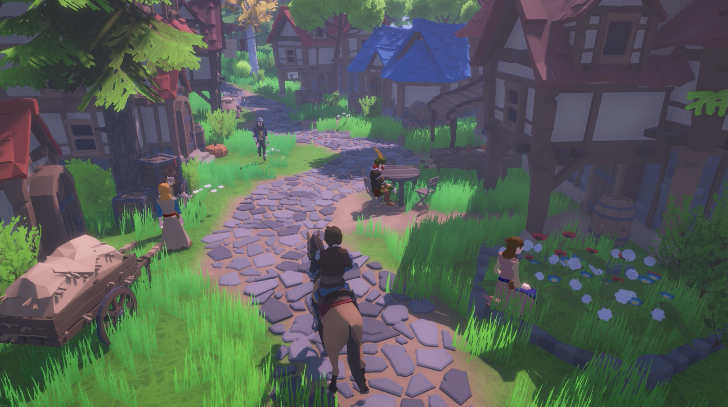

* **Sound Design:**
  + Not a feature TBD

### 4. Levels / Progression

* **Level Structure:** open-world, procedural
* **Progression System:** TBD

### 5. UI / UX

* **HUD Elements:** The HUD will include health and stamina of the player, the player will also be able to see the health of mobs that are nearby, and the health of objects when punched.
* **Menus:** The game will include a main menu, a settings menu and a death screen.
* **Inspiration:** Elden ring and souls like games but lowpoly.

### 6. Technical

* **Engine:** Unity engine version: 2022.3.61f1
* **Key Tools / Plugins: Jetbrain Rider IDE version 2025.1.1**
* **Save System:** For inventory, seed map and player location and stats we will be using JSON

vvvvvvvvvvvvvvvvvvvvvvvvvvvvvvvvvvvvvvvvvvvvvvvvvvvvvvvvvvvvvvv

* **Minimum required specs:**

|  |  |  |  |  |
| --- | --- | --- | --- | --- |
| **Operating system** | **Operating system version** | **CPU** | **Graphics API** | **Additional requirements** |
| **Windows** | Windows 10 version 21H1 (build 19043) or newer | x86, x64 architecture with SSE2 instruction set support, Arm64 | DX10, DX11, DX12 or Vulkan capable GPUs | Hardware vendor officially supported drivers For development: IL2CPP scripting backend requires Visual Studio 2019 with C++ Tools component or later and Windows SDK version 10.0.19041.0 or newer |
| **Universal Windows Platform** | Windows 10 version 21H1 (build 19043) or newer, Xbox One, Xbox Series X and Series S, HoloLens | x86, x64 architecture with SSE2 instruction set support, Arm, Arm64 | DX10, DX11, DX12 capable GPUs | Hardware vendor officially supported drivers. For development: Visual Studio 2019 with C++ Tools component or later and Windows SDK version 10.0.19041.0 or newer. |
| **macOS** | Big Sur 11 or newer | Apple Silicon, x64 architecture with SSE2 | Metal capable Intel and AMD GPUs | Apple officially supported drivers. For development: IL2CPP scripting backend requires Xcode. |
| **Linux** | Ubuntu 22.04, Ubuntu 24.04 | x64 architecture with SSE2 instruction set support  **Note:** Desktop Linux supports only 64-bit architecture. | OpenGL 3.2+, Vulkan capable GPUs | Gnome desktop environment running on top of X11 or Wayland windowing system. Other configuration and user environment as provided stock with the supported distribution (such as Kernel or Compositor) Nvidia and AMD GPUs using Nvidia official proprietary graphics driver, or AMD Mesa graphics driver.  **Notes:**  • **Ubuntu 22.04:** Wayland is supported with AMD graphics cards.  • **Ubuntu 24.04:** Wayland is supported with AMD graphics cards and Nvidia graphics cards utilizing Nvidia proprietary graphics drivers 550 and above. |