Overview
This document will help you to setup and demonstrate Jenkins Groovy Pipeline and use Trivy tool to scan for security as a part of the continues integration (CI).
This also demonstrates the CI flow (automatically trigger the CI flow when there is a code change is pushed to the Application code).
Prerequisites
- A virtual machine is provisioned with the Jenkins, Docker, Trivy installed.
- You are required to configure the Jenkins. Please refer to this guide https://www.cherryservers.com/blog/how-to-install-jenkins-on-ubuntu-22-04 (starts from step #6: Set up Jenkins). While setup the Jenkins, please make sure the plugins below get installed:
  - Jenkins suggested plugins
  - Docker PipelineVersion
  - Pipeline Utility Steps
  - HTML Publisher
- An Azure Container Registry (ACR) is provisioned.
Works details
- Setup Jenkins Organization project
Login to the Jenkins (i.e. http://172.173.112.179:8080/)
- Step 1: Configure GitHub Enterprise Servers
  - Go to Manage Jenkins -> System -> GitHub Enterprise Servers
  - Add a new GitHub Enterprise Servers as below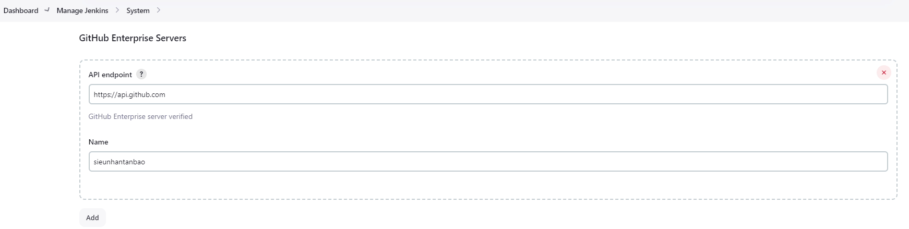
    - API endpoint: https://api.github.com
    - Name: <your GitHub account name>
- Step 2: Configure Global Pipeline Libraries
  - Go to Manage Jenkins -> System -> Global Pipeline Libraries
  - Add a new Global Pipeline Libraries as below 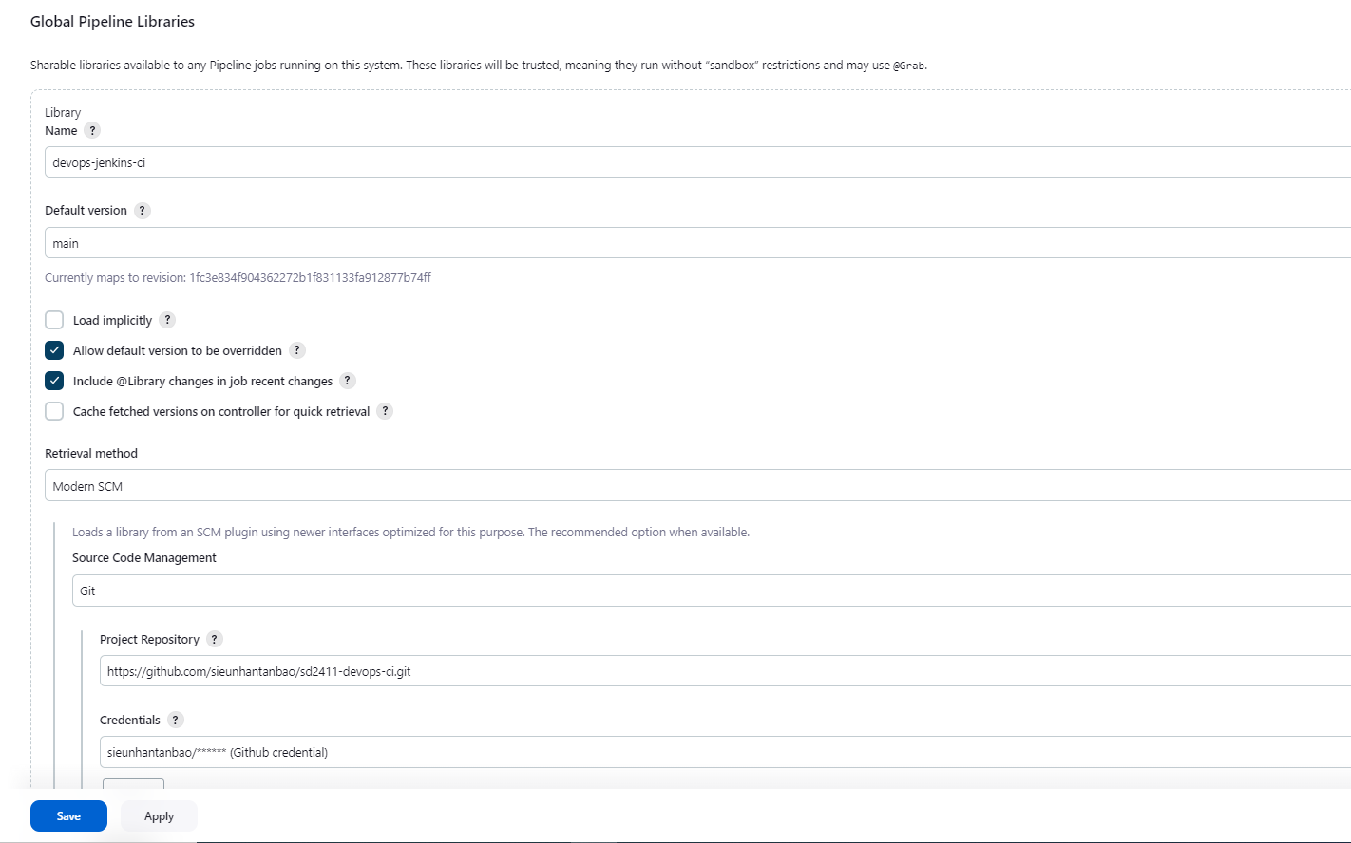
    - Name: <any name that you want> // Please note it for later use.
    - Default version: main
    - Project repository: <URL of your git repository that contain the Jenkins Groovy scripts> // i.e. https://github.com/sieunhantanbao/sd2411-devops-ci.git
    - Credentials: <your github credentials> which is created in the Manage Jenkins -> Credentials.
- Step 3: Create Organization Folder project
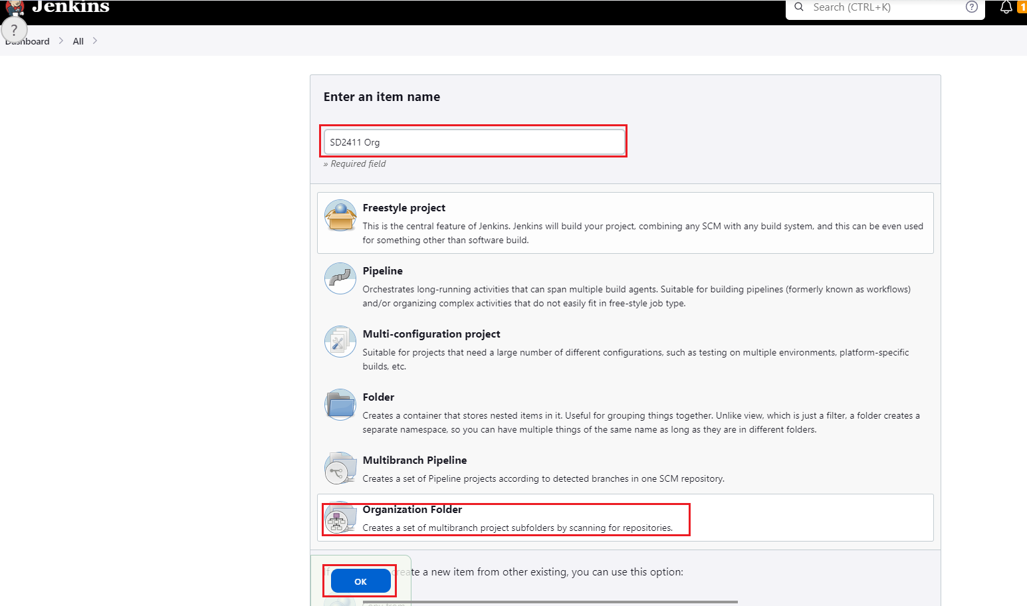
- Step 4: Configure the Organization Folder as below 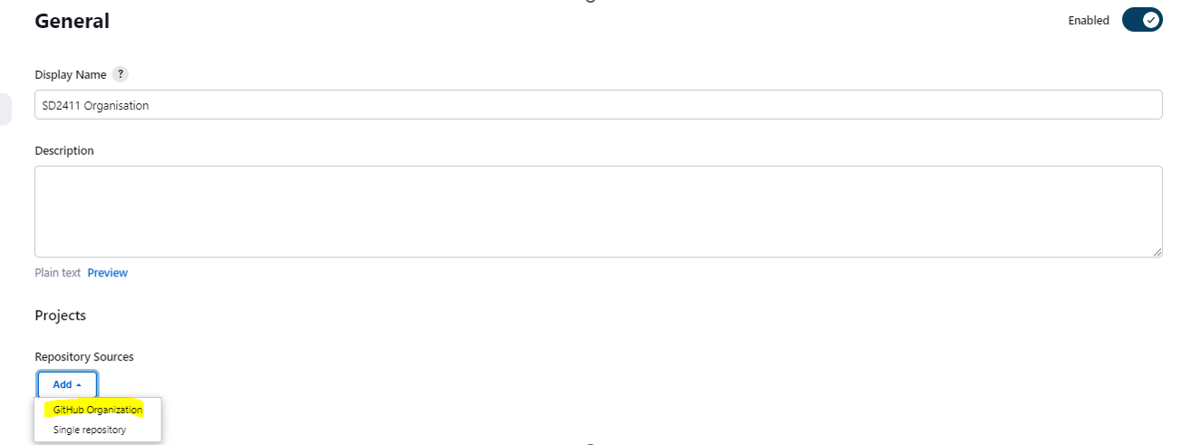 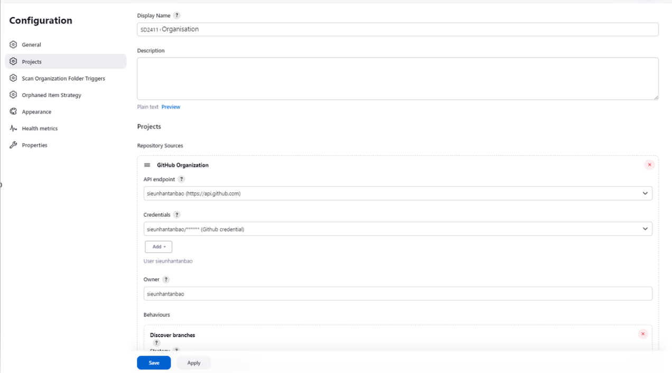
  - Display Name: <Any name that you want or leave it as blank>
  - API endpoint: select the GitHub Enterprise Servers that is created in step 1
  - Credentials: <your github credentials> which is created in the Manage Jenkins -> Credentials.
  - Owner: <your GitHub organization/ GitHub account>
=> After “Save” the Organization Folder project above. From the Jenkins home page:
- Click on: SD2411 Organisation
- Click on: Scan Organization Now (from the left menu)
- Step 5: Check the result/output. Confirm the sd2411_msa repository is added to your Organization Folder project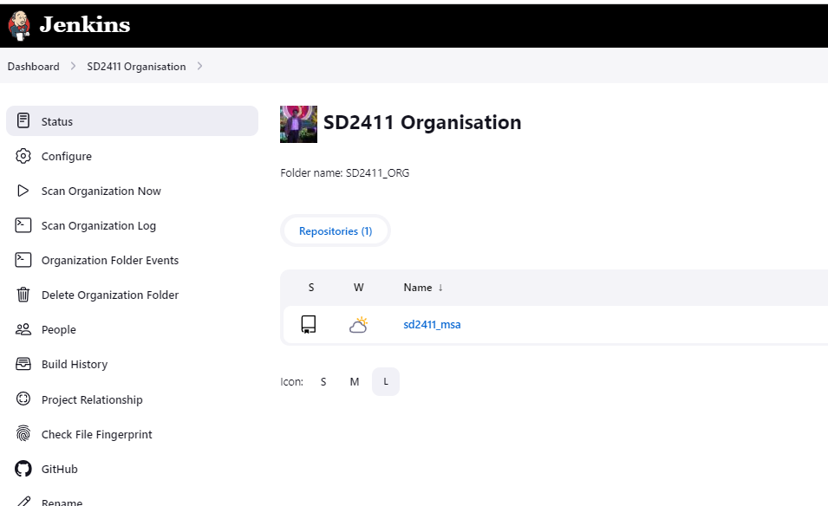
- Jenkins Groovy source code setup
- From the Application source code (i.e. https://github.com/sieunhantanbao/sd2411_msa), in the root of the repository, create a Jenkins file with the following content
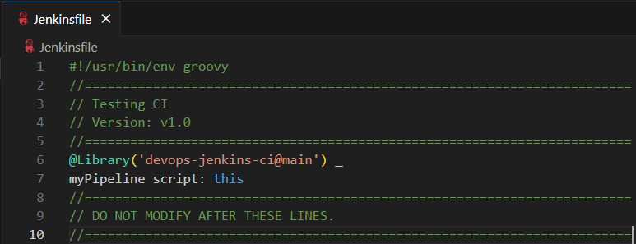
  - The ‘devops-jenkins-ci’ is the name of the Global Pipeline Libraries that we have created earlier.
  - The ‘main’ is the branch name of the devops-ci repository (https://github.com/sieunhantanbao/sd2411-devops-ci).
  - The ‘myPipeline’ is the name of the Jenkins Groovy file in the devops-ci repository (https://github.com/sieunhantanbao/sd2411-devops-ci).
- From the devops-ci repository (i.e. https://github.com/sieunhantanbao/sd2411-devops-ci)
  - Source code structure
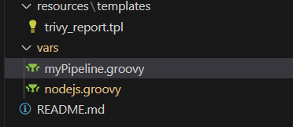
  - The myPipeline.groovy file
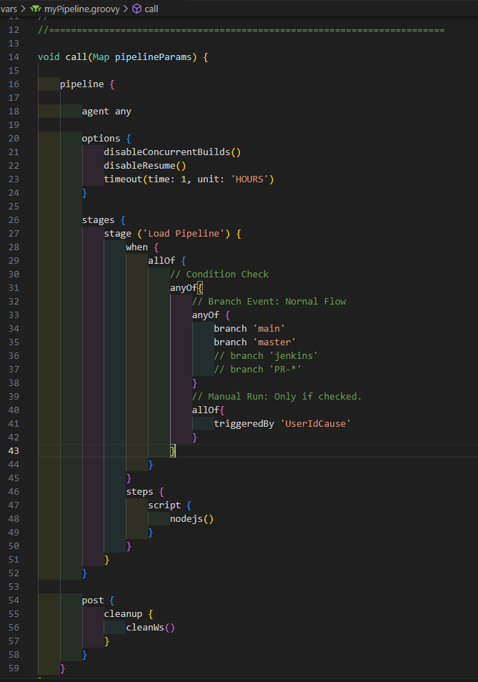
    - This file will be called from the Jenkins file when having any changes are made to the main/master branches of the application source code.
    - This file will call the nodejs.groovy file to run the stages (details of the steps).
  - The nodejs.groovy file
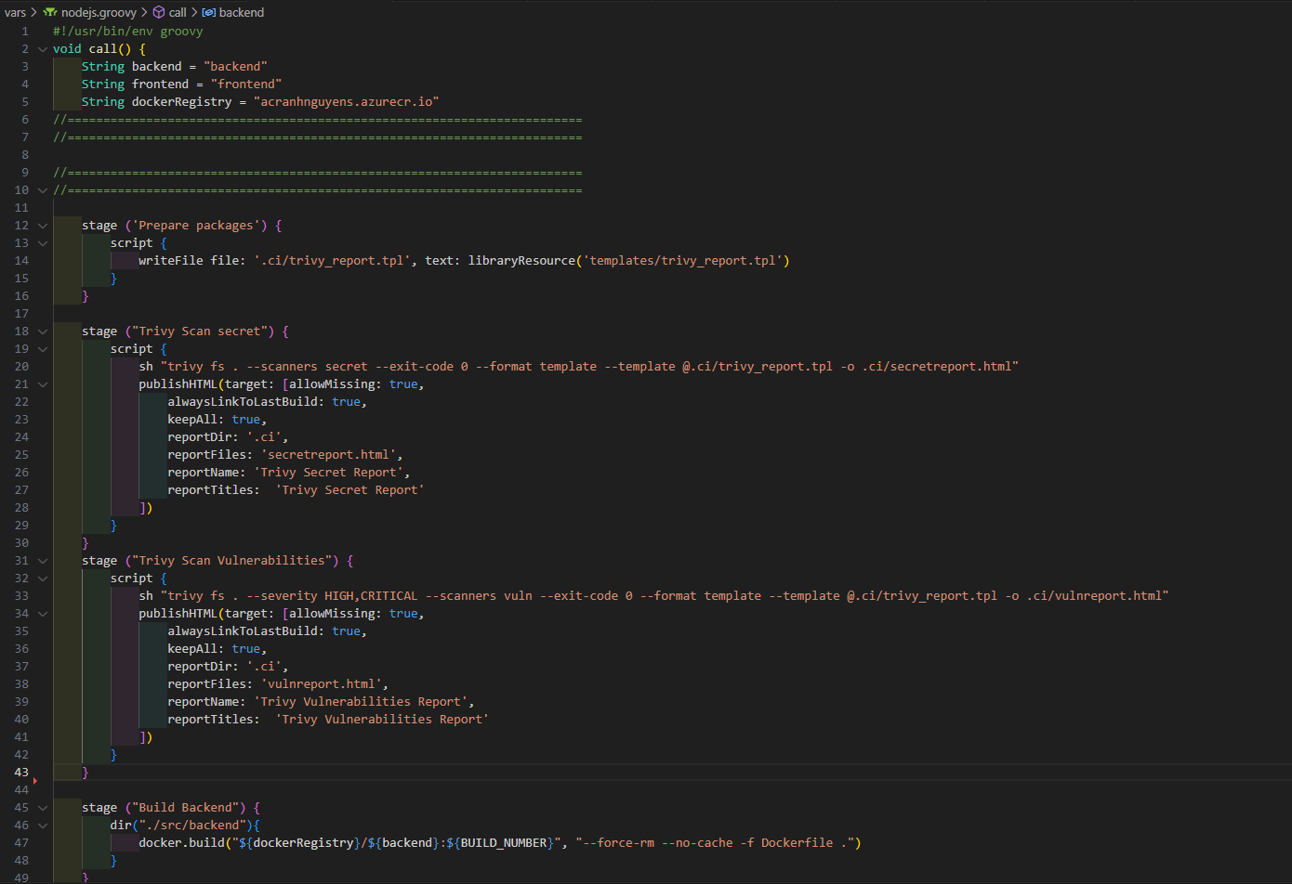
    - Full detail can be found here https://github.com/sieunhantanbao/sd2411-devops-ci/blob/main/vars/nodejs.groovy
    - This contains the list of build stages
      - Prepare packages: Copy the trivy report template (trivy_report.tpl) from the resources/templates to the .ci folder. This template is used for Trivy security and vulnerability reports.
      - Trivy Scan Secret: This stage is to use the Trivy command to scan the security from the application source code, and then export/publish the report to the Jenkins.
      - Trivy Scan Vulnerabilities: This stage is to use the Trivy command to scan the vulnerabilities from the application source code, and then export/publish the report to the Jenkins.
      - Build Backend: This stage is using the docker to build the image for the backend service of the application code.
      - Build Frontend: This stage is using the docker to build the image for the frontend service of the application code.
      - Push Docker Images to ACR – backend: This stage is pushing the backend image to the Azure Container Registry (ACR).
      - Push Docker Images to ACR – frontend: This stage is pushing the frontend image to the Azure Container Registry (ACR).
      - Clean up docker images: This stage is to clear all local docker images created in the Build Backend and Build Frontend in the Virtual Machine (build agent).
    - Please be notified that you need to create a Jenkins credential (i.e. acrcredential) to allow pushing the docker images to the ACR.
    - TODO: This should include some stages for checking Unit Test and SonarQube scan the quality of the application source code.
- Setup webhooks
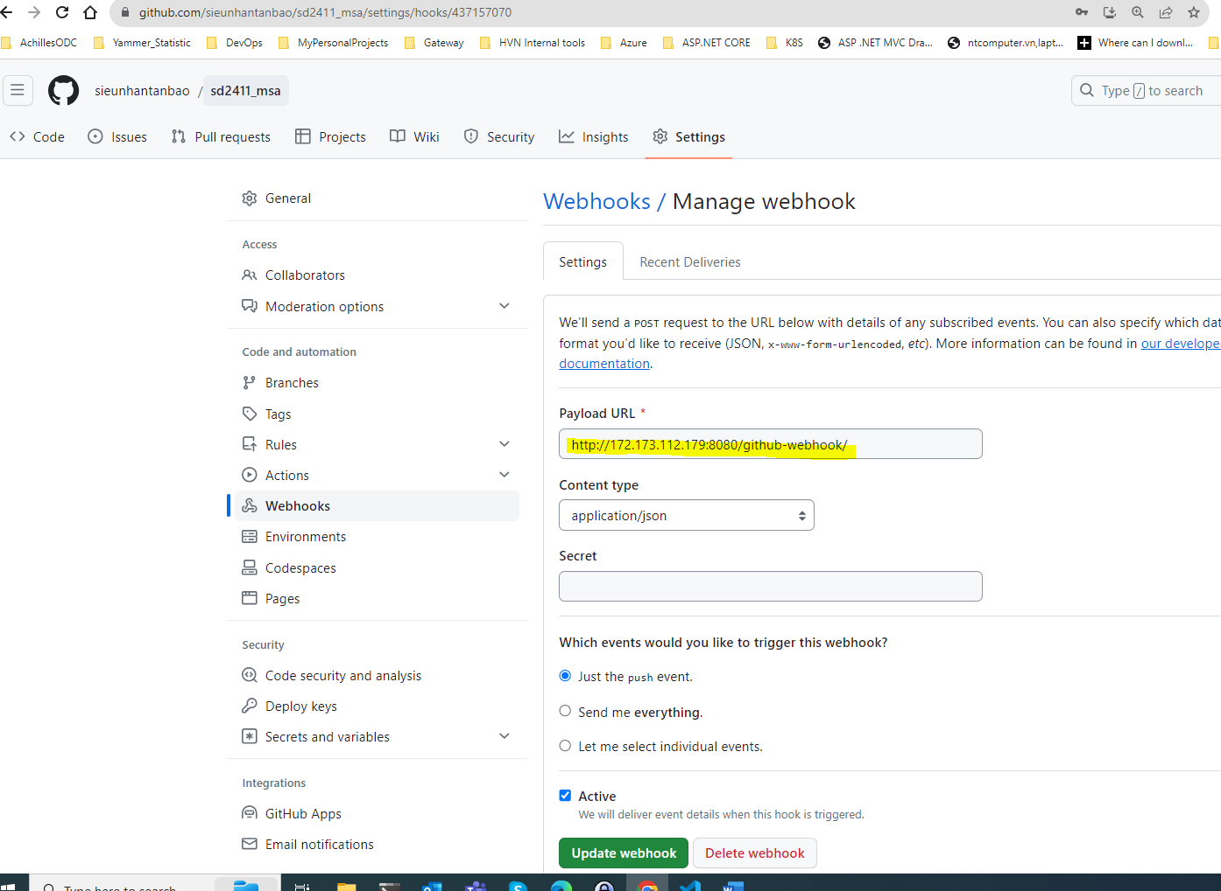
From the GitHub of the Application Code (i.e. https://github.com/sieunhantanbao/sd2411_msa). Click on Settings -> Webhooks. Then input the URL of the Jenkins (i.e http://172.173.112.179:8080/github-webhook/). This is to make sure that if there is any change in this source code, it will make a call to the Jenkins (webhooks) to trigger the CI flow.
- Demonstration
When there is a change in the source code
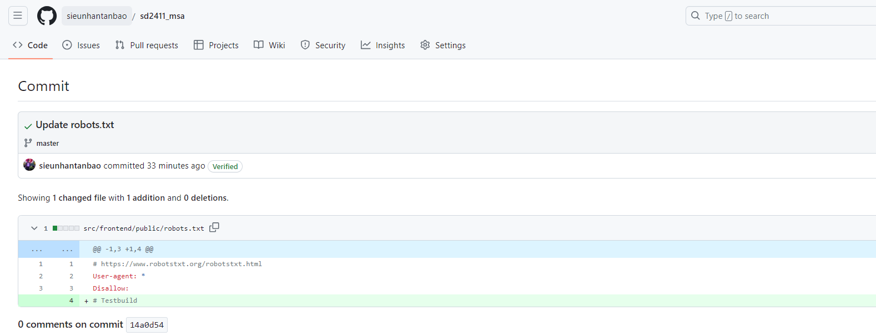
The Jenkins job is triggered and run successfully
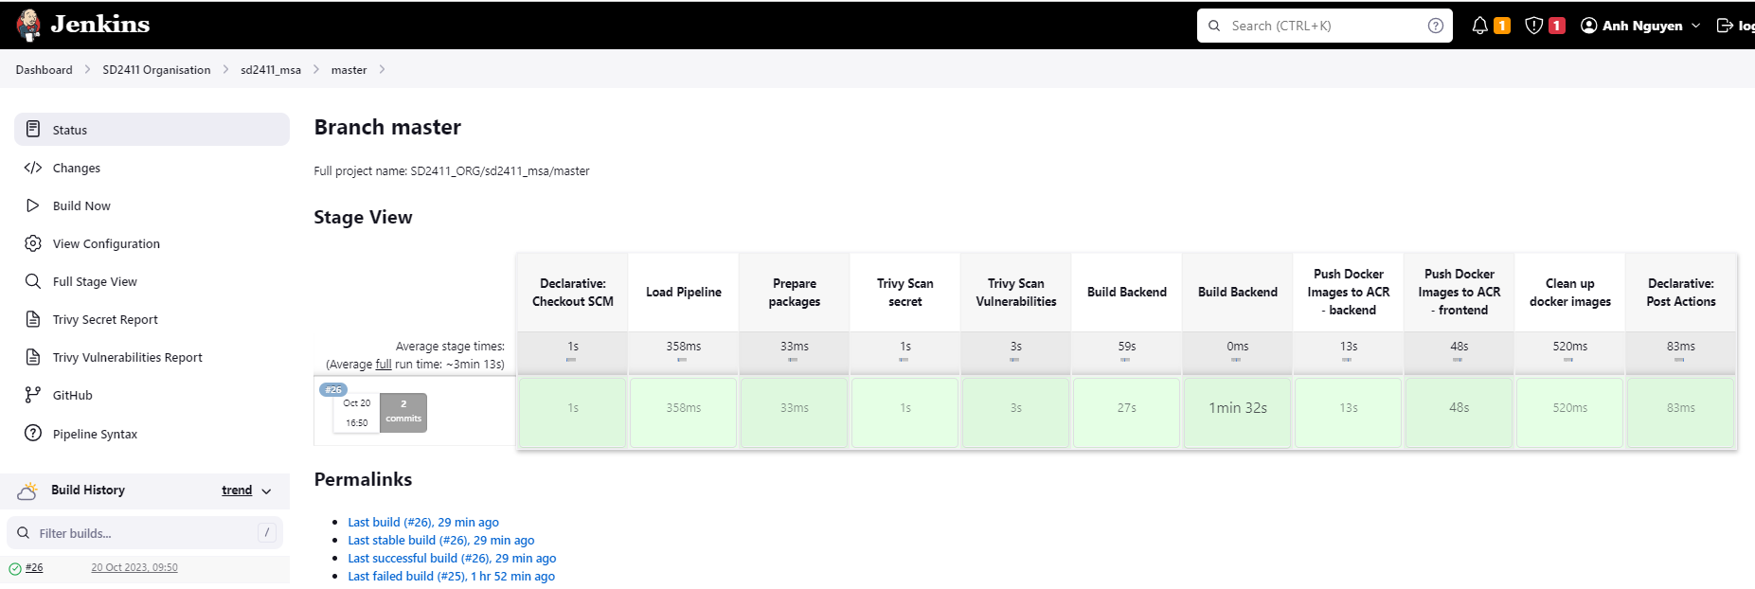
Check the security report
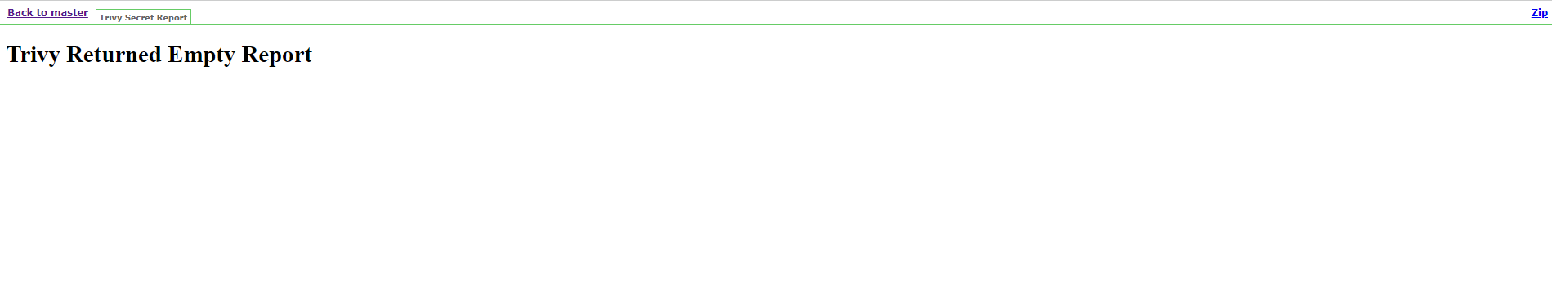
Check the vulnerability report
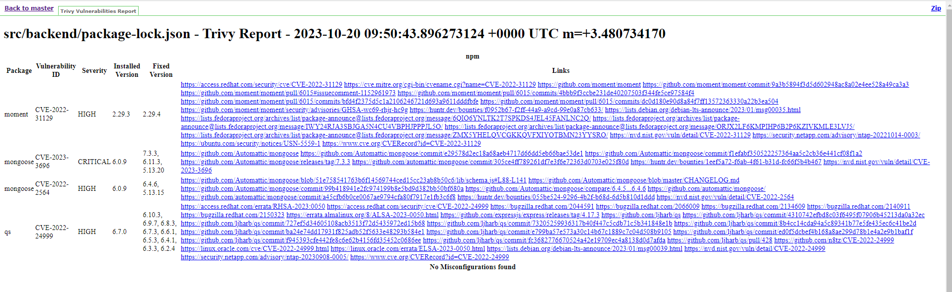
The docker images are published to Azure Container Registry (ACR).
