This document will help you to provision Azure resources (AKS, ACR, VM) using the terraform.

This also includes the installation of Jenkins, Docker, Kubectl CLI, Trivy into the Virtual Machine via a custom data script included when provisioning the Virtual Machine.

**Prerequisites:**

* You must have an Aure account with an Active subscription.
* [Azure Command-line Interface (CLI)](https://learn.microsoft.com/en-us/cli/azure/install-azure-cli) tool is installed on your machine.
* [Kubectl CLI](https://kubernetes.io/docs/tasks/tools/) tool is installed on your machine.
* [Terraform CLI](https://developer.hashicorp.com/terraform/tutorials/aws-get-started/install-cli) tool is installed on your machine.
* You must clone this source code from GitHub <https://github.com/sieunhantanbao/sd2411_azure_infrastructure>
  + git clone <https://github.com/sieunhantanbao/sd2411_azure_infrastructure.git>
  + cd sd2411_azure_infrastructure/

1. **Provision Azure Kubernetes Service (AKS) in Multi-AZs**

* Change directory to */iac/terraform/aks/ha*
* Update the values from the ***variables.tf***if required
* Run the below commands
  + terraform init

* + terraform plan --out tfplan.out

* + terraform apply tfplan.out

* Check the result on the Azure Portal

1. **Provision Virtual Machine (VMs) and install necessary tools**

* Change directory to */iac/terraform/vm*
* Update the values from the ***variables.tf***if required
* Run the below commands
  1. terraform init
  2. terraform plan -out tfplan.out
  3. terraform apply tfplan.out
* Check the result on the Azure Portal

* Please be noted that, we have the **azure-user-data.sh** file (that run when the Virtual Machine is provisioned) to install the Docker, Jenkins, Kubectl CLI, and Trivy

* SSH to the Virtual Machine (the username and password can be found in the **variables.tf** file) and check if the **Docker**, **Jenkins**, **kubectl**, and **Trivy** are installed

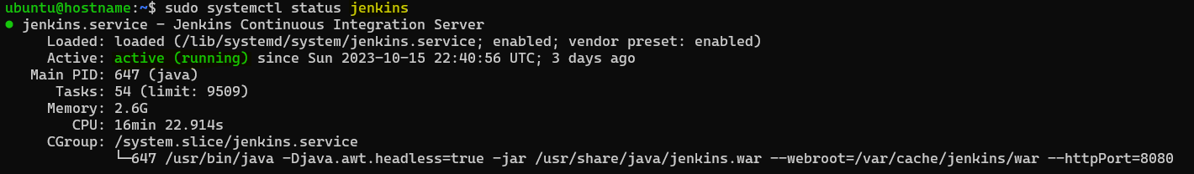

1. **Provision Azure Container Registry (ACR)**

* Change directory to */iac/terraform/acr*
* Update the values from the ***variables.tf***if required
* Run the below commands
  1. terraform init
  2. terraform plan -out tfplan.out
  3. terraform apply tfplan.out
* Check the result on the Azure Portal

