**REPORT WEEK 2**

**(09/20/2021 – 09/24/2021)**

Javascript:

* Callback:

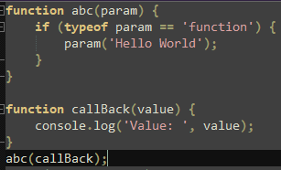

* Promise:

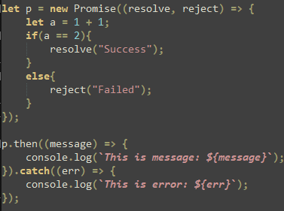

* Async/await:

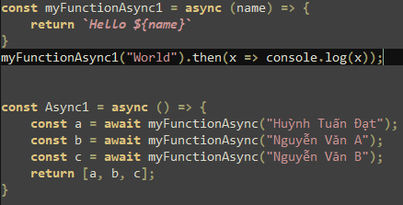

Webix basic layout:

* Login / Signup
* Logout
* Film datatable
* User datatable

UI Demo:

* Finish all the requirements
* Added styles for add, save, delete button
* Added update
* Added changed event for table’s element has an changed value