**FACULTY OF COMPUTING**

**UNIVERSITI TEKNOLOGI MALAYSIA**

**DATA STRUCTRUE & ALGORITHM**  
(MECS0023)

SEMESTER 2 2023/2024

Mini Project Documentation

**Student Course Management System**

**By**

1. **Pang Siew La – MECS235008**

**Section 52**

**Lecturer:**

**Pang Yee Yong**

**For Lecturer Use:**

|  |  |  |
| --- | --- | --- |
| **Description** | **Mark Distribution** | **Mark** |
| Project Report   * System Analysis * Design * Program Code | 10  15  25 |  |
| Presentation & Demo | 25 |  |
| System Prototype | 25 |  |
| Total | 100 |  |

**MECS0023 DSA - MINI PROJECT SPECIFICATION**

**PART 1: INTRODUCTION**

* 1. Synopsis Project

The project aims to develop a text-based application in C++ that manages course and student registrations using Link List and queue

1.2 Objective of the project

The objective is to implement a system that efficiently handles student enrolments and course registrations, while utilizing fundamental data structures such as linked lists and queues.

**PART 2: SYSTEM ANALYSIS AND DESIGN (USE CASE, FLOWCHART AND CLASS DIAGRAM)**

2.1 System Requirements

The system must allow users to:

1. Register a student.
2. Register a course (with a limited number of slots).
3. Enrol a student in a course (if slots are available, otherwise add to a waiting list).
4. De-enrol a student (if there are students on the waiting list, enrol the first student in the queue).
5. Display available courses.
6. Display registered students.

The system has 6 use cases: -

|  |  |
| --- | --- |
| Use Case | Purpose |
| Register a student | Register new student name |
| Register a course | Register new course |
| Enrol a student in a course | Enrol student in a course subject |
| De-enrol a student from a course | Remove a student from enrollment in a course |
| Display available courses | Checking the course subject available |
| Display registered students | Checking the student information are registered |

2.2 System Design

The system will be menu-driven, offering options for each functionality mentioned above.

The class diagram represents the structure of the system in terms of classes, their attributes, methods, and relationships. It illustrates how different entities such as students, courses, and registrations are modelled in the system. The block diagram below divide the flow of processes into register a student, register a course, enrol a student into a course, de-enrol a student from a course, display available courses, and display registered students.

1. Student course management system

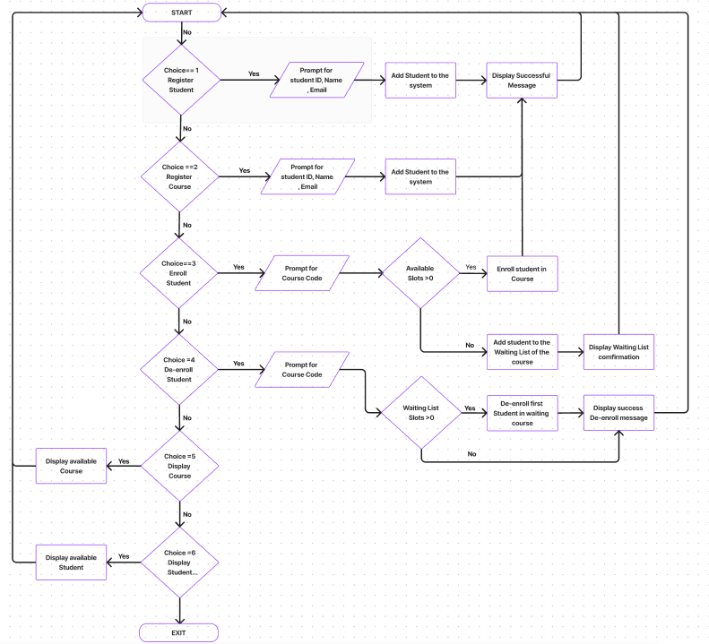

Figure 2.1: Flow chart: Student course management system

1. Register a student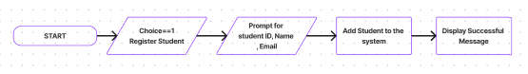

Figure 2.2: Flow chart: Register a student

1. Register a course

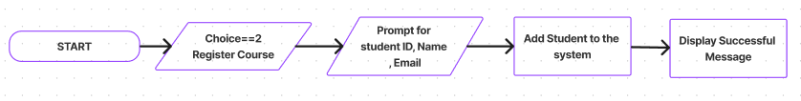

Figure 2.3: Flow chart: Register a course

1. Enrol a student in a course

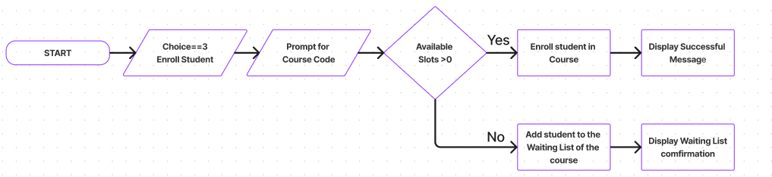

Figure 2.4: Flow chart: Enrol a student in a course

1. De-enrol a student from a course

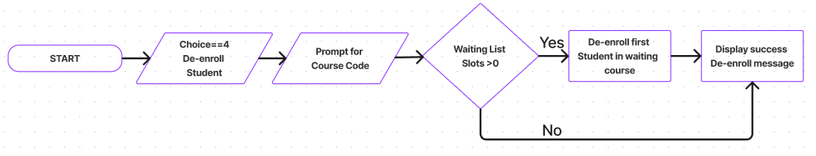

Figure 2.5: Flow chart: De-enrol a student from a course

1. Display available courses

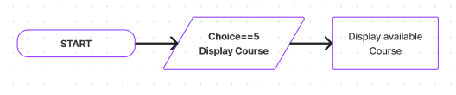

Figure 2.6: Flow chart: Display available course

1. Display registered students

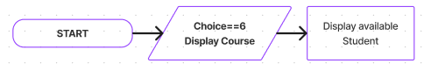

Figure 2.7: Flow chart: Display registered student

**PART 3: SYSTEM PROTOTYPE**

A prototype will be developed to demonstrate the core functionalities of the system.

**Screen 1: Menu Item**

Screen 1: The user must insert an integer value in the range 1-6. If the user enter other number, the system will prompt error message and the screen is displayed again

Prepared By: Siew La

**Screen 2: Register A Student**

Screen 2: The user will be prompted to enter 3 input, student ID (int), student email (string) and student name (string)

Prepared By: Siew La

**Screen 3: Register A Course**

Screen 3: The user will be prompted to enter 4 input, course name (string), course code (string), course slots (int), and credit hours (int).

Prepared By: Siew La

**Screen 4: Enrol or de-enrol student**

Screen 4: The list of courses will be shown to user, user to input the course code

Prepared By: Siew La

**Screen 5: Enrol or de-enrol student Menu**

Screen 5: The user must insert an integer value in the range 1-4. If the user enter other number, the system will prompt error message and the screen is displayed again

Prepared By: Siew La

**Screen 6: List of Available Course**

**Screen 7: List of All Registered Students**

**PART 4: DEVELOPMENT ACTIVITIES**

|  |  |  |  |  |
| --- | --- | --- | --- | --- |
| Meeting Date | Members Participate in Meeting | Activity | Task for each member | Task Achieved (Yes/No) |
| 5 June 2024 | Siew La | Idea Generation | Get the idea approval from Prof | Yes |
| 6 June 2024 | Siew La | Do Flow Generation | Complete the overall workflow | Yes |
| 8 June 2024 | Siew La | Basic File Structure of the Code | Complete the basic file structure | Yes |
| 9 June 2024 | Siew La | Complete the MVP | Complete the MVP | Yes |
| 9 June 2024 | Siew La | Draft the initial report | Complete Initial Report Structure | Yes |
| ? | ? | Fine Turning the Report | ? | ? |
| ? | ? | User Testing | ? | ? |