This is an instant messaging tool based on cloud database. When you register it, you can chat with your friends by the APP.

It was coded by: C# Windows form + ADO.NET + SQL Server.

1.Sign in: If you input the correct account, you could login in. You can choose the opition ‘RemeberPwd’ to remember your password. You can choose the opition ‘AutoLogin’ to quickly login.

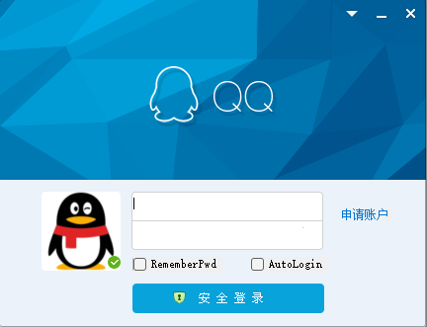

2.Register: If you haven’t an account, you could apply ID after you input the informations.

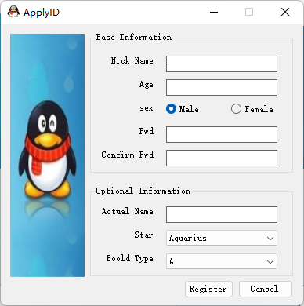

3.Main: After you login in, it will show the main window, you can see all your friends. You could see the login in status of your friends at the friend list. When your friends message you, his/her avatar will be flashing. When you want to chat with a friend you just need to click his/her avatar. You could change to small avatar mode.

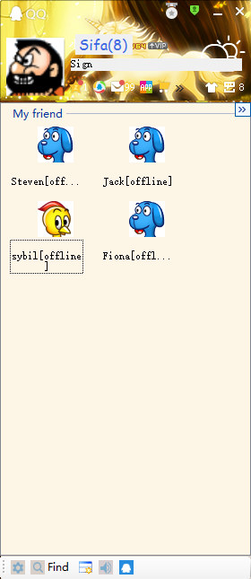 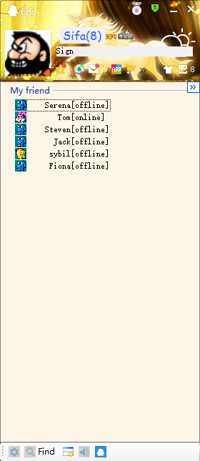

4.Chat: After you click a avatar, the chat windows will show. You can type some messages to your friend or see the message history.

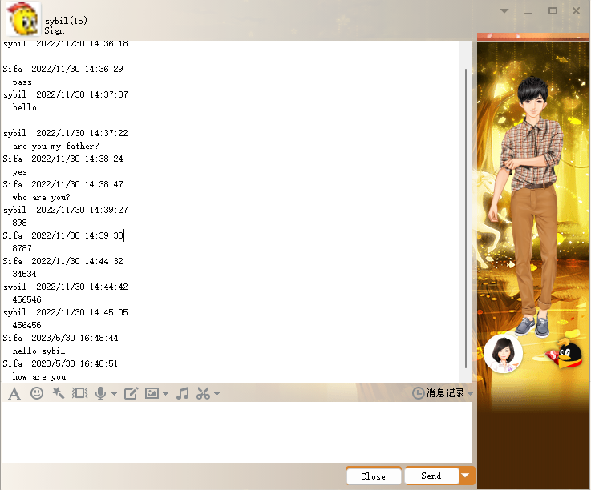

5.Personality: When you click your avatar in main window, you can modify your information and your avatar.

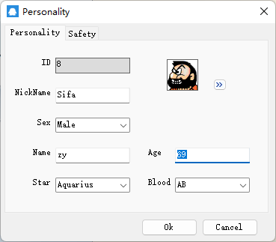

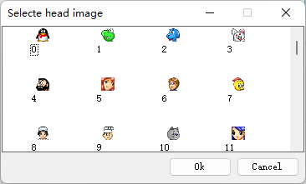

6.Find: It provides three ways to find friends. After you query the people, you could select some people to add friend.

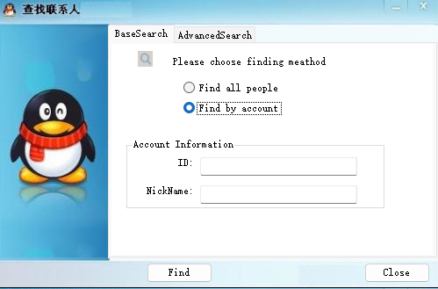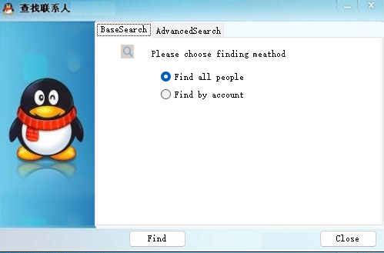

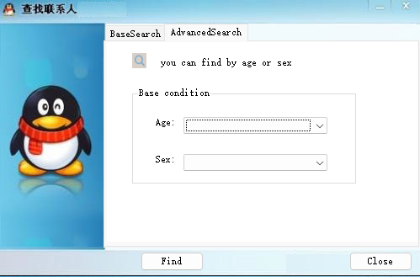

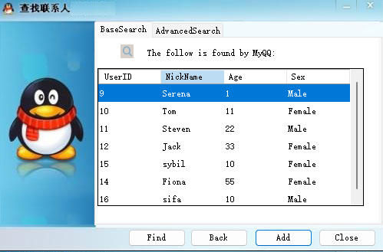

7.Notice: When some strangers want to add you be a friend, the sound icon will flashing at the bottom of main window. If you click the icon, it will show the messages.

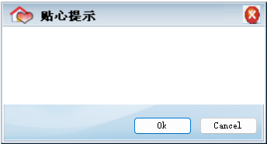

8.Stranger: If you change your friend list in main window, you could see the strangers who want to add you be a friend. You can also message to strangers.

