This website is used to manage the school's teacher and student information, as well as the student's performance information. There are five pages in total.

It was coded by:

**Front end: Next.js（13.4.4）+ React（18.2.0）+ mui（5.13.3）+material-table (6.1.15)**

**Back end: ASP.NET Core + EF Core + SQL Server**

1．Home page：The welcome page show school logo，picture and some base information.

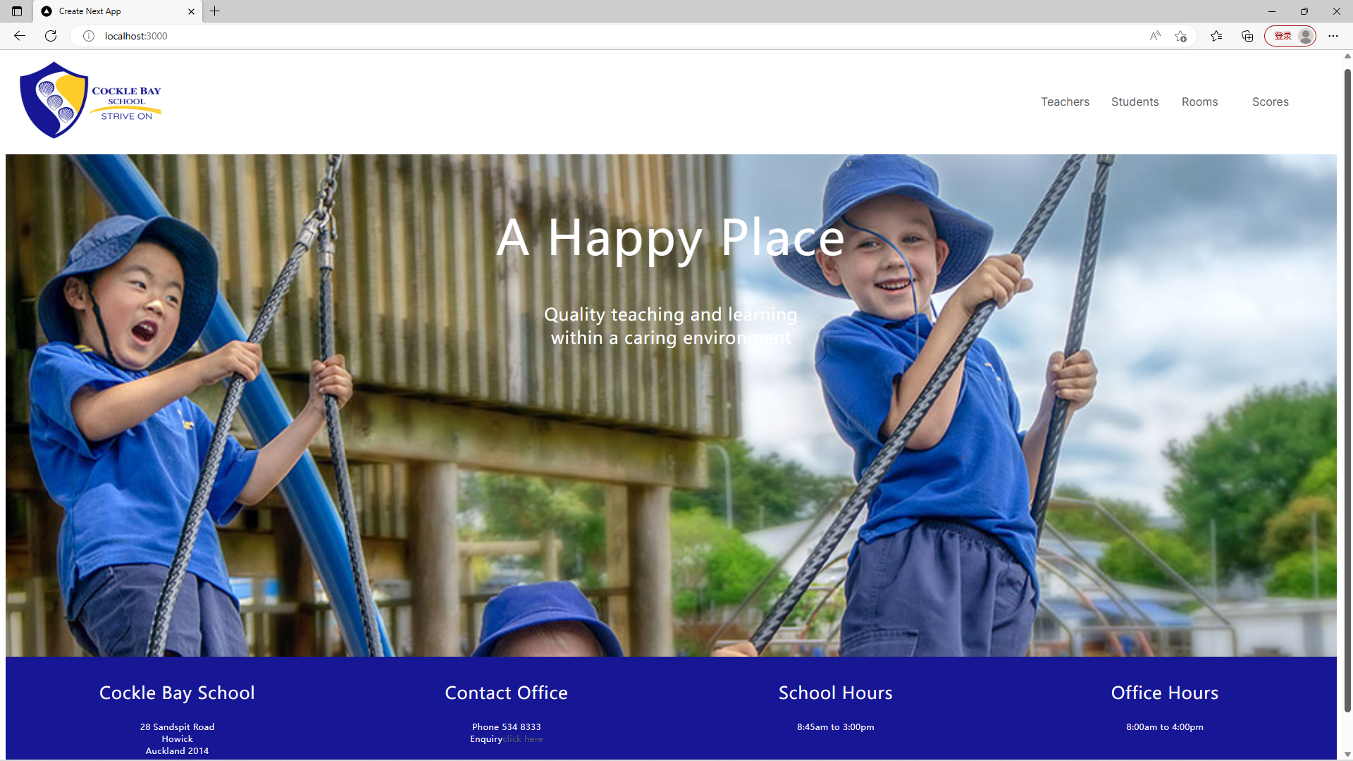

2.Teachers page: You can Query, Edit, Add and Delete the teachers information.

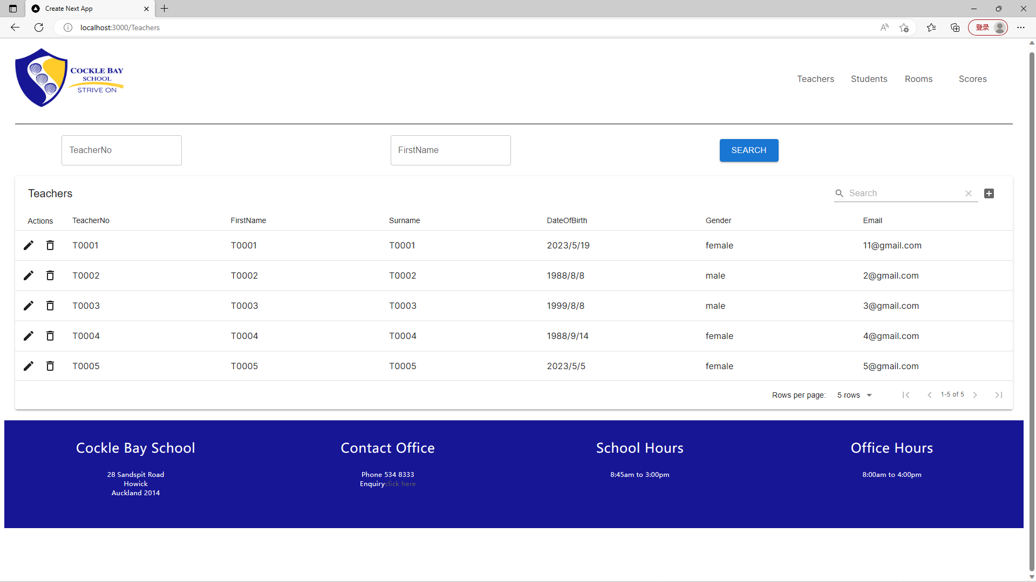

3.Students page: You can Query, Edit, Add and Delete the students information. If you delete a student, the scores of this student will be delete together.

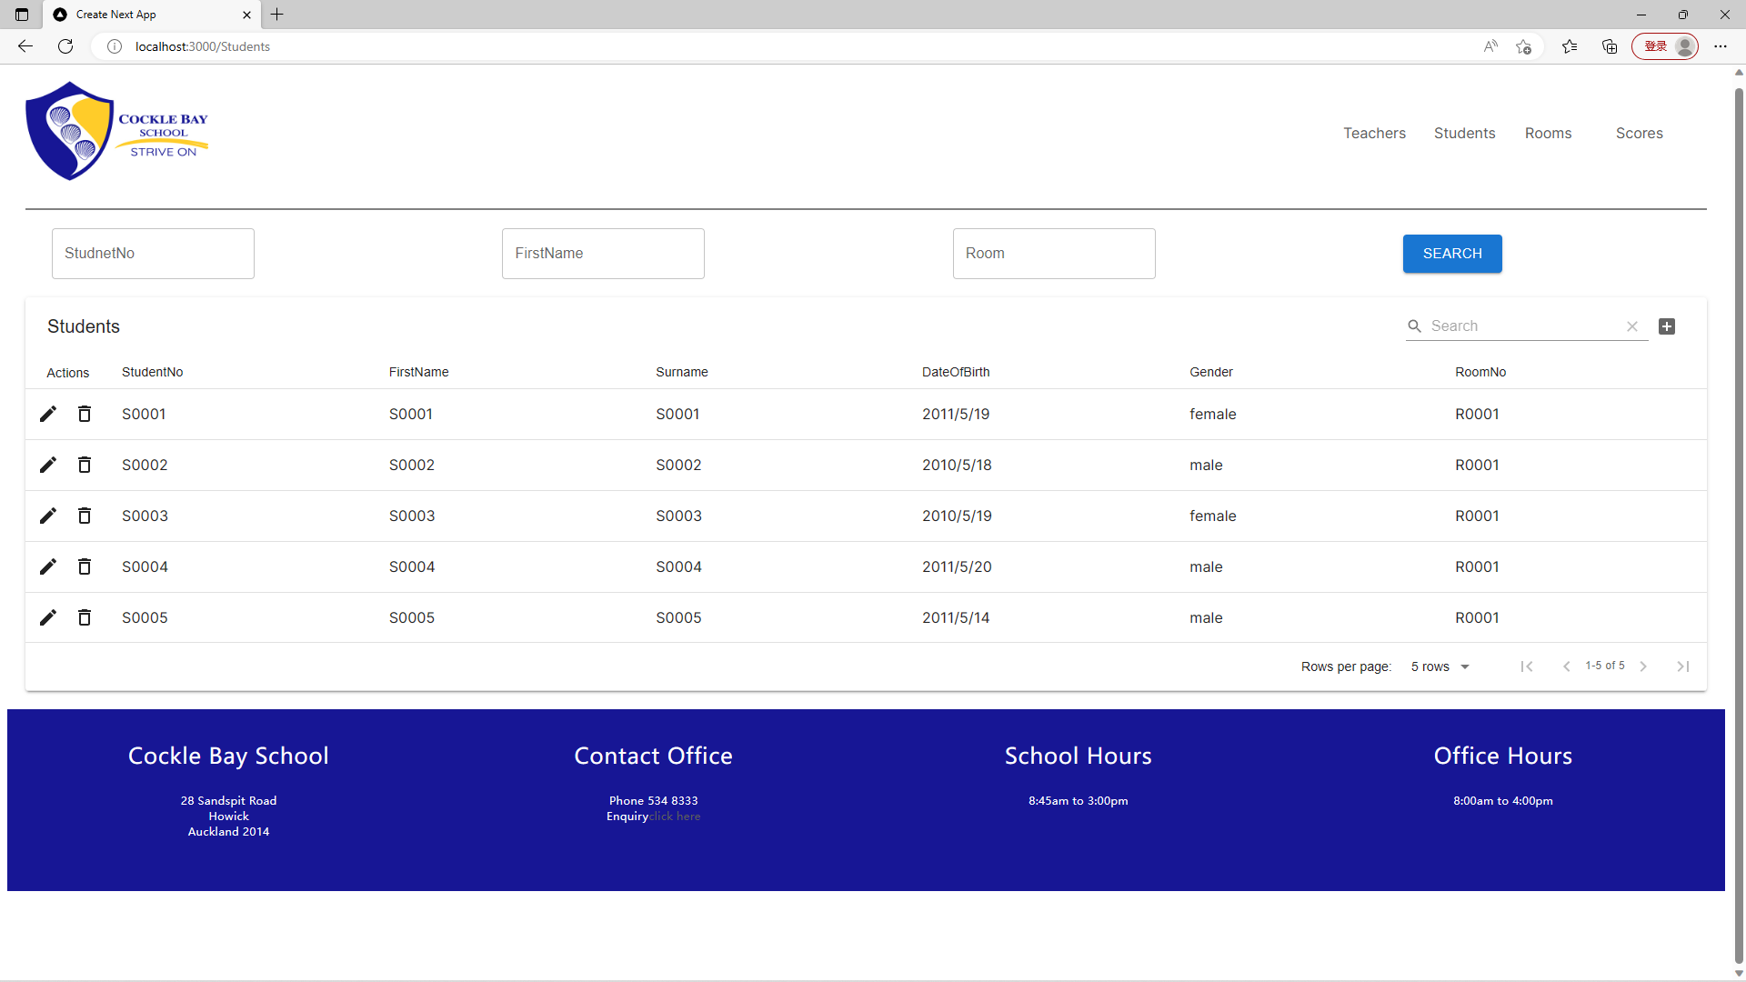

4. Rooms page: You can Query, Edit, Add and Delete the rooms information.

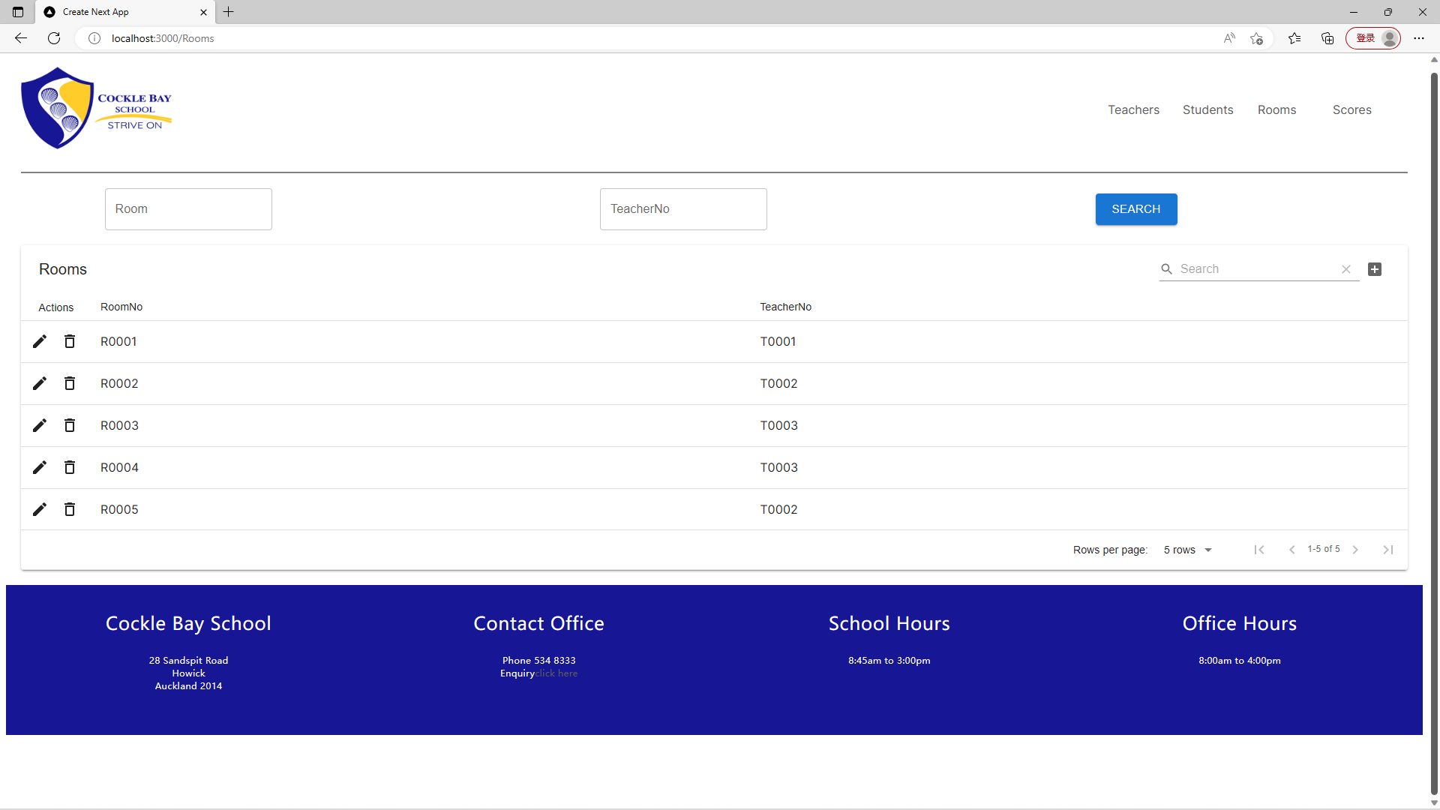

5.Scores page: You can Query, Edit, Add and Delete the rooms information. The query has four different ways: StudentNo, StudentNo+Subject, Room，Room+Subject.

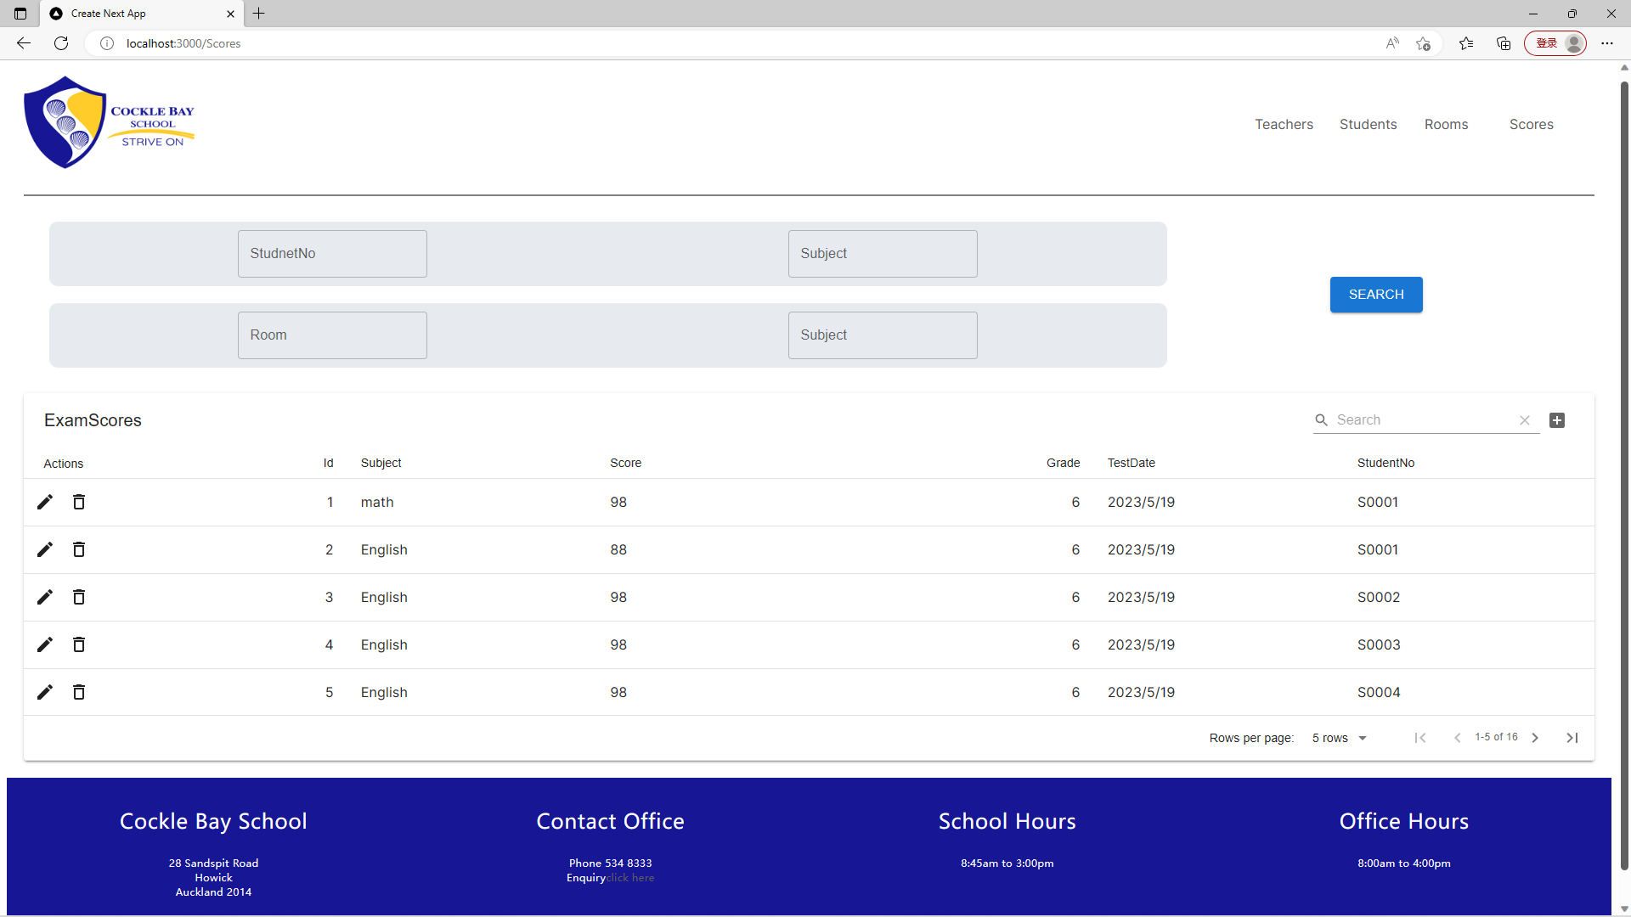

6.This is all ASP.NET APIs. These APIs follow Restful style.

