Fraud Detection in Banking using XGBoost

**Alexander Indrajaya L, Novan Dwi Atmaja, and Siti Fatimah**

The following report describes the methodology and exploratory process in the prediction of fraud event in banking by using indicators gathered from historical transaction. We also use synthetic minority over sampling (smote) technique to solve the imbalanced data problem. We find that by using smote algorithm the recall value has increased significantly even though this technique caused a slight decrease in the area under curve (auc) and accuracy.

*Keywords*: credit scoring, xgboost, smote algorithm

**Executive Summary**

In this report, we will do the fraud detection modeling based on data that has been provided by FinHack 2018. We use the XGboost model as the base model. Previously we would do a features selection and solve unbalanced data problems using the smote algorithm. Next, we will measure the performance and stability of the model.

We divide the data to training and testing (80:20). By using the test data, we found that the smote process provided auc and accuracy reduction of 1% - 4% and a recall increase of more than 28%. The most important variable to predict the credit card default is machine type (ATM, EDC).

**The Dataset**

The data we use consists of 13,125 data. The data contains related history of transaction and the status of whether the transaction is good or not. Data details can be seen on the finhack dashboard.

**Exploratory Data Analysis**

Training data consists of 910 (6.93%) fraud and 12,215 (93.07%) non-fraud.

First, we will measure the predictive power of characteristic using information value (IV). One rule of thumb regarding IV is:

* Less than 0.02 : unpredictive
* 0.02 to 0.1 : weak
* 0.1 to 0.3 : medium
* More than 0.3 : strong

We measure IV using “library (smbinning)”. This algorithm will categorize numeric data into certain bins based on the Conditional Inferences Tree.

> iv_table

Char IV Process

12 id_channel 0.8676 Factor binning OK

11 kepemilikan_kartu 0.8484 Factor binning OK

13 nilai_transaksi 0.4193 Numeric binning OK

16 minimum_nilai_transaksi 0.2288 Numeric binning OK

17 rata_rata_jumlah_transaksi 0.1558 Numeric binning OK

14 rata_rata_nilai_transaksi 0.0775 Numeric binning OK

10 kuartal_transaksi 0.0254 Factor binning OK

1 tipe_kartu NA Too many categories

2 id_merchant NA Too many categories

3 tipe_mesin NA Too many categories

4 tipe_transaksi NA Too many categories

5 nama_transaksi NA Too many categories

6 id_negara NA Too many categories

7 nama_kota NA Too many categories

8 lokasi_mesin NA Too many categories

9 pemilik_mesin NA Too many categories

15 maksimum_nilai_transaksi NA No significant splits

Based on IV, it was found that there were 3 features: id_channel, kepemilikan_kartu, and nilai_transaksi were strong predictor to measure fraud.

From the table above also obtained that the maksimum_nilai_transaksi are significantly do not affect the fraud detection (the tree is not formed).

**Predicting**

The available data showed the existence of imbalanced data cases.

> table(data_train$flag_transaksi_fraud)

0 1

12215 910

However, most of the existing state-of-the-art classification approaches are well developed by assuming the underlying training set is evenly distributed. Thus, they are faced with a severe bias problem when the training set is a highly imbalanced distribution. The resulting decision boundary is severely biased to the minority class, and thus leads to a poor performance according to the receiver operator characteristic (ROC) curve analysis. The synthetic minority oversampling technique (SMOTE) is an important approach by oversampling the positive class or the minority class.

At this stage, we will predict credit default by using XGBoost. We will compare the effect of smote on training data on model performance. The following are the steps we did:

1. Create new data training using SMOTE algorithm
2. convert categorical factor into one-hot encoding
3. construct XGBoost object dengan xgb.DMatrix
4. Construct XGBoost model
5. Predict credit default by using model above
6. Model evaluation

The following is the model comparison:

> table_akurasi

model data auc accuracy recall

1 xgboost train (model) 0.9103861 0.9580912 0.4485597

2 xgboost test 0.8958366 0.9440213 0.3314917

3 smote-xgboost smote_train (model) 0.9538842 0.9207438 0.8006401

4 smote-xgboost test 0.8577229 0.9310739 0.4254144

The smote process slightly reduces the level of accuracy, but can improve recall. By considering that the accuracy is still large, the model with smote will be chosen as the prediction model.

Here the important variables of smote-xgboost model:

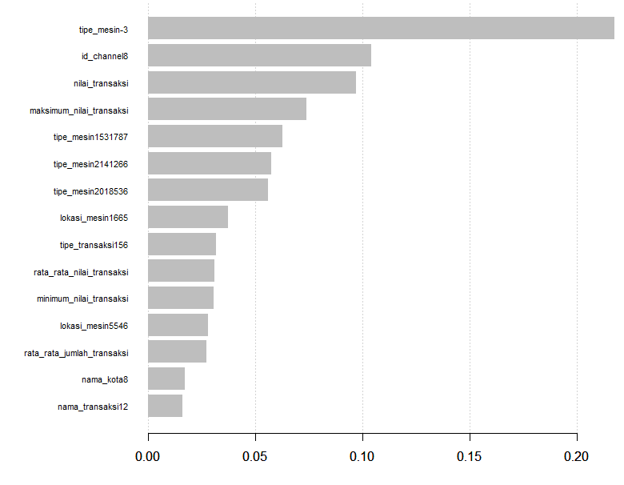

The most important variable is machine type, it contributes more than 20%.