**Example 6.1: Suppose AX and BX contain signed numbers. Write some code to put the biggest one in CX.**

.model small

.stack 100h

.data

msg1 db "Tanvir Ahmmed Sifat IT20026$"

msg2 db 10,13,"$"

.code

main proc

mov ax,@data

mov ds,ax

mov ah,9

lea dx,msg1

int 21h

lea dx,msg2

int 21h

mov ax,3

mov bx,5

cmp ax,bx

jg L1

mov ah,2

mov cx,bx

mov dx,cx

add dx,48

int 21h

jmp dos_exit

L1:

mov ah,2

mov cx,ax

mov dx,cx

add dx,48

int 21h

dos_exit:

mov ah,4ch

int 21h

main endp

end main

**Output:**

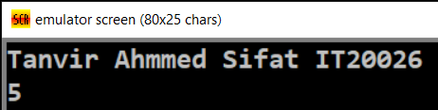

**EX 6.2: REPLACE THE NUMBER IN AX BY ITS ABSOLUTE VALUE.**

.model small

.stack 100h

.data

msg1 db "Tanvir Ahmmed Sifat IT20026$"

msg2 db 10,13,"$"

.code

main proc

mov ax,@data

mov ds,ax

mov ah,9

lea dx,msg1

int 21h

lea dx,msg2

int 21h

mov ax,-3

cmp ax,0

jge L1

neg ax

mov ah,2

add ax,48

mov dx,ax

int 21h

jmp exit

L1:

mov ah,2

add ax,48

mov dx,ax

int 21h

exit:

mov ah,4ch

int 21h

main endp

end main

**Output:**

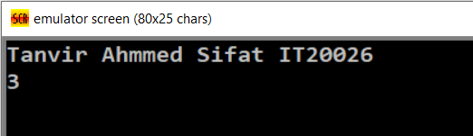

**Example 6.3:Suppose AL and BL contain extended ASCII characters.Display the one comes first in the character sequence.**

.model small

.stack 100h

.data

msg1 db "Tanvir Ahmmed Sifat IT20026$"

msg2 db 10,13,"$"

.code

main proc

mov ax,@data

mov ds,ax

mov ah,9

lea dx,msg1

int 21h

lea dx,msg2

int 21h

mov al,83h

mov bl,85h

cmp al,bl

jb L1

mov ah,2

mov dl,bl

int 21h

jmp dos_exit

L1:

mov ah,2

mov dl,al

int 21h

dos_exit:

mov ah,4ch

int 21h

main endp

end main

**Output:**

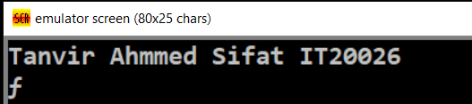

**Example 6.4:If AX contains a negative number , put - 1 in BX ; if AX contains 0, put 0 in BX ; if AX contains a positive number , put 1 in BX.**

.model small

.stack 100h

.data

msg1 db "Tanvir Ahmmed Sifat IT20026$"

msg2 db 10,13,"$"

.code

main proc

mov ax,@data

mov ds,ax

mov ah,9

lea dx,msg1

int 21h

lea dx,msg2

int 21h

mov ah,1

int 21h

mov bx,ax

cmp ax,0

jl negv

je zero

jg pos

negv:

mov bx,-1

jmp dos_exit

zero:

mov bx,0

jmp dos_exit

pos:

mov bx,1

jmp dos_exit

dos_exit:

mov ah,4ch

int 21h

main endp

end main

**Output:**

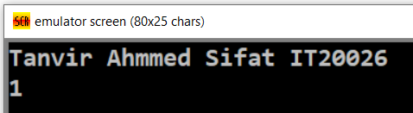

**Example 6.5: If AL contains 1 or 3 , display “O” ; If AL contains 2 or 4 , display “E”**

.model small

.stack 100h

.data

msg1 db "Tanvir Ahmmed Sifat IT20026$"

msg2 db 10,13,"$"

.code

main proc

mov ax,@data

mov ds,ax

mov ah,9

lea dx,msg1

int 21h

lea dx,msg2

int 21h

mov ah,1

int 21h

cmp al,'1'

je o

cmp al,'3'

je o

cmp al,'2'

je e

cmp al,'4'

je e

e:

mov ah,2

mov dl,'E'

int 21h

jmp dos_exit

o:

mov ah,2

mov dl,'O'

int 21h

jmp dos_exit

dos_exit:

mov ah,4ch

int 21h

main endp

end main

**Output:**

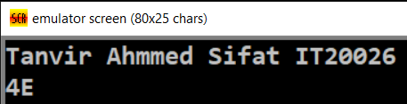

**Example 6.6: Read a character, and if it’s an uppercase letter, display it.**

.model small

.stack 100h

.data

msg1 db "Tanvir Ahmmed Sifat IT20026$"

msg2 db 10,13,"$"

.code

main proc

mov ax,@data

mov ds,ax

mov ah,9

lea dx,msg1

int 21h

lea dx,msg2

int 21h

mov ah,1

int 21h

cmp al,'A'

jl dos_exit

cmp al,'Z'

jg dos_exit

mov ah,2

mov dl,al

int 21h

jmp dos_exit

dos_exit:

mov ah,4ch

int 21h

main endp

end main

**Output:**

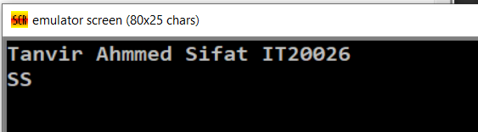

**Example 6.7 : Read a character it it’s “y” or “Y” , display it ; otherwise, terminate the program.**

.model small

.stack 100h

.data

msg1 db "Tanvir Ahmmed Sifat IT20026$"

msg2 db 10,13,"$"

.code

main proc

mov ax,@data

mov ds,ax

mov ah,9

lea dx,msg1

int 21h

lea dx,msg2

int 21h

mov ah,1

int 21h

cmp al,'y'

je show

cmp al,'Y'

je show

jmp dos_exit

show:

mov ah,2

mov dl,al

int 21h

jmp dos_exit

dos_exit:

mov ah,4ch

int 21h

main endp

end main

**Output:**

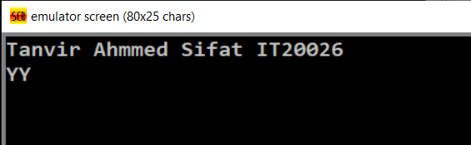

**EX 6.8: WRITE A COUNT -CONTROLLED LOOP TO DISPLAY A ROW OF 80 STARS.**

.model small

.stack 100h

.data

msg1 db "Tanvir Ahmmed Sifat IT20026$"

msg2 db 10,13,"$"

.code

main proc

mov ax,@data

mov ds,ax

mov ah,9

lea dx,msg1

int 21h

lea dx,msg2

int 21h

mov cx,80

jcxz exit

L:

mov ah,2

mov dx,"*"

int 21h

loop l

exit:

mov ah,4ch

int 21h

main endp

end main

**Output:**

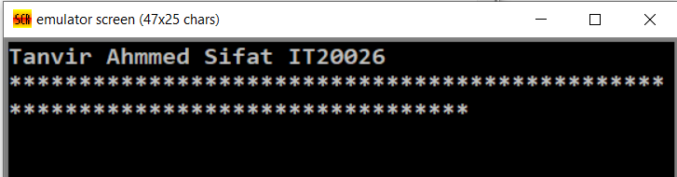

**EX 6.9: Write some code to count the number of characters in an input line**

.model small

.stack 100h

.data

msg1 db "Tanvir Ahmmed Sifat IT20026$"

msg2 db 10,13,"$"

.code

main proc

mov ax,@data

mov ds,ax

mov ah,9

lea dx,msg1

int 21h

lea dx,msg2

int 21h

mov bl,30h

do:

mov ah,1

int 21h

inc bl

cmp al,20h

je show

jmp do

show:

mov ah,2

sub bl,1

mov dl,bl

int 21h

exit:

mov ah,4ch

int 21h

main endp

end main

**Output:**

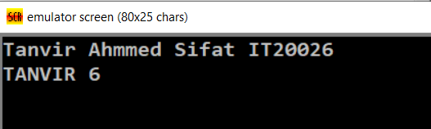

**Example 6.10 : Write some code to read characters until a blank is read.**

.model small

.stack 100h

.data

msg1 db "Tanvir Ahmmed Sifat IT20026$"

msg2 db 10,13,"$"

.code

main proc

mov ax,@data

mov ds,ax

mov ah,9

lea dx,msg1

int 21h

lea dx,msg2

int 21h

mov bl,30h

do:

mov ah,1

int 21h

inc bl

cmp al,20h

je exit

jmp do

show:

mov ah,2

sub bl,1

mov dl,bl

int 21h

exit:

mov ah,4ch

int 21h

main endp

end main

**Output:**

