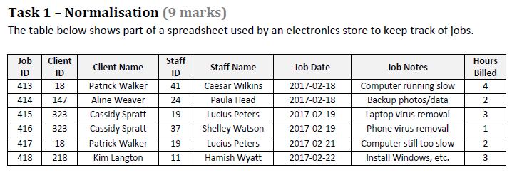

**0NF**

~~R1=(Staff ID, Staff name {Client ID, Client name, Job ID, Job Dates, Job Notes, Hours Billed})~~

**1NF**

R11= (Staff ID, Staff name)

~~R12=(~~ *~~Staff ID~~* ~~,Client ID, Client name, Job ID, Job Dates, Job Notes, Hours Billed)~~

**2NF Remove partial dependencies**

R11= (Staff ID, Staff name)

R1 Does not have a compound key, so it has no partial dependencies

~~R12=(~~ *~~Staff ID~~* ~~,Client ID, Client name, Job ID, Job Dates, Job Notes, Hours Billed)~~

R121= (*Staff ID*, Client ID, Job ID, Job Dates, Job Notes, Hours Billed)

R122= (Client ID, Client Name)

**3NF Remove transitive dependencies**

~~R121= (~~*~~Staff ID~~*~~, Client ID, Job ID, Job Dates, Job Notes, Hours Billed)~~

R1211= *(Staff ID*, *Client ID*, *Job ID*)

R1212= (Job ID, Job Dates, Job Notes, Hours Billed)

**Final Relation**

R11= (Staff ID, Staff name)

R122= (Client ID, Client Name)

R1211= *(Staff ID*, *Client ID*, *Job ID*)

R1212= (Job ID, Job Dates, Job Notes, Hours Billed)

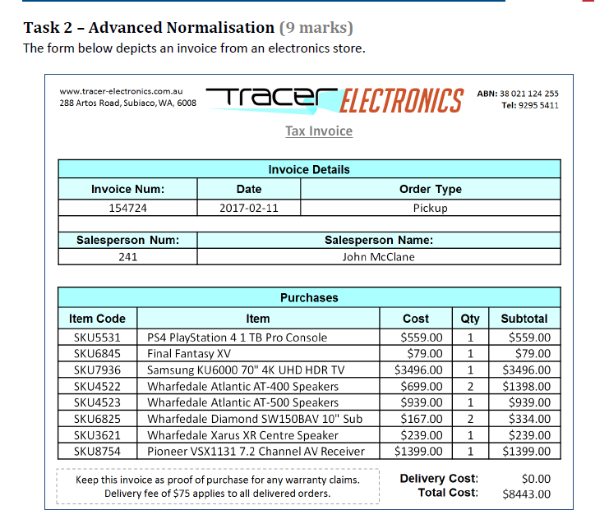

**0NF**

~~R1 = (Salesperson #, Salesperson Name {Invoice#, date, Order type {Item code, Item Description, cost, Qty}})~~

**1NF – Spilt the repeating group**

~~R1 = (Salesperson #, Salesperson Name {Invoice#, date, Order type {Item code, Item Description, cost, Qty}})~~

R11 = (Salesperson #, Salesperson Name)

~~R12 = (Invoice#,~~ *~~Salesperson #,~~* ~~date, Order type {Item code, Item Description, cost, Qty})~~

R121= (Invoice#, *Salesperson#*, date, Order type)

R122= (*Invoice#,* Item code, Item Description, cost, Qty.)

Final Relation at 1NF

R11 = (Salesperson#, Salesperson Name)

R121= (Invoice#, Salesperson #, date, Order type)

R122= (*Invoice#,* Item code, Item Description, cost, Qty.)

**2NF Remove partial dependencies**

~~R122= (~~*~~Invoice#,~~* ~~Item code, Item Description, cost, Qty)~~

R1221= (*Invoice#,* Item code, Qty)

R1222= (Item code, Item Description, cost)

Final Relation at 2NF

R11 = (Salesperson#, Salesperson Name)

R121= (Invoice#, *Salesperson#*, Date, Order Type)

R1221= (*Invoice#,* Item code, Qty.)

R1222= (Item code, Item Description, Cost)

**No transitive dependencies**

* **salesperson details is separated from invoice details at 1NF**

**Final Relations at 3 NF**

R11 = (Salesperson#, Salesperson Name)

R121= (Invoice#, *Salesperson#*, Date, Order Type)

R1221= (*Invoice#,* Item code, Qty.)

R1222= (Item code, Item Description, Cost)