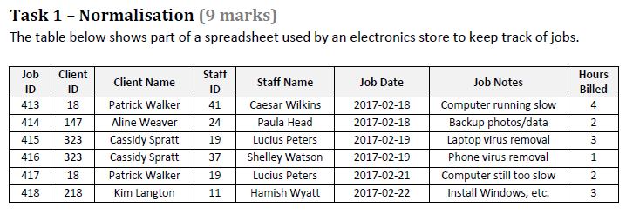

**0NF**

~~R1 = (Staff ID, Staff name {Client ID, Client name, {Job ID, Job Dates, Job Notes, Hours Billed}})~~

**1NF**

R11 = (Staff ID, Staff name)

~~R12 = (~~*~~Staff ID~~*~~, Client ID, Client name, {Job ID, Job Dates, Job Notes, Hours Billed})~~

R121 = (*Staff ID*, Client ID, Client name)

R122 = (*Client ID*, Job ID, Job Dates, Job Notes, Hours Billed)

**2NF**

No partial dep

**3NF**

No transitive dependency

Final Relations:

R11 = (Staff ID, Staff name)

R121 = (*Staff ID*, Client ID, Client name)

R122 = (*Client ID*, Job ID, Job Dates, Job Notes, Hours Billed)

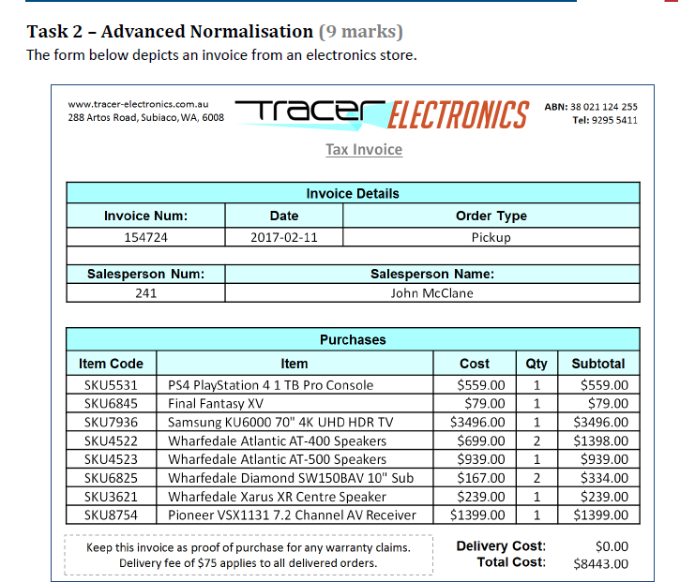

**0NF**

~~R1 = (Salesperson #, Salesperson Name {Invoice#, date, Order type {Item code, Item Description, cost, Qty}})~~

**1NF – Spilt the repeating group**

~~R1 = (Salesperson #, Salesperson Name {Invoice#, date, Order type {Item code, Item Description, cost, Qty}})~~

R11 = (Salesperson #, Salesperson Name)

~~R12 = (Invoice#,~~ *~~Salesperson #,~~* ~~date, Order type {Item code, Item Description, cost, Qty})~~

R121= (Invoice#, *Salesperson#*, date, Order type)

R122= (*Invoice#,* Item code, Item Description, cost, Qty.)

Final Relation at 1NF

R11 = (Salesperson#, Salesperson Name)

R121= (Invoice#, *Salesperson#*, date, Order type)

R122= (*Invoice#,* Item code, Item Description, cost, Qty.)

**2NF Remove partial dependencies**

~~R122= (~~*~~Invoice#,~~* ~~Item code, Item Description, cost, Qty)~~

R1221= (*Invoice#,* Item code, Qty)

R1222= (Item code, Item Description, cost)

Final Relation at 2NF

R11 = (Salesperson#, Salesperson Name)

R121= (Invoice#, *Salesperson#*, Date, Order Type)

R1221= (*Invoice#,* Item code, Qty.)

R1222= (Item code, Item Description, Cost)

**No transitive dependencies**

* **salesperson details is separated from invoice details at 1NF**

**Final Relations at 3 NF**

R11 = (Salesperson#, Salesperson Name)

R121= (Invoice#, *Salesperson#*, Date, Order Type)

R1221= (*Invoice#,* Item code, Qty.)

R1222= (Item code, Item Description, Cost)