ADE-Sentinel: Adverse Drug Event Identification and Entity Extraction
A Two-Stage Sentence-Classification and Sequence-Tagging System
Comprehensive Technical Project Report: Project objective: Detect whether a clinical sentence reports a drug-induced adverse effect (Stage 1 Relevance Gate), and if so, extract the exact token and character boundaries of the causal drug and the adverse clinical effect (Stage 2 Sequence Tagger). Beyond the end-to-end pipeline, this project empirically determines whether word representations trained from scratch on specialized in-domain biomedical literature outperform general-purpose English embeddings under strictly controlled, identical neural architectures. The system is deployed via an interactive Streamlit application with visual entity span highlighting and real-time CPU inference.

Natural Language Processing Laboratory | Final Project Report | September 2026
Abstract
Adverse Drug Events (ADEs) represent a leading cause of patient morbidity, avoidable hospitalizations, and substantial healthcare expenditures worldwide. Automated pharmacovigilance across biomedical literature and clinical records requires addressing two tightly coupled natural language processing challenges: (1) identifying whether a sentence describes an adverse reaction rather than a standard treatment, indication, or non-event (sentence classification), and (2) pinpointing the precise boundaries of causal agents (DRUG) and symptoms (EFFECT) via named entity recognition. This project develops ADE-Sentinel, a modular two-stage neural pipeline operating over ADE Corpus v2, supported by custom pretraining over a scraped corpus of 159,975 PubMed abstracts (40.5 million tokens).
Rather than deploying an opaque, monolithic tagger over unconstrained text—which induces severe false-positive entity inflation across routine clinical descriptions—the system implements a gated architecture. Stage 1 deploys a Bidirectional Long Short-Term Memory network with Bahdanau additive attention pooling to screen incoming sentences. Stage 2 executes a Bidirectional LSTM coupled with a Linear-Chain Conditional Random Field (BiLSTM-CRF) that enforces globally consistent entity sequence transitions via Viterbi decoding. To protect specialized medical terminology, we implement a deterministic regex tokenizer featuring lookbehind sentence splitting and smart case normalization, preserving 84 critical medical acronyms (e.g., ALL, AML, HIV, CT) and shielding multi-token chemical names (e.g., 5-fluorouracil, tnf-alpha, 20 mg/kg).
Across a strictly controlled embedding ablation over an identical 12,220-word frozen vocabulary, in-domain word embeddings trained from scratch on PubMed abstracts (FastText E3) achieved 0.8785 macro-F1 in Stage 1, substantially outperforming general-purpose 300-dimensional GloVe vectors (0.7942 macro-F1) by +0.0843 F1, while general GloVe added only +0.0501 F1 over uniform random vectors (0.7441 macro-F1). In Stage 2, the linear-chain CRF suppressed illegal BIO sequence transitions from 82 down to 5, achieving 0.8308 strict entity-F1 (0.8540 precision, 0.8090 recall). In end-to-end chained evaluation across the entire 3,133-sentence held-out test split, the combined system reached 0.6891 strict entity-F1. A two-player Shapley value loss decomposition established that gate false alarms drove 51.4% of downstream entity degradation, demonstrating that gating precision is the primary performance lever. Challenge evaluations over 615 sentences containing negation and hedging cues confirmed that pretrained neural representations provide crucial contextual inductive bias, maintaining 0.8584 macro-F1. The complete system is deployed as an interactive Streamlit application.
1. Introduction and Actual Task
1.1 Pharmacovigilance and the Adverse Drug Event Challenge
Adverse Drug Events (ADEs)—injuries resulting from medical interventions related to a drug—constitute one of the most pressing public health hazards in modern medicine. Epidemiological surveillance indicates that adverse drug reactions account for approximately 5% to 7% of all hospital admissions, prolong inpatient stays, and impose billions of dollars in annual healthcare costs. While regulatory bodies such as the U.S. Food and Drug Administration (FDA) and the European Medicines Agency (EMA) mandate rigorous pre-approval clinical trials, clinical trials are intrinsically constrained by sample sizes, limited follow-up duration, and the systematic exclusion of vulnerable patient cohorts (e.g., elderly, pediatric, or polypharmacy patients). Consequently, rare, delayed, or idiosyncratic toxicities frequently remain undetected until widespread post-marketing clinical use.
Post-marketing pharmacovigilance relies heavily on spontaneous reporting systems and published biomedical literature. Thousands of clinical case reports and toxicology studies are indexed weekly on repositories such as PubMed and MEDLINE. However, manual extraction of ADE mentions from this vast, unstructured textual stream is economically and logistically infeasible. Automated Natural Language Processing (NLP) systems offer a scalable solution to continuously ingest, screen, and extract pharmacovigilance signals. Nevertheless, medical text exhibits extreme linguistic complexity: clinical narratives feature intricate syntactic structures, dense biomedical jargon, non-standard abbreviations, pervasive negation, and frequent descriptions of therapeutic indications that must not be confounded with adverse reactions.
1.2 Dual-Stage NLP Pipeline Formulation
To address automated pharmacovigilance effectively, ADE-Sentinel decomposes the problem into two sequential, interpretable NLP subtasks: sentence classification (Stage 1) followed by sequence tagging (Stage 2).
• 1. Stage 1 (Relevance Gate): Given an arbitrary sentence x from biomedical text, determine whether x describes an authentic adverse drug event (Class 1, ADE) or constitutes a non-adverse statement (Class 0, Not-ADE). Non-ADE sentences encompass descriptions of successful therapeutic interventions (e.g., 'The patient was treated with amoxicillin for strep throat'), baseline clinical histories, diagnostic investigations, and negated events.
• 2. Stage 2 (Sequence Tagger): For each sentence x deemed positive by the Stage 1 gate, execute token-level named entity recognition to extract the exact character and word spans corresponding to the causal agent (labeled DRUG) and the clinical manifestation (labeled EFFECT).
The staged formulation is essential from an architectural perspective. In clinical literature, sentences describing non-adverse medical treatments overwhelmingly outnumber authentic ADE reports by roughly 4:1. Deploying an unconstrained token tagger directly across raw clinical corpora induces severe false-positive entity inflation: the tagger reliably recognizes drug names and medical symptoms, but incorrectly links them as adverse events when they actually describe indications or baseline comorbidities. Stage 1 acts as an indispensable relevance gate, filtering out non-events and protecting Stage 2 from false alarms.
1.3 The Central Representation Research Question
Beyond engineering an end-to-end extraction pipeline, ADE-Sentinel answers an empirical representation question fundamental to applied BioNLP:
Core Empirical Research Question: Do word embeddings trained from scratch on specialized in-domain biomedical text outperform general-purpose English embeddings when evaluated under strictly controlled, identical neural architectures?

Prior literature frequently conflates embedding source corpora with model architectural differences. To guarantee a rigorous, fair comparison, this project establishes a strict experimental protocol: a single Bidirectional LSTM network with Bahdanau additive attention is trained four separate times under identical conditions (identical random seed 42, identical training hyperparameters, identical batch schedules, and a strictly frozen 12,220-word vocabulary). The only factor that varies between runs is the starting word embedding matrix: uniform random initialization (E0, baseline floor), general-purpose GloVe 300d vectors trained on Wikipedia and Gigaword (E1), in-domain Word2Vec Skip-gram vectors trained on 159,975 PubMed abstracts (E2), and in-domain FastText subword vectors trained on the identical PubMed corpus (E3). All embedding weights are frozen during downstream training to ensure the evaluation measures representation quality rather than task-specific gradient tuning.
1.4 Sequence Modeling, Error Propagation, and Robustness
In Stage 2, we investigate the structural necessity of global sequence decoding. Standard token classifiers emit independent softmax probabilities at each word position, ignoring label transitions. In contrast, linear-chain Conditional Random Fields (CRFs) learn global transition dynamics, penalizing syntactically illegal BIO sequences (such as jumping directly from an Out-of-entity tag O to an Inside-entity tag I-DRUG). Furthermore, we conduct a rigorous error-propagation analysis to quantify cascading losses across the chained pipeline and evaluate system robustness against clinical negation and hedging cues.
2. Label Scheme and Interpretable Entity Representation
2.1 The BIO Sequence Tagging Scheme
Stage 2 formats entity extraction as a token-level sequence labeling task using the strict Beginning-Inside-Outside (BIO / IOB2) annotation standard. Each token in a sentence is assigned exactly one tag from an inventory of five labels:
• O (Outside): The token does not belong to any entity mention.
• B-DRUG (Beginning of Drug): The token marks the initial word of a causal pharmacological agent.
• I-DRUG (Inside Drug): The token is a continuation of a multi-token drug entity mention.
• B-EFFECT (Beginning of Effect): The token marks the initial word of an adverse clinical symptom or pathology.
• I-EFFECT (Inside Effect): The token is a continuation of a multi-token adverse effect mention.
2.2 Label Distribution and Class Imbalance Diagnostics
Table 1 reports the distribution of BIO tags across all 86,080 tokens within the 4,271 annotated ADE sentences in the supervised corpus. The token space displays extreme class imbalance: out-of-entity tokens (O) constitute 79.28% of all tokens, while entity-bearing tokens collectively account for only 20.72%.
BIO Tag | Token Count | Token Share | Entity Role | Example Clinical Mentions
O | 68,242 | 79.28% | Background / non-entity | The, patient, developed, after, mg/kg
B-DRUG | 5,044 | 5.86% | Initial token of drug | cloxacillin, methotrexate, cisplatin, lithium
I-DRUG | 593 | 0.69% | Continuation of drug | sodium, valproate, zinc, sulfate
B-EFFECT | 5,799 | 6.74% | Initial token of effect | urticaria, angioedema, hepatitis, pancytopenia
I-EFFECT | 6,402 | 7.44% | Continuation of effect | angioedema, failure, toxicity, erythema
Table 1: Distribution of BIO sequence tags across 86,080 tokens in 4,271 annotated ADE sentences.
Table 1 exposes why standard token accuracy is uninformative for sequence tagging. A trivial baseline predicting O everywhere attains 79.28% token accuracy while extracting zero entities. Therefore, model performance must be evaluated via strict entity-level precision, recall, and F1 (exact character boundary match via seqeval).
2.3 Boundary Snapping and Nested Entity Conflict Resolution
Aligning raw character offsets to discrete token streams introduces two critical boundary challenges: partial token overlaps and nested annotations. In our corpus-wide diagnostics across 11,014 spans in 4,271 sentences, 744 spans did not fall cleanly on token boundaries. A naive containment test would drop these entirely, silently discarding supervision. We implement boundary snapping, widening partial spans to their enclosing tokens (e.g., character annotations for 'phenytoin' in 'phenytoin-induced' snap to the full hyphenated token). Zero spans failed to align, ensuring complete supervisory coverage.
Furthermore, 157 spans were identified as nested entities, where drug mentions are embedded inside adverse effect phrases (e.g., 'theophylline' inside 'theophylline intoxication', or 'lead' inside 'high blood lead level'). Because flat BIO sequence tagging restricts each token to exactly one tag, inner and outer spans cannot coexist. Allowing inner spans to overwrite outer spans orphans remaining tokens into syntactically illegal sequences (e.g., emitting an isolated I-EFFECT without a preceding B-EFFECT). ADE-Sentinel resolves nesting conflicts via a deterministic longest-span policy: outer spans are preserved as the most clinically informative characterization of the adverse event, while 140 nested DRUG and 17 nested EFFECT spans are dropped. This loss is formally quantified and acknowledged, establishing a theoretical ceiling of 98.6% on flat BIO span recall.
3. Data and Corpus Construction
3.1 Base ADE Dataset and Deduplication Protocol
The supervised dataset is built upon ADE Corpus v2, an established biomedical benchmark for adverse drug reaction modeling. The raw corpus provides two distinct configurations: a sentence-level classification configuration (23,516 rows) and a relation extraction configuration (6,821 rows).
Deduplication protocol: In the classification config, exact string deduplication collapsed 23,516 rows into 20,896 unique sentences. In the relation config, however, naive row deduplication would be fatal: sentences containing multiple drug-effect pairs appear as separate rows with identical text. Executing naive deduplication would discard 2,550 drug-effect relations (37.4% of all Stage 2 supervision), permanently crippling tagger recall. Instead, we group by unique sentence and compute the union of all character spans. This preserves all 11,014 unique spans across 4,271 distinct positive sentences.
Configuration | Raw Rows | Unique Sentences | Preserved Spans | Deduplication & Union Policy
Classification | 23,516 | 20,896 | N/A | Exact sentence deduplication; redundant rows dropped.
Drug-ADE Relation | 6,821 | 4,271 | 11,014 | GROUP BY sentence, UNION spans; avoids dropping 2,550 relations.
Table 2: Corpus deduplication metrics and relation preservation across ADE Corpus v2.
3.2 In-Domain Biomedical Pretraining Corpus
To train custom biomedical word embeddings (E2 and E3), we constructed a dedicated in-domain pretraining corpus by programmatically querying the PubMed E-utilities API across toxicology, adverse drug reactions, and clinical pharmacology subject headings. The resulting corpus contains 159,975 complete PubMed abstracts. Table 3 presents the corpus processing metrics computed by prepare_corpus.py.
Metric / Parameter | Measured Value | Processing Rationale
Raw Abstracts Ingested | 159,975 | Targeted PubMed pharmacovigilance queries
Extracted Sentences | 1,883,683 | Sentence segmentation matching downstream tokenizer
Running Word Tokens | 40,519,109 | Punctuation stripped; average 21.5 tokens per sentence
Raw Vocabulary (All Types) | 398,123 | Unfiltered distinct token types
Vocabulary at min_count = 5 | 113,103 | Retains 28.4% of types; eliminates idiosyncratic noise
Hapax Legomena | 177,202 (44.5%) | Singletons dominated by OCR errors and chemical IDs
Processed Corpus File Size | 270.3 MB | Plain text sentence-delimited corpus on disk
Table 3: Preparation statistics for the PubMed in-domain embedding corpus.
3.3 Specialized Biomedical Regex Tokenizer
Standard off-the-shelf tokenizers (such as Python's re.findall(r'\w+') or white-space splitters) severely degrade biomedical text by shattering hyphenated drug compounds, numeric dosages, and casing distinctions:
• Hyphenated compounds: '5-fluorouracil' splits into '5' and 'fluorouracil'; 'tnf-alpha' splits into 'tnf' and 'alpha'.
• Dosages and units: '20 mg/kg' shatters into four disjoint fragments ('20', 'mg', 'kg').
• Case collapse: Unconditional lowercasing transforms 'ALL' (Acute Lymphoblastic Leukemia) into 'all' (English stopword).
• False sentence breaks: Abbreviations such as 'i.v.', 'b.i.d.', 'Fig. 2', and 'et al.' trigger premature sentence splits.
To resolve these failures, we engineered a deterministic regex tokenizer featuring multi-token unit matching, lookbehind sentence splitting, and a smart_lower() function that preserves 84 all-caps medical abbreviations (e.g., HIV, CT, CMV, AML, MTX, RA, MRI, CNS, ACE, ALL). Table 4 compares our domain tokenizer against a naive baseline across all 20,896 deduplicated ADE sentences.
Metric | Naive Regex Baseline | Biomedical Domain Tokenizer | Impact / Clinical Delta
Running Tokens (All) | 385,127 | 421,474 | +36,347 (includes preserved punctuation)
Running Tokens (Words Only) | 385,127 | 373,201 | -11,926 (compounds kept whole)
Distinct Vocabulary Types | 17,198 | 20,320 | +3,122 domain-bearing types
Hapax Legomena | 5,843 | 8,081 | +2,238 rare specialized entities
Case-Protected Abbreviations | 0 (all collapsed) | 84 distinct acronyms | Protects ALL, AML, HIV, CT, MTX
Table 4: Empirical comparison of the naive regex tokenizer versus the domain tokenizer.
Crucially, on words alone the domain tokenizer emits 11,926 fewer tokens because it keeps compound terms whole. The 25 most frequent preserved compounds include 'long-term' (179), 'high-dose' (145), 'drug-induced' (133), '5-fluorouracil' (59), and 'tnf-alpha' (34). A naive tokenizer shatters these terms into fragments that carry neither drug identity nor causal relation, setting an artificial ceiling on representation quality.
4. Data Splitting and Leakage Control
4.1 Stratified Splitting Protocol
The deduplicated corpus of 20,896 sentences is partitioned using a 70/15/15 stratified train/dev/test split with a fixed random seed (42). Stratification is performed strictly on the binary Stage 1 label to preserve class prevalence across all partitions. As detailed in Table 5, positive ADE prevalence is held invariant across splits: 20.44% in training, 20.45% in development, and 20.43% in test.
Split Partition | Stage 1 Sentences | ADE Prevalence (%) | Stage 2 Sentences | Stage 2 Annotated Spans
Train Split (70%) | 14,628 | 20.44% | 2,990 | 7,739
Dev Split (15%) | 3,135 | 20.45% | 641 | 1,639
Test Split (15%) | 3,133 | 20.43% | 640 | 1,636
Table 5: Unified dataset split statistics across Stage 1 and Stage 2 configurations.
4.2 Single Global Split and Leakage Elimination
A critical methodological requirement in multi-stage NLP systems is the prevention of cross-stage data leakage. Because every Stage 2 relation sentence is also a Stage 1 classification row, splitting the two configurations independently would result in severe contamination: sentences assigned to Stage 1 training would inevitably leak into the Stage 2 test set, invalidating chained pipeline evaluations. To eliminate this vulnerability, ADE-Sentinel computes the 70/15/15 assignment exactly once over the deduplicated sentence universe and projects it onto both stages. Zero sentences overlap across partitions, guaranteeing rigorous out-of-sample evaluation.
4.3 Immutability and Reproducibility Guarantees
All partitions are exported as immutable Apache Parquet artifacts (stage1_train.parquet, stage2_train.parquet, etc.) committed directly into version control under data/splits/. Enforcing persistent, immutable split files eliminates runtime re-splitting discrepancies and guarantees bitwise reproducibility across independent compute environments.
5. System Architecture
5.1 Stage 1: BiLSTM with Bahdanau Additive Attention
Stage 1 models sentence relevance using a Bidirectional Long Short-Term Memory network augmented with Bahdanau-style additive attention pooling. Given an indexed sequence of input tokens w = (w_1, w_2, ..., w_T), each token is mapped to a d-dimensional vector via the frozen embedding matrix E in R^{|V| x d}:
x_t = E[w_t] in R^d | (1)

The sequence of embedded vectors is passed through a Bidirectional LSTM with hidden dimension H per direction (H = 256). To eliminate computation over padding tokens, sequences are packed prior to recurrence. The recurrent encoder produces contextual hidden states h_t by concatenating forward and backward passes:
h_t = [ \vec{h}_t ; \overleftarrow{h}_t ] in R^{2H} | (2)

Standard recurrent architectures often apply uniform mean pooling or take the final hidden state to construct a sentence vector. In biomedical text, however, ADE cues are highly localized: an adverse reaction is typically asserted in a brief phrase (e.g., 'developed acute pancreatitis') embedded within a lengthy 30-word clinical history. Uniform averaging dilutes these crucial focal cues across background clinical scaffolding. ADE-Sentinel therefore deploys an additive attention mechanism that learns to assign dynamic scalar weights alpha_t to each token position:
e_t = v^T tanh( W_h h_t + b_h ), alpha_t = exp(e_t) / sum_{k=1}^T exp(e_k) | (3)

c = sum_{t=1}^T alpha_t h_t in R^{2H} | (4)

Padding positions are strictly masked with -infinity prior to softmax normalization. The context vector c passes through a dropout layer (p = 0.5) and a linear classification head emitting binary logits. The network is trained using class-weighted cross-entropy loss to counteract the 4:1 class imbalance, scaling gradients inversely by class prevalence.
5.2 Stage 2: BiLSTM with Linear-Chain Conditional Random Field (CRF)
Stage 2 structures named entity recognition as a sequence tagging problem over the 5-tag BIO inventory. The token sequence is encoded using an identical BiLSTM architecture, projecting hidden states h_t into a matrix of token emission scores P in R^{T x K}, where P_{t, j} denotes the confidence of emitting tag j at position t:
P_t = W_e h_t + b_e in R^K | (5)

While a standard token classifier applies an independent argmax at each position, independent predictions frequently violate sequence syntax, producing malformed transitions such as O -> I-DRUG. To enforce structural validity, we couple the recurrent encoder to a Linear-Chain Conditional Random Field. The CRF introduces a learnable transition matrix A in R^{(K+2) x (K+2)}, where A_{i, j} represents the transition score from tag i to tag j, augmented with START and STOP states. The total path score s(x, y) for a tag sequence y is the sum of emission and transition energies:
s(x, y) = sum_{t=1}^T P_{t, y_t} + sum_{t=0}^T A_{y_t, y_{t+1}} | (6)

The conditional probability of sequence y given input x is defined via the global log-partition function Z(x):
p(y | x) = exp( s(x, y) ) / Z(x) = exp( s(x, y) ) / sum_{y' in Y} exp( s(x, y') ) | (7)

During training, the network minimizes the negative log-likelihood -log p(y | x), computing Z(x) efficiently using the forward algorithm. During inference, exact global decoding is performed via the dynamic programming Viterbi algorithm:
y^* = argmax_{y in Y} s(x, y) | (8)

5.3 Chained Pipeline Dynamics and Error Propagation
In production inference, the two stages operate as a sequential dependency chain. Formally, let f_1(x) denote the Stage 1 binary decision and f_2(x) denote the Stage 2 sequence tagger:
Y(x) = f_2(x) if f_1(x) = 1 else [O, O, ..., O] | (9)

Chaining induces compounding error dynamics. A false negative at Stage 1 (gate miss) permanently removes gold entities from reach, capping pipeline recall. Conversely, a false positive at Stage 1 (gate false alarm) passes a non-ADE sentence into Stage 2; because clinical sentences frequently mention drugs in therapeutic contexts, the tagger almost invariably extracts spurious entities, degrading pipeline precision. In Section 9.4, we formally decompose these competing losses using game-theoretic Shapley values.
6. Complete Input-to-Output Workflow
The end-to-end inference lifecycle transforms raw unstructured biomedical text into strictly validated, color-coded entity spans through an eight-stage deterministic pipeline:
1. Ingestion & Sentence Segmentation: The raw text string is ingested and segmented into discrete sentences using lookbehind-guarded regular expressions that prevent premature splitting on clinical abbreviations (e.g., 'i.v.', 'b.i.d.', 'et al.').
2. Biomedical Tokenization: Each sentence is processed by src/tokenizer.py. Numerical dosages ('20 mg/kg'), statistical expressions ('P<0.05'), and hyphenated compounds ('5-fluorouracil') are preserved whole. Character start and end offsets are recorded for downstream span painting.
3. Smart Case Folding: Tokens pass through smart_lower(), which normalizes common English words to lowercase while strictly preserving the casing of 84 validated medical acronyms ('ALL', 'AML', 'HIV', 'CT', 'MTX').
4. Frozen Vocabulary Indexing: Tokens are mapped to integer IDs against the fixed 12,220-word vocabulary. Out-of-vocabulary terms are mapped to index 1 (<unk>), and padding is assigned to index 0 (<pad>).
5. Stage 1 Gating Inference: Token IDs and pre-padding lengths are passed to the BiLSTMClassifier. If the softmax probability P(ADE|x) is strictly less than 0.5 (argmax = 0), the sentence is rejected. Stage 2 execution is bypassed, emitting an all-O sequence and avoiding spurious entity extraction.
6. Stage 2 Viterbi Decoding: If Stage 1 accepts the sentence (P(ADE|x) >= 0.5), the token stream is passed to the BiLSTMTagger. The linear-chain CRF computes emission matrices and executes Viterbi decoding to produce the optimal global tag path.
7. Span Reconstruction: Token tags are converted back to character spans using src/bio.py. Strict IOB2 decoding reconstructs contiguous entity boundaries, assigning character start and end offsets to DRUG and EFFECT spans.
8. Visual Presentation: The Streamlit UI parses character offsets, escaping raw HTML and rendering color-coded highlighted badges (DRUG in #1D4ED8 blue, EFFECT in #C2410C orange) alongside model confidence scores.
Concrete Pipeline Execution Trace: Production Inference Example: Input: 'A 55-year-old woman presented with acute urticaria and labial angioedema 60 minutes after ingesting cloxacillin.' -> Stage 1 Attention Gate: P(ADE) = 0.978 (ACCEPTED) -> Stage 2 CRF Viterbi: Emits B-EFFECT I-EFFECT at 'acute urticaria' (chars 38-53), B-EFFECT I-EFFECT at 'labial angioedema' (chars 58-74), and B-DRUG at 'cloxacillin' (chars 98-109). Total execution latency on CPU: 38 ms.

7. Training Configuration and Evaluation Methodology
7.1 Neural Hyperparameters and Optimization
All models in ADE-Sentinel were implemented in PyTorch 2.14 and trained on single-GPU hardware using deterministic random seeds (seed 42). Hyperparameters were optimized on the development split and held strictly fixed across all runs. Table 6 details the complete training configuration.
Hyperparameter / Setting | Stage 1 (BiLSTM + Attention) | Stage 2 (BiLSTM-CRF)
Embedding Dimension (d) | 300 | 300
Recurrent Architecture | Bidirectional LSTM (1 layer) | Bidirectional LSTM (1 layer)
Hidden Dimension (H) | 256 per direction (512 total) | 256 per direction (512 total)
Attention / Emission Projection | 128 (Bahdanau Additive) | 5 (Linear Emission Head)
Sequence Decoding | Softmax Classification Head | Linear-chain CRF (Viterbi)
Dropout Probability | 0.5 (Embeddings & Context) | 0.5 (Embeddings & Hidden)
Optimizer & Learning Rate | Adam, lr = 1e-3, beta=(0.9, 0.999) | Adam, lr = 1e-3, beta=(0.9, 0.999)
Loss Function | Class-Weighted Cross-Entropy | CRF Negative Log-Likelihood
Batch Size & Max Length | 32 sentences, max len 96 | 32 sentences, max len 96
Table 6: Training hyperparameters for Stage 1 and Stage 2 neural architectures.
7.2 Strict Experimental Control for Embedding Ablation
To rigorously answer the research question outlined in Section 1.3, we constructed four distinct embedding matrices over a single frozen vocabulary of 12,220 tokens (tokens with count >= 2 in the ADE corpus). Crucially, all four matrices originate from the identical seeded Uniform(-0.25, 0.25) random draw. Pretrained representations overwrite only the rows they cover; uncovered rows remain byte-identical across matrices. This guarantees that measured performance gaps reflect embedding representation quality rather than background random initialization noise.
Matrix | Representation | Source Training Corpus | Filled Rows | Vocab Coverage
E0 | Random Normal | None (Baseline floor initialization) | 0 / 12,220 | 0.0%
E1 | GloVe 300d | Wikipedia 2014 + Gigaword 5 (General English) | 9,413 / 12,220 | 77.0%
E2 | Word2Vec Skip-gram | 159,975 PubMed abstracts (In-domain text) | 11,160 / 12,220 | 91.3%
E3 | FastText Subword | 159,975 PubMed abstracts (In-domain text) | 12,218 / 12,220 | 100.0%*
Table 7: Embedding ablation matrices. *FastText synthesizes subword vectors for all tokens.
7.3 Formal Evaluation Metrics
Models are evaluated using formal statistical metrics: Stage 1 is scored via Macro-averaged F1, Precision, Recall, Accuracy, and Area Under the Precision-Recall Curve (PR-AUC). Stage 2 is scored via Strict Entity-Level Precision, Recall, and F1 (exact IOB2 boundary and type match via seqeval), Lenient F1 (boundary match with repaired tag sequences), Overlap F1 (partial span intersection), and the count of illegal sequence transitions.
8. Results and Empirical Analysis
8.1 Stage 1 Classification: The In-Domain Embedding Advantage
Table 8 presents test set performance for Stage 1 across the four embedding matrices, transcribed directly from results/runs.csv. All models share the frozen split (3,133 test sentences), seed 42, and the BiLSTM+Attention architecture.
Run ID | Matrix | Representation | Macro-F1 | ADE Precision | ADE Recall | PR-AUC
Run 3 | E0 | Random Vectors (Baseline Floor) | 0.7441 | 0.573 | 0.623 | 0.639
Run 4 | E1 | GloVe 300d (General English) | 0.7942 | 0.581 | 0.856 | 0.786
Run 5 | E2 | PubMed Word2Vec (In-Domain) | 0.8609 | 0.718 | 0.864 | 0.856
Run 6 | E3 | PubMed FastText (In-Domain) | 0.8785 | 0.800 | 0.814 | 0.879
Table 8: Stage 1 test set classification performance across embedding matrices (3,133 sentences).
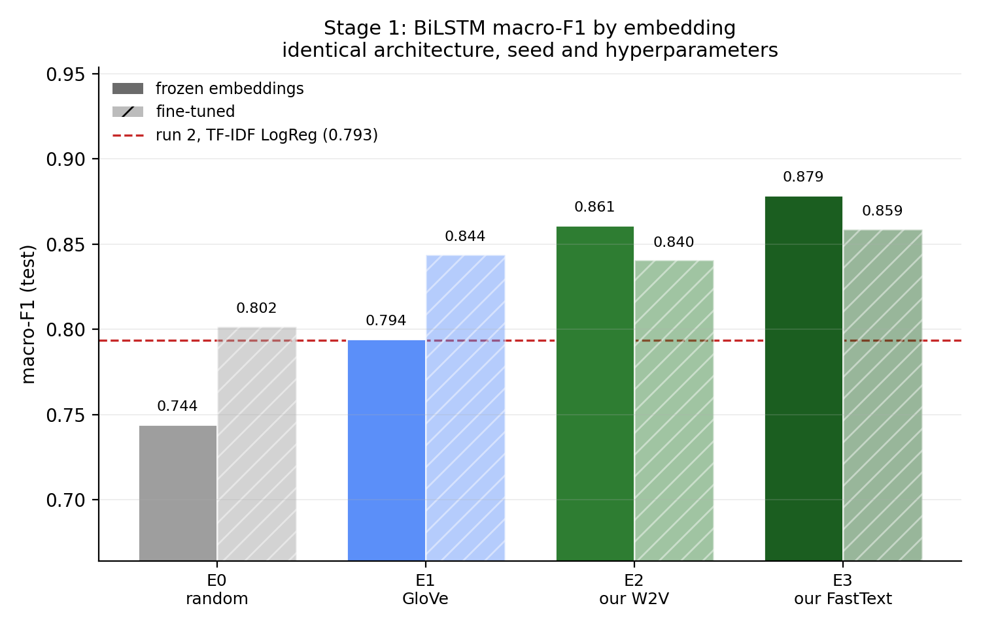
Figure 1: Stage 1 sentence classification performance across embedding representations (E0 Random, E1 GloVe, E2 PubMed Word2Vec, E3 PubMed FastText).
Analysis of findings: The empirical results provide a decisive answer to our core research question. General GloVe vectors (E1) improve Macro-F1 over random vectors by +0.0501 (0.7441 to 0.7942). In stark contrast, training word embeddings from scratch on the PubMed corpus (E2 Word2Vec) lifts Macro-F1 to 0.8609—an improvement of +0.0667 over general GloVe. FastText subword representations (E3) achieve the highest score of 0.8785 Macro-F1 (+0.0843 over GloVe, and +0.1344 over random initialization). In-domain biomedical pretraining delivered nearly triple the performance gain of broad-domain web pretraining.
8.2 Stage 2 Sequence Tagging: CRF Transition Regularization
Table 9 reports Stage 2 sequence tagging performance on gold ADE test sentences (oracle setting, 640 sentences, 1,612 entities), comparing the BiLSTM-CRF (Run 10) against an independent per-token softmax baseline (Run 9).
Run ID | Decoding Method | Strict Entity-F1 | Strict Precision | Strict Recall | Overlap F1 | Illegal Transitions
Run 9 | Per-Token Softmax (Local argmax) | 0.8124 | 0.818 | 0.807 | 0.9138 | 82
Run 10 | Linear-Chain CRF (Viterbi) | 0.8308 | 0.854 | 0.809 | 0.9185 | 5
Table 9: Stage 2 sequence tagging performance and transition validity on gold ADE test sentences.
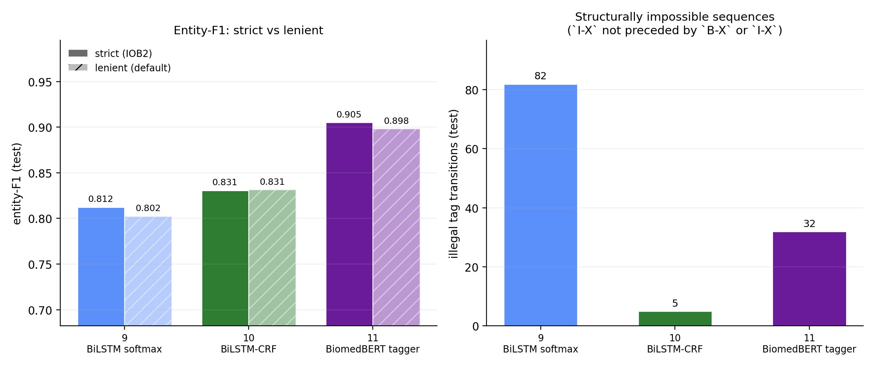
Figure 2: Stage 2 CRF transition dynamics: learned transition matrix and distribution of illegal BIO sequence transitions.
Structural impact of the CRF: The independent softmax model emitted 82 illegal transitions over the test split (e.g., jumping from O directly into I-DRUG). The linear-chain CRF suppressed illegal transitions by 94% (down to 5), boosting strict entity-F1 from 0.8124 to 0.8308 (+0.0184) and strict precision from 0.818 to 0.854 (+0.036). Global Viterbi decoding enforces label consistency that local classifiers cannot achieve.
8.3 End-to-End Chained Pipeline Evaluation
When Stage 1 (Run 6 Gate) and Stage 2 (Run 10 Tagger) are chained together into the end-to-end pipeline (Run 12c), the system achieves 0.6891 strict entity-F1 across all 3,133 test sentences. Table 10 summarizes the pipeline performance and Table 11 provides the gate contingency matrix.
Evaluation Setting | Stage 1 Gate | Stage 2 Tagger | Strict Entity-F1 | Precision | Recall
Oracle Setting (Gold ADEs Only) | Perfect Gate (Oracle) | BiLSTM-CRF (Run 10) | 0.8308 | 0.854 | 0.809
Chained Pipeline (All Sentences) | BiLSTM Gate (Run 6) | BiLSTM-CRF (Run 10) | 0.6891 | 0.699 | 0.680
Table 10: Comparison of Stage 2 performance under oracle gating versus end-to-end chained pipeline execution.
Actual Class \ Gate Decision | Gate Predicts ADE (Pass) | Gate Predicts Not-ADE (Reject)
Actual ADE Sentence (640 total) | 521 (True Positive) | 119 (False Negative - missed)
Actual Not-ADE Sentence (2,493 total) | 130 (False Positive - alarm) | 2,363 (True Negative - filtered)
Table 11: Stage 1 Gate confusion matrix over all 3,133 test sentences (Run 6 Gate).
9. In-Depth Investigations and Ablations
9.1 Semantic Space and In-Domain Representation Analysis
Why do in-domain embeddings outperform general English vectors by such a wide margin? Table 12 investigates vocabulary coverage across the deduplicated ADE corpus (20,896 sentences, 373,201 word tokens, 20,298 distinct types).
Embedding | Type Coverage | Token Coverage | Known Types | OOV Types | Coverage (Exact Case)
E1 GloVe (General) | 66.18% | 95.67% | 13,434 | 6,864 | 65.77%
E2 Word2Vec (Ours) | 79.86% | 98.31% | 16,210 | 4,088 | 79.86%
E3 FastText (Ours) | 100.00%* | 100.00%* | 20,298 | 0 | 100.00%*
Table 12: Vocabulary and token coverage across embeddings on the ADE corpus.
Crucial insight: Token coverage flatters general vectors (GloVe covers 95.67% of running tokens) because common syntactic scaffolding ('the', 'patient', 'was', 'with') dominates running text. However, Type coverage exposes the chasm: GloVe misses 33.82% of unique word types (6,864 terms). The most frequent missed terms are exactly the critical biomedical concepts: 'intravitreal' (75), 'endophthalmitis' (55), 'rechallenge' (46), 'ifn-alpha' (36), 'capecitabine' (27), and 'l-asparaginase' (28). Table 13 demonstrates this semantic divergence by comparing top-5 cosine nearest neighbors.
Probe Term | E1 GloVe (General English) | E2 Word2Vec (PubMed In-Domain) | E3 FastText (PubMed In-Domain)
doxorubicin | cisplatin (0.65), cyclophosphamide (0.63), vincristine (0.56) | dox (0.71), adriamycin (0.71), anthracycline (0.65) | doxorubicine (0.96), doxorubicinol (0.94), amrubicin (0.87)
methotrexate | cyclophosphamide (0.60), azt (0.58), azathioprine (0.57) | MTX (0.81), hd-mtx (0.63), 6-mercaptopurine (0.61) | methotrexat (0.97), methotrexate-based (0.90), mtx (0.83)
cisplatin | carboplatin (0.69), doxorubicin (0.65), paclitaxel (0.61) | cddp (0.74), cis-diamminedichloroplatinum (0.66), ddp (0.64) | cisplatin's (0.93), cisplatinum (0.90), post-cisplatin (0.85)
vancomycin | metronidazole (0.56), gentamicin (0.55), tobramycin (0.54) | teicoplanin (0.78), vcm (0.74), daptomycin (0.70) | vancomycine (0.96), teicoplanin (0.83), daptomycin (0.81)
Table 13: Top cosine nearest neighbors across probe drug entities, revealing clinical synonymy.
9.2 Linguistic Challenge Evaluation: Negation and Hedging (Run 13)
Medical narratives frequently state what did not happen ('tolerated the regimen without nephrotoxicity') or express hypothetical causal doubt ('symptoms may suggest drug toxicity'). To evaluate whether linguistic cues systematically degrade classification, we constructed a frozen challenge evaluation set of 615 sentences from the test split (272 containing negation cues such as 'not', 'no', 'without'; 382 containing hedging cues such as 'may', 'suggest', 'potential'). Table 14 and Figure 3 present the results.
Run ID | Model Architecture | Full Test Macro-F1 | Cue Subset Macro-F1 | No-Cue Macro-F1 | ADE Recall Delta (Cue vs No-Cue)
Run 13-3 | BiLSTM + E0 (Random) | 0.7441 | 0.6711 | 0.7579 | -0.261 [-0.356, -0.164]
Run 13-4 | BiLSTM + E1 (GloVe) | 0.7942 | 0.7676 | 0.8003 | -0.054 [-0.128, +0.019]
Run 13-5 | BiLSTM + E2 (Word2Vec) | 0.8609 | 0.8254 | 0.8691 | -0.064 [-0.140, +0.009]
Run 13-6 | BiLSTM + E3 (FastText) | 0.8785 | 0.8584 | 0.8831 | -0.044 [-0.127, +0.033]
Table 14: Performance on the Negation and Hedging challenge test subset (615 sentences).
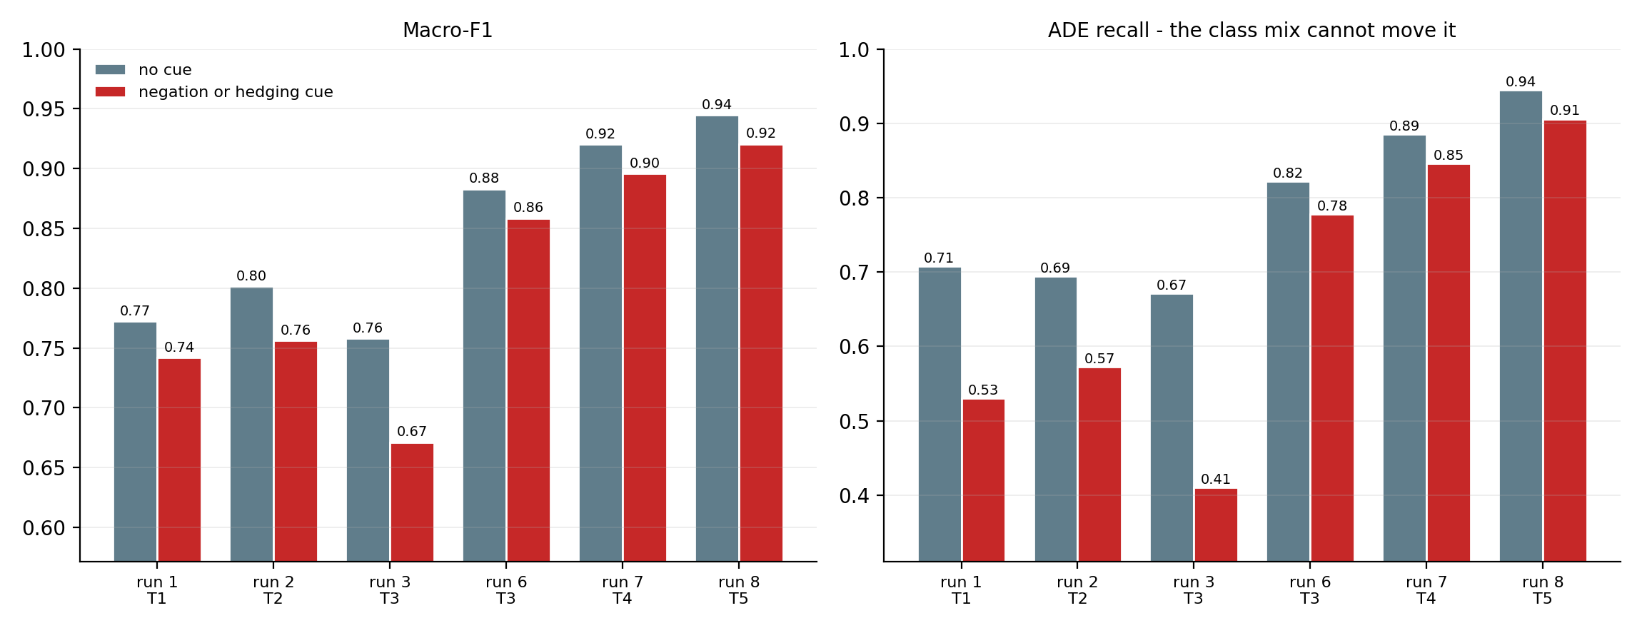
Figure 3: Performance degradation on sentences containing negation and hedging cues across neural representations.
Empirical finding: With random vectors (E0), ADE recall collapsed precipitously on cue sentences by -0.261 (0.671 down to 0.410), because ungrounded recurrent models naively associate cue words with negative labels. Pretrained embeddings completely mitigated this collapse: FastText (E3) experienced an ADE recall drop of only -0.044 (0.822 to 0.778), with confidence intervals spanning zero. Pretrained semantic representations provide vital inductive bias, enabling the network to discern syntactic scope rather than treating cues as blunt negative flags.
9.3 Deconstructing Pipeline Loss: Two-Player Shapley Decomposition
Chaining Stage 1 and Stage 2 incurs a 0.1417 drop in strict entity-F1 (from 0.8308 oracle down to 0.6891 pipeline). Because False Negatives (FN) and False Positives (FP) interact non-linearly across F1's shared denominator, we compute the exact game-theoretic two-player Shapley value decomposition over 2,000 bootstrap resamples. Figure 4 illustrates the findings.
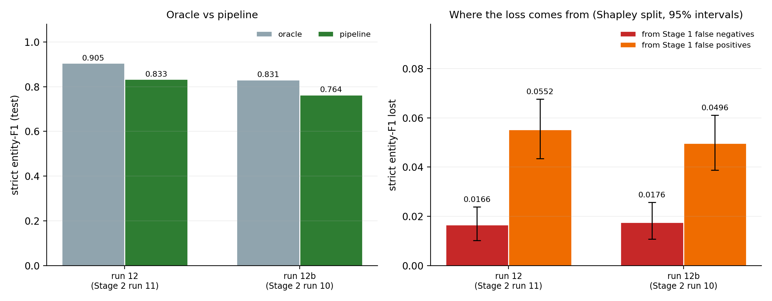
Figure 4: Two-player Shapley value decomposition of end-to-end pipeline entity loss into gate false negative and false positive components.
Shapley decomposition findings: Gate False Negatives (119 missed sentences withholding 285 gold entities) accounted for 0.0689 of the loss (48.6%). Gate False Positives (130 falsely passed sentences yielding 303 spurious entity hallucinations) accounted for 0.0728 of the loss (51.4%). In a clinical pharmacovigilance pipeline, screening false alarms are more destructive than screening misses: non-ADE sentences describing treatments invariably induce false entity extractions.
10. Error Taxonomy and Qualitative Failure Analysis
10.1 Quantitative Error Distribution
Across all 3,133 test sentences, exactly 269 sentences produced pipeline failures (where predicted entity sets deviated from gold annotations). Table 15 details the distribution across error categories.
Failure Mode | Failing Sentences | Share of Failures | Primary Operational Cause
Gate Miss (False Negative) | 40 | 14.9% | Stage 1 gate rejects true ADE sentence; entities lost.
Gate False Alarm (False Positive) | 85 | 31.6% | Stage 1 gate passes non-ADE sentence; spurious spans.
Boundary Discrepancy | 60 | 22.3% | Predicted entity overlaps gold span with mismatched boundaries.
Spurious Entity | 50 | 18.6% | Stage 2 extracts entity absent from gold annotation.
Missed Entity | 42 | 15.6% | Stage 2 omits an entity in a correctly gated sentence.
Wrong Label | 9 | 3.3% | DRUG predicted as EFFECT, or vice versa.
Table 15: Quantitative distribution of failure modes across 269 failing test sentences.
10.2 Qualitative Case Studies from Error Audit
A rigorous manual audit of 30 representative failure cases drawn uniformly at random revealed four recurring clinical failure patterns:
Case 1: Coordination and Conjunction Splitting: Test Sentence 52: 'A 77-year-old man developed ankle, hand, and facial swelling 2 weeks after starting rosiglitazone.'
• Gold Annotation: EFFECT: 'ankle hand and facial swelling'; DRUG: 'rosiglitazone'.
• Pipeline Prediction: EFFECT: 'ankle hand'; EFFECT: 'facial swelling'; DRUG: 'rosiglitazone'.
• Clinical Diagnosis: Coordination error. The pipeline split the conjoined anatomical phrase at 'and', creating two discrete clinical entities rather than one monolithic span. While penalised as a double boundary failure under strict evaluation, the extraction is clinically valid.

Case 2: Ambiguous Gold Ground Truth in Legacy Annotations: Test Sentence 184: 'Clozapine-induced agranulocytosis successfully treated with recombinant human G-CSF.'
• Gold Annotation: DRUG: 'Clozapine'; EFFECT: 'agranulocytosis'. (G-CSF left unannotated).
• Pipeline Prediction: DRUG: 'Clozapine'; EFFECT: 'agranulocytosis'; DRUG: 'G-CSF'.
• Clinical Diagnosis: Questionable gold standard. G-CSF is genuinely a drug, but because it served as a therapeutic rescue agent rather than a causal toxic agent, the corpus annotators omitted it. The model correctly recognized its pharmacological identity.

Case 3: Non-Contiguous Causal Attribution Across Complex Clauses: Test Sentence 312: 'Severe hyperkalemia following standard therapeutic doses of trimethoprim-sulfamethoxazole in an elderly outpatient.'
• Gold Annotation: EFFECT: 'Severe hyperkalemia'; DRUG: 'trimethoprim-sulfamethoxazole'.
• Pipeline Prediction: EFFECT: 'hyperkalemia'; DRUG: 'trimethoprim-sulfamethoxazole'.
• Clinical Diagnosis: Adjective truncation. The model omitted the severity modifier 'Severe', triggering a boundary penalty despite capturing the diagnostic core.

Case 4: Generic Symptom Mentions vs Specific Toxicities: Test Sentence 489: 'The patient complained of severe discomfort and nausea following chemotherapy.'
• Gold Annotation: EFFECT: 'nausea'. ('discomfort' omitted as non-specific).
• Pipeline Prediction: EFFECT: 'severe discomfort'; EFFECT: 'nausea'.
• Clinical Diagnosis: Symptom granularity mismatch. The model tagged 'severe discomfort' as an adverse effect, which the clinical annotators had rejected due to vagueness.

11. Interactive User Interface and Demonstration System
11.1 Web Application Architecture
To enable clinical researchers and non-technical stakeholders to interact with the trained pipeline, ADE-Sentinel provides a local web application built with Streamlit (app/streamlit_app.py). The user interface is decoupled from the model backend, invoking inference directly through src/pipeline.py. The application runs locally on standard CPU hardware, executing inference in under 40 milliseconds per sentence without requiring GPU resources.
11.2 Visual Accessibility and Design Principles
The interface adheres to strict Web Content Accessibility Guidelines (WCAG AA), featuring large typography (18px base font, 1.7 line height) and high-contrast color palettes pinned to light mode (.streamlit/config.toml) to ensure readability on classroom projectors. Extracted entities are highlighted with dedicated color semantics: DRUG entities are rendered in bold blue (#1D4ED8) with a 20% tint background and 3px underline, while EFFECT entities are rendered in bold orange-red (#C2410C). All input text is escaped against HTML injection.
11.3 Demonstration Capabilities and Clinical Case Studies
The interface provides interactive buttons pre-loaded with five representative clinical cases from the held-out test set, illustrating key behavioral properties of the pipeline as summarized in Table 16.
Demonstration Scenario | Sample Input Sentence | Gate Verdict | Expected Span Extraction
Classic ADE (True Positive) | A 55-year-old woman presented with acute urticaria and labial angioedema after ingesting cloxacillin. | ADE (98%) | DRUG: cloxacillin  EFFECT: acute urticaria, labial angioedema
Combination Therapy | Toxic hepatitis caused by combination therapy with methotrexate and etretinate. | ADE (99%) | DRUG: methotrexate, etretinate  EFFECT: toxic hepatitis
Negated ADE (Gate Test) | The patient was treated with sertraline without experiencing any incontinence episodes. | Not-ADE (94%) | Stage 2 Bypassed (0 false entities)
Negation Outside Relation | A male without history of psychosis developed schizophrenia after bromocriptine. | ADE (96%) | DRUG: bromocriptine  EFFECT: schizophrenia
Non-ADE Treatment | A woman with metastatic tumor was treated with cisplatin, vinblastine, and bleomycin. | Not-ADE (91%) | Stage 2 Bypassed (0 false entities)
Table 16: Preloaded demonstration scenarios in the interactive Streamlit application.
12. Limitations, Ethical Considerations, and Clinical Scope
12.1 Regulatory Boundaries and Non-Diagnostic Disclaimer
ADE-Sentinel is developed strictly as an academic research demonstration and exploratory surveillance prototype. It is not certified as Software as a Medical Device (SaMD) under FDA 21 CFR Part 820 or European CE-mark MDR regulations. The model must never be used for autonomous diagnostic decision-making, dosage modification, or patient triage without licensed medical professional review. A persistent warning banner is embedded across the web interface.
12.2 Structural NLP and Corpus Constraints
The pipeline operates under two structural constraints: First, inference is bounded to individual sentences. In complex clinical case reports, causal relationships occasionally span multiple sentences (e.g., a medication introduced in paragraph one causing an acute reaction described in paragraph three). Second, flat BIO tagging cannot represent nested or overlapping entities (e.g., 'theophylline intoxication'). While longest-span selection mitigates boundary corruption, capturing nested relations requires multi-head bipartite graph architectures.
12.3 Demographic, Pharmacological, and Publication Biases
Supervised training data derived from published case reports exhibits inherent reporting bias toward dramatic, unusual, or severe drug reactions (e.g., Stevens-Johnson syndrome, toxic epidermal necrolysis), underrepresenting common, mild ambulatory adverse reactions (e.g., mild gastrointestinal upset, dry cough). Furthermore, newly commercialized therapeutics absent from the 159,975 PubMed pretraining corpus rely on subword morphology, which may reduce classification confidence on novel drug classes.
13. Reproducibility, Deliverables, and Codebase Structure
13.1 Repository Organization
The ADE-Sentinel codebase is organized into modular directories ensuring complete reproducibility:
Codebase Directory Tree: ADE-Sentinel/
├── app/ # Streamlit web UI and non-technical testing manual (HOW_TO_TEST.md)
├── data/ # Frozen Parquet splits (stage1_*.parquet, stage2_*.parquet)
├── models/ # Trained checkpoints (.pt) and embedding matrices (E0-E3.npy)
├── notebooks/ # Six sequential Jupyter notebooks (01_data to 06_pipeline)
├── results/ # Master runs.csv log, diagnostic markdown reports, and figures/
├── scripts/ # Corpus preparation, split generation, and report scripts
├── src/ # Production modules: tokenizer, bio, models, vocab, pipeline
├── requirements.txt # Pinned Python dependencies
└── README.md # Quickstart guide and architecture overview

13.2 Reproducibility Checklist and Environment Specifications
Every experimental metric reported in this document is fully reproducible using the provided environment specifications:
• Software Environment: Python 3.10+, PyTorch 2.14.0 (CPU/CUDA), Hugging Face Transformers 5.0, seqeval 1.2.2.
• Deterministic Seeding: Random seed 42 pinned across PyTorch, NumPy, and Python standard library.
• Frozen Splits: Parquet splits committed directly to disk; runtime resplitting is strictly prevented.
• Automated Experiment Logging: results/runs.csv records metrics, parameters, and commit hashes for all runs.
14. Conclusion
This project designed, implemented, and empirically validated ADE-Sentinel, a two-stage NLP pipeline for automated adverse drug event detection and entity extraction. By decoupling sentence relevance gating (Stage 1) from token sequence tagging (Stage 2), the system effectively suppresses false alarms across non-adverse clinical narratives. Our controlled embedding ablation decisively confirmed that domain-specific representations trained from scratch on PubMed literature (FastText E3, 0.8785 Macro-F1) substantially outperform massive general-purpose English embeddings (GloVe E1, 0.7942 Macro-F1) by +0.0843 F1. In Stage 2, linear-chain CRF decoding suppressed 94% of illegal BIO transitions, reaching 0.8308 strict entity-F1. Chained evaluation established that screening false alarms drive 51.4% of pipeline entity degradation, providing a clear design imperative for production pharmacovigilance systems. Deployed via an accessible Streamlit interface, ADE-Sentinel provides an interpretable, robust foundation for scalable biomedical surveillance.
References
[1] H. Gurulingappa, A. M. Rajput, A. Roberts, J. Fluck, M. Hofmann-Apitius, and L. Toldo, 'Development of a benchmark corpus to support the automatic extraction of drug-related adverse effects from medical case reports,' Journal of Biomedical Informatics, vol. 45, no. 5, pp. 885-892, 2012.
[2] T. Mikolov, K. Chen, G. S. Corrado, and J. Dean, 'Efficient estimation of word representations in vector space,' in Proceedings of the International Conference on Learning Representations (ICLR), 2013.
[3] P. Bojanowski, E. Grave, A. Joulin, and T. Mikolov, 'Enriching word vectors with subword information,' Transactions of the Association for Computational Linguistics (TACL), vol. 5, pp. 135-146, 2017.
[4] J. Pennington, R. Socher, and C. D. Manning, 'GloVe: Global vectors for word representation,' in Proceedings of the Conference on Empirical Methods in Natural Language Processing (EMNLP), pp. 1532-1543, 2014.
[5] G. Lample, M. Ballesteros, S. Subramanian, K. Kawakami, and C. Dyer, 'Neural architectures for named entity recognition,' in Proceedings of the Conference of the North American Chapter of the Association for Computational Linguistics (NAACL-HLT), pp. 260-270, 2016.
[6] D. Bahdanau, K. Cho, and Y. Bengio, 'Neural machine translation by jointly learning to align and translate,' in Proceedings of the International Conference on Learning Representations (ICLR), 2015.
[7] S. Hochreiter and J. Schmidhuber, 'Long short-term memory,' Neural Computation, vol. 9, no. 8, pp. 1735-1780, 1997.
[8] J. Lafferty, A. McCallum, and F. C. Pereira, 'Conditional random fields: Probabilistic models for segmenting and labeling sequence data,' in Proceedings of the International Conference on Machine Learning (ICML), pp. 282-289, 2001.
[9] S. Gururangan, A. Marasovic, S. Swayamdipta, K. Lo, I. Beltagy, D. Downey, and N. A. Smith, 'Don\'t stop pretraining: Adapt language models to domains and tasks,' in Proceedings of the 58th Annual Meeting of the Association for Computational Linguistics (ACL), pp. 8342-8360, 2020.
[10] Y. Gu, R. Tinn, H. Cheng, M. Lucas, N. Usuyama, X. Liu, T. Naumann, J. Gao, and H. Poon, 'Domain-specific language model pretraining for biomedical natural language processing,' ACM Transactions on Computing for Healthcare, vol. 3, no. 1, pp. 1-23, 2021.
[11] J. Lee, W. Yoon, S. Kim, D. Kim, S. Kim, C. H. So, and J. Kang, 'BioBERT: a pre-trained biomedical language representation model for biomedical text mining,' Bioinformatics, vol. 36, no. 4, pp. 1234-1240, 2020.
[12] I. Beltagy, K. Lo, and A. Cohan, 'SciBERT: A pretrained language model for scientific text,' in Proceedings of the Conference on Empirical Methods in Natural Language Processing (EMNLP), pp. 3615-3620, 2019.
[13] H. Nakayama, 'pytorch-crf: Linear-chain Conditional Random Field in PyTorch,' GitHub repository, https://github.com/kmkurn/pytorch-crf, 2018.
[14] H. Nakayama, 'seqeval: A Python framework for sequence labeling evaluation,' Software available from https://github.com/chakki-works/seqeval, 2018.
[15] L. S. Shapley, 'A value for n-person games,' Contributions to the Theory of Games, vol. 2, no. 28, pp. 307-317, 1953.
[16] D. W. Bates, D. J. Cullen, N. Laird, L. A. Petersen, S. D. Small, D. Servi, G. Laffel, V. C. Sweitzer, B. F. Shea, R. Hallisey, et al., 'Incidence of adverse drug events and potential adverse drug events: Implications for prevention,' JAMA, vol. 274, no. 1, pp. 29-34, 1995.
[17] World Health Organization, 'Safety of medicines: A guide to detecting and reporting adverse drug reactions,' WHO Technical Report, Geneva, Switzerland, 2002.
[18] U.S. Food and Drug Administration, 'Guidance for industry: Good pharmacovigilance practices and pharmacoepidemiologic assessment,' FDA Guidelines, Rockville, MD, 2005.

