Academic Stress among Bangladeshi Engineering Students
Dataset Characteristics and Proposed Machine Learning Methodology
Khulna University of Engineering & Technology (KUET)
CSE 4112 —Machine Learning Laboratory
[Group members — 2107003,2107016, 2107018, 2107019,2107024]
Report stage | Post-collection: data characterisation and method proposal
Dataset | 987 responses × 21 columns, collected 30 July 2026 – 10 August 2026
Learning task | Unsupervised — clustering with dimensionality reduction
Primary toolkit | WEKA 3.8 Explorer / Experimenter

1 Purpose and Scope
Data collection is complete. This report documents what was collected and proposes how it should be analysed: it characterises the dataset, compares that dataset and our intended approach against two published reference works, and specifies a concrete WEKA pipeline with named filters, clusterers, and validation steps. It reports no modelling results — those are left for the final report, so the method is fixed in advance rather than chosen after seeing which configuration produced an appealing picture.
Section 3.4 includes one measurement normally treated as analysis — the internal-consistency and correlation structure of the questionnaire — because it is a property of the data rather than a result about students, and because it decides whether the composite stress score assumed in the original proposal is usable. It is not.

2 Dataset Overview
Responses were gathered through an anonymous bilingual (English and Bangla) Google Form between 30 July 2026 and 10 August 2026, a window of 12 days, with the heaviest single day on 07 August 2026 (291 responses). No names, roll numbers, or contact details were collected. The export contains 987 rows and 21 columns.
The columns fall into five blocks. Twelve five-point Likert statements are the primary clustering features. Four background fields (year, CGPA band, gender, living arrangement) plus department and a binary backlog item are held out of clustering and reserved for external validation — all six are imbalanced, as §3.1 shows. Two free-text fields supply the theme flags used for profiling and triangulation in §5.3. The timestamp is dropped before modelling.

3 Data Characteristics

3.1 Respondent composition
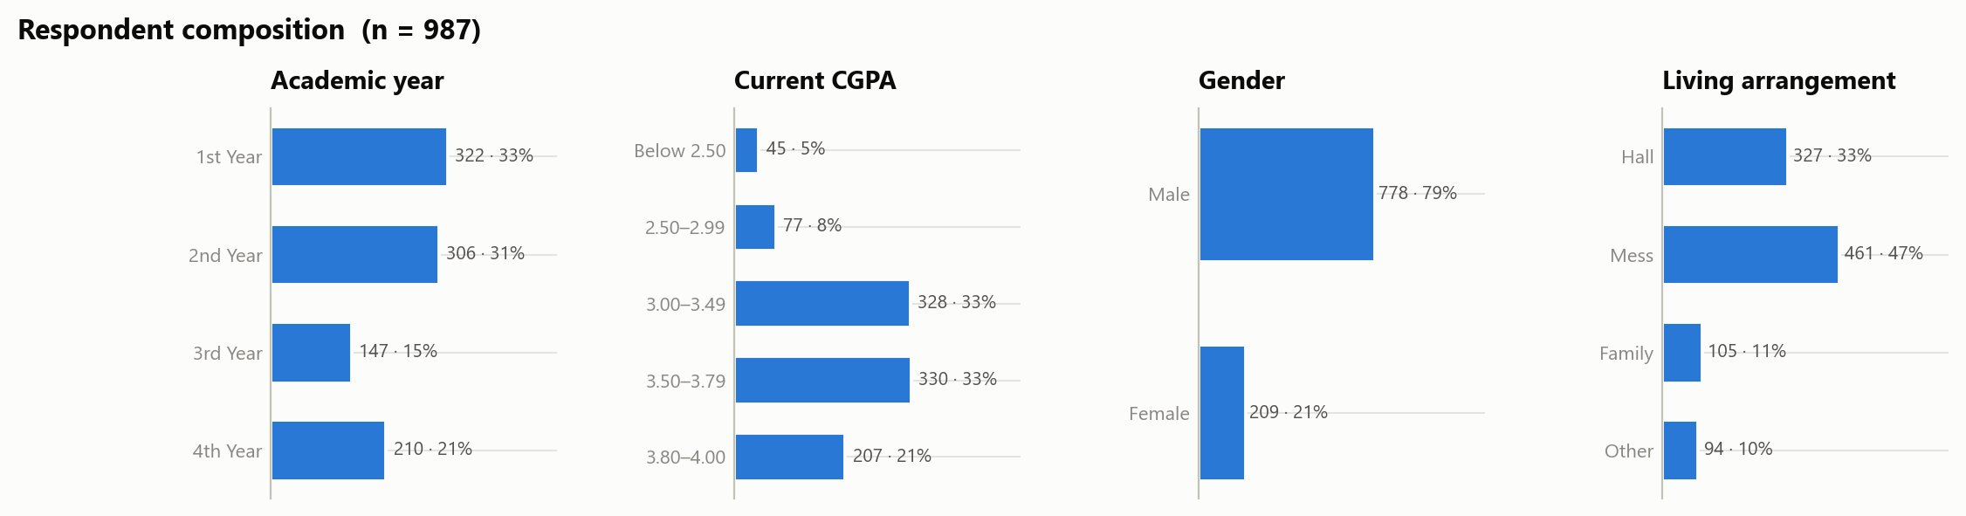
Figure 1. Composition of the sample by academic year, CGPA band, gender, and living arrangement.
The sample is large for a course project but unbalanced in four ways that constrain the method. It is 79% male, a ratio of about 3.7 to 1. It is concentrated in the lower years: 64% are in first or second year, while third year contributes only 15%. The CGPA distribution is top-heavy, with 88% at 3.00 or above and only 45 students below 2.50. And the backlog item is severely imbalanced at 6.4% minority class, ruling it out as a target and making it a weak clustering feature.
Departmental coverage is wide but shallow. Fourteen departments are represented, yet the three largest (CSE, EEE, ME) supply 61% of all responses and 6 departments have fewer than 25 respondents each — the largest-to-smallest ratio is 65 to 1. Department is therefore a descriptive variable reported in percentages for the larger departments only, never a clustering feature and never compared using raw counts.

3.2 Completeness and integrity
Because every closed-ended question was marked required in the form, the quantitative block is complete. This is an unusually clean starting point and removes a whole class of preprocessing decisions.
Integrity check | Result | Consequence for preprocessing
Missing values, closed-ended items | 0 | No imputation filter required
Out-of-range Likert values | 0 | No range validation required
Exact duplicate rows (ignoring timestamp) | 0 | No de-duplication required
Blank open-ended Q1 / Q2 | 131 / 279 | Text features need an explicit 'no answer' level
Table 1. Completeness and integrity checks on the response export.

3.3 Distribution of the Likert items
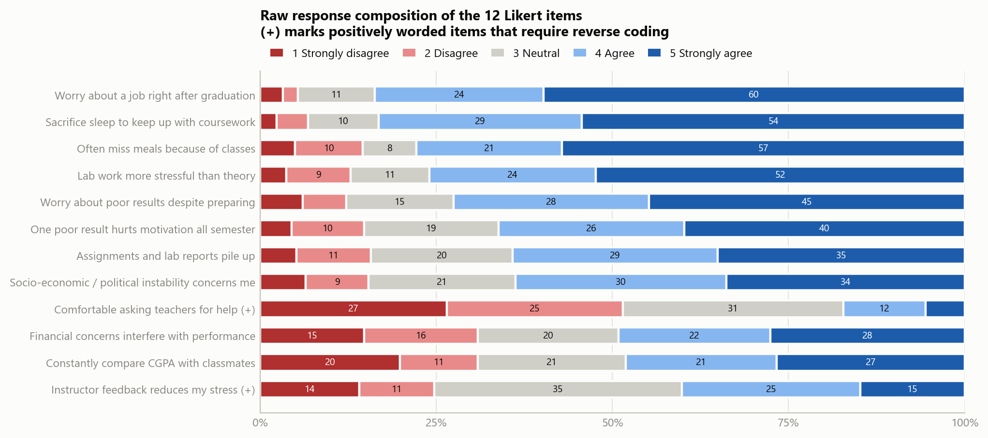
Figure 2. Raw response composition of the twelve Likert items, ordered by strain. Items marked (+) are positively worded and must be reverse coded before any distance is computed.
Agreement is high across most of the instrument. The strongest items are “worry about a job right after graduation” (mean 4.35, 84% agreeing), “sacrifice sleep to keep up with coursework” (4.28, 83%), and “often miss meals because of classes” (4.15, 78%). Two features matter for the method: several items are ceiling-limited — 590 of 987 respondents chose the top box on job worry alone — compressing the variance available to a distance-based clusterer; and two items are positively worded (marked (+)) and run opposite to the other ten.
Item ((+) = positively worded) | Mean | SD | % 4–5 | % 1–2 | Item–total r
Worry about a job right after graduation | 4.35 | 0.98 | 84% | 5% | +0.32
Sacrifice sleep to keep up with coursework | 4.28 | 0.98 | 83% | 7% | +0.35
Often miss meals because of classes | 4.15 | 1.21 | 78% | 15% | +0.31
Lab work more stressful than theory | 4.12 | 1.15 | 76% | 13% | +0.21
Worry about poor results despite preparing | 3.99 | 1.18 | 72% | 12% | +0.38
One poor result hurts motivation all semester | 3.87 | 1.18 | 66% | 15% | +0.37
Assignments and lab reports pile up | 3.78 | 1.18 | 64% | 16% | +0.34
Socio-economic / political instability concerns me | 3.76 | 1.20 | 64% | 15% | +0.10
Financial concerns interfere with performance | 3.31 | 1.41 | 49% | 31% | +0.26
Constantly compare CGPA with classmates | 3.24 | 1.46 | 48% | 31% | +0.16
Instructor feedback reduces my stress (+) | 3.16 | 1.22 | 40% | 25% | +0.19
Comfortable asking teachers for help (+) | 2.45 | 1.16 | 17% | 52% | +0.22
Table 2. Descriptive statistics for the twelve Likert items on their raw 1–5 scale, ordered by strain after direction alignment. Item–total r is computed on direction-aligned scores.
The most polarised items are peer CGPA comparison and financial concern — each attracts both a large agreeing and a large disagreeing group rather than clustering at the middle. These carry the most between-student variance and are the items most likely to drive genuine cluster separation.

3.4 Internal structure of the questionnaire
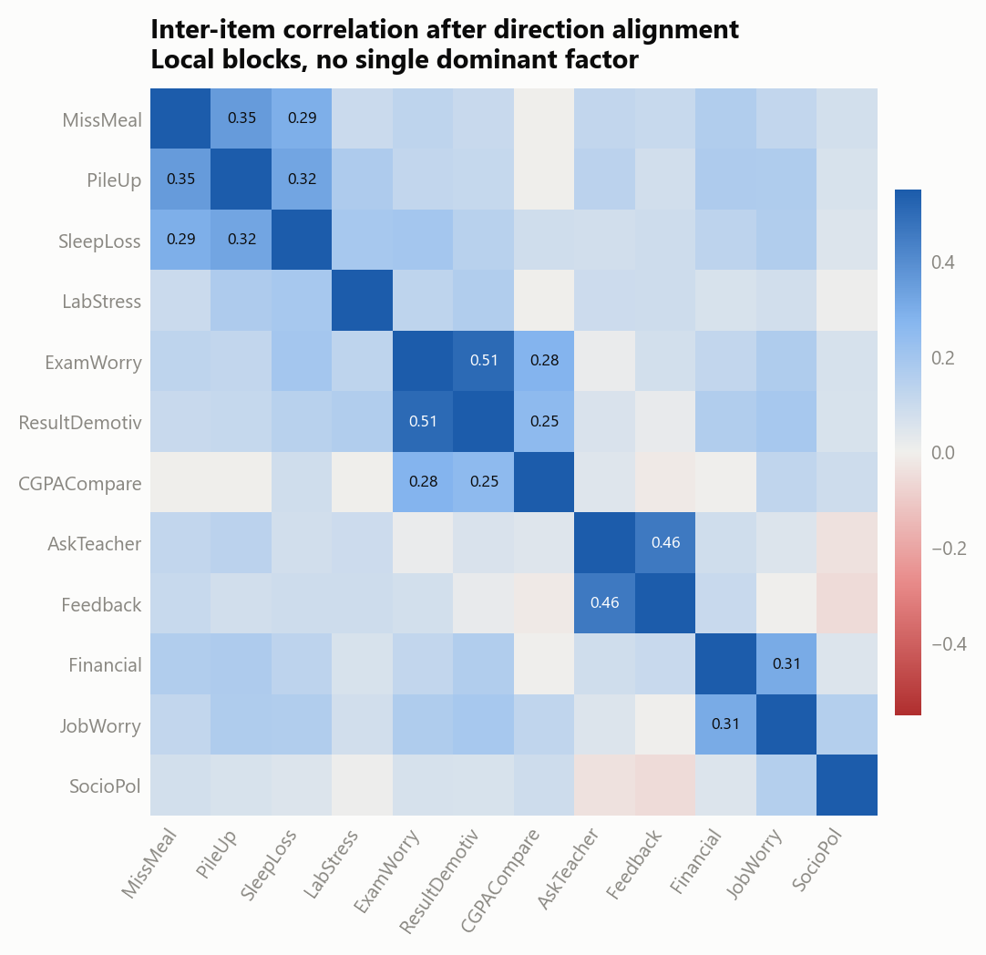
Figure 3. Inter-item correlation after aligning all items to a common direction.
After reverse coding the two positively worded items, Cronbach's alpha across all twelve items is 0.609, below the conventional 0.70 threshold for treating a set of items as one scale. The mean absolute inter-item correlation is only 0.123 and the strongest single pair reaches r = 0.51. Correlations form small local blocks rather than one dominant factor: exam worry with result-driven demotivation, the two instructor-support items with each other, a physical-strain group linking missed meals, piled-up work and lost sleep, and a separate economic pair joining financial concern to job worry. Three items — constantly compare cgpa with classmates, instructor feedback reduces my stress, socio-economic / political instability concerns me — have corrected item–total correlations below 0.20.
Two design decisions follow directly. A single summed or averaged “stress score” is not defensible on this data and will not be used as a target or as a headline number. And because the items are weakly and unevenly correlated, dimensionality reduction is genuinely motivated rather than decorative: the redundancy PCA removes is present, but only in local pockets.

3.5 Response-style quality
The original proposal flagged straight-lining as a risk. It did not materialise. Only 2 respondents (0.2%) gave an identical answer to all twelve items, only 5 (0.5%) fall below a within-row standard deviation of 0.5 (mean 1.24), and 28% used all five scale points at least once. There is a visible acquiescence tendency — 38% of all answers are top-box — but it is consistent with a genuinely stressed population rather than inattentive responding. No exclusion filter is proposed; the low-variance rows are flagged in the dataset documentation and retained.

3.6 Characteristics of the open-ended responses
Property | Q: biggest current stressor | Q: stressor in earlier years
Answered | 856 (86.7%) | 708 (71.7%)
Median / mean length | 5 / 10.7 words | 4 / 8.3 words
≤ 2 words / ≥ 10 words | 28% / 32% | 32% / 24%
Latin script only | 88.1% | 88.7%
Bangla script / both scripts | 9.3% / 2.6% | 9.9% / 1.4%
Romanised Bangla in Latin letters | ≈ 2.5% | ≈ 1.8%
Distinct answers / Latin vocabulary | 778 / 1417 | 628 / 1093
Table 3. Characteristics of the two free-text fields.
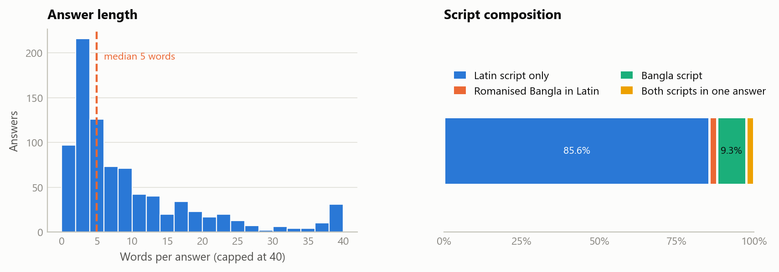
Figure 4. Answer-length distribution and script composition of the current-stressor field.
Three properties govern what can be done with this text. It is short — the median answer is 5 words and 28% are two words or fewer, typically a bare noun phrase such as “lab report” or “CGPA”. It is code-mixed — 9.3% is in Bangla script, 2.6% mixes both scripts in one answer, and a further 2.5% is romanised Bangla in Latin characters. And its sentiment is near-constant, because the question explicitly asks for a source of stress. Section 5.3 sets out what these properties permit and forbid.

4 Comparison with Related Work
Two published sources were used as reference points for instrument design and for method selection. Neither is merged with our data; both are used to position what we collected and to justify what we intend to run.

4.1 Reference A — Data in Brief, Southeast Asian university students
Chusniyah et al. describe a dataset of 969 undergraduates from Indonesia, Malaysia, and Thailand covering positive mental health, happiness, forgiveness, humility, and information-literacy self-efficacy [1]. Its contribution here is the reporting order it demonstrates: factor structure and a correlation matrix are established before any group comparison is interpreted — which is why Section 3.4 exists. Its own analysis is entirely classical (CFA, correlation, regression, Kruskal–Wallis), with no machine learning and no free-text data.

4.2 Reference B — University student psychological stress survey
The second reference is a 610-student university psychological stress survey with fifteen five-point items spanning exam anxiety, sleep disturbance, concentration, curriculum difficulty, financial burden, social isolation, student–professor relations, and loss of motivation [2]. It is the closer analogue to our instrument, and is distributed in three forms: raw, encoded, and a clustering-ready file carrying a derived three-level stress class. It demonstrates the exact workflow we intend — encode, then cluster.
It also supplies our clearest methodological caution. That dataset ships a pre-assigned stress class, fixing the number of groups before the data is examined. We do the opposite: the cluster count must be justified from internal validation measures, and the honest answer may be that the data does not separate cleanly at any k — which would be reported, not hidden.

4.3 How the datasets compare
Dimension | Reference A [1] | Reference B [2] | This dataset
Respondents / population | 969 · general university, 3 countries | 610 · general university | 987 · engineering undergraduates, one institution
Scale items | Multi-scale wellbeing battery | 15 stress items | 12 stress items + 5 background
Engineering-specific items | None | None | Lab vs theory, lab/report pile-up, backlog, CGPA comparison
Open-ended data | None released | None released | 2 fields, 856 and 708 answers
Language handling | One language per respondent | Single language | Code-mixed English / Bangla / romanised Bangla
Stress class label | Not applicable | Supplied with the data | None — to be derived and validated
Table 4. Dataset comparison against the two reference works.

4.4 How the methodologies compare
Stage | Reference A [1] | Reference B [2] | Proposed here
Paradigm | Classical inference | Supervised on a supplied class | Unsupervised clustering
Structure check | Confirmatory factor analysis | Not reported | Cronbach's alpha, correlation matrix, PCA
Model | Regression, Kruskal–Wallis | Classifier on 3 stress classes | SimpleKMeans, EM, HierarchicalClusterer
Choosing group count | Theory-driven | Fixed in advance at 3 | SSE elbow, EM cross-validated likelihood, dendrogram
Validation | Statistical significance | Classification accuracy | Classes-to-clusters on held-out variables, seed stability
Text analysis | None | None | Code-mixed multi-label theme lexicon + NMF cross-check
Toolkit | SPSS | Not specified | WEKA 3.8
Table 5. Methodological comparison. The right-hand column is what Section 5 specifies.
In short, we adopt Reference A's insistence on establishing measurement structure before interpretation and Reference B's encode-then-cluster workflow, while rejecting its pre-assigned class count. The two genuinely new elements are the engineering-specific item set and the code-mixed free-text field, neither of which appears in either reference.

5 Proposed Methodology and Models

5.1 Task formulation
The task is unsupervised clustering of 987 students over the twelve direction-aligned Likert items, with dimensionality reduction applied first. There is no ground-truth stress label, and Section 3.4 established that a summed score is not a valid substitute, so a supervised formulation is unavailable. The background variables — year, gender, living arrangement, CGPA band, department, backlog — are deliberately excluded from the feature set and reserved for external validation, so any association between a cluster and, say, academic year is a genuine finding rather than an artefact of having clustered on that variable.

5.2 Preprocessing and ARFF preparation
The export is converted to ARFF with the twelve Likert items declared numeric, the background fields declared nominal with explicit level lists, and the two free-text fields declared string. Reverse coding of the two positively worded items is done before conversion so that the ARFF is directly usable. The WEKA filter chain is then:
# | WEKA filter (weka.filters.unsupervised.attribute.*) | Purpose
1 | Remove -R 1,19-21 | Drop timestamp, both text fields, and department from the clustering view
2 | NumericToNominal -R <background> | Ensure background fields are nominal for classes-to-clusters use
3 | Standardize | Zero mean, unit variance — required because k-means is variance-sensitive
4 | PrincipalComponents -R 0.95 -A 5 | Retain components covering 95% of variance; see §5.4
Table 6. Preprocessing filter chain applied in the WEKA Explorer Preprocess tab.
Standardization matters more here than it appears. The items share a common 1–5 scale, so it looks unnecessary — but their standard deviations range from 0.97 to 1.46. Left unstandardised, the two most polarised items would dominate the Euclidean distance purely because they are more spread out.

5.3 Purpose and treatment of the open-ended responses
The two free-text fields are not an afterthought to the Likert block; they answer a different question about the same student. The scale items measure how much strain a student carries; the free text reveals what that strain is about — and only the free text can, because it is the one place a student can name a stressor nobody thought to ask about. Several frequent answers in the collected data (session jam, hall food, result-publication delay, non-departmental courses) have no corresponding Likert item at all. The purpose of the text pipeline is therefore threefold: to describe what students volunteer unprompted, to label and profile the clusters of Section 5.5, and to supply convergent validation from a source the clusterer never sees.
Method selection
The three properties documented in Section 3.6 — short answers, code mixing, and constant sentiment — rule out several standard approaches before any code is written. Recording that reasoning is itself part of the methodology:
- Sentiment analysis is excluded. The question asks for a source of stress, so nearly every answer is negative by construction; polarity has almost no between-student variance and cannot discriminate.
- Transformer embeddings are unreliable at this length. Contextual models need context, and a two-word noun phrase supplies none. No widely available pretrained embedding covers romanised Bangla.
- English-only stemming and stopword pipelines would silently degrade the 12% of answers carrying Bangla script — roughly one answer in eight, all of which contain real content.
- Purely unsupervised topic modelling is viable but weak on text this short and this dominated by a single vocabulary; it is retained only as a cross-check, not as the primary method.
The code-mixed stressor lexicon
What does work on this data is a hand-built, code-mixed, multi-label lexicon. Thirteen stressor themes were defined from a close reading of roughly 250 answers, and each theme is given a regular-expression pattern list covering English terms, Bangla-script terms, and the romanised Bangla spellings actually observed. Multi-label assignment is essential rather than convenient: students routinely name two or three distinct stressors in one sentence, so a single-label scheme would discard most of what they wrote.
Theme | Cue terms | Theme | Cue terms
Lab & coursework load | lab report, lab task, sessional, viva · ল্যাব | Teachers & teaching | teacher, sir, lecture · শিক্ষক, স্যার
Exams & results | exam, CGPA, term final, marks · পরীক্ষা, রেজাল্ট | Peers & campus climate | compare, toxic, ragging, politics · তুলনা, বন্ধু
Time & schedule | routine, 8 am, session jam, syllabus · সময়, রুটিন | Living conditions & food | hall food, mess, canteen, transport · খাবার, হল
Career & job uncertainty | job, career, skill, abroad · চাকরি, ভবিষ্যৎ | Sleep & health | sleep, insomnia, tired, anxiety · ঘুম, স্বাস্থ্য
Financial stress | financial, money, cost, tuition · আর্থিক, টাকা | Self-regulation | procrastination, irregular, lazy, distraction · অলস
Family & homesickness | family, home, alone, lonely · পরিবার, একা, দূরে | Curriculum & non-dept | non-dept course, memorisation, rote, credit hours
Generic academic pressure | academic pressure, study pressure · পড়াশোনা, চাপ
Table 7. The thirteen stressor themes with representative cue terms. Each theme becomes one nominal {yes, no} attribute; a single answer may carry several.
A pilot application of the lexicon to the collected answers assigns at least one theme to 85.7% of the current-stressor field and 71.9% of the earlier-years field, at a mean of 1.40 themes per answer. This is reported as a feasibility check on the extraction method, not as a finding about students. The lower figure for the second field is not a lexicon failure: many answers there are procedural non-answers (“same”, “N/A”, “I am in 1st year, no previous experience”) that contain no stressor to extract, and that absence is itself a meaningful category which will be coded explicitly.
Integration with WEKA
Tagging runs outside WEKA and the resulting flags enter the ARFF as nominal attributes alongside an explicit “no answer” level. WEKA's own StringToWordVector is used only as the secondary cross-check, for reasons worth stating plainly: its default WordTokenizer delimiter set does not include the Bangla danda (।), so Bangla sentence-final tokens are not split correctly; its stemmers and stopword lists are English-only; and with a median answer of 5 words, a bag-of-words vector over a 1417-term vocabulary is extremely sparse. It will be run as StringToWordVector -I -T -W 200 on the Latin-script subset only, purely to confirm that the lexicon's dominant themes also surface from a data-driven representation.
Crucially, the theme flags are not clustering features. Clustering is performed on the twelve Likert items alone, exactly as specified in Section 5.1, and the text is applied afterwards. Feeding the themes into the clusterer would destroy their value as independent corroboration.
Planned outputs
- Descriptive. theme prevalence across both fields, and the comparison against the Likert items — in particular whether the highest-scoring survey item is also the most volunteered theme, since prompted agreement and unprompted salience need not coincide.
- Subgroup. theme prevalence broken down by academic year, gender, and living arrangement, reported as row percentages within each subgroup.
- Cluster profiling. theme prevalence within each cluster, used both to name clusters in plain language and as convergent evidence — a high-strain cluster that also shows elevated mentions of sleep, health, or family separation supports the segmentation.
- Cross-check. a six-component NMF over the TF-IDF matrix, reported only as corroboration of the lexicon's largest categories.
Checks that will be reported either way
Two tests are specified in advance so a null result cannot be quietly dropped. First, whether non-response and answer length carry any signal — if students who skip the field, or write less, do not differ in measured strain, then neither is a usable proxy for distress. Second, whether naming a particular theme is associated with higher overall strain, tested across all thirteen themes with a Bonferroni correction (α = 0.05/13 ≈ 0.0038), since thirteen simultaneous comparisons would otherwise produce a false positive by chance alone. A finding that themes are largely independent of measured strain would not be a failure of the text analysis — it would confirm that the two instruments capture different things, which is the reason both were collected.

5.4 Dimensionality reduction
PCA is applied through the PrincipalComponents filter on the standardised matrix, retaining components covering 95% of variance. Two outputs are required: the explained-variance table, so the reduction is justified rather than assumed, and a 2-D projection on the first two components for visual inspection before any clusterer is committed to. Given the weak inter-item correlations in Section 3.4, PCA will likely need many components to reach 95% and will compress far less than a textbook example suggests. Clustering is therefore run on both the reduced matrix and the full standardised item set, and the two compared.

5.5 Candidate clustering models
WEKA clusterer | Key options | Why it is included
SimpleKMeans | -N 2..8 -init 1 -A EuclideanDistance -S 10 | Primary model. Scales easily to 987 rows and gives directly interpretable centroids. -init 1 selects k-means++ initialisation, reducing sensitivity to the seed.
EM | -N -1 -I 100 | With -N -1 WEKA selects the cluster count itself by cross-validated log-likelihood, giving an independent second opinion on k that does not rely on reading an elbow.
HierarchicalClusterer | -N 3 -L WARD -P | Dendrogram cross-check. Reveals whether a broad high-stress group splits into nested sub-groups, which a partitional method cannot show.
Canopy | -N 3 | Fast sanity check on cluster count and a cheap stability comparison.
Table 8. Candidate clustering models, all available in core WEKA 3.8.
One WEKA-specific advantage is worth recording. The original proposal worried that mixing continuous Likert items with categorical demographics would break k-means. WEKA's SimpleKMeans handles nominal attributes natively — centroids take the modal value and mismatched nominal values contribute a fixed distance — so a mixed-attribute run is possible without moving to K-Prototypes, and is retained as a documented secondary experiment.

5.6 Choosing k and validating the clusters
Cluster count is decided from three independent signals rather than one:
- Within-cluster sum of squared errors across k = 2…8 from repeated SimpleKMeans runs, read as an elbow.
- EM's automatic selection with -N -1, which selects the number of clusters by ten-fold cross-validated log-likelihood without human judgement.
- Dendrogram structure from HierarchicalClusterer with Ward linkage, inspected for the height at which merges become expensive.
One limitation of the toolkit must be stated. The WEKA Explorer does not report Silhouette or Davies–Bouldin indices for clusterers in its default installation; SimpleKMeans reports sum of squared errors and EM reports log-likelihood. Since the original proposal committed to silhouette-based validation, cluster assignments will be exported using the AddCluster filter and the silhouette coefficient computed externally from that export. This keeps the promised metric without misrepresenting what WEKA produced.
Validation proceeds on three fronts: classes-to-clusters evaluation against each held-out background variable in turn (year, gender, living arrangement, CGPA band), none of which entered the feature set, so agreement above chance is meaningful external support; stability across at least ten random seeds and on bootstrap subsamples; and the theme-flag cross-check from Section 5.3.

5.7 Cluster profiling and optional supervised extension
Each retained cluster is profiled by the mean of every item, the modal background category, and its theme-flag prevalence, then given a plain-language label assigned from the numbers rather than chosen first. Given the structure in Section 3.4 — where instructor support forms its own correlated block, largely independent of workload strain — the axis most likely to separate groups is whether students experience staff as approachable, and that is what we examine first. If time permits, the cluster label may then be written back with AddCluster and a J48 tree trained on it under ten-fold cross-validation: the purpose is interpretability, not prediction (accuracy would be circular), but J48 yields an explicit rule set per cluster that presents far better than a centroid table.

6 Anticipated Risks and Limitations
- Weak cluster structure is likely. With alpha at 0.61 and a mean inter-item correlation of 0.12, the items may not separate students cleanly at any k. If validation measures say the structure is weak, that will be reported as the finding rather than presented as three confident groups.
- Ceiling effects and sample imbalance. Several items are ceiling-limited, reducing usable variance and possibly pushing clusters to be defined mainly by the two most polarised items. With 64% of the sample in the first two years, 3.7-to-1 gender skew, and 6 departments below 25 respondents, clusters will describe the dominant strata best.
- Self-report, cross-sectional, single-site. Self-report at a single point in time measures perceived stress and is exposed to acquiescence and recall bias. No causal claim is available from this design, and findings apply to one institution at one point in time.
- Text coding is single-coded. The stressor lexicon is authored by the group, so without a second independent coder there is no inter-rater reliability figure and theme prevalences should be read as lower bounds. The ~14% of answers the pilot leaves untagged are unlikely to be a random subset. Double-coding a sample of 100 answers would close this gap cheaply and is recommended.

7 Deliverables
- Cleaned ARFF and data sheet — direction-aligned items, nominal background fields, documented level lists, plus the Section 3 tables as the dataset documentation sheet.
- PCA output — explained-variance table and a 2-D component projection.
- Clustering results — SSE elbow, EM cluster selection, Ward dendrogram, and the chosen k with justification.
- Validation and profiles — classes-to-clusters tables, externally computed silhouette, seed-stability comparison, and cluster profiles (item means, background composition, labels).
- Open-ended outputs — the frozen lexicon pattern file, theme prevalence overall, by subgroup and by cluster, the NMF cross-check, and the two pre-specified null checks from Section 5.3.

References
[1] T. Chusniyah, J. L. S. Jaafar, A. Chaiwutikornwanich, D. Kuswandi, A. Firmanto, A. Mustopa, and G. A. Zahra, “Dataset on positive mental health of Indonesian, Malaysian, and Thailand university students,” Data in Brief, vol. 32, art. 106314, 2020.
[2] Student Psychological Stress Survey Dataset (University Students) — raw, encoded, and clustering variants with accompanying questionnaire; 610 respondents, 15 five-point items.
[3] E. Frank, M. A. Hall, and I. H. Witten, The WEKA Workbench, online appendix to Data Mining: Practical Machine Learning Tools and Techniques, 4th ed. Morgan Kaufmann, 2016.
[4] L. J. Cronbach, “Coefficient alpha and the internal structure of tests,” Psychometrika, vol. 16, no. 3, pp. 297–334, 1951.
[5] D. Arthur and S. Vassilvitskii, “k-means++: the advantages of careful seeding,” in Proc. ACM-SIAM Symposium on Discrete Algorithms, 2007, pp. 1027–1035.
[6] P. J. Rousseeuw, “Silhouettes: a graphical aid to the interpretation and validation of cluster analysis,” Journal of Computational and Applied Mathematics, vol. 20, pp. 53–65, 1987.
[7] J. H. Ward, “Hierarchical grouping to optimize an objective function,” Journal of the American Statistical Association, vol. 58, no. 301, pp. 236–244, 1963.

