Assignment 1: Bidirectional Search

Assume you have to travel from ***Arad*** city to ***Bucharest*** city. You desire to travel this route. Following is a road-map. The cost of moving from one city to another city is same. There remains multiple paths to reach ***Bucharest*** city from ***Arad*** city. In order to quickly find out a shortest route, you require to apply **Breadth First Search** from two directions i.e. one from the starting city ***Arad*** which we call Forward Search and another from the destination city ***Bucharest*** which we call Backward Search. The searching process from both directions will terminate as soon as the overlapping city is discovered from any direction.

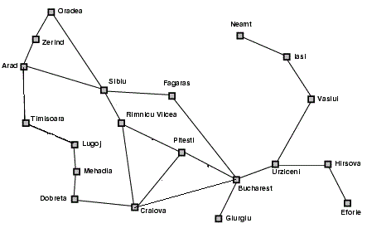

**Input:**

You’ll be given the information of the map, the locations of your starting and the destination city. We’re providing you a sample input (the information needed for the above map) to help you understand the input format.

20 24 (citys,roads)

***Arad*** (Starting Location)

***Bucharest*** (Destination Location)

[information of 24 roads]

Odarea, Sibiu

Farara,Urziccini

Riminecu, Pitesi

……………………

..

.

**Output:**

Print a shortest route with length. You also need to mention (1) the overlapping city with direction (Forward/Backward) on which point you have terminated your search and (2) the number of roads (from the starting city if it is found in Forward direction or from destination city if it is found in Backward direction) you require to reach there. We’re providing you a sample output.

Route: ***Arad->Sibiu->Fagaras ->Bucharast***

Length: ***3***

Direction: ***Forward*** City: ***Fagaras*** #Roads: ***2***